Supporting information
Multi-scale nickel embedded carbon nanotube/boron nitride nanoribbon aerogel for integrated electromagnetic wave absorption and thermal infrared stealth
Yibing Lin^{1, 2, 3, #}, Jing Zhang^{4, #}, Bo Zhong⁵, Yuanlie Yu^{1, 2, 3,} *
¹ State Key Laboratory of Solid Lubrication, Lanzhou Institute of Chemical Physics, Chinese Academy of Sciences, Lanzhou 730000, People’s Republic of China
² Shandong Laboratory of Advanced Materials and Green Manufacturing at Yantai, Yantai 264006, People’s Republic of China
³ Center of Materials Science and Optoelectronics Engineering, University of Chinese Academy of Sciences, Beijing 100049, People’s Republic of China
⁴ International school for optoelectronic engineering, Qilu University of Technology (Shandong Academy of Sciences), Jinan, 250353, People’s Republic of China
⁵ School of Materials Science and Engineering, Harbin Institute of Technology at Weihai, Weihai, 264209, People's Republic of China

# Yibing Lin and Jing Zhang contributed equally to this work.
* Corresponding authors.
E-mail addresses: yuanliehll@163.com or yuanliehll@licp.cas.cn (Y. L. Yu).

S1. Experiments
S1.1 Main materials
Melamine (C₃H₆N₆) and boric acid (H₃BO₃) were purchased from Macklin. Nickel chloride hexahydrate (NiCl₂·6H₂O) was purchased from Aladdin. Polydimethylsiloxane (PDMS) (type: SYLGARD 184) and curing agent were bought from Dow Corning Co., Ltd. (USA). All chemical reagents were used without further purification.
S1.2 Characterizations
The X-ray diffraction (XRD) patterns of the specimens were acquired using a X-Ray Diffraction (D8 ADVANCE, BRuker) equipped with Cu-K α radiation (λ = 0.154 nm, tube voltage = 40 kV, tube current = 40 mA). To further determine the elemental composition and surface chemical bonds of the final products, the composition and bonding states of the BNNR, Ni/BNNR and CNB aerogel were characterized by Fourier transform infrared spectroscopy (FTIR, Trace 100) and X-ray photoelectron spectroscopy (XPS, PHI GENESIS 500) with Al Kα as an X-ray source , respectively. The Raman spectra were through by a Raman spectrometer (LabRam HR Evolution). The morphology and structure of the BNNR, Ni/BNNR and CNB aerogel were observed by scanning electron microscope (SEM, TESCAN CLARA) and transmission electron microscope (TEM, Tecnai G2 F30 and JEM F200), respectively. And the element distribution was analyzed by the Energy dispersion spectrometer (EDS, Ultim Extreme) equipped in the SEM. Nitrogen adsorption-desorption isotherms were recorded by specific surface area and porosity analyzer (Micromeritics ASAP 2460). The magnetic hysteresis loops were recorded by vibration sample magnetometer (VSM, MicroSence EV9). The mass percentage of nickel was measured by inductive coupled plasma emission spectrometer (ICP; Agilent 5110). The thermogravimetry (TG) was performed on a Netzsch STA449F3 thermo-analysis instrument at a heating rate of 10 ℃/min up to 800℃ in air and nitrogen atmosphere, respectively. Electrochemical impedance spectroscopy (EIS) measurements were conducted on the samples using the CH Instruments CHI660E electrochemical workstation, with a Pt plate serving as the counter electrode, an Ag/AgCl reference electrode, and 3.5 wt% NaCl as the electrolyte solution. The thermal conductivity of the sample was measured by the transient hot-wire method thermal conductivity meter at room temperature (TC3000E, XIATECH). Infrared thermal images were taken by the Yoseen X640D thermal imager.
S1.3 Electromagnetic parameters measurement
The electromagnetic parameters of the CNB aerogel were measured by a vector network analyzer (E5063A, Agilent) in the frequency range of 2-18 GHz. The mixture (mixed absorbing materials with paraffin matrix) was pressed into the ring-shaped sample (outer diameter 7.00 mm, inner diameter 3.04 mm) in a mass ratio of 1:9. According to the transmission line theory, the RL values can be calculated according to the following equations [1, 2]:
$RL=20\log\left|\frac{Z_{in}-Z_{0}}{Z_{in}+Z_{0}}\right|$ (S1)
$Z_{in}=Z_{0}\sqrt{\frac{μ_{r}}{ε_{r}}}tanh\left[j\frac{2πfd}{c}\sqrt{ε_{r}μ_{r}}\right]$ (S2)
$α=\frac{\sqrt{2}πf}{c}×\sqrt{\left(μ″ε″-μ'ε'\right)+\sqrt{{\left(μ″ε″-μ'ε'\right)}^{2}+{\left(μ″ε″+μ'ε'\right)}^{2}}}$ (S3)
$η=\frac{|RLmin|}{ρ}$ (S4)
where Z_{in} is the normalized input impedance of the microwave absorber, Z₀ is the input impedance of the free space, f is the absorption frequency, d is the thickness of the absorber, and c is the velocity of light in the free space, μ_{r} and ε_{r} are the complex permittivity and complex permeability, η is the specific absorption efficiency, and ρ is the density, respectively.
The simulated thickness calculated by the quarter-wavelength matching model is defined by the following equation:
$t_{m}=\frac{nλ}{4}=\frac{nc}{4{\sqrt{ε_{r}μ_{r}}f}_{m}}(n=1,3,5····)$ (S5)
Where the t_{m}, λ, f_{m} and c represent the matching thickness, the wavelength of EMW, the matching frequency, and the speed of the EMW in a vacuum, respectively. The experimental t_{m} aligns closely with the calculated thickness based on the quarter-wavelength matching model.
According to the Debye's theory analyzing the relationship between ε' and ε", the mechanism of medium loss can be estimated, and the formula is as follows [3]:
${{(ε)}^{2}+(ε-\frac{ε_{s}+ε_{∞}}{2})}^{2}={(\frac{ε_{s}-ε_{∞}}{2})}^{2}$ (S6)
$ε=ε_{∞}+\frac{ε_{s}-ε_{∞}}{1+ω^{2}τ^{2}}$ (S7)
$ε=\frac{ε_{s}-ε_{∞}}{1+ω^{2}τ^{2}}+\frac{δ}{ωε_{0}}$ (S8)
where ε_{s} and ε∞ is the permittivity of absorbers at the high frequency limit and electrostatic field, respectively; τ is the polarization relaxation time; ε₀ is the vacuum permittivity. Theoretically, each Cole-Cole semicircle corresponds to a polarization relaxation process.
S1.4 RCS simulation
To evaluate the practical application of the samples, further simulations were performed based on far-field responses. In this simulation, the measured model is composed of an upper absorbing layer and a lower perfect electrical conductor (PEC) layer, where the thickness of the upper half is set to 3 mm, and the thickness of the lower half is set to 2 mm, respectively. The side length of the square shape model was designed to 180 mm. Here, the positive x axis is φ=0°, the positive z axis is θ=0°, the sheet is placed on the x-o-y plane along the positive z axis, and the microwave enters the model along the z axis. The excitation source is plane waves, and propagates in the direction of the negative half-axis of the Z-axis. The open (add space) boundary conditions were used in all directions. The scattering detection was determined by Theta and Phi. The radar cross-section (RCS) of the simulated sample is calculated as follows: [4, 5]
$RCS\left(dBm^{2}\right)=10log\left[\frac{4πS}{λ^{2}}{\left|\frac{E_{s}}{E_{i}}\right|}^{2}\right]$ (S9)
where S is the area of the simulated plane, λ is the wavelength of incident EMW, E_{s} and E_{i} are the emitted and the received electric field strength, respectively. The color and multi-directional radiating bars indicate the intensity of scattered EMW, and low scattered signal intensity corresponds to high EMW absorption performance.
S1.5 DFT calculation
The first-principles calculations are based on the CASTEP module of the Material Studio within density-functional theory (DFT).[6, 7] The exchange-correlation interactions functionals were calculated by using the Perdew-Burke-Enzerhof (PBE) functional of generalized gradient approximation (GGA).[8, 9] Ultrasoft pseudopotential serves as the plane wave base. Pulay of BFGS (Broyden-Flecher-Glodfarb-Shanno) is used to address electron relaxation. The plane-wave energy cutoff was set as 517 eV. The convergence threshold was set at 1.0 × 10⁻⁶ eV in energy and 0.01 eVÅ⁻¹ in force. The Brillouin zone was modeled by gamma centered Monkhorst-Pack scheme, and the k-point sampling grid is set to 12 × 12 × 2 grid for all models.
S1.6 The synthesis mechanism of BNNR aerogel
The corresponding chemical reactions for the formation of BNNR aerogel can be described as:[10]
2H₃BO₃+C₃N₆H₆ → C₃N₆H₆·2H₃BO₃ (S10)
C₃N₆H₆·2H₃BO₃ → 2BN+3H₂O+3CO+2NH₃+N₂ (S11)

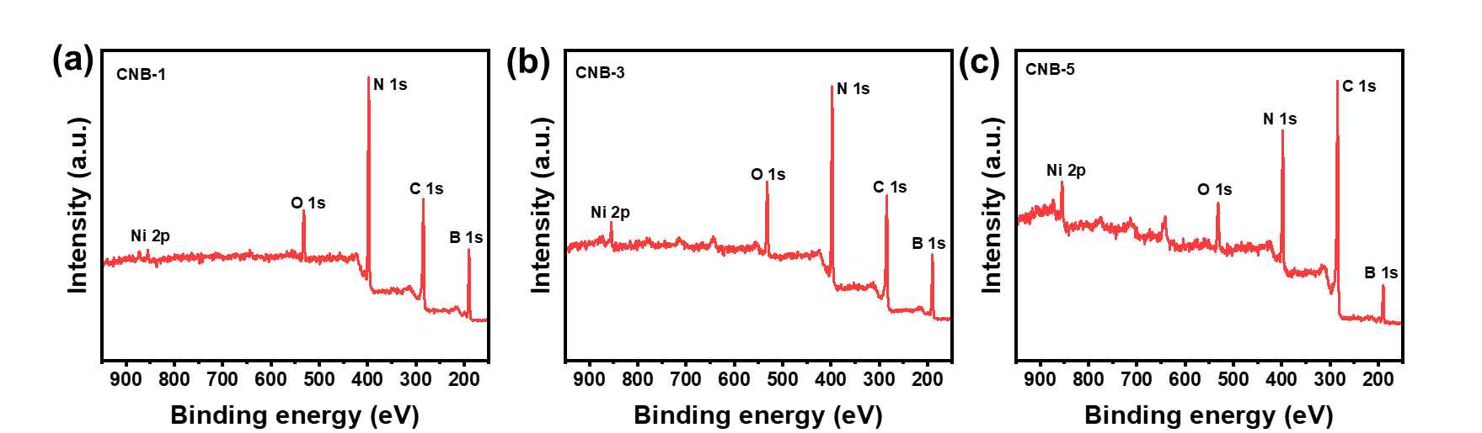
Fig. S1. XPS spectra of CNB aerogel, (a) CNB-1, (b) CNB-3, (c) CNB-5.

Fig. S2. Raman spectra of CNB aerogel.

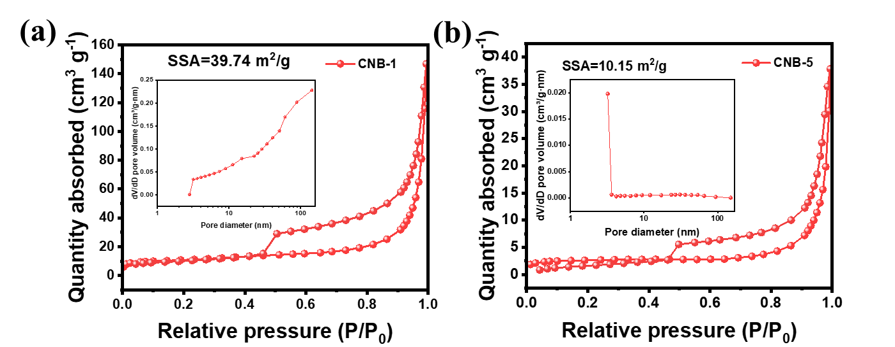
Fig. S3. Nitrogen adsorption-desorption isotherms and pore width distributions of (a) CNB-1 and (b) CNB-5.

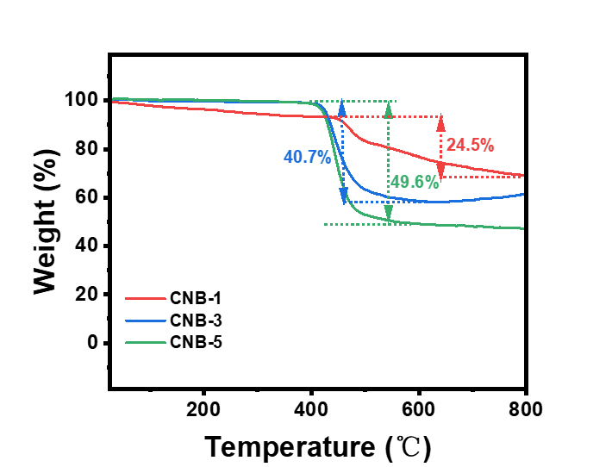
Fig. S4. TG curves of CNB-1, CNB-3 and CNB-5 aerogels under air atmosphere.

Fig. S5. TG curves of pure PDMS, CNB-1/PDMS, CNB-3/PDMS and CNB-5/PDMS aerogel elastomers under N₂ atmosphere.

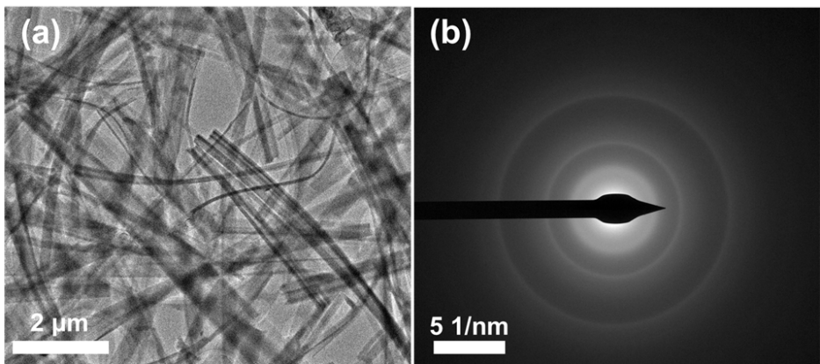
Fig. S6. TEM images of (a) BNNR aerogel. (b) SAED images of BNNR aerogel.

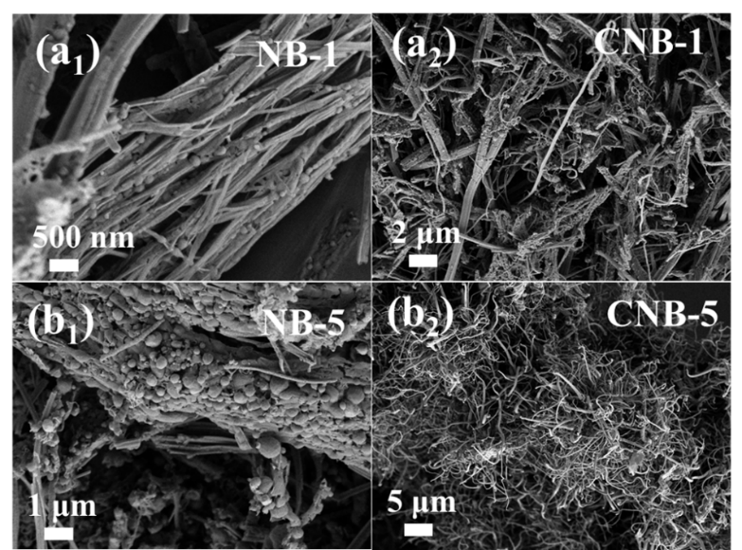
Fig. S7. SEM images of (a₁) NB-1, (a₂) CNB-1, (b₁) NB-5, and (b₂) CNB-5.

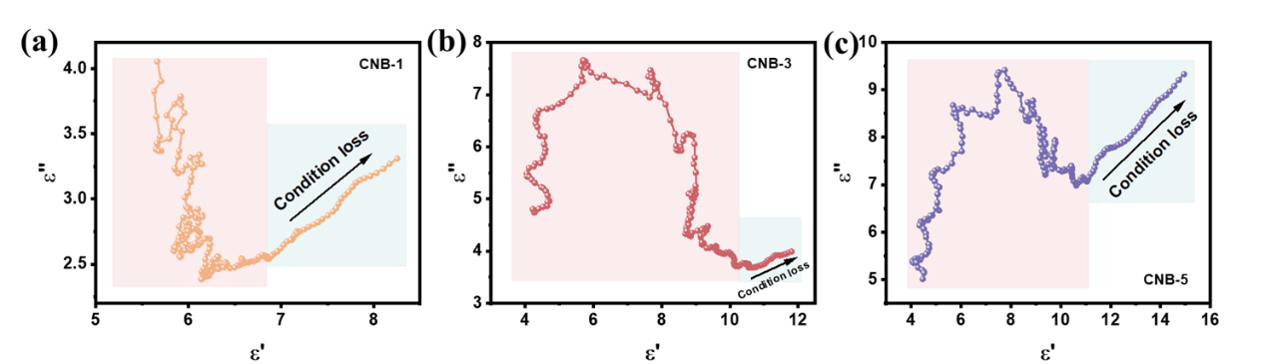
Fig. S8. Cole-Cole model plots: (a) CNB-1 aerogel, (b) CNB-3 aerogel, and (c) CNB-5 aerogel.

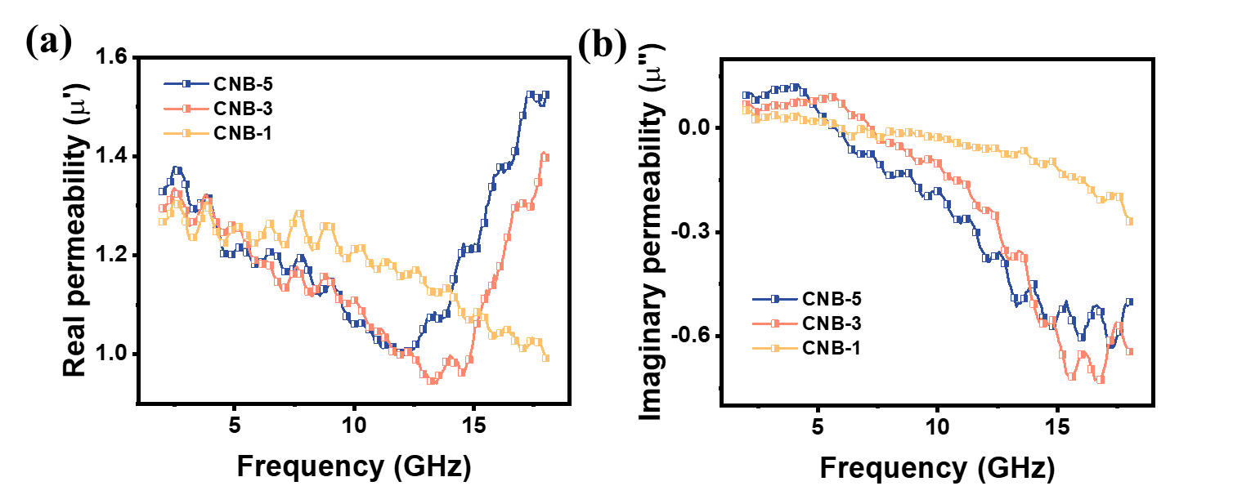
Fig. S9. Electromagnetic patterns: (a) μ′, and (b) μ′′.

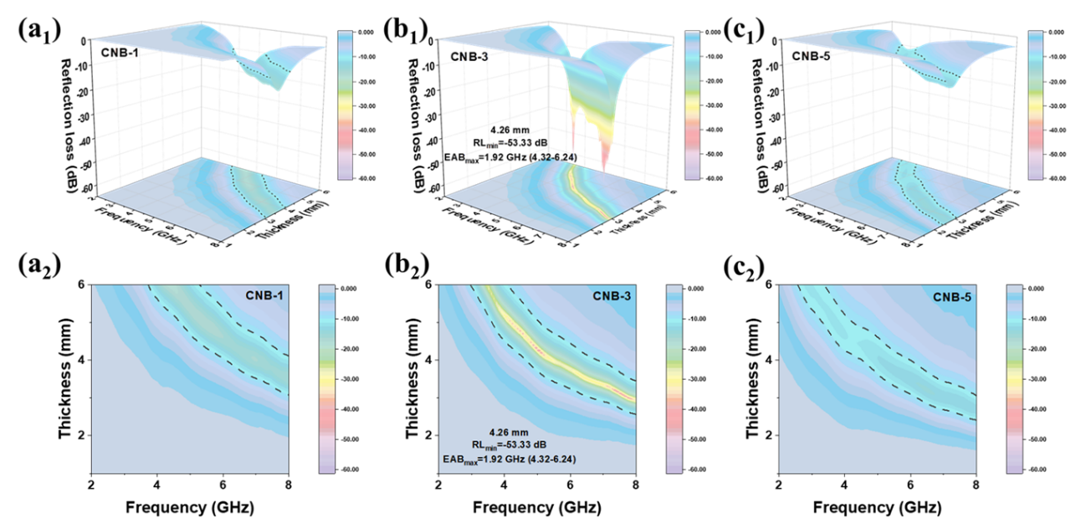
Fig. S10. 3D and 2D plot of RL for different samples, (a₁-a₂) CNB-1 aerogel, (b₁-b₂) CNB-3 aerogel, (c₁-c₂) CNB-5 aerogel in the range of 2.0–8.0 GHz.

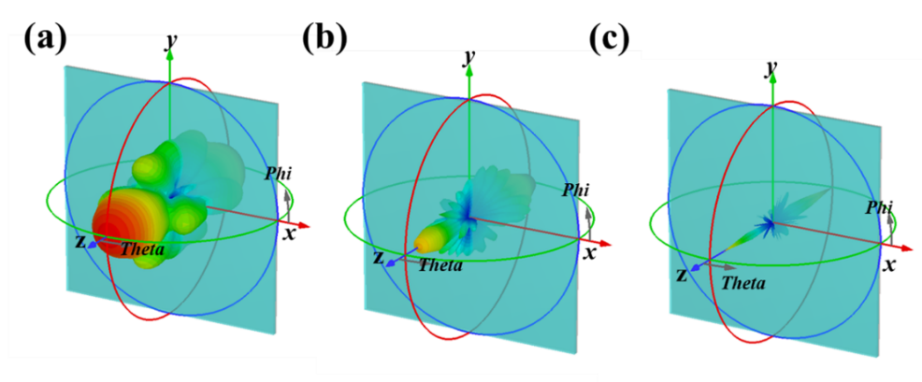
Fig. S11. Three-dimensional images of CST simulations for CNB-3 aerogel at 3 GHz (a), 6 GHz (b), and 17 GHz (c).

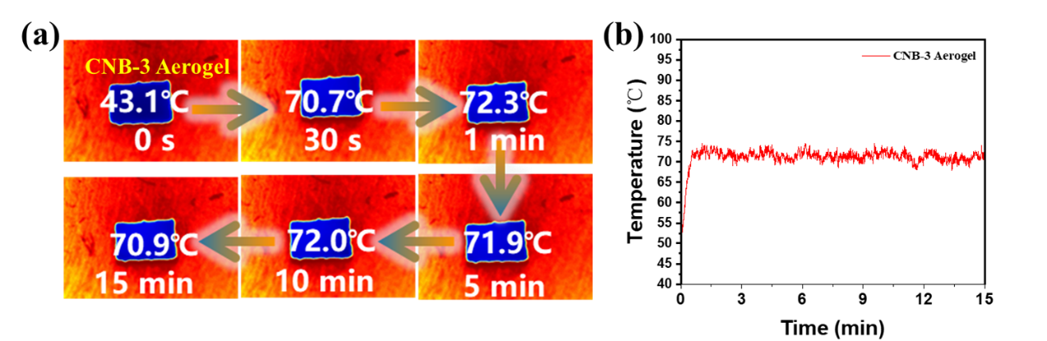
Fig. S12. (a) Infrared thermal images of CNB-3 aerogel on a constant temperature heating plate of 100℃. (b) Temperature–time curves of CNB-3 aerogel surface.

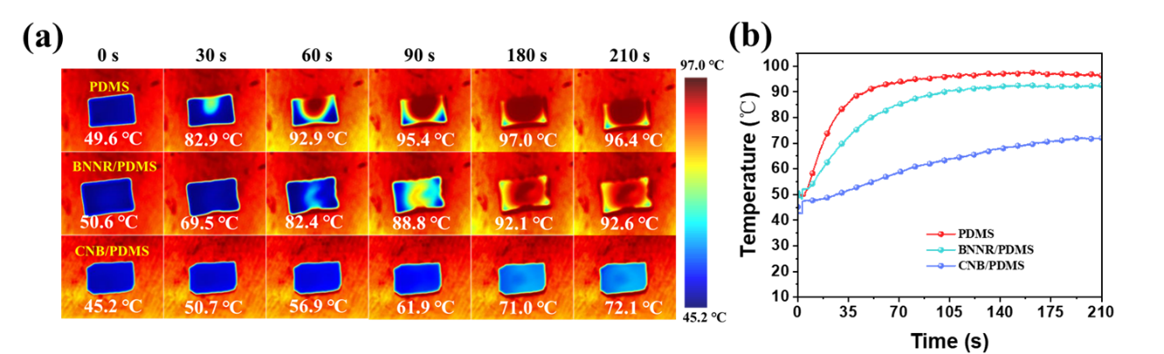
Fig. S13. (a) Infrared thermal images of PDMS, BNNR/PDMS, and CNB/PDMS aerogel elastomer on a constant temperature heating plate of 100℃. (b) Temperature–time curves of samples surface.

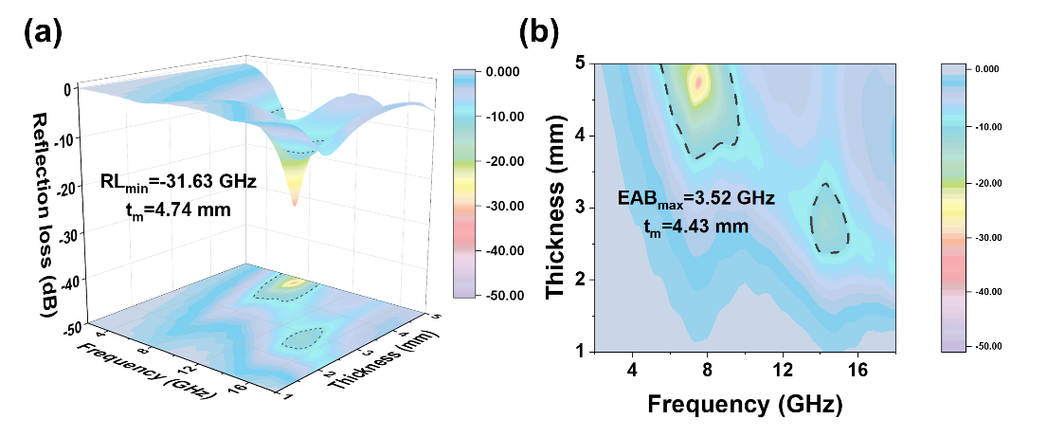
Fig. S14. 3D (a) and 2D (b) map of the RL curves for CNB/PDMS samples.

Table S1. Atomic ratio results from N1s.
Samples | N-B (at%) | pyridinic N(at%) | pyrrolic N(at%) | graphitic N(at%)
CNB-1 | 55.73 | 27.03 | 10.97 | 6.27
CNB-3 | 46.09 | 38.11 | 11.02 | 4.78
CNB-5 | 40.09 | 34.36 | 20.93 | 4.62

Table S2. Comparison this work with some reported materials EMW absorption performance
Material | RL  (dB) | Thickness  (mm) | EAB  (GHz) | Thickness  (mm) |  | Samples | Refs.
Co/CNF | -45 | 1.8 | 4.6 |  | 1.8 | S1 | [11]
CF@Ni-6 | -49.87 | 2.1 | 5.92 |  | 2.2 | S2 | [12]
CNCM-2 | -50.10 | 1.90 | 4.80 |  | 1.90 | S3 | [13]
Co/Ni-CNF-20 | -40.13 | 4.6 | 4.4 |  | 4.6 | S4 | [14]
TiB₂@BN/PDMS | -31.20 | 1.55 | 5.12 |  | 1.75 | S5 | [15]
BN_{0.5}/Ni_{0.5}/CNT₅/WPU | -42.4 | 2.5 | 3.12 |  | 1.5 | S6 | [16]
BGO-1 | -48.9 | 2.1 | 4.2 |  | 2.1 | S7 | [17]
BN@C-2 | -29.12 | 2.5 | 3.44 |  | 2.5 | S8 | [18]
BN/Ni | -42.8 | 1.7 | 2.24 |  | 1.7 | S9 | [19]
BN-MXene/PDMS | -49.72 | 2.0 | 5.8 |  | 2.0 | S10 | [20]
CNTs/h-BN | -40.13 | 4.5 | 3.8 |  | 4.5 | S11 | [21]
CNB-1 | -27.36 | 1.77 | 5.41 |  | 2.18 | / | This work
CNB-3 | -57.12 | 2.83 | 6.93 |  | 1.99 | / | This work
CNB-5 | -20.89 | 1.55 | 6.77 |  | 1.91 | / | This work

Table S3. Comparison this work with some reported materials specific absorption efficiency.
Material | RL  (dB) | Ρ  (g/cm³) | η  (dB·cm³·g⁻¹) |  | Refs.
CoNi/CNT/PNF | -44.7 | 0.107 | 418 | [22]
MXPI-25% | -64.70 | 0.072 | 899 | [23]
SiC_{NF}-1450 | -21.41 | 0.041 | 522 | [24]
GNS/SiC@SiBCN | -75.80 | 0.082 | 924 | [25]
Ni/MnO-CA | -64.09 | 0.0531 | 1207 | [26]
CoNi-MOF@graphene | -42.62 | 0.059 | 722 | [27]
PI/CNT | -51.13 | 0.123 | 416 | [28]
CNB-3 | -57.12 | 0.0403 | 1417 | This work

References
[1] Yao Lihua, Wang Yuchang, Zhao Jianguo, et al. Multifunctional nanocrystalline‐assembled porous hierarchical material and device for integrating microwave absorption, electromagnetic interference shielding, and energy storage [J]. Small, 2023;19(25):2208101. https://doi.org/10.1002/smll.202208101
[2] Zhong Xiao, He Mukun, Zhang Chenyang, et al. Heterostructured BN@Co‐C@C endowing polyester composites excellent thermal conductivity and microwave absorption at c band [J]. Advanced Functional Materials, 2024;34:2313544. https://doi.org/10.1002/adfm.202313544
[3] Fang Jiawen, Ma Yuan, Zhang Zhiyong, et al. Metal–organic framework-derived carbon/carbon nanotubes mediate impedance matching for strong microwave absorption at fairly low temperatures [J]. ACS Applied Materials & Interfaces, 2021;13(28):33496-33504. https://doi.org/10.1021/acsami.1c07792
[4] Liu Xian Yuan, Zhou Jin Man, Xue Ying, et al. Structural engineering of hierarchical magnetic/carbon nanocomposites via in situ growth for high-efficient electromagnetic wave absorption [J]. Nano-Micro Letters, 2024;16(1):174. https://doi.org/10.1007/s40820-024-01396-3
[5] He Yunfei, Su Qiang, Liu Dongdong, et al. Surface engineering strategy for MXene to tailor electromagnetic wave absorption performance [J]. Chemical Engineering Journal, 2024;491:152041. https://doi.org/10.1016/j.cej.2024.152041
[6] Delley B. An all-electron numerical method for solving the local density functional for polyatomic molecules [J]. The Journal of Chemical Physics, 1990;92(1):508-517. https://doi.org/10.1063/1.458452
[7] S. Clark, M. Segall, C. Pickard, et al. First principles methods using castep [J]. Z Krist, 2005;220:567–570.
[8] Delley B. From molecules to solids with the DMol3 approach [J]. The Journal of Chemical Physics, 2000;113(18):7756-7764. https://doi.org/10.1063/1.1316015
[9] J. Perdew, K. Burke, Ernzerhof M. Generalized gradient approximation made simple [J]. Physical Review Letters, 1996;77:3865-3868.
[10] Li Guangyong, Zhu Mengya, Gong Wenbin, et al. Boron nitride aerogels with super‐flexibility ranging from liquid nitrogen temperature to 1000°C [J]. Advanced Functional Materials, 2019;29(20):1900188. https://doi.org/10.1002/adfm.201900188
[11] Xu Jingshen, Lu Na, Zhao Yuelin, et al. In-situ construction of petal-liked porous Co coating layers for electromagnetic wave absorption materials with rich interface-polarization [J]. Chemical Engineering Journal, 2024;502:157870. https://doi.org/10.1016/j.cej.2024.157870
[12] Tan Dalong, Xu Chenhao, Chen Guoning, et al. Charge-transfer states disclosed by first-principles calculations in core-shell carbon fiber@Ni and exploration of its microscopic electromagnetic loss mechanism [J]. Carbon, 2025;234:119931. https://doi.org/10.1016/j.carbon.2024.119931
[13] Zhai Naixin, Luo Juhua, Mei Jie, et al. Interface engineering of heterogeneous NiSe₂‐CoSe₂@C@MoSe₂ for high‐efficient electromagnetic wave absorption [J]. Advanced Functional Materials, 2023;34(9):2312237. https://doi.org/10.1002/adfm.202312237
[14] Sun Ruiling, Ming Xiaoran, Yan Guilong, et al. Efficient nanofibrous electromagnetic wave absorber inspired by spider silk hunting [J]. Small, 2024;20(52):2407178. https://doi.org/10.1002/smll.202407178
[15] Liu Xiongzhang, Geng Chao, An Binglian, et al. Optimized microwave absorption and thermal properties for TiB₂@BN/PDMS composites via TiB₂@BN heterogeneous interface engineering [J]. Journal of Colloid and Interface Science, 2025;689:137249. https://doi.org/10.1016/j.jcis.2025.03.038
[16] Li Zhengxuan, Yang Wang, Chen Zhuo, et al. Boron nitride- and carbon nanotube-bridged interfaces for boosting thermal conduction and electromagnetic wave absorption [J]. ACS Applied Nano Materials, 2024;7(4):4264-4276. https://doi.org/10.1021/acsanm.3c05784
[17] Jiang Zhiyang, Si Haoxu, Chen Xin, et al. Simultaneous enhancement of impedance matching and the absorption behavior of bn/rgo nanocomposites for efficiency microwave absorption [J]. Composites Communications, 2020;22:100503. https://doi.org/10.1016/j.coco.2020.100503
[18] Liu Zhaowei, Luo Ziyun, Xu Yutong, et al. Facile synthesis and microwave absorption capabilities of hierarchical porous BN@C composites [J]. Journal of Alloys and Compounds, 2025;1010:177953. https://doi.org/10.1016/j.jallcom.2024.177953
[19] Zhang Yahong, Si Haoxu, Liu Shengchao, et al. Facile synthesis of BN/Ni nanocomposites for effective regulation of microwave absorption performance [J]. Journal of Alloys and Compounds, 2021;850:156680. https://doi.org/10.1016/j.jallcom.2020.156680
[20] An Dong, He Rizheng, Chen Jiaqi, et al. Interacted boron nitride/MXene hybrids with vertically aligned networks for improving the thermal conductivity, electromagnetic wave absorption and mechanical properties for the polymer-based thermal interface materials [J]. Composites Part A: Applied Science and Manufacturing, 2023;174:107727. https://doi.org/10.1016/j.compositesa.2023.107727
[21] Zhu Shuangxiao, Zhang Qiang, Wang Weili, et al. Synthesis and electromagnetic wave absorption performance of h-BN composites [J]. Journal of Materials Science: Materials in Electronics, 2024;36(1):50. https://doi.org/10.1007/s10854-024-14115-w
[22] Peng Yanmeng, Gong Kaijie, Liu An, et al. Ultralight and rigid pbo nanofiber aerogel with superior electromagnetic wave absorption properties [J]. Journal of Materials Science & Technology, 2025;211:320-329. https://doi.org/10.1016/j.jmst.2024.08.018
[23] Abdul Waras, Zhao Xinyi, Liu Wenbiao, et al. Lightweight MXene/polyimide aerogel composites for high-performance of electromagnetic wave absorption [J]. Materials Today Communications, 2025;46:112942. https://doi.org/10.1016/j.mtcomm.2025.112942
[24] An Zhimin, Ye Changshou, Zhang Rubing, et al. Flexible and recoverable sic nanofiber aerogels for electromagnetic wave absorption [J]. Ceramics International, 2019;45(17):22793-22801. https://doi.org/10.1016/j.ceramint.2019.07.321
[25] Zhou Qian, Zhang Yao, Li Yuekun, et al. Multi-scale GNS/SiC@SiBCN hybrid aerogels with tailorable electromagnetic wave absorption via hierarchical design [J]. Carbon, 2026;246:120911. https://doi.org/10.1016/j.carbon.2025.120911
[26] Wang Shijie, Zhang Xue, Hao Shuyan, et al. Nitrogen-doped magnetic-dielectric-carbon aerogel for high-efficiency electromagnetic wave absorption [J]. Nano-Micro Letters, 2023;16(1):16. https://doi.org/10.1007/s40820-023-01244-w
[27] Zheng Tian, Yu Huanan, Ruan Junhong, et al. Ultralow-loading CoNi-MOF enables ultralight graphene aerogels with superior electromagnetic wave absorption [J]. Applied Surface Science, 2025;714:164491. https://doi.org/10.1016/j.apsusc.2025.164491
[28] Xu Yang, Tan Ruiyang, Jiang Xiaolin, et al. Hierarchical composite polyimide aerogels with hyperbranched siloxane for high electromagnetic wave absorption [J]. Advanced Functional Materials, 2025;35(24):2421389. https://doi.org/10.1002/adfm.202421389

