Supporting Information
Biomimetic 4D printing of binary laminated composite bumper with integrated electro-induced shape recovery and chromic response
Guiwei Li¹, Qiyuan Cao¹, Zeyu Yang¹, Bing Zhang², Jingchao Zheng³, Peng Liu^{3*}, Wenzheng Wu^{1*}, Luquan Ren¹
¹School of Mechanical and Aerospace Engineering, Jilin University, Changchun, Jilin 130025, China
² Faw-volkswagen Automobile Co., Ltd, Changchun, Jilin 130013, China
³ Prototyping Department, General Institute, China FAW Group Co., Ltd., Changchun, Jilin 130000, China
*Wenzheng Wu. E-mail address: wzwu@jlu.edu.cn
*Peng Liu. E-mail address: liupeng6@faw.com.cn
Supplementary Figures
The experimental materials used in this investigation include three types of PLA filaments and one type of PETG filament. The thermochromic PLA filament has a diameter of 1.75 ± 0.03 mm and a density of 1.24 g/cm³. The recommended nozzle temperature for printing is 190–210℃, and the bed temperature is 50–70℃. It was supplied by Qipang Technology (customized). The conductive PLA filament is composed of carbon black (CB) and a polymer matrix, with a diameter of 1.75 ± 0.03 mm and a density of 1.24 g/cm³. The recommended nozzle temperature for printing is 215℃, and the bed temperature is 60℃. It was supplied by Proto-Pasta. The basic PLA filament has a diameter of 1.75 ± 0.03 mm and a density of 1.24 g/cm³. The recommended nozzle temperature for printing is 190–230℃, and the bed temperature is 35–45℃. It was supplied by Bambu Lab. The basic PETG filament has a diameter of 1.75 ± 0.02 mm and a density of 1.3 g/cm³. The recommended nozzle temperature for printing is 220–260℃, and the bed temperature is 60–80℃. It was supplied by Bambu Lab.
Material type | Filament diameter (mm) | Density  (g/cm³) | Nozzle temperature (℃) | Bed temperature (℃) | Material composition
Thermochromic  PLA | 1.75 ± 0.03 | 1.24 | 190-210 | 50-70 | TCMs/PLA
Conductive  PLA | 1.75 ± 0.03 | 1.24 | 215 | 60 | CB/PLA
Basic PLA | 1.75 ± 0.03 | 1.24 | 190-230 | 35-45 | Polymer
Basic PETG | 1.75 ± 0.03 | 1.3 | 220-260 | 60-80 | Polymer
Online Resource 1. Experimental materials and relevant properties.
The front view and side view of the specimen are shown in Online Resource 2a, with specific dimensions indicated. As is shown in Online Resource 2b, a rendering of the three-dimensional model of the automotive bumper specimen, and Online Resource 2c is a schematic diagram of the sandwich-structured design.
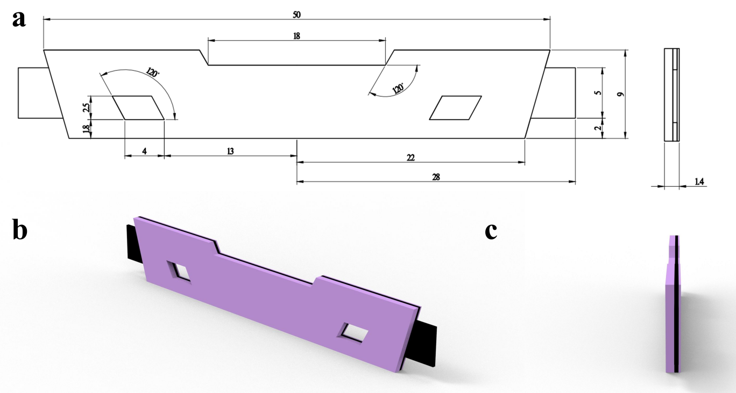
Online Resource 2. Automotive bumper specimen. (a) Specimen dimensions. (b) Specimen rendering. (c) Sandwich-structured design.
The physical implementation of the loading tool is illustrated in Online Resource 3a, accompanied by a step-by-step description of its operation instructions. Online Resource 3b displays a physical photograph of the specimen holder.
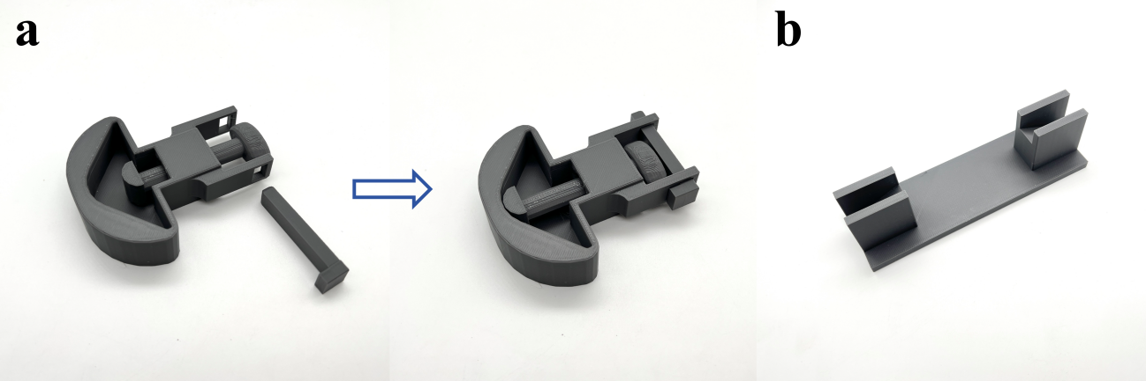
Online Resource 3. Physical display of the designed experimental auxiliary tools: (a) The loading tool operation instructions. (b) The specimen holder.
Online Resource 4 to Online Resource 6 are infrared thermographic images, which were produced by taking shots from the video at 5-second intervals. This processing approach aims to extract thermographic data at representative time points, clearly illustrating the changes in temperature distribution. And it can provide a reliable visual basis for subsequent quantitative analysis.
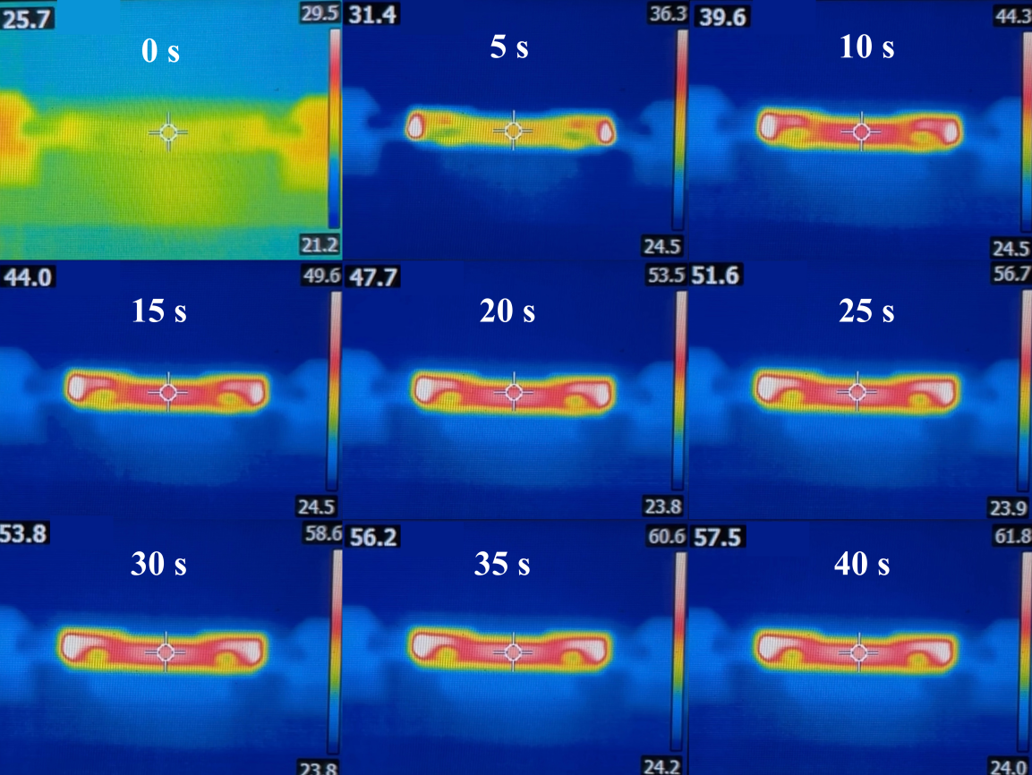
Online Resource 4. Dynamic process of a specimen's center temperature under electrical stimulation before damage (5-second interval).
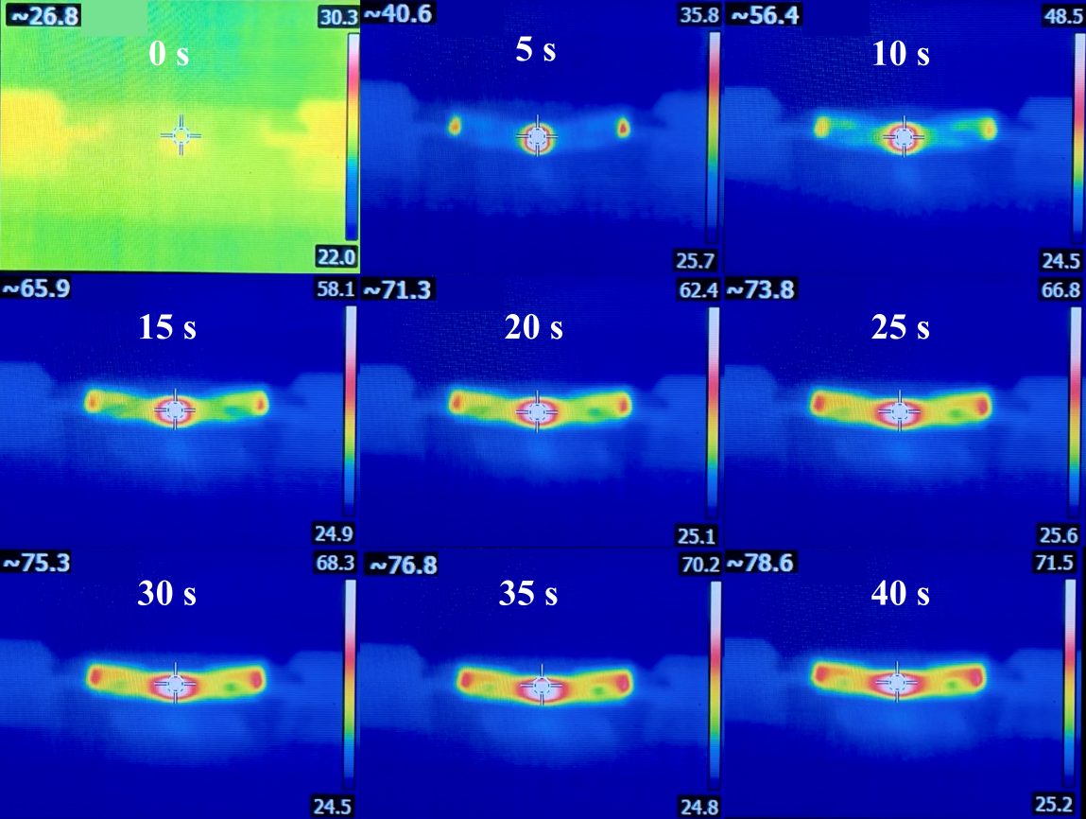
Online Resource 5. Dynamic process of a specimen's center (maximum) temperature under electrical stimulation after damage (5-second interval).
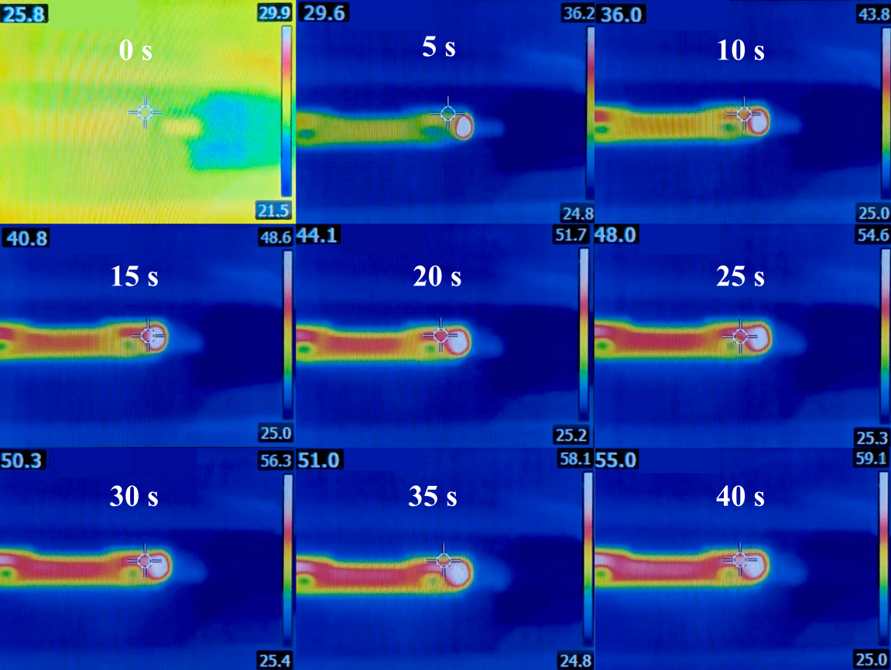
Online Resource 6. Dynamic process of a specimen's maximum temperature under electrical stimulation before damage (5-second interval).
The three-point bending test followed ISO 178 (similar to ASTM D790). The interlaminar shear strength test followed ISO 14130 (equivalent to ASTM D2344). The drop-weight impact test followed GB/T 11548-1989 (similar to ASTM D7136, but differing in specimen dimensions and impact energy range). Since the investigation only performed a lateral comparison among the specimens, the influence of these differences was relatively limited. The relevant test conditions for the mechanical experimental testing are shown in Online Resource 7.
Experiment name | Test standard | Type | Dimensions  (mm) | Span  (mm) | v  (mm/min) | Output
Three-point bending test | ISO178 | 4 | 80×10×1.4 | 22.4 | 2 | Force and displacement
ILSS | ISO14130 | 1 | 28×14×2.8 | 14 | 1 | Force and displacement
Drop-weight impact test | GB/T 11548  -1989 | 4 | ø100×2.8 | ø38 | / | Force and displacement
Online Resource 7. Relevant test conditions for mechanical experimental testing.
As shown in Online Resource 8a, the schematic diagram illustrates the dimensions of a single-material three-point bending specimen. Online Resource 8b shows the dimensions of a dual-material sandwich-structured specimen. Online Resource 8c shows the dual-material sandwich-structured specimen with a thickness ratio of 4 features a biomimetic structure.
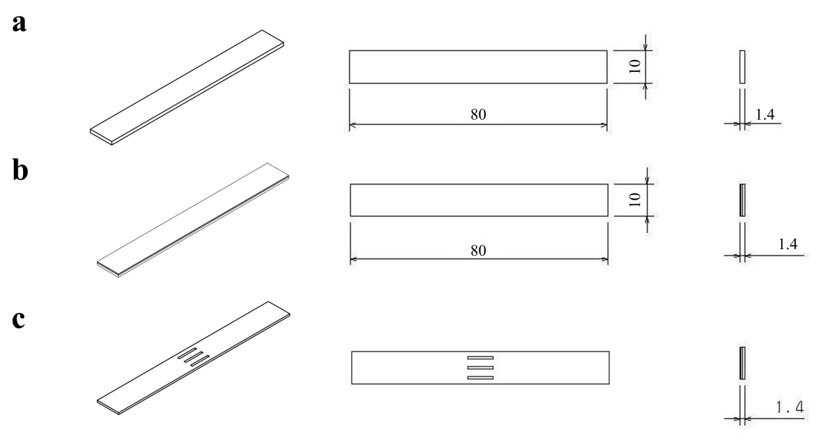
Online Resource 8. Three-point bending specimen dimensions. (a) Single-material three-point bending specimen. (b) Dual-material sandwich-structured specimen. (c) Dual-material sandwich-structured specimen with biomimetic structure.
The mechanical properties of the specimens were assessed via three-point bending tests. Online Resource 9 to Online Resource 12 present the three-point bending mechanical performance tests of four different types of specimens. Five identical parallel specimens were used for each test to minimize experimental error.
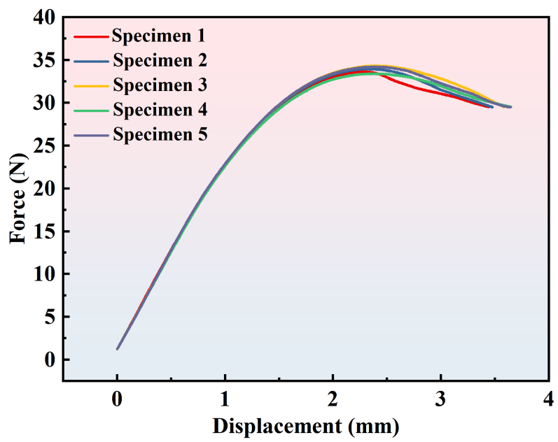
Online Resource 9 Three-point bending mechanical performance test of thermochromic PLA specimens.
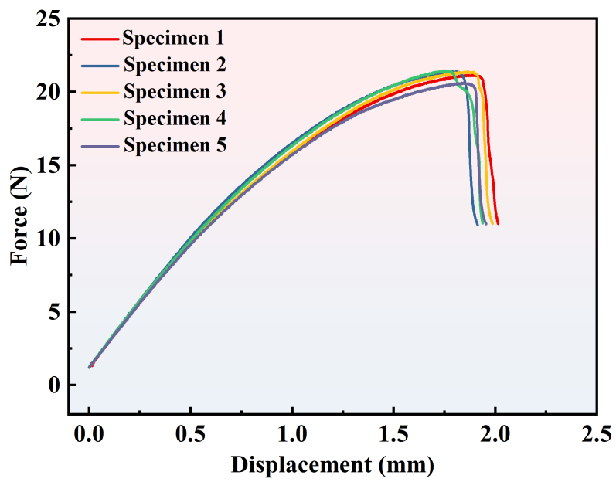
Online Resource 10. Three-point bending mechanical performance test of conductive PLA specimens.
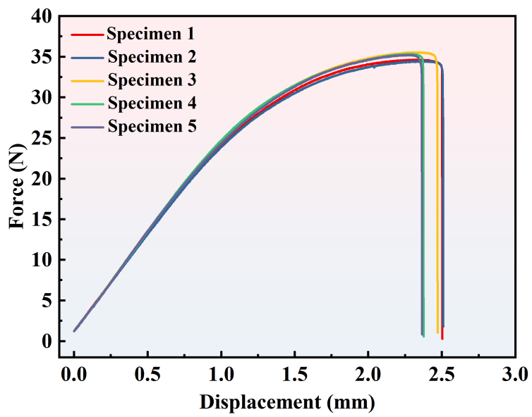
Online Resource 10. Three-point bending mechanical performance test of dual-material sandwich-structured specimens.
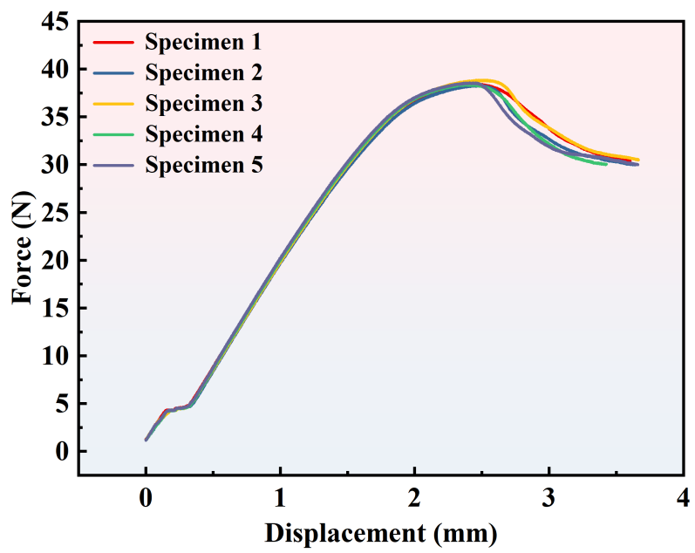
Online Resource 12. Three-point bending mechanical performance test of dual-material sandwich-structured specimens with biomimetic structure.
The dimensions of the interlaminar shear strength test specimen are shown below. The thickness ratio is 4:2:1, with the compression side corresponding to the thickness ratio of 4. The detailed dimensional design is presented in Online Resource 13.
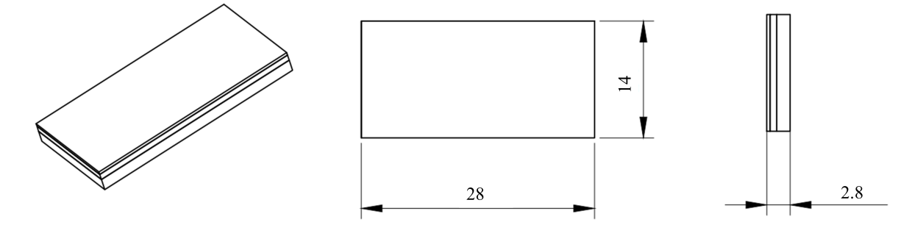
Online Resource 13. Interlaminar shear strength specimen dimensions.
The drop-weight impact test specimen dimensions are presented below. Online Resource 14a is a dual-material specimen, while Online Resource 14b presents the side view. And Online Resource 14c shows the dual-material sandwich structure specimen with a thickness ratio of 4 features a biomimetic structure.
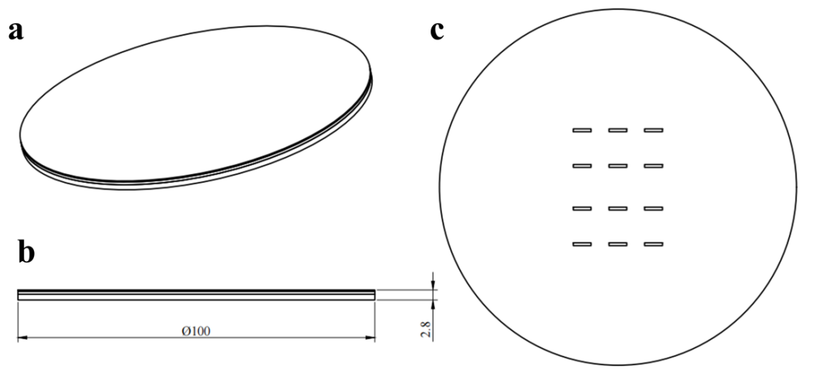
Online Resource 14. Drop-weight impact specimen dimensions. (a) Single-material three-point bending specimen. (b) Dual-material sandwich structure specimen. (c) Dual-material sandwich structure specimen with biomimetic structure.
The following table presents the test conditions and corresponding procedures for experiments under different loading modes. Online Resource 15 provides the experimental test conditions and procedures for shape memory performance testing and preliminary reusability assessment.

Experiment name | Materials | Loading(min) | Stabilizing  (min) | Voltage  (V) | Electrical stimulation(s) | Cycles | Output
Shape memory properties test | PLA-  PLA | 3 | 1 | 60 | 40 | 1 | Rf, Rr
Preliminary reusability assessment | PLA-  PLA | 3 | 1 | 60 | 40 | 5 | Rf, Rr
Preliminary reusability assessment | PETG-  PLA | 8 | 1 | 60 | 60 | 4 | Rf, Rr
Online Resource 15. Experiments under different loading modes.

Supplementary Movies
Online Resource 16. (Movie S1)
Dynamic process of electrically induced damage recovery.
Online Resource 17. (Movie S2)
Dynamic process of a specimen's center temperature under electrical stimulation before damage.
Online Resource 18. (Movie S3)
Dynamic process of a specimen's center (maximum) temperature under electrical stimulation after damage.
Online Resource 19. (Movie S4)
Dynamic process of a specimen's maximum temperature under electrical stimulation before damage.
Online Resource 20. (Movie S5)
Demonstration of the electrochromic dynamic process in a specimen before damage.
Online Resource 21. (Movie S6)
Demonstration of the electrochromic dynamic process in a specimen after damage.

