Supplementary Materials for

Bioinspired Metal Infiltration Strategy for Near-Net-Shape Ceramic-Metal Heterogeneous Composites

Dekun Kong^{a, b}, Hailong Wu^{a, b}, Yumeng Han^{c}, Xue Hanª, DeChao Lyu^{b*}, Zhihui Zhang^{a, b*}, Luquan Ren^{a, d}

ªThe Key Laboratory of Bionic Engineering (Ministry of Education) and the College of Bionic Science and Engineering, Jilin University, Changchun 130025, China.
^{b}Institute of Structured and Architected Materials, Liaoning Academy of Materials, Shenyang 110167, China.
^{c} School of Mechanical and Aerospace Engineering, Jilin University, Changchun 130025, China.
^{d} The State Key Laboratory of Automotive Chassis Integration and Bionics, Jilin University, Changchun, Jilin 130025, China.

*Corresponding author at:
Zhihui Zhang:
The Key Laboratory of Bionic Engineering (Ministry of Education) and the College of Bionic Science and Engineering, Jilin University, Changchun 130025, China. E-mail: zhzh@jlu.edu.cn
DeChao Lyu:
Institute of Structured and Architected Materials, Liaoning Academy of Materials, Shenyang 110167, China. E-mail: dclv@lam.ln.cn

This Supplementary materials contains：
Supplementary Note 1 to Note 5
Figures S1 to S11
Tables S1 to S5
References

Supplementary Note

1. Preparation of ceramic ink
For ink system 1, a certain amount of PLA was placed in a glass container and mixed with DCM at a mass ratio of 1:4. The mixture was stirred thoroughly and left to rest at room temperature for approximately 24 hours, allowing complete dissolution of PLA into a clear solution. This solution was then transferred to a ball mill jar. Ceramic powders were added at a binder-to-powder mass ratio of 24:76, with Al₂O₃ (20 µm) and MgO (1.0 µm) powders mixed in a mass ratio of 70:6. Wet milling was conducted using a ball mill (XQM-4, Changsha Tianchuang Powder Technology Co., Ltd.) for 2 hours. The jar was sealed with tape to prevent solvent evaporation, ensuring a uniform and stable mixing environment. After milling, the ink was loaded into specialized printing syringes. To eliminate fine bubbles, centrifugation was performed at 2000 rpm for 60 seconds using an electric centrifuge (80-2, Changzhou Surui Instrument Co., Ltd.).
Ink system 2 involved preparing a mixture of liquid PDMS and ceramic powders at a mass ratios of 35:65. The liquid PDMS was a pre-mixed combination of PDMS prepolymer and curing agent at a 10:1 mass ratio. Ceramic powders consisted of Al₂O₃ (500 nm) and MgO (1.0 µm) mixed in a 60:5 mass ratios. Initially, liquid PDMS was placed into the ball mill jar, followed by gradual addition of ceramic powders in batches with continuous stirring using a glass rod to maintain homogeneity. To enhance particle dispersion, BYK-110 dispersant was added at 3% of the ceramic powder mass. Mixing combined manual stirring and ball milling to achieve uniform ink consistency and particle dispersion. The prepared ink was then loaded into printing syringes and subjected to the same centrifugation degassing process as ink system 1, ensuring bubble-free ink.

2. Dynamic rheological response during extrusion and deposition
Maintaining structural stability after extrusion is as vital as smooth flow during extrusion. Although the paste flows with a high shear rate and low viscosity inside the nozzle, characterized by G′′>G′, rapid recovery of G′ after deposition is necessary to prevent deformation or collapse. This transition from rest to shear and back was simulated by rheometer tests, schematically presented in Figure S1(a, b). The experiment consisted of three phases: 0.1% low strain for 60 seconds simulating rest or deposition (phases one and three), and 100% high strain for 60 seconds simulating extrusion (phase two). Testing frequency was fixed at 1 Hz with a 1 mm gap between plates.
Figures S1(c) and S1(d) show temporal evolution of G′ and G′′ for the two pastes throughout the test. During the initial rest phase (0-60 s, 0.1% strain), both pastes exhibited solid-like behavior with G′ > G′′. Notably, the G′ of PLA-Al₂O₃ increased slowly over time, whereas PDMS-Al₂O₃ remained stable. This effect is attributed to the volatility of DCM, the solvent in PLA-Al₂O₃, whose evaporation enhances molecular chain entanglement density, thereby increasing G′. Upon entering the extrusion phase (60-120 s, 100% strain), both moduli rapidly decreased, leading to a fluid-like state (G′ < G′′), indicating disruption of internal structure and facilitating flow. Returning to the deposition phase (120-180 s, 0.1% strain), both pastes partially recovered G′, demonstrating reversible viscoelastic behavior. Specifically, PLA-Al₂O₃ regained 4.58% of its initial G′, exceeding G′′ after 170 seconds to regain solid-like traits. PDMS-Al₂O₃ showed a faster and higher recovery at 14.41%. Incomplete restoration is mainly attributed to partial molecular chain breakage and weakened inter-particle interactions caused by high shear stress; nonetheless, as long as the recovered G′ can support the printed structure, printing proceeds effectively.
Overall, both pastes display marked thixotropy with reversible internal structure breakdown and reformation under applied forces. The time-dependent recovery of G′ in PLA-Al₂O₃ reflects stronger molecular chain entanglement requiring time for reassembly after disruption. In contrast, PDMS-Al₂O₃ exhibits nearly instantaneous G′ recovery due to flexible polymer chains and rapid segmental mobility. These distinctions highlight the influence of molecular dynamics on rheological performance in extrusion-based ceramic paste printing.

3. Optimization of thermal decomposition behavior
Thermal gravimetric analysis (TG) and differential scanning calorimetry (DSC) were employed to systematically investigate the high-temperature thermal decomposition behaviors of PLA-Al₂O₃ and PDMS-Al₂O₃ green bodies. The results, including TG-DSC curves and derivative thermogravimetry (DTG) profiles, are presented in Figures 2(e) and 2(f). Serving as the first derivative of the TG curve, the DTG offers clearer resolution of mass changes occurring at distinct decomposition stages. Experiments utilized a simultaneous thermal analyzer (TG-DSC, STA449F5, NETZSCH) under an air atmosphere, with a heating rate of 10℃/min up to 800℃.
For the PLA-Al₂O₃ green body, three characteristic thermal decomposition stages were observed (Figure 2(e)). The first stage, spanning 25℃ to 160℃, exhibited a minor mass loss of approximately 0.5% (from 100% to 99.5%), accompanied by a subtle endothermic peak near 160℃ on the DSC curve. This phase corresponds primarily to the slow volatilization of low molecular weight organics such as ethanol and moisture [1]. The second stage, between 160℃ and 260℃, involved significant mass reduction from 99.5% to 93.8%, with a pronounced peak on the DTG curve and a distinct endothermic peak at 255℃ on the DSC trace. These features indicate vigorous thermal degradation of polymer resin components [2], marking this temperature range as the critical control region for the debinding process. Beyond 260℃, the third stage exhibited stabilization of the weight loss curve, with fluctuations in TG and DTG profiles less than 0.1%. This confirms complete removal of organic binders and transformation into the pure ceramic phase [3]. Thermal decomposition kinetics identified 160℃ and 255℃ as key temperature points guiding a stepwise debinding protocol outlined in Figure S2(a). Subsequent sintering followed to achieve the desired densification. Detailed debinding and sintering parameters are provided in Supplementary Table S1.
Similarly, the PDMS-Al₂O₃ green body displayed a triphasic thermal decomposition pattern, as depicted in Figure 2(f). The initial stage, from 25℃ to 240℃, showed approximately 2% mass loss (from 100% to 98%) without notable thermal events on the DSC curve. This stage mainly involves gradual evaporation of low-boiling components such as solvents in the BYK-110 dispersant and trace small molecules within the PDMS prepolymer, along with early curing of the PDMS prepolymer [4]. The second stage, extending from 240℃ to 700℃, experienced substantial mass loss, dropping from 98% to 75%. The DTG curve revealed distinct mass loss peaks at 240℃, 377℃, 477℃, and 557℃, reflecting sequential thermal decomposition and oxidation of the PDMS organic phase (including both prepolymer and curing agent), rendering this range critical for debinding control [5]. Above 700℃, the third stage saw the weight loss curve level off, confirming complete elimination of organic constituents and the conversion into pure ceramic form [6]. Guided by pyrolysis kinetics, temperatures of 240℃, 377℃, 477℃, and 557℃ were selected as pivotal points for designing a graded heating debinding schedule. After debinding, sintering was conducted to densify the ceramic material. The comprehensive debinding and sintering procedure is detailed in Figure S2(b) and Supplementary Table S1.

4. Analysis of ME forming quality
Material extrusion (ME) technology offers a significant advantage in fabricating complex porous structures, yet the quality of the formed parts depends heavily on the compatibility between the ink’s rheological properties and printing parameters. Within ME processes, extrusion speed, printing speed, and layer height critically influence the morphology and precision of scaffolds. A well-formed porous scaffold requires a delicate balance: sufficient interlayer fusion ensures mechanical stability, while minimal sagging of overhanging lines preserves dimensional fidelity. Given substantial differences in viscosity, modulus, and yield stress among various pastes, a single set of parameters cannot universally optimize all systems; thus, tailored parameter adjustment is essential.
Using a nozzle diameter of 410 μm as a reference, the layer height was initially set at 80% of this value (approximately 328 μm) to promote intimate interlayer bonding. However, due to disparities in yield stress between PLA-Al₂O₃ and PDMS-Al₂O₃ pastes, the actual layer heights were fine-tuned to 0.30 mm for PLA-Al₂O₃ and 0.32 mm for PDMS-Al₂O₃ to compensate for the “swelling effect” post-extrusion. The volatile solvent (DCM) in the PLA-Al₂O₃ paste necessitated higher printing speeds (6 mm/s) to prevent premature solvent evaporation and consequent paste solidification. In contrast, the lower viscosity of the PDMS-Al₂O₃ paste allowed for reduced extrusion pressure (0.3 MPa) and matching lower printing speed (4 mm/s), thereby avoiding issues such as over-extrusion or filament breakage. The optimized parameters were finalized as follows: PLA-Al₂O₃ at 0.30 mm layer height, 6 mm/s printing speed, and 0.4 MPa extrusion pressure; PDMS-Al₂O₃ at 0.32 mm layer height, 4 mm/s printing speed, and 0.3 MPa extrusion pressure.
Employing these parameters, porous scaffolds measuring 10 mm × 10 mm × 5 mm with a 50% infill density were fabricated. Their front and cross-sectional morphologies were characterized using a super-depth-of-field microscope. Quantitative analysis was conducted through dimensional metrics to evaluate forming quality. The shape fidelity of the frontal pores was quantified by the dimensionless parameter $P_{r}$:
$$P_{r}=\frac{L^{2}}{16A}$$ | (6)
Where A represents the actual pore area and L the perimeter. A value of$P_{r}$=1 denotes an ideal square pore and optimal printing accuracy.
As illustrated in Figure S3, the front views and optical morphologies of both scaffolds reveal closely comparable appearances. The pores exhibit sharp contours and well-defined, near-square geometry without noticeable filament misalignment or pore distortion (Figures S3(b) and S3(c)). Measurements performed with ImageJ software on representative frontal pores yielded $P_{r}$ values of 1.02 for PLA-Al₂O₃ and 0.99 for PDMS-Al₂O₃ scaffolds (Figure S3(g)). These values hover near the ideal, and the minimal difference indicates consistent control over filament spreading, interlayer alignment, and pore shape preservation in the plane. This uniformity arises from relatively even stress distribution along the planar direction during ME, with negligible gravitational bias. Both pastes, benefiting from the synergy between their rheology and the applied printing parameters, successfully replicate the pore geometry within the printing plane with precision.
Cross-sectional morphology, however, displays notable disparities between the two pastes (Figures S3(e) and S3(f)). The PLA-Al₂O₃ scaffold’s cross-section presents well-supported overhanging filaments with minimal sagging. Side pore shapes maintain a roughly rectangular “waist-shaped” profile; adjacent layer filaments remain parallel and intersect perpendicularly. Suspended filaments show negligible downward deflection, while pore boundaries are straight vertically and symmetrical horizontally. Interlayer connections reveal only slight contact marks without fusion, preserving the pore’s rectangular shape consistent with the frontal square geometry. On the other hand, the PDMS-Al₂O₃ scaffold exhibits flattened elliptical side pores. Moreover, filament intersections show clear fusion due to insufficient support: upper filaments sag under gravity, increasing contact with lower layers. This results in blurred layer boundaries and an overall elliptical pore profile. The root cause of these morphological differences lies in recovery speed of the G′. Figure S3(h) compares the G′ recovery rates for both pastes 180 seconds after the application of 100% strain. PLA-Al₂O₃ demonstrates a faster recovery (378.2 Pa/s), enabling rapid transition from fluid-like to solid-like states after extrusion. This quick modulus restoration allows overhanging filaments to develop adequate support strength before contacting lower layers. Consequently, the structure effectively resists its own weight and compression from above, preventing excessive interlayer fusion and maintaining well-defined rectangular pores in cross-section. Conversely, PDMS-Al₂O₃’s relatively slower recovery rate (246.6 Pa/s) results in filaments remaining soft and fluid-like for extended periods post-deposition, rendering them vulnerable to deformation under applied load. The upper filaments sag onto the layers below, promoting fusion and adhesion between layers and producing flattened elliptical pores. Despite these differences in layer stacking, the cross-sectional profiles of individual filaments in both pastes approximate a circular shape. This indicates good consistency in single-filament formation and attests to the fundamental soundness of the paste formulations. Such morphological stability also lays the foundation for preserving designed pore structures during subsequent sintering processes.

5 Investigation of line spacing and metal infiltration relationship
In the metal particle infiltration process, the line spacing of biomimetic structures fabricated by ME plays a critical role in determining the infiltration effectiveness of metal particles. Excessive line spacing results in wider pores, which may cause metal particles to be lost easily, hindering effective filling and uniform distribution. This reduction in infiltration uniformity directly compromises the material’s densification and mechanical performance. Conversely, overly narrow line spacing limits the penetration pathways for metal particles, leading to insufficient interior infiltration and weakened interfacial bonding, thereby severely affecting the overall mechanical properties of the composite. Therefore, examining the correlation between line spacing and infiltration outcomes is essential for ensuring thorough and uniform metal particle infiltration throughout the part. In this study, metal particles with diameters ranging from 0 to 25 μm were selected. To prevent particle clogging of pores, the pore width must satisfy the critical condition [7-9]:
$G_{min}$ $≥β∙D_{p}$ | (7)
Here, $β$=3 serves as an empirical safety factor, and $D_{p}$=25 μm denotes the particle diameter. Consequently,
$G_{min}$ $≥3∙25μm=75 μm$ | (8)
It is important to note that this criterion accounts for dynamic particle arrangements during flow and potential agglomeration effects. The pore width should be at least three times the maximum particle diameter to prevent clogging or clustering.
Beyond establishing a minimum pore size to guarantee particle passage, capillary effects must be leveraged to prevent loss of metal solution. The capillary pressure needs to overcome vacuum-induced negative pressure to maintain stable fluid infiltration. According to the Young-Laplace equation [10, 11], capillary pressure ΔP_{cap} is expressed as:
$$∆P_{cap}=\frac{2∙γ∙cosθ}{G}≥{ΔP}_{gravity}=ρgH$$ | (9)
Variables are defined as follows: $γ$ represents the surface tension of the suspension (approximately 0.03 N/m for an alcohol + BYK-163 system); $θ$ is the contact angle between the ceramic and suspension (approximately 30°); ρ denotes the fluid density, approximated as that of alcohol (789 kg/m³); $H$ refers to part height (taken as 0.05 m herein); g is gravitational acceleration (9.8 m/s²). Substituting these values yields:
$$G_{max}≤\frac{2∙γ∙cosθ}{ρgH}≈134 μm$$ | (10)
In summary, the optimal line spacing range can be set as: 0.075mm ≤ G ≤ 0.134 mm.

Supplementary Figures
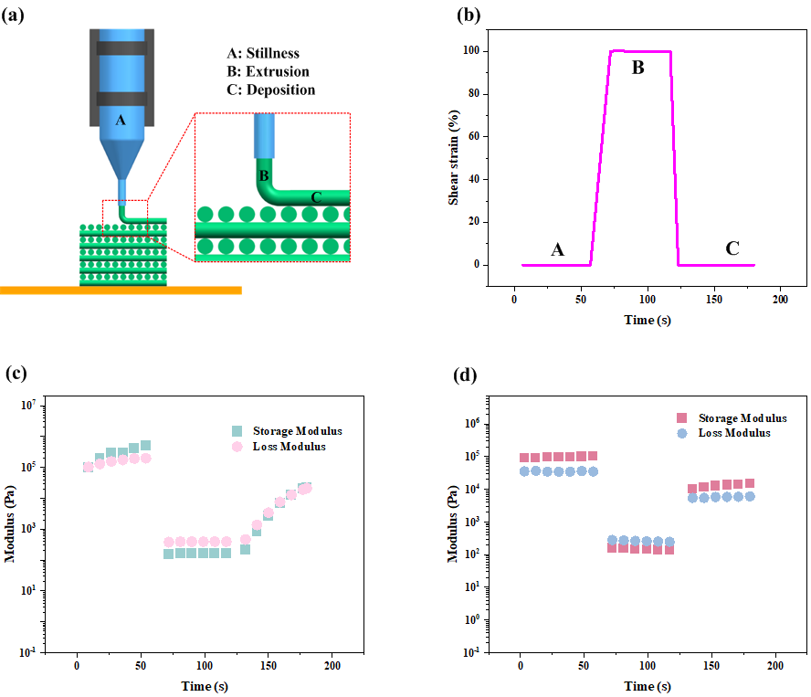
Figure S1. Dynamic rheological response of ceramic pastes during the “rest-extrusion-deposition” process. (a) Schematic illustration of the three stages-rest (A), extrusion (B), and deposition (C) in ME processing of ceramic pastes. (b) Shear strain variation over time during the three-stage rheological test. (c, d) Time-dependent responses of G′ and G′′ for PLA-Al₂O₃ and PDMS-Al₂O₃ pastes during the three-stage test.
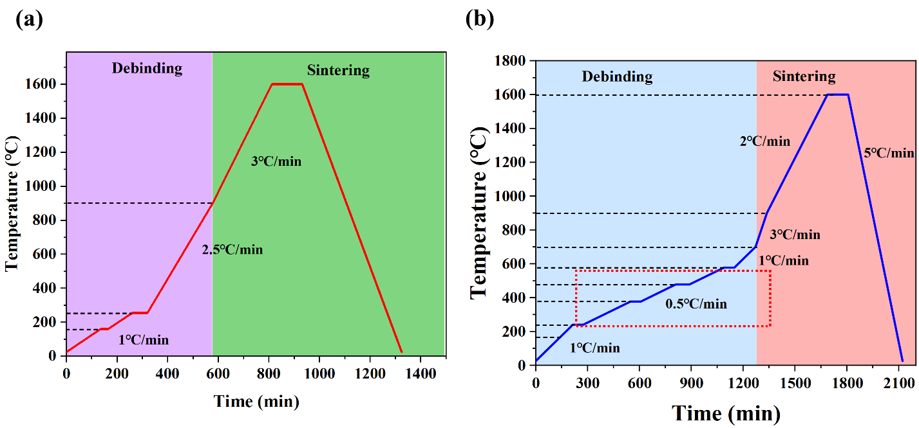
Figure S2. Schematics of debinding and sintering processes. (a) Process parameter charts illustrating debinding and sintering schedules for PLA-Al₂O_{3.} (b) Process parameter charts illustrating debinding and sintering schedules for PDMS-Al₂O₃ green bodies.

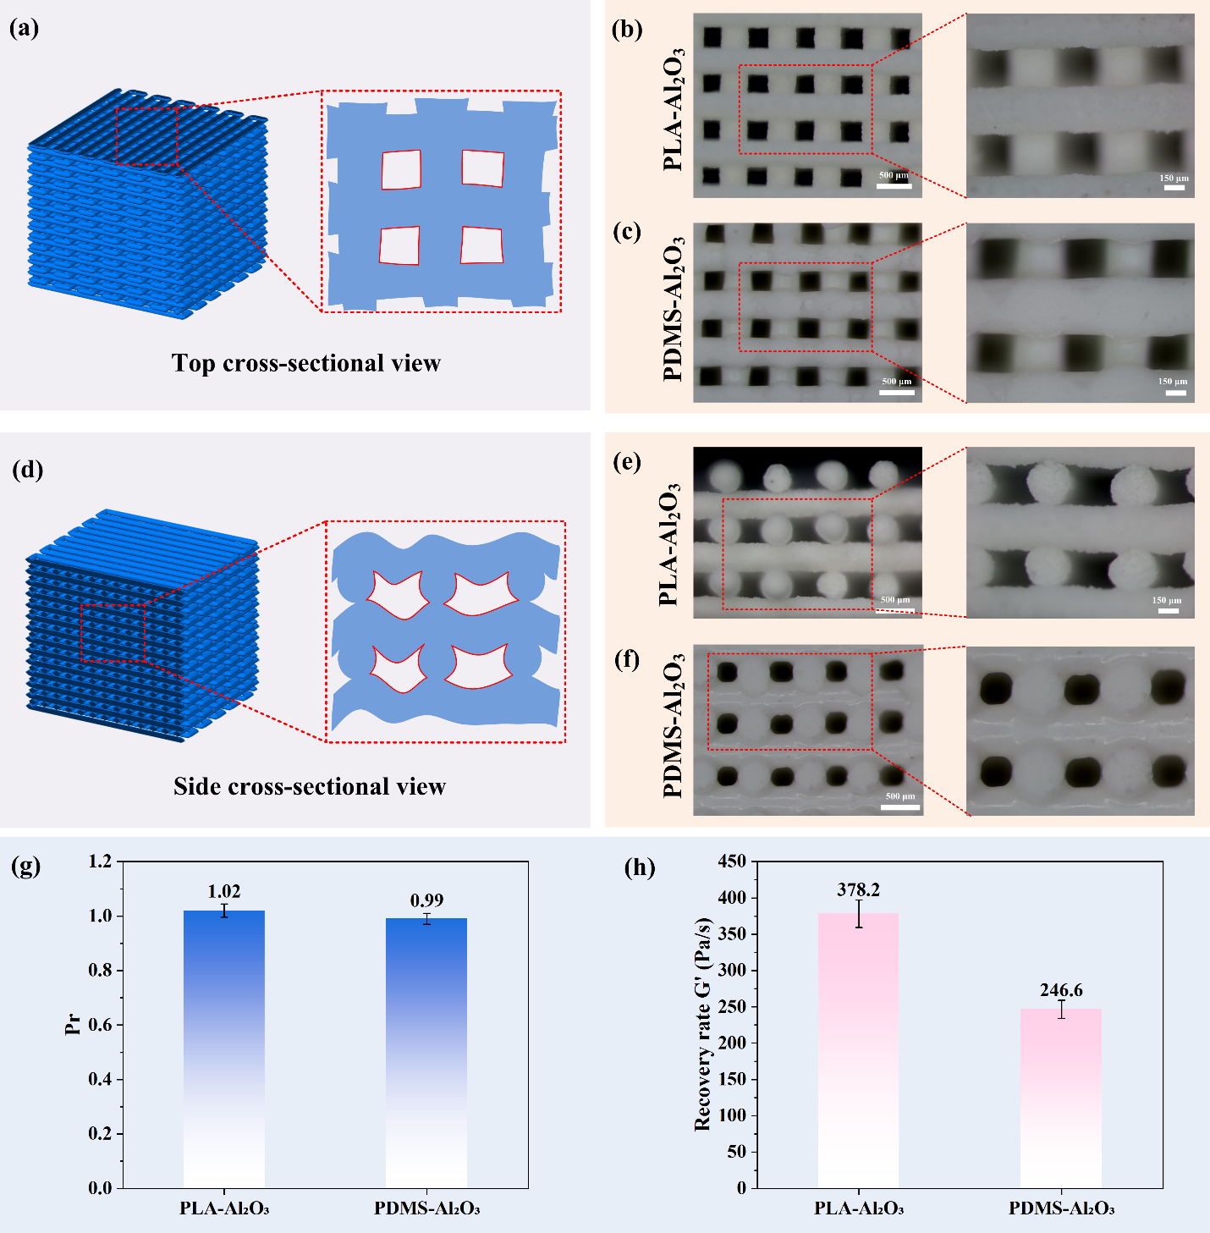
Figure S3. Printing accuracy of parts with different cross sections. (a) Schematic depicting top-surface printing accuracy. (b) Optical image of the frontal surface of a PLA-Al₂O₃ printed green body. (c) Optical image of the frontal surface of a PDMS-Al₂O₃ printed green body. (d) Schematic illustrating cross-sectional printing accuracy. (e) Cross-sectional optical image of PLA-Al₂O₃ printed green body. (f) Cross-sectional optical image of PDMS-Al₂O₃ printed green body. (g) Quantitative comparison of frontal printing accuracy parameter P_{r} for both ceramic pastes. (h) Recovery efficiency of G′ for both pastes measured 180 seconds after deformation.

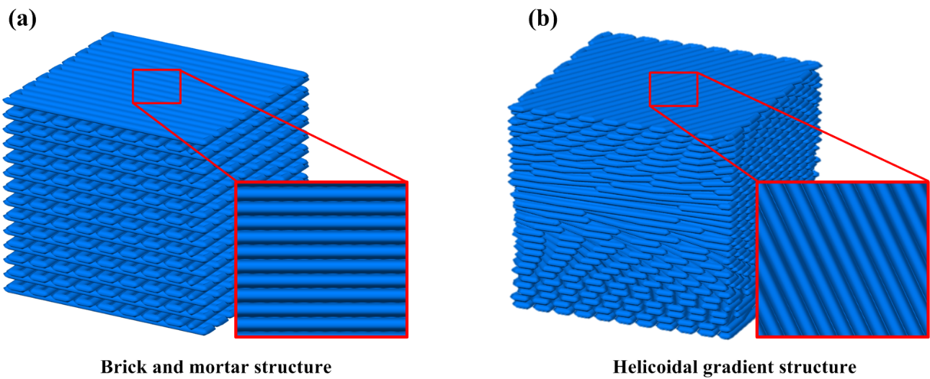
Figure S4. Bioinspired three-dimensional models. (a) Three-dimensional model of BMS inspired by conch shells. (b) Three-dimensional model of an HGS inspired by peacock mantis shrimp.

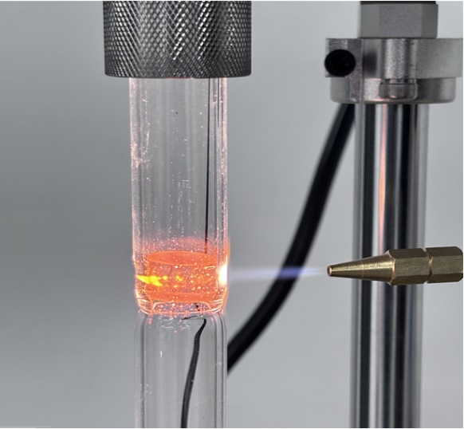
Figure S5. Schematic diagram of the sealing process during vacuum heat treatment.

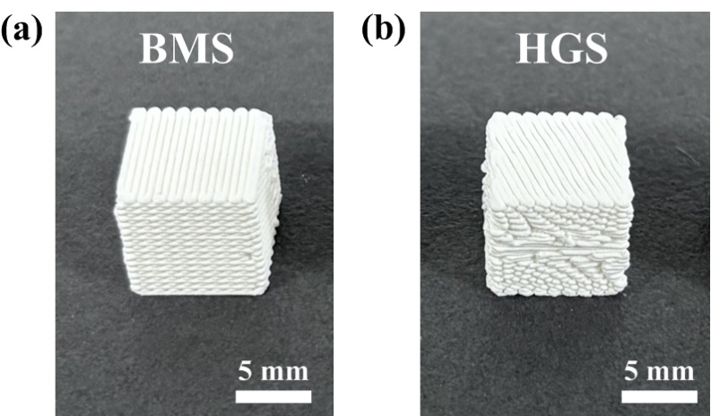
Figure S6. Macroscopic images of two biomimetic structures. (a) Macroscopic image of the BMS. (b) Macroscopic image of the HGS.

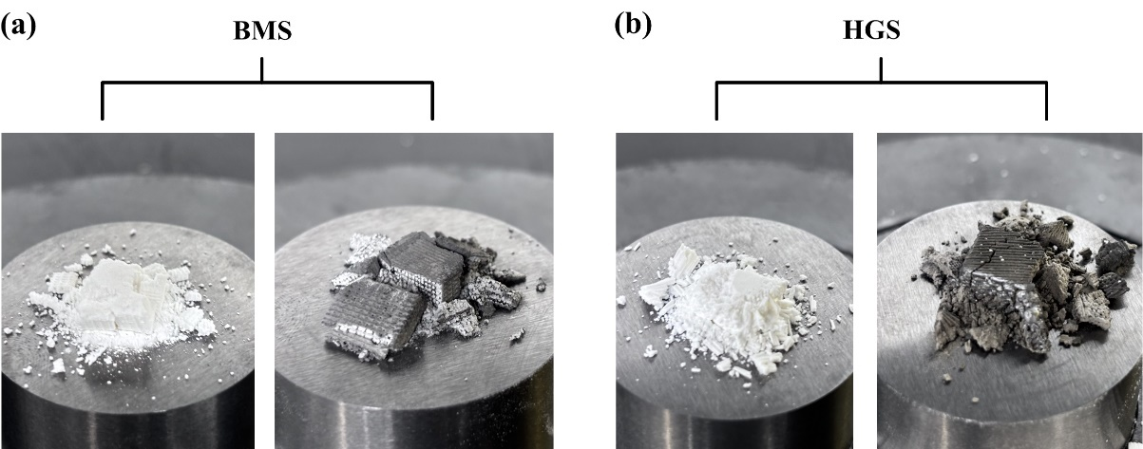
Figure S7. Fracture morphologies of the two biomimetic composite structures after uniaxial compression tests. (a) Failure morphology of the BMS after compression; (b) Failure morphology of the HGS after compression. The un-infiltrated parts mainly exhibited obvious brittle pulverization and fragmentation, whereas the metal-infiltrated composite structures retained a certain degree of structural integrity after failure and showed more pronounced progressive collapse behavior.

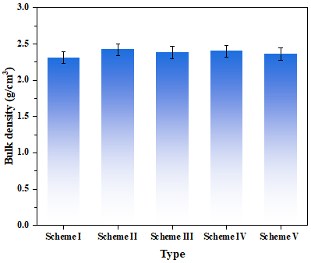
Figure S8. Bulk density of the composites under different processing schemes.

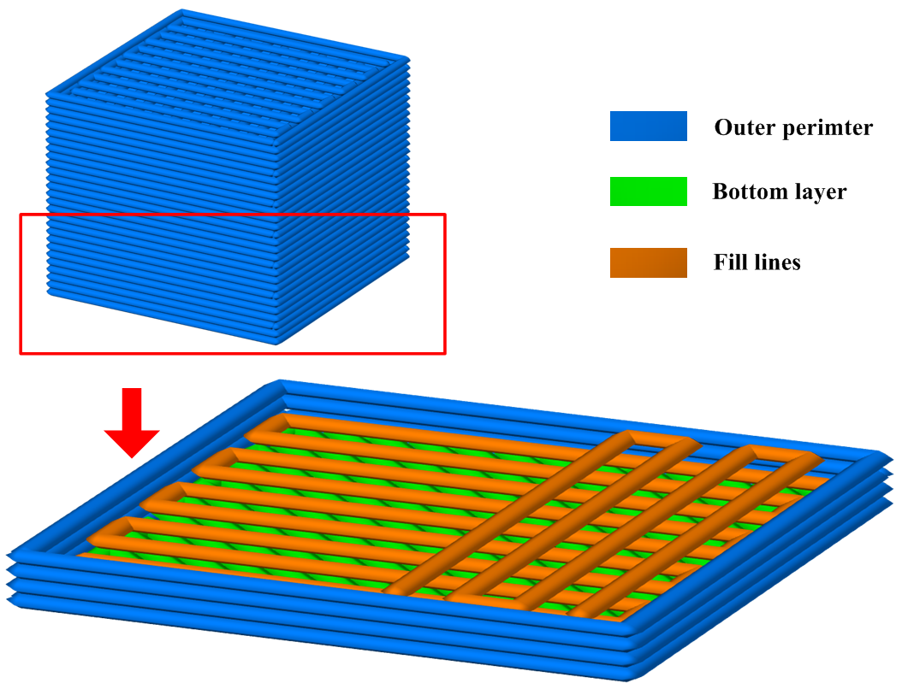
Figure S9. Modeling schematic of the BMS ceramic scaffold.

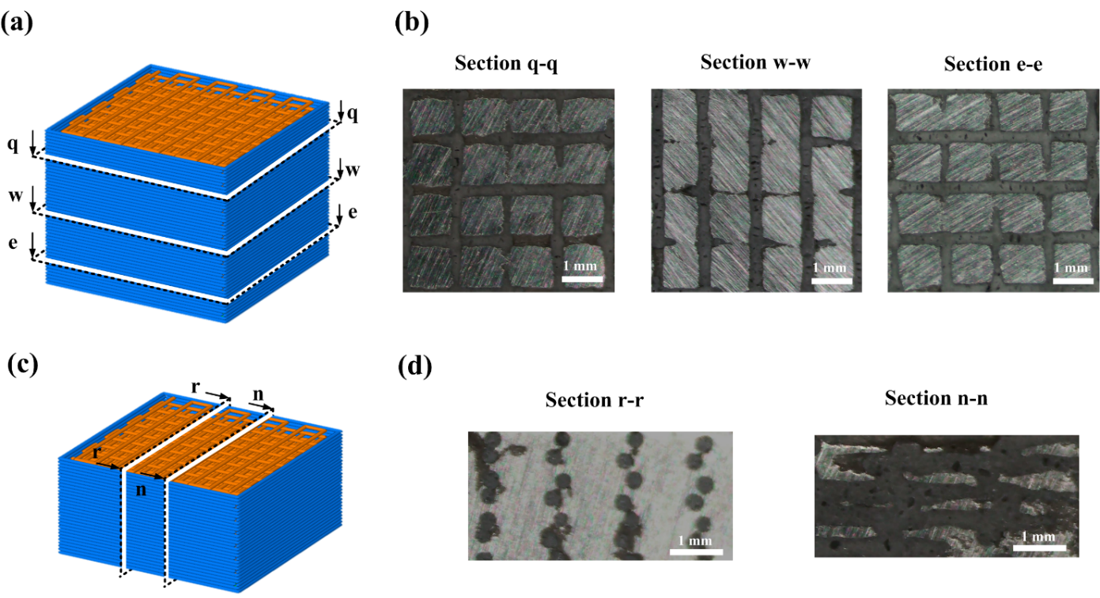
Figure S10. Cross-sectional characterization of the composite structures. (a) Schematic illustration of transverse sectioning along different positions of the part. (b) Optical microscopy images of the corresponding cross-sections taken along the q-q, w-w, and e-e directions, respectively. (c) Schematic illustration of longitudinal sectioning along different positions of the part (d) Optical microscopy images of the corresponding cross-sections taken along the r-r and n-n directions, respectively. In the images, the gray regions correspond to the ceramic phase, while the bright silver regions represent the infiltrated metallic phase. The metallic phase can be observed throughout different sections of the structure, indicating effective infiltration within the internal pore network of the ceramic scaffold.

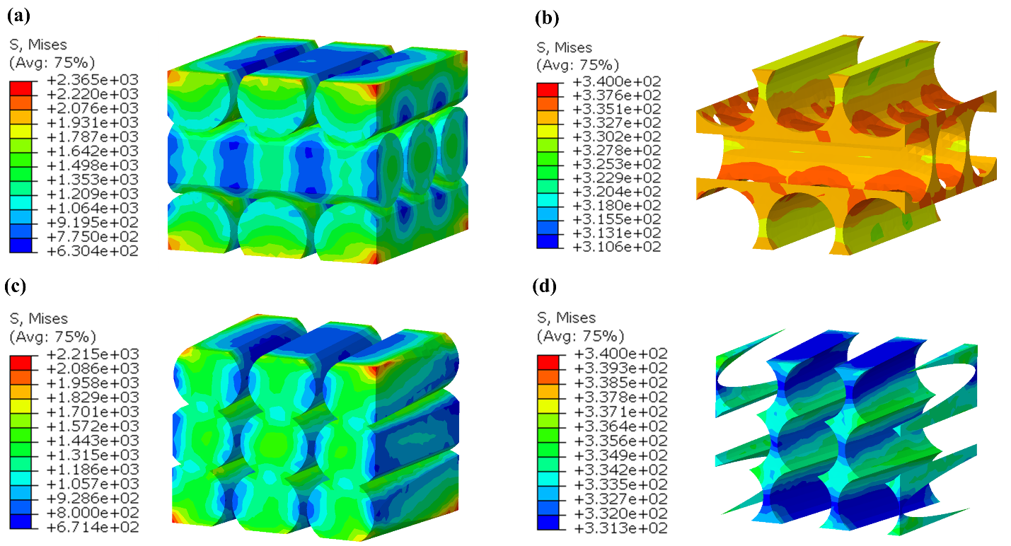
Figure S11. Finite element stress analysis of different regions in two bioinspired structures after thermal treatment. (a) Stress distribution within the ceramic phase of the BMS. (b) Stress state of the ceramic phase in the HGS. (c) Stress distribution within the metal phase of the BMS. (d) Stress distribution within the metal phase of the HGS.

Supplementary Table
Table S1. Debinding and sintering schedules for PLA-Al₂O₃ and PDMS-Al₂O₃ green bodies
Type | Temperature (℃) | Time to Temp (min) | Total time (min) | Phase
PLA-Al₂O₃ | 25 | 0 | 0 | Debinding
PLA-Al₂O₃ | 160 | 135 | 135 | Debinding
PLA-Al₂O₃ | 160 | 30 | 165 | Debinding
PLA-Al₂O₃ | 255 | 125 | 260 | Debinding
PLA-Al₂O₃ | 255 | 60 | 320 | Debinding
PLA-Al₂O₃ | 900 | 258 | 578 | Sintering
PLA-Al₂O₃ | 1600 | 234 | 812 | Sintering
PLA-Al₂O₃ | 1600 | 120 | 932 | Sintering
PLA-Al₂O₃ | 25 | 393 | 1325 | Sintering
PDMS-Al₂O₃ | 25 | 0 | 0 | Debinding
PDMS-Al₂O₃ | 240 | 215 | 215 | Debinding
PDMS-Al₂O₃ | 240 | 60 | 275 | Debinding
PDMS-Al₂O₃ | 377 | 274 | 549 | Debinding
PDMS-Al₂O₃ | 377 | 60 | 609 | Debinding
PDMS-Al₂O₃ | 477 | 200 | 809 | Debinding
PDMS-Al₂O₃ | 477 | 80 | 889 | Debinding
PDMS-Al₂O₃ | 577 | 200 | 1089 | Debinding
PDMS-Al₂O₃ | 577 | 60 | 1149 | Debinding
PDMS-Al₂O₃ | 700 | 123 | 1272 | Debinding
PDMS-Al₂O₃ | 900 | 66 | 1338 | Sintering
PDMS-Al₂O₃ | 1600 | 350 | 1688 | Sintering
PDMS-Al₂O₃ | 1600 | 120 | 1808 | Sintering
PDMS-Al₂O₃ | 25 | 315 | 2123 | Sintering

Table S2. FEM parameters of the Al₂O₃ part and the AlSi₁₀Mg
 | Density (kg/m³) | Modulus of elasticity (GPa) | Poisson's ratio
Al₂O₃ part | 2400 | 350 | 0.24
AlSi₁₀Mg | 2700 | 75 | 0.30

Table S3. Johnson-Cook strength model parameters for AlSi₁₀Mg
Parameter | Value
Yield stress (A), MPa | 331.17
train hardening coefficient (B), MPa | 579.647
Strain rate hardening coefficient (C) | 0.032
Strain hardening exponent (n) | 0.99
Thermal softening exponent (m) | 0.945
Reference strain rate (ε₀), s⁻¹ | 1
Melting temperature (T_{melt}), K | 843
Transition temperature (T_{transition}), K | 298

Table S4. Johnson-Cook fracture model parameters for AlSi₁₀Mg
Parameter | Value
Initial failure strain (D₁) | 0.04704
Exponential factor (D₂) | 1.155
Triaxiality factor (D₃) | -0.841
Strain rate factor (D₄) | -0.042
Temperature factor (D₅) | 0
Reference strain rate (ε₀), s⁻¹ | 1
Melting temperature (T_{melt}), K | 843
Transition temperature (T_{transition}), K | 298

Table S5. Comparison of linear shrinkage and ceramic yield in 3D-printed ceramics
Ceramics | linear shrinkage (%) | Ceramic yield Y (%) | Ref.
SiOC | 35.40 | 44.10 | [12]
SiOC | 25.00 | 51.40 | [13]
SiOC | 29.70 | 59.00 | [14]
ZrB₂ | 28.00 | 18.00 | [15]
Al₂O₃ | 19.63 | 74.00 | [16]
SiCN | 29.20 | 63.70 | [17]
ZrOC | 42.00 | 21.00 | [18]
Si₃N₄ | 25.47 | 69.42 | [19]
SiC | 25.10 | 74.40 | [20]
Al₂O₃ | 19.5 | 72 | [21]
Al₂O₃ | 8.95 | 72.5 | [22]
Al₂O₃ | 12.0 | 60 | [23]
Al₂O₃ | 14.69 | 65 | This work
Al₂O₃ | 0.49 | 92.5 | This work

References
[1] D. Amoabeng, S.S. Velankar, A review of conductive polymer composites filled with low melting point metal alloys, Polymer Engineering & Science 58(6) (2018) 1010-1019. https://doi.org/10.1002/pen.24774
[2] S.-S. Liu, M. Li, J.-M. Wu, A.-N. Chen, Y.-S. Shi, C.-H. Li, Preparation of high-porosity Al2O3 ceramic foams via selective laser sintering of Al2O3 poly-hollow microspheres, Ceramics International 46(4) (2020) 4240-4247. https://doi.org/10.1016/j.ceramint.2019.10.144
[3] X. Shuai, Y. Zeng, P. Li, J. Chen, Fabrication of fine and complex lattice structure Al2O3 ceramic by digital light processing 3D printing technology, Journal of Materials Science 55(16) (2020) 6771-6782. https://doi.org/10.1007/s10853-020-04503-y
[4] Z.Y. Deng, T. Fukasawa, M. Ando, G.J. Zhang, T. Ohji, High‐surface‐area alumina ceramics fabricated by the decomposition of Al (OH) 3, Journal of the American Ceramic Society 84(3) (2001) 485-491. https://doi.org/10.1111/j.1151-2916.2001.tb00687.x
[5] Y.-S. Eom, J.-W. Baek, J.-T. Moon, J.-D. Nam, J.-M. Kim, Characterization of polymer matrix and low melting point solder for anisotropic conductive film, Microelectronic Engineering 85(2) (2008) 327-331. https://doi.org/10.1016/j.mee.2007.07.005
[6] H. Wang, J. Wang, H. Guo, X. Chen, X. Yu, Y. Ma, P. Ji, K. Naito, Z. Zhang, Q. Zhang, A novel high temperature vinylpyridine-based phthalonitrile polymer with a low melting point and good mechanical properties, Polymer Chemistry 9(8) (2018) 976-983. https://doi.org/10.1039/C7PY01990D
[7] Y. Wang, F. Li, An Emerging Pore‐Making Strategy: Confined Swelling‐Induced Pore Generation in Block Copolymer Materials, Advanced Materials 23(19) (2011) 2134-2148. https://doi.org/10.1002/adma.201004022
[8] V. Valtchev, L. Tosheva, Porous nanosized particles: preparation, properties, and applications, Chemical reviews 113(8) (2013) 6734-6760. https://doi.org/10.1021/cr300439k
[9] F. Tang, H. Fudouzi, T. Uchikoshi, Y. Sakka, Preparation of porous materials with controlled pore size and porosity, Journal of the European Ceramic Society 24(2) (2004) 341-344. https://doi.org/10.1016/S0955-2219(03)00223-1
[10] H. Liu, G. Cao, Effectiveness of the Young-Laplace equation at nanoscale, Scientific reports 6(1) (2016) 23936. https://doi.org/10.1038/srep23936
[11] T. Chen, M.-S. Chiu, C.-N. Weng, Derivation of the generalized Young-Laplace equation of curved interfaces in nanoscaled solids, Journal of Applied Physics 100(7) (2006). https://doi.org/10.1063/1.2356094
[12] Y. Fu, G. Xu, Z. Chen, D. Wang, C. Lao, Multiple metals doped polymer-derived SiOC ceramics for 3D printing, Ceramics International 44(10) (2018) 11030-11038. https://doi.org/10.1016/j.ceramint.2018.03.075
[13] E. Zanchetta, M. Cattaldo, G. Franchin, M. Schwentenwein, J. Homa, G. Brusatin, P. Colombo, Stereolithography of SiOC ceramic microcomponents, Advanced Materials (Deerfield Beach, Fla.) 28(2) (2015) 370-376. https://doi.org/10.1002/adma.201503470
[14] J.M. Hundley, Z.C. Eckel, E. Schueller, K. Cante, S.M. Biesboer, B.D. Yahata, T.A. Schaedler, Geometric characterization of additively manufactured polymer derived ceramics, Additive Manufacturing 18 (2017) 95-102. https://doi.org/10.1016/j.addma.2017.08.009
[15] S. Chen, J. Li, H. Shi, X. Chen, G. Liu, S. Meng, J. Lu, Lightweight and geometrically complex ceramics derived from 4D printed shape memory precursor with reconfigurability and programmability for sensing and actuation applications, Chemical Engineering Journal 455 (2023) 140655. https://doi.org/10.1016/j.cej.2022.140655
[16] H. Xing, B. Zou, X. Liu, X. Wang, C. Huang, Y. Hu, Fabrication strategy of complicated Al2O3-Si3N4 functionally graded materials by stereolithography 3D printing, Journal of the European Ceramic Society 40(15) (2020) 5797-5809. https://doi.org/10.1016/j.jeurceramsoc.2020.05.022
[17] J. Xiao, D. Liu, H. Cheng, Y. Jia, S. Zhou, M. Zu, Carbon nanotubes as light absorbers in digital light processing three-dimensional printing of SiCN ceramics from preceramic polysilazane, Ceramics International 46(11) (2020) 19393-19400. https://doi.org/10.1016/j.ceramint.2020.04.282
[18] Y. Fu, Z. Chen, G. Xu, Y. Wei, C. Lao, Preparation and stereolithography 3D printing of ultralight and ultrastrong ZrOC porous ceramics, Journal of Alloys and Compounds 789 (2019) 867-873. https://doi.org/10.1016/j.jallcom.2019.03.026
[19] M. Wang, C. Xie, R. He, G. Ding, K. Zhang, G. Wang, D. Fang, Polymer‐derived silicon nitride ceramics by digital light processing based additive manufacturing, Journal of the American Ceramic Society 102(9) (2019) 5117-5126. https://doi.org/10.1111/jace.16389
[20] J. Chen, Y. Wang, X. Pei, C. Bao, Z. Huang, L. He, Q. Huang, Preparation and stereolithography of SiC ceramic precursor with high photosensitivity and ceramic yield, Ceramics International 46(9) (2020) 13066-13072. https://doi.org/10.1016/j.ceramint.2020.02.077
[21] A. Guo, D. Kong, X. Zhou, H. Kong, P. Qu, S. Wang, H. Wang, Y. Hu, Method for Preparing Damage-Resistant 3D-Printed Ceramics via Interior-to-Exterior Strengthening and Toughening, Additive Manufacturing (2022) 103272. https://doi.org/10.1016/j.addma.2022.103272
[22] H. Wu, A. Guo, D. Kong, X. Sheng, C. Liu, J. Wu, P. Qu, S. Wang, S. Guo, Y. Hu, Additive manufacturing of bionic layered ceramic-metal composites for enhanced toughness and damage resistance, Virtual and Physical Prototyping 20(1) (2025) e2443102. https://doi.org/10.1080/17452759.2024.2443102
[23] D. Kong, A. Guo, H. Wu, X. Li, J. Wu, Y. Hu, P. Qu, S. Wang, S. Guo, Four-Dimensional Printing of Polymer-Derived Ceramics with High-resolution, Reconfigurability, and Shape Memory Effects, Additive Manufacturing 83 (2024) 104050. https://doi.org/10.1016/j.addma.2024.104050

