Platinum Nanozymes Loaded Contact Lenses: Screening of Oxidoreductase Activities and Efficient Degradation of Organic Dye
Said El Turk*^{, 1}, Mohammed Ayaz Uddin¹, Aswathi Ram P.¹, Afra AlMeraikhi³, Aisha T. Khaleel³, Valentyn S. Volkov⁴, Andreas Schiffer¹, Wael Zaki¹, and Haider Butt*^{, 1,2}
¹Department of Mechanical & Nuclear Engineering, Khalifa University of Science and Technology, Abu Dhabi, P.O. Box 127788, United Arab Emirates
²Advanced Digital & Additive Manufacturing (ADAM) Research Group, Khalifa University of Science and Technology, Abu Dhabi 127788, United Arab Emirates.
³Borouge Pte. Ltd., Abu Dhabi, United Arab Emirates
⁴Emerging Technologies Research Center, XPANCEO, Dubai Investment Park First, Dubai, United Arab Emirates
*Corresponding author: 100049722@ku.ac.ae, Haider.Butt@ku.ac.ae

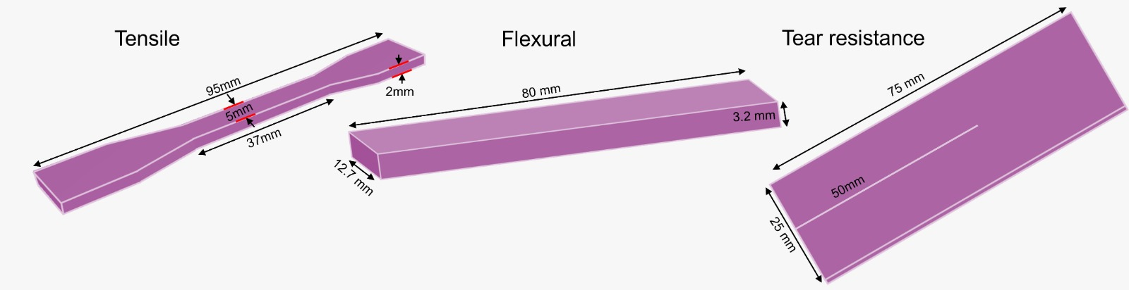
Figure S1: Bulk specimens used for tensile, flexural, and tear tests.

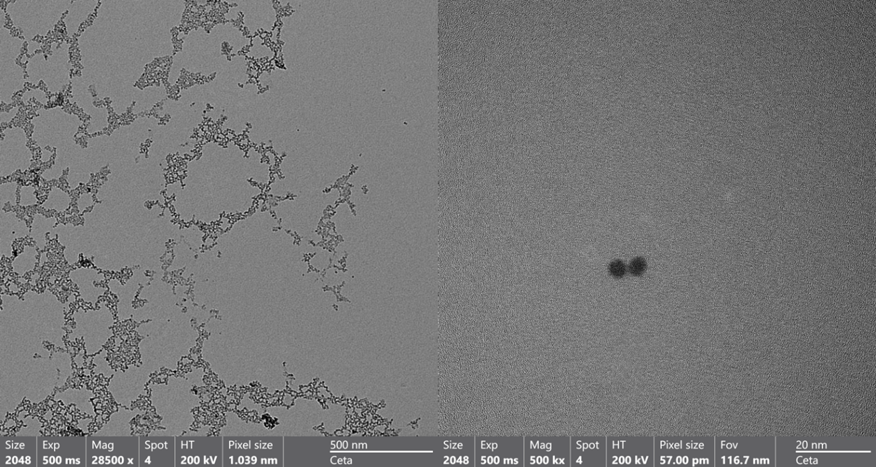
Figure S2: TEM imaging of Pt NZs solution (0.5 mM) at low magnification (left) and high magnification (right).

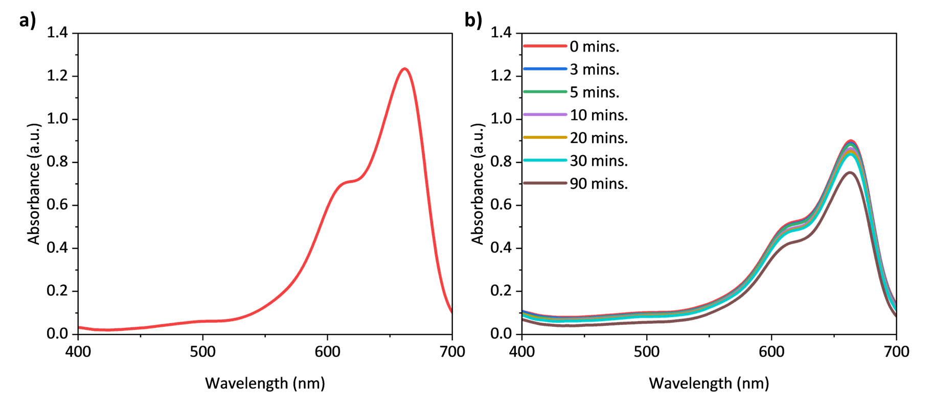
Figure S3: The absorption spectra of: a) MB. b) A solution of MB and H₂O₂.
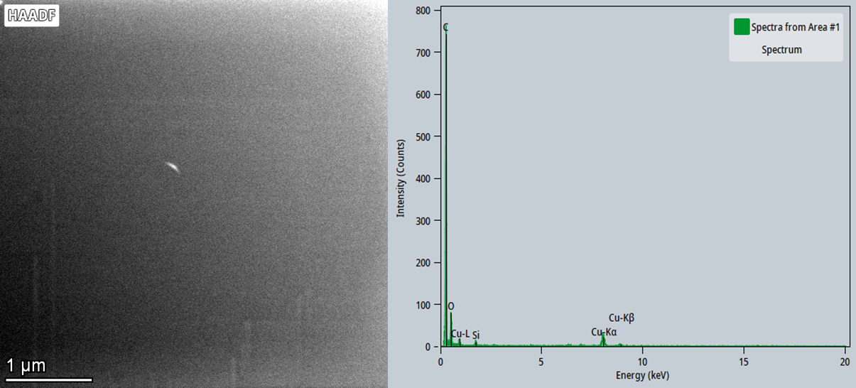
Figure S4: TEM imaging of lens storage water solution (Left) and EDS spectra (right).
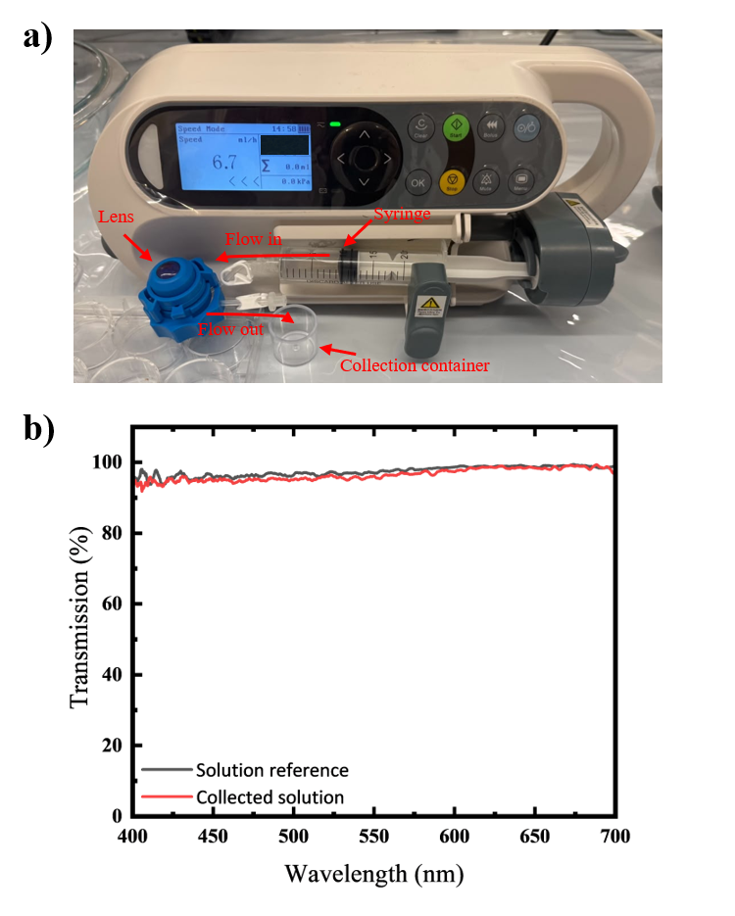
Figure S5: Artificial Anterior Chamber leakage assessment: a) Representative image showing the setup used. b) Transmission spectra obtained.
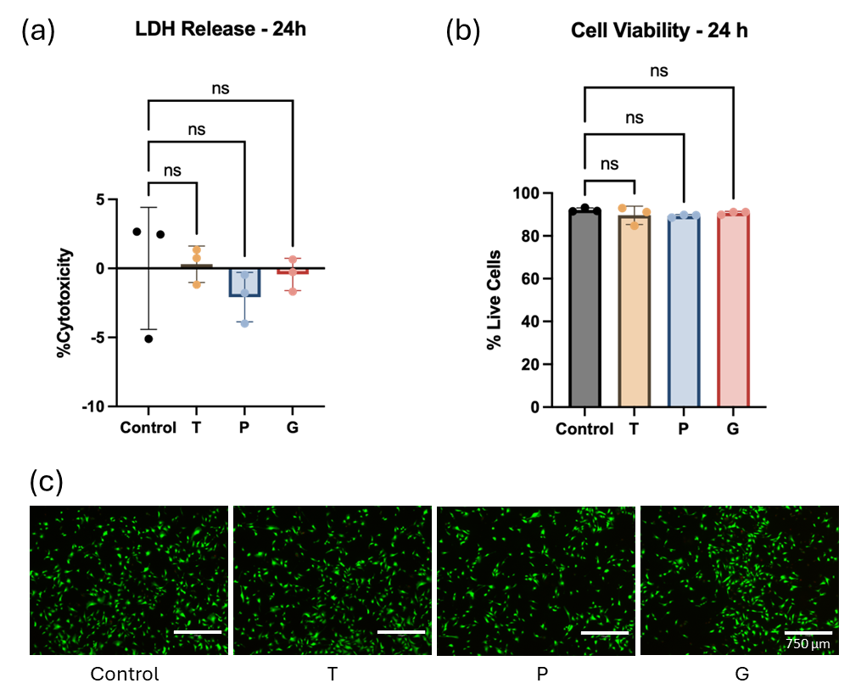
Figure S6: Biocompatibility of transparent (T), Pt NZs (P)-, and Au NZs (G)- loaded hydrogel extracts in human dermal fibroblasts after 24 h exposure. (a)Cytotoxicity assessed by lactate dehydrogenase (LDH) release into the supernatant, normalised to media (0%) and lysis (100%) controls. (b) Cell viability quantified by Calcein-AM/propidium iodide (Live/Dead) staining and expressed as the percentage of live cells relative to total fluorescence. (c) Representative fluorescence micrographs of fibroblasts co-stained with Calcein-AM (green, live cells) and propidium iodide (red, dead cells) following 24 h incubation with media (Control), T extract, P, extract, or G extract; scale bar = 750 µm. Data are presented as mean ± SD (n = 3 per group). Statistical analysis was performed by one-way ANOVA followed by Dunnett's multiple comparisons test (each extract vs. Control). ns, not significant.

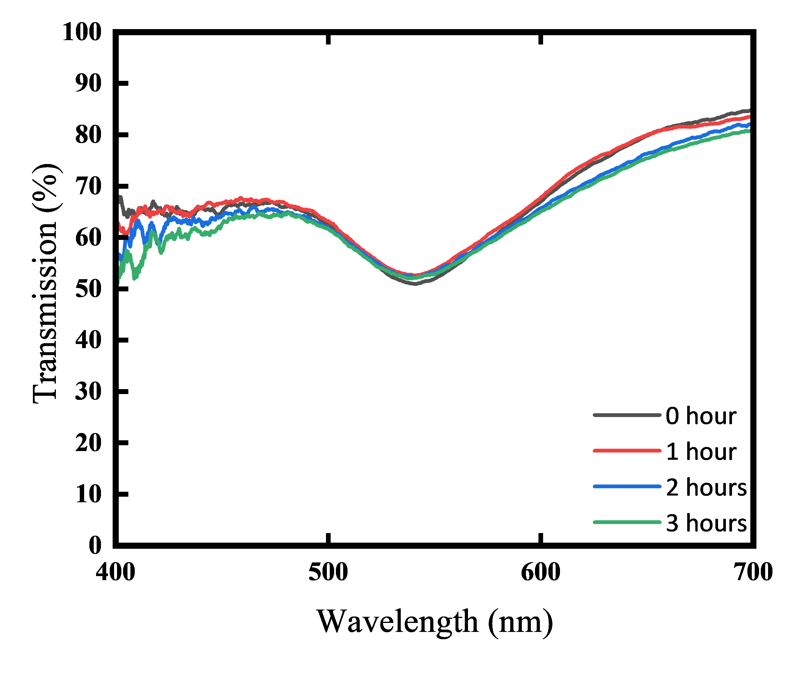
Figure S7: Transmission spectra of a lens before and after three cycles of exposure to H₂O₂.
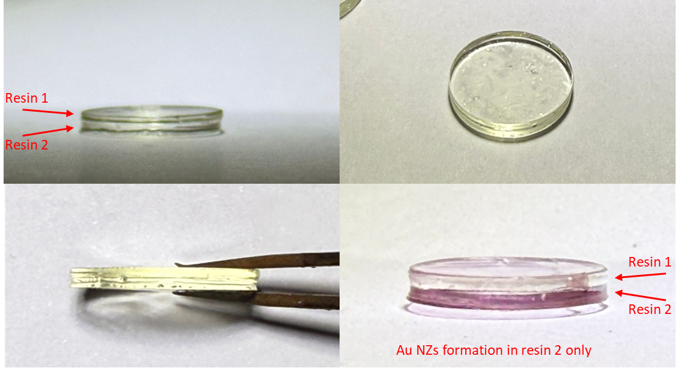
Figure S8: The 3D printing of multi-material discs using two different resins and incorporating Au NZs only in Resin 2.
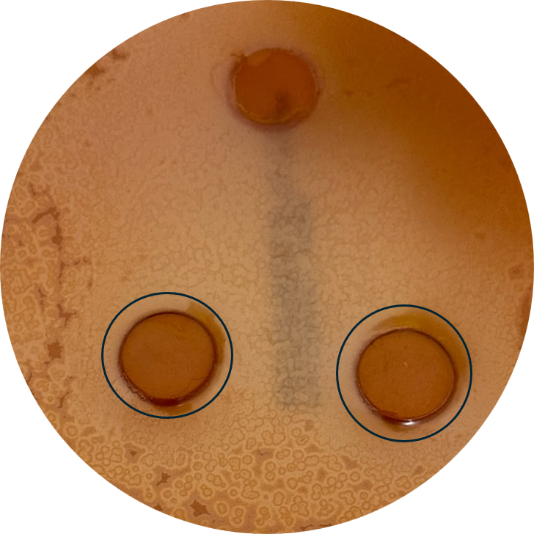
Figure S9: Antibacterial assay: The agar plate after approximately 24 hours of incubating the lenses with bacteria.

