Supporting Information

ROS-Responsive Curcumin Nanoparticles Reprogram the Microbiota-Gut-Brain Axis for Inflammatory Bowel Disease Therapy

Xueyi Chen,^{1,#} Yu Li,^{1,#} Peijun Ye,¹ Wenting Chen,¹ Yongshi Chen,¹ Dong Li,³ Yingyi Feng,¹ Yunhan Feng,² Yuehui Liang,⁴ Corke Harold,^{5,6} Bo-Bo Zhang,^{1,*} Qiongqiong Yang^{1,2,*}
¹ Guangdong Provincial Key Laboratory of Marine Biotechnology, Department of Biology, College of Science, Shantou University, Shantou 515063, Guangdong, China
² College of Light Industry and Food Engineering, Guangxi University, Nanning 530004, China
³ Chemistry and Chemical Engineering Guangdong Laboratory, Shantou 515031, China
⁴ Institute of Digestive Disease, Guangxi Academy of Medical Sciences, the People’s Hospital of Guangxi Zhuang Autonomous Region, Nanning 530021, China
⁵ Faculty of Biotechnology and Food Engineering, Technion-Israel Institute of Technology, Haifa 320003, Israel
⁶ Biotechnology and Food Engineering program, Guangdong Technion-Israel Institute of Technology, Shantou 515063, Guangdong, China
# These authors contributed equally to this work.
Corresponding authors:
Bo-Bo Zhang, email: bbzhang@stu.edu.cn
Qiongqiong Yang, email: qiongqiongyang@stu.edu.cn

Figure S1. Synthesis procedure of ALG-Se.

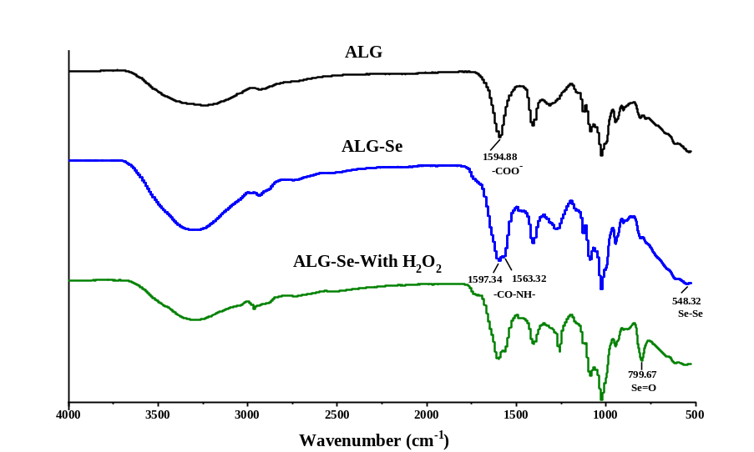
Figure S2. FT-IR of ALG, ALG-Se, and oxidative ALG-Se.

Figure S3. ¹H NMR of ALG, ALG-Se, and oxidative ALG-Se.

Figure S4. Zeta potential of ALG, ALG-Se, and oxidative ALG-Se.

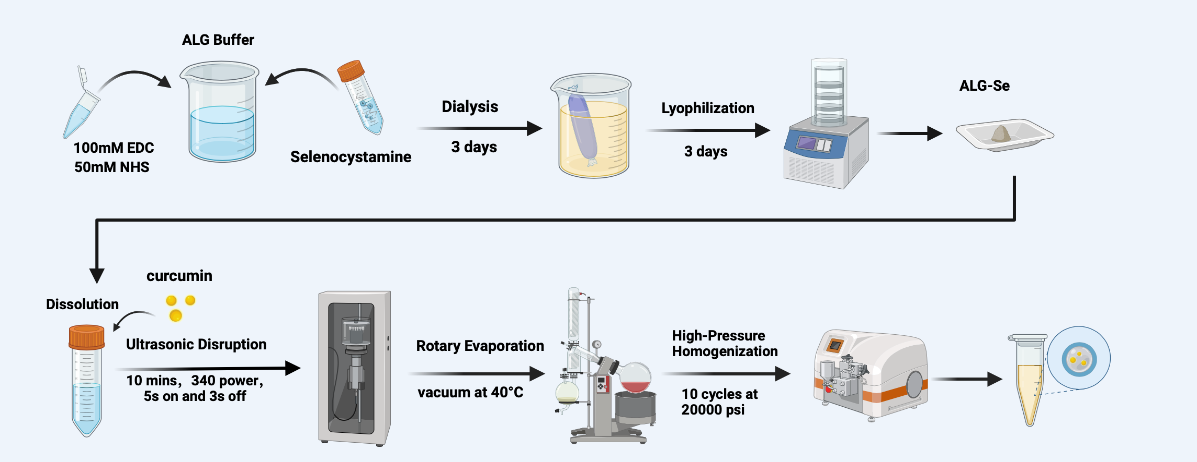
Figure S5. Synthesis procedure of CUR@ALG-Se.

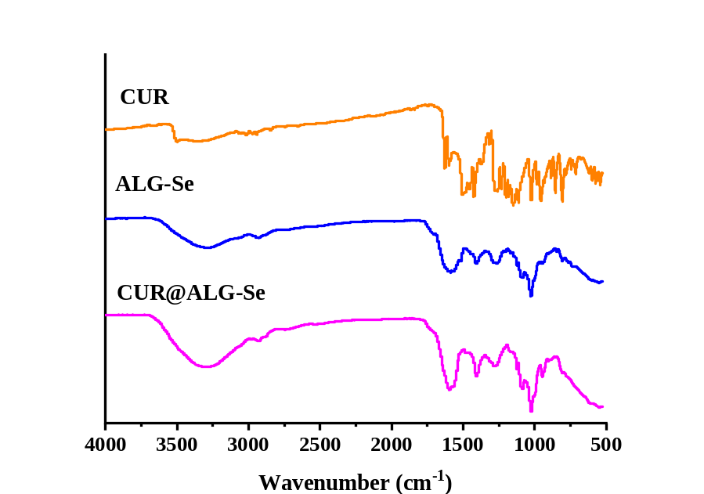
Figure S6. FT-IR of CUR, ALG-Se, and CUR@ALG-Se.

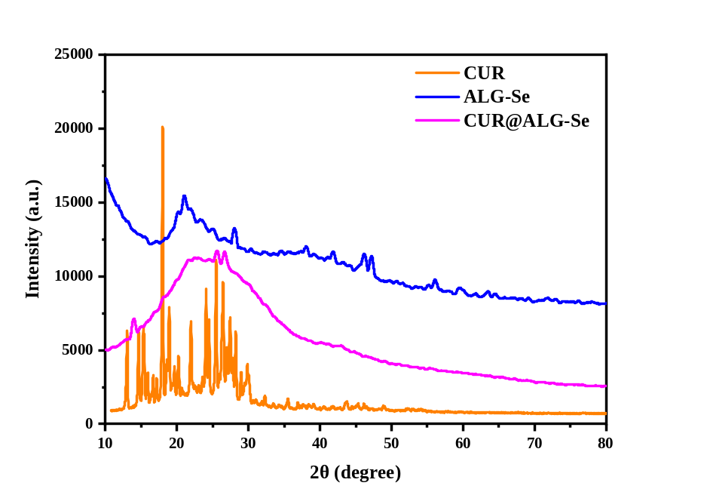
Figure S7. XRD of CUR, ALG-Se, and CUR@ALG-Se.

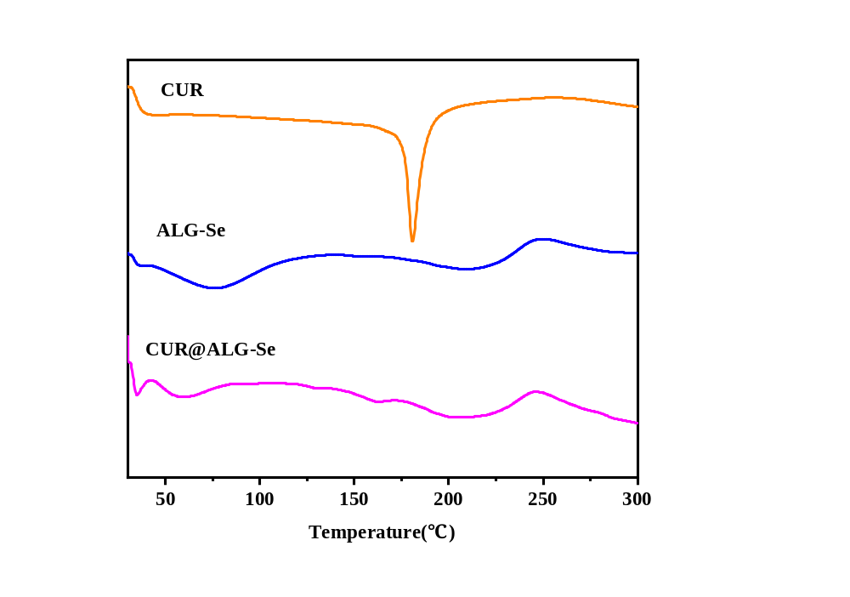
Figure S8. DSC of CUR, ALG-Se, and CUR@ALG-Se.

Figure S9. Curcumin retention rate during simulated gastric-intestinal digestions.

Figure S10. Particle distribution of CUR@ALG-Se after 10 mM H₂O₂ treatment over time (0, 2, 12, and 24 h).

Figure S11. Zeta potential of CUR@ALG-Se after 10 mM H₂O₂ treatment over time (0, 2, 12, and 24 h).

Figure S12. Biosafety evaluation of CUR@ALG-Se. Data are presented as mean ± SD (n = 6). Statistical analysis was performed using one-way ANOVA, ns, P > 0.05.

Figure S13. Time-dependent scavenging of ROS by CUR@ALG-Se. HT29 cells were treated with 0.125 μg/mL CUR@ALG-Se for varying time periods (0, 0.5, 1, and 2 h). Intracellular ROS levels were quantified by flow cytometry. Data are presented as mean ± SD (n = 6), statistical analysis was performed using one-way ANOVA, ns, P > 0.05, ****P < 0.0001.

Figure S14. Concentration-dependent scavenging of ROS by CUR@ALG-Se. HT29 cells were treated with the different concentrations of CUR@ALG-Se for 1 h prior to ROS induction and measurement. Data are presented as mean ± SD (n = 6), statistical analysis was performed using one-way ANOVA, P ≥ 0.05, ns, P > 0.05, ****P < 0.0001.

Figure S15. CompuSyn-generated dose-effect relationship and combination index (CI) analysis of CUR, ALG-Se and CUR@ALG-Se in HT-29 cells. (A) Dose-effect curves of CUR, ALG-Se and CUR@ALG-Se. (B) Fa-CI curve of CUR@ALG-Se. CI<1, CI=1, CI>1 denote synergistic, additive, and antagonistic effects, respectively.

Figure S16. Cellular uptake behavior of CUR@ALG-Se by normal and oxidative-stressed HT29 cells. (A) Cellular uptake in HT29 cells under normal or oxidative stress, visualized via CLSM. Scale bar: 10 μm. (B) Cellular uptake behaviors of CUR@CMC-Se as quantitated by flow cytometry in normal or oxidative-stressed HT29 cells, data are presented as mean ± SD (n = 6), statistical analysis was performed using two-way ANOVA, ns, P > 0.05, ***P < 0.001 and ****P < 0.0001.

Figure S17. Flow cytometric analysis of competitive inhibition by free folic acid preconditioning on folate receptor-mediated uptake of nanoparticle. (A) Normal HT-29 cells. (B) Oxidative-stressed HT-29 cells, data are presented as mean ± SD (n = 3), statistical analysis was performed using two-way ANOVA, ns, P > 0.05, ***P < 0.001 and ****P < 0.0001.

Figure S18. Flow cytometric analysis of nanoparticle uptake via different endocytic pathways. (A-B) Effect of chlorpromazine on clathrin-mediated endocytosis. (C-D) Effect of genistein on caveolae-mediated endocytosis. (E-F) Effect of EIPA on macropinocytosis, data are presented as mean ± SD (n = 3), statistical analysis was performed using two-way ANOVA, ns, P > 0.05, ***P < 0.001 and ****P < 0.0001.

Figure S19. Colonic retention of ALG-Cy5.5 and ALG-Se-Cy5.5 in colitis mice

Figure S20. Ex vivo fluorescence imaging of major organs of mice (heart, liver, spleen, lung and kidney) at different time points after treatment.

Figure S21. The DAI scores (A) and the spleen coefficient (B) of mice after the different treatments. Data are presented as mean ± SD (n = 6). Data are presented as mean ± SD (n = 6), statistical analysis was performed using two-way ANOVA(a) and one-way ANOVA(b), ns, P > 0.05, ***P < 0.001 and ****P < 0.0001.

Figure S22. Histopathological evaluation of colon tissue. (A) Colon histology scoring in different treated groups. (B) The number of goblet cells. (C) The colonic crypts depth. Data are presented as mean ± SD (n = 3), statistical analysis was performed using one-way ANOVA, *P < 0.05, **P < 0.01, ***P < 0.001, and ****P < 0.0001.

Figure S23. Heatmap illustration of gut microbial distribution at the genus level.

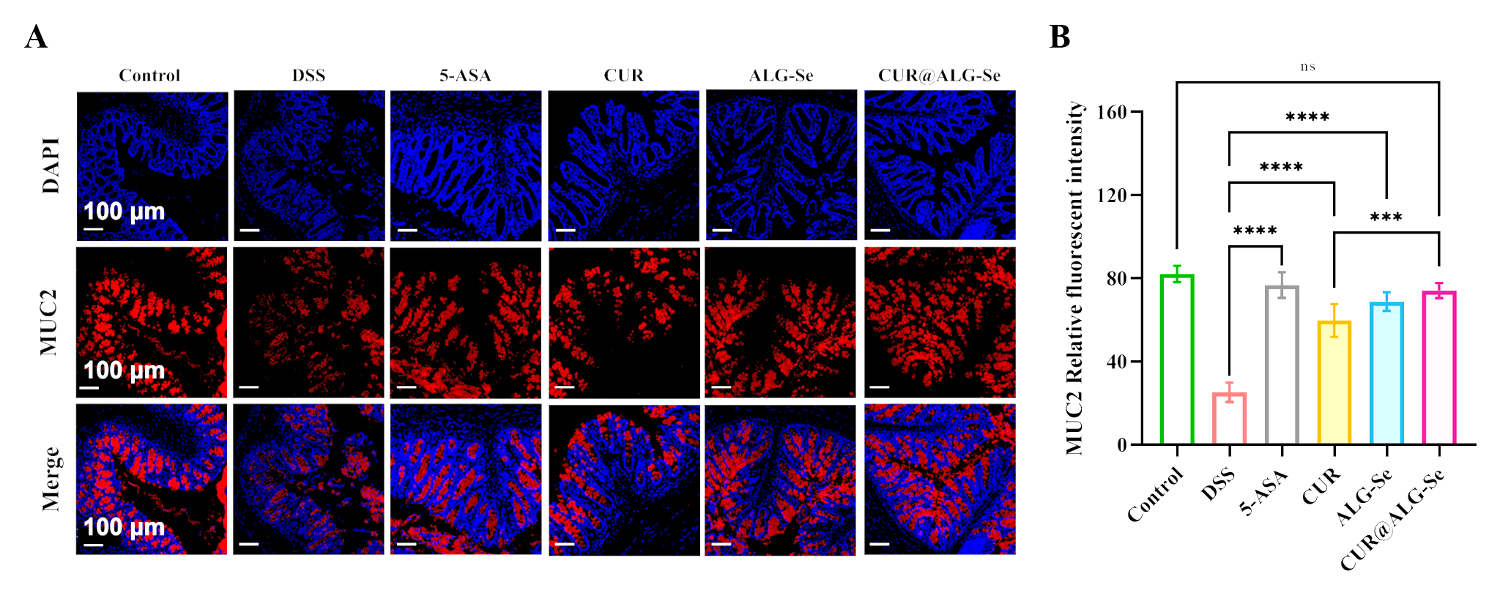
Figure S24. (A) Immunofluorescence staining images of colonic sections show the expression level of MUC2 [4′,6-diamidino-2-phenylindole (DAPI; blue) and MUC2 (red)]. Scale bars: 100 μm. (B) Quantitative analysis based on the mean fluorescence intensity of immunofluorescence staining images. Data are presented as mean ± SD (n = 3), statistical analysis was performed using one-way ANOVA, ns, P > 0.05, *P < 0.05, **P < 0.01, ***P < 0.001, and ****P < 0.0001.

Figure S25. Serum FITC-dextran levels in each group of mice. Data are presented as mean ± SD (n = 3), statistical analysis was performed using one-way ANOVA, ns, P > 0.05, *P < 0.05.

Figure S26. Quantitative analysis based on the mean fluorescence intensity of GFAP(A), IBA(B), MAP2(C). Data are presented as mean ± SD (n = 3), statistical analysis was performed using one-way ANOVA, ns, P > 0.05, *P < 0.05, **P < 0.01, ***P < 0.001, and ****P < 0.0001.

Table S1. Histological score in the colon tissues of UC mice
Score | Ulceration | Changes in epithelial | Degree of inflammatory infiltration
0 | 0 | Normal | Normal
1 | 0 | Goblet cells loss | Infiltration around crypt
2 | 2 | Massive loss of goblet  cells | Mucosal muscle infiltration
3 | 3 | Crypt absence | Generally Mucosal muscle infiltration or incrassation
4 | ＞3 | Severe loss of crypt or  polyps regenerated | Submucosa infiltration

Table S2. Drug dosage and administration schedule table
Drug group | Dosage (mg/kg/d) | Gavage dose | Administration frequency
5-ASA | 200 | 500 μL/d | Once a day
CUR | 15 | 500 μL/d | Once a day
ALG-Se | 150 | 500 μL/d | Once a day
CUR@ALG-Se | 15 | 500 μL/d | Once a day
*The dose of the ALG-Se group is equivalent to that of the ALG-Se component in the CUR@ALG-Se group.
*The dose of CUR@ALG-Se is expressed as the equivalent curcumin content (15 mg/kg/d).

