Supporting Information

Sustainable Mechanochemical Production of Amino Graphene for Enhanced Electrothermal Carbon Dioxide Capture
Rahul Navikª, Ding Xiao^{c}, and Jia Li^{a,b *}
ªWu Jieh Yee School of Interdisciplinary Studies, Lingnan University, Tuen Mun, Hong Kong (SAR), China
^{b}Lingnan University Shenzhen Research Institute, Shenzhen 518057, China
^{c}Stoddart Institute of Molecular Science, Department of Chemistry, Zhejiang University, Hangzhou, 310058, China
Corresponding authors: Prof. Jia LI
*Corresponding author e-mail: jia.li@ln.edu.hk (Jia Li); Phone no.: (852)26167350 (Jia Li)

S1. Characterization
The GNs–PEI suspension was first adjusted to an aqueous concentration of 1 mg/mL using a water-bath sonicator to ensure uniform dispersion. The resulting solution was subsequently centrifuged at 500 rpm for 30 min to remove unstable aggregates. The clear supernatant was carefully collected, and its absorbance at 660 nm was recorded using a UV–vis spectrophotometer (UV 1900, Shimadzu Japan). The concentration of the dispersed fraction was then quantitatively determined based on the Lambert–Beer law [1] as described in Eq. 1.
Al = αC (1)
where A-absorbance; α- absorption coefficient (1610); C- concentration; l- cuvette length (m⁻¹). The absorption coefficient (α) was determined using multiple GNs dispersions of known concentrations, prepared in an aqueous medium with surfactant assistance to ensure stability. UV–vis spectra of these dispersions were recorded over the wavelength range of 200-700 nm. The maximum absorbance values extracted from each spectrum were plotted against the corresponding GNs-PEI concentrations. The value of α was obtained from the slope of the resulting linear fit. The yield of GNs flakes (Y, %) was subsequently calculated following Eq. 2.
Y(%) = C × 100/100 × 100% (2)
where C is the GNs-PEI concentration aforementioned.
The structure of the samples was examined and analyzed using a field emission scanning electron microscope S-4800, Hitachi, Japan), a high-resolution transmission electron microscope (JEOL JEM 2100F, Japan) at 200 kV acceleration voltage, an atomic force microscope (Nanosensor, type NCL-100 Digital Instrument, Multimode 3000, USA) in tapping mode, an atomic force microscope (Nanosensor, Type NCL-100 Digital Instrument, Multimode 3000, USA) in tapping mode and Raman spectrophotometer (Bruker Optics Senterra R2200-L dispersive Raman microscope) at 532.2 nm laser excitation wavelength. The Raman spectrum was measured from 500 – 3500 cm⁻¹ range. The phase of the graphene was evaluated using an X-ray diffractometer (D/max-2200/PC diffractometer, Rigaku Corporation, Japan) operated at 45 kV and 40 mA using Cu-Kα irradiation with a wavelength of λ = 1.5406 Å.
The chemical structure of samples was investigated using Fourier transform infrared spectroscopy (Perkin Elmer Spectrum 100 spectrophotometer (Madison, USA) and X-ray photoelectron spectroscopy (Thermo K-alpha XPS instrument). The Fourier transform infrared spectroscopy spectrum was recorded in transmission mode with a resolution of 16 cm⁻¹ and wavenumber region from 4000 to 400 cm⁻¹, undergoing 32 scans. Before the experiments, the X-ray photoelectron spectroscopy instrument was calibrated using standard peak positions of carbon atoms (284.80 eV), and recorded spectrums were deconvoluted at a fixed value of 20% Lorenztian-Gaussian using Peak fit software.
Before adsorption measurement, all samples were degassed in a glass tube at 150 ℃ under vacuum for 1 h. In addition, to investigate the impact of plasma treatment on the hydrophilicity of graphene aerogels, moisture adsorption isotherms were collected at 30 ℃.

S2. Statistical analysis of exfoliated nanosheets
The length and height of exfoliated nanosheets were analyzed using AFM measurement. The height and length were recorded on 50 flakes from AFM images using the Nasoscope Analysis 1.8 program. A histogram of height and length was plotted using Origin Pro 2022 software (OriginLab Corp.). The next step involved fitting histograms using a nonlinear polynomial peak fit function. Mean thickness, lateral dimension, and standard deviation were provided based on output.

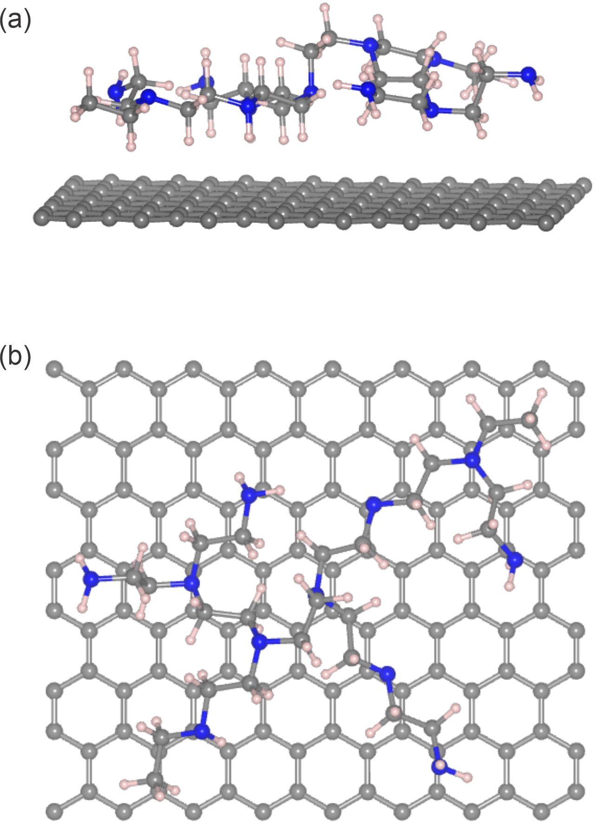
Fig. S1. Mechanism of the PAME method. Structure’s (a) side view and (b) top views of GNs/PEI. (Black atoms: carbon; blue atoms: nitrogen; and pink atoms: hydrogen).

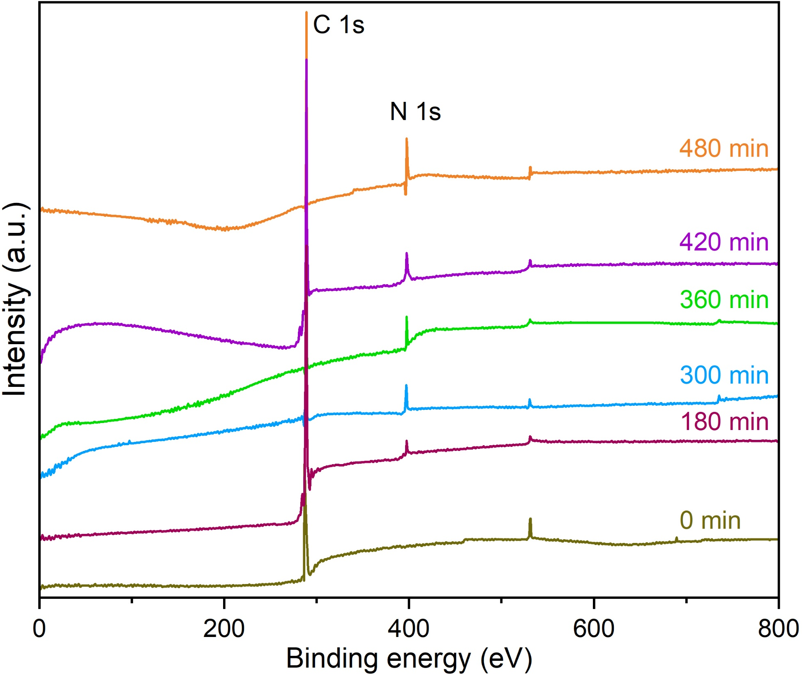
Fig. S2. Chemical properties of GNs-PEI. Profiles showing survey XPS spectra of bulk graphite and GNs-PEI processed for different durations.

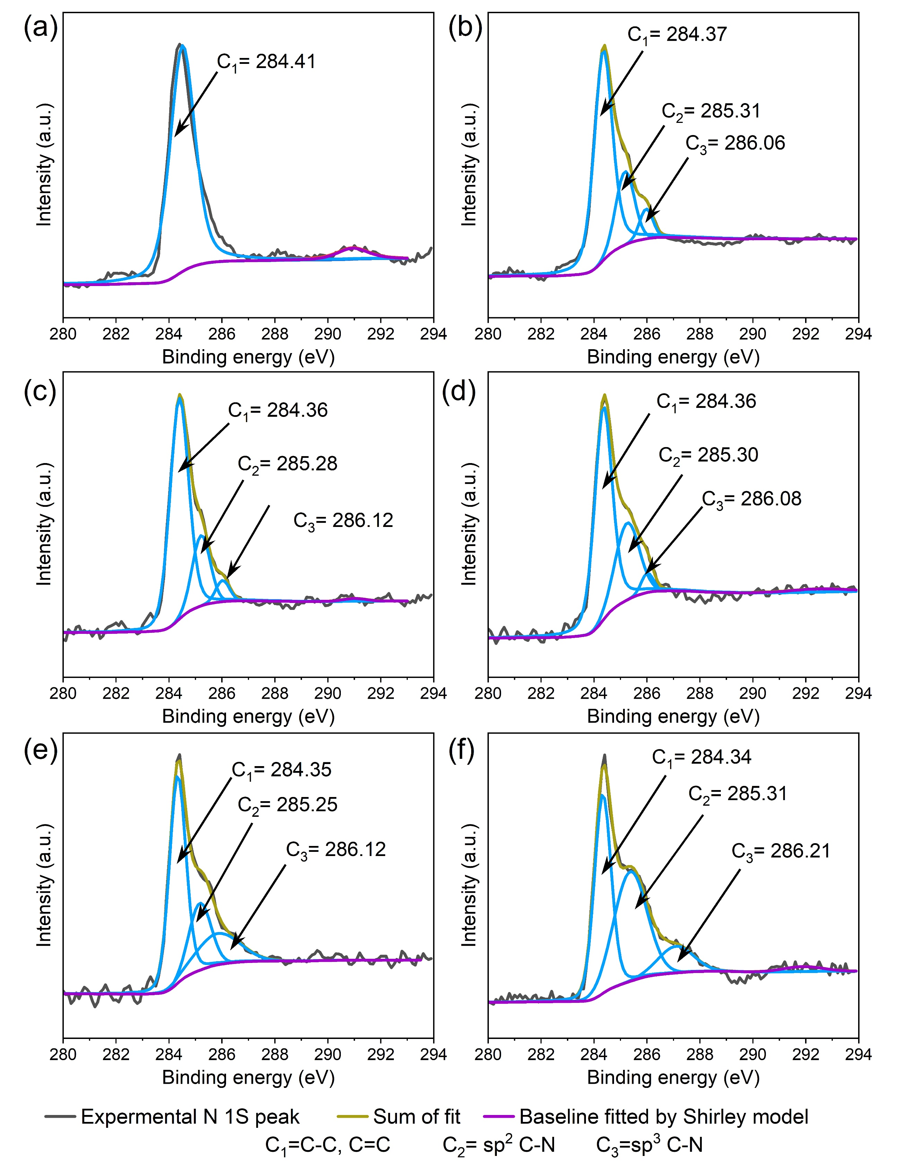
Fig. S3. Chemical properties of GNs-PEI. the deconvoluted C1s peak of (a) bulk graphite and GNs-PEI for (b) 180 min (c) 300 min, (d) 360 min (e) 420 min and (f) 480 min.
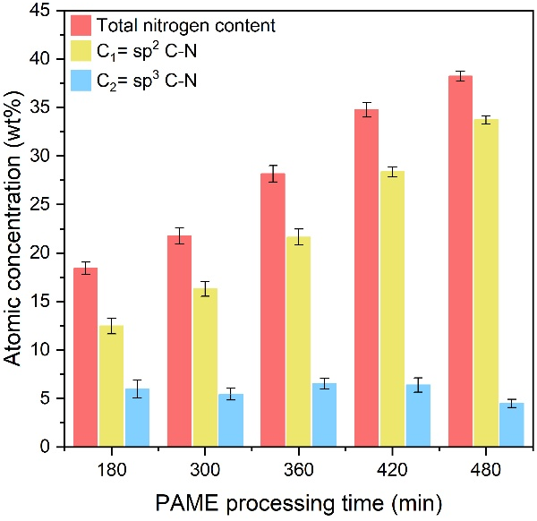
Fig. S4. Chemical properties of GNs-PEI. Content distributions of nitrogen configurations fetched from deconvoluted C 1s XPS spectrum after PAME for different duration.

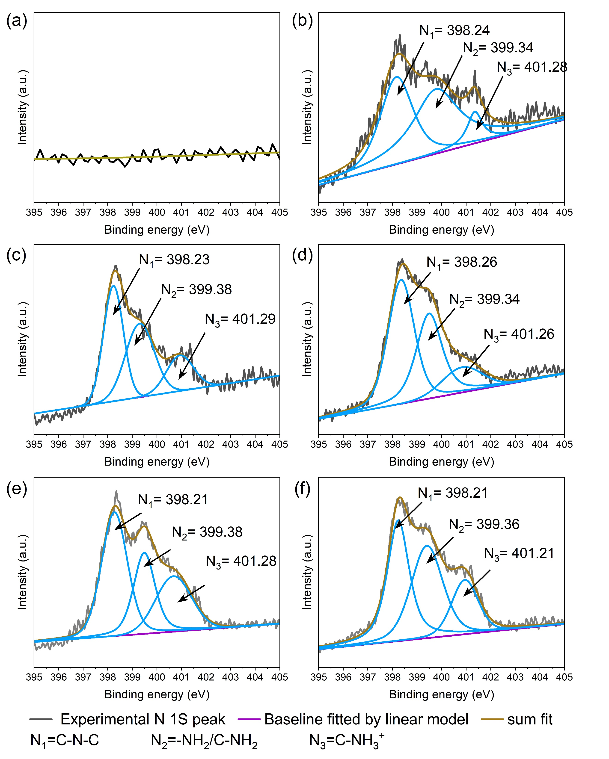
Fig. S5. Chemical properties of GNs-PEI. the deconvoluted N1s peak of (a) bulk graphite and GNs-PEI for (b) 180 min (c) 300 min, (d) 360 min (e) 420 min and (f) 480 min.
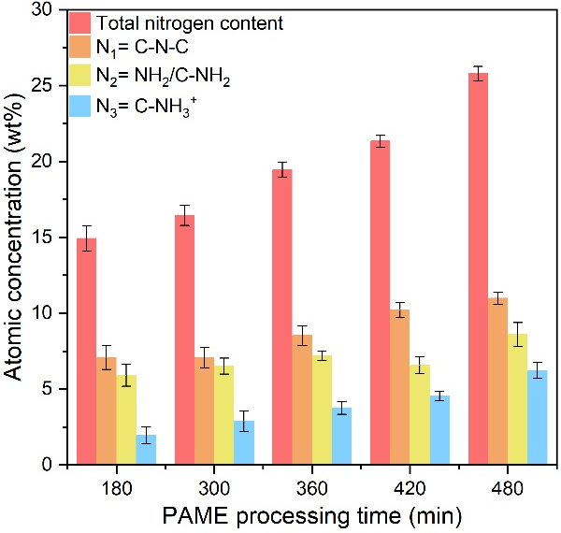
Fig. S6. Chemical properties of GNs-PEI. Content distributions of nitrogen configurations fetched from deconvoluted N1s XPS spectrum after PAME for different duration.
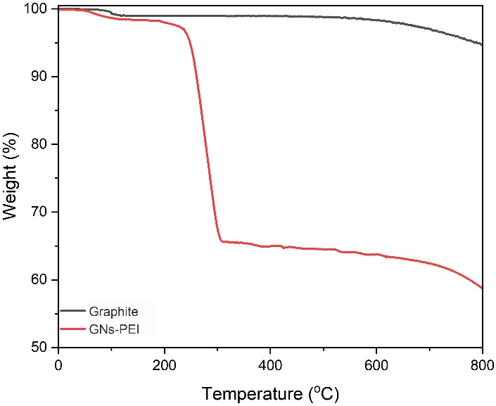
Fig. S7. Structure and morphology of GNs-PEI. Thermal profiles of graphite and GNs-PEI recorded thermogravimetrically.
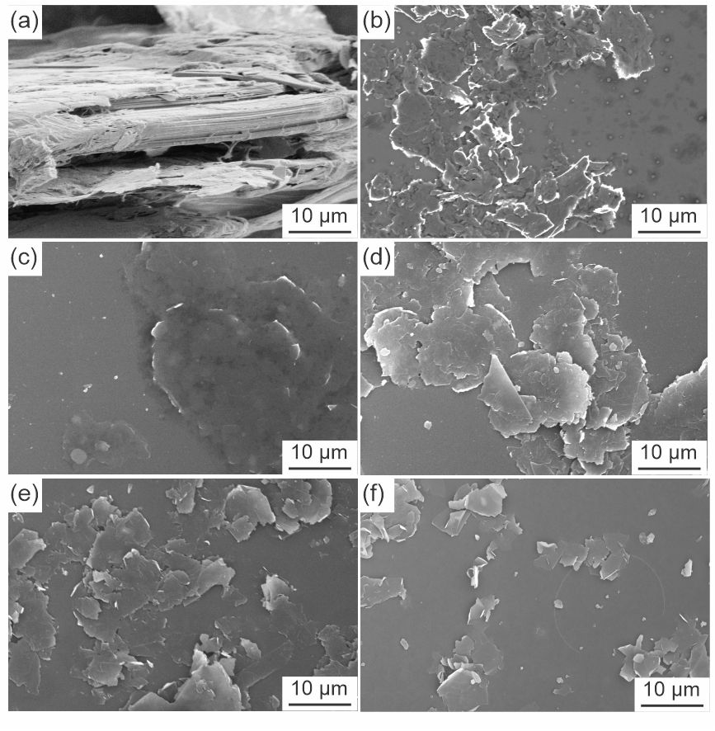
Fig. S8. Structure of GNs-PEI FLG: SEM images of (a) raw graphite and GNs-PEI prepared through PAME process for (b)180 min (c) 300 min, (d) 360 min, (e) 420 min and (f) 480 min.

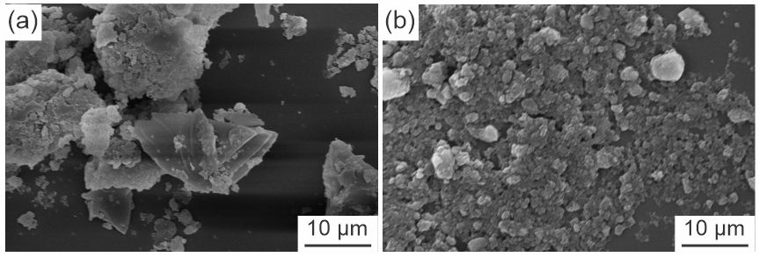
Fig. S9. Structure of GNs-PEI FLG: SEM images of exfoliated graphene my milling without PEI for (a)300 min and (b) 480 min.
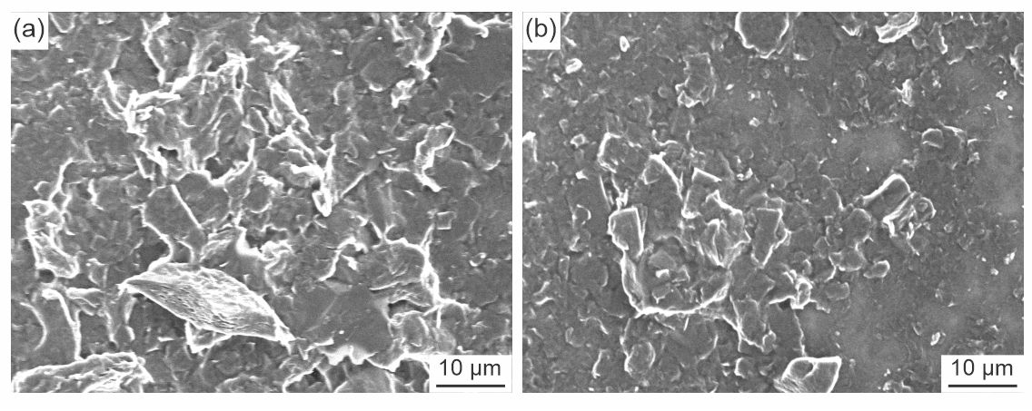
Fig. S10. SEM images of exfoliated graphene my physical mixing of PEI and bulk graphite for (a)300 min and (b) 480 min.

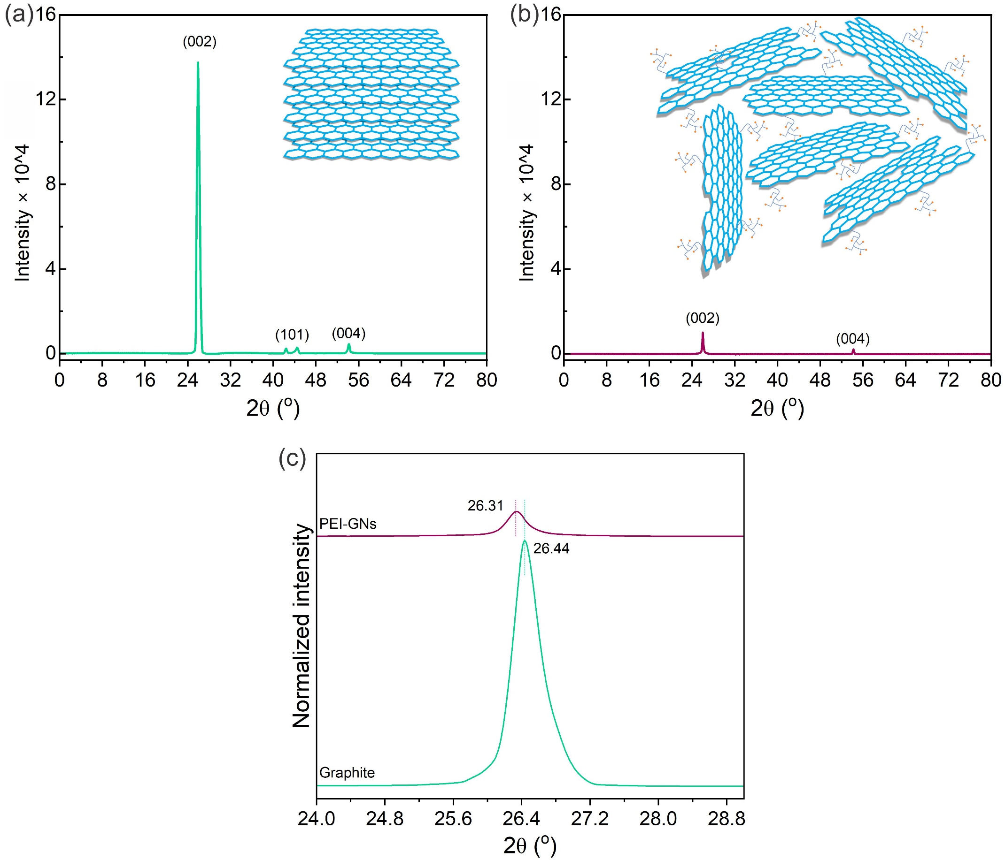
Fig. S11. Structure and morphology of GNs-PEI. X-ray diffraction patterns of (a) graphite and (b) GNs-PEI and (c) magnified (002) diffraction bands of graphite and GNs-PEI.
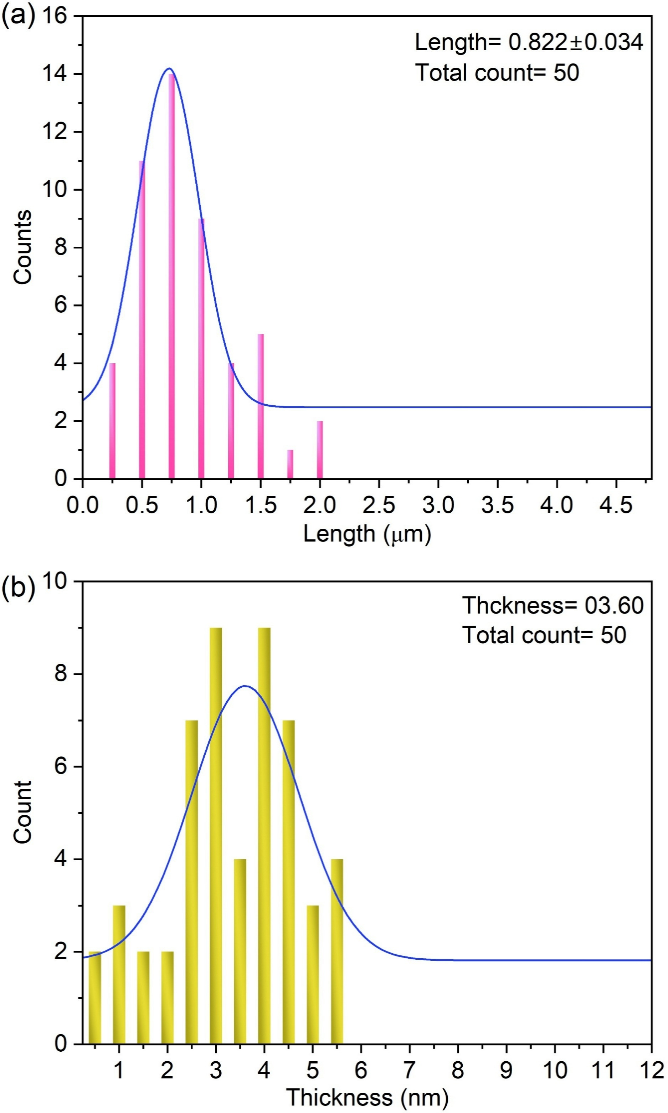
Fig. S12. Evaluation of structure and morphology of GNs-PEI. Histogram of (a) lateral size and (b) thickness of GNs-PEI.

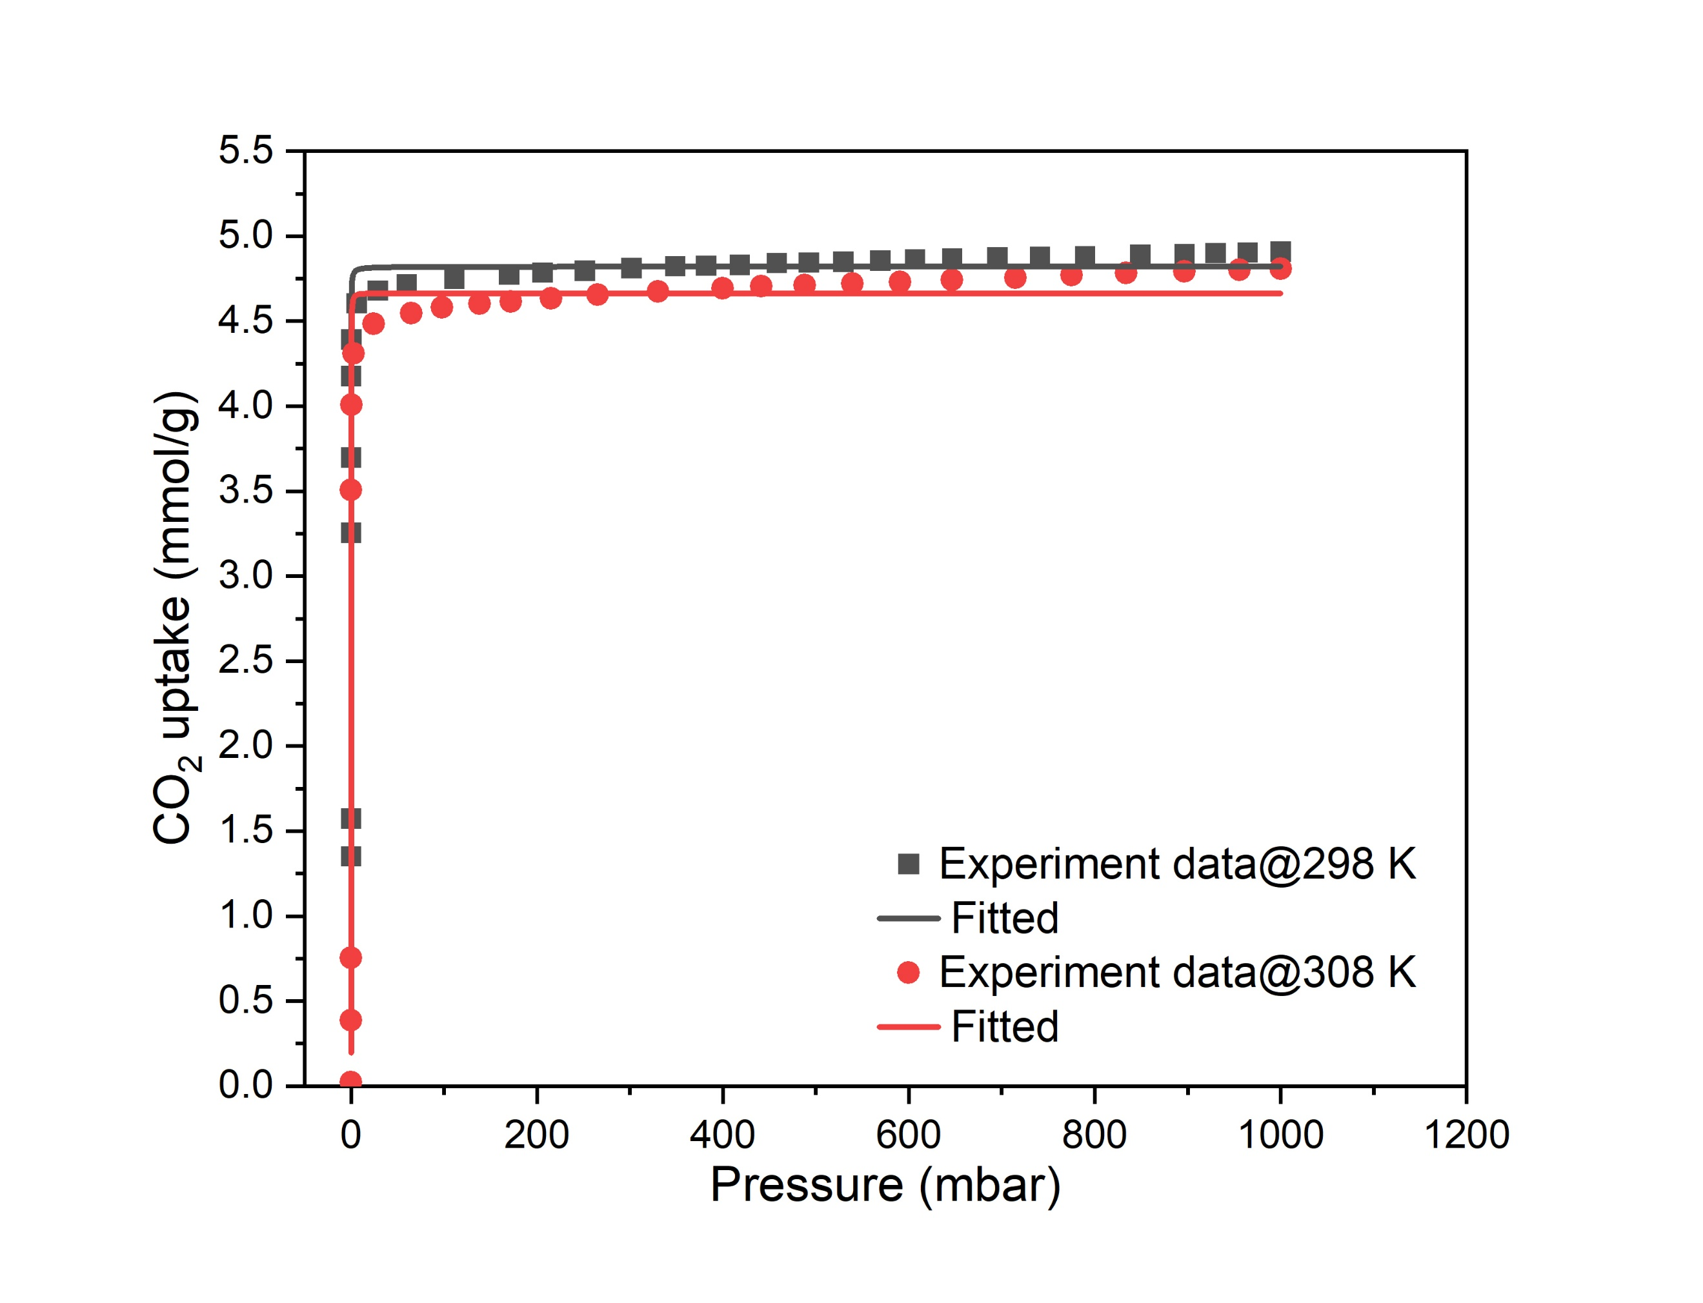

Fig. S13. Determination of heat of adsorption (Q_{st}). Fitting of the experimental CO₂ adsorption isotherm data for GNs-PEI at 298 K and 308 K using the the Freundlich-Langmuir model, according to the Eq. (3).
$n=\frac{a∙b∙p^{c}}{1+b∙p^{c}}$ (3)
where n is the amount of CO2 adsorbed, p the pressure, a is the maximal loading, b the affinity constant and c the heterogeneity exponent.

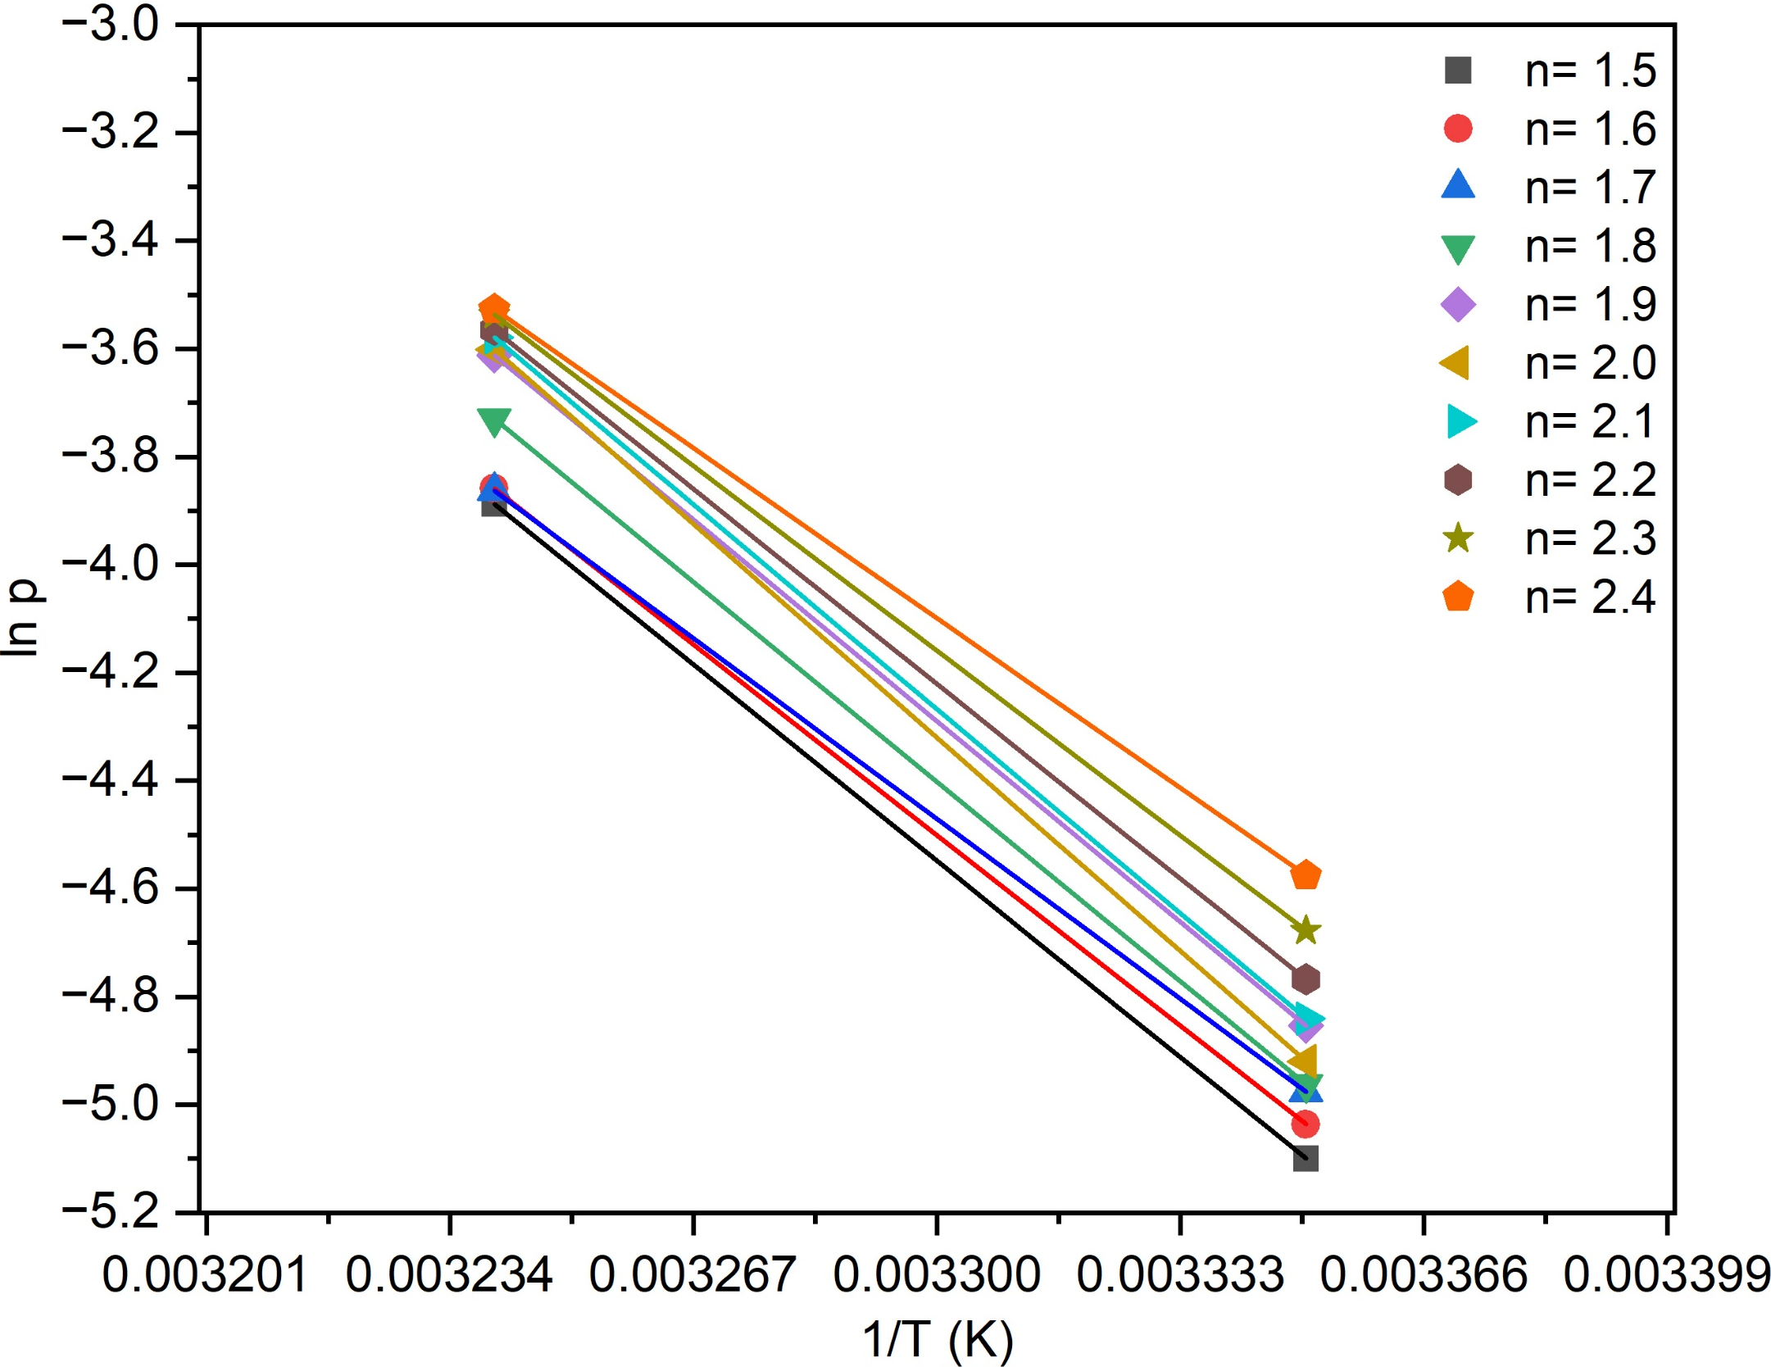
Fig. S14. Determination of heat of adsorption (Q_{st}). Isosteric ln p against 1/T plot for T1 = 298 K and T2 = 308 K for 10 different loadings n (in mmol/g) illustrates the determination of Q_{st} (n) from the slopes (m = Q_{st}(n)/R) of the straight lines (R = universal gas constant, 8.314).

Table S1. The calculated values of ID/IG, n_{D} and L_{D} in bulk graphite and GNs-PEI are listed.
Sample | I_{D}/I_{G} | L_{D} | n_{D}×10¹¹ nm⁻²
EG | 0.12 | 20.09 | 77.82
GNs-PEI | 0.71 | 6.19 | 81.99

Table S2. Comparative review of graphene for CO₂ capture.
Abbreviations: GO-Graphene oxide, rGO-Reduced graphene oxide, KMnO₄-Potassium permanganate, K₂FeO₄-Potassium ferreate, H₂O₂-Hydrogen peroxide, KOH-Potassium hydroxide, UV-Ultraviolet, HKUST-1-Hong Kong University of Science and Technology-1, MOF-Metal Organic Framework, PpPDA- p-Ppolyphenylenediamine, CuBTC/GA-IL- Copper(Il) benzene-1,3,5-tricarboxylate. /Graphene aerogel/Ionic liquid, MgO- magnesium oxide, PEI-polyethyleneimine, and PAME- Polyamine assisted-mechanochemistry.
Graphene based adsorbents | Preparation method | Adsorption method (volumetric unless specified) | Adsorption conditions (Temperature/Pressure) | Adsorption capacity (mmol/g) | Ref.
Layered graphene -graphite flakes. | KMnO₄ + K₂FeO₄ + H₂O₂ activation |  | 30 ℃, and 1 bar | 1.14 | [2]
Wrinkle flake-shaped GO | Amine functionalization. |  | 25 ℃, 1 bar | 0.91 | [3]
rGO-based monolith | | Mild reduction and self-assembled into 3D structure |  | 25 ℃, 1 atm | 2.1 | [4]
Surface-microporous graphene | Direct synthesis of 3D graphene foam using CO₂ |  | 25 ℃, 1 bar | 2.28 | [5]
Surface-microporous graphene | Direct synthesis of graphene foam using CO₂ and KOH activation |  | 25 ℃, 1 bar | 3.13 | [5]
HKUST-1/GO | UV-activation |  | 0 ℃, 1 bar | 5.14 | [6]
Table S2 (continued next page)

Table S2 (continued)
Graphene based adsorbents | Preparation method | Adsorption method (volumetric unless specified) | Adsorption conditions (Temperature/Pressure) | Adsorption capacity (mmol/g) | Ref.
rGO monoliths | Modification using heteroatoms | Gravimetric | 25 ℃, 1 atm | 1.67 | [7]
MOF/GO-Arg | _{L}-arginine modified GO and compositing with MOFs | Dynamic breakthrough | 50 ℃, 1 bar | 3.37 | [8]
PpPDA/rGO | KOH chemical activation and amine modification |  | 25 ℃, 1 bar | 4.65 | [9]
CuBTC/GA-IL | MOF compositing and ionic liquid incorporation |  | 25 ℃, 1 bar | 3.71 | [10]
GO/mesoporous resin composite | Carbonizing of melamine-resorcinol-formaldehyde resin with GO |  | 25 ℃, 500 kPa | 5.21 | [11]
Monolithic rGO | Malic acid assisted reduction and KOH-activation |  | 25 ℃, 1 bar | 2.35 | [12]
Monolithic GO | Oxalic acid assisted reduction and UV treatments | Breakthrough | 25 ℃, 1 bar | 1.65 | [13]
3D self-assembled graphene | 3D self-assembled graphene (by hydrothermal synthesis | High pressure volumetric | 25 ℃, 30 bar | 2.18 | [14]
Table 2 (continued next page)
Table S2 (continued)
Graphene based adsorbents | Preparation method | Adsorption method (volumetric unless specified) | Adsorption conditions (Temperature/Pressure) | Adsorption capacity (mmol/g) | Ref.
GO/MgO/PEI composite | Compositing GO, Magnesium Oxide, and PEI | High-pressure volumetric | 25 ℃, 8.7 bar | 6.63 | [15]
GNs-PEI | Polyamine assisted-mechanochemistry (PAME) |  | 25 ℃ | 4.91 | This work
GNs-PEI | PAME |  | 35 ℃ | 4.48 | This work
GNs-PEI | PAME |  | 45 ℃ | 4.32 | This work
GNs-PEI | PAME |  | 55 ℃ | 4.01 | This work
GNs-PEI | PAME | Breakthrough | 30 ℃ (dry) | 3.62 | This work
GNs-PEI | PAME | Breakthrough | 50 ℃ (dry) | 3.06 | This work

References
[1] Lotya M, Hernandez Y, King PJ, Smith RJ, Nicolosi V, Karlsson LS, Blighe FM, De S, Wang Z, McGovern I (2009) Liquid phase production of graphene by exfoliation of graphite in surfactant/water solutions. J. Am. Chem. Soc. 131: 3611. https://doi.org/10.1021/ja807449u.
[2] Aquatar MO, Mankar JS, Bhatia U, Rayalu SS, Krupadam RJ (2021) Graphene nanosheets from hazardous/solid wastes: An efficient CO2 capture material. J. Environ. Chem. Eng. 9: 105839. https://doi.org/10.1016/j.jece.2021.105839.
[3] Hosseini Y, Najafi M, Khalili S, Jahanshahi M, Peyravi M (2021) Assembly of amine-functionalized graphene oxide for efficient and selective adsorption of CO2. Mater. Chem. Phys. 270: 124788. https://doi.org/10.1016/j.matchemphys.2021.124788.
[4] Politakos N, Barbarin I, Cantador LS, Cecilia JA, Mehravar E, Tomovska R (2020) Graphene-based monolithic nanostructures for CO2 capture. Ind. Eng. Chem. Res. 59: 8612. https://doi.org/10.1021/acs.iecr.9b06998.
[5] Tian Y, Lin Y, Hagio T, Hu YH (2020) Surface-microporous graphene for CO2 adsorption. Catal. Today 356: 514. https://doi.org/10.1016/j.cattod.2020.06.002.
[6] Varghese AM, Reddy KSK, Bhoria N, Singh S, Pokhrel J, Karanikolos GN (2021) Enhancing effect of UV activation of graphene oxide on carbon capture performance of metal-organic framework/graphene oxide hybrid adsorbents. Chem. Eng. J. 420: 129677. https://doi.org/10.1016/j.cej.2021.129677.
[7] Politakos N, Cordero-Lanzac T, Tomovska R (2021) Understanding the adsorption capacity for CO2 in reduced graphene oxide (rGO) and modified ones with different heteroatoms in relation to surface and textural characteristics. Appl. Sci. 11: 9631. https://doi.org/10.3390/app11209631.
[8] Zhao Y, Ge H, Miao Y, Chen J, Cai W (2020) CO2 capture ability of Cu-based metal-organic frameworks synergized with amino acid-functionalized layered materials. Catal. Today 356: 604. https://doi.org/10.1016/j.cattod.2019.12.016.
[9] Wang Y, Wang H, Zhang TC, Yuan S, Liang B (2020) N-doped porous carbon derived from rGO-Incorporated polyphenylenediamine composites for CO2 adsorption and supercapacitors. J. Power Sources 472: 228610. https://doi.org/10.1016/j.jpowsour.2020.228610.
[10] Ren W, Wei Z, Xia X, Hong Z, Li S (2020) CO2 adsorption performance of CuBTC/graphene aerogel composites. J. Nanopart. Res. 22: 191. https://doi.org/10.1007/s11051-020-04933-4.
[11] Ouyang L, Xiao J, Jiang H, Yuan S (2021) Nitrogen-doped porous carbon materials derived from graphene oxide/melamine resin composites for CO2 adsorption. Molecules 26: 5293. https://doi.org/10.3390/molecules26175293.
[12] Jha RK, Bhunia H, Basu S (2024) Enhancing CO2 capture through innovating monolithic graphene oxide frameworks. Environ. Res. 249: 118426. https://doi.org/10.1016/j.envres.2024.118426.
[13] Jha RK, Bhunia H, Basu S (2024) UV activated monolithic graphene Oxide-Based adsorbents for dynamic CO2 Capture: kinetic, isotherm and thermodynamic studies. Chem. Eng. Sci. 285: 119572. https://doi.org/10.1016/j.ces.2023.119572.
[14] Nayak B, Gauswami M, Yalagandula L, Singh SA, Kuncharam BVR (2026) Carbon Dioxide Adsorption Using Porous 3D Self-Assembled Graphene. ACS Omega. https://doi.org/10.1021/acsomega.5c10331.
[15] Rezvannasab SG, Safari N, Ghaedi AM (2025) Synthesis and performance enhancement of GO/MgO/PEI composite for CO₂ capture: effects of operating parameters. J. CO2 Util. 102: 103245. https://doi.org/10.1016/j.jcou.2025.103245.

