Supplementary Information

Cobalt–imidazolate framework nanozyme with carboxylesterase-mimicking activity for dual-mode detection of carbaryl via substrate-specific mechanistic validation

Thinh Viet Dang^{1,†}, Sathish Panneer Selvam^{2,†}, Xuan Ai Le^{1,†}, Sungbo Cho^{2,3,4,*} and Moon Il Kim^{1,*}

¹Deparment of BioNano Technology, Gachon University, 1342 Seongnamdae-ro, Sujeong-gu, Seongnam, Gyeonggi 13120, Republic of Korea
²Department of Electronic Engineering, Gachon University, 1342 Seongnamdae-ro, Sujeong-gu, Seongnam, Gyeonggi 13120, Republic of Korea
³Department of Semiconductor Engineering, Gachon University, 1342 Seongnamdae-ro, Sujeong-gu, Seongnam, Gyeonggi 13120, Republic of Korea
⁴Gachon Advanced Institute for Health Science & Technology (GAIHST), Gachon University, Incheon 21999, Republic of Korea

†These authors contributed equally to this work.

*To whom correspondence should be addressed.

Tel.: +82-31-750-8563; Fax: +82-31-750-4748. E-mail: moonil@gachon.ac.kr (M.I. Kim);
Tel.: +82-31-750-5321; Fax: +82-31-750-5830. E-mail: sbcho@gachon.ac.kr (S. Cho)

Table of contents

- Methods
- Supporting Figures and Tables
- References

1. Methods
Screening of enzymatic activities
Other enzyme-like activities of ZIF-67, such as oxidase (OXD), peroxidase (POD), alkaline phosphatase (ALP), laccase (LAC), and glucose oxidase (GOX) were evaluated as follows.
1.1 Oxidase-like activity
OXD-like activity was assessed by mixing 100 µL of ZIF-67 (0.1 mg/mL) with 900 µL of sodium acetate buffer (50 mM, pH 4) containing TMB (1 mM). After incubation for 10 min, the mixture was centrifuged (10,000 × g, 2 min), and the absorbance of the supernatant was recorded at 652 nm using a microplate reader (Synergy H1, BioTek, VT).
1.2 POD-like activity
POD-like activity was examined by reacting 100 µL of ZIF-67 (0.1 mg/mL) with 900 µL of sodium acetate buffer (50 mM, pH 4) containing TMB (1 mM) and H₂O₂ (5 mM). Following 10 min of incubation, the solution was centrifuged (10,000 × g, 2 min), and the absorbance of the supernatant was measured at 652 nm with a microplate reader.
1.3 ALP-like activity
ALP-like activity was determined by monitoring the hydrolysis of p-NPP (0.1 mg/mL) in deionized water in the presence of ZIF-67 (0.1 mg/mL) as a catalyst. The reaction mixture was incubated for 30 min, then centrifuged (10,000 × g, 2 min). The absorbance of the hydrolysis product (p-NP) was recorded at 405 nm using a microplate reader.
1.4 LAC-like activity
LAC-like activity was evaluated by adding 100 µL of ZIF-67 (0.1 mg/mL) to 900 µL of MES buffer (50 mM, pH 6.8) containing 2,4-DP (0.1 mg/mL) and 4-AP (0.1 mg/mL). After incubation for 30 min, the solution was centrifuged (10,000 × g, 2 min), and the absorbance was measured at 510 nm using a microplate reader.
1.5 GOX-like activity
GOX-like activity was tested by mixing 100 µL of ZIF-67 (0.1 mg/mL) with 200 µL of PBS buffer (10 mM, pH 7.4) containing glucose (50 mM), followed by incubation at 37 °C for 30 min. Subsequently, 700 µL of sodium acetate buffer (50 mM, pH 4) containing TMB (1 mM) was added. Owing to the inherent POD-like activity of ZIF-67, no horseradish peroxidase (HRP) was required. After a further 10 min of incubation, the mixture was centrifuged (10,000 × g, 2 min), and the absorbance of the supernatant was recorded at 652 nm with a microplate reader.

2. Supporting Figures and Tables

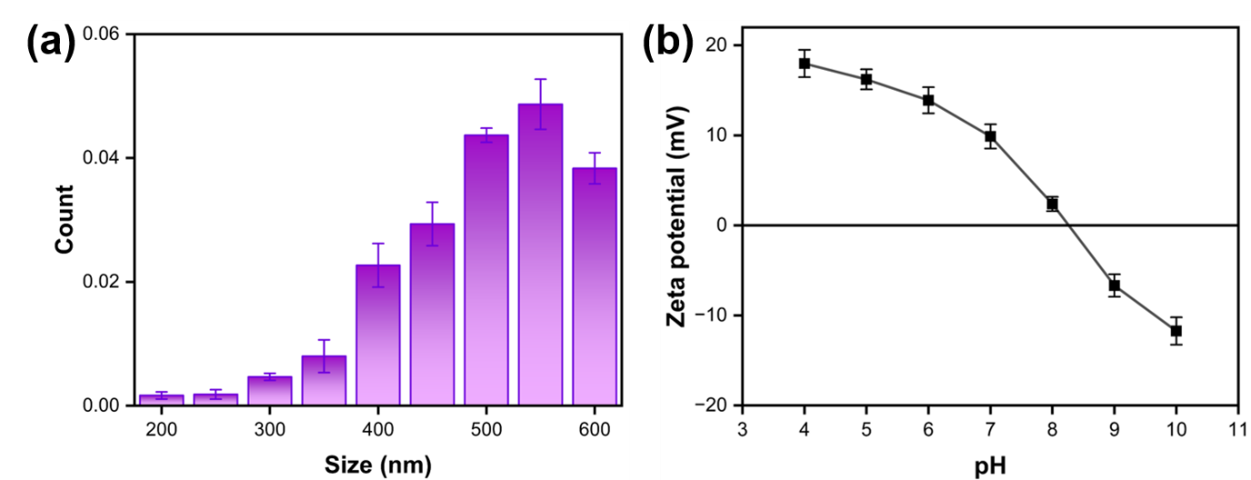
Figure S1. Colloidal characterization of ZIF-67 dispersed in deionized water (0.1 mg mL⁻¹, 50 °C). (a) Particle size distribution determined by nanoparticle tracking analysis (NTA) and (b) zeta potential of ZIF-67.

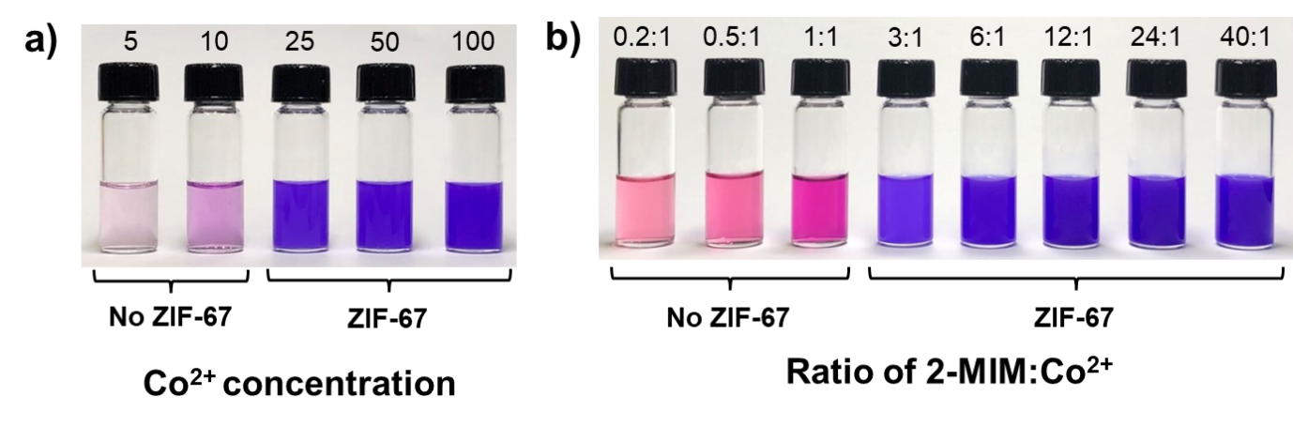
Figure S2. Optimization of (a) Co²⁺ concentration and (b) 2-MIM/Co²⁺ ratio for the synthesis of ZIF-67.

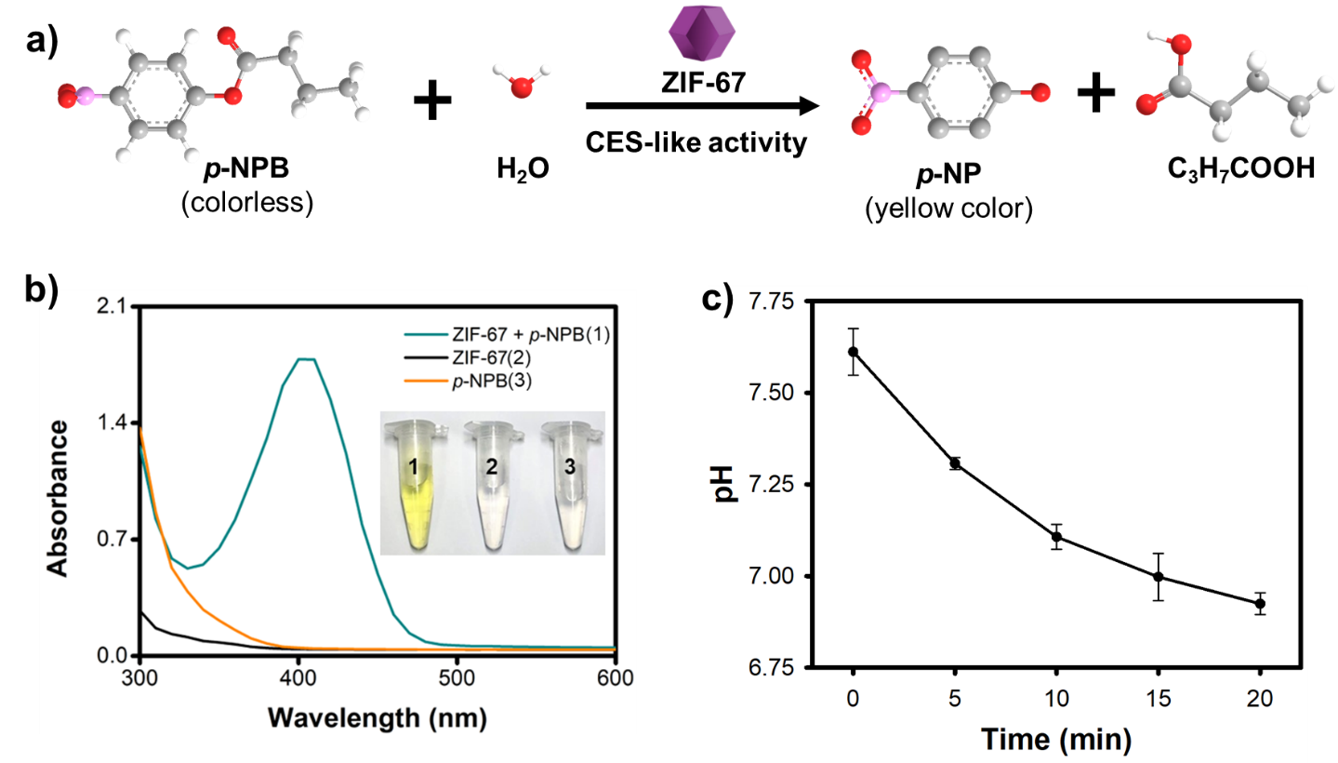
Figure S3. Evaluation of CES-like activity using p-NPB: (a) schematic illustration of hydrolysis catalyzed by ZIF-67; (b) absorbance changes confirming p-NPB hydrolysis; and (c) pH variation during the reaction.

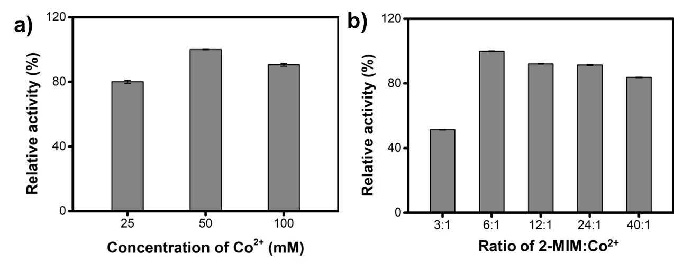
Figure S4. Comparison of CES-like activity of ZIF-67 synthesized under different Co²⁺ concentrations and 2-MIM/Co²⁺ ratios, via the hydrolysis of p-NPA.

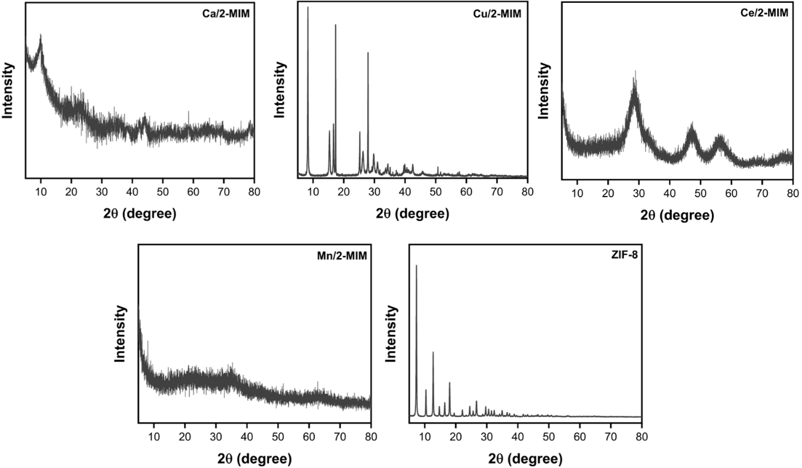
Figure S5. Powder XRD patterns of control materials, including Ca/2-MIM, Cu/2-MIM, Ce/2-MIM, Mn/2-MIM, and Zn/2-MIM (ZIF-8).

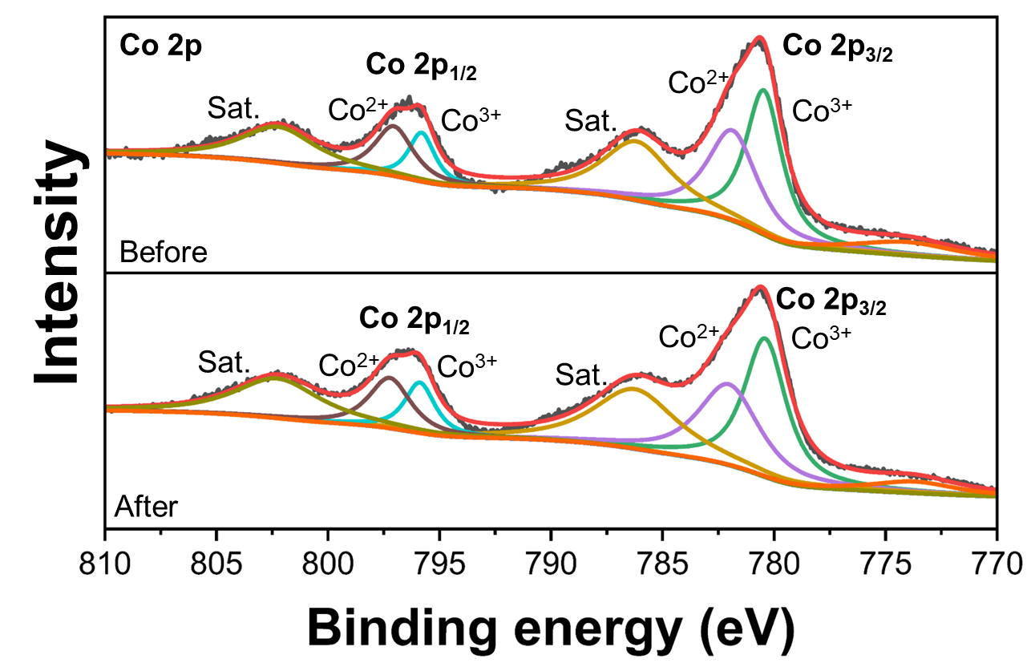
Figure S6. High resolution XPS spectra of Co 2p within ZIF-67 before and after catalytic reaction.

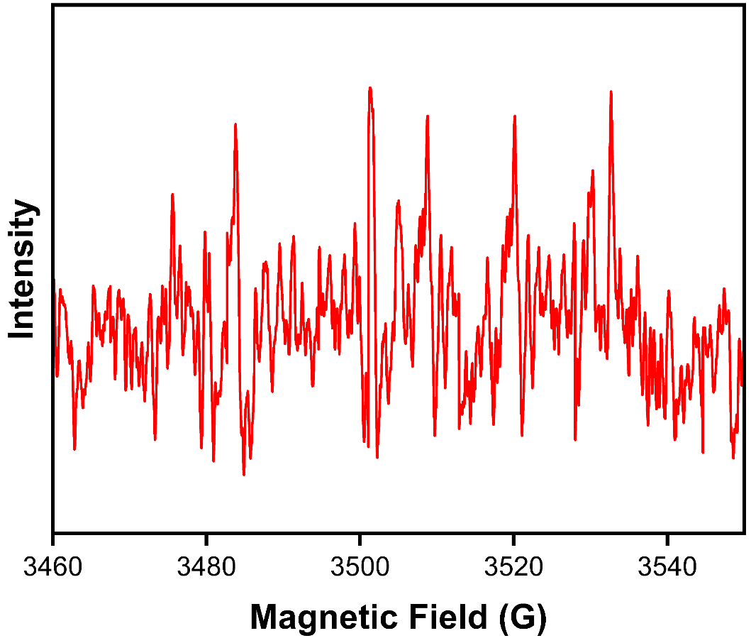
Figure S7. EPR spectra recorded during the CES-like hydrolysis of carbaryl catalyzed by ZIF-67 using DMPO as a spin-trapping agent. The absence of detectable DMPO-radical adduct signals confirms that reactive oxygen species (ROS) are not involved in the hydrolytic catalytic pathway.

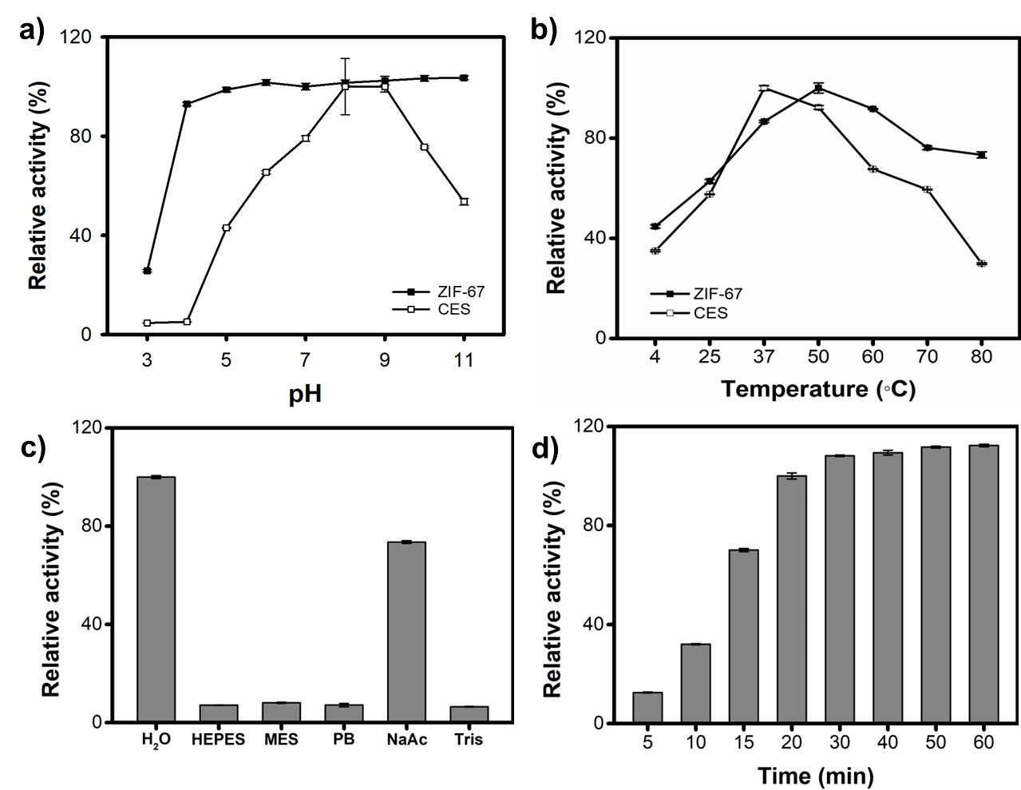
Figure S8. Optimization of hydrolysis conditions catalyzed by ZIF-67: effects of (a) pH, (b) temperature, (c) buffer type, and (d) incubation time.

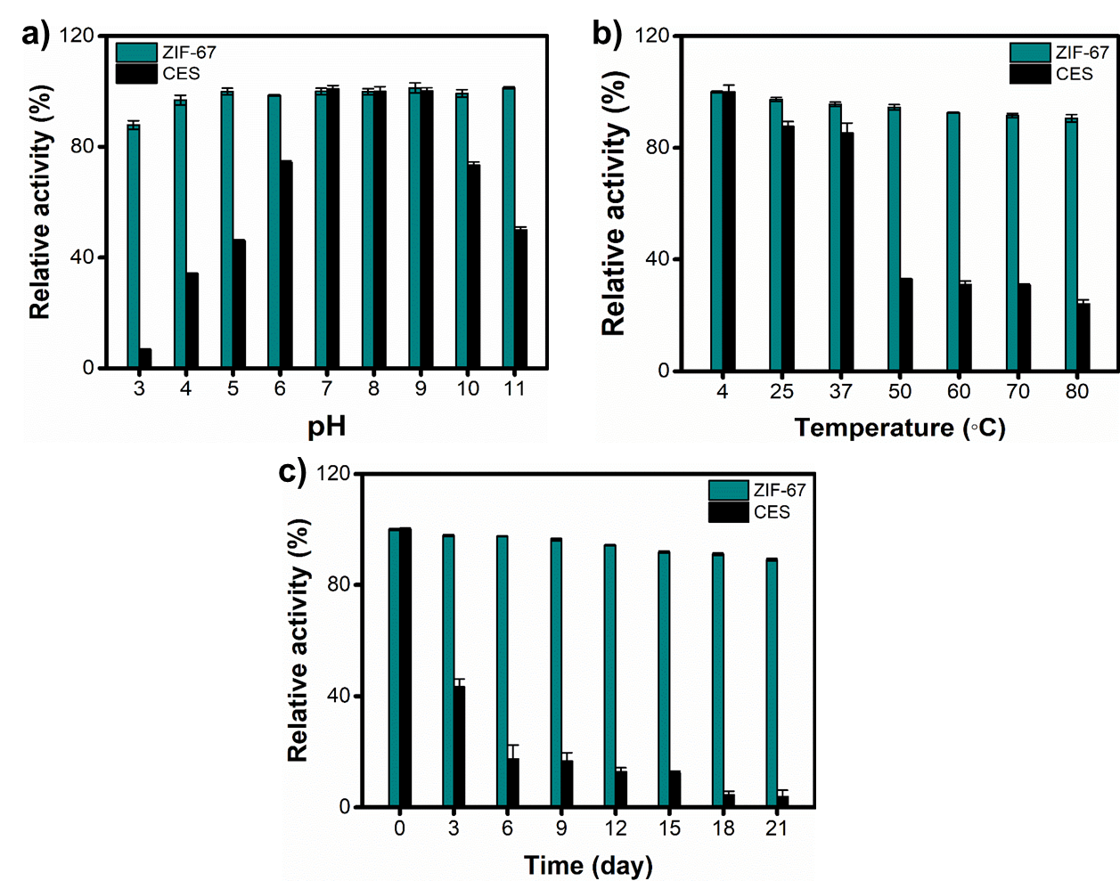
Figure S9. Stability of ZIF-67 across different (a) pH, (b) temperature, and (c) long-term storage period.

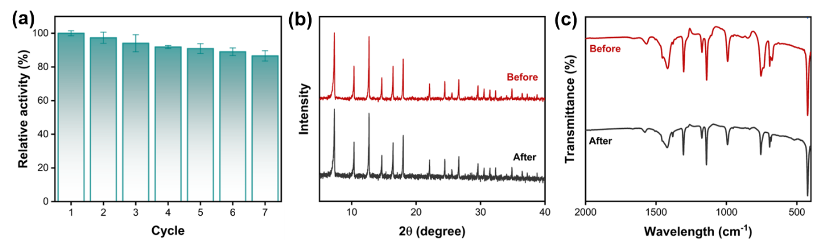
Figure S10. Reusability of ZIF-67 during repeated p-NPA hydrolysis. (a) Relative CES-like activity over seven consecutive catalytic cycles. (b) XRD patterns and (c) FT-IR spectra of ZIF-67 before and after seven reuse cycles.

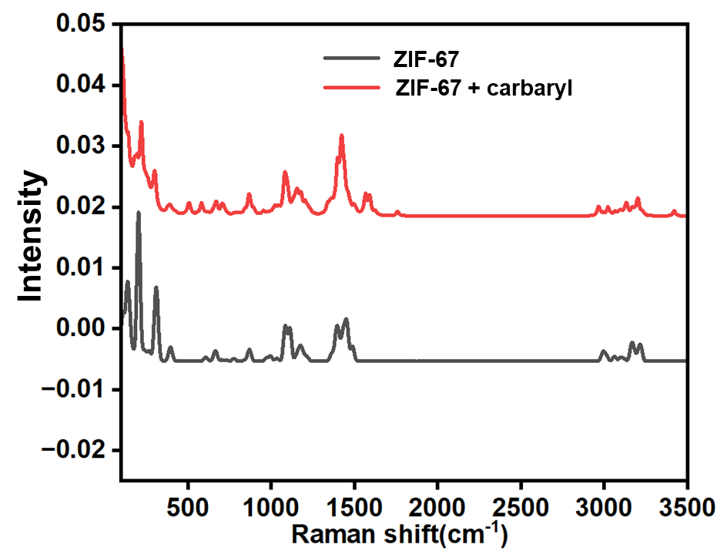
Figure S11. Raman spectra of ZIF-67 and ZIF-67/carbaryl mixture.

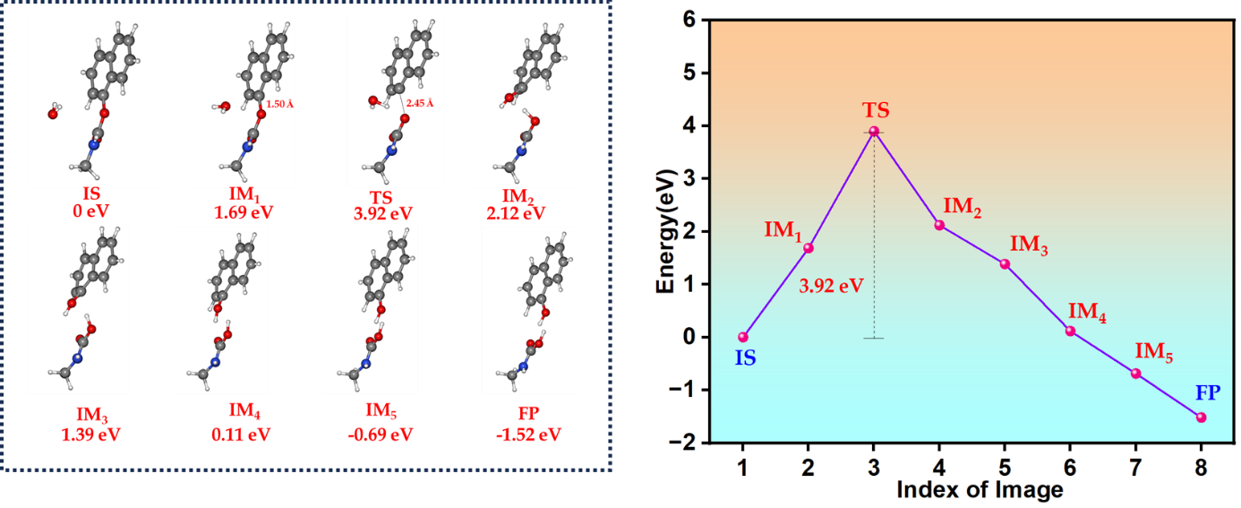
Figure S12. CI-NEB analysis of the minimum energy pathway and corresponding energy barrier for uncatalyzed carbaryl hydrolysis in water.

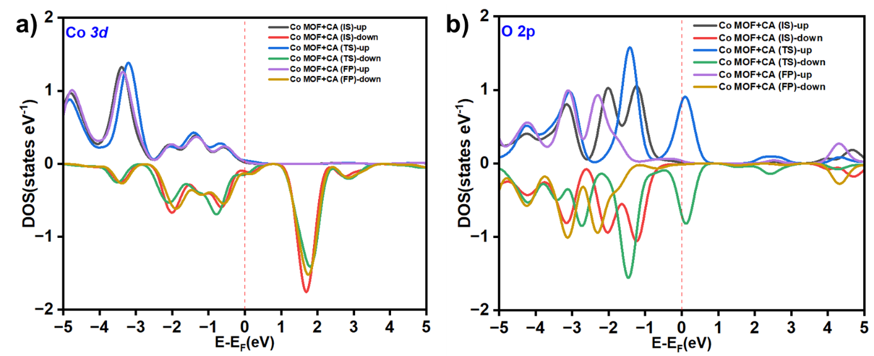
Figure S13. Spin-polarized (a) Co 3d and (b) O 2p projected density of states (PDOS) plots of ZIF-67.

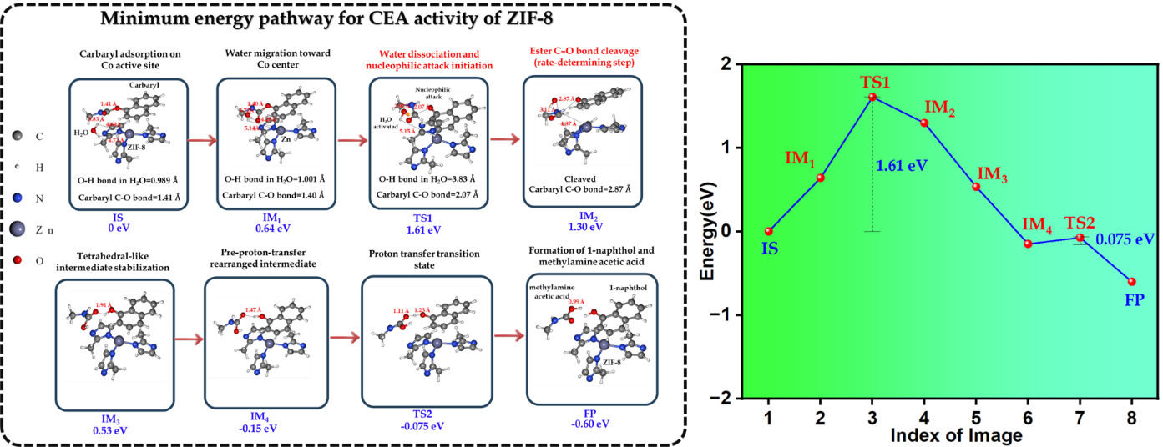
Figure S14. CI-NEB analysis of the minimum energy pathway and corresponding energy barrier for carbaryl hydrolysis catalyzed by ZIF-8 (Zn).

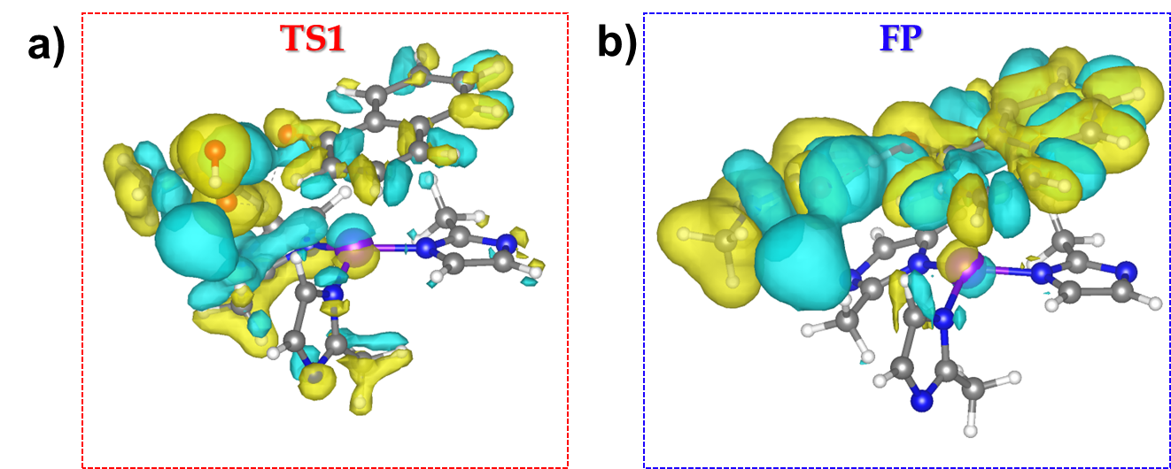
Figure S15. Electron density difference plots of the (a) transition state (TS) and (b) final product (FP) of the esterase reaction catalyzed by ZIF-8 (Zn).

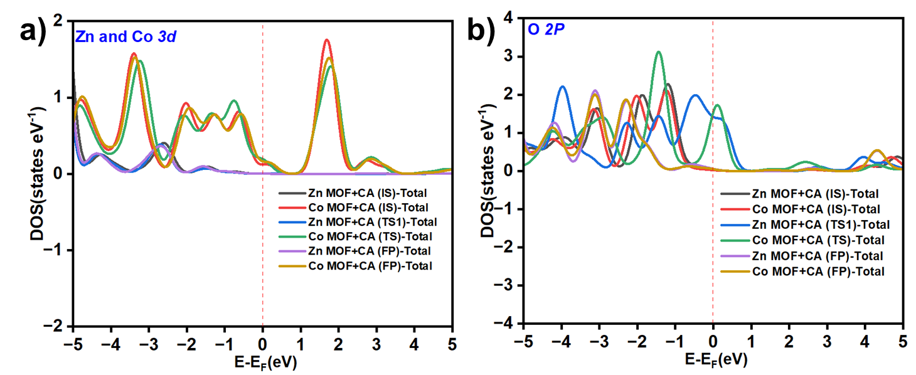
Figure S16. Spin-polarized projected density of states (PDOS) of ZIF-67 and ZIF-8: (a) Co 3d orbitals and (b) O 2p orbitals.

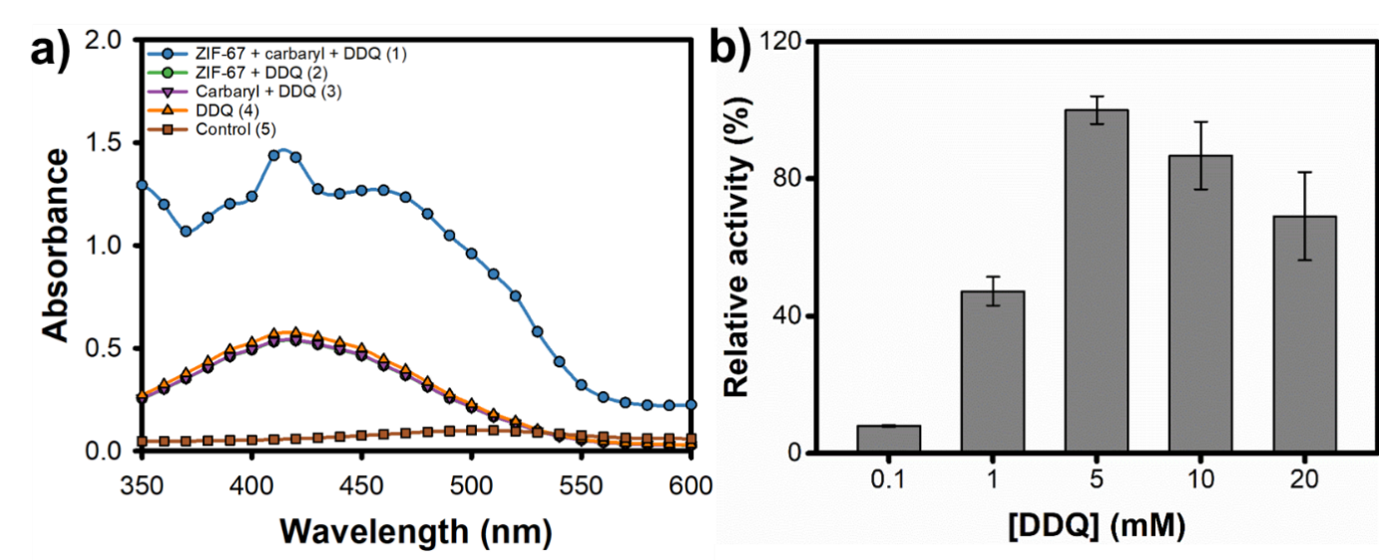
Figure S17. Optimization of colorimetric assay: (a) UV-vis absorbance of the 1-naphthol/DDQ complex catalyzed by ZIF-67 and (b) optimized concentration of DDQ.

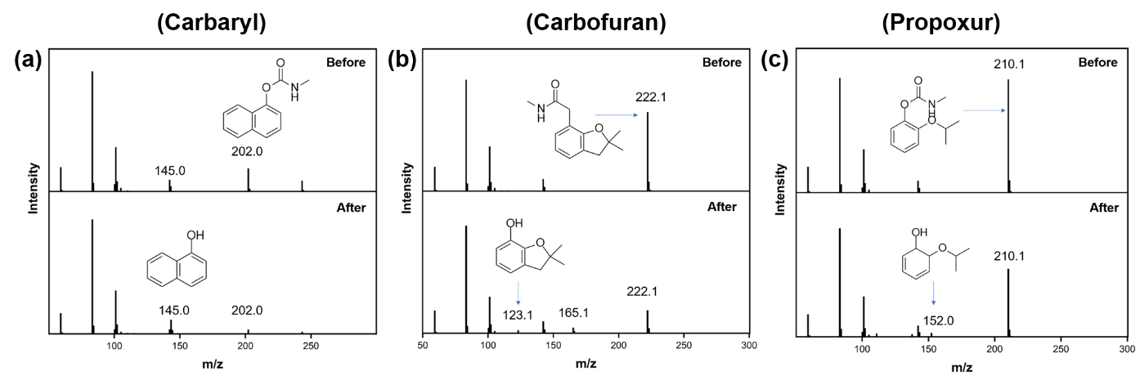
Figure S18. High-resolution mass spectrometric characterization of carbamate hydrolysis catalyzed by ZIF-67. Mass spectra of (a) carbaryl, (b) carbofuran, and (c) propoxur before and after incubation with ZIF-67 (0.1 mg mL⁻¹, pH 7.0, 50 °C, 20 min). The disappearance of parent carbamate ions and the appearance of corresponding hydrolysis products confirm the CES-like hydrolytic activity of ZIF-67 toward carbamate esters. Mass spectra were acquired using an Orbitrap Exploris 120 mass spectrometer (Thermo Fisher Scientific, MA, USA).

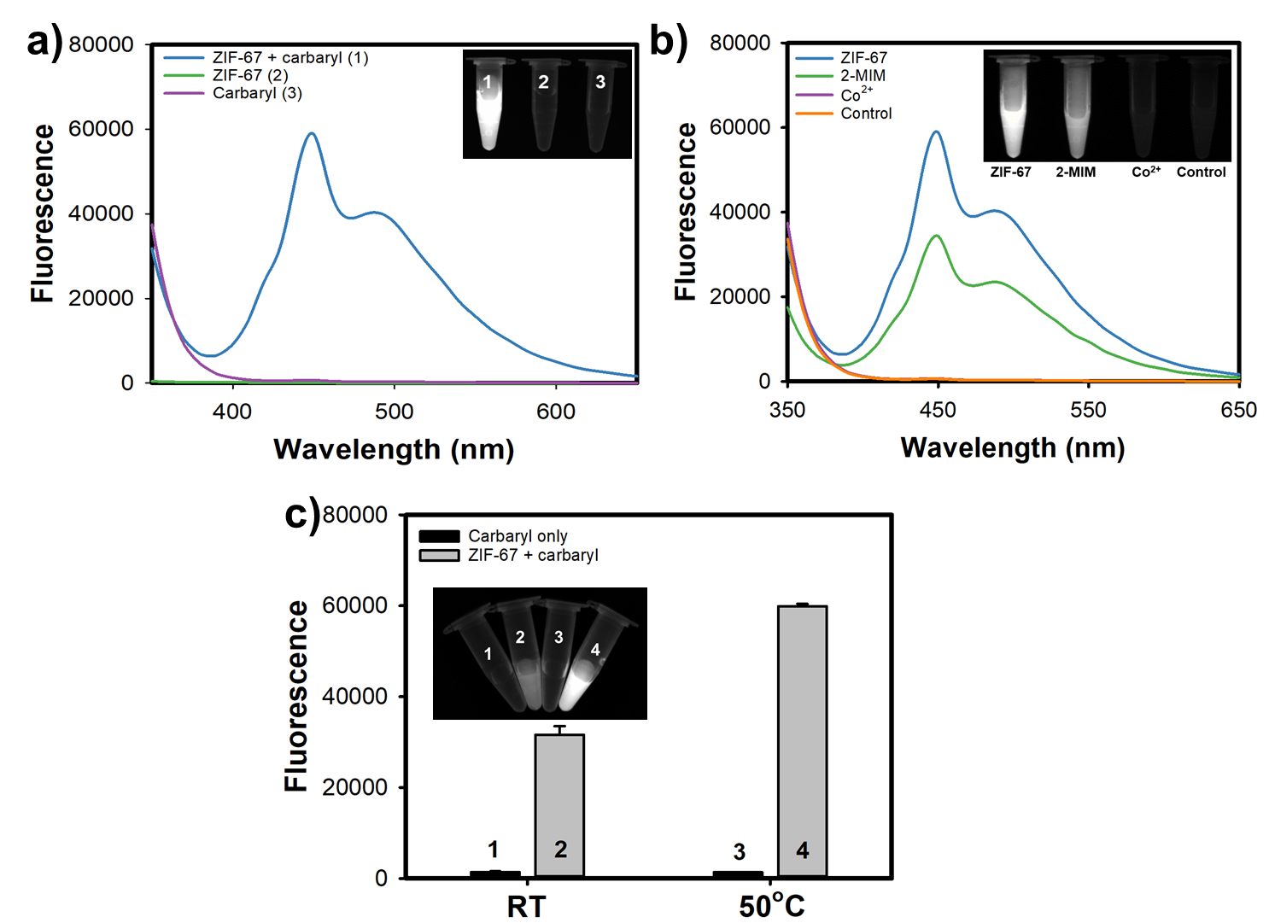
Figure S19. (a) Emission spectra of 1-naphthol generated after the hydrolysis of carbaryl catalyzed by ZIF-67. (b) Comparison of the CES-like activity of ZIF-67 with its synthetic precursors. (c) Effects of the temperatures on carbaryl hydrolysis with and without ZIF-67.

Table S1. BET surface area and porosity parameters of ZIF-67.
Parameter | Value
BET surface area (m² g⁻¹) | 1162
Langmuir surface area (m² g⁻¹) | 1273
Micropore volume (cm³ g⁻¹) | 0.44
Average pore diameter (nm) | 1.52

Table S2. Comparison of the linear range and LOD values of ZIF-67-based carbaryl assay with previously reported methods.
Methods | Materials | Linear range  (μM) | LOD  (μM) | References
Colorimetry | NH2-MIL-101(Fe) | 9-452 | 6.554 | ¹
 | Ni-NPC SANs | - | 6.78 | ²
 | RTB-POD | 452-13,560 | 271.2 | ³
 | Ce-BGONRs/Ce-NGONRs | 45-22,602 | 99.45 | ⁴
 | Ce-GONRs | 9-3616 | 1.04 | ⁵
 | AMP-Ce-fluorescein | 0-452 | 6.916 | ⁶
 | ZIF-67 | 37.5-600 | 0.92 | This work
Fluorometry | CdSe-ZnS-MIP | 0.497-398 | 0.147 | ⁷
 | GQDs | 1.78-6.01 | 0.129 | ⁸
 | Eu³⁺@MOF-253 | - | 0.35 | ⁹
 | ZIF-67 | 3.75-45 | 0.05 | This work

Table S3. Accuracy (recovery) and precision (CV) of ZIF-67-based assay for carbaryl determination in tap water and vegetable extracts.
 | Samples | Initial  (μM) | Added  (μM) | Expected  (μM) | Measured^{b}  (μM) | Recovery^{c}  (%) | SD^{d} | CVe  (%)
Colorimetry | Tap water | N.D.ª | 25 | 25 | 25.3 | 101.2 | 0.22 | 0.87
Colorimetry | Tap water | N.D.ª | 50 | 50 | 48.9 | 97.8 | 0.87 | 1.78
Colorimetry | Tap water | N.D.ª | 75 | 75 | 75.2 | 100.3 | 0.98 | 1.30
Colorimetry | Tap water | N.D.ª | 100 | 100 | 101.8 | 101.8 | 1.36 | 1.34
Colorimetry | Spinach | N.D.ª | 25 | 25 | 24.4 | 97.6 | 0.12 | 0.49
Colorimetry | Spinach | N.D.ª | 50 | 50 | 49.5 | 99.0 | 0.68 | 1.37
Colorimetry | Spinach | N.D.ª | 75 | 75 | 74.7 | 99.6 | 1.79 | 2.40
Colorimetry | Spinach | N.D.ª | 100 | 100 | 98.3 | 98.3 | 2.64 | 2.69
Colorimetry | Cucumber | N.D.ª | 25 | 25 | 24.8 | 99.2 | 0.47 | 1.90
Colorimetry | Cucumber | N.D.ª | 50 | 50 | 51.1 | 102.2 | 1.43 | 2.80
Colorimetry | Cucumber | N.D.ª | 75 | 75 | 76.4 | 101.9 | 0.62 | 0.81
Colorimetry | Cucumber | N.D.ª | 100 | 100 | 102.6 | 102.6 | 2.01 | 1.96
Fluorometry | Tap water | N.D.ª | 25 | 25 | 25.1 | 100.4 | 0.36 | 1.43
Fluorometry | Tap water | N.D.ª | 50 | 50 | 51.2 | 102.4 | 1.22 | 2.38
Fluorometry | Tap water | N.D.ª | 75 | 75 | 73.8 | 98.4 | 0.66 | 0.89
Fluorometry | Tap water | N.D.ª | 100 | 100 | 102.6 | 102.6 | 1.11 | 1.08
Fluorometry | Spinach | N.D.ª | 25 | 25 | 24.8 | 99.2 | 0.56 | 2.26
Fluorometry | Spinach | N.D.ª | 50 | 50 | 50.3 | 100.6 | 0.94 | 1.87
Fluorometry | Spinach | N.D.ª | 75 | 75 | 74.1 | 98.8 | 1.23 | 1.66
Fluorometry | Spinach | N.D.ª | 100 | 100 | 99.5 | 99.5 | 2.07 | 2.08
Fluorometry | Cucumber | N.D.ª | 25 | 25 | 24.9 | 99.6 | 0.17 | 0.68
Fluorometry | Cucumber | N.D.ª | 50 | 50 | 49.6 | 99.2 | 0.66 | 1.33
Fluorometry | Cucumber | N.D.ª | 75 | 75 | 74.4 | 99.2 | 1.33 | 1.79
Fluorometry | Cucumber | N.D.ª | 100 | 100 | 98.4 | 98.4 | 3.01 | 3.06
ª Not detected; ^{b} Mean value of five independent measurements; ^{c} Measured value/expected value × 100; ^{d} Standard deviation of five independent measurements; ^{e} Coefficient of variation (CV) = (SD/mean) × 100.
3. References

[1] Liu P, Li X, Xu X, Ye K, Wang L, Zhu H, Wang M, Niu X (2021) Integrating peroxidase-mimicking activity with photoluminescence into one framework structure for high-performance ratiometric fluorescent pesticide sensing. Sens Actuators B Chem 328:129024. https://doi.org/10.1016/j.snb.2020.129024
[2] Xu X, Ma M, Gao J, Sun T, Guo Y, Feng D, Zhang L (2024) Multifunctional Ni-NPC single-atom nanozyme for removal and smartphone-assisted visualization monitoring of carbamate pesticides. Inorg Chem 63:1225–1233. https://doi.org/10.1021/acs.inorgchem.3c03642
[3] Supharoek S-A, Ponhong K, Siriangkhawut W, Grudpan KA (2019) A new method for spectrophotometric determination of carbaryl based on rubber tree bark peroxidase enzymatic reaction. Microchem J 144:56–61. https://doi.org/10.1016/j.microc.2018.08.048
[4] Tai S, Wang J, Sun F, Pan Q, Peng C, Wang ZA (2023) A colorimetric sensor array based on nanoceria crosslinked and heteroatom-doped graphene oxide nanoribbons for the detection and discrimination of multiple pesticides. Anal Chim Acta 1283:341929. https://doi.org/10.1016/j.aca.2023.341929
[5] Tai S, Pan Q, Chen X, Peng C, Zhang C, Wang Z (2023) Selective inhibition toward the enzyme-like activity of 3D porous cerium-doped graphene oxide nanoribbons for highly sensitive and enzyme-free colorimetric detection of pesticides. Sens Actuators B Chem 378:133130. https://doi.org/10.1016/j.snb.2022.133130
[6] Lu W, Lou S, Yang B, Wu M, Hao H, Guo Z (2023) Light-activated nanozymes (adenosine monophosphate–Ce³⁺–fluorescein) for colorimetric detection of carbaryl by breaking a pH limitation. Sens Actuators B Chem 396:134548. https://doi.org/10.1016/j.snb.2023.134548
[7] Zhang C, Cui H, Cai J, Duan Y, Liu Y (2015) Development of fluorescence sensing material based on CdSe/ZnS quantum dots and molecularly imprinted polymer for the detection of carbaryl in rice and Chinese cabbage. J Agric Food Chem 63:4966–4973. https://doi.org/10.1021/acs.jafc.5b01072
[8] Soriano ML, Jiménez-Sánchez A, Cárdenas S (2021) Passivated graphene quantum dots for carbaryl determination in juices. J Sep Sci 44:1652–1659. https://doi.org/10.1002/jssc.202001200
[9] Qin S-J, Yan BA (2018) A facile indicator box based on Eu³⁺-functionalized MOF hybrid for the determination of 1-naphthol, a biomarker for carbaryl in urine. Sens Actuators B Chem 259:125–132. https://doi.org/10.1016/j.snb.2017.12.060

