Supplementary Information

Interfacial shear strength in short-fiber thermoplastic biocomposites: pressure dependence and implications for manufacturing
Natália Victoria dos Santos¹, Lucia Gioiella¹, Giulia Ronconi², Libera Vitiello^{1,3}, Valentina Mazzanti², Sabrina Carola Carroccio³, Veronica Ambrogi¹, Martina Salzano de Luna¹, Giovanni Filippone^{1*}

¹ Dipartimento di Ingegneria Chimica, dei Materiali e della Produzione Industriale, Università di Napoli Federico II, p. le Tecchio 80, Napoli, Italy
² Department of Engineering, Università degli Studi di Ferrara, via Saragat 1, 44122 Ferrara, Italy
³ Institute for Polymers, Composites and Biomaterials IPCB-CNR, via P. Gaifami 18, 95126, Catania, Italy
*Corresponding author
Email address: gfilippo@unina.it (G. Filippone)

S1. Fiber length and apparent diameter distribution in the biocomposites at 8.5 and 17 vol.% of fibers
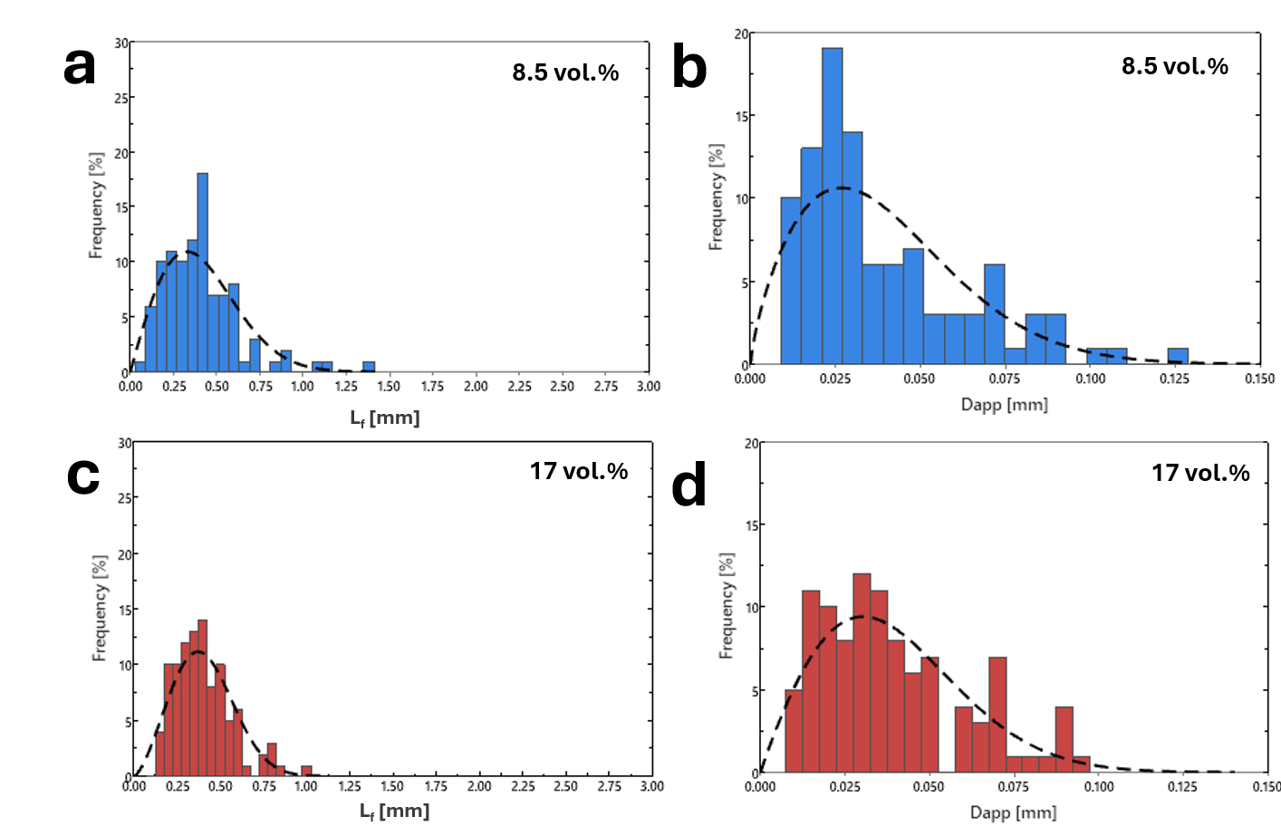
Figure F1 Fiber length (a, c) and apparent diameter (b, d) distributions for the composites containing 8.5 (a, b) and 17 vol.% (c, d) of hemp fibers.

Table T1 Summary of the shape and scale parameters obtained by fitting a two-parameter Weibull distribution to the length and apparent diameter distributions shown in Figure F1.
Sample | Length |  |  | Apparent diameter
Sample | Average [mm] | Shape parameter | Scale parameter [mm] | Average [μm] | Shape parameter | Scale parameter [mm]
PLA/hemp at 8.5 vol.% fibers | 0.41 | 2.0 | 0.47 | 39.3 | 1.7 | 0.04
PLA/hemp at 17 vol.% fibers | 0.40 | 2.5 | 0.46 | 39.2 | 1.9 | 0.04

S2. Stress-strain curves of the PLA/hemp composites and summary of the mechanical properties of PLA, hemp fibers, and PLA/hemp composites
Figure F2 Stress-strain curves for the PLA/Hemp composites at 8.5 (left) and 17 vol.% of fibers (right).

Table T2 Summary of the mechanical properties of PLA, hemp fibers (bundles), and PLA/hemp composites.
Sample | Tensile strength [MPa] | Young’s modulus [GPa] | Strain at break [%]
PLA | 48.75 ± 0.09 | 3.15 ± 0.06 | 5.94 ± 1.80
hemp fibers (bundles) | 637.3 ± 197.1 | 24.5 ± 0.97 | 3.1 ± 1.8
PLA/hemp at 8.5 vol.% fibers | 50.56 ± 3.04 | 3.86 ± 0.05 | 2.48 ± 0.46
PLA/hemp at 17 vol.% fibers | 53.48 ± 2.70 | 4.60 ± 0.10 | 2.54 ± 0.31

Regarding the tensile tests on fiber bundles, whose mechanical properties are typically highly dispersed, a two-parameter Weibull analysis was performed to further describe the strength scatter. The analysis yielded a Weibull modulus of 3.44 and a characteristic strength of 709 MPa, consistent with the broad statistical variability typically observed for natural fiber bundles.

S3. Application of the Bowyer and Bader model
According to the Bowyer and Bader model, at any composite strain during uniaxial tensile tests, $ε_{c}$, the tensile stress of a short fiber composite (cylindrical fibers with radius $R_{f}$) is [R1]:

$σ_{c}=C\left[\sum_{L_{i}<L_{ϵ}}{\frac{τ_{y}^{BB}L_{i}V_{i}}{2R_{f}}}+\sum_{L_{j}≥L_{ϵ}}{E_{f}ε_{c}\left(1-\frac{E_{f}ε_{c}R_{f}}{2τ_{y}^{BB}L_{j}}\right)}V_{j}\right]+E_{m}ε_{c}\left(1-V_{f}\right)$ (E1)

where:
- $C$ is a fiber orientation factor ($C$=1 for fibers perfectly aligned along the tensile direction, $C$=3/8 for planar random orientation, and $C$=1/5 for a random distribution in three dimensions [R2]);
- $τ_{y}^{BB}$ is the interfacial shear strength;
- $L_{ϵ}=\frac{E_{f}ε_{c}R_{f}}{τ_{y}^{BB}}$ is the critical fiber length that discriminates between “short fibers” ($L_{i}<L_{ϵ}$), which carry an average stress equal to $\frac{τ_{y}^{BB}L_{i}}{2R_{f}}$, and “long fibers”, which carry a higher average stress equal to $E_{f}ε_{c}\left(1-\frac{E_{f}ε_{c}R_{f}}{2τ_{y}^{BB}L_{j}}\right)$;
- $L_{i}$ and $L_{j}$ are the volume fractions of the fibers shorter and longer than $L_{ϵ}$;
- $V_{i}$ and $V_{j}$ are the volume fractions of the fibers shorter and longer than $L_{ϵ}$;
- $E_{f}$ and $E_{m}$ are the Young’s moduli of fiber and matrix;
- $V_{f}$ is the total fiber volume fraction.

If one knows the Young’s moduli of fiber and matrix and the fiber length distribution, the only two unknown parameters are $C$ and $τ_{y}^{BB}$, which can be derived by fitting Eq. E1 to the experimental stress-strain curve of the composite. In practical terms, we followed the algorithm described in [R3].
Eq. E1 is rewritten as:

$σ_{c}= C\left(X+Y\right)+Z$ (E2)

where $X=\sum_{L_{i}<L_{ϵ}}{\frac{τ_{y}^{BB}L_{i}V_{i}}{2R_{f}}}$ denotes the portion of the total resistance attributed to fibers under the critical fiber length (Equation 4), $Y=\sum_{L_{j}≥L_{ϵ}}{E_{f}ε_{c}\left(1-\frac{E_{f}ε_{c}R_{f}}{2τ_{y}^{BB}L_{j}}\right)}V_{j}$ corresponds to the contribution from fibers above the critical fiber length, and ${Z=E}_{m}ε_{c}\left(1-V_{f}\right)$ represents the resistance provided by the matrix.
The composite stresses at two arbitrary values of strain are needed. We selected $ε_{c1}$=0.5% and $ε_{c2}$=1.0% for both volumetric fractions. The corresponding stresses $σ_{c1}$ and $σ_{c2}$ are available (see Figure F2). Now, the contribution of the fibers at each strain can be estimated in two ways:
- by subtracting the contribution of the matrix ($Z$) from the experimental stress: $σ_{ci}-Z_{i}$ ($i$=1 or 2)
- by summing the contributions of the short and long fibers: $X_{i}+Y_{i}$($i$=1 or 2)

This means the ratios $R$ and $R'$ defined as:
$R= \frac{σ_{c1}- Z_{1}}{σ_{c2}- Z_{2}}$ (E3)
$R'= \frac{X_{1}+ Y_{1}}{X_{2}+ Y_{2}}$ (E4)

Must be equal. Therefore, an iterative procedure is adopted until convergence, eventually leading to the values of $C$ and $τ_{y}^{BB}$. The following algorithm is applied:

- $R$ is estimated from the knowledge of the stress–strain curve of the composite and the Young’s modulus of the matrix.
- A first estimate of interfacial shear strength, ${τ_{y}^{BB}}_{I}$, is assumed.
- The values of $L_{ε_{c1}}=\frac{E_{f}ε_{c1}R_{f}}{{τ_{y}^{BB}}_{I}}$ and $L_{ε_{c2}}=\frac{E_{f}ε_{c2}R_{f}}{{τ_{y}^{BB}}_{I}}$ are assessed.
- The volume fractions of “short” (${V_{i}}_{I}$) and “long” fibers (${V_{j}}_{I}$) are assessed (for each one of the selected strains $ε_{c1}$ and $ε_{c2}$).
- $X$ and $Y$ are estimated at $ε_{c1}$ and $ε_{c2}$, leading to a first estimate for $R'$, ${R'}_{I}$.
- If ${R'}_{I}$ is equal to $R$, then ${τ_{y}^{BB}}_{I}$ is accepted; otherwise, the steps 2-6 are reiterated starting from a different tentative value for the interfacial shear strength.
- Once convergence is achieved at the $n$-th step, the obtained value of ${τ_{y}^{BB}}_{n}$ is accepted as $τ_{y}^{BB}$ and is inserted in Eq. (E2) to infer $C$.

The values used to apply the previous procedure are summarized in Table T2. We assumed $R_{f}={D_{eq}}/2$. The total fiber volume fraction $V_{f}$ was estimated from the mass fractions ($w_{f}$ and $w_{m}$) and densities ($ρ_{f}$ and $ρ_{m}$) of fibers and matrix as $V_{f}=\frac{{w_{f}}/{ρ_{f}}}{{w_{f}}/{ρ_{f}}+{w_{m}}/{ρ_{m}}}$
The fiber length and apparent diameter distributions of the composites are shown in Figure F1.

Table T3 Parameters used and derived by applying the Bowyer and Bader model to the experimental data of two representative tensile tests on the composites at 8.5 and 17 vol.% of fibers.
Parameter | Fiber content [vol.%]
Parameter | 8.5 | 17
Initial Data
Fiber apparent diameter $D_{app}$ [μm] | 39 (± 25) | 39 (± 21)
Fiber density $ρ_{f}$ [g/cm³] | 1.51 | 1.51
Matrix density $ρ_{m}$ [g/cm³] | 1.26 | 1.26
Fiber mass fraction $w_{f}$ [%] | 10 | 20
Fiber volume fraction $V_{f}$ [%] | 8.5 | 17.3
Young’s modulus of the fibers ($E_{f}$) [GPa] | 24.5 (± 0.97) | 24.5 (± 0.97)
Young’s modulus of the matrix ($E_{m}$) [GPa] | 3.15 (± 0.06) | 3.15 (± 0.06)
Condition 1
ε₁ [%] | 0.5 | 0.5
σ₁ [MPa] | 18.47 | 22.0
$L_{ϵ1}$ [μm] | 0.195 | 0.162
V_{i1} [%] | 0.29 | 0.19
V_{j1} [%] | 8.16 | 17.10
X₁ [GPa] | 0.13 | 0.10
Y₁ [GPa] | 7.96 | 17.16
Z₁ [GPa] | 14.71 | 13.29
Condition 2
ε₂ (%) | 1.0 | 1.0
σ₂ (MPa) | 34.57 | 39.48
$L_{ϵ2}$ (μm) | 385 | 322
V_{i2} (%) | 2.62 | 3.62
V_{j2} (%) | 5.83 | 13.67
X₂ [GPa] | 2.15 | 3.36
Y₂ [GPa] | 9.56 | 22.75
Z₂ [GPa] | 29.13 | 26.31
Convergence conditions
$R$ [-] | 0.691 | 0.661
$R'$ [-] | 0.691 | 0.661
Results
$τ_{y}^{BB}$ [MPa] | 12.52 | 15.00
$C$ [-] | 0.465 | 0.504

References
[R1] Bowyer, W. H., Bader, M. G. (1972). On the re-inforcement of thermoplastics by imperfectly aligned discontinuous fibres. Journal of materials Science, 7(11), 1315-1321. https://doi.org/10.1007/BF00550698
[R2] Sanadi, A. R., Young, R. A., Clemons, C., Rowell, R. M. (1994). Recycled newspaper fibers as reinforcing fillers in thermoplastics: Part I-Analysis of tensile and impact properties in polypropylene. Journal of reinforced plastics and composites, 13(1), 54-67. https://doi.org/10.1177/073168449401300104
[R3] Li, Y., Pickering, K. L., Farrell, R. L. (2009). Determination of interfacial shear strength of white rot fungi treated hemp fibre reinforced polypropylene. Composites Science and technology, 69(7-8), 1165-1171. https://doi.org/10.1016/j.compscitech.2009.02.018.

