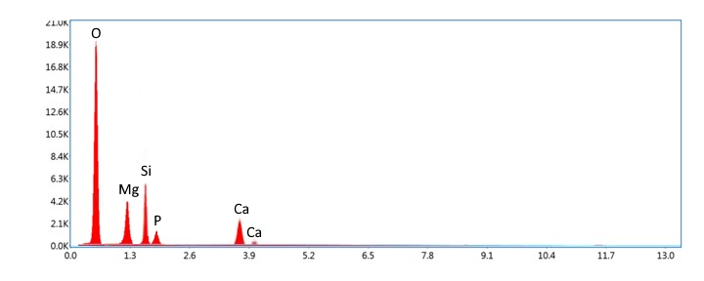
(a)
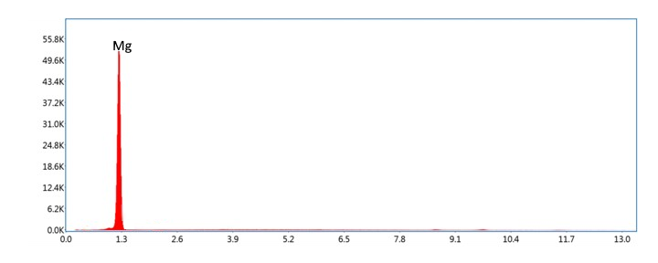
(b)
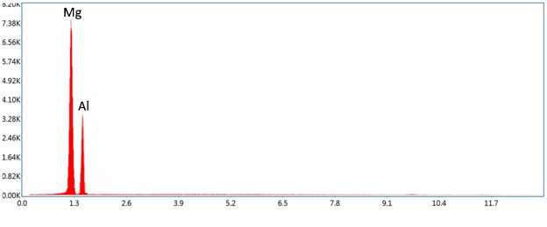
(c)
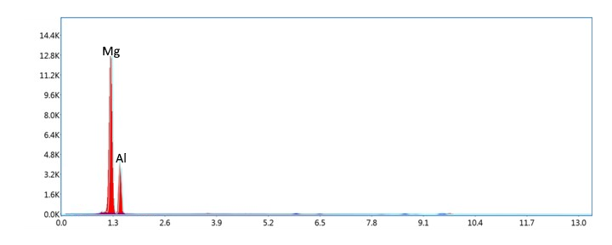
(d)
Figure S1. EDS spectra acquired from the regions marked in Figure 3: (a) Point I, (b) Point II, (c) Point III, and (d) Point IV.

