Supplementary Material for
Robust and Reusable Near-Infrared Photocatalyst Derived from SnO₂ Quantum Dots-Decorated MXene for Rapid Water Disinfection

Haibei Li^{1, †, *}, Tangping Zhang^{1, †}, Chengyu Jia¹, Zhongwei Yang¹, Tianjiao Chen¹, Dong Yang¹, Danyang Shi¹, Shuqing Zhou¹, Yue Zhao¹, Xihao Chen², Ning Wang³, Junwen Li¹, Min Jin^{1, *}

¹Tianjin Key Laboratory of Risk Assessment and Control for Environment & Food Safety, State Key Laboratory of Pathogen and Biosecurity, Academy of Military Medical Sciences, Tianjin 300050, China
²School of Materials Science and Engineering, Chongqing University of Arts and Sciences, Chongqing 402160, China
³School of Science, Key Laboratory of High Performance Scientific Computation, Xihua University, Chengdu 610039, China

†These authors contributed equally to this work.

*Correspondence and address requesting for reprints to:
Dr. Min Jin. China. E-mail: jinminzh@126.com.
or
Dr. Haibei Li. China. E-mail: lihaibei445906949@163.com.

Fig. S1. TEM images of SnO₂ QDs with size distribution.

Fig. S2. Chemical state analysis by high-resolution XPS. (a) Ti 2p spectra of Ti₃C₂T_{x} and SnO₂ QDs/Ti₃C₂T_{x}; (b) C 1s spectrum of SnO₂ QDs/Ti₃C₂T_{x}; (c) Sn 3d spectra of SnO₂ QDs and SnO₂ QDs/Ti₃C₂T_{x}; (d) O 1s spectrum of SnO₂ QDs/Ti₃C₂T_{x}.

Fig. S3. Evaluation of in vitro safety of SnO₂ QDs/Ti₃C₂T_{x}. Viability of (a) CHO, (b) Vero, and (c) HeLa cells upon treatment with SnO₂ QDs/Ti₃C₂T_{x} at varying concentrations. Data are presented as the mean ± SD (n = 3). n.s., not significant, using one-way ANOVA.

Fig. S4. Optical bandgap analysis. The bandgap of (a) SnO₂ QDs, (b) Ti₃C₂T_{x} and (c) SnO₂ QDs/Ti₃C₂T_{x}.

Fig. S5. Photothermal performance of SnO₂ QDs/Ti₃C₂T_{x}. (a) Photothermal curves and (b) real-time infrared thermal images of Ti₃C₂T_{x} and SnO₂ QDs/Ti₃C₂T_{x} under 808 nm NIR irradiation. Data are presented as the mean ± SD (n = 3). ***p < 0.001 using one-way ANOVA.

Fig. S6. Effect of temperature on the dark microbial inactivation performance of SnO₂ QDs/Ti₃C₂T_{x}. Killing efficiency against (a) E. coli and (b) MS2 at room temperature (25 °C) and 70 °C within 5 min in the dark. Data are mean ± SD (n = 3); **p < 0.01 (Student’s t‑test).

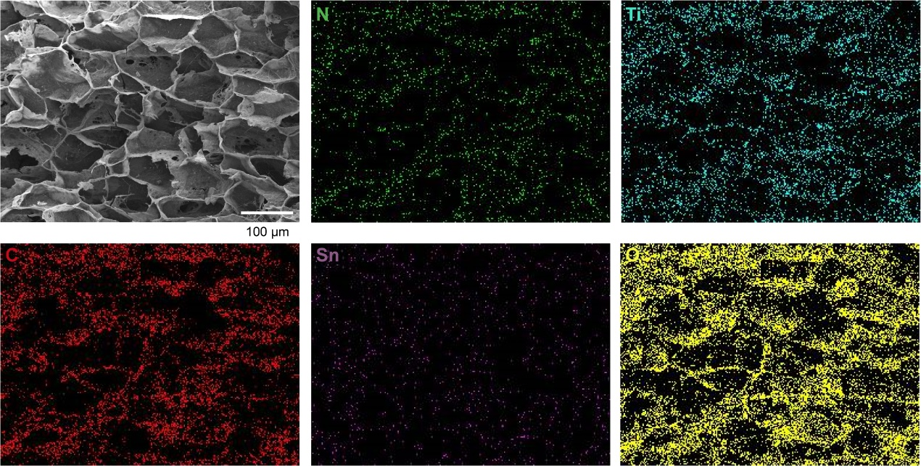
Fig. S7. Elemental mapping images of N, Ti, C, Sn, and O in SnO₂ QDs/Ti₃C₂T_{x}@CS-CA-DA.

Fig. S8. Surface hydrophilicity and swelling behavior of materials. (a) Swelling ratio and (b) contact angles of CS-CA-DA, Ti₃C₂T_{x}@CS-CA-DA, and SnO₂ QDs/Ti₃C₂T_{x}@CS-CA-DA. Data are presented as the mean ± SD (n = 3). n.s., not significant, using one-way ANOVA.

Fig. S9. Killing efficiency of SnO₂ QDs/Ti₃C₂T_{x}@CS-CA-DA against E. coli upon 808 nm NIR irradiation under various environmental conditions. (a) pH variation, (b) humic acid concentration variation, and (c) turbidity (NTU) variation.

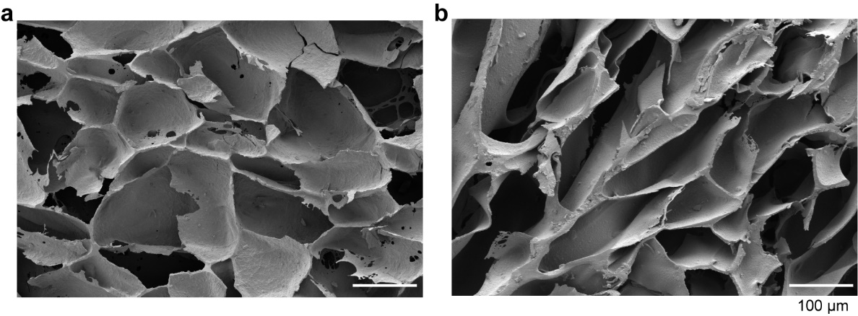
Fig. S10. SEM images of SnO₂ QDs/Ti₃C₂T_{x}@CS-CA-DA (a) prior to and (b) following five successive reaction cycles. Scale bar, 100 μm.

Fig. S11. FTIR spectra of SnO₂ QDs/Ti₃C₂T_{x}@CS-CA-DA following five successive reaction cycles.

Fig. S12. Storage stability of the microbicidal efficiency of SnO₂ QDs/Ti₃C₂T_{x}@CS-CA-DA. Microbicidal efficiency of SnO₂ QDs/Ti₃C₂T_{x}@CS-CA-DA against (a) E. coli and (b) MS2 after 30 days of storage at room temperature. Data are presented as mean ± SD (n = 3). ***p < 0.001 (Student's t‑test).

Fig. S13. Evaluation of SnO₂ QDs/Ti₃C₂T_{x}@CS-CA-DA for disinfecting native microbial communities in river water. (a) Inactivation kinetics under 808 nm NIR irradiation over time. (b) Microbial killing efficiency of SnO₂ QDs/Ti₃C₂T_{x}@CS-CA-DA at 15 min, with and without NIR irradiation. Data are presented as the mean ± SD (n = 3). n.s., not significant. ***p < 0.001 using one-way ANOVA.

Table S1. Bandgap and band edge positions of various QDs.
Property | Work function (eV) | CB position (vs. NHE) | VB position (vs. NHE) | Ref.
SnO₂ QDs | 6.13 | -0.55 | 3.65 | [1, 2]
Carbon QDs | 4.15 | -1.04 | 0.66 | [3]
Graphene QDs | 4.59 | -0.46 | 0.81 | [4]
MoS₂ QDs | 4.25 | −0.64 | 0.89 | [5, 6]

Table S2. The Sn loading content of catalysts.
Catalysts | Sn loading content (wt%)
SnO₂ QDs/Ti₃C₂T_{x} | 5.68

Table S3. Comparison of bactericidal performance with MXene-based systems under 808 nm NIR light.
Catalyst System | Power (W/cm²) | Catalyst dosage (mg/mL) | Irradiation time (min) | Bacteria | Sterilization rate | Ref.
PANi/TiO₂/Ti₃C₂T_{x} | 1.5 | 1.5 | 10 | E. coli | 99.90% | [7]
Ti₃C₂/CoNWs | 1.5 | 1.0 | 20 | S. aureus, E. coli | 90% | [8]
MXene@CuS-CeO | 2.0 | 0.5 | 10 | S. aureus, E. coli | 100% | [9]
SnO₂ QDs/Ti₃C₂T_{x} | 0.8 | 0.5 | 5 | S. aureus, E. coli | ＞99.9999% | This study

Table S4. Mass change of SnO₂ QDs/Ti₃C₂T_{x}@CS-CA-DA before and after five cyclic stability tests.
Condition | Weight (g) | Mass loss (%)
Before cycling | 0.280 | –
After 5 cycles | 0.268 | 4.29

Table S5. Concentration of metal ions dissolved from SnO₂ QDs/Ti₃C₂T_{x}@CS-CA-DA under 808 nm NIR irradiation in Haihe River water.
Metal ion | Measured concentration (mg/L) | Background concentration (mg/L)
Ti | 0.002 | 0.001
Sn | 0.038 | 0.009

References
1. Chu K, Liu Y-p, Li Y-b, Wang J, Zhang H. Electronically Coupled SnO2 Quantum Dots and Graphene for Efficient Nitrogen Reduction Reaction. ACS Applied Materials & Interfaces. 2019;11:31806-15.
2. Liu J, Zhang Q, Tian X, Hong Y, Nie Y, Su N, Jin G, Zhai Z, Fu C. Highly efficient photocatalytic degradation of oil pollutants by oxygen deficient SnO2 quantum dots for water remediation. Chemical Engineering Journal. 2021;404.
3. Ma H, Wang T, Xu Y, Shi W, Ma R, Xia Z, Yang Q, Xie G, Chen S. Phenanthraquinone modified carbon quantum dots covalent-grafted onto Cu-MOF for photocatalytic CO2 reduction: Construction of dual-active sites and parallel charge channels based on the cooperation between photoexcitation and electron-entrap. Applied Catalysis B: Environment and Energy. 2024;349:123857.
4. Li W, Jing J, Wei Z, Xu J, Shi W, Wang H, Zhu X, Du Y, Wang Y, Li J, Zhu Y. Near-Infrared Light-Driven Efficient Tumor Elimination via Strong Oxidative Photogenerated Holes in Donor–Acceptor Supramolecular Porphyrin. JACS Au. 2025;5:3500-12.
5. Polumati G, Kolli CSR, Flores M, Kumar A, Sanghvi A, Bugallo ADL, Sahatiya P. Mixed-Dimensional van der Waals Heterostructure (2D ReS2/0D MoS2 Quantum Dots)-Based Broad Spectral Range with Ultrahigh-Responsive Photodetector. ACS Applied Materials & Interfaces. 2024;16:19261-70.
6. Kayal A, De M. Dual Photocatalytic Pathways: Substrate-Directed Oxidative and Reductive Photocatalysis in the Presence of MoS2 Quantum Dots (QDs). ACS Catalysis. 2026;16:2897-909.
7. Jin C, Sun D, Sun Z, Rao S, Wu Z, Cheng C, Liu L, Liu Q, Yang J. Interfacial engineering of Ni-phytate and Ti3C2Tx MXene-sensitized TiO2 toward enhanced sterilization efficacy under 808 nm NIR light irradiation. Applied Catalysis B: Environmental. 2023;330.
8. Liu Y, Tian Y, Han Q, Yin J, Zhang J, Yu Y, Yang W, Deng Y. Synergism of 2D/1D MXene/cobalt nanowire heterojunctions for boosted photo-activated antibacterial application. Chemical Engineering Journal. 2021;410.
9. Yu Z, Lin J, Wang Y, He C, Shi Y, Hu Y, Jiang Y, Cheng J. Design, synergistic mechanisms, and application of a MXene@CuS–CeO₂ photothermal–nanozyme multimodal antibacterial material in real water systems. Chemical Engineering Journal. 2026;532:174295.

