Supplementary material
Bioinspired Hierarchical Assembly of Silk Fibroin Nanoparticles and PDMS on Basalt Fibers for Vivid Coloration and Extreme Environment Resistance in Aerospace Composites
Supplementary Figures: S1–S19
Figure S1. Acetone treatment of BF fabric to remove oil and impurities.
Figure S2. Deposition of different dosages of SF on BF.
Figure S3. A process for the nanoscale deposition of SF based on BF.
Figure S4. Optical photographs of SF and SNPs.
Figure S5. SEM of SF and SNPs.
Figure S6. XRD of SF and SNPs.
Figure S7. XPS of BF.
Figure S8. Spectral curves of K/S values for DBF@SNPs fabric.
Figure S9. 3D micrographs of BF, BF@SNPs, DBF@SNPs, and PDBS fabric.
Figure S10. Spectral curves of K/S values for PDBS fabric.
Figure S11. Color fastness to rubbing before (DBF@SNPs fabric) and after PDMS treatment (PDBS fabric).
Figure S12. Color fastness to soap washing before (DBF@SNPs fabric) and after PDMS treatment (PDBS fabric).
Figure S13. WCA of DBF@SNPs and PDBS fabric (50% v/v ethanol).
Figure S14. Spectral curves of K/S values for PDBS fabric before and after high and low temperature cycling treatment.
Figure S15. Color fastness rating of PDBS fabric after high-low temperature cycling treatment.
Figure S16. Photographs of PDBS fabric before and after high-low temperature cycling treatment.
Figure S17. Photograph of PDBS fabric subjected to Xenon lamp–simulated UV radiation treatment.
Figure S18. Spectral curves of K/S values for PDBS fabric after UV radiation treatment.
Figure S19. Photographs of PDBS samples before and after UV radiation treatment.
Supplementary Movies: S1–3
Movie S1. The color construction process of BF.
Movie S2. Contact angle testing of fabrics.
Movie S3. Contact angle testing of water, milk, tea, and coffee.
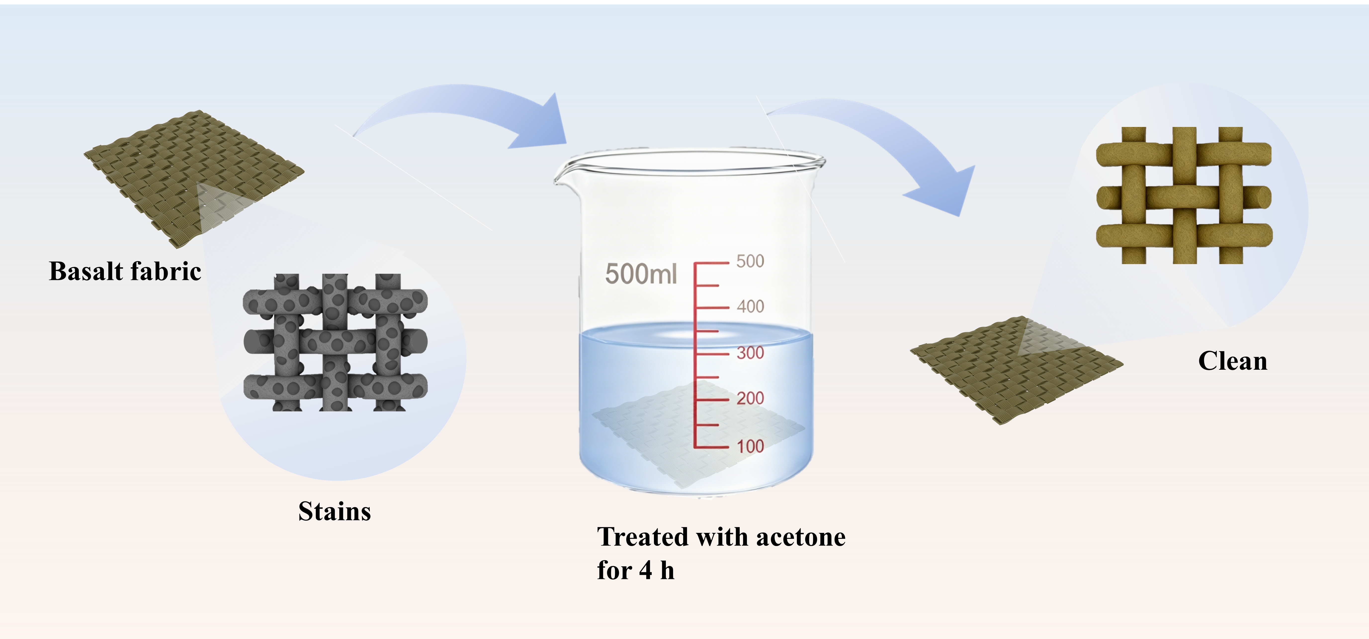
Figure S1. Acetone treatment of BF fabric to remove oil and impurities.

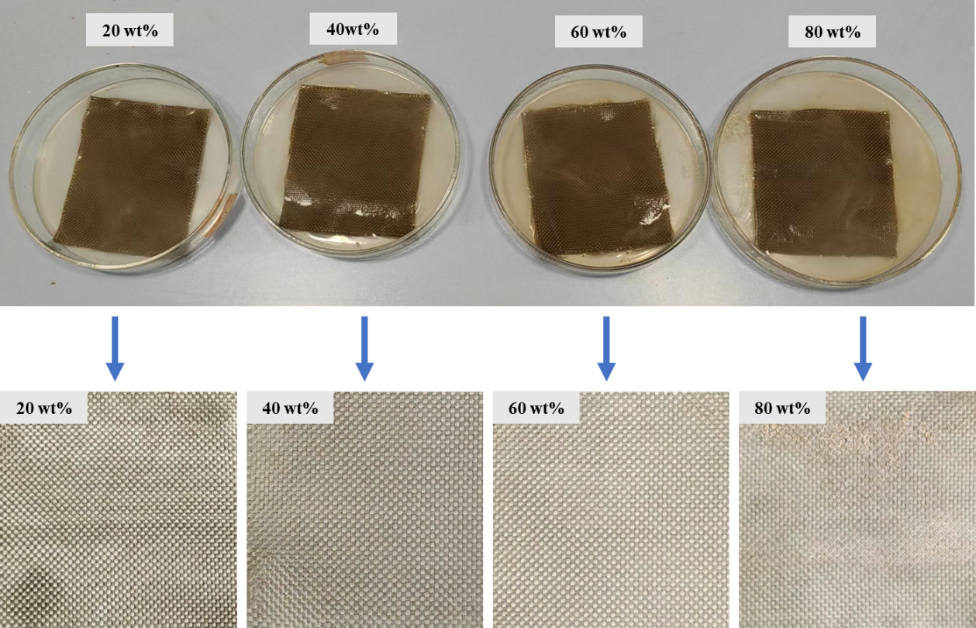
Figure S2. Deposition of different dosages of SF on BF.

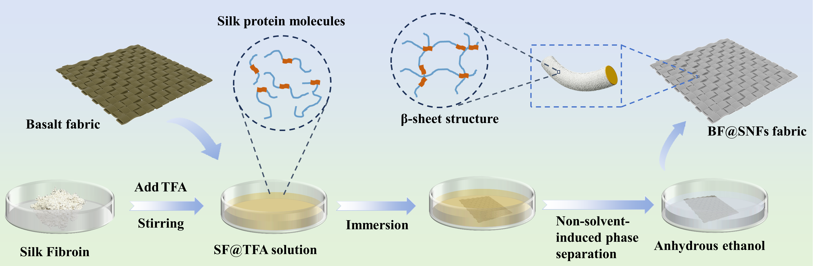
Figure S3. A process for the nanoscale deposition of SF based on BF.

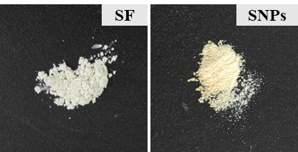
Figure S4. Optical photographs of SF and SNPs.

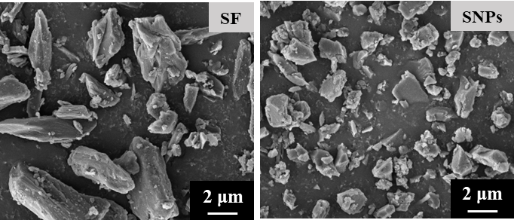
Figure S5. SEM of SF and SNPs.

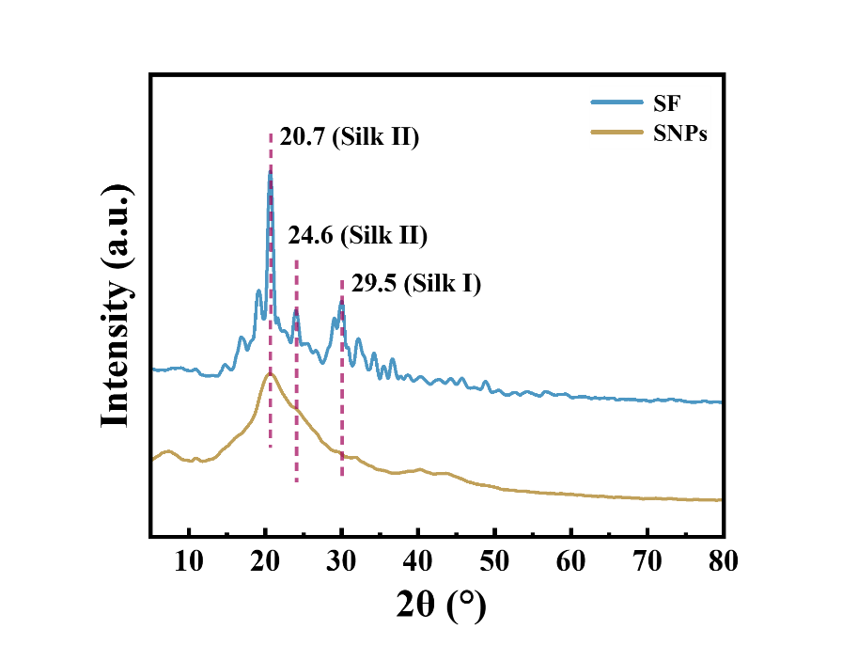
Figure S6. XRD of SF and SNPs.

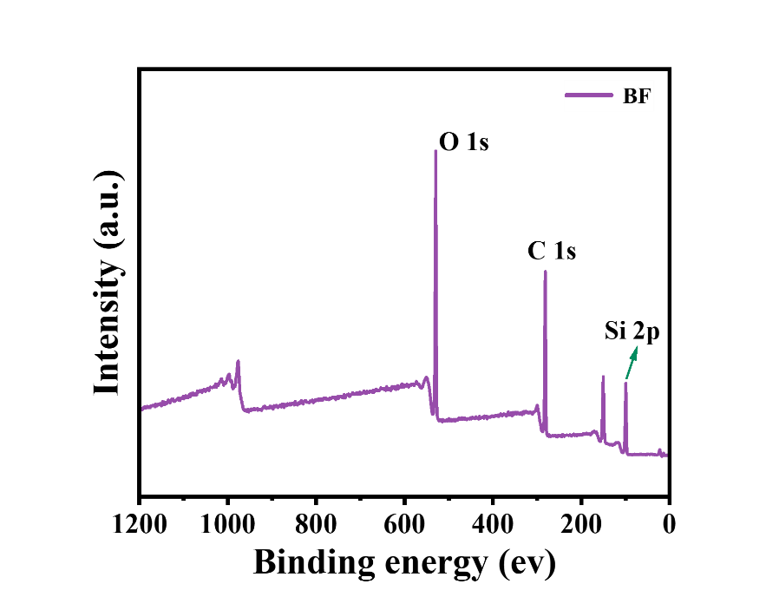
Figure S7. XPS of BF.

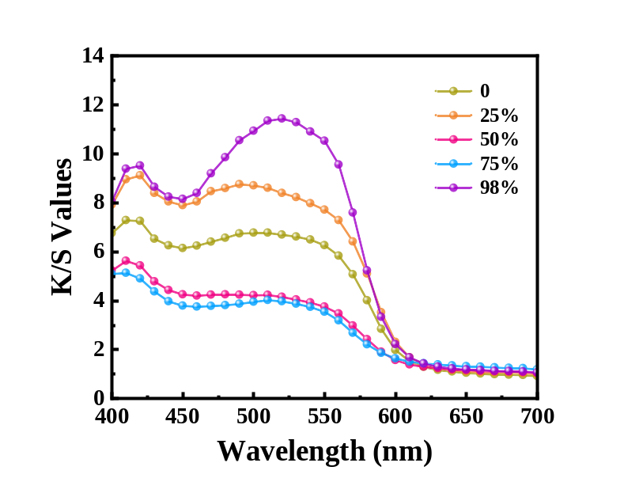
Figure S8. Spectral curves of K/S values for DBF@SNPs fabric.

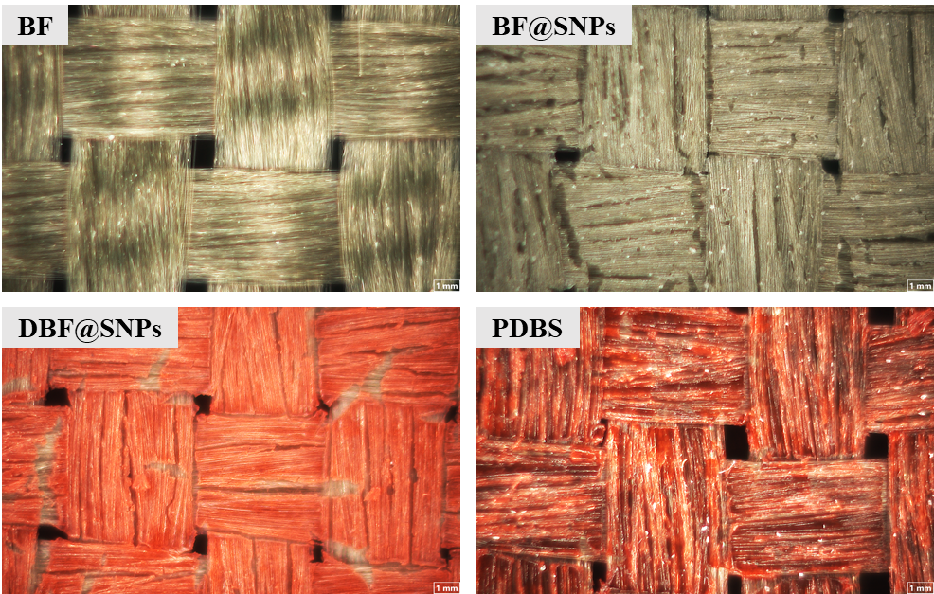
Figure S9. 3D micrographs of BF, BF@SNPs, DBF@SNPs, and PDBS fabric.

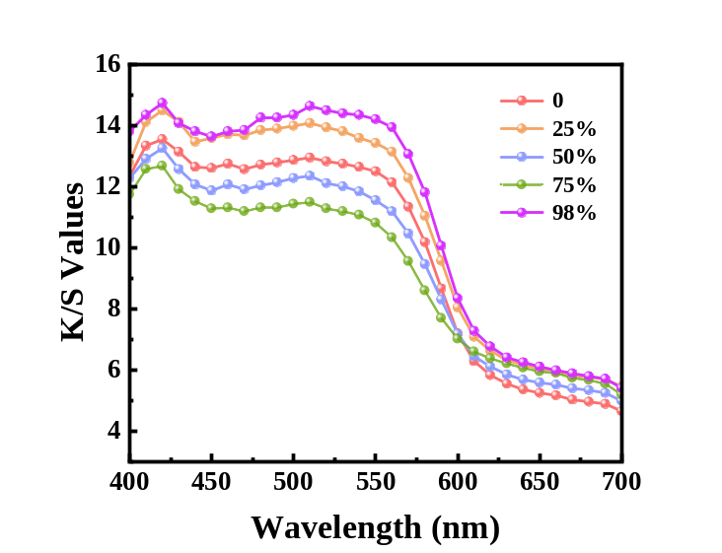
Figure S10. Spectral curves of K/S values for PDBS fabric.

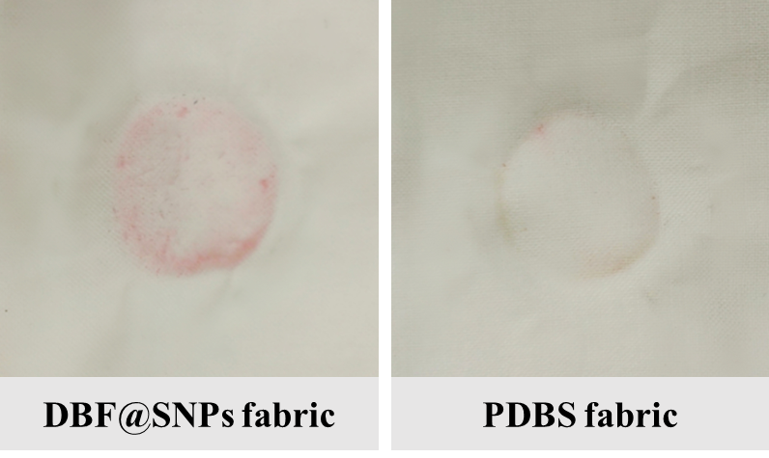
Figure S11. Color fastness to rubbing before (DBF@SNPs fabric) and after PDMS treatment (PDBS fabric).

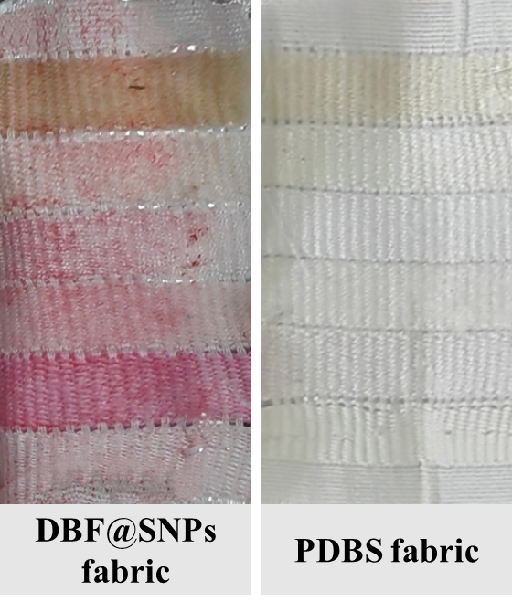
Figure S12. Color fastness to soap washing before (DBF@SNPs fabric) and after PDMS treatment (PDBS fabric).

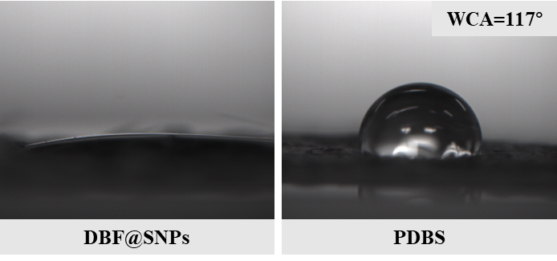
Figure S13. WCA of DBF@SNPs and PDBS fabric (50% v/v ethanol).

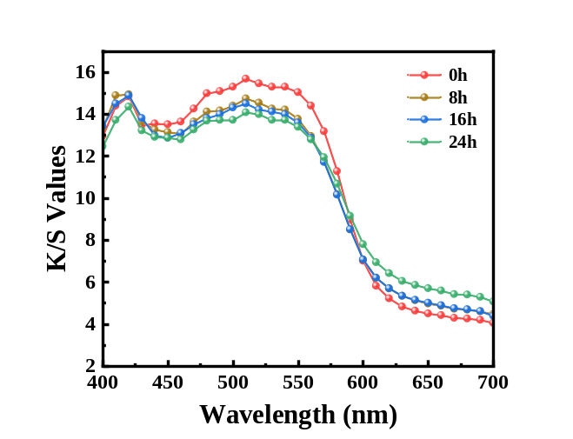
Figure S14. Spectral curves of K/S values for PDBS fabric before and after high and low temperature cycling treatment.

Figure S15. Color fastness rating of PDBS fabric after high-low temperature cycling treatment.

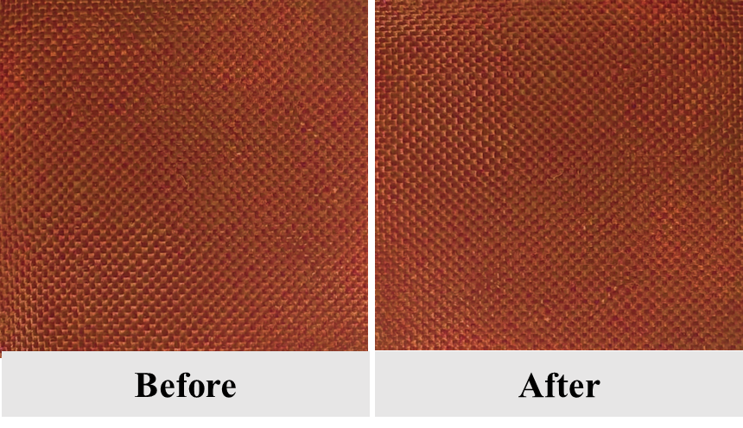
Figure S16. Photographs of PDBS fabric before and after high-low temperature cycling treatment.

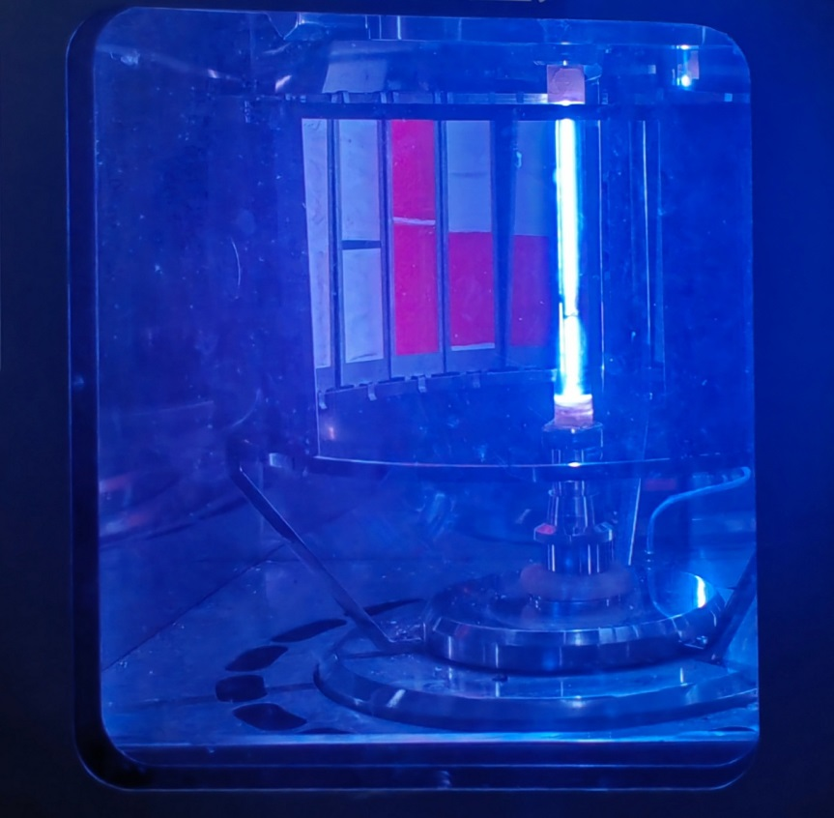
Figure S17. Photograph of PDBS fabric subjected to Xenon lamp–simulated UV radiation treatment.

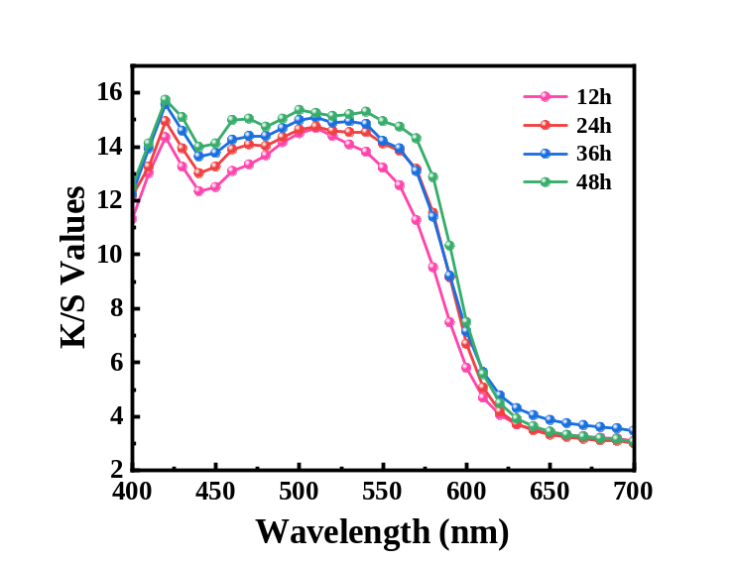
Figure S18. Spectral curves of K/S values for PDBS fabric after UV radiation treatment.

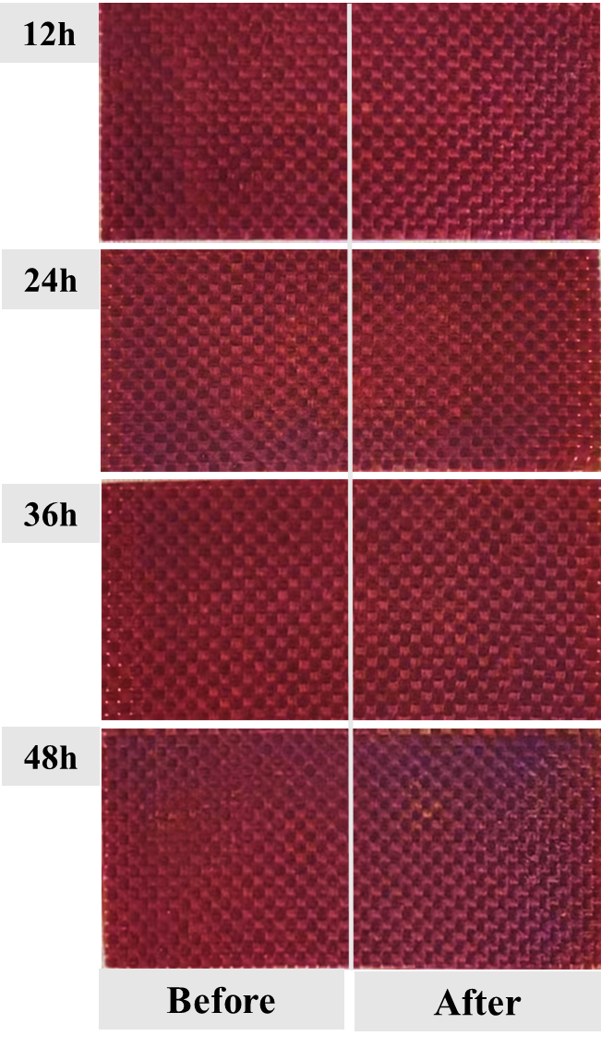
Figure S19. Photographs of PDBS samples before and after UV radiation treatment.

