Supporting Information
Interface-engineered Bi₂Te₃-MXene heterostructure for multifunctional energy conversion and storage

Tata Sanjay Kanna Sharma*ª, Beena Mol Babuª, Jayasmita Jana^{b}, Leelashree Solaiappan^{c}, Rajeev Kumar^{d}, Mahima M Kuriam^{c}, Youngil Lee^{d}, Seung Hyun Hurª, Tae Joo Shin^{e}, Jin Suk Chung*ª, Won Mook Choi*ª

ªDepartment of Chemical Engineering, University of Ulsan, Ulsan, 44610, Republic of Korea
^{b}Department of Chemistry, Manipal University of Jaipur, Dehmi Kalan, Jaipur, 303007, India
^{c}Department of Physics, Indian Institute of Technology-Madras, Chennai, 600036, India
^{d}Department of Chemistry, University of Ulsan, Ulsan 44776, Republic of Korea
^{e}Graduate School of Semiconductor Materials and Devices Engineering, Ulsan National University of Science and Technology (UNIST), Ulsan, 44919, Republic of Korea

*Corresponding author: wmchoi98@ulsan.ac.kr (W.M.C)
kannasri00@gmail.com (T.S.K.S)
jschung@ulsan.ac.kr (J.S.C)

Experimental Section
Materials
Bismuth nitrate pentahydrate (Bi(NO₃)₃·5H₂O, ≥99.9%, Sigma-Aldrich) and tellurium dioxide (TeO₂, 99.9%, Alfa Aesar) were used as precursors for Bi₂Te₃ synthesis. Titanium aluminum carbide (Ti₃AlC₂, MAX phase) was synthesized in-house from titanium powder (Ti, 99.5%, Alfa Aesar), aluminum powder (Al, 99.5%, Sigma-Aldrich), and graphite powder (C, 99.9%, Merck). Hydrofluoric acid (HF, 40%, Sigma-Aldrich) and lithium fluoride (LiF, ≥98%, Sigma-Aldrich) were used for selective etching of Al layers to obtain Ti₃C₂T_{x} MXene, while hydrochloric acid (HCl, 37%) and deionized water were used during washing. Polyvinylpyrrolidone (PVP, M_{w} = 40,000, Sigma-Aldrich), cetyltrimethylammonium bromide (CTAB, ≥99%, SRL), and sodium dodecyl sulfate (SDS, ≥99%, Merck) acted as surfactants and structure-directing agents during hydrothermal synthesis. Ethylene glycol (EG, ≥99%, Merck) was employed as the solvent, and ethanol (≥99.5%) was used for washing and dispersion. All chemicals were used as received without further purification, and deionized water (resistivity ≥18.2 MΩ·cm) was used throughout the experiments.

Synthesis of Ti₃AlC₂ MAX and Ti₃C₂T_{x} MXene
Stoichiometric amounts of Ti, Al, and graphite powders were weighed in the molar ratio 3:1:2. The powders were homogenized by ball milling for 12 h in ethanol, dried, and pressed into pellets. These pellets were sintered at 1400 ºC for 4 h under flowing argon atmosphere to obtain phase-pure Ti₃AlC₂. The black ceramic product was ground into a fine powder for subsequent etching and named as MAX phase. For the synthesis of Ti₃C₂T_{x} MXene, the Al layers in Ti₃AlC₂ MAX were selectively etched either using HF (40%) solution. HF was dissolved in 9 M HCl, followed by the gradual addition of Ti₃AlC₂ MAX powder. The reaction mixture was stirred at 40 ºC for 24 h, resulting in the removal of Al atoms and the formation of Ti₃C₂T_{x} MXene with –O, –OH, and –F surface terminations. The etched powder was repeatedly washed with deionized water until the supernatant reached pH = 6, followed by centrifugation. Finally, the suspension was subjected to ultrasonication under argon protection to delaminate multilayer Ti₃C₂T_{x} into few-layer nanosheets.

Synthesis of Bi₂Te₃ nanosheets and Bi₂Te₃/Ti₃C₂T_{x} composite
Bi₂Te₃ nanosheets were synthesized by a PVP-assisted hydrothermal reduction method. Briefly, Bi(NO₃)₃·5H₂O was dissolved in ethylene glycol under stirring, while TeO₂ was reduced in situ in the same medium. Differnet surfactants, including polyvinylpyrrolidone (PVP), cetyltrimethylammonium bromide (CTAB), and sodium dodecyl sulfate (SDS), were added separately to analyze and control crystal growth and suppress secondary phases. The homogeneous solution was transferred into a Teflon-lined stainless-steel autoclave and heated at 180 ºC for 4 h. After cooling to room temperature, the product was washed with ethanol and deionized water and dried under vacuum at 60 ºC, whereas to prepare a phase-pure sample PVP was taken and time variation of hydrothermal treatment was performed keeping temperature constant and by varying time from 4, 8, 16 and 32 h. The phase-pure Bi₂Te₃ nanosheets obtained after 4 h of PVP-assisted hydrothermal synthesis were subsequently combined with a pre-dispersed Ti₃C₂T_{x} MXene colloid. The mixture of Bi₂Te₃ and Ti₃C₂T_{x} MXene was subjected to ultrasonication at room temperature for 12 h, followed by probe sonication for 4 min in a cold bath to promote intimate contact between the Bi₂Te₃ nanosheets and Ti₃C₂T_{x} layers. The resulting Bi₂Te₃/Ti₃C₂T_{x} composite was collected by centrifugation, repeatedly washed with ethanol and deionized water, and vacuum-dried at 60 °C. This two-step assembly produced a sheet-on-sheet heterostructure in which Bi₂Te₃ nanosheets were intimately associated with the Ti₃C₂T_{x} MXene sheets

Characterizations
The morphologies of the as-synthesized catalyst surfaces were observed through powder X-ray diffraction (PXRD) pattern of all the powder samples was recorded in the 2θ range of 10-90º using a Rigaku X-ray diffractometer (D/MAZX 2500V/PC, Japan) with Cu Kα radiation (0.154 nm). The Raman peaks were obtained via the DXRTM3 Raman Microscope (Thermo Fisher Scientific) for fine powder samples. Then an ESCALAB 250XI (Thermo Fisher Scientific) spectrophotometer was used for ultraviolet photoelectron spectroscopy. Magnetic measurements were carried out using a Quantum Design Physical Property Measurement System (PPMS) equipped with a vibrating sample magnetometer (VSM) option. Isothermal magnetization (M–H) curves were recorded at room temperature in magnetic fields ranging from −70 kOe to +70 kOe. The raw data were further processed to subtract the linear diamagnetic background in order to isolate the intrinsic ferromagnetic component, enabling accurate estimation of the saturation magnetization (M_{s}) values.
High-resolution synchrotron XRD measurements were carried out at the 7D beamline of the Pohang Accelerator Laboratory (PAL), South Korea. The experiments were performed in Debye-Scherrer geometry using finely ground powders sealed in quartz capillaries (φ = 0.3 mm) to minimize preferred orientation effects. A highly monochromatic X-ray beam with a wavelength of λ = 0.62 Å was employed, and diffraction patterns were collected using a two-dimensional Pilatus area detector with precise calibration against a LaB₆ standard. Data were recorded at room temperature (300 K) under ambient conditions, with a step size equivalent to 0.002º in 2θ, enabling excellent resolution of subtle peak shifts and broadening. The collected patterns were subsequently converted into intensity versus 2θ profiles and analyzed using Rietveld refinement to extract lattice parameters, atomic positions, bond length/angles, microstrain, and dislocation densities. This high-resolution synchrotron provided unambiguous confirmation of the rhombohedral R-3m phase of Bi₂Te₃ and its structural integrity in the Bi₂Te₃/Ti₃C₂T_{x} composite, while also revealing subtle lattice distortions associated with the Bi₂Te₃/Ti₃C₂T_{x} interface. Notably, the refinement-derived increase in microstrain and controlled dislocation density in the composite directly correlates with enhanced interfacial charge transfer and defect-mediated catalytic activity, underscoring the intimate link between structural perturbations and functional performance.
Raman measurements were carried out using a Renishaw inVia Reflex Raman spectrometer equipped with a 532 nm excitation laser and a high-resolution grating (1800 lines mm⁻¹). The laser was focused onto the sample surface through a 50× objective, yielding a spot size of 1 μm, while the incident power was kept below 1 mW to avoid local heating. The scattered light was dispersed by the spectrograph and collected using a thermoelectrically cooled CCD detector. Temperature-dependent Raman spectra were recorded using a Linkam THMS600 heating-cooling stage, allowing precise control of the sample environment from 298 K to 788 K with ±0.1 K stability. Spectra were collected in the backscattering configuration, and the temperature ramp was carried out in increments of 20 K with an equilibration time of 5 min at each step to ensure thermal stability. Calibration was performed against the Si phonon peak at 520.7 cm⁻¹. This setup, available at the Central Raman Facility, IIT Madras, enabled us to track the evolution of phonon modes (Eg and A1g symmetries) as a function of temperature, providing insight into lattice anharmonicity, phonon scattering, and interfacial strain effects in both Bi₂Te₃ and the Bi₂Te₃/Ti₃C₂T_{x} composite.
XPS measurements were performed at the Ulsan National Institute of Science and Technology (UNIST)–UCR Center, South Korea, using a Thermo Scientific ESCALAB 250Xi spectrometer equipped with a monochromatic Al Kα source (hν = 1486.6 eV). The spectra were acquired in ultra-high vacuum (UHV, 10⁻⁹ mbar) with a pass energy of 20 eV for high-resolution scans and 100 eV for survey spectra. The binding energy scale was calibrated against the C 1s peak at 284.6 eV. Valence band maximum (VBM) measurements were obtained with a lower pass energy setting to enhance energy resolution, allowing accurate determination of band edge positions. To probe the compositional depth profile, Ar⁺ ion sputtering (3 keV, raster mode) was employed in a cyclic sequence of sputtering and acquisition, enabling the evaluation of the chemical state distribution across the Bi₂Te₃/Ti₃C₂T_{x} heterointerface. Data was processed using Thermo Avantage software, with peak deconvolution performed after Shirley background subtraction and Gaussian-Lorentzian peak fitting. These measurements provided quantitative insight into elemental oxidation states, interfacial chemical bonding, and electronic structure evolution across the composite, while the VBM and depth-profiling analyses confirmed efficient charge transfer and strong anchoring between Bi₂Te₃ and Ti₃C₂T_{x}.
High-resolution transmission electron microscopy (HRTEM), high-angle annular dark-field (HAADF) imaging, and selected area electron diffraction (SAED) were performed at the UNIST-UCR Center, South Korea, using a JEOL JEM-ARM200F microscope operated at 200 kV, equipped with an Oxford Instruments EDX detector for elemental mapping. These measurements enabled direct visualization of lattice fringes, defect structures, and interfacial crystallinity, while EDX mapping confirmed the spatial distribution of Bi, Te, Ti, C, O, and F across the heterostructure. Time-of-flight secondary ion mass spectrometry (TOF-SIMS) analysis was conducted on an IONTOF TOF.SIMS 5 instrument, operated in both positive and negative ion modes, to map the lateral distribution of Bi, Te, Ti, C, O, and F species with sub-micron resolution. The combined TEM–EDX–SAED and TOF-SIMS results provided complementary structural and chemical evidence for the termination-assisted anchoring of Bi₂Te₃ platelets on Ti₃C₂T_{x} and the resulting strong interfacial coupling.

Electrochemical characterization
All electrochemical measurements were performed using a standard three-electrode setup comprising a working electrode, reference electrode, and counter electrode. A Hg/HgO electrode (in 3 M NaOH) was used as the reference electrode, while a graphite rod served as the counter electrode. For the working electrode, nickel foam (geometric area of 1.0 cm²) coated with as-prepared catalysts was used for HER and OER measurements, and a glassy carbon electrode (10 mm outer diameter) coated with the prepared catalysts was for ORR analysis. The glassy carbon electrode was activated using Al and diamond polishing solution following the standard process. For comparison, the commercial 10% Pt/C and IrO₂ catalysts were also evaluated under same experimental condition. The catalysts ink including synthesized Bi₂Te₃/Ti₃C₂T_{x}, Pt/C and IrO₂ was prepared by dispersing the catalyst in a 5% (v/v) Nafion solution in isopropyl alcohol at 1 mg·mL⁻¹, followed by sonication for 30 min to ensure uniform dispersion. The resulting catalyst ink was coated onto the working electrode surface and dried overnight, yielding a catalyst loading of 4 mg·cm⁻². Electrocatalytic activity was evaluated using linear sweep voltammetry (LSV) in the potential ranges of 0-0.5 V and 1.1-1.8 V vs. RHE at a scan rate of 5 mV·s⁻¹ in N₂-saturated 0.1 M KOH for HER, O₂/N₂ as actually used for OER and O₂-saturated 0.1 M KOH for ORR. Electrochemical impedance spectroscopy (EIS) was conducted in the frequency range of 100 kHz to 1 Hz at applied potentials of -0.60 V and 0.62 V. All measured potentials vs. Hg/HgO were converted to the reversible hydrogen electrode (RHE) scale using the following equation:
$$E_{RHE}=E_{Hg/HgO}+ E_{Hg/HgO}^{0}+0.059×pH$$
Here, $E_{RHE}$ is the converted potential and $E_{Hg/HgO}$ is the measured potential at the Hg/HgO reference electrode. The reference electrode was calibrated to obtain a formal potential of 0.921 V at experimental pH [1]. The overpotentials ($η)$ were calculated with respect to the RHE using the following relation,
$η =E_{RHE} - E_{theo} \left(V\right)$
where $E_{theo}$ is the theoretical redox potential; 0 V for HER and 1.23 V for OER.
The polarization curves were obtained with an 85% i-R correction as obtained in the instrument software. The $η$ can be related to the current density,$J$, through the Tafel equation as described below,
$η = b log J + a$
The slope ($b$) is denoted as Tafel slope and can be obtained by fitting the linear region of the experimental data on equation. The electrochemically active surface area (ECSA) of the catalysts was estimated by determining the electrochemical double-layer capacitance ($C_{ⅆl}$). This was derived from cyclic voltammetry (CV) curves recorded in a potential range exhibiting non-Faradaic behavior at varying scan rates (20–100 mV·s⁻¹). The anodic charging current was plotted as a function of scan rate, and the slope of the linear fit provided the $C_{ⅆl}$values. The ECSA was then calculated using the following relation,
$$ECSA=\frac{C_{dl}}{C_{s}}$$
$C_{dl}$ was obtained from the slope of the relative current density, ( $ΔJ=\frac{J_{a}-J_{c}}{2}$), vs. square root of scan rate (𝜈^{1/2}) equation over the non-faradaic region during scanning at scan rates within 20-100 mV·s⁻¹. The value of $C_{s}$, specific capacitance of the catalyst per unit area under the same condition was taken to be 0.035 mF·cm⁻² [2].
The catalytic activity was further confirmed through calculation of turnover frequency (TOF) as [3],
$TOF=\frac{J×A_{g}}{n×F×q}$
where $J$ is the current density at a certain overpotential, $A_{g}$ is the geometric surface area of the electrode (1 cm²), $F$, Faraday constant = 96500 C·mol⁻¹, and $q$ is the number of catalytic active sites, calculated from the peak area under reduction peak of the involved metal.
The CV and LSV curves were obtained at a scan rate of 5 mV·s⁻¹ within the potential window of -0.6 to 2.0 V (CV), -0.6 to 0 V (HER) and 0-2.0 V (OER) and the efficiency were calculated following the equations that includes theoretical Gibbs free energy as a function of temperature [4],
$η_{Faradaic}=\frac{1⋅23 V}{E_{cell}}$ @ 25ºC ---------- (S6)
ORR was measured at a potential window of 1.0 to 0.2 V with 5 mV·s⁻¹ scan rate at different rotating speeds. The numbers of electrons transferred (n) during ORR was calculated by the following the Koutecky-Levich equation at various electrode potentials based on the different rotating speeds,
$\frac{1}{J}=\frac{1}{J_{k}}+\frac{1}{J_{L}}=\frac{1}{J_{k}}+\frac{1}{Bω^{1/2}}$
$$B=0.62nFC_{0}D_{0}^{\frac{2}{3}}ν^{-\frac{1}{6}}$$
where J is the measured current density, J_{k} and J_{L} are the kinetic and diffusion-limiting current densities, ω is the angular velocity, n is transferred electron number, F is the Faraday constant (96485 C·mol⁻¹), C₀ is the bulk concentration of O₂ (1.2×10⁻⁶ mol·cm⁻³ for 0.1 M KOH), D₀ is the diffusion coefficient of O₂ (1.9×10⁻⁵ cm²·s⁻¹ in 0.1 M KOH), and ν is the kinematic viscosity of the electrolyte (0.01 cm²·s⁻¹ in 0.1 M KOH). For the RRDE test, a GC disk (0.2475 cm²) surrounded by a Pt ring (0.1861 cm²) was used. The current was collected in O₂-saturated 0.1 M KOH from GC disk and Pt ring, respectively. The electrons transferred number (n) and the hydrogen peroxide percentage (% H₂O₂) during the ORR process are calculated using the following relations,
$n=\frac{4 I_{d}}{I_{d}+\frac{I_{r}}{N}}$
$n = 4-2p$
where I_{d} is the disk current, I_{r} is the ring current and N (the value is 0.37) is the collection efficiency of the Pt ring electrode. $p$ is the H₂O₂ production %.

Characterization of Li- and Na-battery
Electrode slurries were prepared using an aqueous binder system to ensure environmentally sustainable electrode processing. Sodium carboxymethylcellulose (Na-CMC, M_{w}=250,000, DS = 0.9, ACROS Organics) solution (10 mg·mL⁻¹) was prepared in a mixed solvent of deionized (DI) water and ethanol (3:2 v/v). Polyacrylic acid (PAA, M_{w}=104,400, ACROS Organics) solution (10 mg·mL⁻¹) was prepared in DI water. The active material, Super P (TIMCAL), Na-CMC, and PAA were mixed in the weight ratio of 0.74:0.20:0.03:0.03, respectively, using a planetary ball mill. To adjust slurry viscosity, 1.5 mL of ethanol was added during processing. The Na-CMC/PAA blend was selected for its strong H-bonding/ionic interactions with oxide/chalcogenide surfaces and demonstrated long-term cohesion during conversion/alloying cycling in prior reports (improved elasticity and interparticle adhesion versus single-binder systems). The homogeneous slurry was cast onto copper foil (thickness = 18 μm) using a doctor blade, followed by drying at 80 °C overnight in a vacuum oven. The electrode film was subsequently calendered using a roll press to achieve uniform thickness. The average thickness of the coated film (excluding Cu foil) was 27.5 μm. Electrode disks of 15.8 mm diameter (geometric area = 1.96 cm²) were punched. The total coating mass per disk was 0.9 mg, corresponding to an active material loading of 0.46 mg·cm⁻². CR2032 coin-type half cells were assembled in an Ar-filled glovebox (O₂ and H₂O < 0.1 ppm) using lithium metal foil as the counter/reference electrode, Celgard porous polypropylene as separator, and 1 M LiPF₆ in ethylene carbonate/dimethyl carbonate (EC:DMC, 1:1 v/v, commercial) as the electrolyte. For comparative sodium-ion studies, sodium metal foil and 1 M NaClO₄ in propylene carbonate (PC) with 5% FEC additive were used as the counter electrode and electrolyte, respectively. Electrochemical tests were conducted at ambient temperature. Galvanostatic charge–discharge cycling was carried out using a WonATech WBCS 3000 battery cycler (Korea) in the voltage window of 0.05-3.0 V vs. Li⁺/Li (or Na⁺/Na) under constant current and constant voltage charging protocols at various current densities.

Note S1. X-ray diffraction analysis
1.1. Surfactant-assisted hydrothermal synthesis of phase-pure crystals Bi₂Te₃
X-ray diffraction analysis of various surfactant varied Bi₂Te₃ samples diffraction peaks are displayed in Fig. S1a. CTAB as the surfactant reveals a series of reflections that match well with the standard rhombohedral phase of Bi₂Te₃ (JCPDS 01-089-2009, space group R-3m). The most intense diffraction peaks appear at 2θ = 17.5º, 27.5º, 37.8º, 41.2º and 44.5º, which can be assigned to the (0 0 6), (0 1 5), (0 1 10), (0 0 12) and (0 0 15) planes, respectively. The dominance of these (00ℓ) basal reflections indicates a strong preferred orientation along the c-axis, consistent with the layered structure of Bi₂Te₃ and platelet-like crystal morphology. The refined lattice constants for the CTAB sample are a = 4.3854 Å and c = 30.5059 Å, giving a unit-cell volume of 508.1 Å³. The slight expansion of the c-axis compared to the JCPDS reference (c = 30.483 Å) suggests interlayer strain, possibly induced by residual CTAB molecules adsorbed on the Te-terminated basal planes during the hydrothermal process. This subtle elongation of the quintuple-layer spacing influences the nearest Bi–Te bond distances, calculated as 3.02 Å and 3.39 Å for the closest Bi–Te1 and Bi–Te₂ neighbors, respectively. Such bond elongation reflects minor lattice distortions that can arise when CTAB, a cationic surfactant, coordinates to negatively charged Te sites, altering van der Waals interactions between quintuple layers.
In contrast, the PVP-assisted hydrothermal synthesis yields an XRD pattern with sharper reflections and lattice constants that align most closely with the JCPDS 00-008-0021. Prominent peaks at 2θ = 27.6º (0 1 5), 37.8º (0 1 10), and higher-order basal reflections such as (0 0 15) confirm the crystallization of pure Bi₂Te₃ without detectable secondary phases. The refined lattice parameters for the PVP sample are a = 4.3831 Å and c = 30.4561 Å, corresponding to a unit-cell volume of 506.7 Å³, which nearly perfectly reproduces the reference cell volume (506.8 Å³). Bond-length analysis reveals Bi–Te distances near 3.01-3.40 Å, consistent with the expected octahedral coordination environment of Bi in the tetradymite structure. PVP, a neutral polymeric surfactant, likely stabilizes growing nuclei via steric hindrance rather than ionic interactions, which minimizes distortion of the layered stacking and results in lattice constants closest to the ideal Bi₂Te₃ structure. The absence of extraneous peaks indicates high phase purity, while the relative intensities of basal-plane reflections reveal enhanced texture consistent with the preferential growth of layered nanosheets. The close agreement of both a and c with the JCPDS reference highlights PVP as the most effective surfactant in directing the formation of defect-minimized Bi₂Te₃.
The SDS-mediated sample also yields Bi₂Te₃ diffraction peaks at similar positions (notably at 2θ = 27.5º for the (0 1 5) plane and 41.2º for the (0 0 12) plane), and the refined lattice constants (JCPDS = 01-089-4303, a = 4.3831 Å, c = 30.4561 Å, V = 506.7 Å³) are nearly identical to those of the PVP-derived sample. This indicates that SDS, an anionic surfactant, also facilitates the formation of well-ordered Bi₂Te₃. However, careful inspection of peak broadening suggests that crystallite sizes in the SDS case may be smaller, with broader (00ℓ) reflections indicating either higher microstrain or incomplete stacking along the c-axis. This can be rationalized by the strong ionic nature of SDS, which may disrupt local growth environments during hydrothermal synthesis, resulting in subtle structural disorder even though the average lattice parameters are similar to those of the PVP sample. Taken together, the solvent variation study demonstrates that all three surfactants successfully yield phase-pure Bi₂Te₃, but the PVP-assisted route produces the sharpest peaks, the most accurate lattice constants, and bond length most consistent with the ideal tetradymite structure. Therefore, the PVP-mediated synthesis is identified as the most favourable pathway for stabilizing high-quality Bi₂Te₃.

1.2. Time-resolved hydrothermal synthesis of Bi₂Te₃ with PVP (4, 8, 16, 32 h)
To elucidate the temporal evolution of Bi₂Te₃ formation under hydrothermal conditions, samples prepared at 4, 8, 16, and 32 h with PVP as the growth-directing agent were analysed and observed diffraction peaks are displayed in Fig. S1b. At 4 h, the diffraction pattern already shows the hallmark peaks of Bi₂Te₃, with intense basal reflections at 2θ = 17.4º (0 0 6), 27.6º (0 1 5), and 37.8º (0 1 10), confirming that crystalline Bi₂Te₃ nucleates rapidly at 180 °C. The refined lattice constants are a = 4.3807 Å and c = 30.4956 Å, with a cell volume of 506.8 Å³, closely matching the JCPDS standard. The calculated Bi–Te bond length (3.02-3.40 Å) are consistent with bulk Bi₂Te₃, signifying that the correct layered structure is established within the first 4 h. This early crystallization suggests that PVP effectively stabilizes nuclei and promotes rapid ordering of quintuple layers, yielding a well-defined tetradymite phase without requiring prolonged dwell times.
After 8 h of hydrothermal synthesis, the pattern remains consistent with Bi₂Te₃, but the refined lattice constants show a slightly elongated c-axis (c = 30.5650 Å), while remains essentially constant at 4.3803 Å. The unit-cell volume increases to 507.9 Å³, and the number of detected peaks decreases slightly, which may indicate reduced crystallinity or increased stacking disorder. This c-axis elongation can be interpreted as transient interlayer expansion due to incomplete desorption of PVP or other hydrothermal by-products trapped between layers. Such disorder weakens the coherence of basal stacking, leading to peak broadening and reduced intensity of higher-order (00ℓ) reflections.
At 16 h, the XRD pattern displays the highest number of detectable reflections (18), demonstrating that extended dwell allows for improved crystallinity and the appearance of additional non-basal reflections. The fitted lattice constants (a = 4.3843 Å, c = 30.4394 Å) nearly reproduce the reference values, with a unit-cell volume of 506.7 Å³. This suggests that annealing-like processes during the hydrothermal dwell eliminate disorder, resulting in highly ordered quintuple layers with minimized strain. The bond length calculated from these parameters remain close to the canonical Bi-Te values, further reinforcing the high structural fidelity at this stage. The 16 h sample thus represents an optimal balance between phase purity and long-range ordering.
At 32 h, however, the diffraction pattern shows fewer peaks (9 detected), and the lattice constants deviate more strongly: a contract significantly to 4.3588 Å, while c expands to 30.5995 Å, with the cell volume decreasing to 503.5 Å³. Such anisotropic lattice distortion indicates the onset of strain and defect accumulation, possibly arising from overgrowth, Ostwald ripening, or compositional drift (e.g., Te volatility or Bi/Te non-stoichiometry) during prolonged hydrothermal treatment. These structural perturbations alter Bi–Te bond distances slightly, reflecting local distortions in the coordination polyhedra. The reduced number of peaks and enhanced strain are consistent with partial degradation of crystallinity at extended dwell times. Taken together, the time-resolved study demonstrates that Bi₂Te₃ crystallizes fully within 4 h, undergoes disorder at 8 h, reaches optimal crystallinity at 16 h, and then suffers from defect formation by 32 h. The consistency of the 4 h lattice constants and bond length with reference values and the absence of prolonged defect evolution confirm that the 4 h PVP-assisted synthesis produces the most reliable Bi₂Te₃ phase under the tested conditions, validating the experimental observation that the 4 h sample is superior to others.

1.3. Phase identification of MAX and Ti₃C₂T_{x} MXene
The XRD pattern of Ti₃AlC₂ displays sharp reflections at 2θ = 34.0º, 36.8º, 39.1º, 41.9º, 48.7º and 60.2º, consistent with the hexagonal MAX structure (space group P6₃/mmc) (XRD diffraction peaks observed for Ti₃AlC₂ MAX and Ti₃C₂T_{x} MXene phase are displayed in Fig. S2a). Indexing confirms peaks such as (104), (105) and higher-order planes from the layered Ti–C slabs interleaved with Al. Lattice refinement yields a = 3.070 Å and c = 18.473 Å (V = 150.8 Å³), in good agreement with literature values. The peak sharpness indicates high crystallinity, while the absence of extraneous reflections excludes significant oxide or carbide impurities. These features confirm the formation of well-ordered Ti₃AlC₂ as the precursor for MXene synthesis.
Upon selective Al removal using hydrofluoric acid, the XRD fingerprint changes drastically with the disappearance of strong MAX reflections and the appearance of a dominant low-angle basal reflection. The most intense peak is observed at 2θ = 18.2º, corresponding to d (002) = 4.865 Å and an effective c = 9.73 Å. This shift evidence successful conversion to Ti₃C₂T_{x} with enlarged interlayer spacing compared to c/2 = 9.24 Å in MAX. Additional peaks at 23.3º, 25.1º, 34.0º, 41.7º and 47.8º can be attributed to higher-order (00ℓ) harmonics and in-plane Ti–C reflections. The broadening of these reflections indicates reduced stacking coherence and turbostratic disorder typical of chemically delaminated MXenes. The term Tₓ denotes surface terminations (–O, –OH, –F) formed during etching, which stabilize the layers and modulate interlayer distances. Their presence explains the precise position of the (002) peak, as different termination groups and intercalants adjust d-spacing. No intense overlaps with MAX peaks were detected within tolerance, confirming effective Al removal. The resulting XRD pattern thus provides direct evidence for the structural transformation from Ti₃AlC₂ MAX to Ti₃C₂T_{x} MXene with characteristic basal-plane reflections and termination-induced interlayer expansion.

Note S2. Raman analysis
2.1. Surfactant-assisted hydrothermal synthesis growth of phase-pure crystals Bi₂Te₃
The Raman spectra were collected for Bi₂Te₃ synthesized with different surfactants (CTAB, PVP, and SDS), and Fig. S4 reveals the obtained Raman spectra for CTAB, PVP, and SDS surfactants, and the observed 2D images of Bi₂Te₃ and Bi₂Te₃/Ti₃C₂T_{x}. It reveals the characteristic vibrational fingerprints of the rhombohedral R-3m structure. The intrinsic Raman-active modes include Eg and A₁g phonons, typically observed at 62 cm⁻¹ (Eg¹), 102 cm⁻¹ (A₁g²), 122 cm⁻¹ (A₁u¹), symmetry-forbidden in perfect crystals but activated by finite thickness and surface disorder), and 148 cm⁻¹ (A₁g²). In all surfactant-assisted samples, these modes are clearly resolved, confirming the preservation of crystalline ordering. However, distinct spectral variations reflect the influence of surfactants on stacking order, cation coordination, and surface chemistry.
In the CTAB-assisted sample, the A₁g² peak exhibits a slight red shift relative to pristine Bi₂Te₃, accompanied by a broadening of full width at half maximum (FWHM). This suggests enhanced phonon-phonon scattering, likely due to stacking faults introduced by the surfactant templating environment. SDS-assisted Bi₂Te₃ shows comparatively sharper A₁g² peaks and a marginal blue shift, indicative of compressive strain induced by tighter Te–Bi–Te bonding and smaller effective cation radii coordination. In the PVP-assisted sample, the forbidden A₁u¹ mode is significantly intensified, consistent with increased disorder and finite-size effects arising from nanosheet confinement. Additionally, suppression of oxide-related peaks near 650–750 cm⁻¹ is most pronounced in the PVP system, pointing to improved surface passivation. The comparative analysis highlights the structural role of surfactants: CTAB introduces higher stacking disorder, SDS favours compressive strain and lattice stiffening, and PVP enhances defect-mediated symmetry breaking while minimizing surface oxidation. These effects manifest as systematic Raman shifts, intensity modulation, and FWHM variation, serving as sensitive structural fingerprints of surfactant-directed growth.

2.2. Time-resolved hydrothermal synthesis of Bi₂Te₃ with PVP
Time-resolved Raman analysis of PVP-assisted for 4, 8, 16, and 32 h reveals provides direct insight into growth kinetics, crystallinity evolution, and interfacial ordering (Fig. S4). At short reaction time (4 h), the spectra exhibit broadened phonon modes with reduced intensities, particularly in A₁g², reflecting high defect density, limited crystallite size, and increased phonon scattering. The A₁u¹ mode dominates at this stage, confirming translational symmetry breaking due to nanoscale thickness and incomplete stacking of quintuple layers. With increasing synthesis time (8-16 h), both A₁g² and A₁u¹ modes undergo systematic blue shifts (phonon hardening) and narrowing of FWHM, signifying reduced stacking faults, enhanced cation ordering, and progressive strain relaxation. These changes are consistent with stronger Bi–Te bond force constants and a reduction in interfacial disorder. By 32 h, the A₁g² mode stabilizes with the highest intensity and sharpest linewidth, reflecting long-range crystalline coherence and minimized phonon scattering. Notably, the ratio I(A₁g²)/I(A₁u¹) increases monotonically with synthesis time, establishing it as a spectroscopic marker of structural ordering and defect suppression. The progressive evolution of Raman features with synthesis time directly correlates with cation coordination and bond angle optimization in the rhombohedral lattice. Short synthesis times yield bond angle distortions and stacking faults, while extended growth enables near-equilibrium Bi–Te bond geometry. The observed phonon stiffening and FWHM reduction thus capture the transition from disorder-dominated to crystallinity-dominated vibrational dynamics.

2.3. Lorentzian peak fitted Bi₂Te₃ and Bi₂Te₃/Ti₃C₂T_{x} composite
Pristine Bi₂Te₃ crystallizes in the rhombohedral R-3m space group, consisting of quintuple layers (QLs) stacked along the c-axis in the sequence –Te(1)–Bi–Te(2)–Bi–Te(1)–. Each QL is composed of five monoatomic planes, and its thickness strongly influences the vibrational properties of nanosheets. From group theoretical considerations, the primitive cell (five atoms) produces 15 vibrational modes at the Γ point:
$$Γ=2Γ_{1}^{+} \left(A_{1g}\right)+ 2Γ_{3}^{+} \left(E_{g}\right)+3Γ_{2}^{-} \left(A_{2u}\right)+ 3Γ_{3}^{-} \left(E_{u}\right)$$
Here, the Γ₂⁻(A₂u) and Γ₃⁻(Eᵤ) modes correspond to acoustic vibrations, leaving four Raman-active modes (Eg¹, A₁g¹, Eg², and A₁g²) expected near 36.5, 62.0, 102.3, and 134.0 cm⁻¹. The E_{g} modes correspond to in-plane vibrations of Bi–Te atoms, while the A₁g modes arise from out-of-plane vibrations. In our experiments, the accessible spectral window (>100 cm⁻¹) excluded the lowest Eg¹ and A₁g¹ modes, but two prominent peaks were resolved at 122 cm⁻¹ and 148 cm⁻¹, corresponding to the A₁u¹ and A₁g² modes, respectively. The A₁u¹ mode is formally infrared-active and Raman-forbidden in perfect crystals but becomes Raman-active in few-layer Bi₂Te₃, where translational symmetry is broken. Its activation is thus widely regarded as a spectroscopic fingerprint of structural disorder or reduced dimensionality [5,6]. Topological insulators (TIs) are a new state of quantum matter with a band gap in bulk and conducting surface states. To ensure statistically meaningful results, we have investigated several regions from every sample. In our study, the A₁u¹ mode undergoes a blue shift in the Bi₂Te₃/Ti₃C₂T_{x} composite, indicative of compressive strain and interfacial distortion induced by MXene anchoring.
The A₁g² mode, associated with out-of-phase vibrations of Bi and Te along, shows both a blue shift and narrowing of FWHM upon MXene incorporation. The shift reflects phonon hardening due to enhanced interatomic force constants at the Bi–Te interface, while the narrower FWHM indicates reduced phonon scattering and improved lattice coherence. The observed intensity enhancement can be linked to MXene-induced electronic redistribution, which modifies the Raman polarizability tensor. Together, these results provide spectroscopic evidence of interfacial strain, defect modulation, and improved vibrational coherence in the composite. Two higher-frequency modes at 652 and 748 cm⁻¹ were also observed in pristine Bi₂Te₃. These are commonly assigned to surface oxides such as Bi₂O₃ or TeO₂ [7,8]. This result gives an insight into relations between structural peculiarities and observed spectral features for the crystals promising as nonlinear optical materials.

2.4. Temperature-dependent Raman analysis
Following the room temperature phase analysis of the Raman spectra, temperature-dependent Raman spectra were recorded in the range from 298 K to 788 K to investigate anharmonic phonon dynamics. Pristine Bi₂Te₃: The low-frequency A_{1u}¹ and A_{1g}² modes exhibit a progressive blue shift up to 380 K, beyond which they begin to merge into a broader peak. This behavior reflects increased phonon–phonon scattering and the breakdown of long-range vibrational coherence. The high-frequency oxide-related band (680 cm⁻¹) broadens and disappears above 400 K, indicating either the collapse of surface vibrational features or thermal disordering of oxide phases. The A_{1g}² peak, initially the most intense, undergoes broadening and intensity reduction with heating, eventually becoming comparable to the merged low-frequency bands. This is consistent with phonon softening, anharmonic lattice dynamics, and reduced phonon lifetime at high temperatures. Bi₂Te₃/Ti₃C₂T_{x} Composite: The A_{1g}² mode at 148 cm⁻¹ remains the most dominant feature across the entire temperature range, showing only a mild blue shift. This implies phonon stiffening due to interfacial compressive strain and MXene-induced stabilization. The high-frequency bands (650 and 748 cm⁻¹) exhibit anomalous behavior: the 650 cm⁻¹ mode intensifies steadily up to 385 K, while the 748 cm⁻¹ mode remains stable. Above 385 K, both intensify further, without losing spectral definition. Such temperature-activated Raman enhancement suggests interfacial charge redistribution and dynamic coupling between Bi₂Te₃ and MXene, which selectively activates vibrational channels.

Note S3. X-ray photoelectron spectroscopy (XPS): Oxidation states, peak broadening mechanisms, and interfacial orbital hybridization in Bi₂Te₃ and Bi₂Te₃/Ti₃C₂T_{x}
The pristine Bi₂Te₃ sample was confirmed to be single-phase, with Bi and Te in their expected oxidation states of +3 and –2, respectively. Its layered structure consists of quintuple atomic sheets (–Te1–Bi–Te2–Bi–Te1–) separated by weak van der Waals gaps, and the electronic states of the elements are strongly influenced by this anisotropic bonding environment. High-resolution XPS spectra of Bi 4f and Te 3d revealed binding energies consistent with reference values, but with subtle shifts that we attribute to local perturbations such as defects, vacancies, and surface relaxation. These perturbations modify the core-level states and lead to broadening of the XPS peaks. Peak broadening is quantified by the full width at half maximum (FWHM), which arises from both instrumental and intrinsic contributions. Among intrinsic effects, Franck–Condon (FC) broadening is significant: ionization excites the system into a vibrational manifold, and vertical transitions on the potential energy surface produce a spread of kinetic energies, giving a Gaussian component to the line shape. Thus, FC effects are a key contributor to the observed broadening in Bi₂Te₃. The electronic states can also be rationalized using the frozen orbital (FO) approximation, appropriate for closed-shell systems like Bi₂Te₃. In this model, electron removal is described by annihilation of the orbital from the ground-state wavefunction:
Furthermore, Bi₂Te₃, with its closed-shell configuration, gives rise to the frozen orbital (FO, Ψ_{k} ^{N−1} = a_{k}Ψ_{k}^{N}, a_{k}= annihilation operator, ɛ_{k}= the orbital energy) with similar initial and final state energies,
BE_{k}(initial) = BE_{k}(FO) = BE_{k} (KT) = -ɛ_{k}
The peak broadening was observed in Bi₂Te₃/Ti₃C₂T_{x} composite with positive shift in BE [9], and we review basic and advanced concepts needed for the correct analysis of XPS features. We place these concepts on rigorous foundations and explore their physical and chemical meanings without stressing the derivation of mathematical formulations, which can be found in the cited literature. The significance and value of combining theory and experiment is demonstrated by discussions of the physical and chemical origins of the main and satellite XPS features for a variety of molecular and condensed phase materials, indicated increment of covalent nature in M-X as a function of initial state. Moreover, on composite formation, the surface faces partial oxidation giving rise to a Bi-O bond though 4f-2p hybridization this in turn modifies the bond length and strength of Bi-Te bonds. This leads to Bi4f to involve with closed shell orbitals of O(2p) and Te(3d), a many-body system with multiplate transitions resulting in complex XPS spectra. Thus, the covalency of the Bi-Te bond [$r_{eff}={\left|{\left\langle r\right\rangle }^{2}\right|}^{1∕2}, r origine is Bi nucleus$] got modified depending on the extent of mixing of ligand field split orbitals
($r_{eff}\left[ψ\left(Bi-Te\right)\right]=(A^{2} [<ψ\left(Bi4f\right)|\left.r^{2}\right|{ψ\left(Bi4f\right)>]+ B^{2}[<ψ\left(Te3d\right)|\left.r^{2}\right|ψ\left(Te3d\right)>])}^{1/2}$ and $r_{eff}\left[ψ\left(Bi-O\right)\right]=(A^{2} [<ψ\left(Bi4f\right)|\left.r^{2}\right|{ψ\left(Bi4f\right)>]+ B^{2}[<ψ\left(O2p\right)|\left.r^{2}\right|ψ\left(O2p\right)>])}^{1/2}$).
where A and B are the mixing coefficients of Bi and ligand orbitals. This captures the ligand-field–induced orbital mixing that explains the broadened and asymmetric peak shapes of the composite.

Note S4. FE-SEM analysis
FE-SEM images reinforce these morphological and interfacial trends. Pristine Bi₂Te₃ is observed as discrete hexagonal nanosheets with smooth basal planes, lateral dimensions of 450-600 nm, and thicknesses below 40 nm (Fig. S9). The uniform faceting and dense platelet stacking confirm anisotropic growth dominated by basal-plane expansion. EDX elemental mapping validates composition, showing only Bi and Te, with no evidence of impurity phases. Such morphologies, while structurally perfect, offer limited surface area and restricted edge sites, reducing their catalytic efficiency but favoring thermoelectric uniformity. Continuing, the Bi₂Te₃/Ti₃C₂T_{x} heterostructure exhibits anchored platelet assemblies conformally distributed over MXene sheets. The lateral platelet size shrinks to 200-450 nm, and the surfaces become roughened by nanocrystallite decoration, yielding a hierarchical sheet-on-sheet morphology. This structural transformation not only increases the accessible surface area but also maximizes interfacial contact between Bi₂Te₃and Ti₃C₂T_{x}. Elemental mapping confirms strong chemical integration: Bi and Te signals colocalize with platelet regions, while Ti, C, O, and F are uniformly distributed across the MXene scaffold (Fig. S10-S11). No secondary or impurity peaks were observed, reaffirming phase purity of the composite. Importantly, this anchoring mechanism enables stable physical and electronic coupling: the metallic conductivity of Ti₃C₂T_{x} provides a percolative charge-transfer backbone, while the decorated Bi₂Te₃ nanosheets introduce multiple heterointerfaces. The anchoring enhances charge transfer via MXene- Bi₂Te₃ orbital overlap, boosts electrical conductivity, and prevents nanosheet restacking, ensuring higher stability under operational conditions. At the same time, surface roughening and defect incorporation from strain generate catalytically favorable sites. Thus, the pristine Bi₂Te₃ can be viewed as an ideal crystalline thermoelectric platform, whereas the Bi₂Te₃/Ti₃C₂T_{x} composite represents a structurally tuned, interface-engineered material optimized for synergistic charge transport, catalytic activity, and structural robustness.

Note S5. TOF-SIMS depth profiling and 2D chemical mapping: Oxidation suppression, stoichiometric uniformity, and interfacial stabilization in Bi₂Te₃/Ti₃C₂T_{x}
Time-of-flight secondary ion mass spectrometry (TOF-SIMS) was employed to investigate the surface and subsurface chemistry of Bi₂Te₃, a quintessential Van der Waals layered compound. High-resolution static mode spectra revealed dominant secondary ions corresponding to Bi⁺ (m/z = 208.98) and Te⁺ (m/z = 127.60) with relative surface intensities of approximately 100 a.u. and 90 a.u., respectively. The detection of BiO⁺ (m/z = 224.98) and TeO⁺ (m/z = 143.60), with intensities peaking at the topmost 5-10 nm, indicates significant surface oxidation. The appearance of OH⁻ (m/z = 17) and H₂O⁺ (m/z = 18) fragments further confirms environmental exposure, catalyzing the formation of surface oxides such as Bi₂O₃ and TeO₂. Depth profiling using Cs⁺ sputtering revealed a strong Bi⁺ peak at 250 nm and a Te⁺ peak at 270 nm, with Gaussian-fitted full-width at half maximum (FWHM) values of 80 nm, consistent with bulk distribution in layered Bi₂Te₃ films. The surface BiO⁺ and TeO⁺ signals decayed exponentially beyond 20 nm, suggesting an oxide layer thickness of approximately 10-15 nm. This thin oxide is typical for ambient-aged Bi₂Te₃ and corresponds to initial environmental degradation or exposure. As shown in Fig. S12, TOF-SIMS ion mapping of Bi₂Te₃/Ti₃C₂T_{x} composites displays negative ion spectra showing distributions of C⁻, O⁻, F⁻, Ti⁻, Te⁻, Bi⁻, and their summed intensities. Clear surface signals of Bi⁻ and Te⁻ confirm the layered Bi₂Te₃ phase, while O⁻ and F⁻ indicate partial surface oxidation and MXene termination groups. Positive ion spectra of C⁺, O⁺, F⁺, Ti⁺, Te⁺, Bi⁺, and their cumulative intensities. The uniform distribution of Ti, C, and F alongside Bi and Te confirms intimate interfacial integration of MXene sheets with Bi₂Te₃ platelets. Compared to pristine Bi₂Te₃, the composite exhibits suppressed oxide-related fragments (BiO⁺, TeO⁺) and improved homogeneity. Compared with pristine Bi₂Te₃, the composite exhibits an approximately 40% reduction in the BiO⁺ and TeO⁺ oxide-related signals, indicating a lower extent of pre-existing surface oxidation under the examined ambient/pre-characterization conditions. This observation suggests that the presence of Ti₃C₂T_{x} can partially mitigate surface oxidation of Bi₂Te₃ during material handling and storage; however, it does not imply complete suppression of oxidation under electrochemical operating conditions.
The layer-by-layer depth profile exhibits periodic modulations in Bi and Te intensities, indicative of the quintuple-layer structure (Te(1)–Bi–Te(2)–Bi–Te(1)) inherent to rhombohedral R-3m Bi₂Te₃. Each quintuple layer has a thickness of 1 nm, and the van der Waals gap, located between Te(1) atoms of adjacent quintuple layers, produces subtle dips in intensity due to reduced secondary ion yields from chemically inert regions. Chemical signatures at these interlayer spacings were consistent with decreased ion yields (by 15%) and minor variations in Bi/Te ratio, suggesting weak interlayer bonding. Across the depth profile, stoichiometric deviations from the ideal Bi:Te ratio of 2:3 were observed. In certain layers, the Bi/Te ratio fluctuated from 0.66 to 0.73, attributed to slight Te deficiency or Bi enrichment during film growth or sputter-induced migration. To further elucidate chemical homogeneity, 2D ion mapping of the sample surface over a 50 µm × 50 µm area was performed. The resulting maps showed heterogeneous distributions of Bi⁺ and Te⁺, with Bi-rich domains (intensities >85 a.u.) coexisting with Te-rich patches (up to 90 a.u.), particularly near grain boundaries. This nanoscale heterogeneities align with variations often observed in physical vapor deposition or molecular beam epitaxy-grown Bi₂Te₃ films. Grain boundaries were visualized as regions of lower overall ion intensity but increased BiO⁺ and TeO⁺ signals, suggesting preferential oxidation along these defect lines. Such inhomogeneities are critical in understanding the thermoelectric performance and surface reactivity of Bi₂Te₃, especially in topological insulator applications where stoichiometry and surface purity govern Dirac surface states.
Upon incorporating Ti₃C₂T_{x} MXene nanosheets (where T = –O, –OH, –F; X = 2) into the Bi₂Te₃ matrix to form a Bi₂Te₃/Ti₃C₂T_{x} nanocomposite, several significant chemical and structural transformations were observed in the TOF-SIMS spectra. First, the intensity of BiO⁺ and TeO⁺ ions decreased markedly (by 40%), suggesting improved oxidative stability. This suppression of surface oxidation is attributed to the oxygen-scavenging nature of terminal –OH/–O groups on Ti₃C₂T_{x} and its interfacial passivation of Bi₂Te₃. Additionally, new ion fragments such as Ti⁺ (m/z = 48), TiO⁺ (m/z = 64), and TiF⁺ (m/z = 85) were detected, confirming homogeneous distribution of MXene within the composite matrix.
Depth profiles of the composite showed a broadened Bi⁺ and Te⁺ signal, indicating structural intermixing. The Bi/Te ratio also narrowed to a range of 0.65–0.68, indicating improved stoichiometric uniformity due to templating or stabilizing effects from the Ti₃C₂T_{x} nanosheets. Notably, 2D chemical mapping revealed a more homogeneous spatial distribution of Bi⁺ and Te⁺ ions in the composite film. Unlike the pristine Bi₂Te₃ which showed clear grain boundaries and Bi-rich/Te-rich segregations the nanocomposite exhibited a smoother ion landscape with less phase contrast and reduced nanoscale heterogeneity. The observed changes in the TOF-SIMS depth profile are therefore interpreted as changes in surface/subsurface chemical homogeneity rather than direct evidence of MXene intercalation into the Bi₂Te₃ quintuple layers. This structural rearrangement not only enhances chemical stability but also may improve electrical conductivity through enhanced carrier pathways. The suppression of surface oxidation, tightening of Bi/Te stoichiometry, and improved compositional uniformity collectively indicate that Ti₃C₂T_{x} functions both as a barrier layer and as an electronic synergist
Note S6. Two-electrode water-splitting
To further evaluate practical performance, the Bi₂Te₃/Ti₃C₂T_{x} composite was employed as both the anode and cathode in a two-electrode water-splitting device using 0.1 M KOH as the electrolyte. The overall cell voltage of 1.69 V is obtained to achieve a current density of 10 mA·cm⁻² for the Bi₂Te₃/Ti₃C₂T_{x} || Bi₂Te₃/Ti₃C₂T_{x} configuration. This value is notably lower than 1.7 V of the commercial Pt/C || IrO₂ system (Fig. S17a-d). Additionally, the performance of Bi₂Te₃/Ti₃C₂T_{x} || Bi₂Te₃/Ti₃C₂T_{x} electrode exceeds that of several previously reported electrocatalysts, as summarized in Table 1. The energy efficiency of the overall water-splitting process was further quantified in terms of the Faradaic efficiency ($η_{Faradaic}$) using the equation $η_{Faradaic}=\frac{1⋅23 V}{E_{cell}}$ @ 25ºC [4], when $η_{Faradaic}$ considers Gibbs free energy as the function of temperature. At a current density of 100 mA·cm⁻², the Bi₂Te₃/Ti₃C₂T_{x} || Bi₂Te₃/Ti₃C₂T_{x} system achieved the Faradaic efficiency of 65.07%; the loss of efficiency can be attributed to the cell-level limitations like gas crossover or ohmic loss in real electrolyte environment as post-catalytic studies do not show the sighs of significant surface reconstruction or metal leaching out. Still, this result highlights the promising energy conversion efficiency and the robust potential of the composite for potential for practical water-splitting applications.

Fig. S1. XRD patterns of (a) Surfactant assisted hydrothermal routes (CTAB, PVP, SDS); (b) time-resolved PVP-mediated growth (4, 8, 16, 32 h).

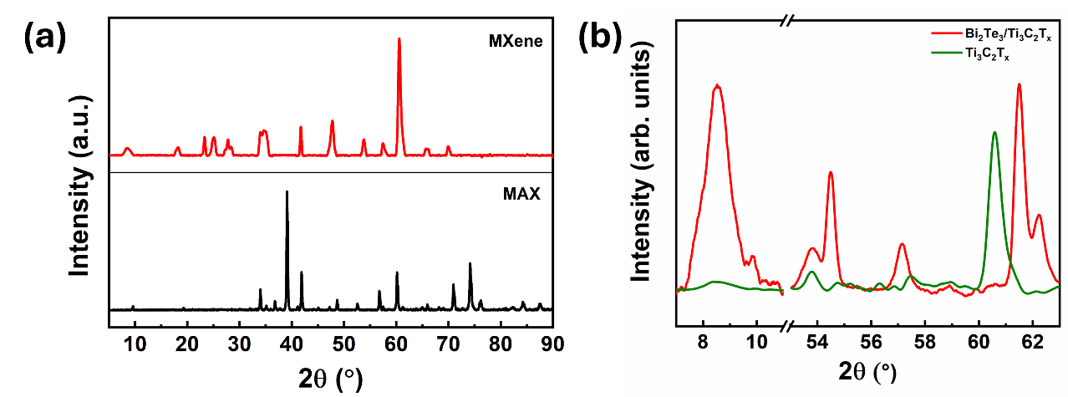
Fig. S2. (a) XRD patterns observed for Ti₃AlC₂ MAX and Ti₃C₂T_{x} MXene phases; (b) XRD patterns comparing Ti₃C₂T_{x} MXene phase and Bi₂Te₃/Ti₃C₂T_{x} composite.

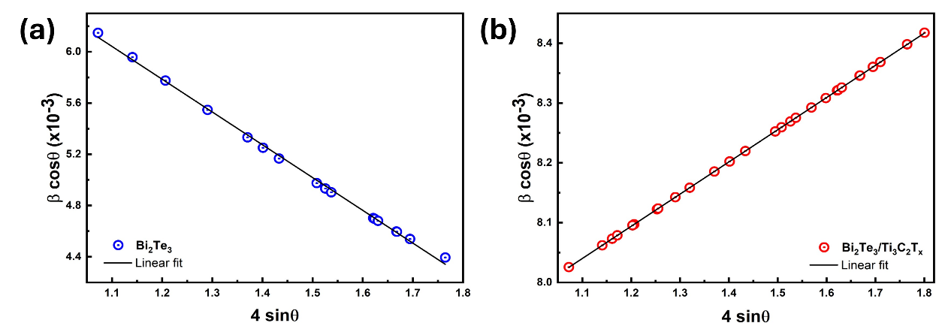
Fig. S3. Williamson-Hall plots obtained for (a) Bi₂Te₃ and (b) Bi₂Te₃/Ti₃C₂T_{x} composite.

Fig. S4. Raman spectra (a) observed for CTAB, PVP, and SDS surfactants, (b) PVP-assisted Bi₂Te₃ (4, 8, 16, and 32 h); (c) illustrates the Lorentzian peak fitting observed for Ti₃C₂T_{x} MXene and (d) shows the observed 2D images of Bi₂Te₃ and Bi₂Te₃/Ti₃C₂T_{x}.

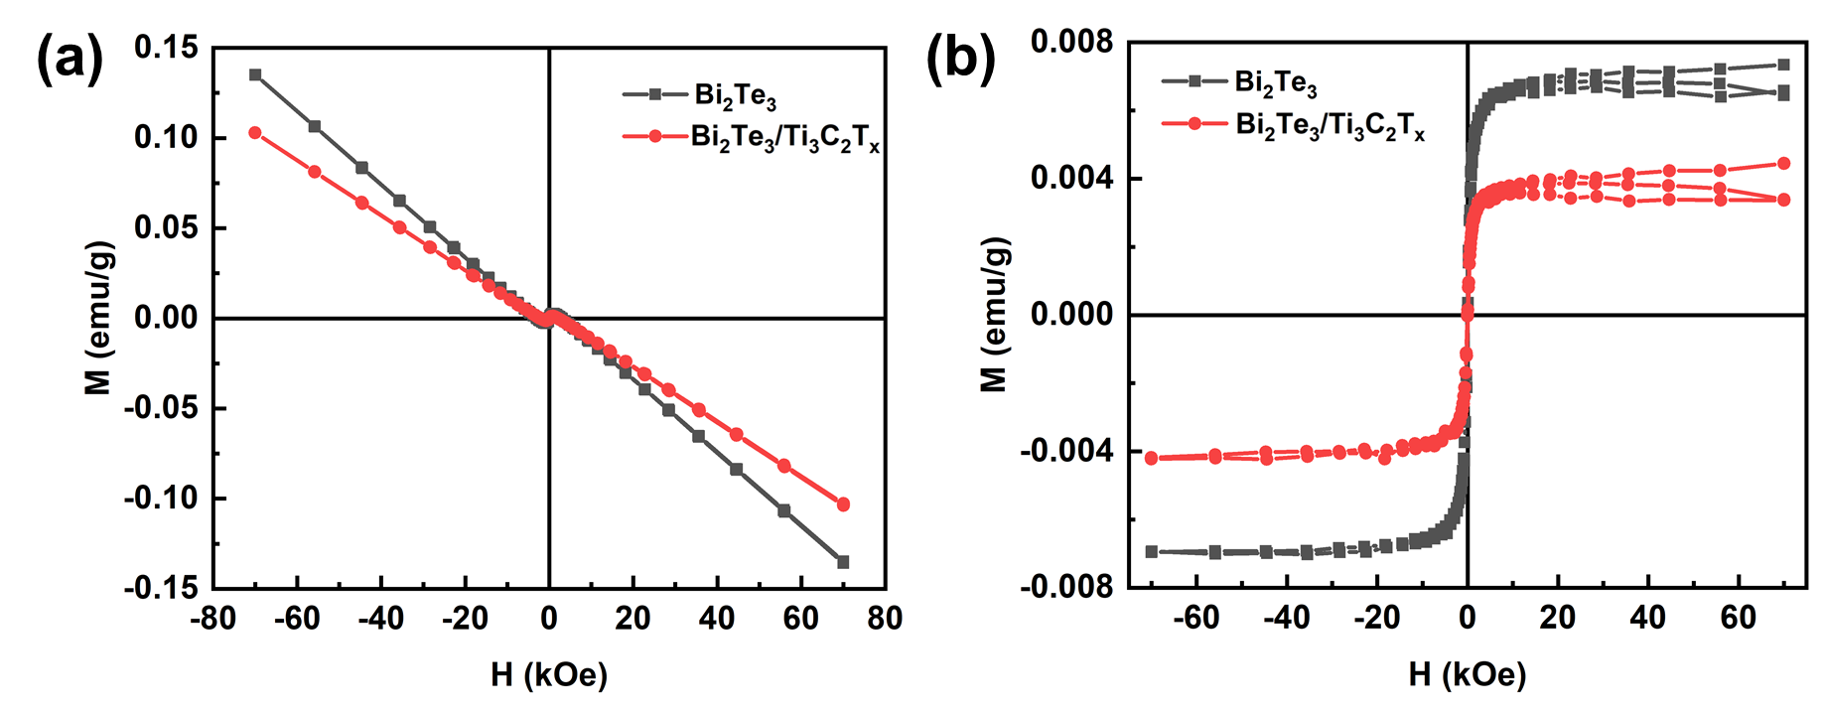
Fig. S5. Magnetic properties of Bi₂Te₃ and Bi₂Te₃/Ti₃C₂T_{x} (a) M-H curves, and (b) corrected diamagnetic response.

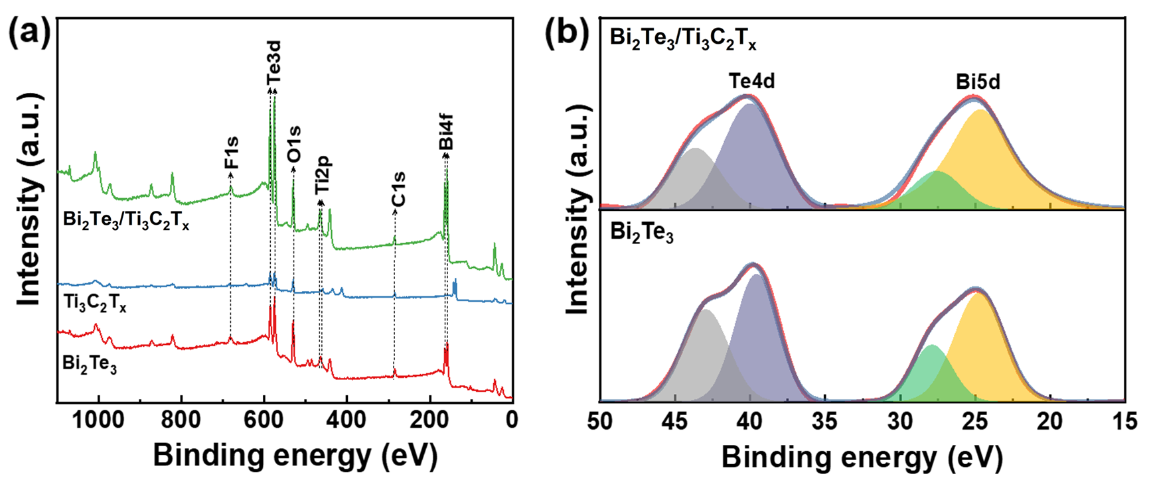
Fig. S6. (a) XPS survey spectra of the as-synthesized materials. (b) Elemental Te 4d and Bi 5d peaks of telluride materials.

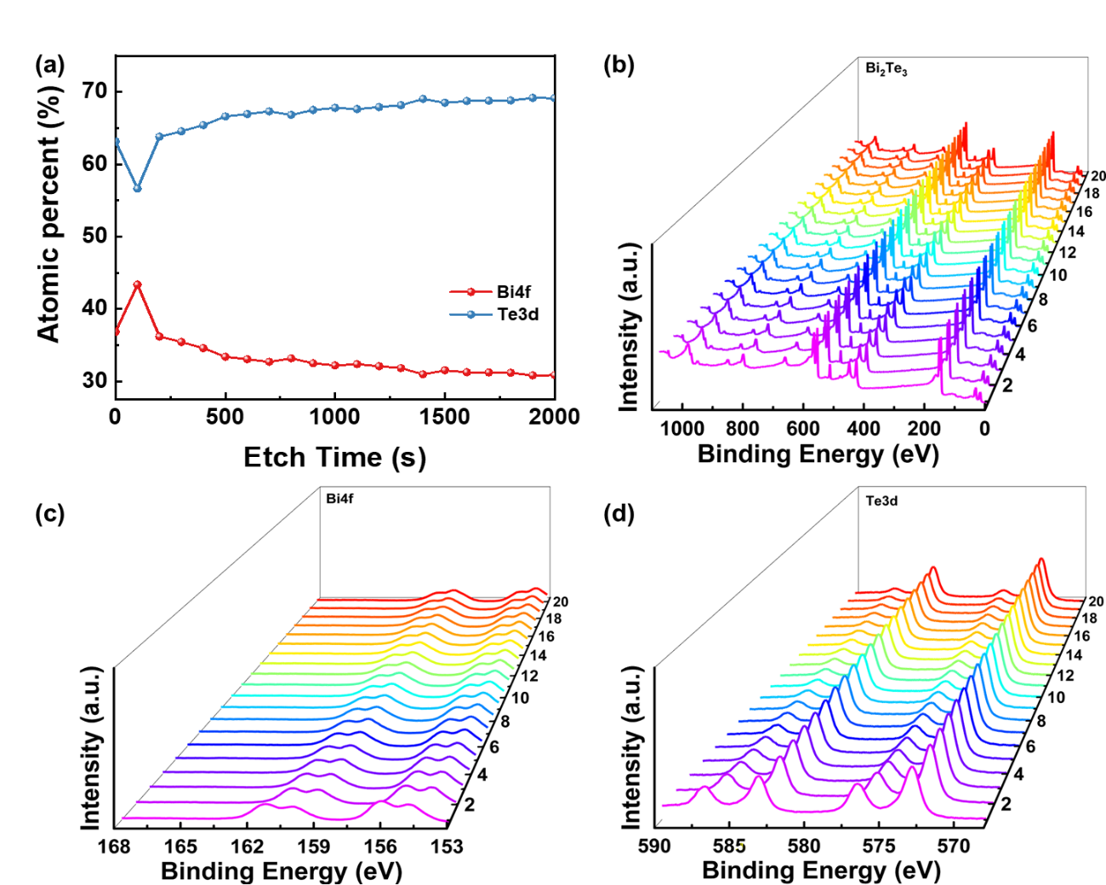
Fig. S7. (a) Atomic % of individual elements. Depth profiles for Bi₂Te₃ (b) survey spectra, elemental (c) Bi 4f and (d) Te 3d.

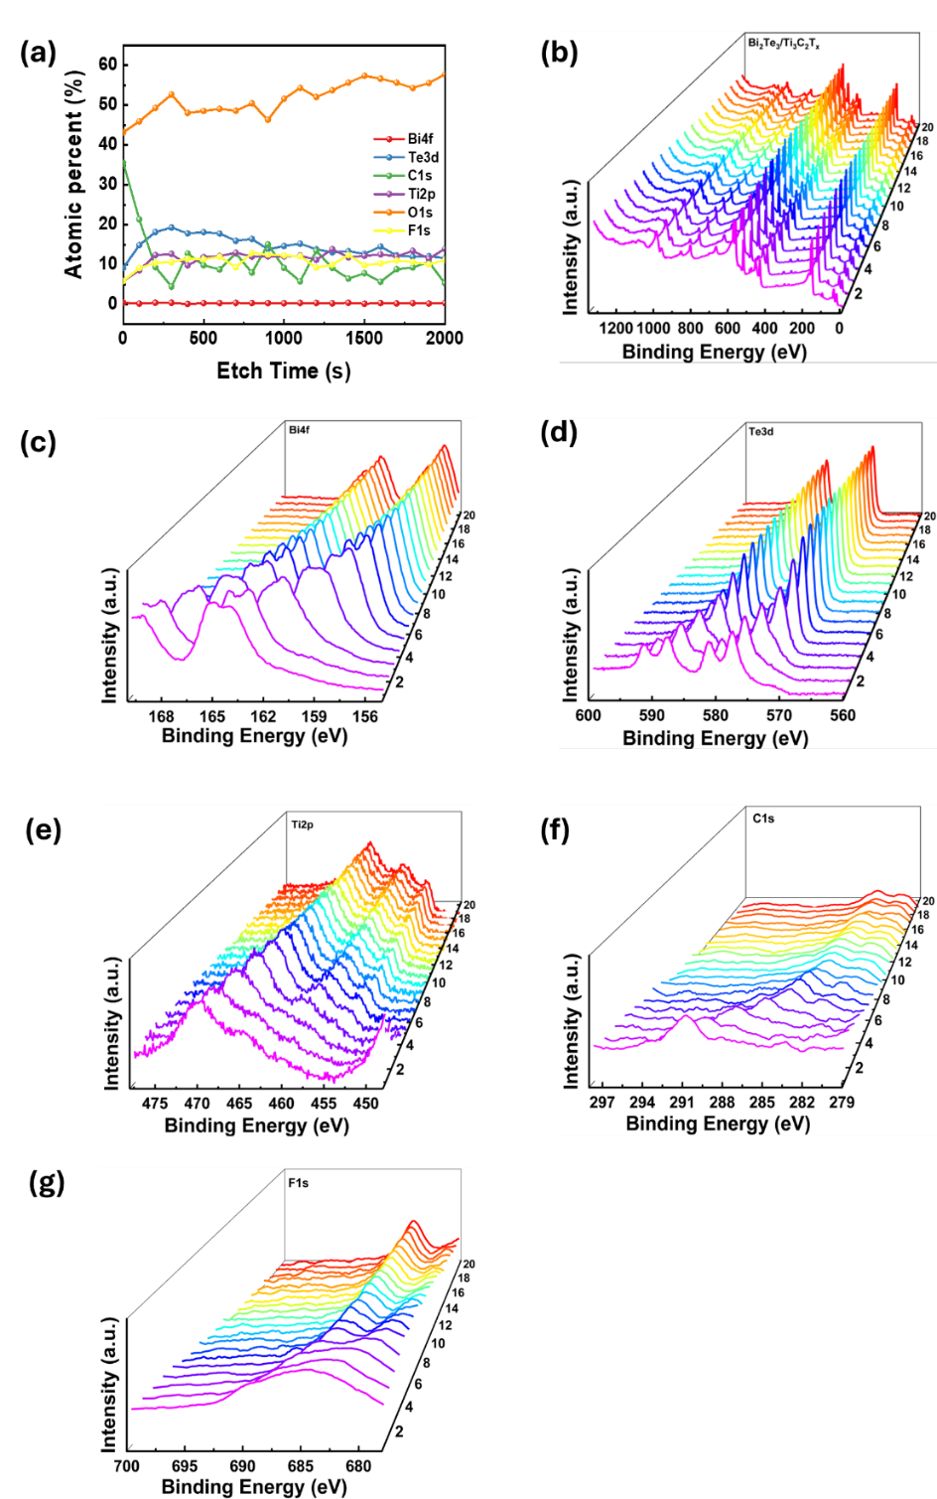
Fig. S8. (a) Atomic % of elements from XPS spectra of the Bi₂Te₃/Ti₃C₂T_{x} composite. Depth profiles (b) survey spectra, (c) Bi 4f, (d) Te 3d, (e) Ti 2p, (f) C 1s, and (g) F 1s.

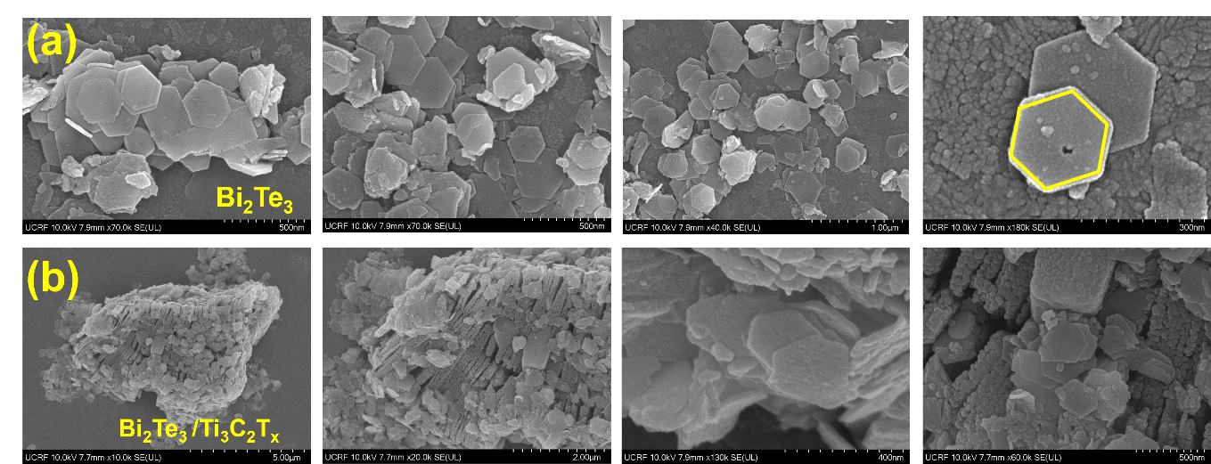
Fig. S9. FE-SEM images observed for (a) Bi₂Te₃ and (b) Bi₂Te₃/Ti₃C₂T_{x} composites.

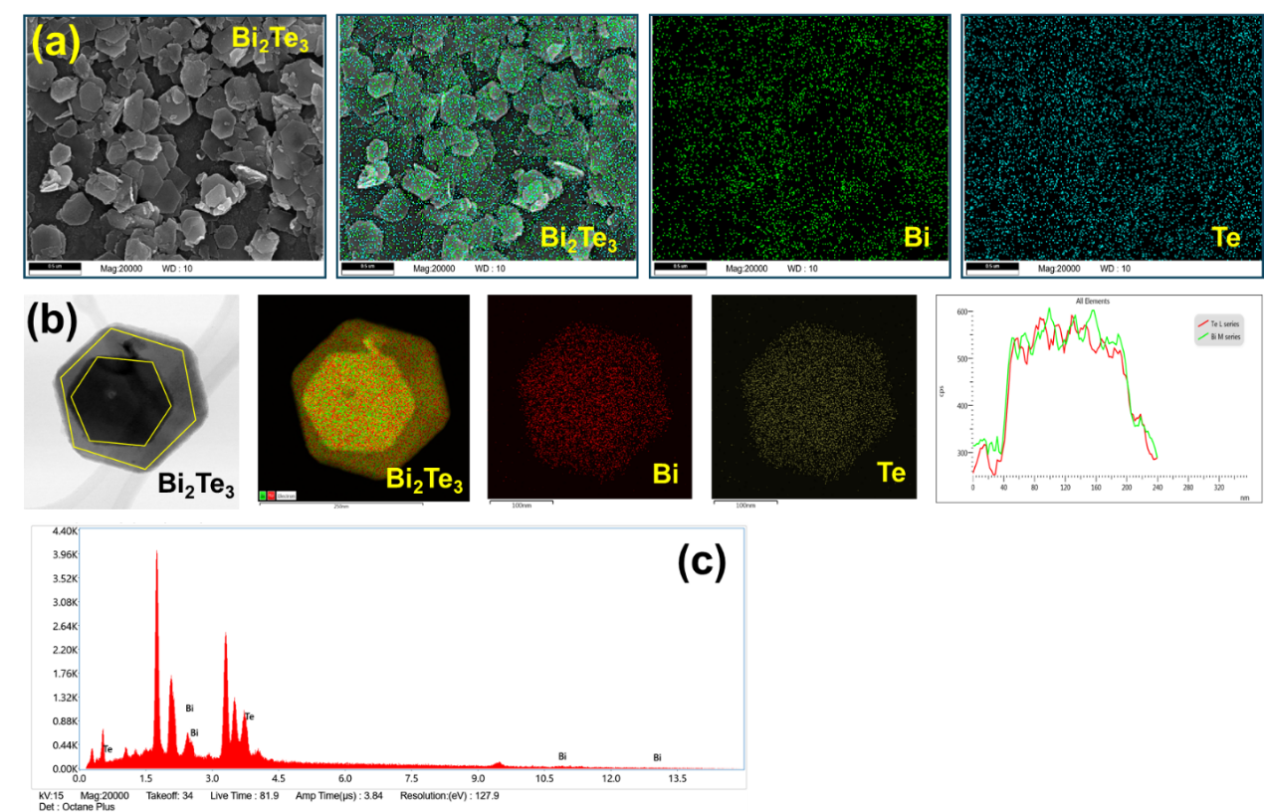
Fig. S10. EDX elemental mapping observed for each individual element in (a) Bi₂Te₃ through FE-SEM/EDX; (b) Bi₂Te₃ through TEM-EDX and line mapping; (c) EDX-atomic percentage spectrum.

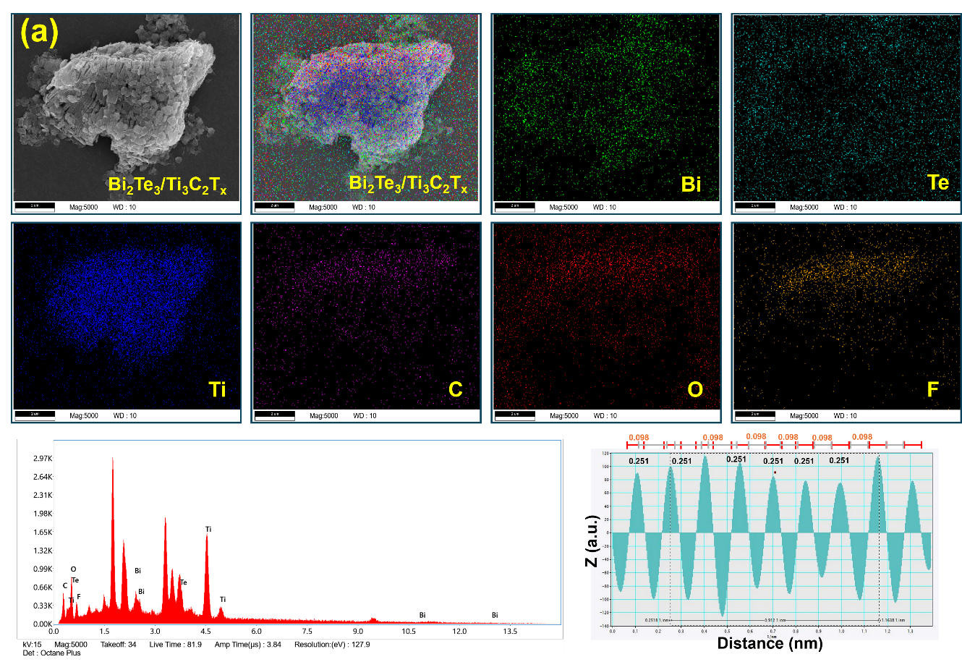
Fig. S11. The EDX elemental mapping. Atomic percentage and d-spacing (TEM) of Bi₂Te₃/Ti₃C₂T_{x} composite.

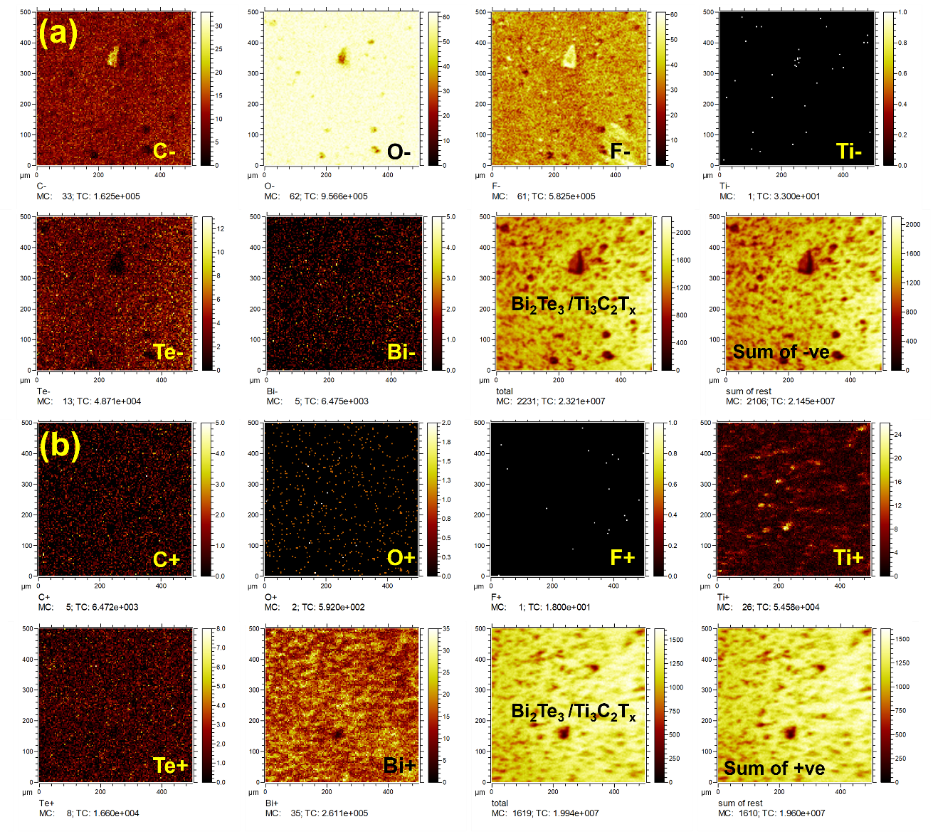
Fig. S12. TOF-SIMS ion mapping of Bi₂Te₃/Ti₃C₂T_{x} composites. (a) Negative ion spectra showing distributions of C⁻, O⁻, F⁻, Ti⁻, Te⁻, Bi⁻, and their summed intensities. (b) Positive ion spectra of C⁺, O⁺, F⁺, Ti⁺, Te⁺, Bi⁺, and their cumulative intensities.

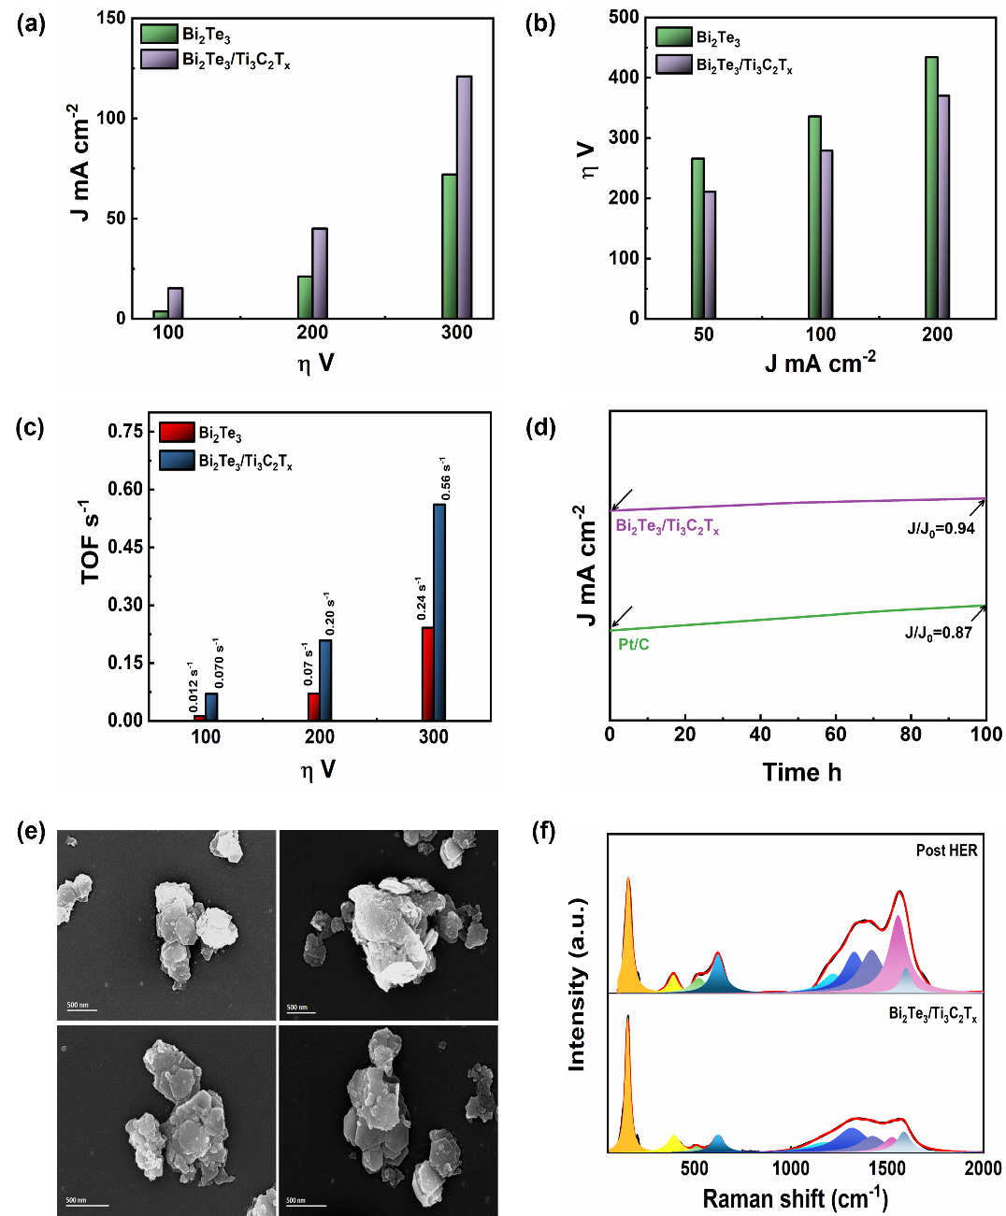
Fig. S13. (a) Variation of current densities with overpotentials, (b) variation of overpotentials with current densities, (c) TOF variation with overpotentials for the tellurides at cathode in 0.1 M KOH. (d) Chronoamperometric curves of Bi₂Te₃/Ti₃C₂T_{x} composite over 100 h at 250 mV. Post catalytic (e) FE-SEM and (f) Raman pattern of Bi₂Te₃/Ti₃C₂T_{x}

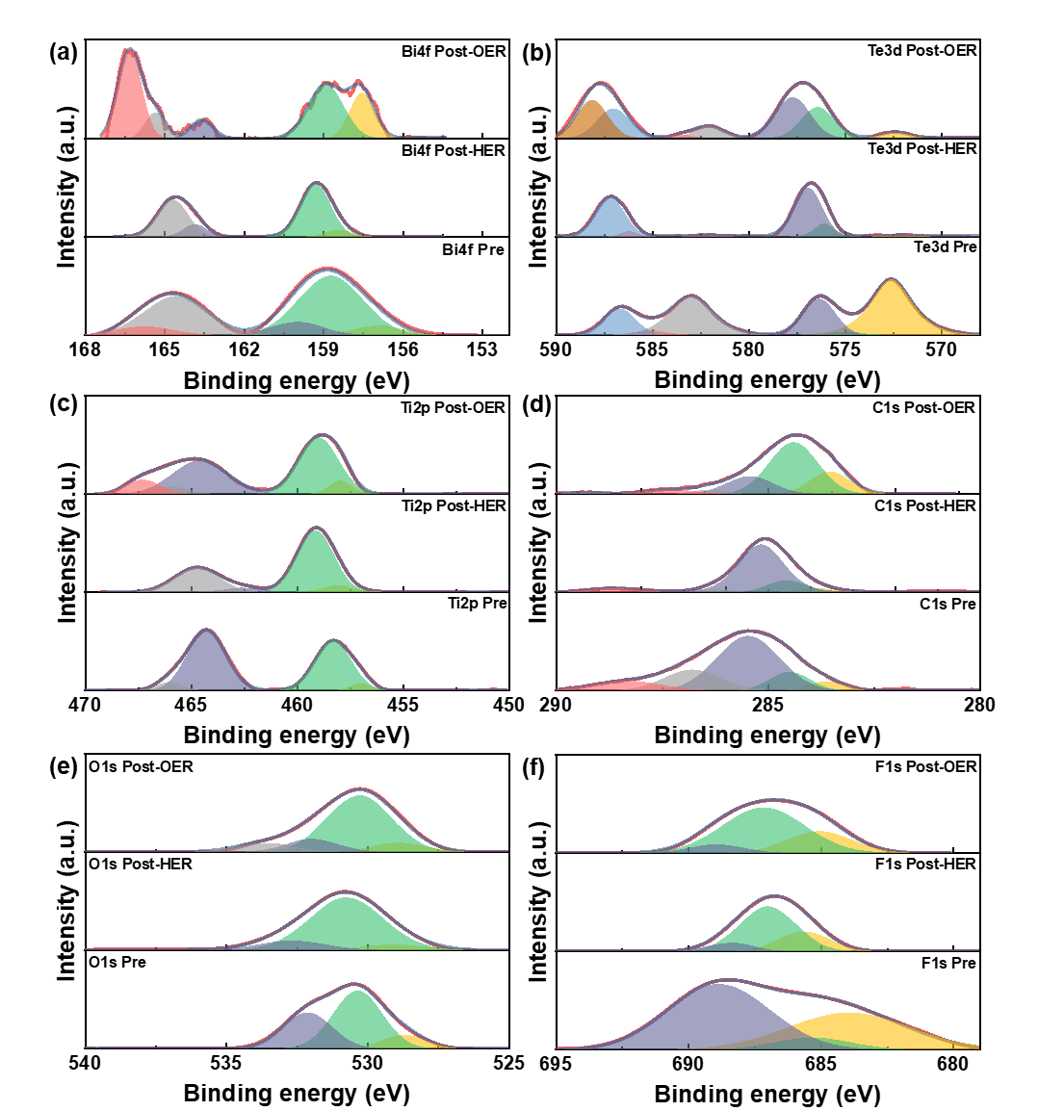
Fig. S14. Post catalytic elemental XPS spectra of (a) Bi 4f, (b) Te 3d, (c) Ti 2p, (d) C 1s, (e) O 1s, and (f) F 1s of Bi₂Te₃/Ti₃C₂T_{x}.

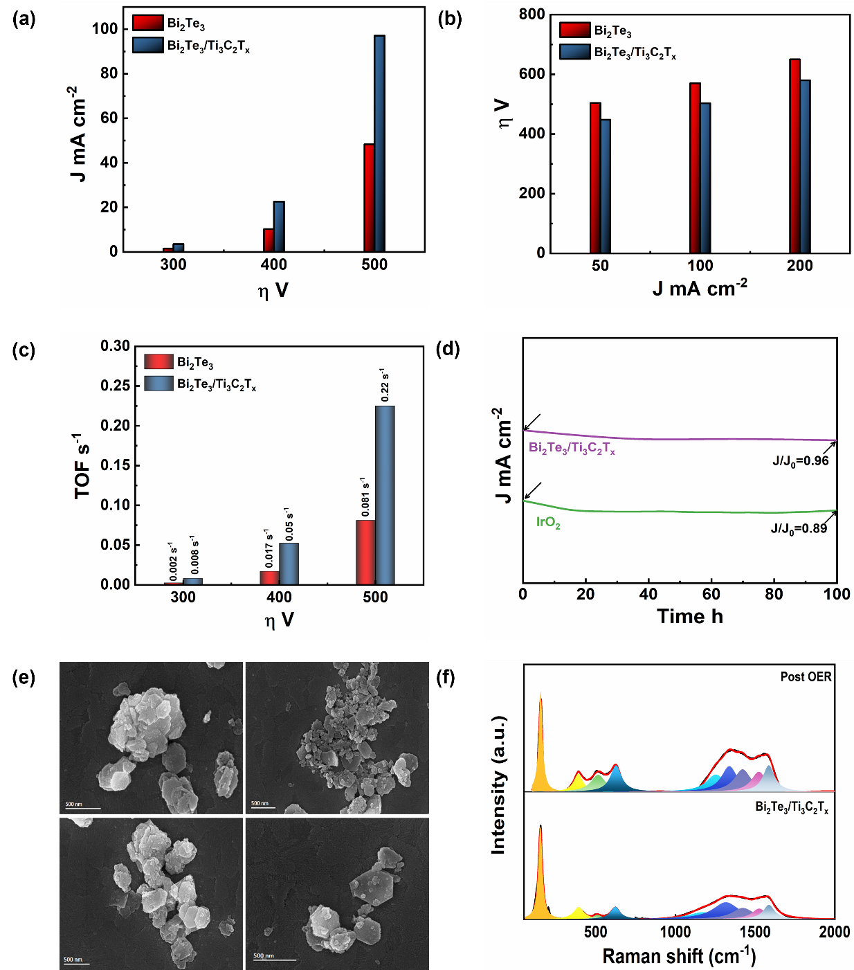
Fig. S15. (a) Variation of current densities with overpotentials, (b) variation of overpotentials with current densities, (c) TOF variation with overpotentials for the tellurides at anodes in 0.1 M KOH. (d) Chronoamperometric curves of Bi₂Te₃/Ti₃C₂T_{x} composite over 100 h at 250 mV. Post catalytic (e) FE-SEM and (f) Raman pattern of Bi₂Te₃/Ti₃C₂T_{x.}

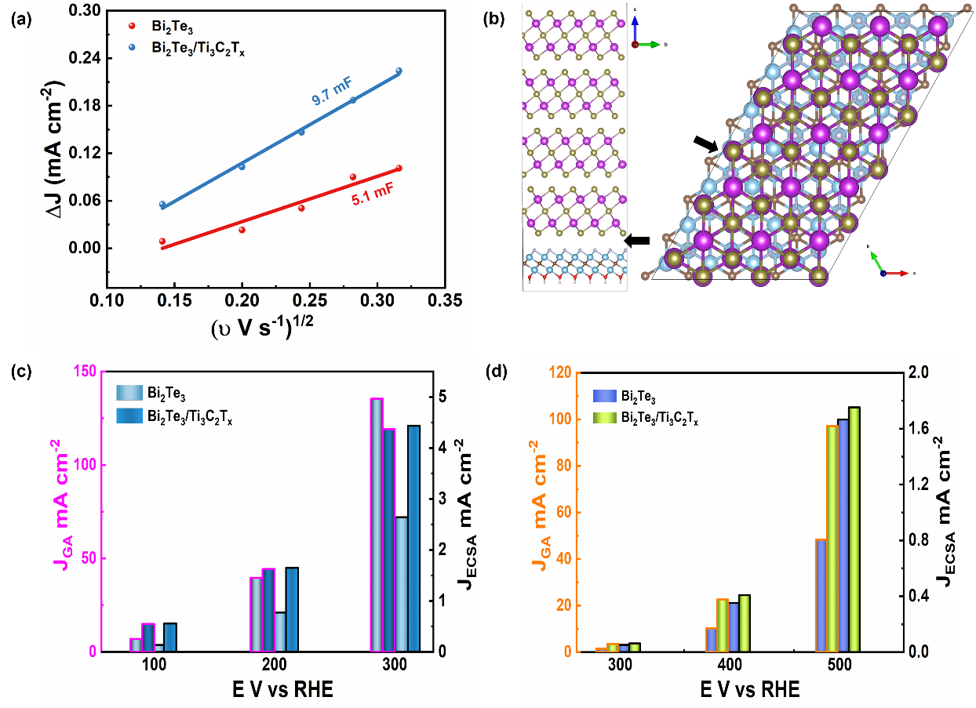
Fig. S16. (a) Variation of relative current density with root of scan rate for calculation of C_{dl}, (b) atomic arrangement showing heterojunction in composite (top and side view). Variation of current densities with respect to electrode geometric area and ESCA with overpotentials for (c) HER and (d) OER.

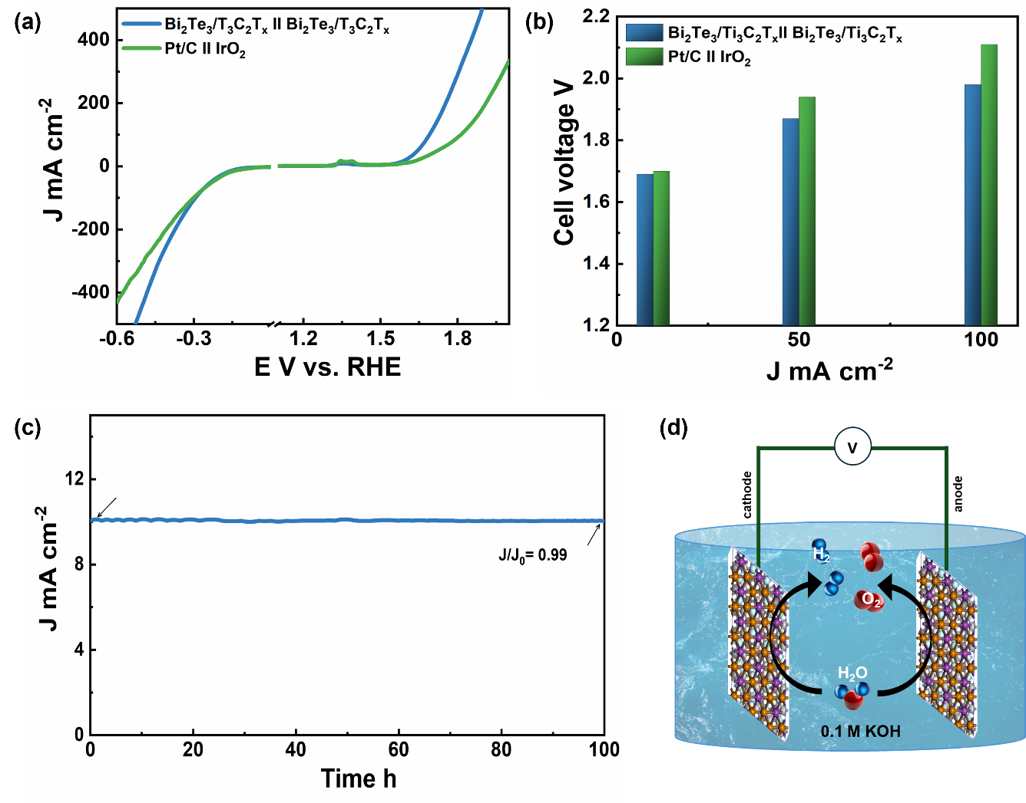
Fig. S17. Two-electrode system with Bi₂Te₃/Ti₃C₂T_{x}; (a) polarization curves for cathode and anode, (b) variation of cell voltages with current densities, (c) chronoamperometric curve at a cell voltage of 1.6 V, and (d) schematic of single cell system.

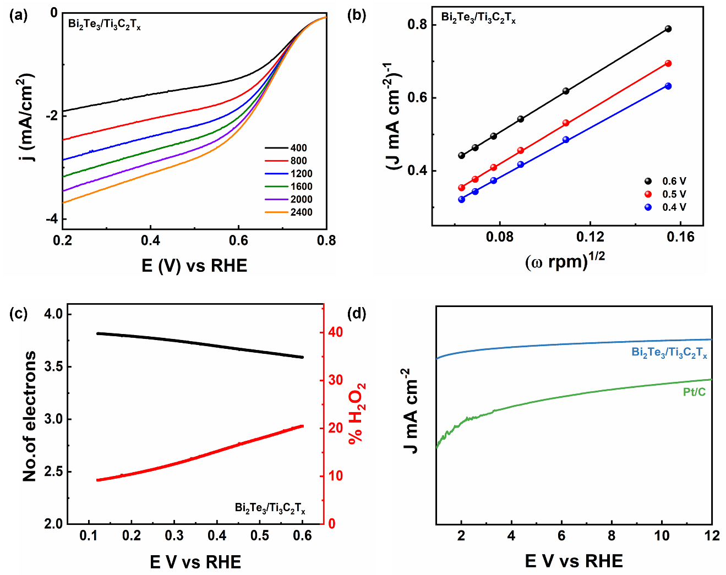
Fig. S18. (a) LSV curves of Bi₂Te₃/Ti₃C₂T_{x} composite at different rotation, (b) K-L plot at different potentials, (c) Variation of electron transfer number with H₂O₂ %, and (d) chronoamperometric curves at 0.6 V over 12 h to monitor stability during ORR. Condition for each experiment: 0.1 M KOH electrolyte.

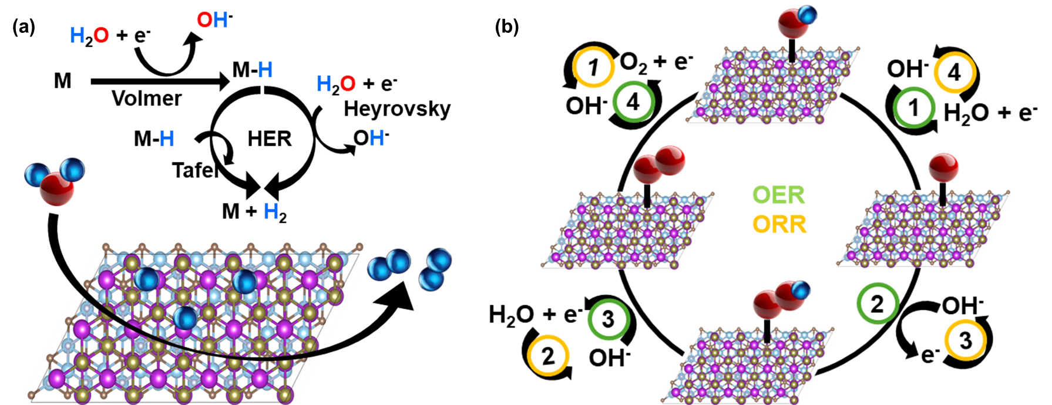

Fig. S19. Schematics of mechanistic path of HER, OER and ORR.
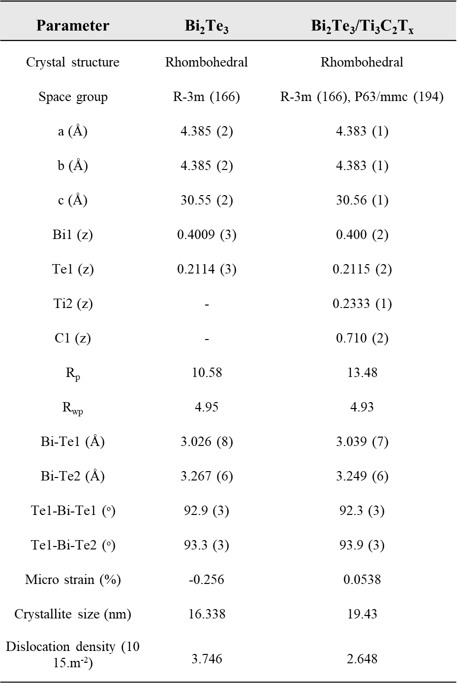
Table S1. Crystal data intensity collection for Bi₂Te₃ and Bi₂Te₃/Ti₃C₂T_{x} composite.
Atom positions Bi (0,0,z), Te1 (0,0,z), Te2 (0,0,0), Ti1 (0,0,0), Ti2 ($\frac{1}{3}$, $\frac{2}{3}$,z), C $\frac{1}{3}$, $\frac{2}{3}$,z).

Table S2. Lorentzian-Fitted Raman mode parameters at 303 K for Bi₂Te₃ and Bi₂Te₃/Ti₃C₂T_{x} composite.
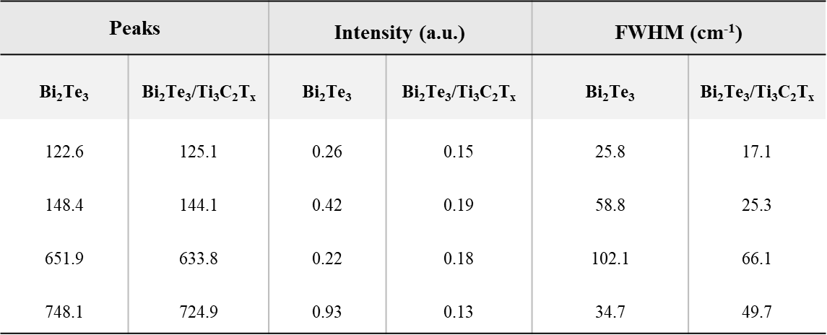

Table S3. Account electronic states of individual elements as obtained from XPS spectra.
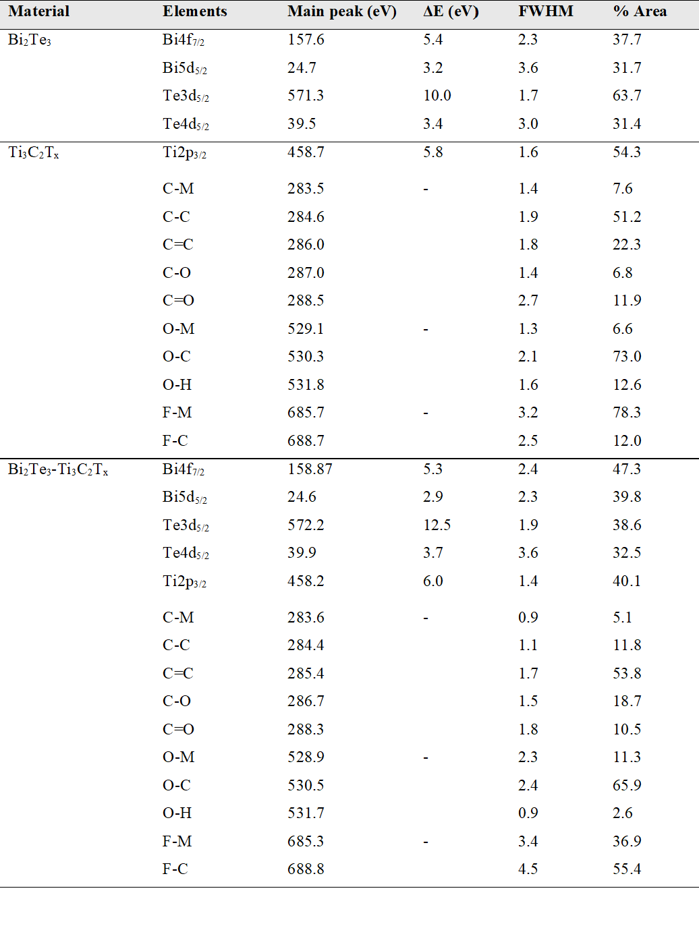
Table S4. TOF-SIMS ion species, intensities, and interpretations for Bi₂Te₃/Ti₃C₂T_{x} composites
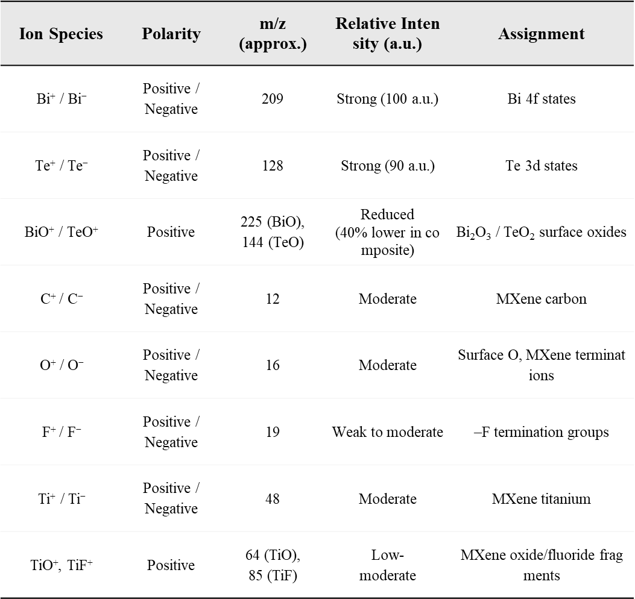

Table S5. Account of active sites as obtained from double layer capacitance
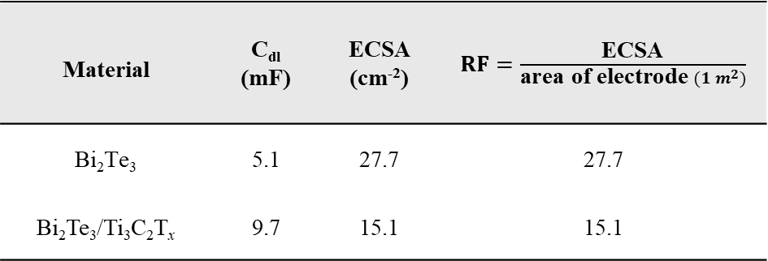

Table S6. The account of catalytic activity of the synthesized materials.
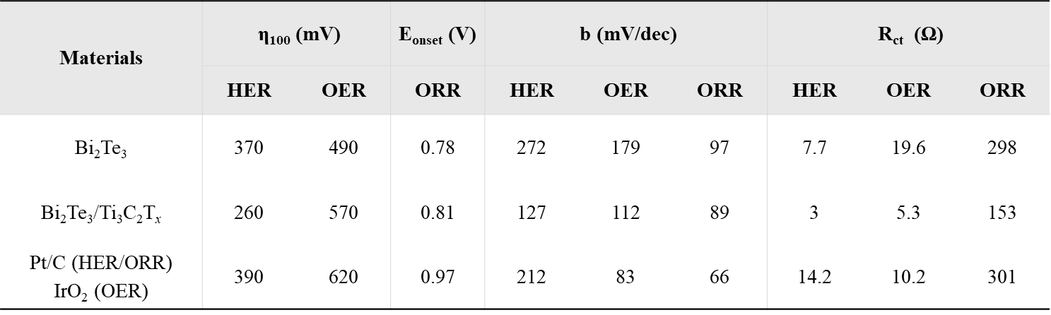

References
[1] Jana J, Nivetha R, Diem HN, Van Phuc T, Kang SG, Chung JS, Choi WM, Hur SH. Improved kinetics of reduction of alkaline water on the g‐CN‐supported transition metal oxide/boride hetero‐interface: A case study. International Journal of Energy Research. 2022; 46:14979-93. https://doi.org/10.1002/er.8198
[2] Zhou Z, Wei L, Wang Y, Karahan HE, Chen Z, Lei Y, Chen X, Zhai S, Liao X, Chen Y. Hydrogen evolution reaction activity of nickel phosphide is highly sensitive to electrolyte pH. J Mater Chem A 5, 20390–20397 (2017). https://doi.org/10.1039/C7TA06000A
[3] Chen X, Yu Z, Wei L, Zhou Z, Zhai S, Chen J, Wang Y, Huang Q, Karahan HE, Liao X. Ultrathin nickel boride nanosheets anchored on functionalized carbon nanotubes as bifunctional electrocatalysts for overall water splitting. J Mater Chem A 7, 764–774 (2019). https://doi.org/10.1039/C8TA09130G
[4] Zeng K, Zhang D. Recent progress in alkaline water electrolysis for hydrogen production and applications. Prog Energy Combust Sci 36, 307–326 (2010). https://doi.org/10.1016/j.pecs.2009.11.002
[5] Wang C, Zhu X, Nilsson L, Wen J, Wang G, Shan X, Zhang Q, Zhang S, Jia J, Xue Q. In situ Raman spectroscopy of topological insulator Bi₂Te₃ films with varying thickness. Nano Res 6, 688–692 (2013). https://doi.org/10.1007/s12274-013-0344-4
[6] Rodríguez-Fernández C, Manzano CV, Romero AH, Martín J, Martín-González M, de Lima MM Jr, Cantarero A. The fingerprint of Te-rich and stoichiometric Bi₂Te₃ nanowires by Raman spectroscopy. Nanotechnology 27, 075706 (2016). DOI 10.1088/0957-4484/27/7/075706
[7] Depablos-Rivera O, Martinez A, Rodil SE. Interpretation of the Raman spectra of bismuth oxide thin films presenting different crystallographic phases. J Alloys Compd 853, 157245 (2021). https://doi.org/10.1016/j.jallcom.2020.157245
[8] Smirnov M, Kuznetsov V, Roginskii E, Cornette J, Dutreilh-Colas M, Noguera O, Masson O, Thomas P. Raman spectra and structural peculiarities of TeO₂–TeO₃ mixed oxides. J Phys Condens Matter 30, 475403 (2018). 10.1088/1361-648X/aae811
[9] Bagus PS, Ilton ES, Nelin CJ. The interpretation of XPS spectra: insights into materials properties. Surf Sci Rep 68, 273–304 (2013). https://doi.org/10.1016/j.surfrep.2013.03.001

