High-performance flexible capacitive sensor based on a carbonyl iron particle/multilayer graphene composite dielectric network for robotic object recognition

Qiyu Wangª, Ruqi Dingª, Dezheng Huaª, Yurui Shenª, Jun Wu^{c}, Ting Zhang^{d}, Xinhua Liu^{a,b,*}

ª School of Mechatronic Engineering, China University of Mining and Technology, Xuzhou 221116, China
^{b} State Key Laboratory of Intelligent Mining Equipment Technology, China University of Mining and Technology, Xuzhou 221116, China
^{c} School of Metallurgy and Materials, College of Engineering and Physical Sciences, University of Birmingham, Birmingham B15 2SE, United Kingdom
^{d} Robotics and Microsystems Center, Soochow University, Suzhou 215137, China

*Corresponding author: liuxinhua@cumt.edu.cn

Table of Contents
Fig. S1 Cross-sectional SEM image of the assembled flexible capacitive sensor. 1
Fig. S2 EDS elemental mapping of Si, C, and Fe. 2
Fig. S3 Large-area SEM images and corresponding EDS elemental mappings of the optimized CIP/MLG/PDMS composite. (a–c) SEM images obtained from three representative regions at 100× magnification and the corresponding Fe and C elemental mappings. 3
Table S1 Comparison between our previous resistive CIP/MLG/PDMS sensor and the present capacitive sensor. 4
Fig. S4 Finite-element simulation workflow.. 5
Table S2 Parameters and boundary conditions used in the finite-element simulations of MLG/PDMS, CIP/PDMS, and CIP/MLG/PDMS composites. 6
Table S3 FEA-derived capacitance values under relaxed and compressed states for the MLG/PDMS, CIP/PDMS, and CIP/MLG/PDMS models. 7
Table S4. Frequency-dependent electrical and dielectric properties of CIP/MLG/PDMS composites with different filler compositions. 8
Table S5 Composite formulations of the CIP/MLG/PDMS dielectric layers. 9
Fig. S5 Relative capacitance change versus pressure for varying samples. 10
Table S6. DC electrical properties of CIP/MLG/PDMS composites with different MLG contents. 11
Fig. S6 Resistance–pressure response of the optimized CIP/MLG/PDMS composite under a 1000 V DC test. 12
Table S7 Comparison of sensitivity, linear range, detection limit, response time, and durability between the present sensor and recently reported capacitive pressure sensors. 13
Fig. S7 Repeatability of the detection-limit measurement at 0.318 Pa. 15
Fig. S8 Partial enlargement of the sensitivity curve. 16
Fig. S9 Synchronized capacitance and force responses during cyclic loading–unloading. 17
Fig. S10 Tensile fracture behavior of the sensor and the corresponding tensile test setup. 18
Fig. S11 Temperature control test bench. 19
Fig. S12 Baseline offset of capacitive sensors at 25-100 ℃ 20
Fig. S13 Durability test of the sensing layer subjected to 8000 cycles of reciprocating tension at 20% strain. 21
Fig. S14 Pressure-sensing performance of the flexible capacitive sensor under different bending conditions. 22
Fig. S15 Baseline offset of capacitive sensors at 25-45 ℃. 23
Table S8 Piecewise pressure sensitivity of the sensor under different bending radii.. 24

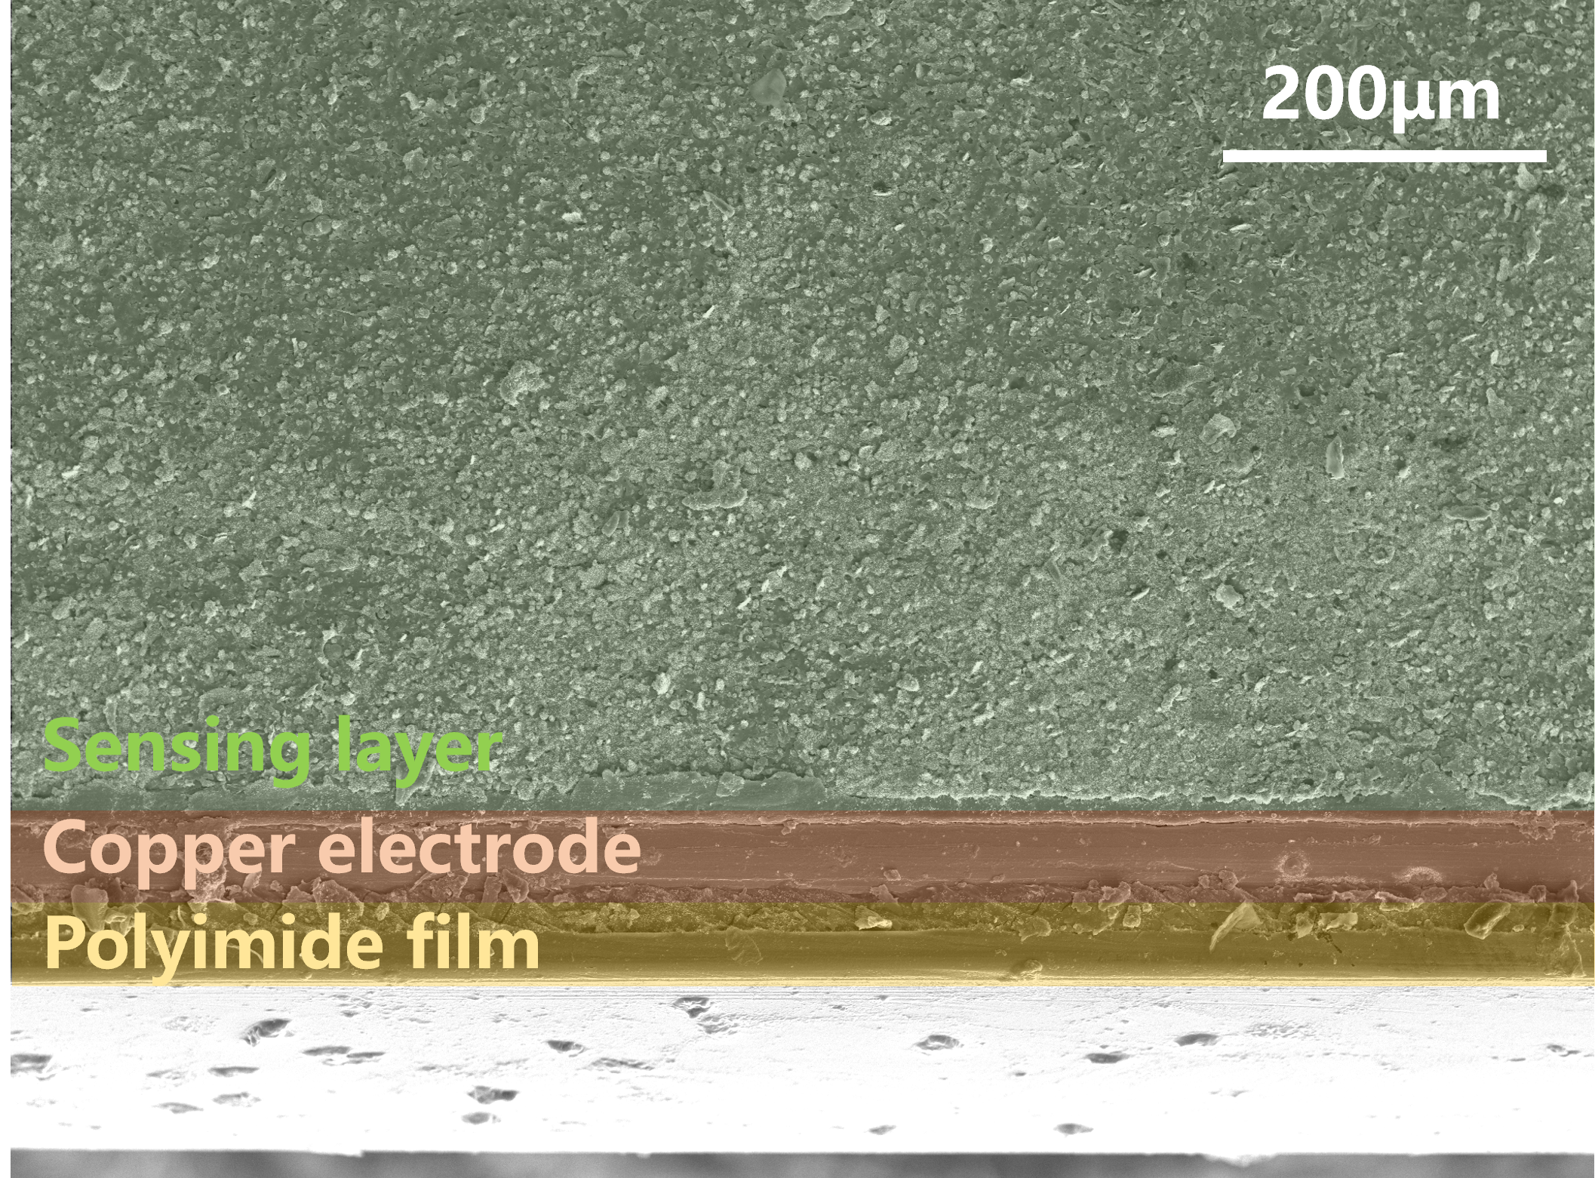

Fig. S1 Cross-sectional SEM image of the assembled flexible capacitive sensor.

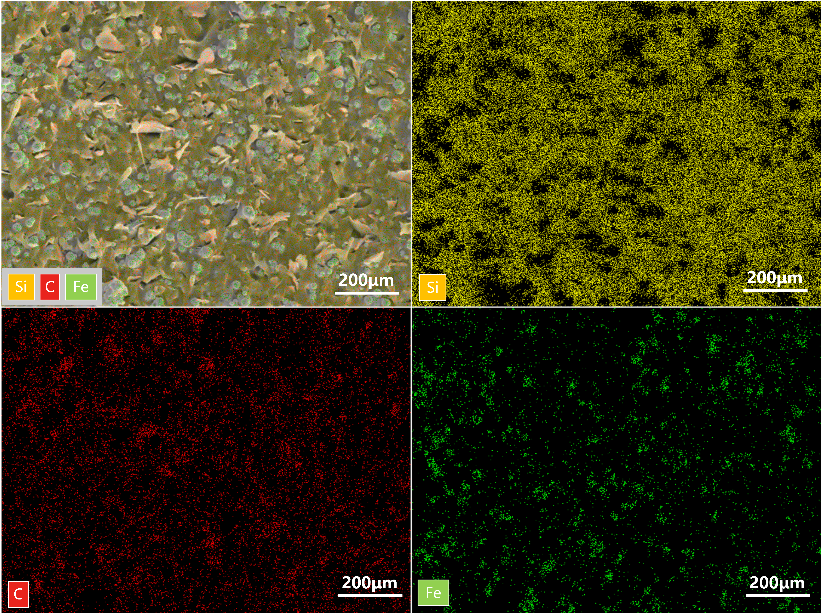

Fig. S2 EDS elemental mapping of Si, C, and Fe.

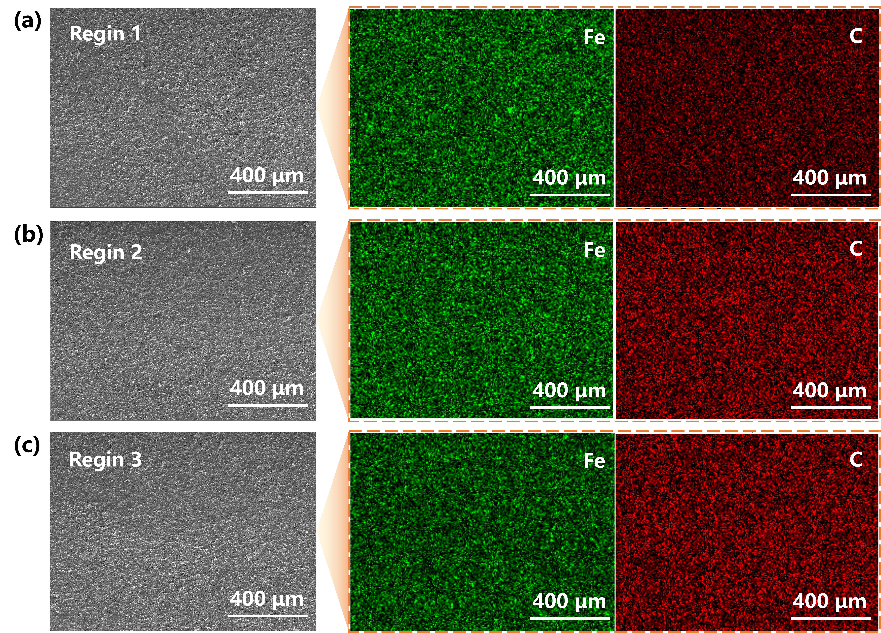

Fig. S3 Large-area SEM images and corresponding EDS elemental mappings of the optimized CIP/MLG/PDMS composite. (a–c) SEM images obtained from three representative regions at 100× magnification and the corresponding Fe and C elemental mappings.

Table S1 Comparison of the present capacitive sensor with our previously reported resistive CIP/MLG/PDMS sensor.
Characteristics | Previous work ^{[35]} | Present work
Material | CIP/MLG/PDMS | CIP/MLG/PDMS
Filler organization | Magnetically aligned anisotropic network | Heterogeneous particulate–lamellar network
Transduction mechanism | Resistance | Capacitance
Pressure sensitivity | 0.16 kPa⁻¹ | 0.04 kPa⁻¹
Pressure sensing range | 0–381 kPa | 0–954 kPa
Detection limit | — | 0.318 Pa

To clarify the distinction between the present capacitive sensor and our previously reported resistive CIP/MLG/PDMS sensor, their material architecture, transduction mechanism, and sensing characteristics are summarized in Table S1.

Fig. S4 Finite-element simulation workflow.

Table S2 Parameters and boundary conditions used in the finite-element simulations of MLG/PDMS, CIP/PDMS, and CIP/MLG/PDMS composites.
Parameter | MLG/PDMS | CIP/PDMS | CIP/MLG/PDMS
Model dimension | 30 × 30 × 30 μm³ | 30 × 30 × 30 μm³ | 30 × 30 × 30 μm³
CIP diameter | — | 3 μm | 3 μm
Number of CIP particles | 0 | 70 | 70
MLG size | 10 × 4 × 0.1 μm³ | — | 10 × 4 × 0.1 μm³
Number of MLG sheets | 50 | 0 | 50
Applied normal force | 1.0 mN | 1.0 mN | 1.0 mN
Top electrical potential | 1 V | 1 V | 1 V
Bottom electrical potential | 0 V | 0 V | 0 V
Mesh type | Free tetrahedral | Free tetrahedral | Free tetrahedral
Global minimum element size | 0.04 μm | 0.04 μm | 0.04 μm
Global maximum element size | 2.5 μm | 2.5 μm | 2.5 μm
The parameters summarized in Table S2 define the finite-element simulation conditions for the MLG/PDMS, CIP/PDMS, and CIP/MLG/PDMS models. Consistent model dimensions, loading conditions, electrical boundary conditions, and mesh settings were used to ensure a reliable comparison of the capacitance responses among the different filler architectures.

Table S3 FEA-derived capacitance values under relaxed and compressed states for the MLG/PDMS, CIP/PDMS, and CIP/MLG/PDMS models.
Type | Uncompressed capacitance (fF) | Compressed capacitance (fF) | ΔC/C₀ (%)
MLG/PDMS | 0.717189 | 0.823698 | 14.851
CIP/PDMS | 0.803351 | 0.926368 | 15.313
CIP/MLG/PDMS | 0.806399 | 0.968055 | 20.047

The simulated capacitance values quantify the pressure-dependent responses of the three dielectric configurations. The CIP/MLG/PDMS model exhibits the largest relative capacitance change, consistent with enhanced pressure-dependent dielectric modulation associated with the heterogeneous spherical–lamellar filler architecture.

Table S4 Frequency-dependent electrical and dielectric properties of CIP/MLG/PDMS composites with different filler compositions.
CIP/MLG (wt%) | Frequency | C_{p} (pF) | D = tanδ | |Z| | θ | ε_{r} | σ_{AC} (S·m⁻¹)
70/0 | 1 kHz | 19.9 | 0.2321 | 7.772MΩ | -76.93° | 7.15 | 9.24E-08
70/0 | 10 kHz | 15.7 | 0.1758 | 1.024MΩ | -79.82° | 5.64 | 5.52E-07
70/0 | 100 kHz | 9.9 | 0.3082 | 168.97kΩ | -72.85° | 3.56 | 6.10E-06
70/1 | 1 kHz | 16.1 | 0.0881 | 9.94MΩ | -85.02° | 5.79 | 2.84E-08
70/1 | 10 kHz | 13.3 | 0.0944 | 1.184MΩ | -84.63° | 4.78 | 2.51E-07
70/1 | 100 kHz | 10 | 0.3543 | 170.46kΩ | -70.09° | 3.60 | 7.09E-06
70/2 | 1 kHz | 20.3 | 0.082 | 7.943MΩ | -85.52° | 7.30 | 3.3E-08
70/2 | 10 kHz | 17.8 | 0.0898 | 0.895MΩ | -84.89° | 6.40 | 3.20E-07
70/2 | 100 kHz | 18.2 | 0.3679 | 92.95kΩ | -70.02° | 6.54 | 1.34E-05
70/3 | 1 kHz | 24.3 | 0.0801 | 6.458MΩ | -85.21° | 8.74 | 3.89E-08
70/3 | 10 kHz | 22.2 | 0.0953 | 722.47kΩ | -84.54° | 7.98 | 4.23E-07
70/3 | 100 kHz | 23.2 | 0.3564 | 73.967kΩ | -70.33° | 8.34 | 1.65E-05
70/4 | 1 kHz | 26.3 | 0.0632 | 6.211 MΩ | −86.58° | 9.45 | 3.32E-08
70/4 | 10 kHz | 23.2 | 0.0789 | 690.77 kΩ | −85.46° | 8.34 | 3.66E-07
70/4 | 100 kHz | 25.1 | 0.4447 | 69.648 kΩ | −65.93° | 9.02 | 2.23E-06
0/4 | 1 kHz | 9.5 | 0.0087 | 16.85MΩ | -89.62° | 3.42 | 1.65E-09
0/4 | 10 kHz | 7.8 | 0.0304 | 2.026MΩ | -88.35° | 2.80 | 4.74E-08
0/4 | 100 kHz | 4.4 | 0.2599 | 379.57kΩ | -75.16° | 1.58 | 2.29E-06
Frequency-dependent dielectric measurements were performed for composites with different CIP/MLG/PDMS compositions at 1, 10, and 100 kHz under identical conditions. The parallel capacitance (C_{p}), dissipation factor (D=tanδ), impedance magnitude (|Z|), and phase angle were recorded. The relative permittivity was calculated from
(S1)
The AC conductivity was obtained from
(S2)
where A and t represent the effective electrode area and thickness of the dielectric layer, respectively, and ε₀ is the vacuum permittivity (8.854×10⁻¹² F·m⁻¹).

Table S5 Composite formulations of the CIP/MLG/PDMS dielectric layers.
Sample | CIP content (wt%) | MLG content (wt%) | PDMS content (wt%)
1 | 70 | 0 | 30
2 | 70 | 1 | 29
3 | 70 | 2 | 28
4 | 70 | 3 | 27
5 | 70 | 4 | 26
6 | 60 | 0 | 40
7 | 60 | 1 | 39
8 | 60 | 2 | 38
9 | 60 | 3 | 37
10 | 60 | 4 | 36
11 | 60 | 5 | 35
12 | 60 | 6 | 34
13 | 50 | 0 | 50
14 | 50 | 2 | 48
15 | 50 | 4 | 46
16 | 50 | 6 | 44
17 | 50 | 8 | 42
18 | 40 | 0 | 60
19 | 40 | 2 | 58
20 | 40 | 4 | 56
21 | 40 | 6 | 54
22 | 40 | 8 | 52
23 | 40 | 10 | 50
24 | 30 | 0 | 70
25 | 30 | 2 | 68
26 | 30 | 4 | 66
27 | 30 | 6 | 64
28 | 30 | 8 | 62
29 | 30 | 10 | 60
30 | 30 | 12 | 58
31 | 20 | 0 | 80
32 | 20 | 2 | 78
33 | 20 | 4 | 76
34 | 20 | 6 | 74
35 | 20 | 8 | 72
36 | 20 | 10 | 70
37 | 20 | 12 | 68
38 | 20 | 14 | 66
39 | 10 | 0 | 90
40 | 10 | 4 | 86
41 | 10 | 8 | 82
42 | 10 | 12 | 78
43 | 10 | 16 | 74
44 | 0 | 4 | 96
45 | 0 | 8 | 92
46 | 0 | 12 | 88
47 | 0 | 16 | 84

These formulations were used to screen CIP/MLG/PDMS dielectric networks; sample 5 was selected as the optimized sensing layer.

Fig. S5 Relative capacitance change versus pressure for varying samples.

Table S6 DC electrical properties of CIP/MLG/PDMS composites with different MLG contents.
Sample | CIP (wt%) | MLG (wt%) | PDMS (wt%) | Insulation resistance (Ω) | Volume resistivity (Ω·m) | DC conductivity (S·m⁻¹)
1 | 70 | 1 | 29 | 9.31E+09 | 2.93E+09 | 3.42E-10
2 | 70 | 2 | 28 | 7.02E+09 | 2.21E+09 | 4.53E-10
3 | 70 | 3 | 27 | 5.75E+09 | 1.81E+09 | 5.54E-10
4 | 70 | 4 | 26 | 2.39E+09 | 7.51E+08 | 1.33E-09
As shown in Table S6, the insulation resistance decreased gradually with increasing MLG content, accompanied by an increase in DC conductivity from 3.42×10⁻¹⁰ to 1.33×10⁻⁹ Sm⁻¹. Nevertheless, all investigated composites remained highly resistive, with volume resistivities on the order of 10⁸–10⁹ Ω·m. In particular, the optimized 70 wt% CIP/4 wt% MLG composite retained a volume resistivity of 7.51×108 Ω·m, indicating that the composite remained in a highly resistive electrical state despite the increased MLG content.

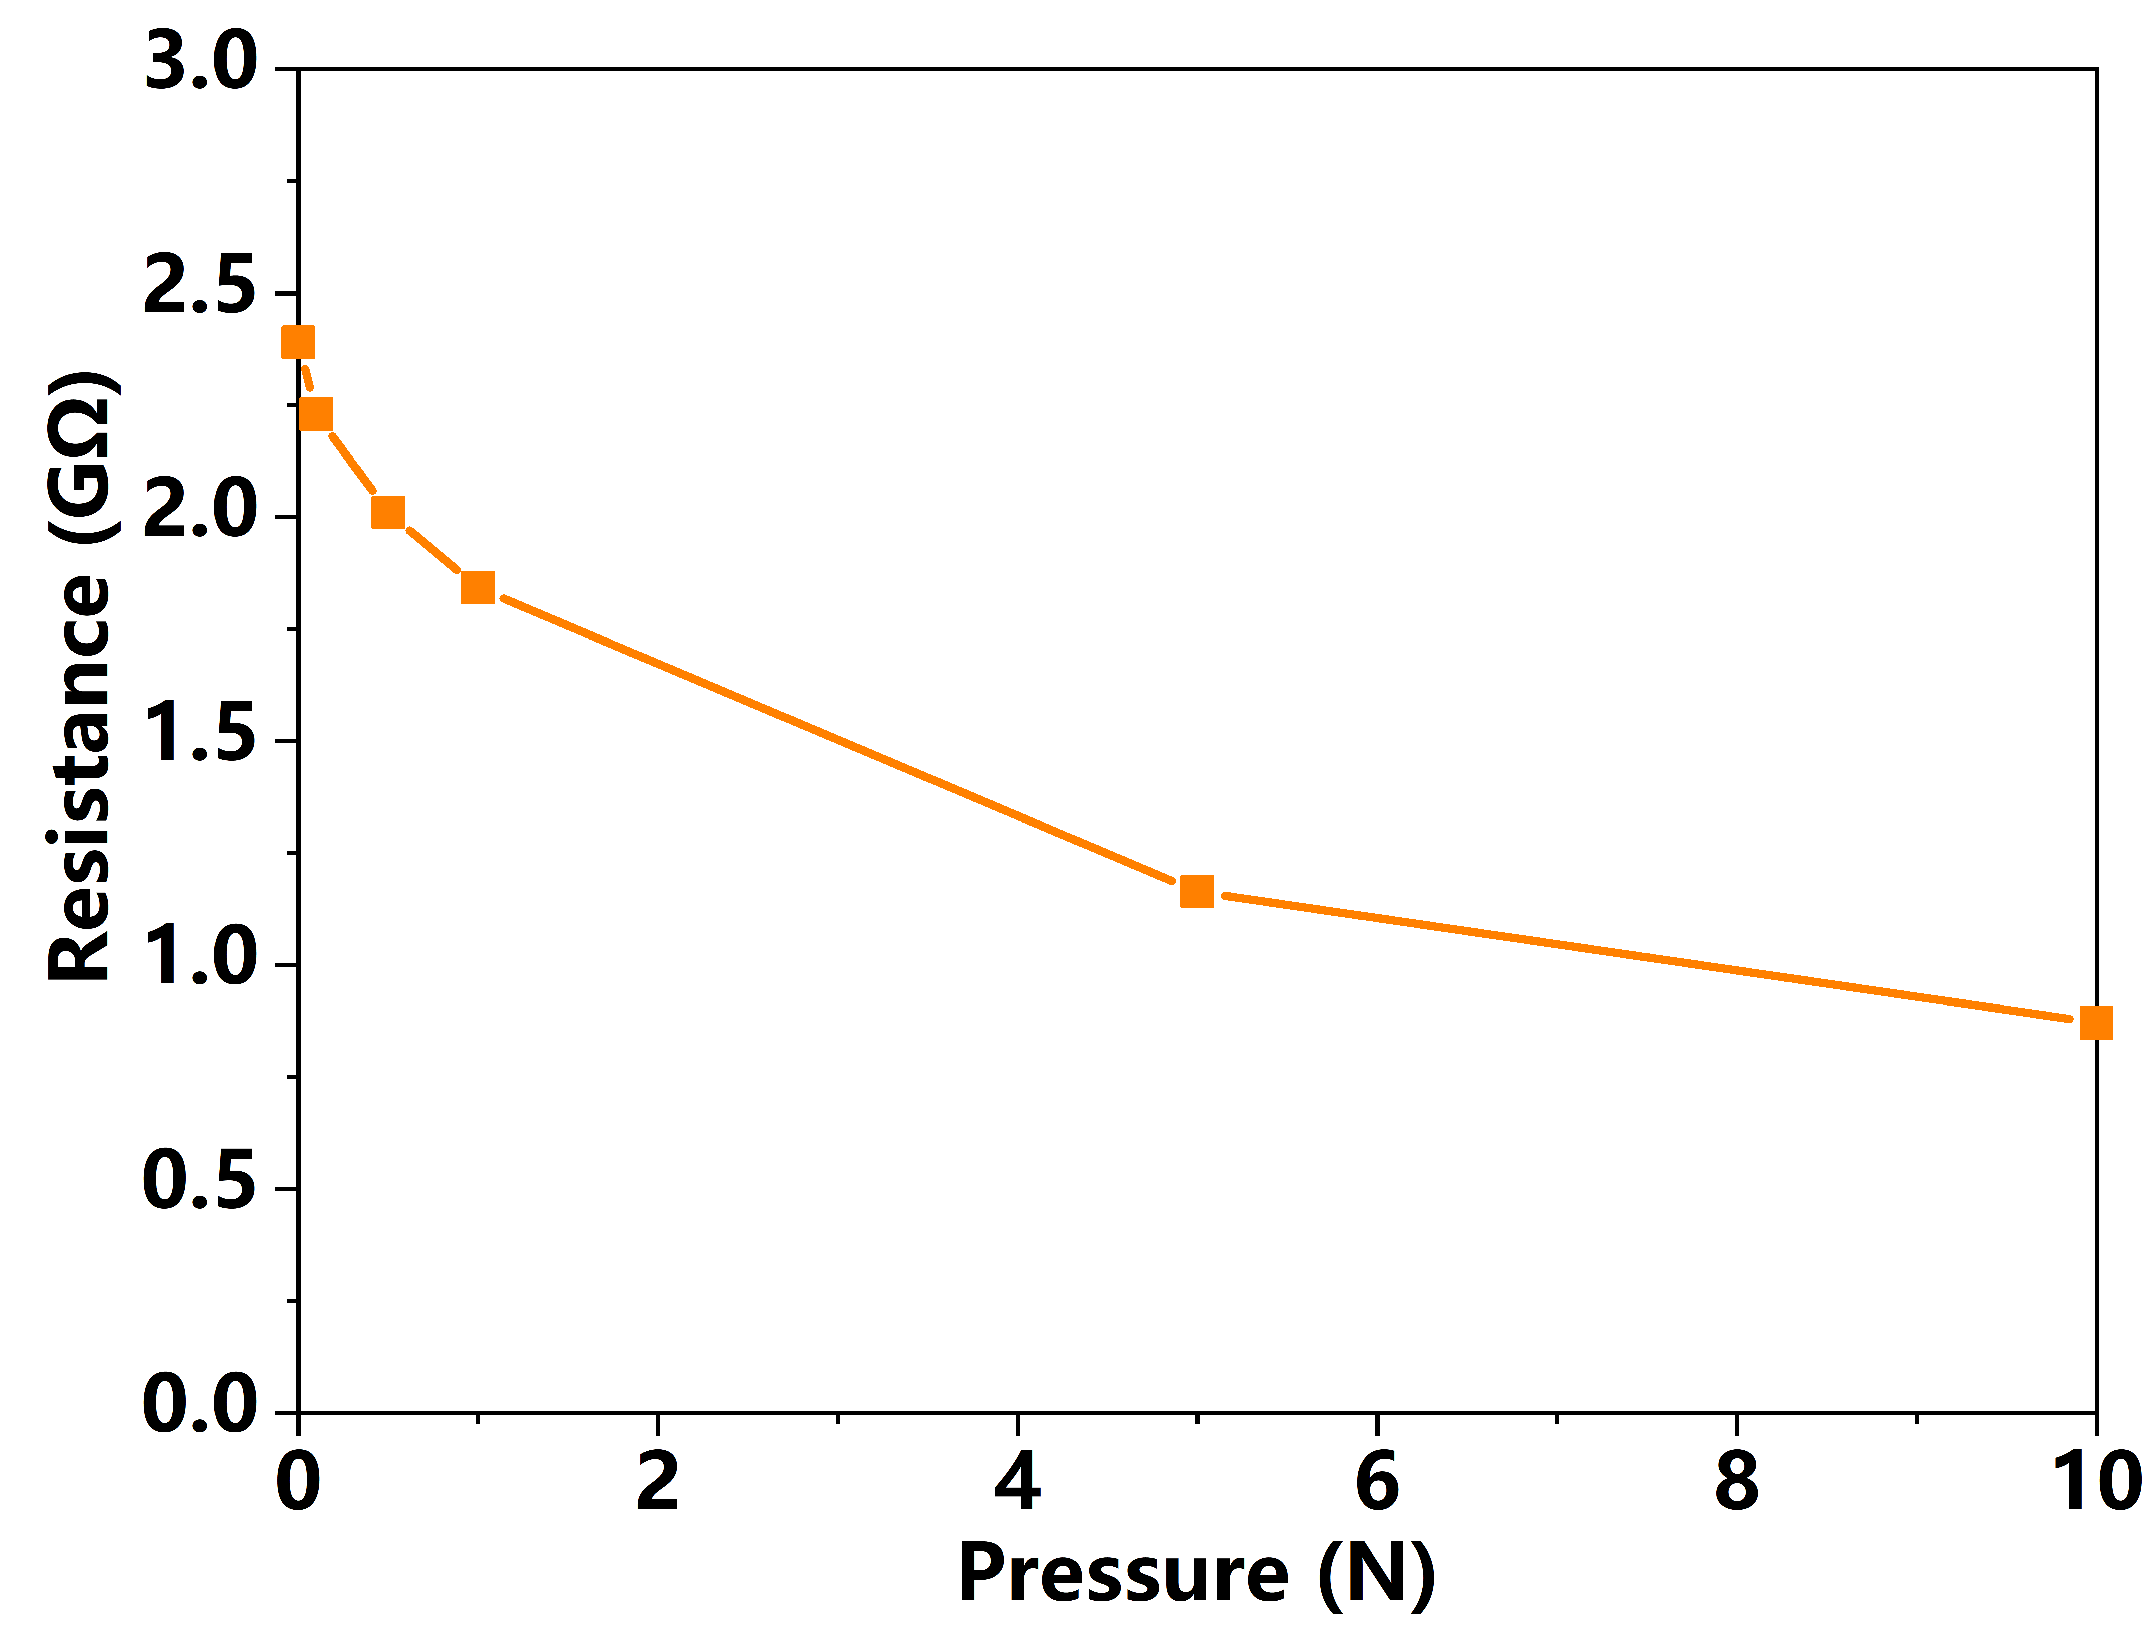

Fig. S6 Resistance–pressure response of the optimized CIP/MLG/PDMS composite under a 1000 V DC test.

Table S7 Comparison of sensitivity, linear range, detection limit, response time, and durability between the present sensor and recently reported capacitive pressure sensors.
Reference | Year | Sensitivity (kPa⁻¹) | Linear range (kPa) | Detection limit (Pa) | Response time (ms) | Durability (cycles)
[35] IEEE Sensors Journal | 2024 | 0.031 | 0.0147–1 | 14.7 | 132 | 10000
[35] IEEE Sensors Journal | 2024 | 0.008 | 1–10 | 14.7 | 132 | 10000
[35] IEEE Sensors Journal | 2024 | 0.002 | 10–100 | 14.7 | 132 | 10000
[36] ACS Applied Materials & Interfaces | 2023 | 0.0466 | 0–1 | 27 | 94 | 11400
[36] ACS Applied Materials & Interfaces | 2023 | 0.0029 | 1–200 | 27 | 94 | 11400
[36] ACS Applied Materials & Interfaces | 2023 | 0.0018 | 200–500 | 27 | 94 | 11400
[37] ACS Applied Materials & Interfaces | 2023 | 0.016 | 0–184 | 70 | 300 | 150
[37] ACS Applied Materials & Interfaces | 2023 | 0.0064 | 184–420 | 70 | 300 | 150
[37] ACS Applied Materials & Interfaces | 2023 | 0.0016 | 420–800 | 70 | 300 | 150
[38] Advanced Materials Technologies | 2019 | 0.03971 | 0–0.85 | 3.6 | 110 | 10000
[38] Advanced Materials Technologies | 2019 | 0.00192 | 0.85–35 | 3.6 | 110 | 10000
[38] Advanced Materials Technologies | 2019 | 0.000701 | 35–200 | 3.6 | 110 | 10000
[39] ACS Applied Materials & Interfaces | 2024 | 0.022 | 6.2–44.1 | 25 | 72 | 1000
[39] ACS Applied Materials & Interfaces | 2024 | 0.011 | 44.1–120 | 25 | 72 | 1000
[40] Science China Technological Sciences | 2023 | 0.00633 | 0–300 | 100 | 40 | 360
[40] Science China Technological Sciences | 2023 | 0.00126 | 300–1000 | 100 | 40 | 360
This work | 2026 | 0.04 | 0–3.18 | 0.318 | 132 | 6000
This work | 2026 | 0.0097 | 3.18–31.8 | 0.318 | 132 | 6000
This work | 2026 | 0.0027 | 31.8–318 | 0.318 | 132 | 6000
This work | 2026 | 0.0011 | 318–954 | 0.318 | 132 | 6000
This comparison evaluates the present sensor against recent capacitive pressure sensors using sensitivity, linear range, detection limit, response time. Our sensor shows a balanced profile by combining favourable low-pressure sensitivity, a broad range up to 954 kPa, and a detection limit of 0.318 Pa.

Fig. S7 Repeatability of the detection-limit measurement at 0.318 Pa.

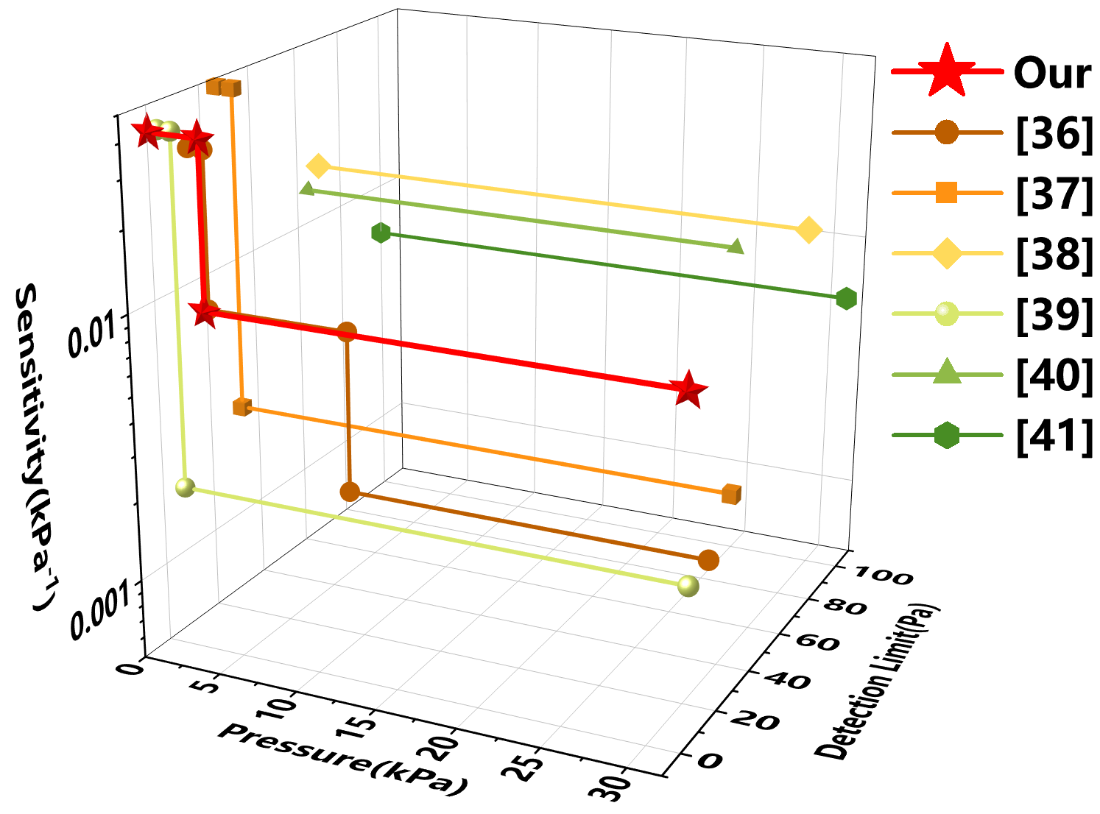

Fig. S8 Partial enlargement of the sensitivity curve.

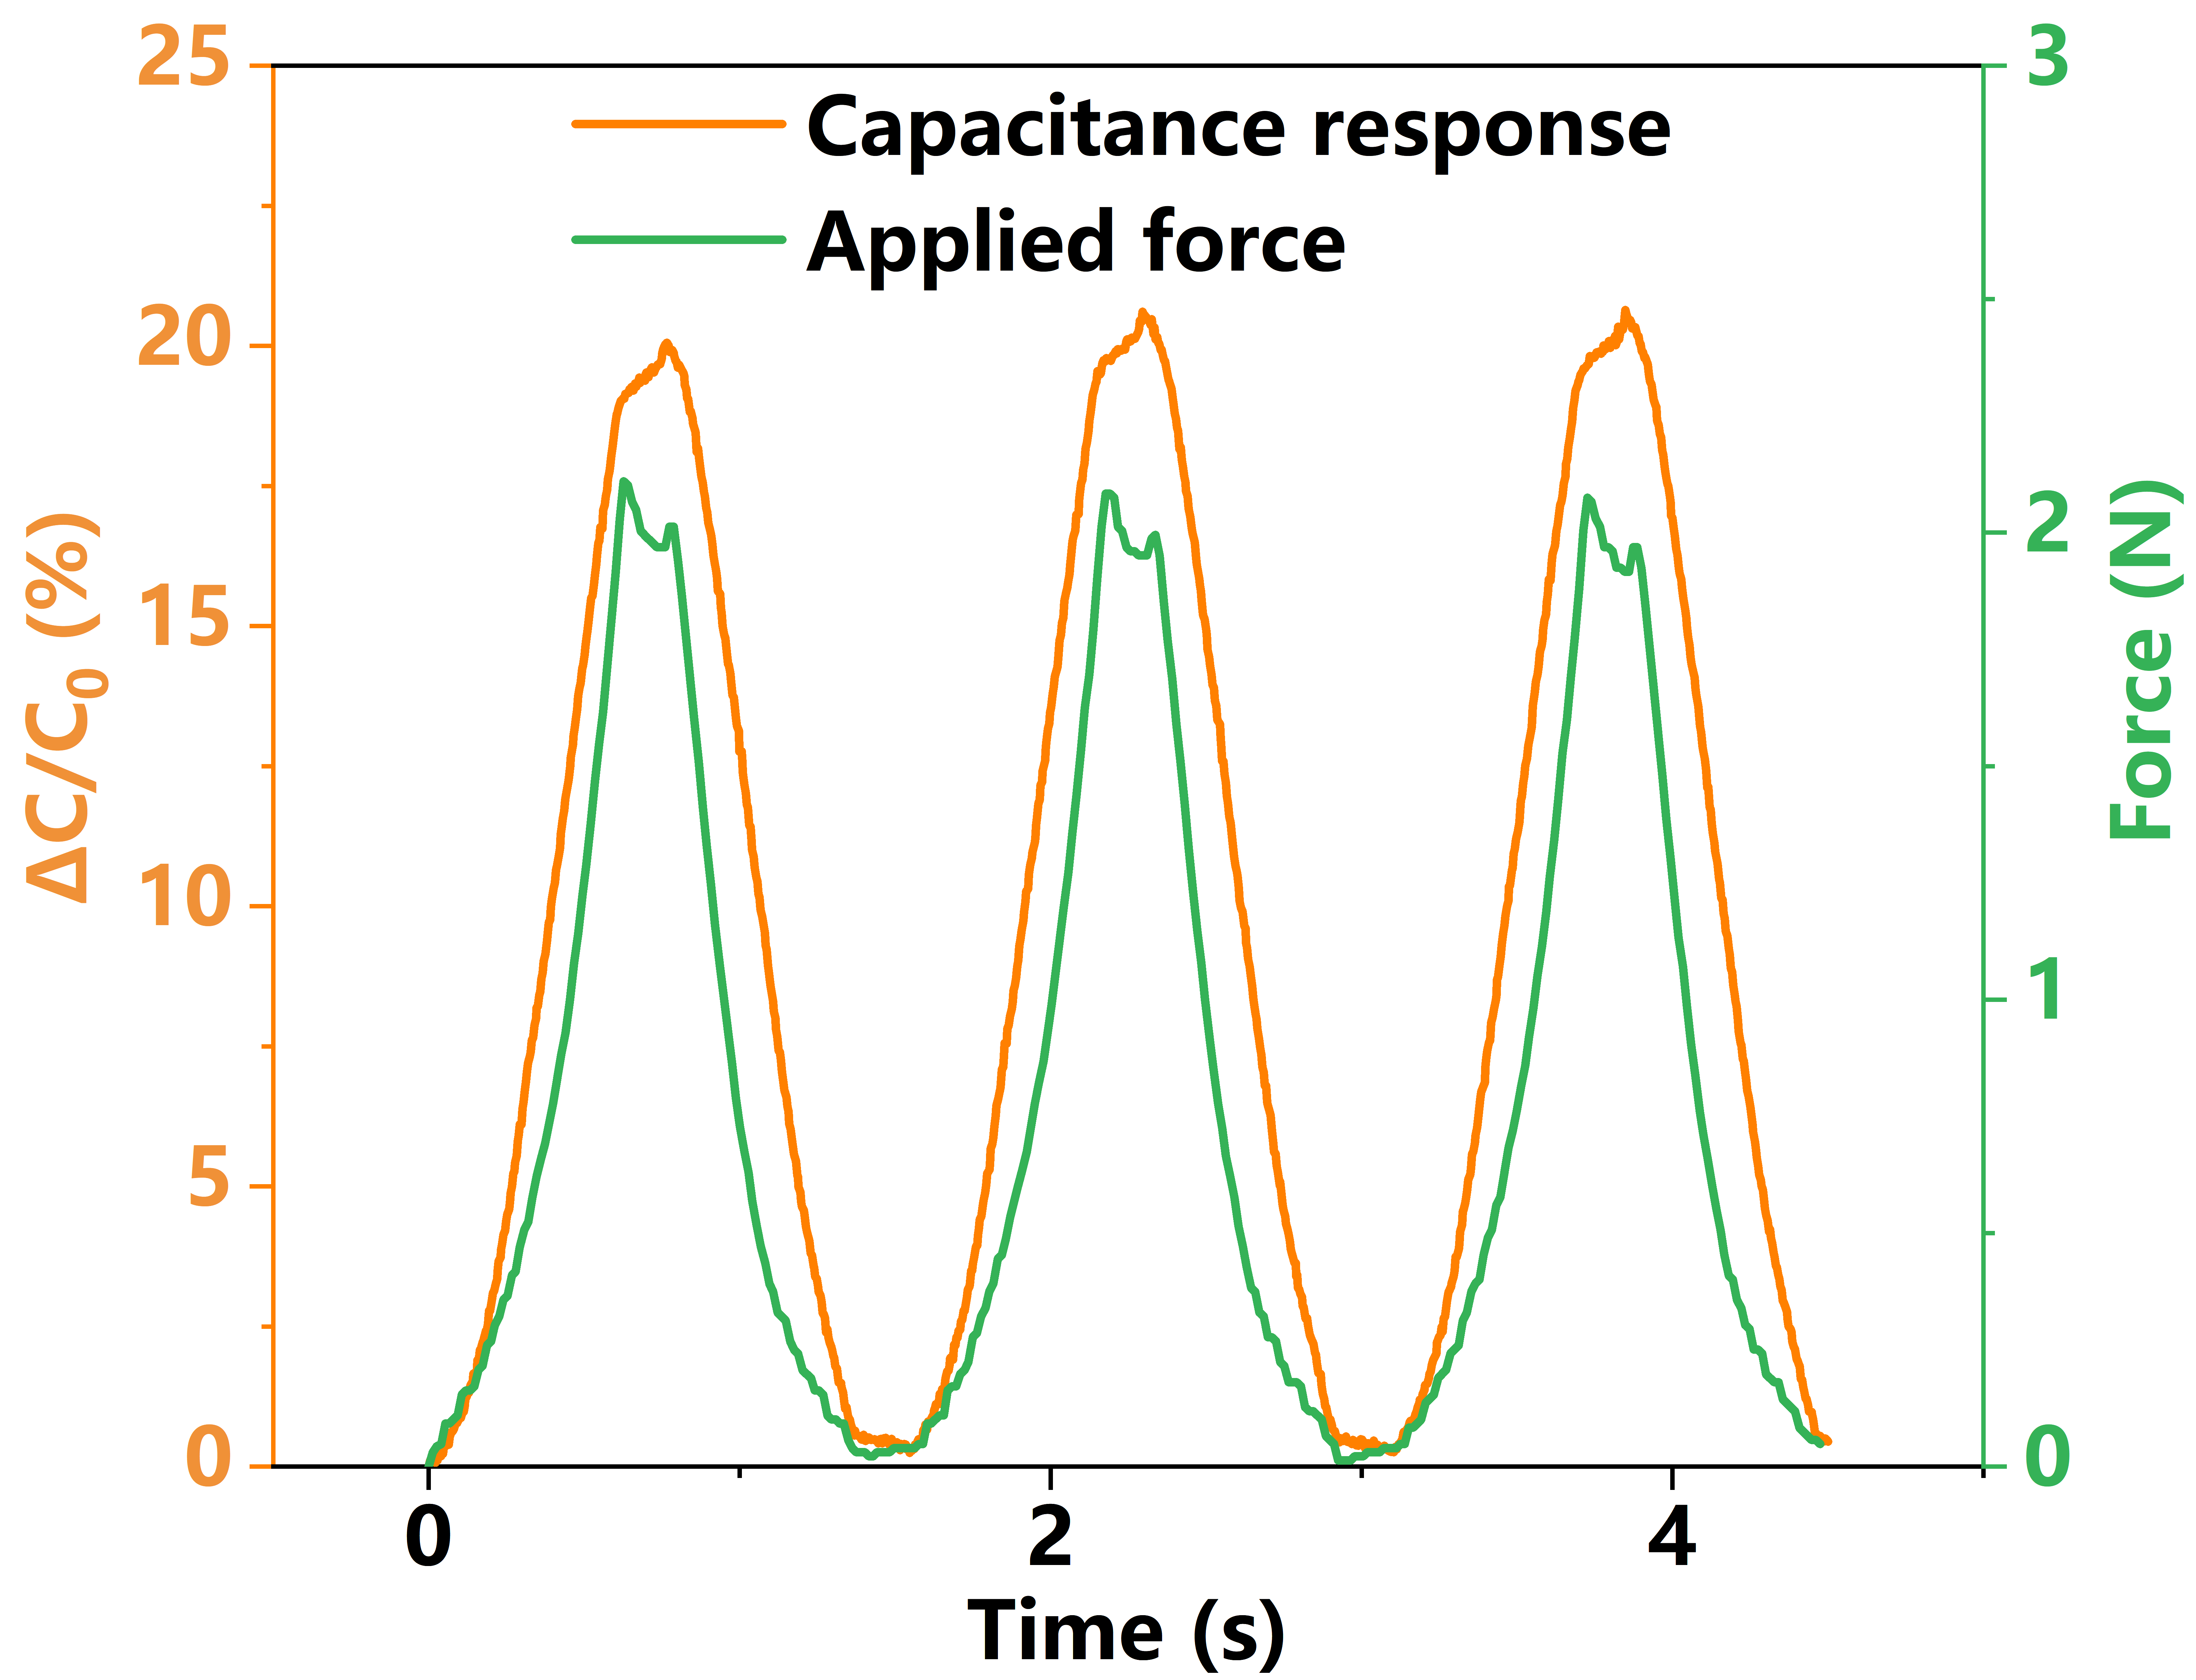

Fig. S9 Synchronized capacitance and force responses during cyclic loading–unloading.

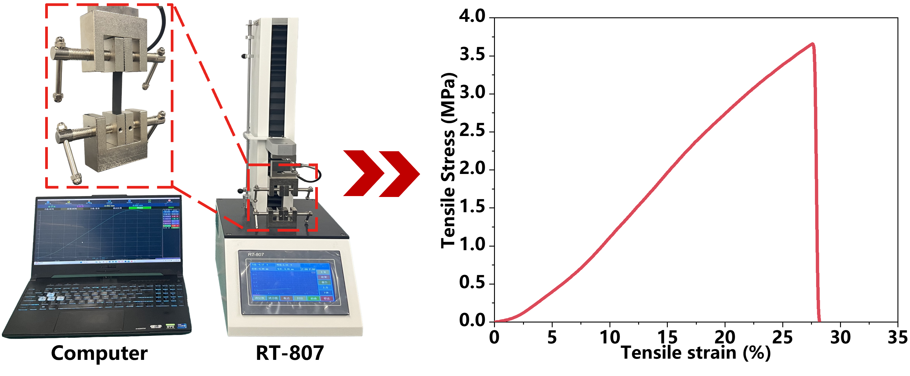

Fig. S10 Tensile fracture behavior of the sensor and the corresponding tensile test setup.

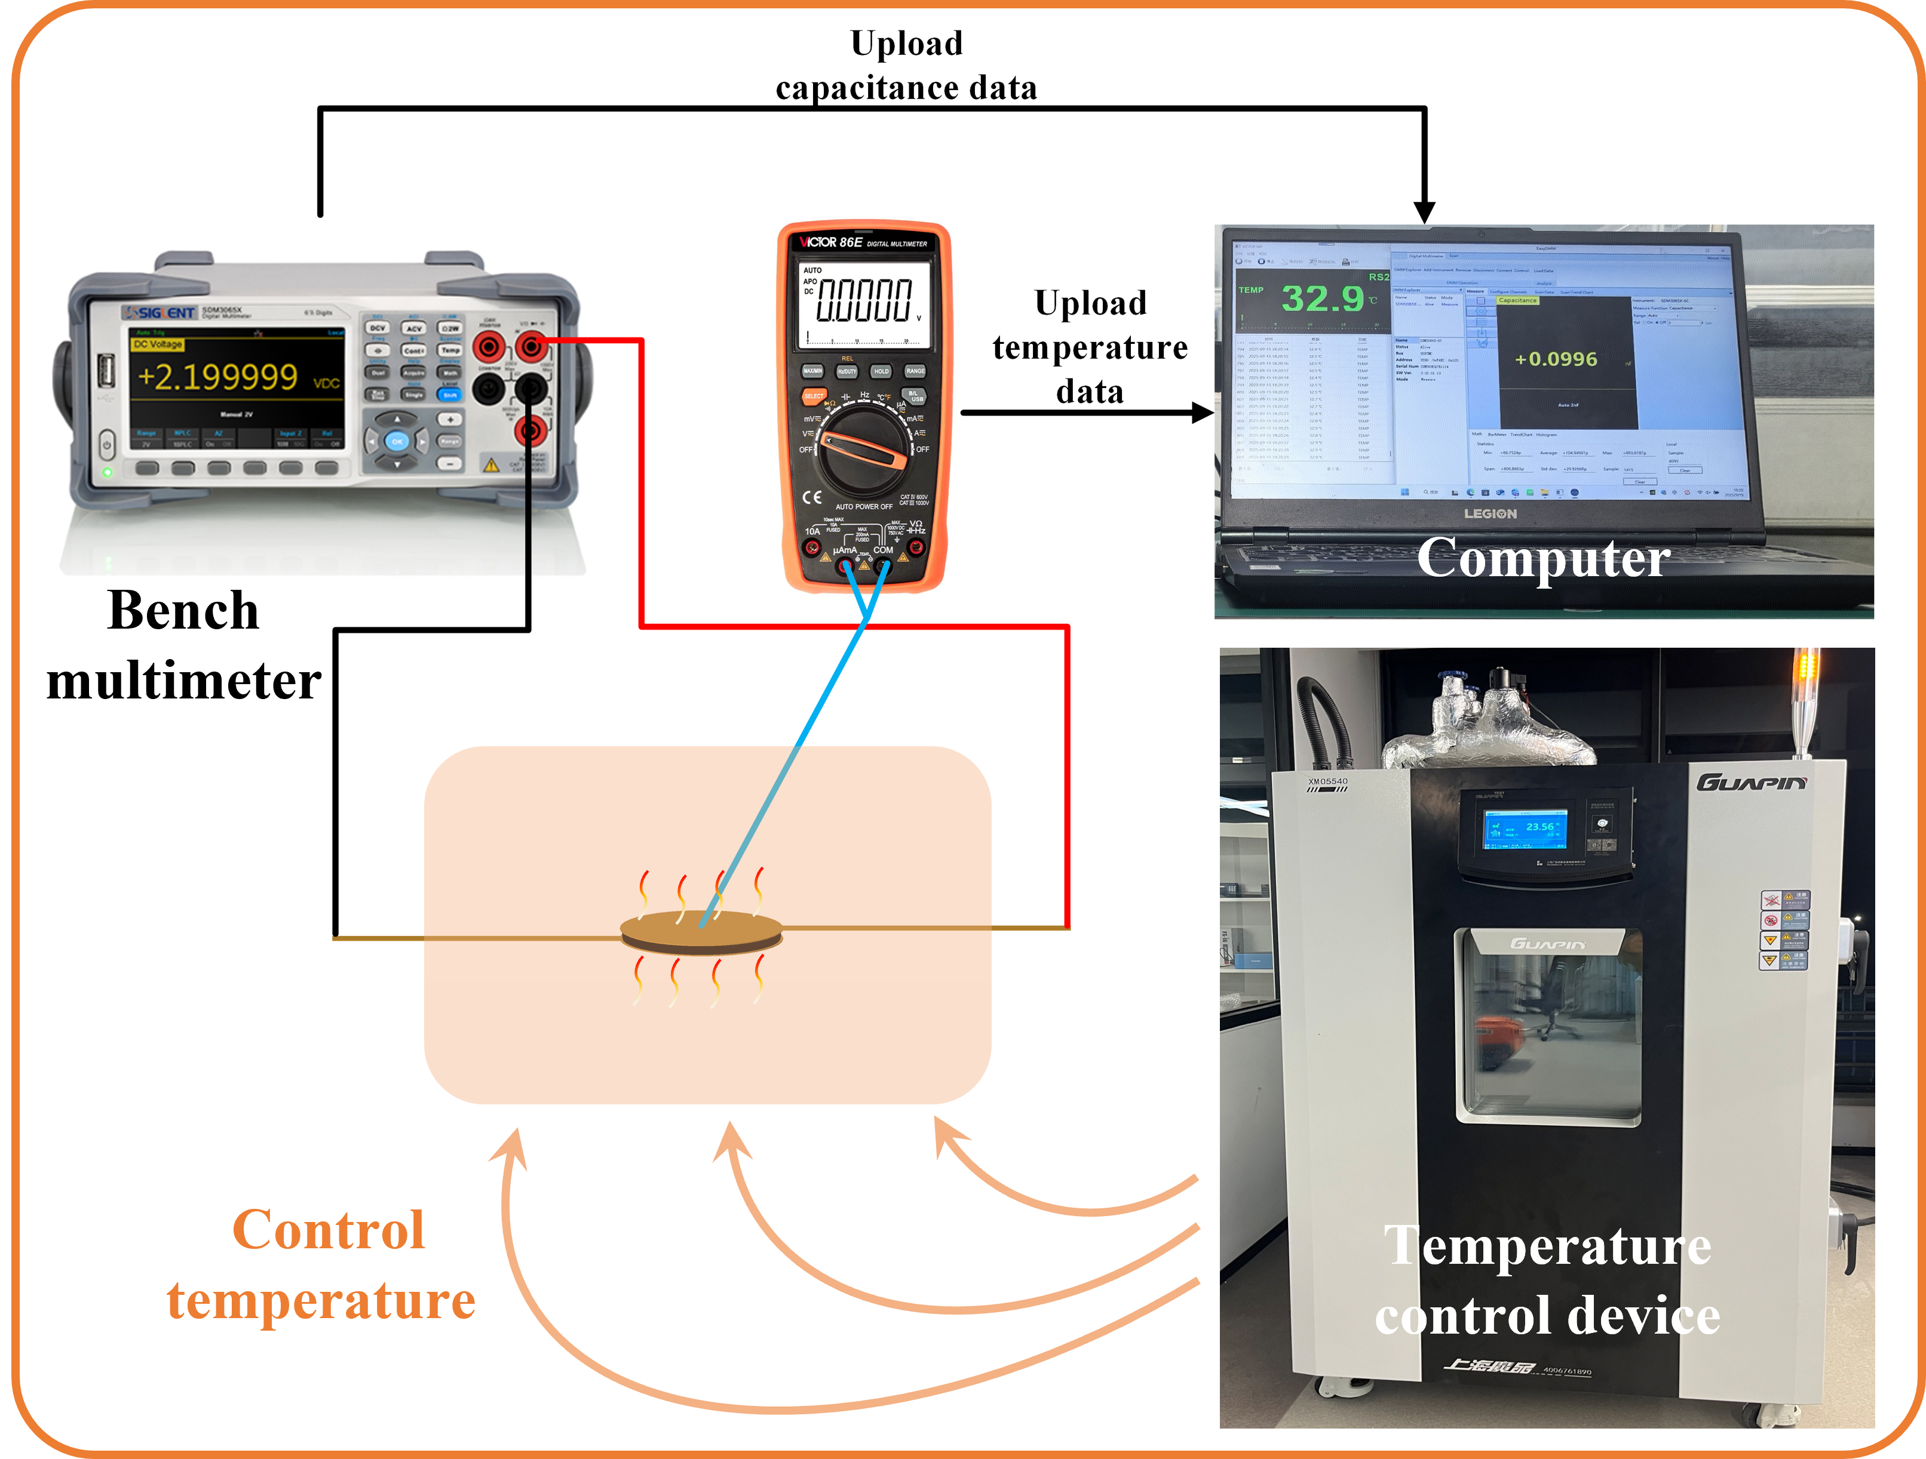

Fig. S11 Temperature control test bench.

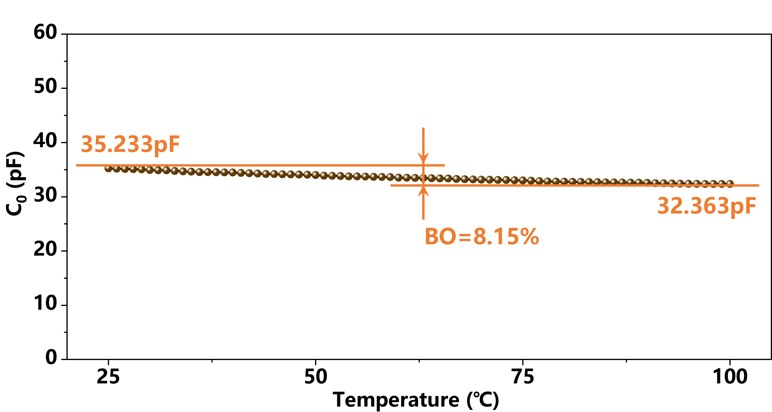

Fig. S12 Baseline offset of capacitive sensors at 25-100 ℃
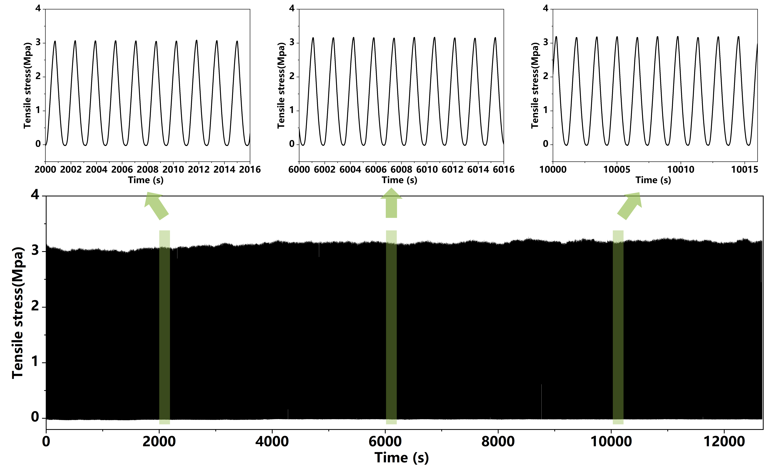

Fig. S13 Durability test of the sensing layer subjected to 8000 cycles of reciprocating tension at 20% strain.

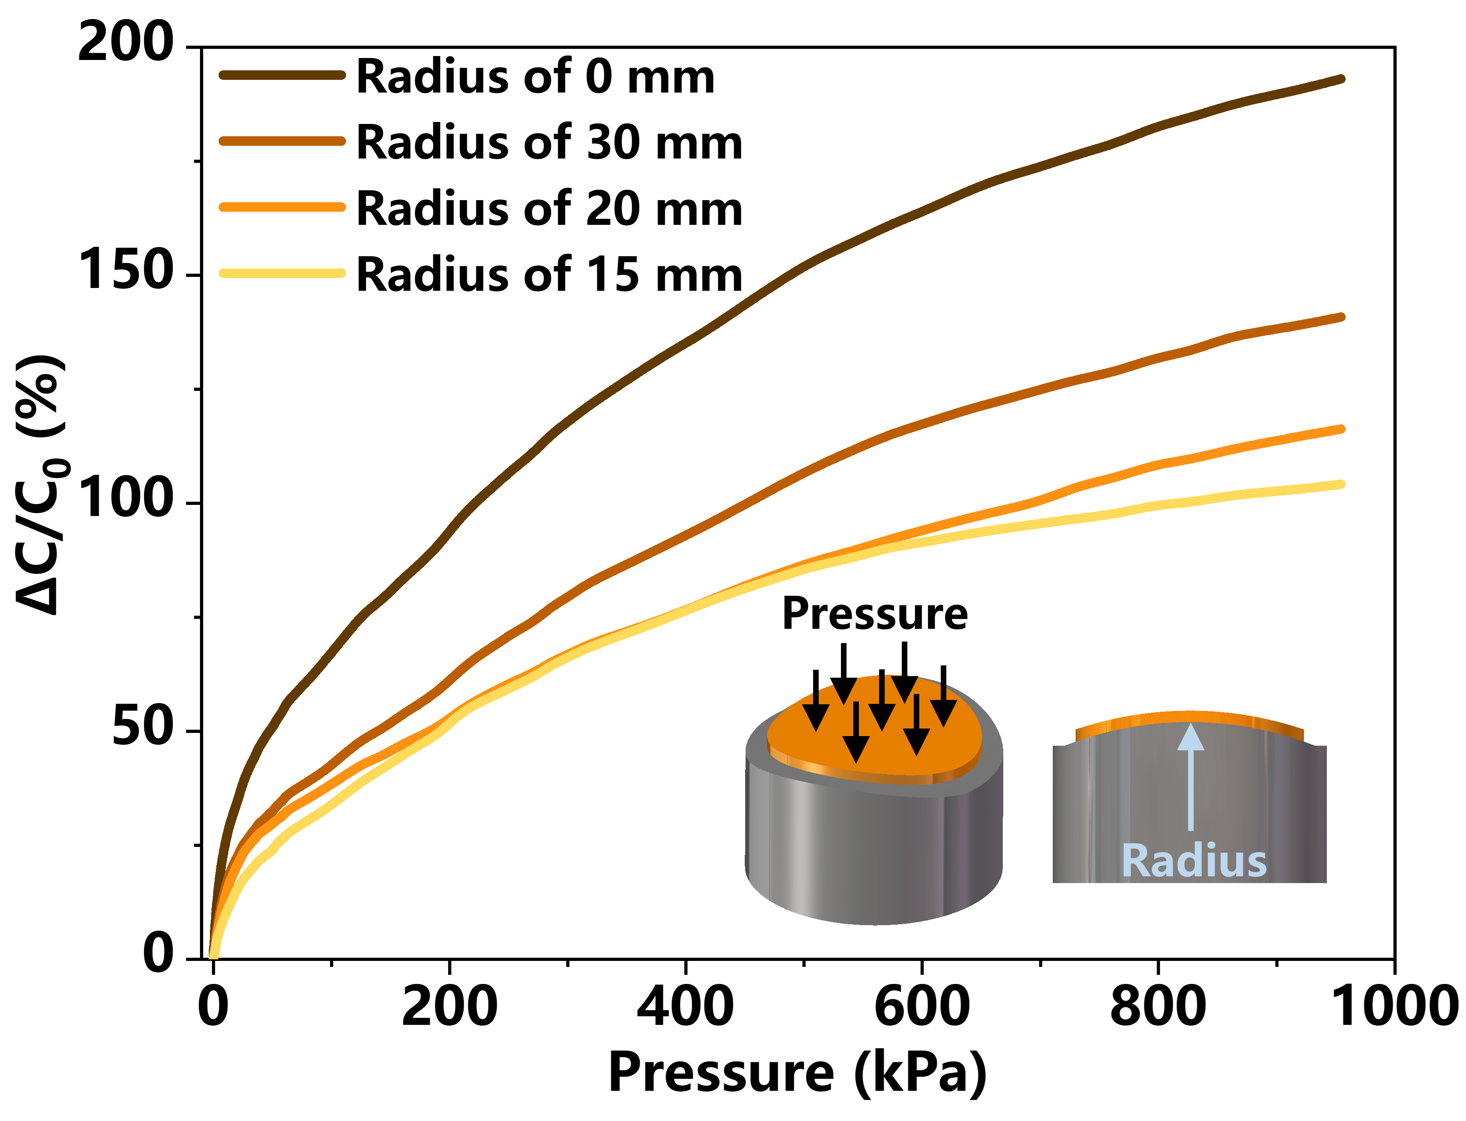

Fig. S14 Pressure-sensing performance of the flexible capacitive sensor under different bending conditions.

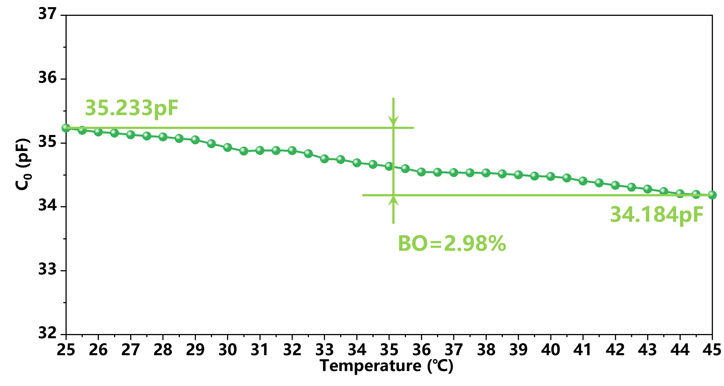

Fig. S15 Baseline offset of capacitive sensors at 25-45 ℃.

Table S8 Piecewise pressure sensitivity of the sensor under different bending radii.
Radius (mm) | Sensitivity (kPa⁻¹) | Linear range (kPa)
0 | 0.04 | 0–3.18
0 | 0.0097 | 3.18–31.8
0 | 0.0027 | 31.8–318
0 | 0.0011 | 318–954
30 | 0.0201 | 0–3.18
30 | 0.00678 | 3.18–31.8
30 | 0.00190 | 31.8–318
30 | 0.000909 | 318–954
20 | 0.0178 | 0–3.18
20 | 0.00659 | 3.18–31.8
20 | 0.00151 | 31.8–318
20 | 0.000746 | 318–954
15 | 0.0148 | 0–3.18
15 | 0.00521 | 3.18–31.8
15 | 0.00173 | 31.8–318
15 | 0.000535 | 318–954
As summarized in Table S8, the pressure sensitivity gradually decreases with decreasing bending radius, indicating that bending deformation influences the initial sensing state of the device. Nevertheless, the sensor preserves the same piecewise pressure-response ranges and remains responsive over the full pressure range of 0–954 kPa under all tested bending conditions, confirming its stable pressure-sensing capability on curved surfaces.

