Self-powered Rehabilitation Monitoring via Cation-Regulated Interfacial Polarization in Fluoride-filled P(VDF-TrFE) sensors

Yingjuan Yan,ª Weimin Xia,^{a,*} Yinghui Wang,ª Haixuan Ren,^{b} Wei Xia,^{b} Jing Li,^{b} Xusheng Wang,^{b} Zhicheng Zhang,^{c, *}

- School of Materials Science and Engineering, Xi’an University of Technology, Xi’an 710048, China.
- College of Printing, Packaging and Digital Media, Xi’an University of Technology, Xi’an 710054, China.
- School of Chemistry, Xi’an Jiaotong University, Xi’an 710049, China.

*Authors to whom correspondence should be addressed:
Dr. Weimin Xia, Email: xiaweimin@xaut.edu.cn (W. Xia).

1. Piezoelectric properties of composites

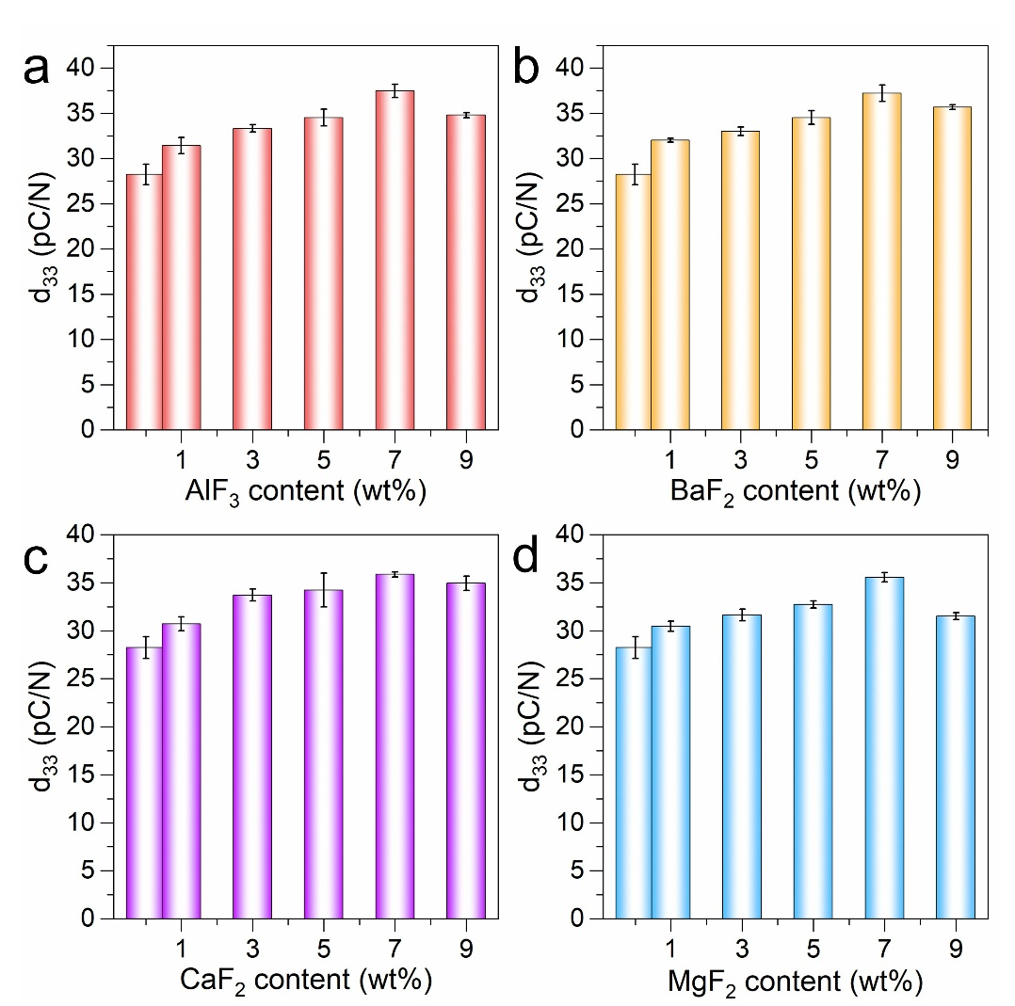
Figure S1 (a-d) show the quasi-static |d₃₃| curves of the composite film as a function of the AlF₃, BaF₂, CaF₂, and MgF₂ content, respectively
2. Crystal structure of composite films

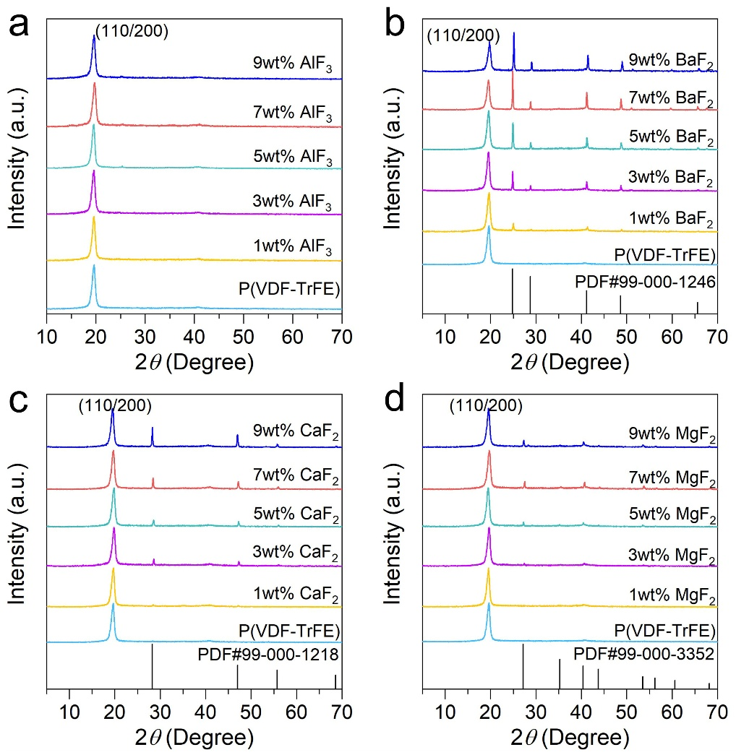
Figure S2 (a-d) show the XRD patterns of a series of P(VDF-TrFE) samples doped with different concentrations of AlF₃, BaF₂, CaF₂, and MgF₂

Table 1 β phase diffraction peak related to P(VDF-TrFE) was subjected to FWHM quantitative analysis
Sample | 2θ (°) | FWHM (°) | θ | β (rad) | D (nm)
P(VDF-TrFE) | 19.3 | 0.77 | 9.650 | 0.01344 | 10.47
PA | 19.69 | 0.90 | 9.845 | 0.01571 | 8.96
PB | 19.52 | 0.84 | 9.760 | 0.01466 | 9.60
PC | 19.62 | 0.85 | 9.810 | 0.01484 | 9.48
PM | 19.67 | 0.88 | 9.835 | 0.01536 | 9.16

3. Phase transition kinetics of composite films
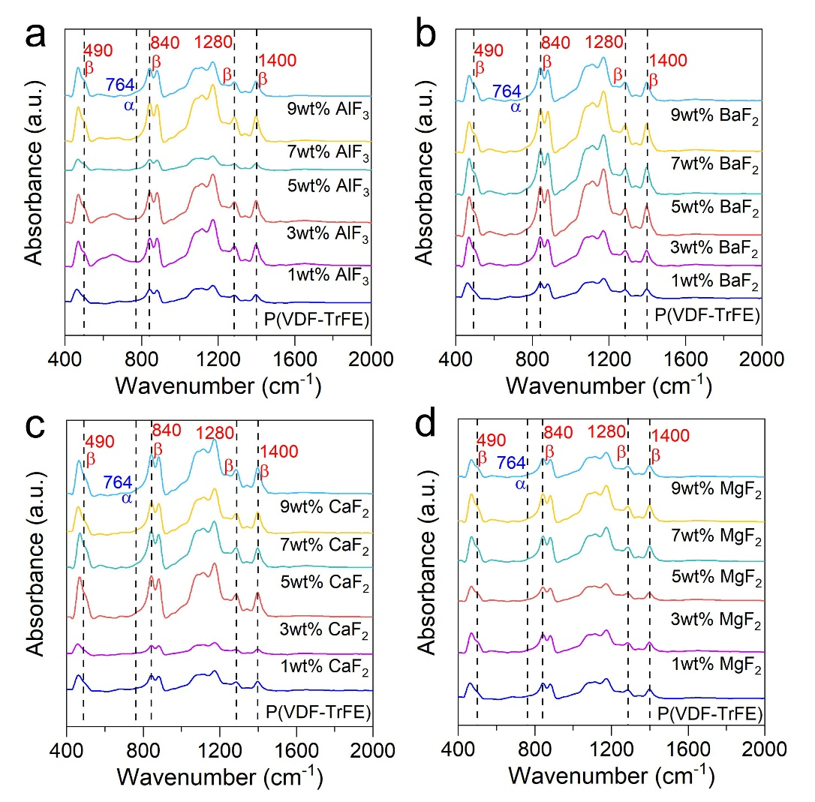
Figure S3 (a-d) show the FTIR spectra of a series of P(VDF-TrFE) samples doped with different concentrations of AlF₃, BaF₂, CaF₂, and MgF₂

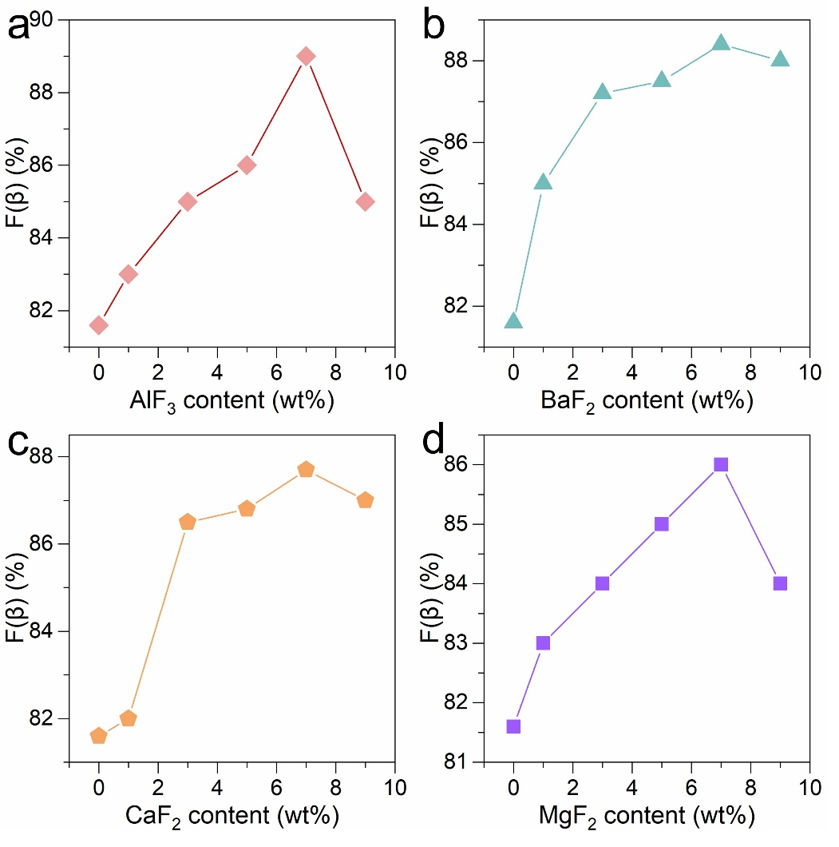
Figure S4 (a-d) show the curves depicting the variation of the β-phase content in P(VDF-TrFE) doped with different concentrations of AlF₃, BaF₂, CaF₂, and MgF₂ as a function of doping concentration

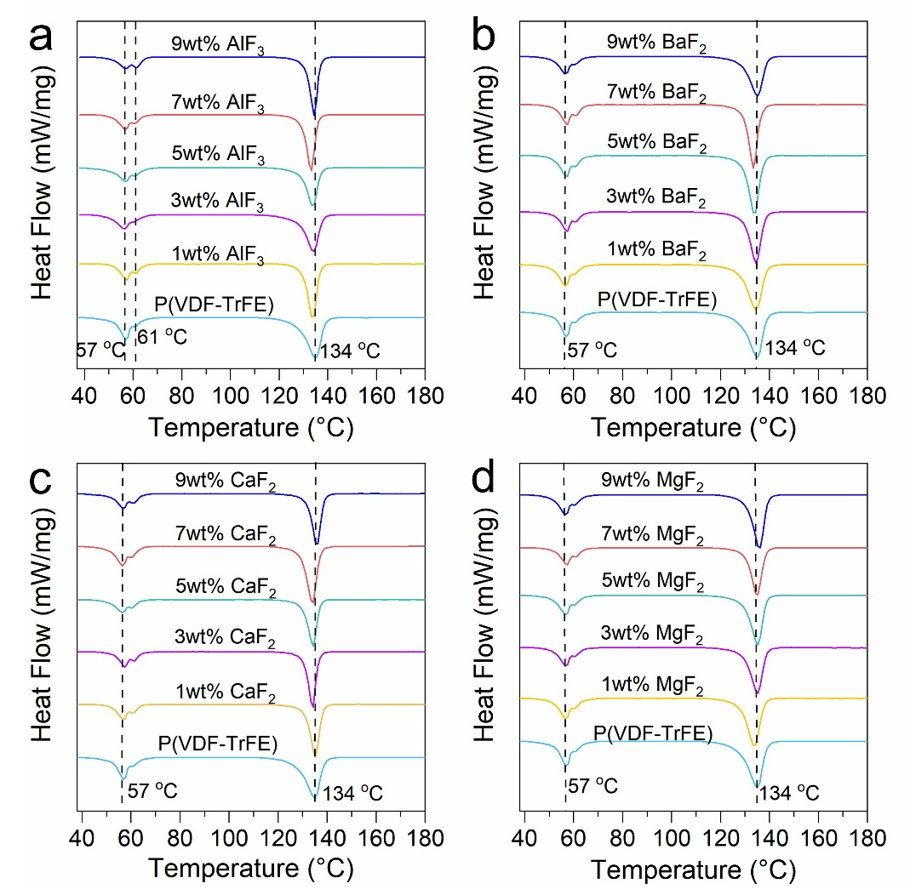
Figure S5 (a-d) show a series of DSC curves for P(VDF-TrFE) doped with different concentrations of AlF₃, BaF₂, CaF₂, and MgF₂, respectively
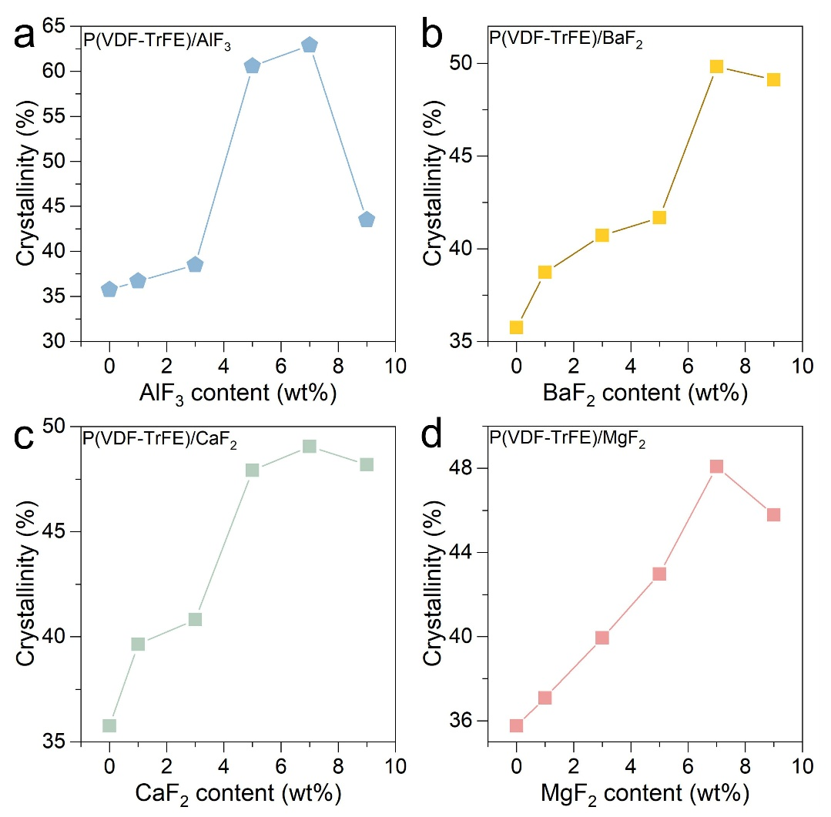
Figure S6 (a-d) Plot of crystallinity versus doping concentration for P(VDF-TrFE) doped with different amounts of AlF₃, BaF₂, CaF₂, and MgF₂

4. XPS Spectroscopy of samples

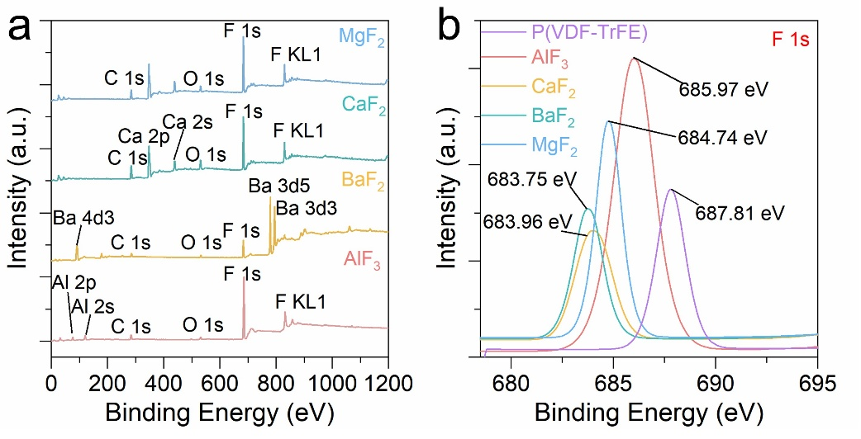
Figure S7 (a) High-resolution XPS total spectra of AlF₃, BaF₂, CaF₂, and MgF₂ powders (b) High-resolution F 1s XPS spectra of P(VDF-TrFE), AlF₃, BaF₂, CaF₂, and MgF₂ powders, respectively

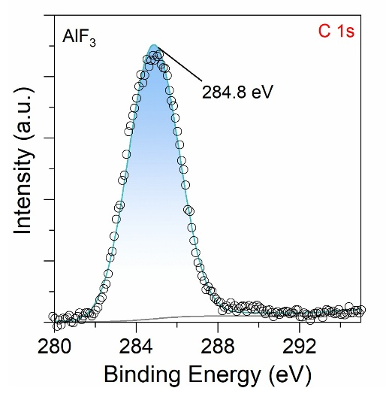
Figure S8 High-resolution C1s XPS fitting of AlF₃ powders

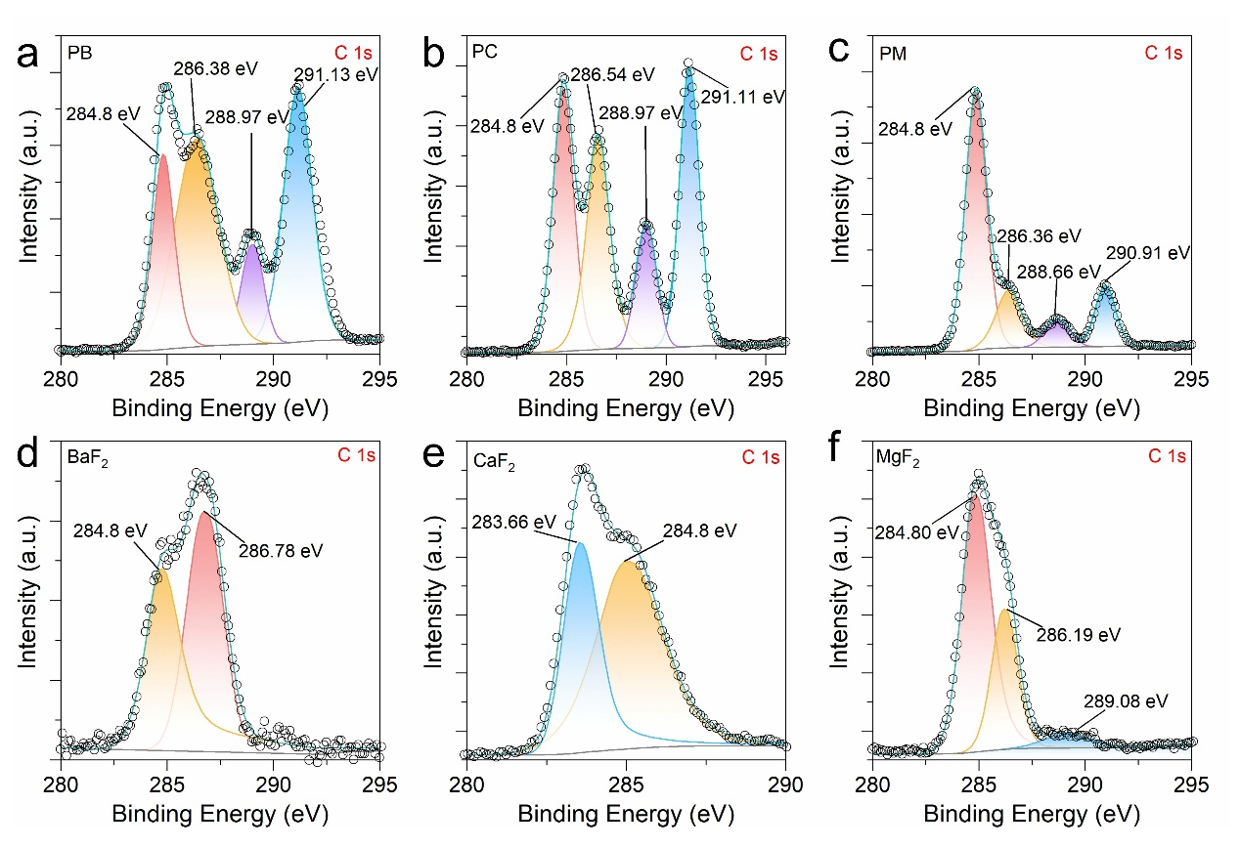
Figure S9 (a-c) show the high-resolution XPS spectra of the C1s peak in the PB, PC, and PM composite films, respectively (d-f) show the high-resolution XPS spectra of the C1s peak in BaF₂, CaF₂, and MgF₂ powders, respectively

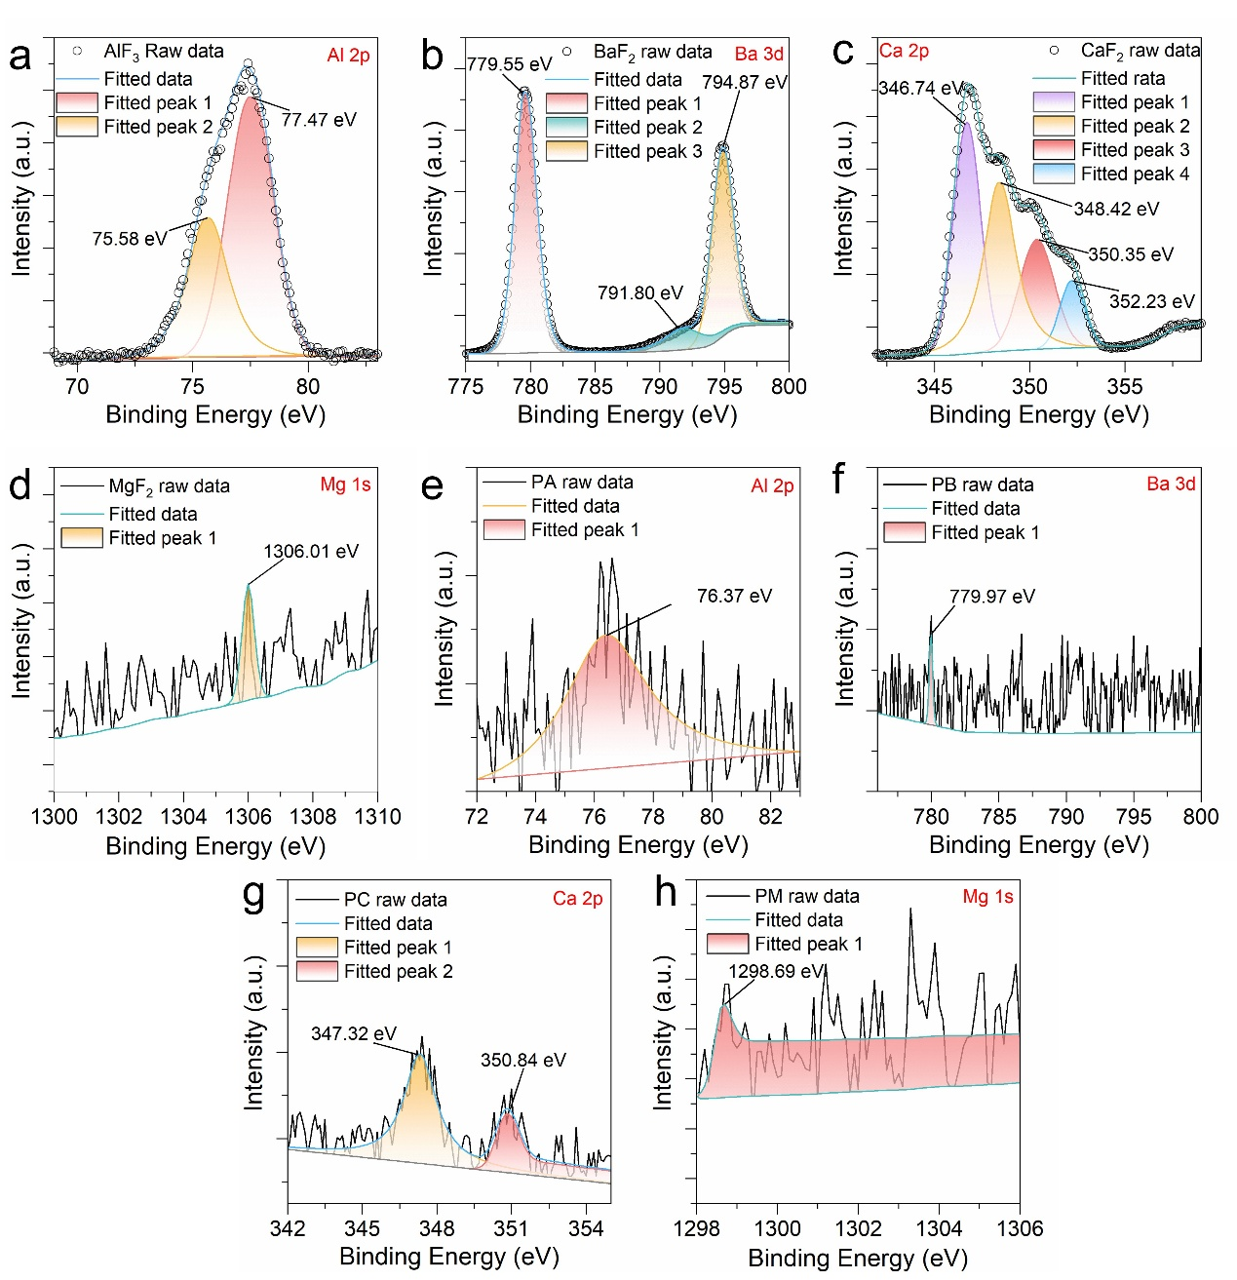
Figure S10 (a-d) show the high-resolution XPS spectra of the cations Al 2p, Ba 3d, Ca 2p, and Mg 1s in AlF₃, BaF₂, CaF₂, and MgF₂ powders, respectively (e-h) show the high-resolution XPS spectra of the cations Al 2p, Ba 3d, Ca 2p, and Mg 1s in the PA, PB, PC, and PM composite films, respectively

5. Dielectric properties of composites

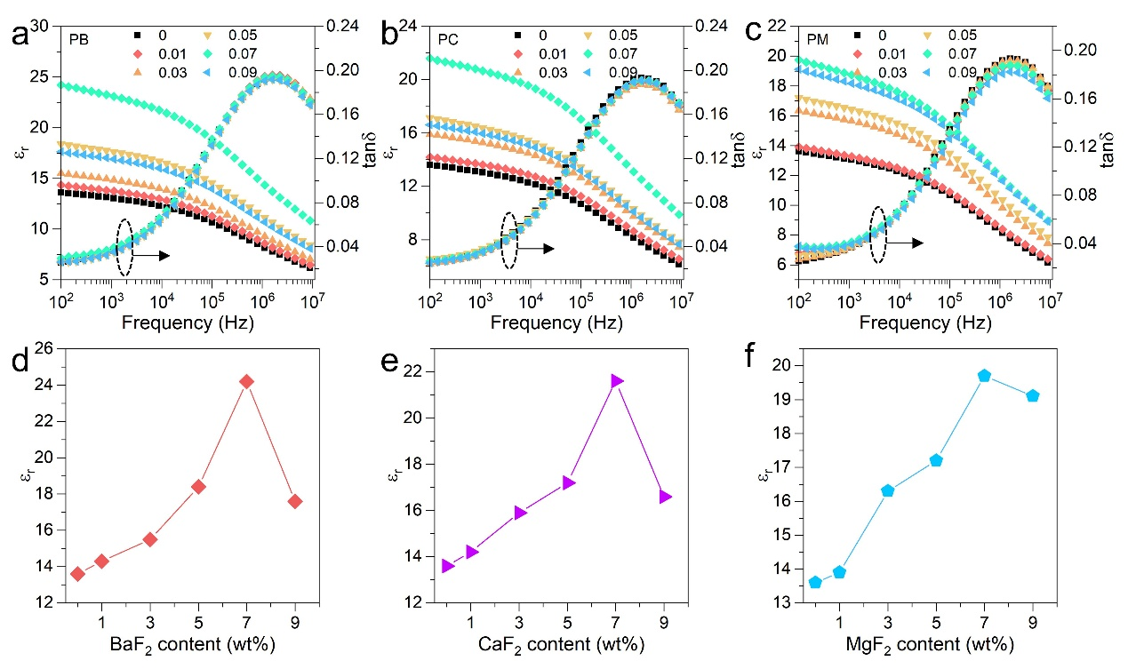
Figure S11 (a-c) show the frequency-dependent dielectric properties of P(VDF-TrFE) doped with different concentrations of BaF₂, CaF₂, and MgF₂, respectively (d-f) show the corresponding plots of the dielectric constant as a function of doping concentration

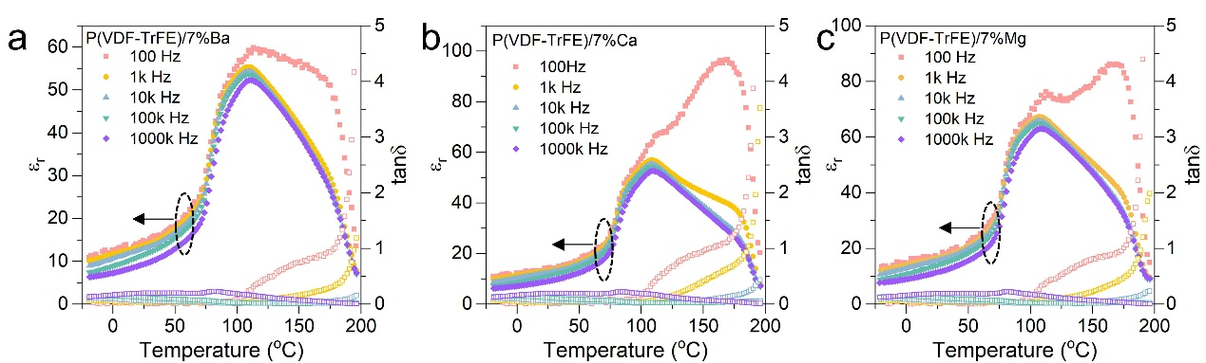
Figure S12 (a-c) show the dielectric temperature spectra of P(VDF-TrFE) doped with 7% BaF₂, CaF₂, and MgF₂, respectively, in the frequency range of 100 Hz to 1 MHz

6. Electrical Properties of composites

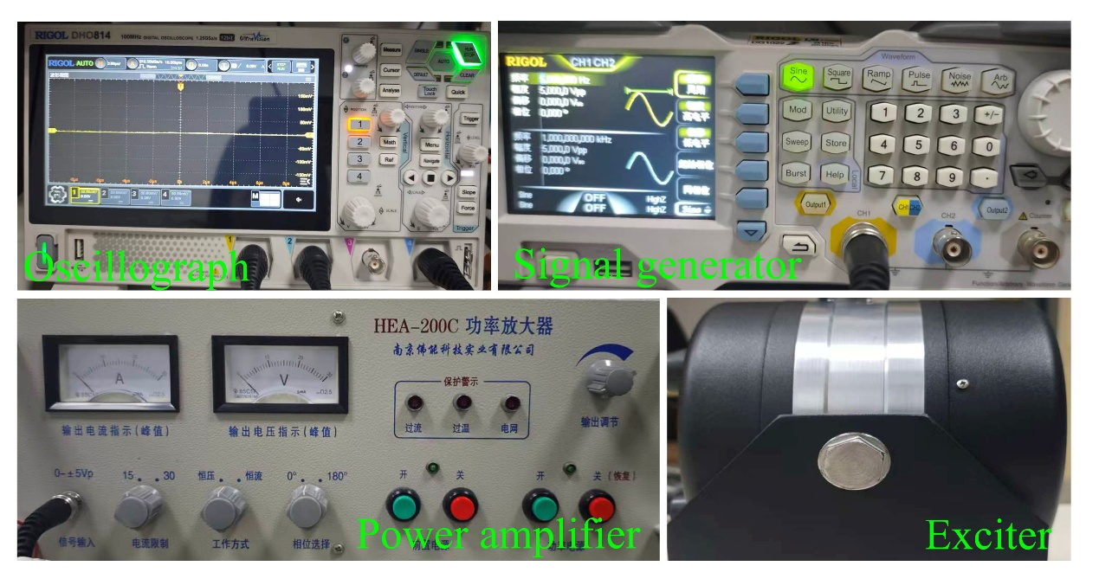
Figure S13 Electrical test devices

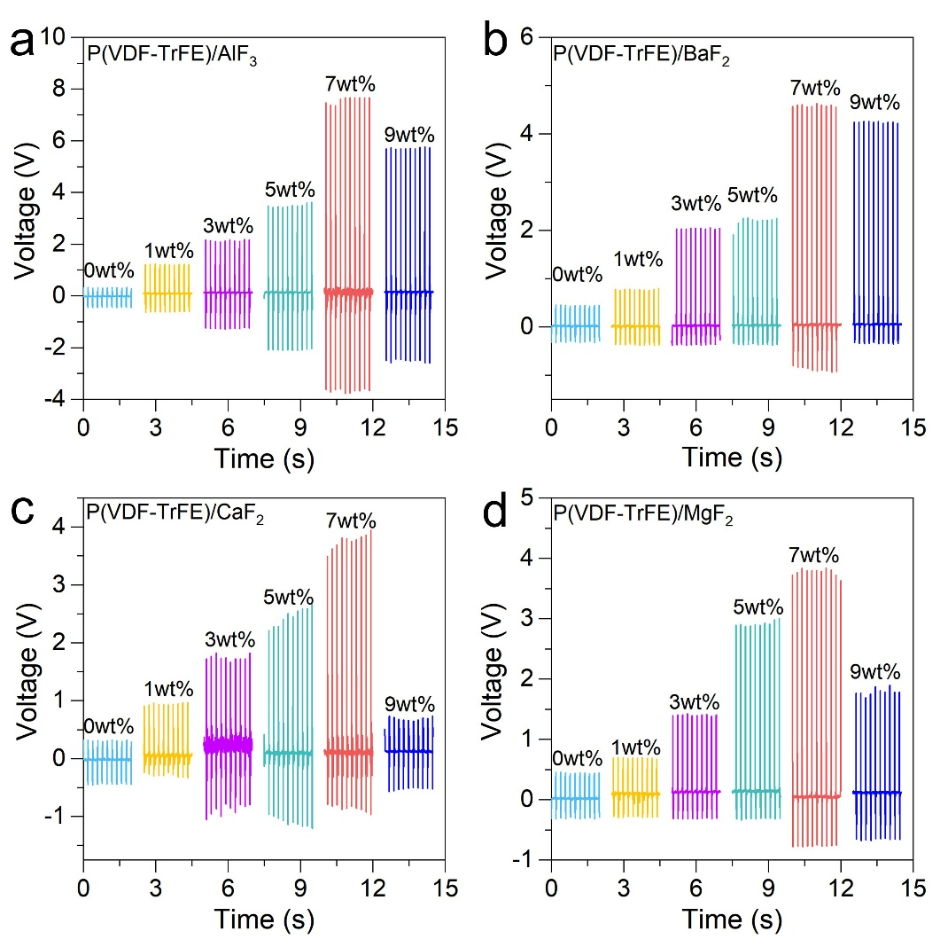
Figure S14 (a-d) show the electrical output characteristics of P(VDF-TrFE) doped with different concentrations of AlF₃, BaF₂, CaF₂, and MgF₂, respectively

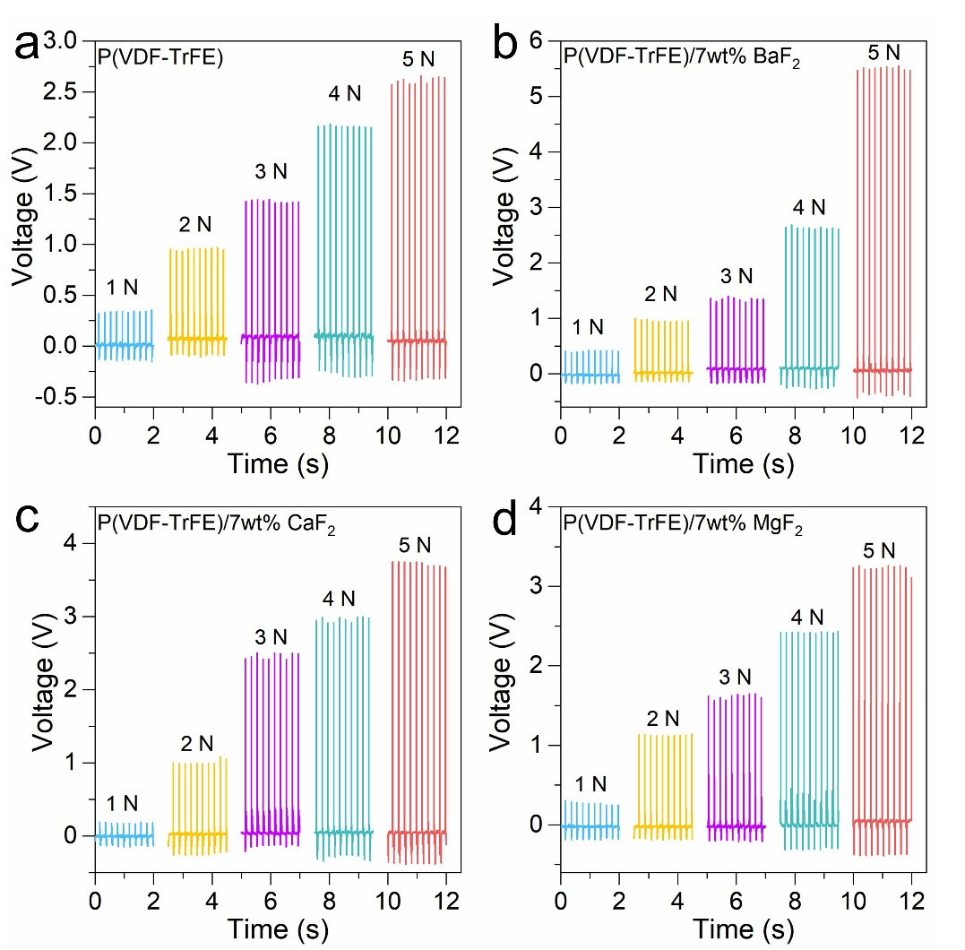
Figure S15 (a-d) show the frequency dependence of the output voltages of the P(VDF-TrFE), PB, PC, and PM piezoelectric sensors, respectively

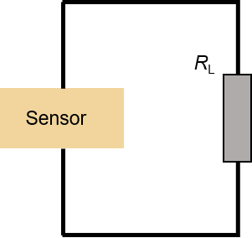
Figure S16 Circuit Diagram for an External Load

