Supplementrary information
Chain-length-dependent structure–activity relationships in the deep oxidation of multi-component aldehydes over an S-scheme ternary bismuth oxynitride/titanium dioxide/graphite heterojunction photocatalyst

Yan Luª, Sherif A. Younis^{a, b}, Ki-Hyun Kim^{a,} *

ªDepartment of Civil and Environmental Engineering, Hanyang University, 222 Wangsimni-Ro, Seoul 04763, Republic of Korea
^{b}Analysis and Evaluation Department, Egyptian Petroleum Research Institute, Nasr City, Cairo 11727, Egypt

*Corresponding Author: Ki-Hyun Kim (kkim61@nate.com, kkim61@hanyang.ac.kr)

Note S1 Reaction regime in the closed chamber using the 3D HC filter
To determine whether the measured rates were limited by aldehyde delivery to the catalyst, we estimated the gas-phase mass-transfer coefficient in the monolith channels, k_{g}, from the Sherwood correlation for monolith reactors (Eqs. S1-S4) ^{[1]}. The apparent first-order constant measured in the chamber was placed on the same basis as a surface rate coefficient, k_{s}, by multiplying it by the ratio of the chamber volume to the geometric catalyst area (Eq. S5). Over the fan settings used, k_{g} exceeded k_{s} by a factor of 128 to 175 (Table S1), so the aldehyde concentration at the catalyst surface stayed within 0.8% of the bulk value (Eq. S6) and the reaction was not limited by external diffusion.
$Re=\frac{ud}{ν}$ (S1)
$Sc=\frac{ν}{D}$ (S2)
$Sh=3.66{\left[1+0.095\frac{d}{L}Re Sc\right]}^{0.45}$ (S3)
$k_{g}=\frac{ShD}{d}$ (S4)
$k_{s}=\frac{k_{app}V}{A} , A=πdLN$ (S5)
$\frac{C_{s}}{C_{b}}={\left(1+\frac{k_{s}}{k_{g}}\right)}^{-1}$ (S6)

Table S1. Parameters and results of the mass-transfer estimate. Three values correspond to the 100, 130, and 160 L min⁻¹ fan settings.
Parameter | Value | Source
Channel diameter, d | 2.0 mm | measured
Channel length, L | 10 mm | measured
Number of channels, N | 441 | measured
Catalyst area, A | 0.0277 m² | πdLN
Channel velocity, u | 1.20 / 1.56 / 1.92 m s−1 | Q / (N π d² / 4)
Diffusivity of FA in air, D | 0.174 cm² s⁻¹ | ^{[2]}
Schmidt number, Sc | 0.90 | Eq. S2
Reynolds number, Re | 154 / 200 / 247 | Eq. S1
Sherwood number, Sh | 6.54 / 7.14 / 7.69 | Eq. S3
Mass-transfer coefficient, k_{g} | 0.057 / 0.062 / 0.067 m s⁻¹ | Eqs. S3, S4
Surface rate coefficient, k_{s} | 3.3 / 4.9 / 4.2 × 10⁻⁴ m s⁻¹ | Eq. S5
k_{g}/k_{s} | 175 / 128 / 161 | —

Table S2. Experimental design matrix for the photocatalytic removal of aldehyde VOCs.
Order | Stage | Catalysts | Aldehydes/C₀ (ppm) | Flow rate  (L min⁻¹) | RH  (%) | Light source/duration | Monitoring instruments | Results
1 | Catalyst screening test | All catalysts | Single FA at 100 ppm | 160 | 0 | dark run (80 min), then FA re-injected and 1 W UV-LED run (80 min) | GC-FID | Table 3; Fig. 8a-b
2 | Effect of catalyst loading | TGBN-10  (0.05 and 0.10 g HC filter) | Single FA at 5 ppm | 160 | 0 | 1 W UV-LED / 10 min | Electrochemical sensor | Table 4[A]; Fig. 9a
3 | Single aldehydes  (FA, AA, PA, and VA) | TGBN-10 | Single FA, AA, PA, and VA vapors (C₀ =100 ppm each) | 160 | 0 | 1 W UV-LED / 80 min | GC-FID | Table 4[B]-1; Fig. 9b
4 | Effect of component complexity and loading concentration | TGBN-10 | Mixed FA, AA, PA, and VA component mixture (C₀ = 100-400 ppm total) | 160 | 0 | 1 W UV-LED / 80 min | GC-FID | Table 4[B]-2 to 4; Fig. 9c
5 | Effect of airflow rate | TGBN-10 | Mixed-component (n = 4 aldehydes, C₀ = 100 ppm total, each at 25 ppm) | 100 / 130 / 160 | 0 | 1 W UV-LED / 80 min | GC-FID | Table 5[A]; Fig. 9d
6 | Effect of RH | TGBN-10 |  | 160 | 0 -80% | 1 W UV-LED / 80 min | GC-FID | Table 5[B]; Fig. 9e
7 | Reuse cycling | TGBN-10 |  | 160 | 0 | 1 W UV-LED /80 min over five consecutive cycles | GC-FID | Fig. 9f
8 | Mineralization and CO₂ evolution | TGBN-10 | Single vs mixed aldehydes (C₀ = 100 ppm). In the mixture, total C₀ = 100 ppm, with each at 25 ppm. | 160 | 0 | 1 W UV-LED / 80 min | GC-FID (CO₂) | Fig. 12

Table S3. One-way ANOVA statistics for PCO of aldehyde species onto the prepared TGBN-x filter under varying operational conditions.
Response | Source | df | Sum of squares (SS) | Mean square (MS) | F-value | p-value
(a) Catalyst screening (8 catalysts; 100 ppm FA, dry air, 1 W UV-LED, 80 min)
RE (%) | Catalyst | 7 | 2.45 × 10³ | 350 | 37.5 | <0.0001
RE (%) | Error | 16 | 149 | 9.33
RE (%) | Total | 23 | 2.60 × 10³
k (min⁻¹) | Catalyst | 7 | 2.11 × 10⁻³ | 3.02 × 10⁻⁴ | 32.4 | <0.0001
k (min⁻¹) | Error | 16 | 1.49 × 10⁻⁴ | 9.31 × 10⁻⁶
k (min⁻¹) | Total | 23 | 2.26 × 10⁻³
(b) Aldehyde chain length (FA, VA, PA, AA; 100 ppm each)
Single component | Aldehyde | 3 | 1.12 × 10⁴ | 3.73 × 10³ | 693 | <0.0001
Single component | Error | 8 | 43.0 | 5.38
Single component | Total | 11 | 1.12 × 10⁴
Four-component mixture | Aldehyde | 3 | 7.73 × 10³ | 2.58 × 10³ | 653 | <0.0001
Four-component mixture | Error | 8 | 31.6 | 3.95
Four-component mixture | Total | 11 | 7.77 × 10³
(c) Loading of the four-component mixture (100, 200, 400 ppm total)
FA | Loading | 2 | 1.33 × 10³ | 666 | 95.3 | <0.0001
FA | Error | 6 | 41.9 | 6.98
FA | Total | 8 | 1.37 × 10³
AA | Loading | 2 | 14.8 | 7.41 | 44.3 | 0.000255
AA | Error | 6 | 1.00 | 0.167
AA | Total | 8 | 15.8
PA | Loading | 2 | 479 | 239 | 152 | <0.0001
PA | Error | 6 | 9.47 | 1.58
PA | Total | 8 | 488
VA | Loading | 2 | 86.6 | 43.3 | 4.33 | 0.0685
VA | Error | 6 | 60.0 | 10.0
VA | Total | 8 | 147
(d) AP flow rate (100, 130, 160 L min⁻¹; 100 ppm total)
FA | Flow rate | 2 | 364 | 182 | 19.0 | 0.00254
FA | Error | 6 | 57.5 | 9.59
FA | Total | 8 | 422
AA | -
AA | - | - | - | - | - | -
PA | Flow rate | 2 | 69.5 | 34.8 | 26.7 | 0.00103
PA | Error | 6 | 7.81 | 1.30
PA | Total | 8 | 77.3
VA | Flow rate | 2 | 384 | 192 | 19.4 | 0.00241
VA | Error | 6 | 59.4 | 9.91
VA | Total | 8 | 443
(e) Relative humidity (0, 20, 50, 80%; 100 ppm total)
FA | RH | 3 | 264 | 87.9 | 8.50 | 0.00720
FA | Error | 8 | 82.7 | 10.3
FA | Total | 11 | 346
AA | RH | 3 | 58.5 | 19.5 | 123 | <0.0001
AA | Error | 8 | 1.27 | 0.159
AA | Total | 11 | 59.7
PA | RH | 3 | 328 | 109 | 148 | <0.0001
PA | Error | 8 | 5.90 | 0.737
PA | Total | 11 | 334
VA | RH | 3 | 773 | 258 | 39.6 | <0.0001
VA | Error | 8 | 52.0 | 6.50
VA | Total | 11 | 825
Note: RE refers to removal efficiency after 80 min; k = first-order rate constant. n = 3 independent runs per level; p < 0.05 was taken as the statistically significant level at 95% confidence.

Table S4. IR peak attributions of in situ DRIFTS spectra for TGBN-10 (Fig. 11) under 1 W UV-LED and RH = 0% (or 80%) conditions.
Wavenumber (cm⁻¹) | Assignment | Species | References
1070–1100 | ν(C–O) | DOM / oxygenated intermediates | ^{[3]}
1240–1260 | ν(C–O) | DOM / ester-like species | ^{[4]}
1320–1340 | νs(OCO) | strongly coordinated formate (HCOO⁻) | ^{[5]}
1350–1375 | νs(OCO) | bidentate formate | ^{[6]}
1410–1440 | νs(COO⁻) | surface carboxylate | ^{[6]}
1520–1560 | νas(COO⁻) | surface carboxylate | ^{[7]}
1570–1595 | νas(OCO) | formate species | ^{[6]}
1653 | ν(C=O) (coordinated) | adsorbed aldehyde/intermediate | ^{[8]}
1720–1740 | ν(C=O) | free aldehyde | ^{[9]}
2850–2960 | νas, νs(C–H) | alkyl residues (CH₂/CH₃) | ^{[10]}
3580–3650 | ν(OH) | isolated surface hydroxyls | ^{[11]}
~3400 (broad) | hydrogen-bonded ν(OH) | adsorbed H₂O | ^{[12]}
2340–2360 | ν₃(CO₂) | gaseous CO₂ | ^{[13]}

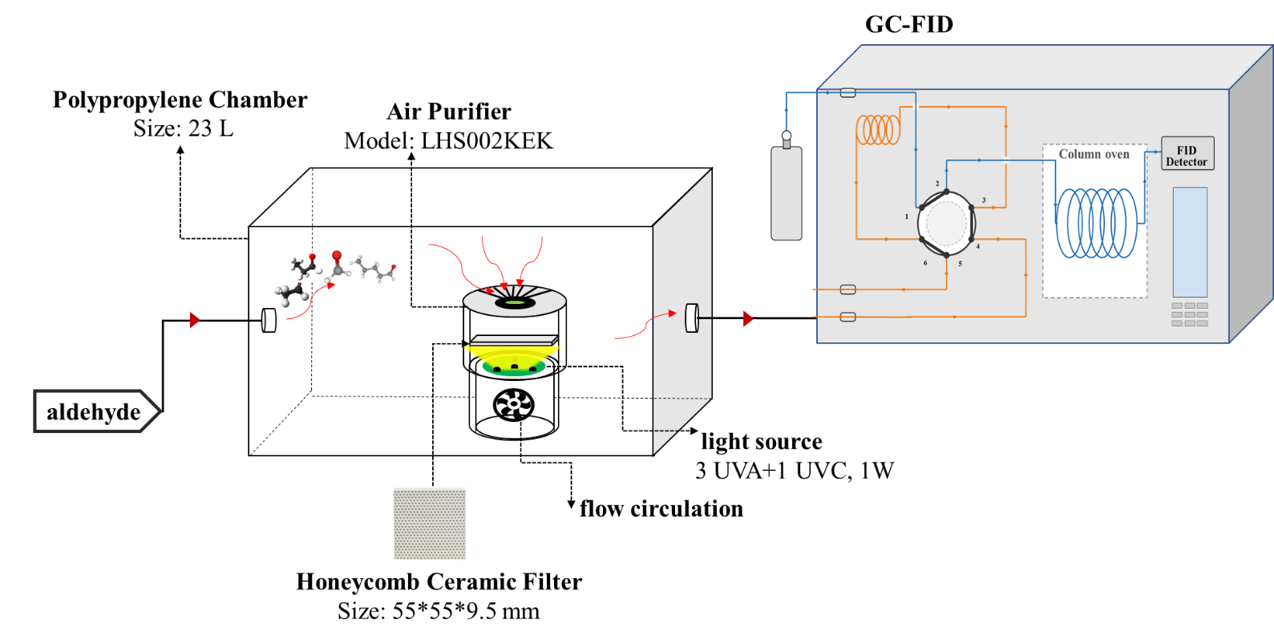
Fig. S1. Schematic of the PCO experimental setup for indoor aldehyde VOC removal across the prepared 3D HC air purifier filters and their monitoring process using a GC-FID instrument.

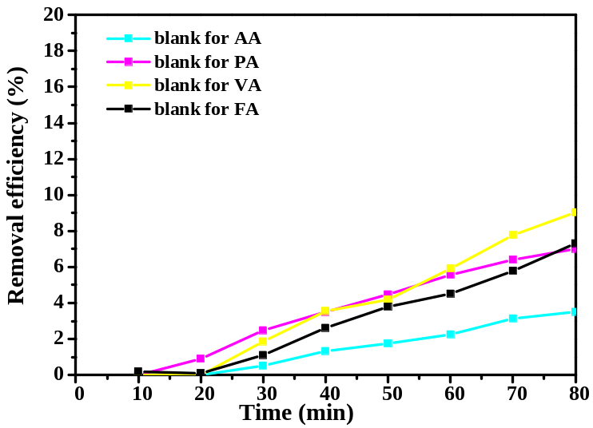
Fig. S2. The natural attenuation trends of aldehydes (C1-C5) in the simulated indoor chamber and in the absence of air purifier systems.

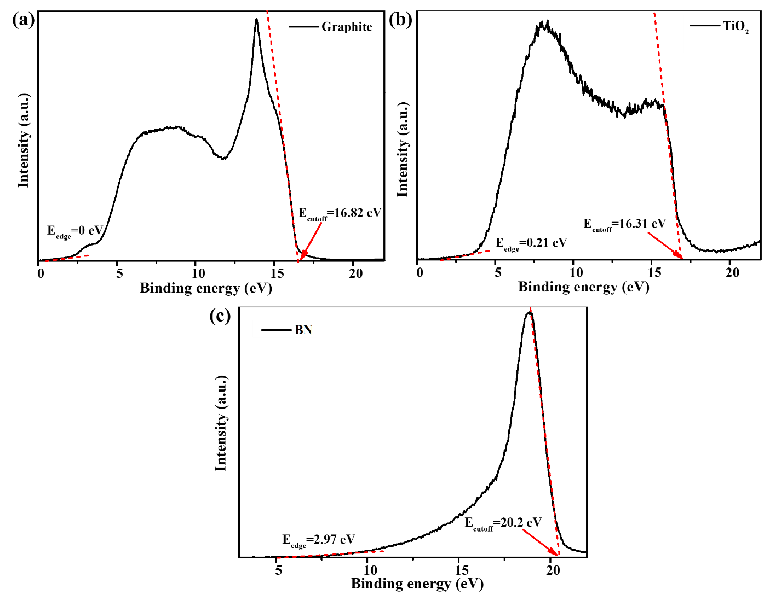
Fig. S3. UPS spectra of the prepared materials: (a) graphite, (b) TiO₂, and (c) BN.

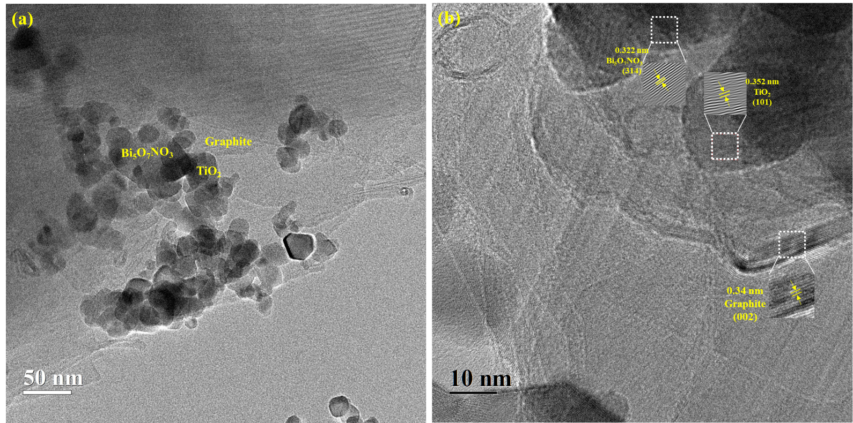
Fig. S4. HR-TEM images of the TGBN-10 after use: (a) 50,000×, and (b) 250,000×.

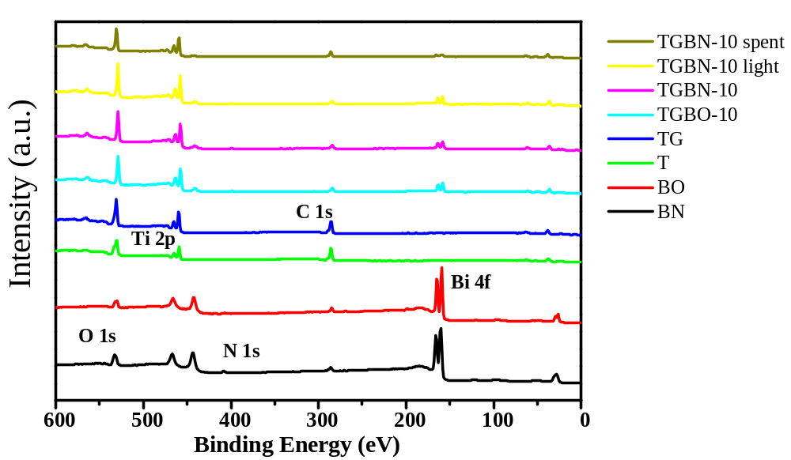
Fig. S5. XPS survey spectra of TGBN-10 vs TGBO-10 and their pristine counterparts.

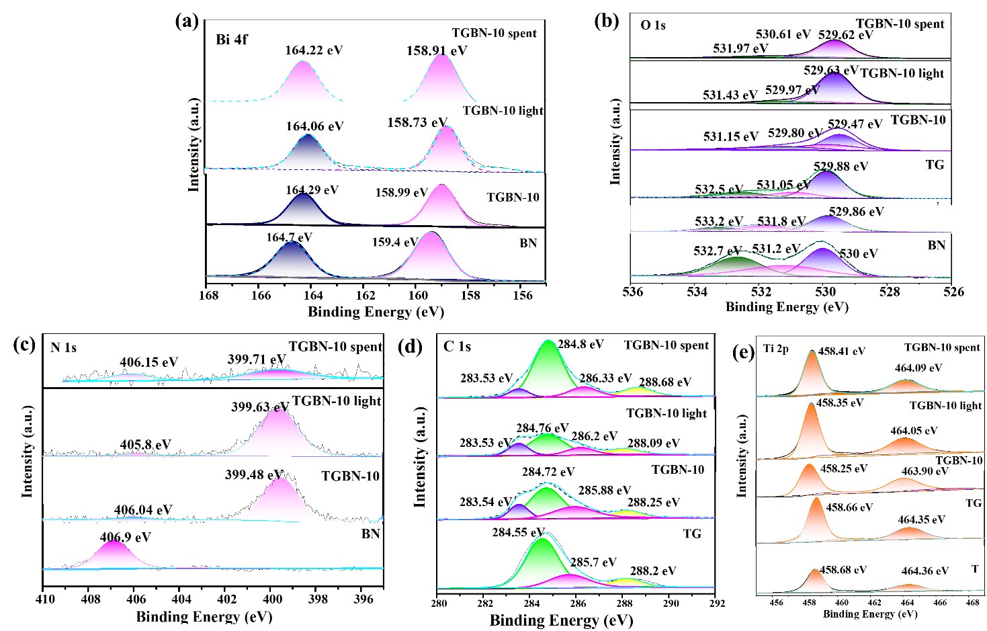
Fig. S6. XPS spectra of TGBN-10 (relative to reference photocatalysts) under light, dark, and post-PCO reaction conditions: (a) Bi 4f, (b) O 1s, (c) N 1s, (d) C 1s, and (e) Ti 2p.

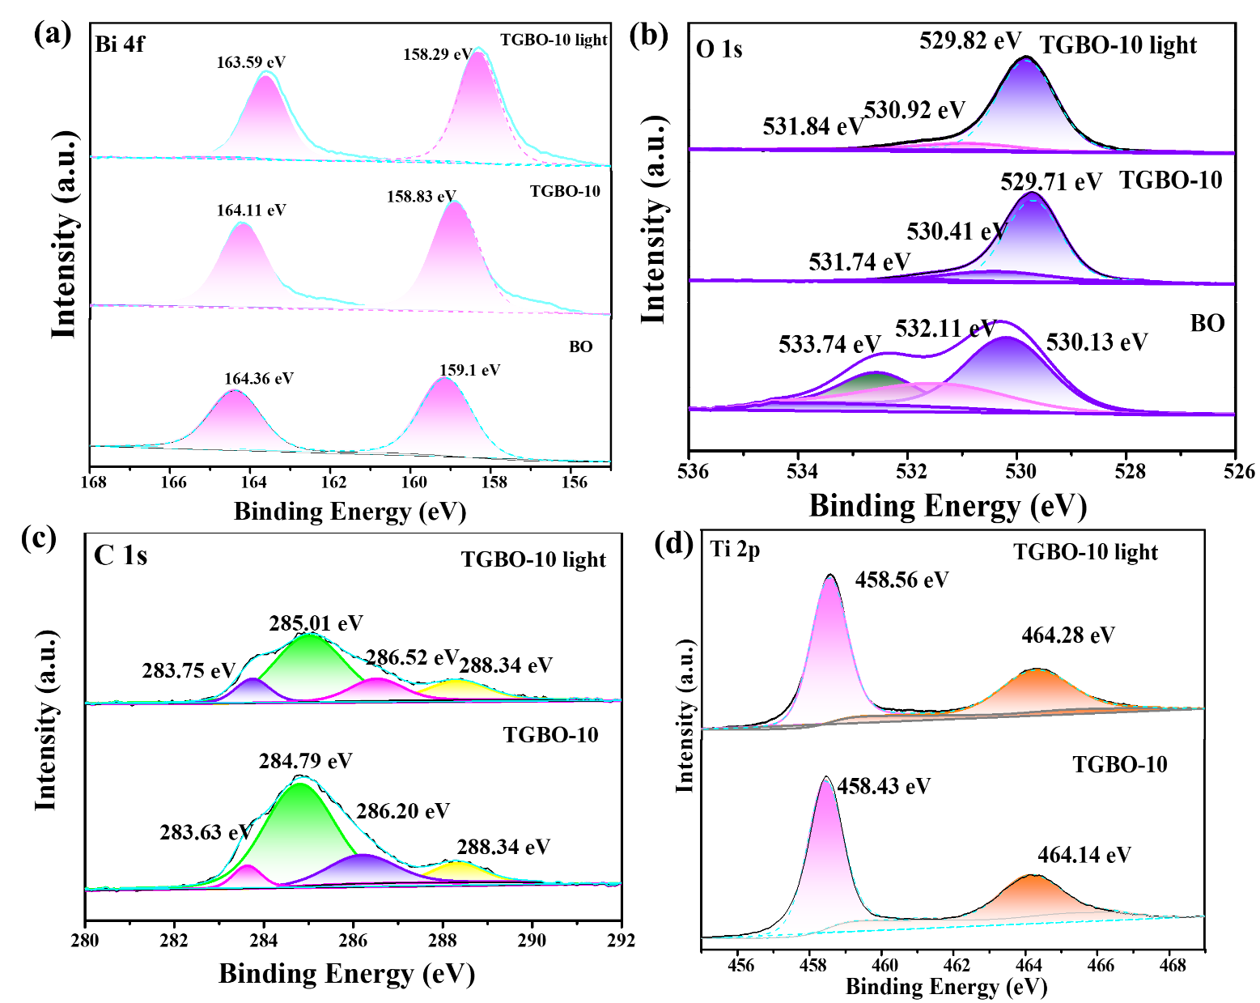
Fig. S7. XPS spectra of TGBO-10 (relative to reference photocatalysts) under light vs. dark conditions: (a) Bi 4f, (b) O 1s,(c) C 1s, and (d) Ti 2p.
Note S2: Detailed XPS core-level assignments.
This note collects the detailed core-level assignments supporting the XPS discussion in Section 3.4.3 of the main text. The corresponding spectra are presented in Figs. S5–S7, and all deconvoluted peak parameters are summarized in Table 6 of the main text.

In the pristine and binary reference materials, both BN and BO exhibit Bi³⁺-related Bi 4f signals (Figs. S6a and S7a), with a characteristic spin-orbit doublet of Bi 4f_{7/2} (BE of 159.4–159.1 eV) and Bi 4f_{5/2} (BE of 164.7 eV) ^{[14]}. In pure BN, the O 1s core-level spectrum (Fig. S6b) contains a dominant lattice oxygen (O_{latt}) peak at 530 eV, accompanied by higher-binding-energy contributions associated with nitrate oxygen species (NO₃⁻) at 531.2 eV for O–N bonding and 532.7 eV for terminal O. The N 1s feature near 406.9 eV is assigned to a coordinated NO₃⁻ group in the BN lattice (Fig. S6c) ^{[15]}. Comparatively, in pure BO, the O 1s core-level spectrum deconvolutes into three components associated with O_{latt}, defect-/adsorbed-oxygen environments (O_{vac}), and surface hydroxyl species (O_{OH}) at BEs of 530.13, 532.11, and 533.74 eV, respectively (Fig. S7b). TG displays analogous O 1s core-level features of O_{latt} at 529.88 eV, O_{vac} at 531.05 eV, and O_{OH} at 532.5 eV (Fig. S6b), together with C 1s (Fig. S6d) contributions from graphitic C–C/sp² carbon (284.55 eV), C–O (285.7 eV), and carboxyl/carbonyl groups (C=O/O–C=O at 288.2 eV). It also retains the Ti⁴⁺ doublets at 458.66 eV (Ti 2p_{3/2}) and 464.35 eV (Ti 2p_{1/2}) (Fig. S6e). The small Ti 2p shift between TiO₂ and TG, ΔBE ≈ 0.02 eV (Fig. S6e), is consistent with a low-barrier TiO₂–graphite contact.
Given the lower work function of graphite relative to TiO₂ (Φ of 4.39 vs 5.11 eV; Section 3.1.2 of the main text), electron redistribution from graphite to the n-type TiO₂ is expected upon contact, producing an electron-accumulation layer rather than a depletion barrier at the TiO₂ surface. The TiO₂–graphite contact in TGBN-10 and TGBO-10 therefore acts as an Ohmic-like, low-barrier pathway that improves interfacial charge transport and enables efficient carrier extraction at the interface. In TGBN-10, the N 1s region (Fig. S6c) resolves two nitrogen environments at the modified BN/TiO₂–graphite interface. In the dark, the nitrate-related component remains detectable but downshifts by 0.86 eV (from 406.9 to 406.04 eV), whereas a second component near 399.48 eV is assigned to a Ti–O–N interfacial environment ^{[16, 17]}. Under illumination, the two components shift consistently with their associated phases: the nitrate-related peak moves from 406.04 to 405.8 eV, following the electron-enriched BN phase, whereas the Ti–O–N component moves from 399.48 to 399.63 eV, following the electron-depleted TiO₂ (Table 6 of the main text).

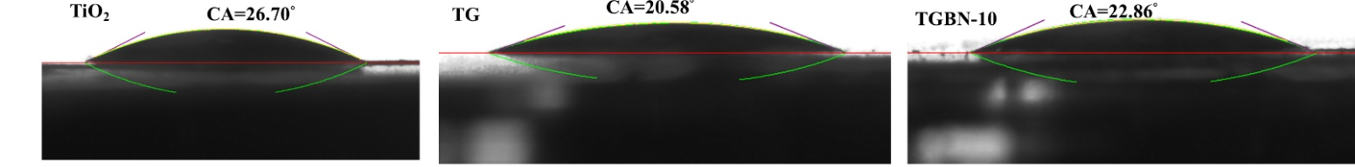
Fig. S8. Water contact angles of TiO₂, TG, and TGBN-10 recorded at the moment of deposition.
Note S3: Surface wettability of TGBN-10 via water contact angle analysis.
The wettability of TGBN-10 (relative to pristine TiO₂ and TG powders) was evaluated by the sessile-drop method (Fig. S8 and Table 2 of the main text). All samples showed low initial water contact angles (26.70° for TiO₂, 20.58° for TG, and 22.86° for TGBN-10), confirming their strongly hydrophilic surface character. The lower contact angle of TG relative to pristine TiO₂ indicates that incorporation of graphite did not compromise water accessibility; instead, it likely modified the surface-energy distribution and increased the availability of polar adsorption sites ^{[18]}. The slightly higher, but still low, contact angle of TGBN-10 relative to TG suggests that BN incorporation partially alters the exposed surface chemistry while preserving the highly hydrophilic character required for gas–solid interfacial reactions. The wettability results are consistent with the O 1s XPS analysis (Table 6 of the main text and Fig. S6b), in which the high-binding-energy oxygen component was assigned to surface hydroxyl species and/or adsorbed water ^{[19]}. Although a contact-angle measurement alone cannot quantify hydroxyl density, the agreement between the contact angles, the O 1s XPS, and the DRIFTS hydroxyl-related measurements supports the presence of a hydroxylated oxide surface. These observations demonstrate that TGBN-10 retains sufficient hydrophilic and hydroxylated surface character despite graphite incorporation, which enables initial hydrogen-bond-assisted capture of the polar aldehyde at hydroxylated Bi/Ti sites, while the ternary BN/TiO₂/graphite architecture promotes charge separation and subsequent photooxidative turnover.

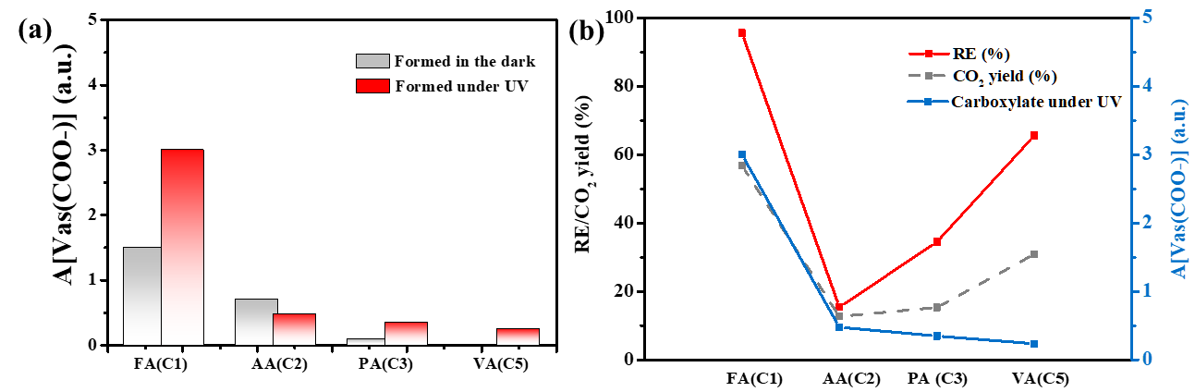
Fig. S9. Quantitative correspondence between the surface carboxylate and the extent of deep oxidation over TGBN-10: (a) Integrated area of the νas(COO⁻) band at 1520–1600 cm⁻¹: the dark period (grey) and the illumination (red), and (b) the carboxylate added under illumination (right axis) with the removal efficiency and the CO₂ yield against the carbon number of the aldehyde.

References
[1] RD Hawthorn. Afterburner catalysts: effects of heat and mass transfer between gas and catalyst surface [J]. AIChE Symposium Series, 1974, 70: 428-38.
[2] EN Fuller, PD Schettler, JC Giddings. New method for prediction of binary gas-phase diffusion coefficients [J]. Industrial & Engineering Chemistry, 1966, 58: 18-27.
[3] X Li, Y Huang, W Ho, et al. Modulation of sulfur vacancies at ZnIn2S4-δ/g-C3N4 heterojunction interface for successive C-H secession in photocatalytic gaseous formaldehyde complete oxidation [J]. Applied Catalysis B: Environmental, 2023, 338: 123048.
[4] J Guo, C Lin, C Jiang, et al. Review on noble metal-based catalysts for formaldehyde oxidation at room temperature [J]. Applied Surface Science, 2019, 475: 237-55.
[5] Z Yan, Z Xu, J Yu, et al. Enhanced formaldehyde oxidation on CeO2/AlOOH-supported Pt catalyst at room temperature [J]. Applied Catalysis B: Environmental, 2016, 199: 458-65.
[6] FP Rotzinger, JM Kesselman-Truttmann, SJ Hug, et al. Structure and Vibrational Spectrum of Formate and Acetate Adsorbed from Aqueous Solution onto the TiO2 Rutile (110) Surface [J]. The Journal of Physical Chemistry B, 2004, 108: 5004-17.
[7] CB Mendive, T Bredow, MA Blesa, et al. ATR-FTIR measurements and quantum chemical calculations concerning the adsorption and photoreaction of oxalic acid on TiO2 [J]. Physical Chemistry Chemical Physics, 2006, 8: 3232-47.
[8] S Nishiyama, T Hara, S Tsuruya, et al. Infrared Spectroscopy Study of Aldehydes Adsorbed on Rh−Sn Bimetallic Systems: Selective Activation of Aldehydes by Tin [J]. The Journal of Physical Chemistry B, 1999, 103: 4431-9.
[9] Z Yan, Z Xu, J Yu, et al. Effect of microstructure and surface hydroxyls on the catalytic activity of Au/AlOOH for formaldehyde removal at room temperature [J]. Journal of Colloid and Interface Science, 2017, 501: 164-74.
[10] T Chafik, S Kameoka, Y Ukisu, et al. In situ diffuse reflectance infrared Fourier transform spectroscopy study of surface species involved in NOx reduction by ethanol over alumina-supported silver catalyst [J]. Journal of Molecular Catalysis A: Chemical, 1998, 136: 203-11.
[11] S Sun, J Ding, J Bao, et al. Photocatalytic Oxidation of Gaseous Formaldehyde on TiO2: An In Situ DRIFTS Study [J]. Catalysis Letters, 2010, 137: 239-46.
[12] Z Ai, K Deng, Q Wan, et al. Facile Microwave-Assisted Synthesis and Magnetic and Gas Sensing Properties of Fe3O4 Nanoroses [J]. The Journal of Physical Chemistry C, 2010, 114: 6237-42.
[13] C Zhang, F Liu, Y Zhai, et al. Alkali-Metal-Promoted Pt/TiO2 Opens a More Efficient Pathway to Formaldehyde Oxidation at Ambient Temperatures [J]. Angewandte Chemie International Edition, 2012, 51: 9628-32.
[14] H Ren, X Sun, T Li, et al. Preparation of a Z-scheme BiVO4/Cu2O/PPy heterojunction and studying its CO2 reducing properties [J]. RSC Advances, 2025, 15: 13313-22.
[15] J Henych, M Št’astný, Z Němečková, et al. Cerium–Bismuth Oxides/Oxynitrates with Low Toxicity for the Removal and Degradation of Organophosphates and Bisphenols [J]. ACS Applied Nano Materials, 2022, 5: 17956-68.
[16] M Pisarek, M Krawczyk, M Hołdyński, et al. Plasma Nitriding of TiO2 Nanotubes: N-Doping in Situ Investigations Using XPS [J]. ACS Omega, 2020, 5: 8647-58.
[17] S Shimizu, T Yoshii, G Nishikawa, et al. Unlocking the chemical environment of nitrogen in perovskite-type oxides [J]. Chemical Science, 2024, 15: 10350-8.
[18] N Giovambattista, PG Debenedetti, PJ Rossky. Effect of Surface Polarity on Water Contact Angle and Interfacial Hydration Structure [J]. The Journal of Physical Chemistry B, 2007, 111: 9581-7.
[19] H Idriss. On the wrong assignment of the XPS O1s signal at 531–532 eV attributed to oxygen vacancies in photo- and electro-catalysts for water splitting and other materials applications [J]. Surface Science, 2021, 712: 121894-.
[20] C-M Hung, J-H Shi, H-C Tsai, et al. Interspersed Assembled Monolayers Enhance Hole Transport in High-Efficiency Organic and Perovskite Solar Cells [J]. Journal of the American Chemical Society, 2025, 147: 23683-95.
[21] N Kang, L Li, Z Wan, et al. Weak Hydrogen Bond with Iodide Modulating Crystallization of Methylammonium Lead Iodide for High-Performance Perovskite Solar Cells [J]. Micromachines, 2026, 17: 15.

