Supporting information for
Carbon-Supply-Programmed CNT Growth for Ultrathin Microwave Absorbers from Waste Batteries and Plastics

Zhengyu Yongª, Yuhang Weiª, Runliang Cuiª, Erjun Tang^{c}, Baocai Xu^{b}, Ting Shi^{d,}*, Ningning Cao^{e,}*, Han-Ming Zhang^{a,*}

ª Hebei Key Laboratory of Flexible Functional Materials, School of Materials Science and Engineering, Hebei University of Science and Technology, Shijiazhuang 050018, Hebei, P. R. China.
^{b} Hebei Vocational University of Industry and Technology, Shijiazhuang 050091, Hebei, P. R. China.
^{c} Chemical and Pharmaceutical Engineering, Hebei University of Science and Technology, Hebei Research center of Pharmaceutical and Chemical Engineering, Shijiazhuang 050018, Hebei, P. R. China.
^{d} Instrumental analysis & research center, Sun Yat-sen University, Shenzhen 518107, Guangdong, P. R. China.
^{e} State Key Laboratory of Integrated Optoelectronics, School of Materials Science and Engineering, Jilin University, Changchun 130012, P. R. China.
*Corresponding authors
E-mail addresses: zhanghm16@163.com (H.-M. Zhang); shiting96@mail.sysu.edu.cn (T. Shi); caonn1991@nju.edu.cn (N. Cao).

Contents:
Text S1. Supplementary Methods S5
Text S2. Supplementary Characterizations S6−S7
Fig. S1. LDPE mass change curve with temperature under argon conditions (TGA). S8
Fig. S2. TG-MS curves of gaseous products released during LDPE pyrolysis under argon atmosphere. S9
Fig. S3. XRD patterns of all NCC-6.7-x (x = 500, 550, and 600) samples. S10
Fig. S4. (a–d) SEM images of NCC-6.7-500 at different magnifications. S11
Fig. S5. (a–d) SEM images of NCC-6.7-550 at different magnifications. S12
Fig. S6. (a–d) SEM images of NCC-6.7-600 at different magnifications. S13
Fig. S7. (a–d) SEM images of NCC-20 at different magnifications. S14
Fig. S8. (a–d) SEM images of NCC-10 at different magnifications. S15
Fig. S9. (a–d) SEM images of NCC-6.7 at different magnifications. S16
Fig. S10. (a–d) SEM images of NCC-5 at different magnifications. S17
Fig. S11. (a–d) SEM images of NCC-4 at different magnifications. S18
Fig. S12. (a–d) SEM images of NCP-20 at different magnifications. S19
Fig. S13. (a–d) SEM images of NCP-10 at different magnifications. S20
Fig. S14. (a–d) SEM images of NCP-6.7 at different magnifications. S21
Fig. S15. (a–d) SEM images of NCP-5 at different magnifications. S22
Fig. S16. (a–d) SEM images of NCP-4 at different magnifications. S23
Fig. S17. Length distribution histograms of carbon nanotubes for all NCC-x samples.
S24
Fig. S18. Diameter distribution histograms of carbon nanotubes for all NCC-x samples.
S25
Fig. S19. XRD patterns of all NCP-x samples and filtrate. S26
Text S3. Supplementary XPS analysis S27
Fig. S20. (a) Ni 2p, (b) Co 2p, (c) Mn 2p, and (d) O 1s high-resolution XPS spectra of NCC-20. S28
Fig. S21. (a) Ni 2p, (b) Co 2p, (c) Mn 2p, and (d) O 1s high-resolution XPS spectra of NCC-10. S29
Fig. S22. (a) Ni 2p, (b) Co 2p, (c) Mn 2p, and (d) O 1s high-resolution XPS spectra of NCC-6.7. S30
Fig. S23. (a) Ni 2p, (b) Co 2p, (c) Mn 2p, and (d) O 1s high-resolution XPS spectra of NCC-5. S31
Fig. S24. (a) Ni 2p, (b) Co 2p, (c) Mn 2p, and (d) O 1s high-resolution XPS spectra of NCC-4. S32
Fig. S25. TEM images of (a–c) NCC-10 and (d–f) NCC-5 at different magnification, respectively. S33
Fig. S26. SAED ring patterns of (a) NCC-10 and (b) NCC-5, respectively. S34
Fig. S27. Mapping of different regions of the NCC-6.7. S35
Fig. S28. Pore size distribution curves of (a) NCC-20, (b) NCC-10, (c) NCC-6.7, (d) NCC-5, and (e) NCC-4, respectively. S36
Fig. S29. Nitrogen adsorption-desorption isotherms of (a) NCC-20, (b) NCC-10, (c) NCC-6.7, (d) NCC-5, and (e) NCC-4, respectively. S37
Fig. S30. Frequency dependence of (a) real permeability (μ′), (b) imaginary permeability (μ′′), and (c) magnetic loss tangent for the NCC‑x series materials. S38
Fig. S31. Cole-Cole plots of (a) NCC-20, (b) NCC-10, (c) NCC-6.7, (d) NCC-5, and (e) NCC-4, respectively. S39
Fig. S32. (a) Real permittivity (ε′) and imaginary permittivity (ε′′) of NCP-6.7 and NCC-6.7. (b) Cole-Cole plot of NCP-6.7. (c) Comparison of specific surface areas and total pore volumes for the series of NCC-6.7 and NCP-6.7. S40
Fig. S33. Reflection loss, impedance matching, quarter-wavelength curves of all NCC-x samples.. S41
Fig. S34. Three-dimensional reflection loss mapping of (a) NCC-20 and (b) NCC-4.
S42
Fig. S35. Comprehensive visualization of (a) NCC-20, (b) NCC-4. S43
Fig. S36. (a) Three-dimensional reflection loss mapping and (b) Two-dimensional reflection loss projection of NCP-6.7. S44
Fig. S37. Wave absorption performance of pristine cotton textile in different directions (Cotton textile itself has almost no wave-absorbing properties). S45
Fig. S38. Digital pictures of (a) pristine CT and (b) CT-6.7 on heating pad before heating treatment. S46
Fig. S39. Comparison of thermal conductivity between pristine CT and CT-6.7. S47
Fig. S40. Stretching process of (a) pristine CT and (b) CT-6.7. S48
Fig. S41. Tensile strength of pristine CT and CT-6.7. S49
Fig. S42. Bending test of CT-6.7 samples. S50
Fig. S43. SEM images of CT-6.7 after bending test. S51
Fig. S44. Contact angle measurements and corresponding water droplet models of NCC-20 and NCC-4. S52
Fig. S45. Schematic workflow comparison of the present waste-to-absorber upcycling strategy against conventional Pyro, Hydro, and Regen. S53
Fig. S46. Exhaust gas generated during material preparation was collected using a gas sampling bag. S54
Fig. S47. Economic analysis and environmental impact assessment S55
Fig. S48. Electromagnetic parameters of NCCW-x (x = 10, 6.7, 5). S56
Fig. S49. Cole-Cole curves of (a) NCCW-10, (b) NCCW-6.7, and (c) NCCW-5 respectively. S57
Fig. S50. (a–c) Three-dimensional and (d–f) Two-dimensional reflection loss projections of NCCW-x (x = 10, 6.7, 5). S58
Fig. S51. Comparison of (a) economic revenue and (b) GHG emissions for different waste LDPE treatment technologies. S59
Fig. S52. XRD patterns of NCC-6.7-x (x=1, 2, and 3) samples. S60
Fig. S53. (a–d) SEM images of NCC-6.7-1 at different magnifications. S61
Fig. S54. (a–d) SEM images of NCC-6.7-2 at different magnifications. S62
Fig. S55. (a–d) SEM images of NCC-6.7-3 at different magnifications. S63
Fig. S56. (a–c) Three-dimensional and (d–f) Two-dimensional reflection loss projections of NCC-6.7-x (x=1, 2, and 3). S64
Fig. S57. XRD patterns of LFP-6.7, LCO-6.7, and NCM111-6.7 samples. S65
Fig. S58. (a–d) SEM images of LFP-6.7 at different magnifications. S66
Fig. S59. (a–d) SEM images of LCO-6.7 at different magnifications. S67
Fig. S60. (a–d) SEM images of NCM111-6.7 at different magnifications. S68
Fig. S61. (a–c) Three-dimensional and (d–f) Two-dimensional reflection loss projections of LFP-6.7, LCO-6.7 and NCM111-6.7. S69
Table S1. Comparison of RL_{min}, EAB, and thickness of different samples. S70
Table S2. The cost of consumed chemicals. S71
Table S3. Recycling cost ($ per kg feedstock) of different battery recycling technologies. S72
Table S4. Income ($ per kg feedstock) from different methods of recycling materials.
S73
Table S5. Total cost and revenue ($ per kg feedstock) of recycling batteries by different methods. S74
Table S6. Recycling profit ($ per kg feedstock) of different battery recycling technologies. S75
Table S7. GHG emission (g per kg feedstock) and total energy consumption (MJ per kg feedstock) of different battery recycling technologies. S76
Table S8. The comprehensive performance data of CNT, Ferrite, NCM/CNT-800 and our NCC-6.7 come from different articles and markets. S77
Table S9. GHG emission (g per kg feedstock) LDPE with different treatment methods.
S78
References S79

Text S1. Supplementary Methods

1.1 The coating process of the absorbent fabric material is as follows
NCC‑6.7 powder (4 g) was dispersed in 40 g of waterborne polyurethane under mechanical stirring at 300 rpm for 2 h. The homogeneous slurry was coated onto a 20 × 20 cm² cotton textile using a wire bar coater and dried for 1 h. The resulting composite is designated CT‑6.7, with pristine cotton textile denoted as CT.

1.2 Preparation of electrode materials
A mixture containing 0.1 g of the as‑prepared absorber powder, 0.125 g of PVDF, and 0.125 g of carbon black was thoroughly ground in an agate mortar for 20 min to achieve a homogeneous composite. An appropriate amount of N‑methyl‑2‑pyrrolidone (NMP) was then added to form a uniform slurry, which was subsequently coated onto a 1 × 1 cm² nickel foam substrate using a doctor blade. After drying, the working electrode was obtained.

1.3 Electrochemical test conditions
Electrochemical impedance spectroscopy (EIS) and corrosion potential measurements were performed on a Gamry electrochemical workstation using a standard three‑electrode configuration in a 3.5 wt% aqueous NaCl solution. The working electrode was prepared by coating the as‑synthesized absorber onto the designated substrate, while a glassy carbon electrode and a saturated calomel electrode (SCE) served as the counter and reference electrodes, respectively.

1.4 Test method for material contact angle
For contact angle measurements, the absorber powder was uniformly affixed onto a glass slide using conductive adhesive, and its hydrophobicity was evaluated using seawater as the probing liquid.

Text S2. Supplementary Characterizations

2.1 Electromagnetic Parameter Characterization
According to the free electron theory, the magnitude of conductance loss is directly correlated with the conductivity (σ):
$ε^{"}=\frac{σ}{2πε_{0}f}$ | Eq. 1
where ε₀ is the dielectric constant in a vacuum. Eq. 1 indicates that an increase in material conductivity results in a corresponding enhancement of ε″ [1].
According to the transmission line theory and metal backplate model, and based on the measured electromagnetic parameters, the following formula is used to calculate the material’s wave absorption performance (MA).
$RL=20log\left|\frac{Z_{in}}{Z_{0}}\right|$ | Eq. 2
$Z=\left|Z_{in}/Z_{0}\right|=\sqrt{\left|μ_{r}/ε_{r}\right|}tanh\left[j\left(\frac{2πfd}{c}\right)\right]\sqrt{μ_{r}ε_{r}}$ | Eq. 3
Among them, Z_{in} and Z₀ are the input impedance and the free-space impedance, respectively. ε_{r} and μ_{r} are relative permittivity and relative permeability of the material, respectively. f, d, and c represent the frequency of the incident wave, the thickness of the material, and the speed of light respectively.
Generally, the attenuation constant (α) is performed to qualitatively evaluate the EMW dissipation ability of absorbers, which can be calculated based on the following equation:
$α= \frac{\sqrt{2}πf}{c}\sqrt{\left(μ^{''}ε^{''}-μ^{'}ε^{'}\right)+\sqrt{{\left(μ^{''}ε^{''}-μ^{'}ε^{'}\right)}^{2}+{\left(μ^{'}ε^{''}+μ^{''}ε^{'}\right)}^{2}}}$ | Eq. 4
where f and c represent the EMW frequency and vacuum velocity of light, respectively.
Based on the Debye theory, ε″ can be taken as the complex contribution including relaxation and conductance:
$ε^{''}\left(ω\right)=ε_{p}^{''}+ε_{c}^{''}=\left(ε_{s}-ε_{∞}\right)\frac{ωτ}{1+ω^{2}τ^{2}}+\frac{σ}{ε_{0}ω}$ | Eq. 5
where σ represents electrical conductivity and ω refers to the angular frequency. Therefore, ε″ could be divided into two parts: ε_{p}″ induced by relaxation and ε_{c}″ generated by conductance [2].
The relaxation time, electrical conductivity, polarization loss, and conduction loss are extracted by nonlinear least-squares fitting of the complex permittivity spectra:
$ε=ε_{∞}+\frac{ε_{s}-ε_{∞}}{1+ω^{2}τ^{2}}-i\left(\frac{\left(ε_{s}-ε_{∞}\right)ωτ}{1+ω^{2}τ^{2}}+\frac{σ}{ωε_{0}}\right)$ | Eq. 6
where ε∞ is optical dielectric constant, ε_{s} is static dielectric constant, ε₀ is free space dielectric constant, τ is the relaxation time and σ is the conductivity.
To obtain ε_{c}″ and ε_{p}″, the ε_{s}, ε∞, σ and τ should be fitted firstly, which are signed as a group β. The sum of squares is S:
$S=\sum_{i=1}^{m}{r_{i}^{2}}$ | Eq. 7
where r_{i} represents ε_{fit}-ε. The objective is to minimize S by optimizing β. To achieve higher fitting accuracy, the original dataset is divided into twenty subsets, which are fitted separately, and the average value is adopted as the final result [2].
The relationship between the position of the relaxation peak and polarization relaxation time τ can be expressed by the following equation:
$τ=\frac{1}{2πf_{peak}}$ | Eq. 8
where f_{peak} is the frequency position of the relaxation peak maximum [3].
Δε is defined as the dielectric relaxation strength (Δε=ε_{s}-ε∞), given by the difference between the static permittivity (ε_{s}) and the high-frequency limit permittivity (ε∞) based on Debye relaxation theory [4]. For an ideal single Debye relaxation, the dielectric loss reaches its maximum at ωτ = 1, where ε″_{max} = Δε/2, allowing Δε to be approximately estimated from the peak value. Therefore, it follows:
$∆ε=2ε_{max}^{"}$ | Eq. 9

2.2 Calculation of material performance to price
Calculation method of the ratio of material performance to price (FoM) [5]:
$FoM=\frac{\left|{RL}_{min}\right|×EAB}{Cost×Thickness}$ | Eq. 10
where cost represents the material cost, RL_{min} denotes the minimum reflection loss, EAB is the effective absorption bandwidth, and Thickness corresponds to the thickness of the absorber.

Supplementary Figures
The thermal stability of the samples was evaluated by the temperature at 10% weight loss (T_{10%}) derived from the TGA curves, which serves as a practical indicator for the onset of major decomposition to minimize interference from initial adsorbed moisture or volatile residues.

Fig. S1. LDPE mass change curve with temperature under argon conditions (TGA).

Fig. S2. TG-MS curves of gaseous products released during LDPE pyrolysis under argon atmosphere.

Fig. S3. XRD patterns of all NCC-6.7-x (x = 500, 550, and 600) samples.

Fig. S4. (a–d) SEM images of NCC-6.7-500 at different magnifications.

Fig. S5. (a–d) SEM images of NCC-6.7-550 at different magnifications.

Fig. S6. (a–d) SEM images of NCC-6.7-600 at different magnifications.

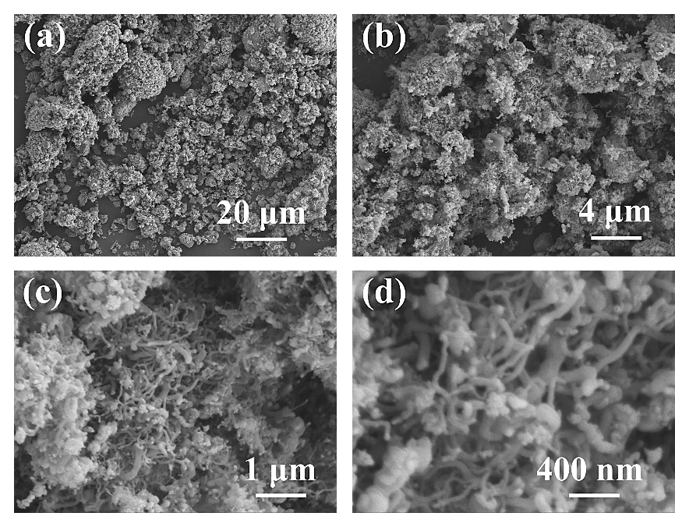

Fig. S7. (a–d) SEM images of NCC-20 at different magnifications.

Fig. S8. (a–d) SEM images of NCC-10 at different magnifications.

Fig. S9. (a–d) SEM images of NCC-6.7 at different magnifications.

Fig. S10. (a–d) SEM images of NCC-5 at different magnifications.

Fig. S11. (a–d) SEM images of NCC-4 at different magnifications.

Fig. S12. (a–d) SEM images of NCP-20 at different magnifications.

Fig. S13. (a–d) SEM images of NCP-10 at different magnifications.

Fig. S14. (a–d) SEM images of NCP-6.7 at different magnifications.

Fig. S15. (a–d) SEM images of NCP-5 at different magnifications.

Fig. S16. (a–d) SEM images of NCP-4 at different magnifications.

The length distribution of carbon nanotubes was determined by selecting representative regions at identical magnification, followed by measurement and statistical analysis using ImageJ software. For diameter analysis, a consistent number of carbon nanotubes were randomly selected, and their diameters were measured and statistically analyzed using ImageJ.

Fig. S17. Length distribution histograms of carbon nanotubes for all NCC-x samples.

Fig. S18. Diameter distribution histograms of carbon nanotubes for all NCC-x samples.

Fig. S19. XRD patterns of all NCP-x samples and filtrate.

Text S3. Supplementary XPS analysis
The surface chemical states and elemental compositions were further investigated via high-resolution XPS spectra. The Ni 2p spectrum was deconvoluted into spin-orbit split components, corresponding to Ni 2p_{3/2} and Ni 2p_{1/2}. Specifically, the Ni 2p_{3/2} region exhibited three characteristic peaks at 852.7 eV (assigned to metallic Ni⁰), 855.53 eV (attributed to Ni²⁺), and a satellite peak at 862.14 eV. In contrast, the Ni 2p_{1/2} region showed a main peak at 873.23 eV, accompanied by a satellite at 880.97 eV. These results clearly confirmed the coexistence of metallic Ni and oxidized Ni species in the samples [6].
Similarly, the Co 2p spectrum revealed complex multiplet splitting, which is indicative of the presence of multiple cobalt valence states. The Co 2p_{3/2} region was fitted into four peaks at 779.71 eV (Co⁰), 781.94 eV (Co³⁺), 785.12 eV (Co²⁺), and a satellite peak at 787.6 eV. Correspondingly, the Co 2p_{1/2} region consisted of peaks at 795.21 eV (Co⁰), 796.49 eV (Co³⁺), 798.02 eV (Co²⁺), and a satellite peak at 803.21 eV. The coexistence of Co⁰, Co²⁺, and Co³⁺ suggested partial oxidation of metallic Co and the formation of heterogeneous chemical environments on the sample surface [7, 8].
For Mn, two main peaks are observed at 641.71 eV (Mn 2p_{3/2}) and 653.73 eV (Mn 2p_{1/2}), along with a satellite feature at 646.21 eV, confirming the presence of oxidized Mn species in the samples [9].
The O 1s spectrum was deconvoluted into four distinct components located at 530.36 eV (metal–oxygen bonds, M–O), 531.8 eV (C=O), 532.71 eV (C–O), and 533.78 eV (adsorbed oxygen, O_{ad}). These oxygen-containing species not only verified the presence of metal oxides and surface functional groups but also contributed to interfacial polarization and dipolar relaxation, which could facilitate the enhancement of relevant physicochemical properties [10].

Fig. S20. (a) Ni 2p, (b) Co 2p, (c) Mn 2p, and (d) O 1s high-resolution XPS spectra of NCC-20.

Fig. S21. (a) Ni 2p, (b) Co 2p, (c) Mn 2p, and (d) O 1s high-resolution XPS spectra of NCC-10.

Fig. S22. (a) Ni 2p, (b) Co 2p, (c) Mn 2p, and (d) O 1s high-resolution XPS spectra of NCC-6.7.

Fig. S23. (a) Ni 2p, (b) Co 2p, (c) Mn 2p, and (d) O 1s high-resolution XPS spectra of NCC-5.

Fig. S24. (a) Ni 2p, (b) Co 2p, (c) Mn 2p, and (d) O 1s high-resolution XPS spectra of NCC-4.

Fig. S25. TEM images of (a–c) NCC-10 and (d–f) NCC-5 at different magnification, respectively.

Fig. S26. SAED ring patterns of (a) NCC-10 and (b) NCC-5, respectively.

Fig. S27. Mapping of different regions of the NCC-6.7.

Fig. S28. Pore size distribution curves of (a) NCC-20, (b) NCC-10, (c) NCC-6.7, (d) NCC-5, and (e) NCC-4, respectively.

Fig. S29. Nitrogen adsorption-desorption isotherms of (a) NCC-20, (b) NCC-10, (c) NCC-6.7, (d) NCC-5, and (e) NCC-4, respectively.

Fig. S30. Frequency dependence of (a) real permeability (μ′), (b) imaginary permeability (μ′′), and (c) magnetic loss tangent for the NCC‑x series materials.

Fig. S31. Cole-Cole plots of (a) NCC-20, (b) NCC-10, (c) NCC-6.7, (d) NCC-5, and (e) NCC-4, respectively.

Fig. S32. (a) Real permittivity (ε′) and imaginary permittivity (ε′′) of NCP-6.7 and NCC-6.7. Cole-Cole plot of (b) NCP-6.7. (c) Comparison of specific surface areas and total pore volumes for the series of NCC-6.7 and NCP-6.7.

Fig. S33. Reflection loss, impedance matching, quarter-wavelength curves of all NCC-x samples.

Fig. S34. Three-dimensional reflection loss mapping of (a) NCC-20 and (b) NCC-4.

Fig. S35. Comprehensive visualization of NCC-x. (a) NCC-20, (b) NCC-10, (c) NCC-6.7, (d) NCC-5, (e) NCC-4.

Fig. S36. (a) Three-dimensional reflection loss mapping and (b) Two-dimensional reflection loss projection of NCP-6.7.

Fig. S37. Wave absorption performance of pristine cotton textile in different directions (Cotton textile itself has almost no wave-absorbing properties).

The experiment began by heating the heating pad to 120 °C. The textile sample was then placed on the pad, and its temperature changes were monitored using a thermal imaging camera.

Fig. S38. Digital pictures of (a) pristine CT and (b) CT-6.7 on heating pad before heating treatment.

Fig. S39. Comparison of thermal conductivity between pristine CT and CT-6.7.

Fig. S40. Stretching process of (a) pristine CT and (b) CT-6.7.

Fig. S41. Tensile strength of pristine CT and CT-6.7.

Fig. S42. Bending test of CT-6.7 sample.

Fig. S43. SEM images of CT-6.7 after bending test.

Fig. S44. Contact angle measurements and corresponding water droplet models of NCC-20 and NCC-4.

Fig. S45. Schematic workflow comparison of the present waste-to-absorber upcycling strategy against conventional Pyro, Hydro, and Regen.

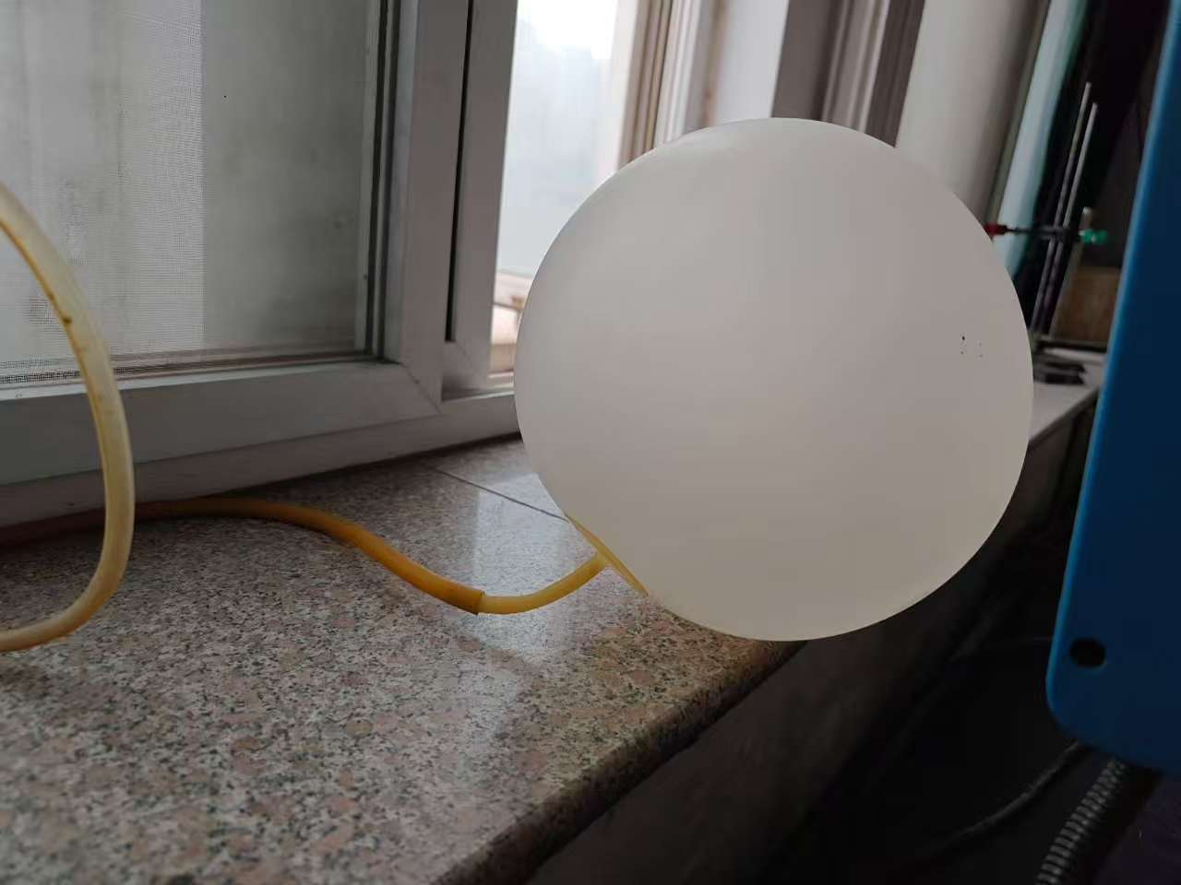

Fig. S46. Exhaust gas generated during material preparation was collected using a gas sampling bag.

Fig. S47. Economic analysis and environmental impact assessment.
(a) Detailed cost breakdown analysis;
(b) Revenue comparison of products generated by different routes;
(c) Profit analysis of the proposed strategy;
(d) Comparison of GHG emissions and energy consumption among different recycling technologies;
(e) Radar chart comparing process simplicity, product value, environmental impact, and economic viability;
(f) FoM comparison based on absorption performance, cost, and thickness.

Fig. S48. Electromagnetic parameters of NCCW-x (x = 10, 6.7, 5).
(a) Real part of permittivity;
(b) Imaginary part of permittivity;
(c) Attenuation constant;
(d) Real part of permeability;
(e) Imaginary part of permeability;
(f) C₀ curves.

Fig. S49. Cole-Cole curves of (a) NCCW-10, (b) NCCW-6.7, and (c) NCCW-5 respectively.

Fig. S50. (a–c) Three-dimensional and (d–f) Two-dimensional reflection loss projections of NCCW-x (x = 10, 6.7, 5).

Fig. S51. Comparison of (a) economic revenue and (b) GHG emissions for different waste LDPE treatment technologies.

Fig. S52. XRD patterns of NCC-6.7-x (x=1, 2, and 3) samples.

Fig. S53. (a–d) SEM images of NCC-6.7-1 at different magnifications.

Fig. S54. (a–d) SEM images of NCC-6.7-2 at different magnifications.

Fig. S55. (a–d) SEM images of NCC-6.7-3 at different magnifications.

Fig. S56. (a–c) Three-dimensional and (d–f) Two-dimensional reflection loss projections of NCC-6.7-x (x=1, 2, and 3).
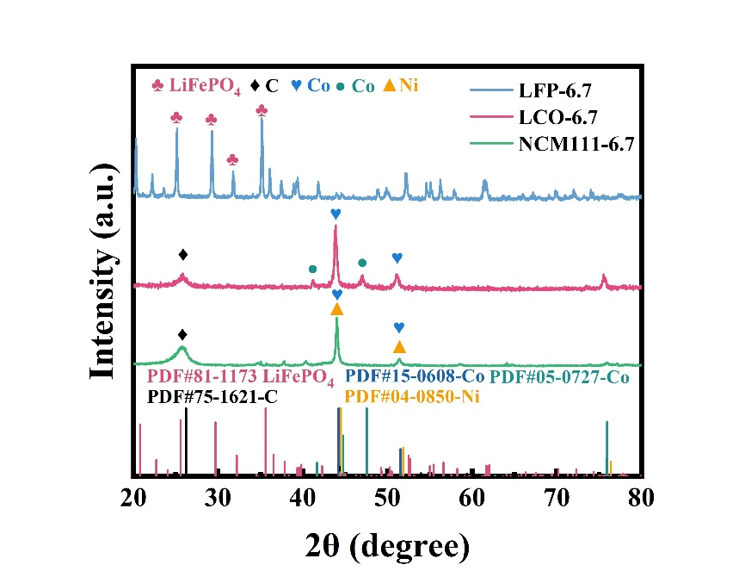

Fig. S57. XRD patterns of LFP-6.7, LCO-6.7, and NCM111-6.7 samples.

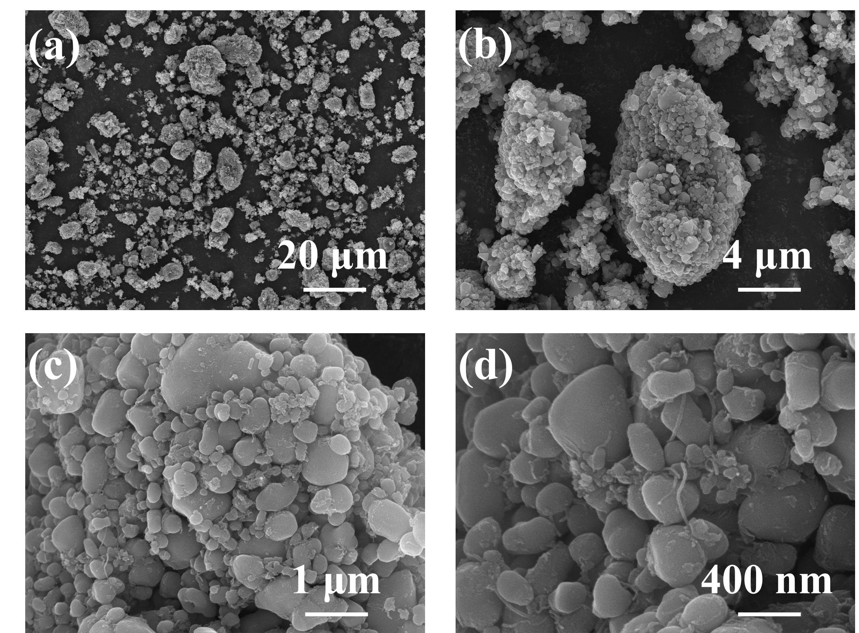

Fig. S58. (a–d) SEM images of LFP-6.7 at different magnifications.

Fig. S59. (a–d) SEM images of LCO-6.7 at different magnifications.

Fig. S60. (a–d) SEM images of NCM111-6.7 at different magnifications.

Fig. S61. (a–c) Three-dimensional and (d–f) Two-dimensional reflection loss projections of LFP-6.7, LCO-6.7 and NCM111-6.7.

Supplementary Tables

Table S1. Comparison of RL_{min}, EAB, and thickness of different samples.
Material | RL_{min}  (dB) | EAB  (GHz) | Thickness  (mm) | Ref
NCC-6.7 | –63.45 | 4.25 | 1.63 | This work
Co-HCNF | –51.5 | 5.3 | 1.5 | [11]
CCM composite | –43.9 | 4.4 | 1.5 | [12]
CNT@SiO₂ | –58.72 | 5.12 | 2 | [13]
MXene@SiO₂-15CNTs | –48.38 | 5.47 | 2.1 | [14]
TPU/CNT composites | –25.33 | 4.89 | 2.35 | [15]
NCM/CNT-800 | –67.87 | 7 | 2.43 | [16]
2-Ni-MWCNTs/Ti₃C₂Tx | –44.08 | 1.52 | 2.49 | [17]
CoNi@NC-CoNi@CNTs | –71.7 | 5.4 | 2.78 | [18]
NPCF05 | –56.20 | 6.41 | 3.5 | [19]
Fe₃O₄@C absorber | –73.5 | 4.78 | 4.55 | [20]
Co/SSPC | –66.91 | 5.09 | 4.79 | [21]

Table S2. The cost of consumed chemicals.
Technology | Material | Unit price ($ per kg) | Data source
Pyro | Limestone | 0.13 | Everbatt 2023
Pyro | Sand | 0.05 | Everbatt 2023
Pyro | Sulfuric acid | 0.08 | Everbatt 2023
Pyro | Lime | 0.13 | Everbatt 2023
Hydro | Sulfuric acid | 0.08 | Everbatt 2023
Hydro | Hydrogen Peroxide | 1.46 | Everbatt 2023
Hydro | Sodium Hydroxide | 0.45 | Everbatt 2023
Hydro | Soda Ash | 0.14 | Everbatt 2023
Hydro | Lime | 0.13 | Everbatt 2023
Regen | Lithium hydroxide | 34.89 | Everbatt 2023
This work | NCM | 12.9 | SMM
This work | LDPE | 1.47 | 21CP
Note:
All currency conversions in this table are calculated based on the exchange rates as of April 13, 2026.
SMM: https://www.smm.cn/.
21CP: https:// quote.21cp.com.

Table S3. Recycling cost ($ per kg feedstock) of different battery recycling technologies.
 | Pyro | Hydro | Regen | This work
Materials | 15.2 | 15.2 | 15.2 | 42.3
Energy costs | 35.7 | 23.1 | 28.3 | 19
Maintenance | 13.2 | 13.2 | 13.2 | 11.9
Plant overhead | 12.3 | 11 | 17 | 13
Other fixed costs | 11.3 | 13.4 | 12.5 | 11
Other variable costs | 8.1 | 3.9 | 7.2 | 12
Note:
All currency conversions in this table are calculated based on the exchange rates as of April 13, 2026.

Table S4. Revenue ($ per kg feedstock) from different methods of recycling materials.
 | Pyro | Hydro | Regen | This work
Li₂CO₃ |  | 10.2 | - | 1.9
Co | 33.1 | 34.5 | - | -
Ni | 66.7 | 73.1 | - | -
Mn | 29.4 | - | - | -
NCM | - | - | 202.5 | -
Graph | - | 18.4 | - | -
NCC-6.7 | - | - | - | 1501.9
Note:
“-” meant no data.
All currency conversions in this table are calculated based on the exchange rates as of April 13, 2026.

Table S5. Total cost and revenue ($ per kg feedstock) of recycling batteries by different methods [22].
Technology | cost | revenue
Pyro | 95.8 | 129.2
Hydro | 79.8 | 136.2
Regen | 93.4 | 202.5
This work | 109.2 | 1501.9
Note:
The total cost of this work is calculated comprehensively, and the income is based on the same performance.
All currency conversions in this table are calculated based on the exchange rates as of April 13, 2026.

Table S6. Recycling profit ($ per kg feedstock) of different battery recycling technologies.
 | Pyro | Hydro | Regen | This work
Profit | 33.4 | 56.4 | 109.1 | 1392.7
Note:
All currency conversions in this table are calculated based on the exchange rates as of April 13, 2026.
The revenue estimation in this study is based on the market price of commercially available absorbers with comparable performance.

Table S7. GHG emission (g per kg feedstock) and total energy consumption (MJ per kg feedstock) of different battery recycling technologies [22].
 | Pyro | Hydro | Regen | This work
GHGs | 4798.2 | 3620.8 | 3031.3 | 2389.1
Total energy | 35.7 | 23.1 | 28.3 | 19
Note：
All currency conversions in this table are calculated based on the exchange rates as of April 13, 2026.
The energy consumption data were obtained from repeated laboratory measurements and calculated as the average value to minimize measurement uncertainty.

Table S8. The comprehensive performance data of CNT, Ferrite, NCM/CNT-800 and our NCC-6.7 come from different articles and markets.
Material | RLmin  (dB) | EAB  (GHz) | Cost  ($ per kg) | Thickness  (mm) | Ref
CNT | −30 | 4 | 180 | 3 | Made in China
Ferrite | −25 | 5 | 66 | 2 | Made in China
NCM/CNT-800 | −67.87 | 7 | 160 | 2.43 | [16]
NCC-6.7 | −63.45 | 4.25 | 109.2 | 1.63 | This work
Note:
Made in China: https://cn.made-in-china.com/.

Table S9. GHG emission (g per kg feedstock) LDPE with different treatment methods.
Method | GHGs | Ref
Landfill | 1188 | [23]
Incineration | 2600 | [24]
Co-pyrolysis for upcycling | 2389.1 | This work

Reference
[1] Li Y, Qing Y, Li W, Ma C, Bai Z, Shao G, Wang H, Huang M, Liu X, Fan B (2025) Harnessing Carbon‐Containing Materials for Next‐Generation High‐Temperature Electromagnetic Wave Absorbers. Carbon Energy 8:1-33. https://doi.org/10.1002/cey2.70118.
[2] Wang H, Meng F, Huang F, Jing C, Li Y, Wei W, Zhou Z (2019) Interface Modulating CNTs@PANi Hybrids by Controlled Unzipping of the Walls of CNTs To Achieve Tunable High-Performance Microwave Absorption. ACS Appl Mater Inter 11:12142-12153. https://doi.org/10.1021/acsami.9b01122.
[3] Ren B, Jia Y, Qi L, Fu Q, Lin Y, Yu H, Cheng J, Dai M, Song Q, Zhang Y, Hou X, Li H (2025) Broadband electromagnetic absorption up to 1473 K enabled by dielectric frequency-dispersion engineering in ceramic composites. Nature Communications 17:318. https://doi.org/10.1038/s41467-025-67003-0.
[4] Cheng J, Chen Q, Wang H, Jin Y, Jiang S, Xie B, Wang Y, Zheng H, Liu B, Wu C, Zheng G, Che R (2026) Engineering Dielectric Genes in Debye Relaxation Model toward Frequency‐Band‐Reliant Electromagnetic Responses. Adv Mater 38:e21471. https://doi.org/10.1002/adma.202521471.
[5] Li N, McCulloch I, Brabec CJ (2018) Analyzing the efficiency, stability and cost potential for fullerene-free organic photovoltaics in one figure of merit. Energy Environ Sci 11:1355-1361. https://doi.org/10.1039/c8ee00151k.
[6] Zhang X, Wang J, Fan Y, Ren H, Liu Z, Wang Y, Liu Y, Bai H, Kong L (2021) NiCo alloy/C nanocomposites derived from a Ni-doped ZIF-67 for lightweight microwave absorbers. Nanotechnology 32:385602. https://doi.org/10.1088/1361-6528/ac0ac3.
[7] Wang C, Liu Y, Jia Z, Zhao W, Wu G (2022) Multicomponent nanoparticles synergistic one-dimensional nanofibers as heterostructure absorbers for tunable and efficient microwave absorption. Nano-Micro Lett 15. https://doi.org/10.1007/s40820-022-00986-3.
[8] Wang S, Xu Y, Fu R, Zhu H, Jiao Q, Feng T, Feng C, Shi D, Li H, Zhao Y (2019) Rational construction of hierarchically porous Fe–Co/N-doped carbon/rGO composites for broadband microwave absorption. Nano-Micro Letters 11:76. https://doi.org/10.1007/s40820-019-0307-8.
[9] Sun Q, Liu J, Xie Y, Wang S, Li Q, Xing Z, Qi L, Pan K, Chen Y (2022) Monodisperse MnO nanoparticles in situ grown on reduced graphene oxide via hydrophobic interaction for excellent electromagnetic wave absorption. J Mater Res 37:2175-2184. https://doi.org/10.1557/s43578-022-00491-8.
[10] Zhang Z, Chen Q, Huang L, Yang X, Yuan Y (2023) Recycling Polyethylene into High‐Value Porous Carbon Composites for Microwave Absorption. Adv Eng Mater 25:2300366. https://doi.org/10.1002/adem.202300366.
[11] He L, Xu H, Cui Y, Qi J, Wang X, Jin Q (2024) Co-Doped Porous Carbon/Carbon Nanotube Heterostructures Derived from ZIF-L@ZIF-67 for Efficient Microwave Absorption. Molecules 29:2426. https://doi.org/10.3390/molecules29112426.
[12] Sun X, Li X, Chen P, Zhu Y (2023) Construction of urchin-like multiple core-shelled Co/CoS₂@NC@MoS2 composites for effective microwave absorption. J Alloy Comd 936:168243. https://doi.org/10.1016/j.jallcom.2022.168243.
[13] Chen Y, Wang Y, Tang Z, Li K, Luo Z, Luo Y, Wang Z, Zhang X, Xia L, Wang X, Yang Y (2026) Micronano synergistic design constructs sea-urchin-like hollow SiO₂ internal filled conductive network structure for electromagnetic wave absorption. Colloid Surf A 728:138756. https://doi.org/10.1016/j.colsurfa.2025.138756.
[14] Mu Z, Wang L, Fan B, Du Z, Yue J, Liu Y, Huang X (2025) In situ growth of carbon nanotubes on MXenes for high-performance electromagnetic wave absorption. RSC Advances 15:26506-26514. https://doi.org/10.1039/d5ra03991f.
[15] Li Y, Xu Y, Wen G, Wang J (2025) Fabrication of 3D Porous and Flexible Thermoplastic Polyurethane/Carbon Nanotube Composites Towards High-Performance Microwave Absorption. Molecules 30:3610. https://doi.org/10.3390/molecules30173610.
[16] Qiu B, Hou Y, Shi Z, Du P, Xu N, Xie H, Liu K, Chen J, Li B, Han Q, Wang D, Lee LYS, Liu M, Fu D, Yin H (2026) Co-upcycling spent lithium-ion batteries and plastics into microwave absorbing materials with Ni-Co catalyst control. Nature Communications 17:2822. https://doi.org/10.1038/s41467-026-69501-1.
[17] Tang Q, Fan Q, He L, Yu P, Huang Q, Chen Y, Fan B, Liang K (2025) Few-Layered MXene Modulating In Situ Growth of Carbon Nanotubes for Enhanced Microwave Absorption. Molecules 30:1625. https://doi.org/10.3390/molecules30071625.
[18] Liang Q, He M, Zhan B, Guo H, Qi X, Qu Y, Zhang Y, Zhong W, Gu J (2025) Yolk–Shell CoNi@N-Doped Carbon-CoNi@CNTs for Enhanced Microwave Absorption, Photothermal, Anti-Corrosion, and Antimicrobial Properties. Nano-Micro Lett 17:167. https://doi.org/10.1007/s40820-024-01626-8.
[19] Wu J, Wang T, Kong J (2025) Microwave absorption properties of Ni/porous carbon fiber composites derived from flax fiber templates. Carbon 238:120305. https://doi.org/10.1016/j.carbon.2025.120305.
[20] Wu M, Rao L, Liu L, Li Y, Zhang Y, Ji Z, Ying G (2023) Urchin-like Fe₃O₄@C hollow spheres with core–shell structure: Controllable synthesis and microwave absorption. J Colloid Interf Sci 649:313-324. https://doi.org/10.1016/j.jcis.2023.06.077.
[21] Liu K, Ai Y, Cui M, Huang R, Su R (2025) Graphitization Optimization of Cobalt-Doped Porous Carbon Derived from Seaweed Sludge for Enhanced Microwave Absorption. Polymers 17:1572. https://doi.org/10.3390/polym17111572.
[22] Narang P, De PK, Kumari M, Shah NH (2023) A bottom-up method to analyze the environmental and economic impacts of recycling lithium-ion batteries with different cathode chemistries. Environ Dev Sustain 27:6831-6879. https://doi.org/10.1007/s10668-023-04169-x.
[23] Julius Gbenga A, Oluwaseun Justina A, Yaya Mumeen O, Bibian Anulika O, Aminu Kabir A, Yusuf Temitope A, Lukman B (2025) A Comparative study of carbon footprints of LDPE plastic waste landfilling and valorization to gasoline for generator usage. Glob J Eng Technol Adv 22:228-235. https://doi.org/10.30574/gjeta.2025.22.3.0072.
[24] W. Leal Filho JB, E. Carpio-Vallejo, A. Dobri, V. Voronova (2025) Decarbonising the plastic industry: A review of carbon emissions in the lifecycle of plastics production. Sci Total Environ 999:180337. https://doi.org/10.1016/j.scitotenv.2025.180337.

