Supplementary Information

Fabrication of large-sized robust carbon aerogel composites via pre-shrinkage-induced interfacial engineering
Rui Luo^{a,b}, Jian Li^{a,}*, Keye Bao^{a,b}, Chenglong Huª, Meng Yanª, Weiwei Zhangª, Rida Zhaoª, Shengyang Pangª, Sufang Tang^{a,}*
ª Shenyang National Laboratory for Materials Science, Institute of Metal Research, Chinese Academy of Sciences, Shenyang, 110016, China
^{b} School of Materials Science and Engineering, University of Science and Technology of China, Shenyang, 110016, China
* Corresponding author. Email: lijian@imr.ac.cn; sftang@imr.ac.cn
1. Supplementary Text: Experimental section
2. Supplementary Figures S1-S17
3. Supplementary Tables S1-S4
4. Note: The detailed derivation of Eq. 1

Supplementary Text: Experimental section
1 Raw materials
Phenolic resin (PR), supplied by Jining Baiyi Chemical Co., Ltd., China, was used as the raw material to synthesis the precursor aerogel for CA matrix. Hexamethylenetetramine (HMTA) and ethylene glycol (EG), purchased from Sinopharm Chemical Reagent Co., Ltd., China, were adopted as cross-linker and solvent, respectively. Viscous fiber (VF) felts, provided by Tianniao high-tech Co., China, were used as the precursors of reinforcement for fiber-reinforced CA composites. They were fabricated by needle-punching stacked nets of chopped fibers along the Z direction, and had a bulk density of 0.15 g·cm⁻³.
2 Preprocessing of VF felts
The VF felts were individually subjected to heat treatment in a box furnace under an argon atmosphere. For each felt, the temperature was first raised from room temperature to 100 °C at a heating rate of 3 °C·min⁻¹, and then increased gradually at 1 °C·min⁻¹ to its designated target temperatures of 150, 200, 265, 300, 350, 500 and 1000 °C, respectively. After reaching the target temperatures, each felt was held at its respective endpoint temperature for 60 minutes, and then cooled in the furnace. Additionally, an untreated VF felt was also included for comparison. The heat-treated VF felts were designated as VF-X, where X represents the final heat treatment temperature.
3 Fabrication of C_{VF}/CA
The preparation process of C_{VF}/CA mainly includes the following steps. Firstly, the PR solution was prepared by adding phenolic resin and HMTA into ethylene glycol with a specific mass ratio (PR: EG: HMTA=1: 1–6: 0.08–0.24), followed by mechanical stirring for 2 h. After completely dissolved, the resultant PR solution was introduced into an aluminum mold containing VF felts under vacuum conditions at approximately −99 kPa. Subsequently, the heat-treated VF felts impregnated with PR solution were sealed and transformed into an oven to form VF/PR wet gels at 120 ºC for 12 h, and then at 150 ºC for 24 h. Then the wet gels were directly dried at ambient pressure in an oven at 120–150 ºC for 1–3 days to form VF/PR aerogels. Finally, the resulting organic aerogels were carbonized under a vacuum of −98 kPa to form carbon aerogels. The carbonization temperature was first increased from room temperature to 200 °C at a rate of 6 °C·min⁻¹, followed by a ramp of 1 °C·min⁻¹ up to 700 °C. Subsequently, the temperature was raised to 1000 °C at a rate of 5 °C·min⁻¹, held at 1000 °C for 60 min, and finally furnace-cooled to room temperature.
4 Characterizations and measurements
4.1 Microstructural characterization
The chemical structures of pristine VFs and heat-treated VFs were studied by Fourier-transform infrared (FTIR) spectrometry using a Nicolet6700 FT-IR spectrometer. The microscopic morphology and structures of the materials were observed by scanning electron microscope (SEM) using a Verios G4 UC filed emission scanning electron microscope and by transmission electron microscopy (TEM) using a Tecnai F20 transmission electron microscope. The fiber diameter, particle size and neck width were analyzed based on their high-magnification SEM images through an image processing method using Image J software. To ensure the reliability and validity of the results, all data subjected to statistical analysis consisted of no fewer than 100 samples per set. The fiber/matrix interfacial bonding and spatial distribution of defects in C_{VF}/CA were visualized by XRT imaging using a Xradia versa XRM-500 3D X-ray microscope operating at an accelerating voltage of 80 kV. A total of 1600 2D projections were acquired and reconstructed into 3D volume renderings using the Fourier back-projection algorithm. Image processing and analysis were carried out with Avizo Fire 7.1 software. The microscopic pore structural characteristics in the C_{VF}/CA material were examined by nitrogen adsorption-desorption experiment using a Micromeritics ASAP 2460 3.01 analyzer and by mercury intrusion measurement with a Micromeritics AutoPore V 9620 porosimeter.
4.2 Mechanical testing
Uniaxial compression tests were conducted on cuboid specimens with dimensions of ~10 × 10 × 12 mm³ using a CMT4503 universal testing machine at a constant displacement rate of 1 mm·min⁻¹. Three-point bending tests were performed on the same machine with beam-shaped samples with thickness of 5 mm, width of 8 mm, and loading span of 60 mm at a constant displacement rate of 0.5 mm·min⁻¹. The high-temperature compression and bending tests were performed at 1800℃ using a UZDL-2200 ultrahigh temperature mechanical testing system. The sample dimensions and displacement rates were kept consistent with those used for room temperature tests. In the above tests, all samples were polished prior to measurement to ensure parallelism between the top and bottom surfaces. In each testing, at least three replicates were utilized, and data analyses were carried out on with Origin 2020.
Single-edge notched bend (SENB) tests were conducted to evaluate the fracture toughness of the C_{VF}/CA material using a CMT 2502 universal testing machine at a constant displacement rate of 0.5 mm·min⁻¹ with a loading span of 32 mm. Rectangular specimens with dimensions of ~8 mm in width and ~4 mm in thickness were side-notched to central width using a water-cooled, low-speed diamond wire saw. The load was applied in such a configuration that the crack propagation was perpendicular to the fiber layers. For mode I fracture, the plane-strain fracture toughness of the material, K_{Ic}, can be accessed according to the following equations:
${\text{K}}_{\text{Ic}} \text{=}\frac{\text{FS}}{\text{B}{\text{w}}^{\frac{\text{3}}{\text{2}}}} \text{f}\left(\frac{a_{0}}{\text{w}}\right)$, (S1)
f$\left(\frac{a_{0}}{\text{w}}\right)\text{=} \frac{\text{3}}{\text{2}}{\left(\frac{a_{0}}{\text{w}}\right)}^{\frac{\text{1}}{\text{2}}}\text{×}\frac{\text{1.99}-\frac{a_{0}}{\text{w}}\left(\text{1}-\frac{a_{0}}{\text{w}}\right)\left[\text{2.15}-\text{3.93}\frac{a_{0}}{\text{w}}+\text{2.7}{\left(\frac{a_{0}}{\text{w}}\right)}^{\text{2}}\right]}{\left(\text{1}+\frac{\text{2}a_{0}}{\text{w}}\right){\left(\text{1}-\frac{a_{0}}{\text{w}}\right)}^{\frac{\text{3}}{\text{2}}}}$, (S2)
where F is the maximum load in SENB test, S is the loading span, a₀ is the initial notch depth, and B and W are the thickness and width of sample, respectively. The measured K_{Ic} value was confirmed to satisfy the small-scale yielding and plane-strain conditions in accordance with the ASTM Standard E399, as specified by the criterion a₀, B, and (W-a₀) all exceeding $2.5{(K_{Ic}/σ_{y})}^{2}$ where $σ_{y}$ is the yield strength.
4.3 Raman spectroscopy measurements
The residual stresses in the CA materials were studied using Raman spectroscopy measurements, based on the principle that stress-induced shifts in Raman band positions correspond to changes in the phonon frequencies of the carbon structure relative to its stress-free state. The measurements were performed using a Horiba Jobin-Yvon LabRam HR800 laser confocal Raman spectrometer with an excitation light source of He-Ne laser with a wavelength of 532 nm and a spatial resolution of 1-2 μm. The C_{VF}/CA monoliths were characterized and compared with finely ground powder of pure CA material, which served as a stress-free reference sample. For each composite sample, Raman spectra were collected from nine randomly selected measurement points in each of two orientations, i.e., the cross-section perpendicular to the fiber layer plane (Z-direction) and within the fiber layer plane (XY-direction), and the relative G-band shifts were calculated. The Raman spectrometer was calibrated using standard Si wafer samples prior to tests.
4.4 Thermal performance measurements
Thermogravimetric (TG) analysis of the VFs was conducted using a HITACH STA200 analyzer under argon atmosphere, with the temperature increased from room temperature to 1000 ℃ at a heating rate of 10 ℃·min⁻¹. Thermal conductivity of C_{VF}/CA was measured at room temperature in air through the transient hot-wire method on a TC 3000E apparatus. In both the hot-plate and alcohol-lamp heating tests, commercially available alumina insulating brick and insulating carbon felt (with densities of 0.42 g·cm⁻³ and 0.37 g·cm⁻³, respectively) were selected as reference samples, as their densities are comparable to that of our tested sample (0.39 g·cm⁻³). All samples were machined to identical thickness (25 mm) to eliminate the influence of thickness variation on the thermal insulation evaluation; in the alcohol-lamp heating tests, all samples were positioned at the same distance from the lamp to ensure comparable incident heat flux; in the hot-plate tests, an oxidized, hardened aviation aluminum heating plate with a surface temperature uniformity better than ±5 °C was used, thereby ensuring consistent incident heat flux. The surface temperature variations were recorded with a thermal infrared camera (Fluke Ti400U), and the readings were corrected based on the emissivity of each material prior to obtaining the final temperature values. To characterize the high-temperature thermal insulation performance, a butane ablation test was performed. The test fixture was configured to house a square C_{VF}/CA sample (15 mm in thickness), with a 4-mm-thick SiC/C plate placed in front of the sample to simulate real-world service conditions. In addition, the entire sample assembly was peripherally encased in alumina insulation bricks to minimize lateral heat loss and cross-ventilation. The fixture was then subjected to a butane flame at a distance of approximately 60 mm for 700 s. The temperatures at the frontside of the fixture and the rear-side of C_{VF}/CA core were monitored using a thermocouple and an infrared imager, respectively.

Supplementary Figures S1-S17
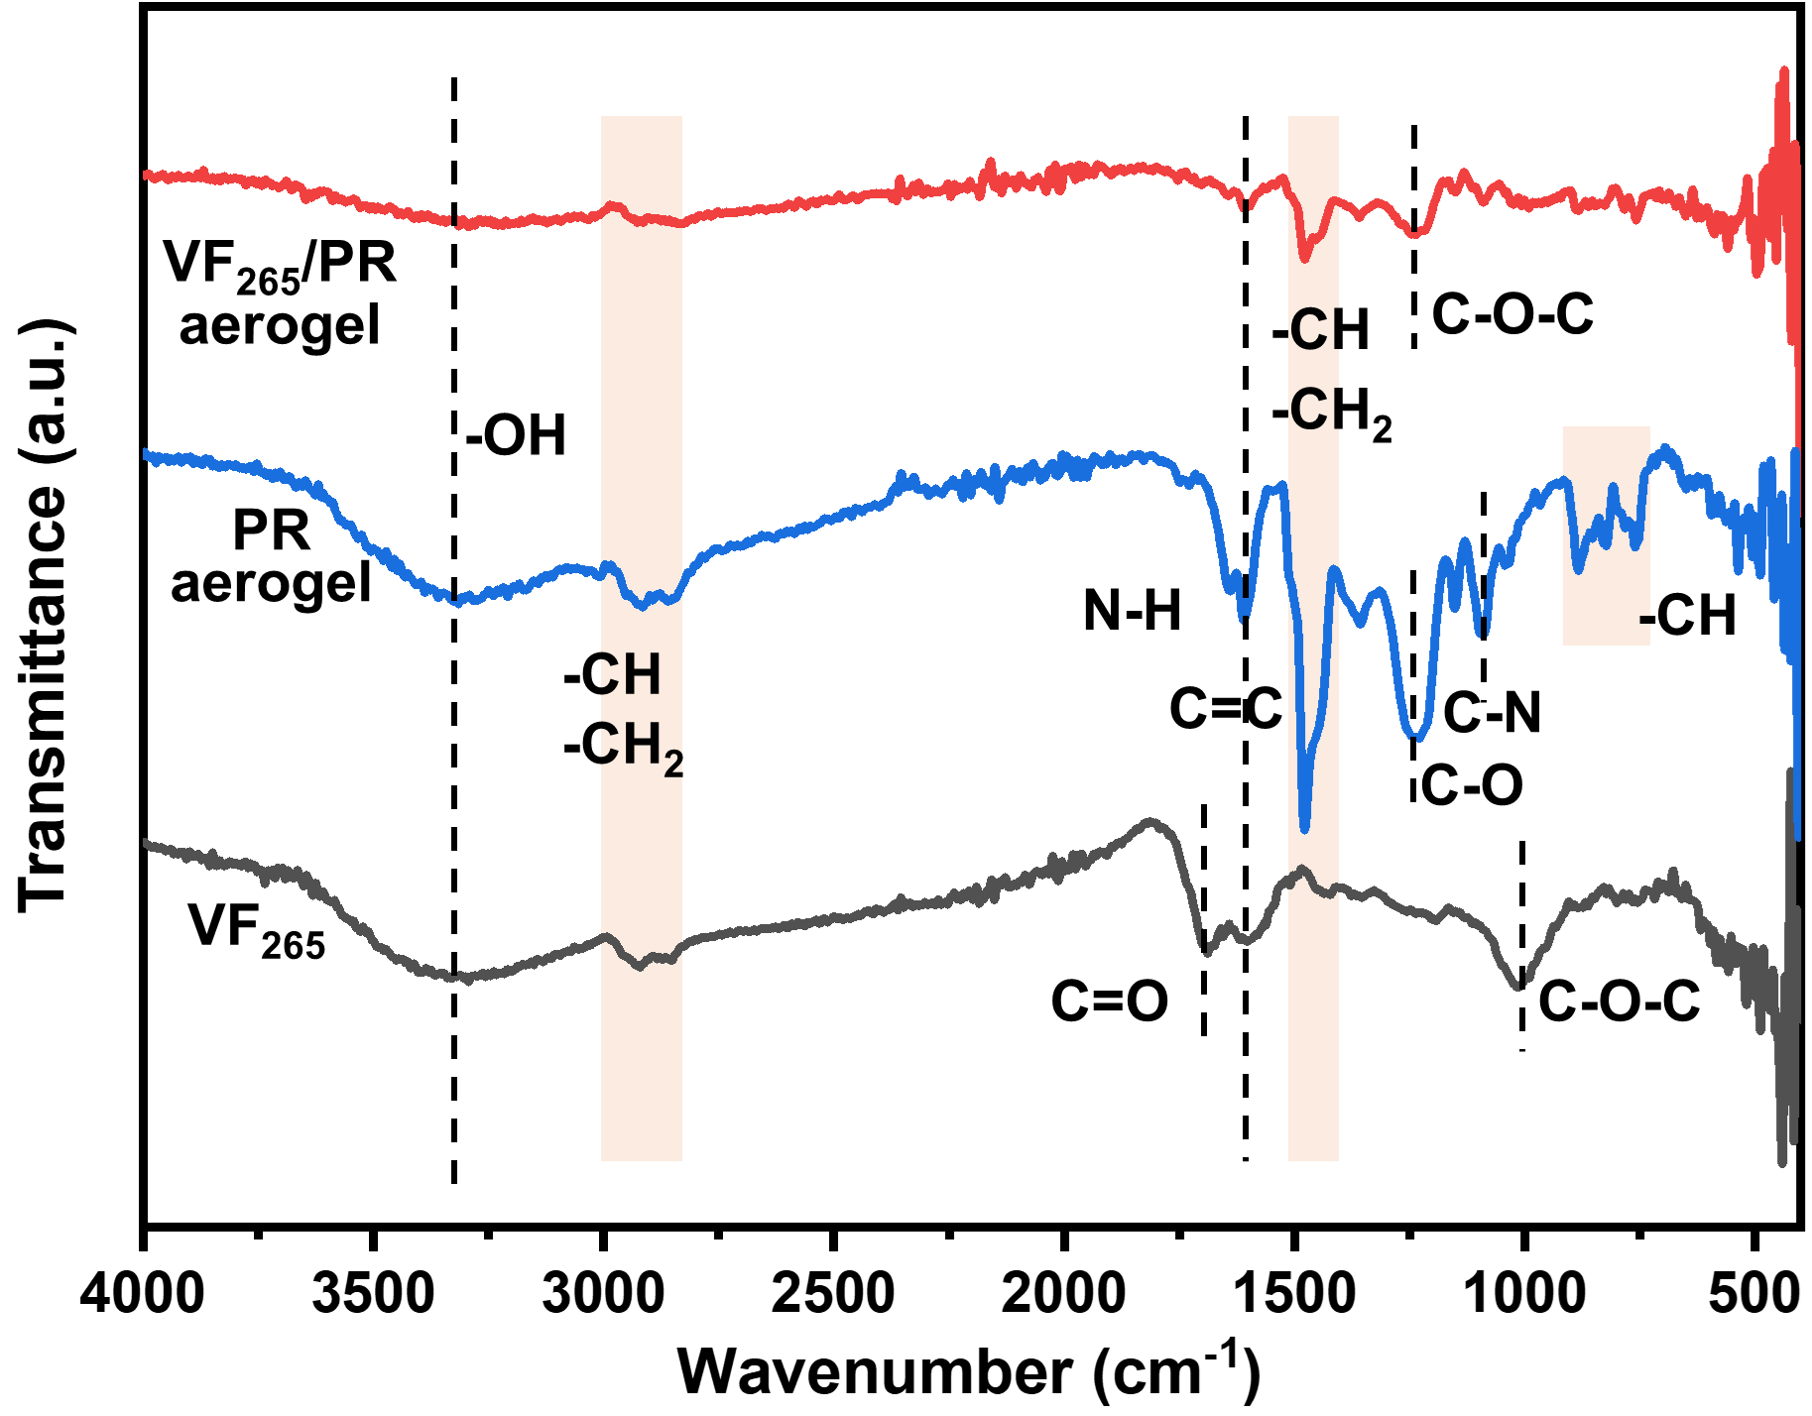
Fig. S1. Comparison of FTIR spectra of VF pretreated at 265 °C (VF₂₆₅), pure phenolic resin (PR) aerogel and VF₂₆₅/PR aerogel.

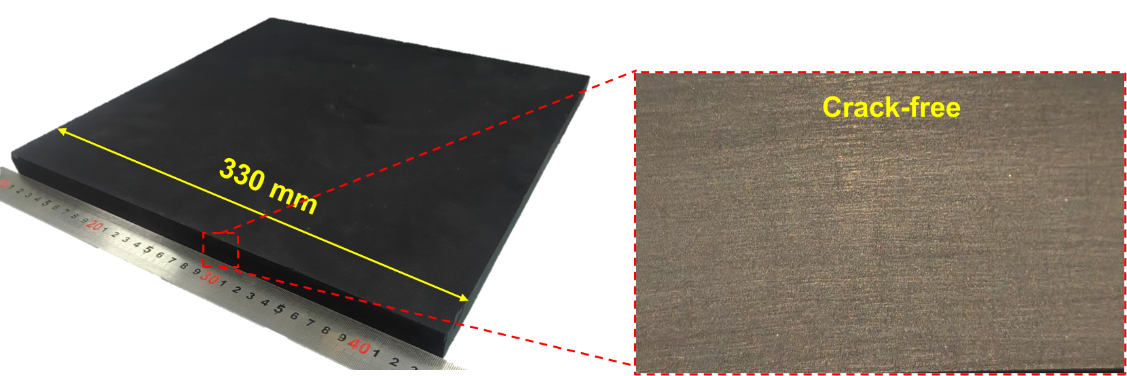
Fig. S2. Overall appearance of a large-sized C_{VF}/CA plate. The plate, with dimensions of approximately 330 mm × 330 mm × 25 mm, shows no evidence of macroscopic deformation or delamination. The optical image in the right panel highlights the smooth and crack-free lateral surface of the bulk C_{VF}/CA.

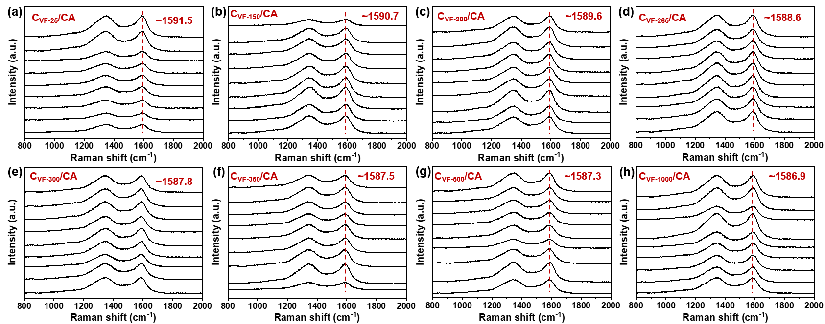
Fig. S3. Raman spectra for C_{VF}/CA reinforced with VFs pretreated at different temperatures. For each composite sample, Raman spectra were collected from nine randomly selected measurement points in each of two orientations, i.e., the cross-section perpendicular to the fiber layer plane (Z-direction) and within the fiber layer plane (X/Y-direction).
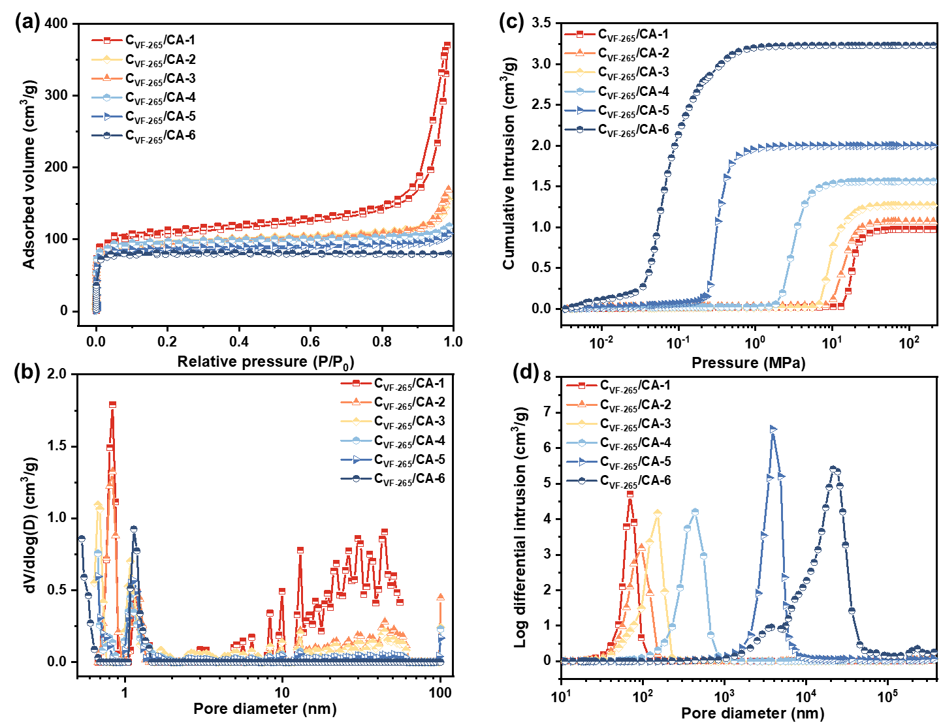
Fig. S4. Characteristics of pore structure in the C_{VF-265}/CA composites. a) Nitrogen adsorption-desorption isotherms and b) size distribution of micro- and mesopores of C_{VF-265}/CA with different densities. P₀ denotes the saturated vapor pressure of gas at the adsorption temperature, and P denotes the pressure of gas at adsorption equilibrium. c) Cumulative mercury intrusion curves and d) size distribution of relatively large pores of C_{VF-265}/CA with different densities. As the density increases, the nitrogen adsorption-desorption isotherms evolve from type Ⅰ to type Ⅱ, and ultimately to a mixed type Ⅱ and type Ⅳ with a hysteresis loop of type-H4, indicating an increasing mesopore content, in agreement with the pore size distribution curves. These results indicate that the higher-density aerogels exhibit a typical wedge-shaped slit pore structure comprising a mix of micropores, mesopores, and macropores, whereas the lower-density aerogels are primarily composed of micropores and macropores. The cumulative mercury intrusion curves of C_{VF-265}/CA with different densities exhibit a similar trend, featured by an S-shaped profile. Notably, all curves maintain a plateau at pressure up to approximately 220 MPa, demonstrating the robust skeleton strength of the matrix, capable of preserving the porous structure even under high-pressure mercury intrusion. The subtle distinction between the curves lies in the sequence in which the sharply rising region occurs, which is attributed to the increase in the pore size, as corroborated by the pore size distribution curves.
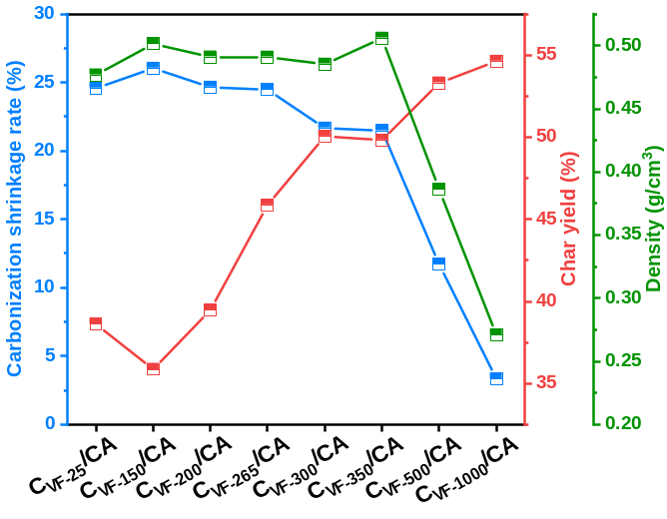
Fig. S5. Carbonization shrinkage rate, char yield and density of CA composites reinforced with fibers pretreated at various temperatures.
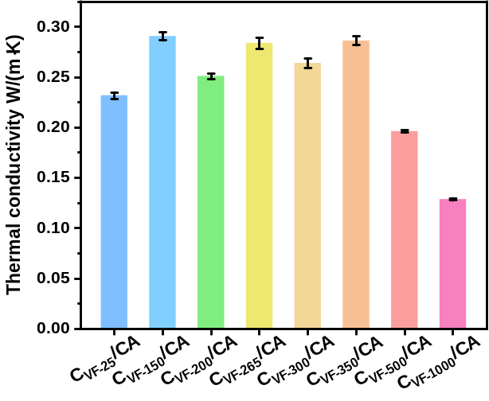
Fig. S6. Thermal conductivity of CA composites reinforced with fibers pretreated at various temperatures.

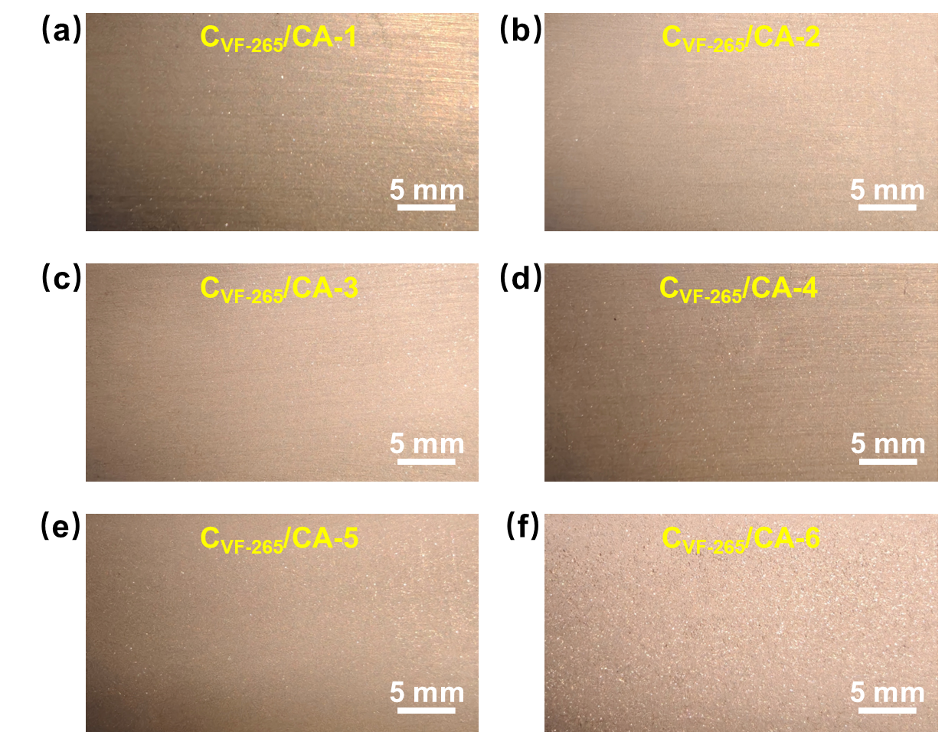
Fig. S7. Macroscopic cross-sectional morphology of C_{VF-265}/CA with different densities. The corresponding optical images for all samples demonstrate intact, crack- and void-free cross-sections.

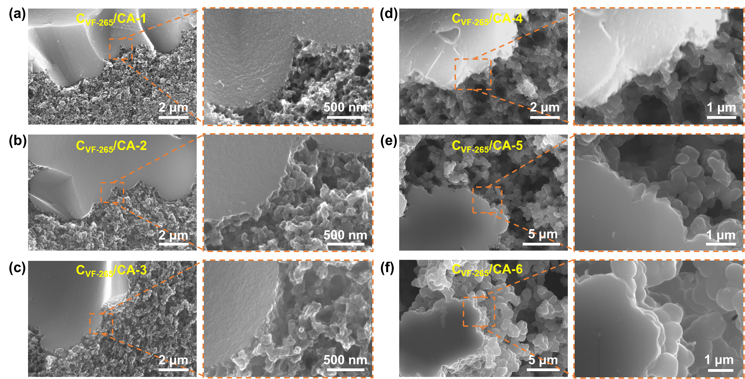
Fig. S8. Fiber/matrix interface characteristics of density-varied C_{VF-265}/CA. The corresponding SEM images for all samples demonstrate excellent interfacial bonding, solidly proving the efficacy of the fiber pretreatment strategy to enable synergistic shrinkage during carbonization process.

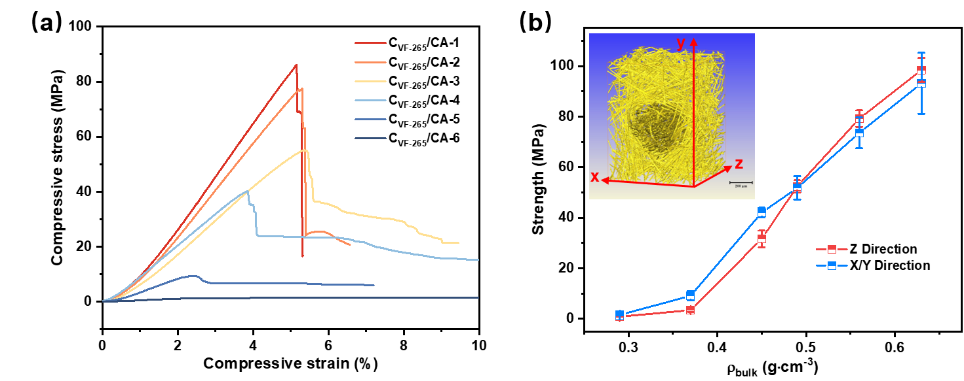
Fig. S9. Compressive properties of C_{VF-265/}CA in the X/Y-direction. a) Representative compressive stress-strain curves of C_{VF-265/}CA. b) Comparison of compressive strength of C_{VF-265/}CA in the Z-direction versus the X/Y-direction at various densities. The inset in b) shows the anisotropy of the fiber felt. The fracture behavior in the X/Y-directions is similar to that in the Z-direction – exhibiting brittle fracture at high densities and pseudo-plastic fracture at low to medium densities. Notably, the compressive strength in the Z-direction is slightly higher than that in the X/Y-directions at high densities, whereas the opposite trend is observed at low densities. This reversal is primarily attributed to the density-dependent variation in fiber/matrix interfacial bonding and load-transfer efficiency, which leads to opposite dominant load-bearing modes and failure mechanisms in the two orthogonal directions.

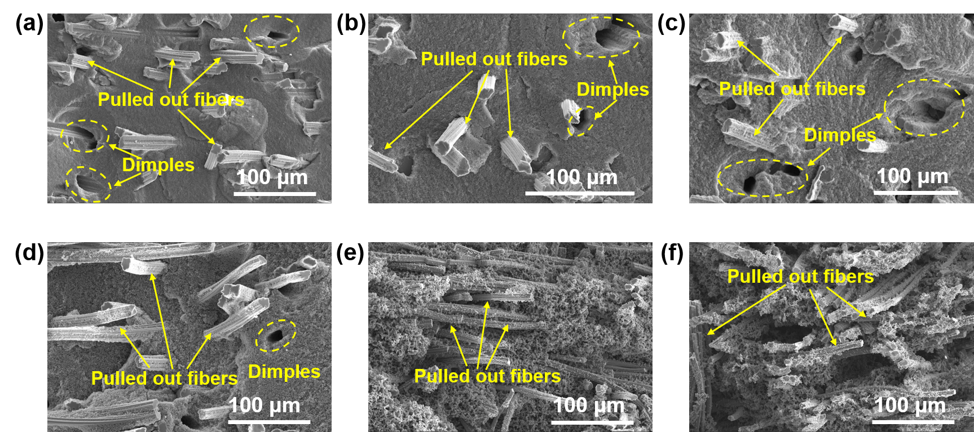
Fig. S10 Fracture morphology of the C_{VF-265}/CA materials at varying densities. SEM images showing the fracture surfaces of the C_{VF-265}/CA with densities decreasing from a) to f). An obvious rough fracture surface and fiber pull-out can be found on all specimens, demonstrating that interfacial debonding and subsequent fiber sliding are the dominant energy dissipation mechanisms, which effectively enhance the fracture toughness. Further careful inspection reveals that the high-density C_{VF}/CA composites show shorter fiber pull-out lengths, with large dimples surrounding the cavities left by the pulled-out fibers. This is mainly attributed to the relatively strong fiber/matrix interfacial bonding. Meanwhile, numerous microcracks are observed around the pulled-out fibers, which are mainly caused by crack deflection at the fiber/matrix interface. In contrast, the low-density C_{VF}/CA exhibit notably longer fiber pull-out lengths due to the weaker interfacial bonding, which significantly improves the overall toughness of the material but sacrifices strength.

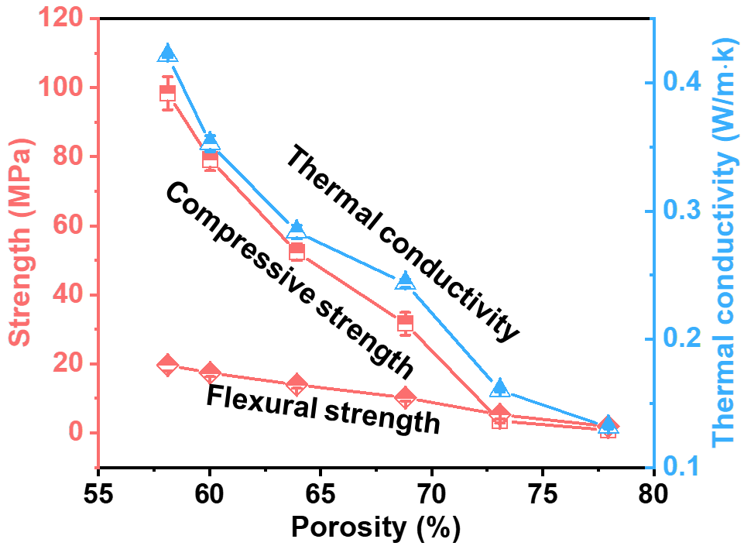
Fig. S11. Dependence of strengths and thermal conductivity on porosity in C_{VF-265}/CA.

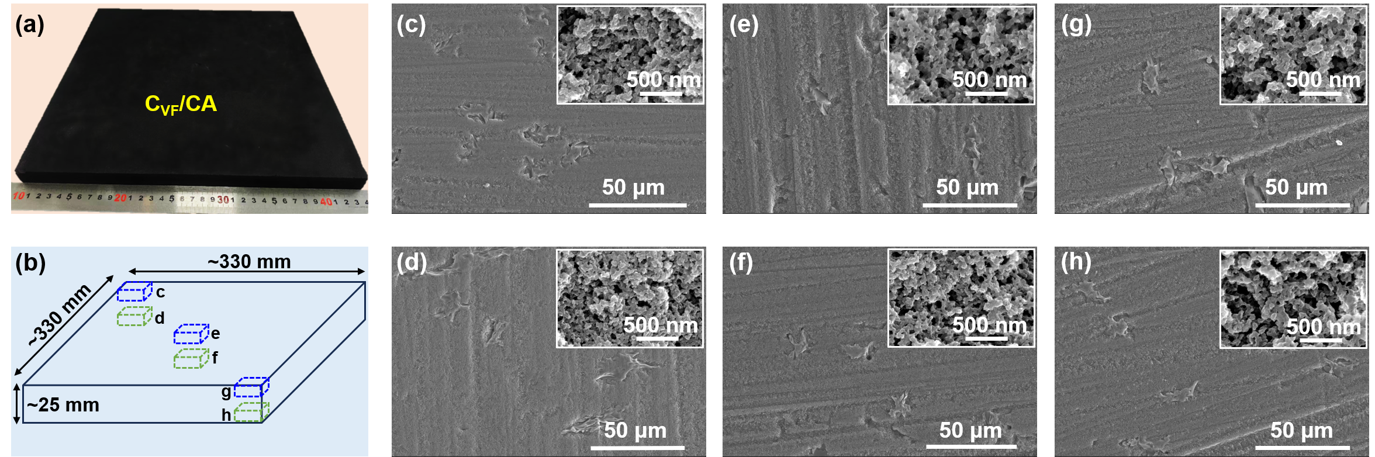
Fig. S12. Structural homogeneity of laboratory-fabricated large-sized C_{VF}/CA material. Overall appearance and SEM micrographs at different magnifications taken from various positions of the large-sized C_{VF}/CA material with dimensions of 330 × 330 × 25 mm³.

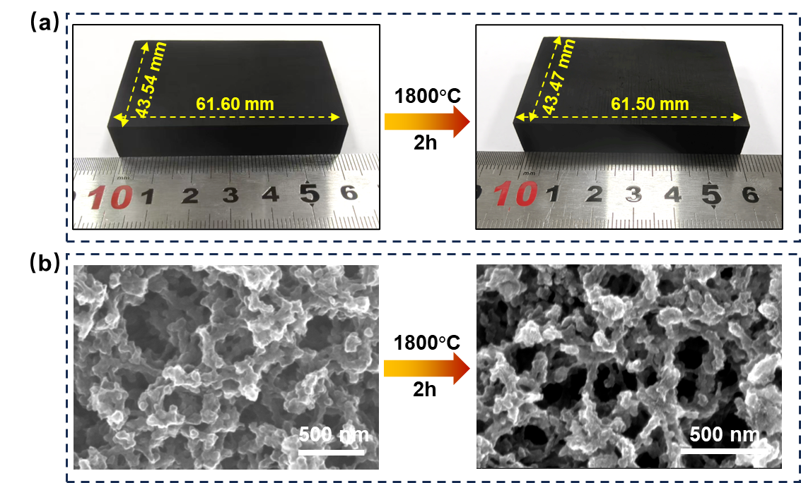
Fig. S13. Thermal stability of C_{VF-265}/CA in terms of macroscopic dimensions and microscopic structures. a) Photographs of C_{VF}/CA before and after heat treatment at 1800 °C for 2h. b) SEM images of the CA matrix in the C_{VF}/CA material microstructure before and after treatment. The cuboid sample retains its original shape remarkably well after the high-temperature exposure. The linear shrinkage is minimal, measured at only 0.16 % (X), 0.16 % (Y), and 0.39 % (Z), underscoring its exceptional dimensional stability. This limited shrinkage is attributed to the release of impurity atoms (e.g., O, N, H) and the concomitant rearrangement of the carbon network at high temperatures. Notably, the matrix preserves its highly porous 3D network nanostructure after treatment. The primary microstructural changes involve a slight reduction in the size of carbon nanoparticles and their connecting necks, coupled with an increase in average pore size and an overall decrease in porosity.

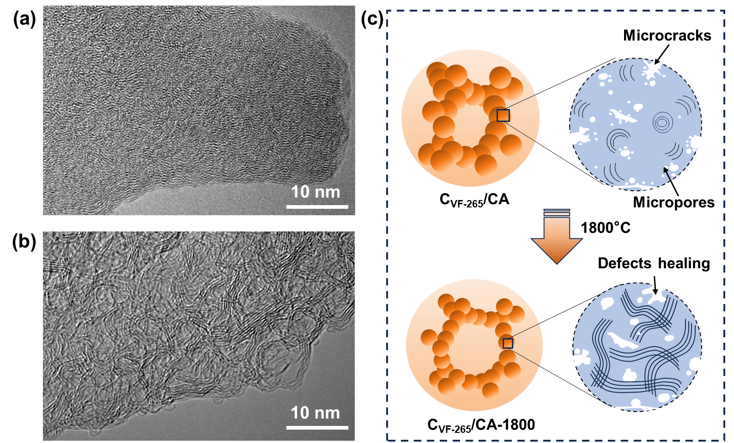
Fig. S14. Crystallinity variation and schematic structural evolution of C_{VF-265}/CA upon heat treatment. TEM images of the C_{VF-265}/CA a) before and b) after heat treatment at 1800 °C for 2 h revealing a structural transformation from an amorphous turbostratic into an entangled ribbon-like morphology, while the carbon atoms principally remain in an amorphous state. c) A schematic illustration depicting the structural evolution of C_{VF-265}/CA during heat treatment.

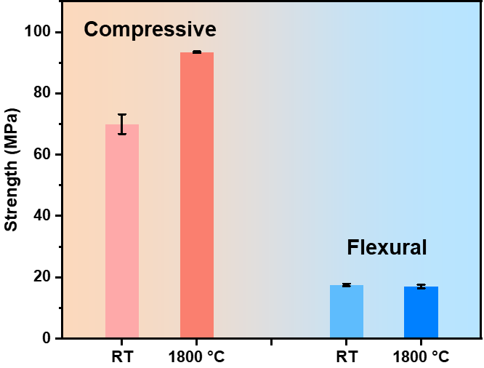
Fig. S15. Compressive and flexural strengths of C_{VF-265}/CA at room temperature (RT) and at 1800 °C.
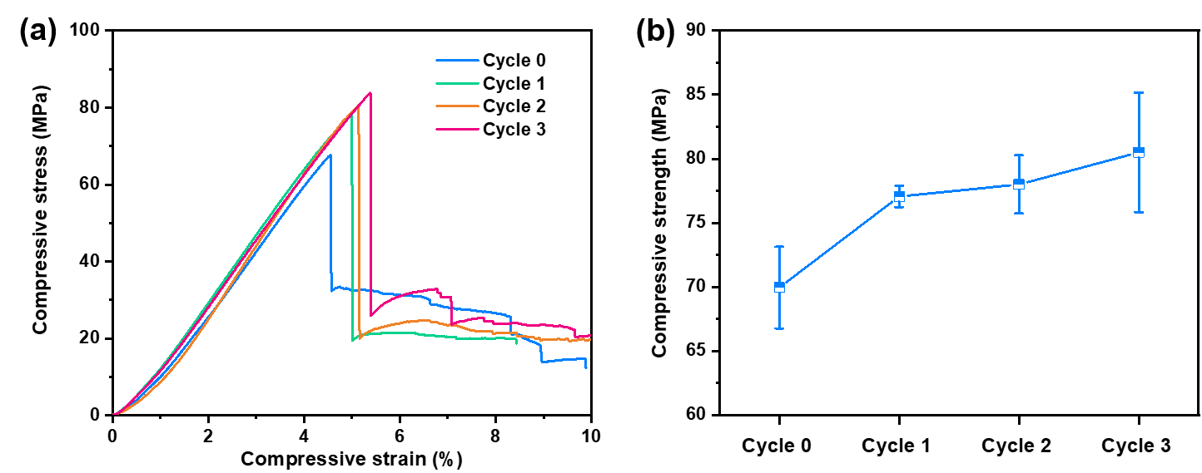
Fig. S16. Mechanical property evolution of C_{VF-265}/CA upon multiple thermal cycles. a) Representative compressive stress-strain curves of C_{VF-265/}CA under repeated thermal cycling. b) Evolution of C_{VF-265/}CA compressive strength with increasing thermal cycling. The compressive strength increased by approximately 10.1% after the first cycle. However, after the second and third cycles, the compressive strength showed only modest increments of 1.2% and 3.2%, respectively, indicating that the strengthening effect had reached saturation after the first cycle.

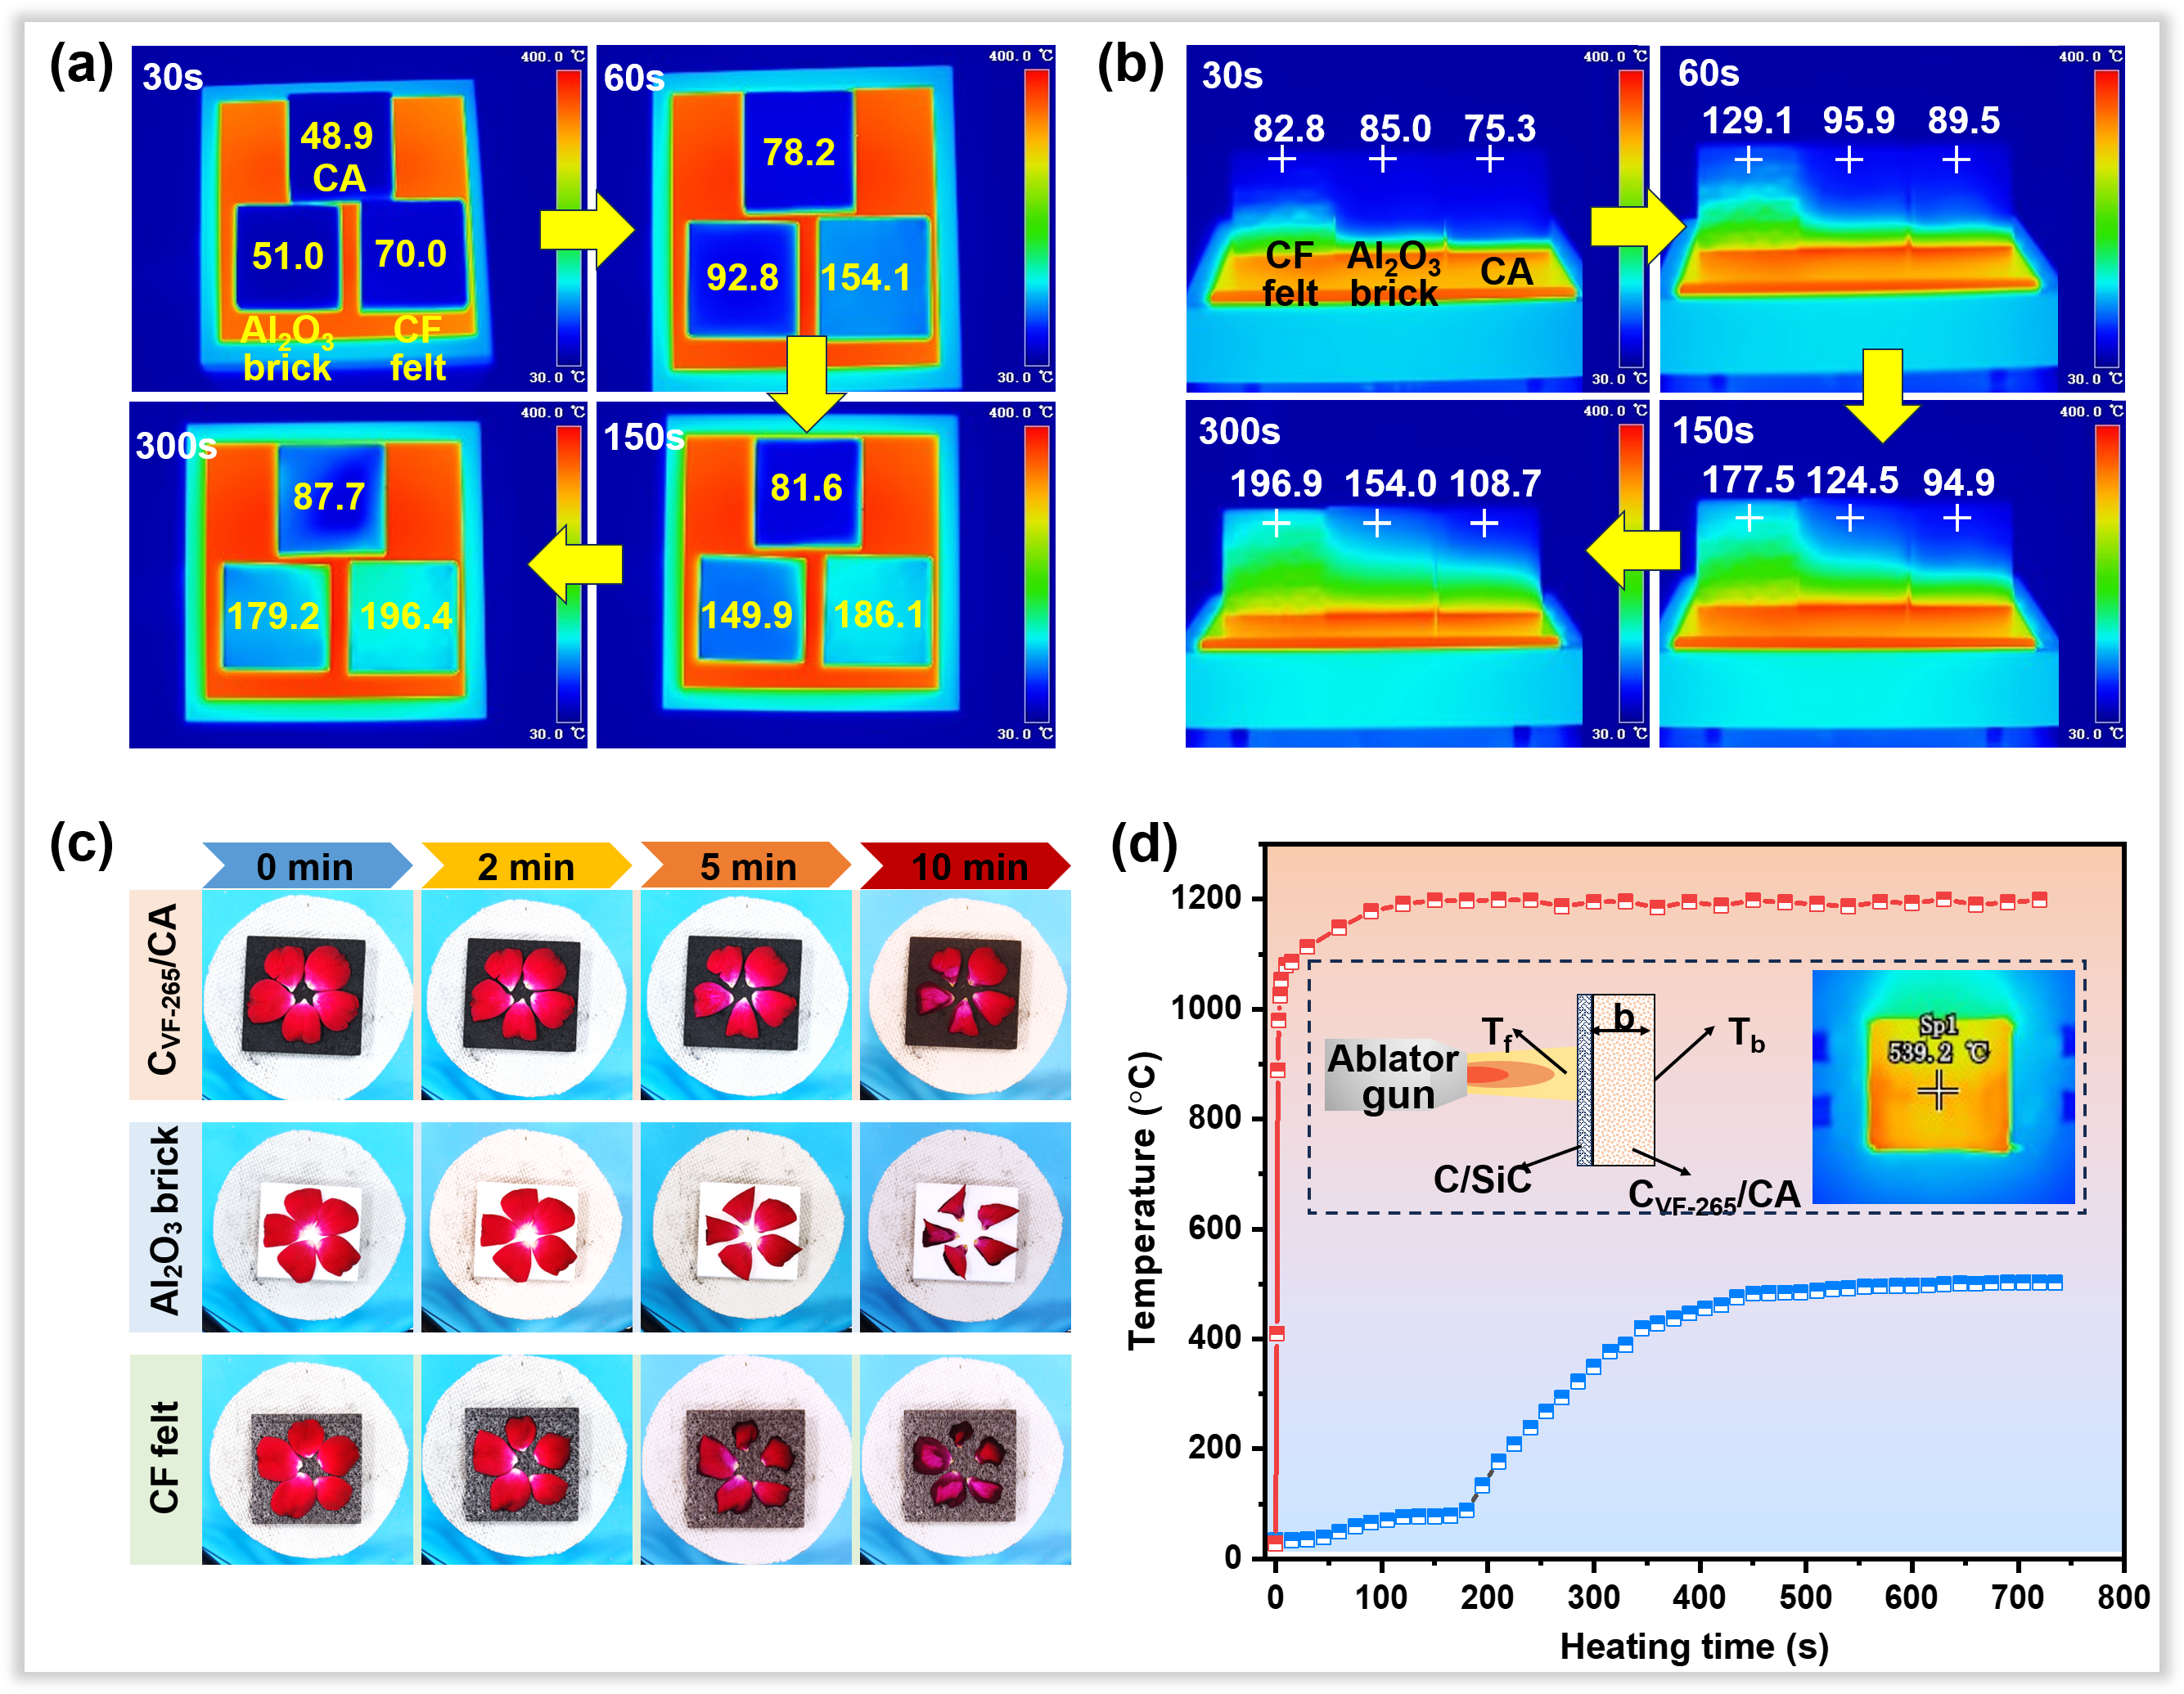
Fig. S17. The thermal insulation performances of C_{VF-265}/CA. a-c) Comparative thermal insulation performance of C_{VF-265}/CA, commercial alumina (Al₂O₃) brick and carbon fiber (CF) felt with a similar density a,b) placed on a 400 °C hot plate and c) a heating device of the alcohol lamp, respectively. d) Temperature variation of front and back surface of the C_{VF-265}/CA exposed to butane flame. The insets in d) exhibits the configuration of the testing fixture. The C_{VF-265}/CA demonstrates the slowest temperature rise and reaches a substantially lower backside temperature after 300 s, which was significantly lower than those of the alumina insulation brick and carbon fiber felt. Clearly seen, the fresh petals on C_{VF-265}/CA exhibits only slight wilting after 10 min of alcohol lamp heating, whereas those placed on the alumina insulation brick or carbon felt underwent apparent curling and carbonization. Finally, during the butane blowtorch flame heating, the rear side of a 15 mm thick C_{VF-265}/CA shows a temperature reduction of nearly 650 °C relative to the front side, validating its effectiveness as a TPS material against high-intensity flames.

Supplementary Tables S1-S4
Table S1. Characteristic band wave-numbers and their corresponding functional group assignments for VFs.
Wavenumber  (cm⁻¹) | Assignment | Wavenumber  (cm⁻¹) | Assignment
3324 | Stretching vibration of O-H bond | 1426 | Shear vibration of CH₂, CH group
2890 | Stretching vibration of C-H in CH₃, CH₂ group | 1364, 1255 | Mixed vibration of CH₂, CH group
1640 | Bending vibration of O-H bond | 1155 | Stretching vibration of C-O-C bond
1685 | Stretching vibration of conjugated C=O bond | 1017 | Stretching vibration of C-O bond
1580 | Stretching vibration of C=C in aromatic rings | 892 | Stretching vibration of β-1,4 glycosidic bond
Table S2. Porosity parameters of C_{VF-265}/CA with different densities through nitrogen adsorption-desorption isotherms and cumulative mercury intrusion porosimetry measurements. a: Brunauer-Emmett-Teller (BET) specific area; b: micropore surface area; c: mesopore surface area; d: micropore volume; e: mesopore volume; f: macropore volume; g: macropore pore size.
Material | Nitrogen adsorption-desorption isotherms |  |  |  |  |  | Mercury intrusion porosimetry
Material | S_{BET} ª/  m²·g⁻¹ | S_{mic} ^{b}/  m²·g⁻¹ | S_{meso}^{c}/  m²·g⁻¹ | V_{mic} ^{d}/  cm³·g⁻¹ | V_{meso}^{e}/  cm³·g⁻¹ |  | V_{mac}^{f}/  cm³·g⁻¹ | D_{m}^{g}/  nm
C_{VF-265}/CA-1 | 405.83 | 303.34 | 81.34 | 0.1214 | 0.3693 |  | 0.9756 | 64.99
C_{VF-265}/CA-2 | 371.97 | 343.28 | 25.17 | 0.1342 | 0.0704 |  | 1.0714 | 82.45
C_{VF-265}/CA-3 | 360.10 | 322.56 | 31.64 | 0.1307 | 0.0660 |  | 1.2698 | 110.94
C_{VF-265}/CA-4 | 370.99 | 354.89 | 17.55 | 0.1408 | 0.0316 |  | 1.5642 | 349.41
C_{VF-265}/CA-5 | 332.31 | 316.94 | 15.89 | 0.1258 | 0.0310 |  | 2.0022 | 3384.80
C_{VF-265}/CA-6 | 319.02 | 299.59 | 1.66 | 0.1142 | 0.0042 |  | 3.2298 | 9445.80

Table S3. The basic performance parameters of C_{VF}/CA with different pretreatment temperatures.
Samples | Bulk density  (g·cm⁻³) |  | Compressive strength  (MPa) |  | Flexural strength  (MPa) | Thermal conductivity  (W·m⁻¹·K⁻¹)
C_{VF-25}/CA |  | 0.48 | 16.90±1.43 |  | 5.50±0.52 | 0.2317±0.0032
C_{VF-150}/CA |  | 0.50 | 37.78±2.60 |  | 10.18±0.73 | 0.2905±0.0040
C_{VF-200}/CA |  | 0.49 | 41.28±0.76 |  | 10.30±0.82 | 0.2509±0.0028
C_{VF-265}/CA |  | 0.49 | 52.39±2.41 |  | 13.94±1.03 | 0.2837±0.0053
C_{VF-300}/CA |  | 0.49 | 46.64±4.97 |  | 14.25±1.25 | 0.2638±0.0048
C_{VF-350}/CA |  | 0.50 | 51.42±2.67 | 12.62±0.66 |  | 0.2860±0.0043
C_{VF-500}/CA |  | 0.39 | 9.74±0.36 | 7.45±0.44 |  | 0.1962±0.0011
C_{VF-1000}/CA |  | 0.27 | 6.52±0.36 | 4.03±0.41 |  | 0.1286±0.0010

Table S4. The basic performance parameters of C_{VF-265}/CA with different densities.
Samples | Bulk density  (g·cm⁻³) |  | Compressive strength  (MPa) |  | Flexural strength  (MPa) | Thermal conductivity  (W·m⁻¹·K⁻¹)
C_{VF-265}/CA-1 |  | 0.63 | 98.40±4.78 |  | 19.64±1.62 | 0.4212±0.0015
C_{VF-265}/CA-2 |  | 0.56 | 79.20±3.25 |  | 17.38±1.07 | 0.3493±0.0062
C_{VF-265}/CA-3 |  | 0.49 | 52.39±2.42 |  | 13.94±1.03 | 0.2837±0.0053
C_{VF-265}/CA-4 |  | 0.45 | 31.63±3.29 |  | 10.18±0.92 | 0.2436±0.0032
C_{VF-265}/CA-5 |  | 0.37 | 3.44±0.63 |  | 5.27±1.26 | 0.1601±0.0013
C_{VF-265}/CA-6 |  | 0.29 | 0.83±0.04 | 1.90±0.44 |  | 0.1313±0.0012

Note: The detailed derivation of Eq. 1
It should be noted that the shrinkage formula used in our manuscript (Eq. 1) is not a simple restatement of the conventional linear shrinkage, but rather a custom-defined parameter tailored to the specific needs of this work. Its purpose is to independently characterize the shrinkage behavior of the pre-treated fiber felt during the subsequent carbonization process, thereby enabling a more accurate assessment of the effectiveness of the pretreatment strategy in regulating the shrinkage of the fiber felt. For clarity, the complete derivation of this formula is presented below (Fig. S1). Following the conventional definition of linear shrinkage, the overall shrinkage of the pristine organic fiber felt during direct carbonization is given by:
$φ_{c}=\frac{L_{o}-L_{c}}{L_{o}}$ (S1)
where L_{o} is the initial length of the original fiber felt, and L_{c} is the length after direct carbonization. Similarly, the shrinkage occurring during the pretreatment process can be expressed as:
$φ_{pre}=\frac{L_{o}-L_{pre}}{L_{o}}$ (S2)
where L_{pre} is the length of the fiber felt after pretreatment. In this work, the parameter of primary interest is the shrinkage that takes place during the subsequent carbonization of the pre-treated fiber felt, which is defined as:
$φ=\frac{L_{pre}-L_{c}}{L_{pre}}$ (S3)
Starting from Eq. (3), we algebraically rearrange both the numerator and the denominator to express $φ$ in terms of $φ_{c}$ and $φ_{pre}$. For the numerator: $L_{pre}-L_{c}={(L}_{o}-L_{c})-(L_{o}-L_{pre})$; For the denominator: $L_{pre}=L_{o}-(L_{o}-L_{pre})=L_{o}(1-\frac{L_{o}-L_{pre}}{L_{o}})=L_{o}(1-φ_{pre})$; Substituting these expressions into Eq. (S3) yields:
$φ=\frac{(L_{o}-L_{c})-(L_{o}-L_{pre})}{L_{o}(1-φ_{pre})}$ (S4)
Dividing both the numerator and the denominator by L_{o}:
$φ=\frac{\frac{L_{o}-L_{c}}{L_{o}}-\frac{L_{o}-L_{pre}}{L_{o}}}{1-φ_{pre}}$ (S5)
Finally, substituting Eqs. (S1) and (S2) into Eq. (S5), we obtain the formula used in our manuscript:
$φ=\frac{φ_{c}-φ_{pre}}{1-φ_{pre}}=\frac{a-φ_{pre}}{1-φ_{pre}}$ (S6)
The essential distinction between this formula and the conventional linear shrinkage definition lies in the fact that it directly correlates the carbonization shrinkage of the pre-treated fiber felt ($φ$) with both the pre-shrinkage introduced during pretreatment ($φ_{pre}$) and the intrinsic total shrinkage of the material ($φ_{c}$), thereby consolidating multiple independent parameters into a single parameter. This approach offers three key advantages: 1) it eliminates the direct influence of the initial length $L_{o}$, allowing $φ$ to more faithfully reflect the actual shrinkage behavior of the pre-treated fiber felt during subsequent carbonization; 2) it facilitates quantitative comparisons across different pretreatment conditions by effectively decoupling the shrinkage contributions from the pretreatment and carbonization stages; and 3) it is physically more meaningful than the conventional total shrinkage for evaluating the effectiveness of the pre-shrinkage matching strategy. To the best of our knowledge, this custom-defined parameter is proposed for the first time in the present work, with the aim of providing a more accurate description and assessment of the effectiveness of the active shrinkage regulation strategy.
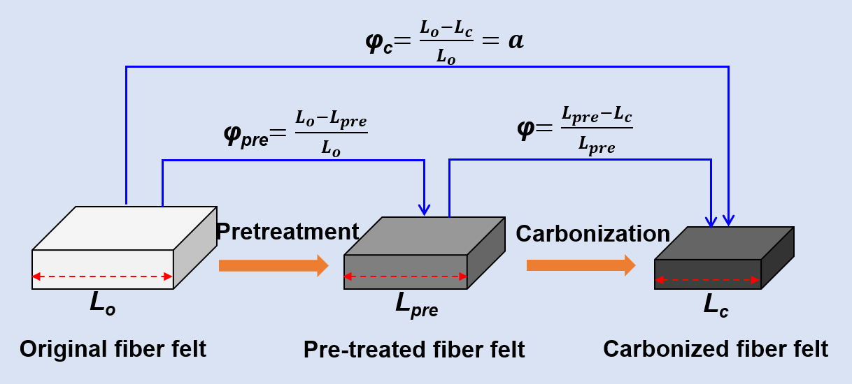
Fig. S1. Schematic illustration of the shrinkage behavior of fiber felt during pretreatment and carbonization processes.

