Supporting Information

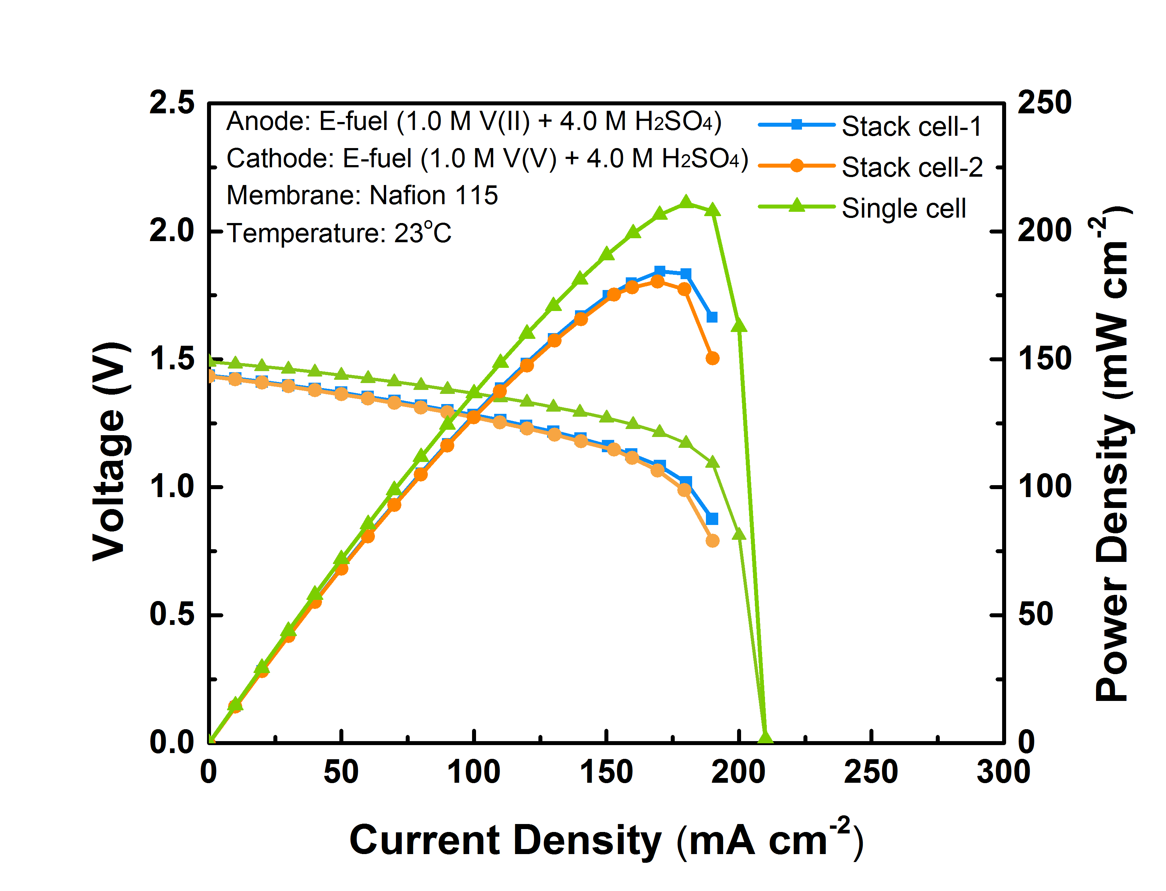
Figure S1 Performance consistency between the two single cells inside the stack and comparison with the single passive e-fuel cell.

Table S1 Peak power density comparison among various liquid fuel cells.
Fuel | Year | Anode catalyst | Membrane | Temp | Peak Power Density  (mW cm⁻²) | Ref
MeOH | 2020 | Pt-Ru/C | Nafion 211 | 15 ˚C | 11.15 | 1
MeOH | 2016 | Pt-Ru black  (4.0 mg cm⁻²) | Nafion 117 | 20˚C | 24.2 | 2
MeOH | 2016 | Pt-Ru black  (4.0 mg cm⁻²) | Nafion 115 | 25 ˚C | 29.3 | 3
MeOH | 2006 | Pt-Ru black  (8.0 mg cm⁻²) | Nafion 112 | R.T. | ~45 | 4
MeOH | 2006 | Pt-Ru  (4.0 mg cm⁻²) | Nafion 117 | 2 ˚C | ~16 | 5
EtOH | 2019 | Pd-Ru  (2.0 mg cm⁻²) | Nafion 117 | 30 ˚C | 1.54 | 6
EtOH | 2015 | Pd/C  (1.7 mg cm⁻²) | A006 AEM | 25 ˚C | 17 | 7
EtOH | 2012 | Pd-CeO₂/C  (1.0 mg cm⁻²) | A006 AEM | 25 ˚C | 66 | 8
EtOH | 2009 | Pd-(Ni-Zn)/C  (1.0 mg cm⁻²) | A006 AEM | 20 ˚C | 58 | 9
Formic acid | 2010 | Pd/C  (1.0 mg cm⁻²) | Nafion 212 | R.T. | 19.6 | 10
Formic acid | 2009 | Pd black  (4.0 mg cm⁻²) | Nafion 212 | 25 ˚C | 69.9 | 11
Formic acid | 2005 | Pd black  (8.0 mg cm⁻²) | Nafion 115 | 30 ˚C | 177 | 12
Formic acid | 2003 | Pt-Ru black  (12.0 mg cm⁻²) | Nafion 117 | R.T. | 33 | 13
E-fuel | 2021 | Catalyst-free graphite felt | Nafion 117 | -20 ˚C | 67.4 | 14
 |  |  |  | -10 ˚C | 76.7 | 14
 |  |  |  | 0 ˚C | 118.9 | 14
 |  |  |  | 10 ˚C | 150.7 | 14
 |  |  |  | 20˚C | 199.2 | 14
E-fuel | 2024 | Catalyst-free graphite felt | Nafion 115 | -20 ˚C | 110.34 | This work
 |  |  |  | -10 ˚C | 134.62 | This work
 |  |  |  | 0 ˚C | 153.05 | This work
 |  |  |  | 10 ˚C | 169.73 | This work
 |  |  |  | 23˚C | 211.03 | This work

References:
1. Y. Fang, J. Qi, F. Wang, Y. Hao, J. Zhu and P. Zhang, Highly Durable Passive Direct Methanol Fuel Cell with Three‐Dimensional Ordered Porous NiCo2O4 as Cathode Catalyst, Chemelectrochem, 2020, 7, 2314-2324.
2. V. Oliveira, J. Pereira and A. Pinto, Effect of anode diffusion layer (GDL) on the performance of a passive direct methanol fuel cell (DMFC), International Journal of Hydrogen Energy, 2016, 41, 19455-19462.
3. J. Zheng, W. Bi, X. Dong, J. Zhu, H. Mao, S. Li and S. Zhang, High performance tetra-sulfonated poly (p-phenylene-co-aryl ether ketone) membranes with microblock moieties for passive direct methanol fuel cells, Journal of Membrane Science, 2016, 517, 47-56.
4. H. Kim, J. Oh, J. Kim and H. Chang, Membrane electrode assembly for passive direct methanol fuel cells, Journal of Power Sources, 2006, 162, 497-501.
5. D. Chu and R. Jiang, Effect of operating conditions on energy efficiency for a small passive direct methanol fuel cell, Electrochimica Acta, 2006, 51, 5829-5835.
6. N. Shaari, S. K. Kamarudin and Z. Zakaria, Enhanced alkaline stability and performance of alkali‐doped quaternized poly (vinyl alcohol) membranes for passive direct ethanol fuel cell, International Journal of Energy Research, 2019, 43, 5252-5265.
7. R. M. Modibedi, T. Mehlo, K. I. Ozoemena and M. K. Mathe, Preparation, characterisation and application of Pd/C nanocatalyst in passive alkaline direct ethanol fuel cells (ADEFC), International Journal of Hydrogen Energy, 2015, 40, 15605-15612.
8. V. Bambagioni, C. Bianchini, Y. Chen, J. Filippi, P. Fornasiero, M. Innocenti, A. Lavacchi, A. Marchionni, W. Oberhauser and F. Vizza, Energy Efficiency Enhancement of Ethanol Electrooxidation on Pd–CeO2/C in Passive and Active Polymer Electrolyte‐Membrane Fuel Cells, ChemSusChem, 2012, 5, 1266-1273.
9. C. Bianchini, V. Bambagioni, J. Filippi, A. Marchionni, F. Vizza, P. Bert and A. Tampucci, Selective oxidation of ethanol to acetic acid in highly efficient polymer electrolyte membrane-direct ethanol fuel cells, Electrochemistry Communications, 2009, 11, 1077-1080.
10. P. Hong, S. Liao, J. Zeng and X. Huang, Design, fabrication and performance evaluation of a miniature air breathing direct formic acid fuel cell based on printed circuit board technology, Journal of power sources, 2010, 195, 7332-7337.
11. Y. Kang, M. Ren, T. Yuan, Y. Qiao, Z. Zou and H. Yang, Effect of Nafion aggregation in the anode catalytic layer on the performance of a direct formic acid fuel cell, Journal of Power Sources, 2010, 195, 2649-2652.
12. S. Ha, Z. Dunbar and R. Masel, Characterization of a high performing passive direct formic acid fuel cell, Journal of Power Sources, 2006, 158, 129-136.
13. S. Ha, B. Adams and R. Masel, A miniature air breathing direct formic acid fuel cell, Journal of Power Sources, 2004, 128, 119-124.
14. X. Shi, X. Huo, O. C. Esan, Y. Ma, L. An and T. Zhao, A liquid e-fuel cell operating at− 20° C, Journal of Power Sources, 2021, 506, 230198.

