Supplementary Materials

Smart pH responsive System Based on Hybrid Mesoporous Silica Nanoparticles For Delivery of Fungicide to Control Fusarium Crown and Root rot In Tomato
Mohamed A. Mosa^{1,2}*, Sozan E. El-Abeid^{1,2}, M. M. A. Khalifa², T.H. Elsharouny³, Sahar M. El-Baz², and Ayman Y. Ahmed^{1,2}
¹Nanotechnology & Advanced Nano-Materials Laboratory (NANML), Plant Pathology Research Institute, Agricultural Research Center, Giza 12619, Egypt

²Plant Pathology Research Institute, Agricultural Research Center, Giza 12619, Egypt
³Department of Agricultural Microbiology, Faculty of Agriculture, Sohag University, Sohag, Egypt
*Corresponding authors. e-mail: mohammed_sharouny@yahoo.com (Mohamed A. Mosa)
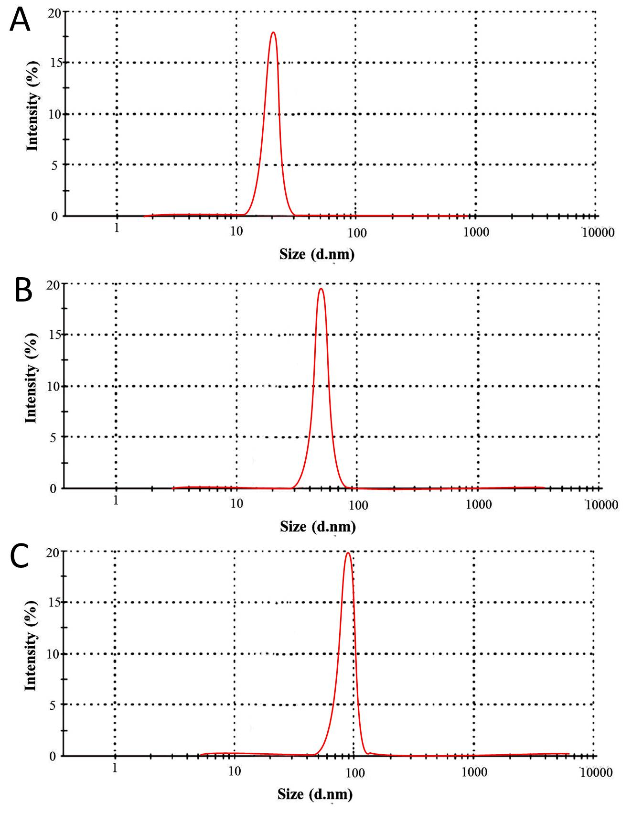

Figure S1. Dynmic light scattering (DLS) analysis of the formmed MSNs, (A) 20 nm, (B) 50 nm, and (C) 90 nm.
Treatment |  | Concentration (mg/l) |  | Inhibition rate (%)
 |  |  |  | 4 days | 6 days | 8 days
fludioxonil (Technical) |  | 0.05 |  | 16.23±1.35 | 19.23±1.35 | 20.12±0.3
 |  | 0.1 |  | 25.55±0.5 | 29.35±2.8 | 32.19±2.5
 |  | 0.2 |  | 29.55±0.5 | 37.35±2.8 | 42.89±2.5
 |  | 0.4 |  | 32.55±0.5 | 38.35±2.8 | 46±2.5
 |  | 0.8 |  | 38±1.28 | 45.7±1.28 | 57±1.28
 |  | 1 |  | 45.44±0.0 | 49.44±0.0 | 60.44±0.0
Flu@MSNs _{20nm}-HTCC |  | 0.05 |  | 81.35±2.047 | 85.15±1.09 | 90.23±1.35
 |  | 0.1 |  | 89.90±1.1 | 91.153±1.09 | 100.0±0.0
 |  | 0.2 |  | 100.0±0.0 | 100.0±0.0 | 100.0±0.0
 |  | 0.4 |  | 100.0±0.0 | 100.0±0.0 | 100.0±0.0
 |  | 0.8 |  | 100.0±0.0 | 100.0±0.0 | 100.0±0.0
 |  | 1 |  | 100.0±0.0 | 100.0±0.0 | 100.0±0.0
Controls | MSNs_{20nm}-HTCC |  |  | 21.12±0.23 | 24.22±0.22 | 28.90±0.10
Controls | MSNs |  | 20nm | 14.33 | 17.55±0.27 | 25.15±0.7
Controls |  |  | 50 nm | 10.55±0.5 | 14.35±2.8 | 25.23±1.0
Controls |  |  | 90 nm | 8.55±0.3 | 10.55±1.8 | 18.89±2.5
Controls | HTCC |  |  | 2.2±1.3 | 3.5±2.04 | 4.2±1.28
Controls | Untreated control |  |  | 0.0 | 0.0 | 0.0

Table S2 : Inhibition activity of the following: (1) fludioxonil fungicide (Flu), and (2) Flu@ MSNs_{20nm}-HTCC at different concentrations (0.05, 0.1, 0.2,0.4,0.8, and 1.0) mg/l, (3) MSNs_{20nm-}HTCC, HTCC alone, and (4)MSNs at different sizes (20,50 and 90) nm against the mycelial growth of the FORL fungal pathogen after incubation at 25 °C± 1 for 4, 6, and 8 d.

