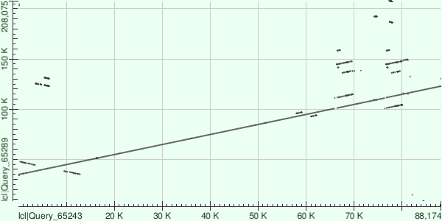

Supplementary Figure 1. Dot plot following alignment of the 45 contigs assembled following illumina sequencing of 46H22(Emeriewen et al. 2018) against the single contig derived from MinIon sequencing in the current study. The largest contig of 88 Kbp showing high identity and alignment with the single contig of 216, 813 bp. On the y axis are the sequence positions of the MinIon-derived sequence of 46H22 whilst the x axis are the other contigs. Some small contigs could not align to the MinIon derived sequence. Alignment was performed using NCBI megablast function.

