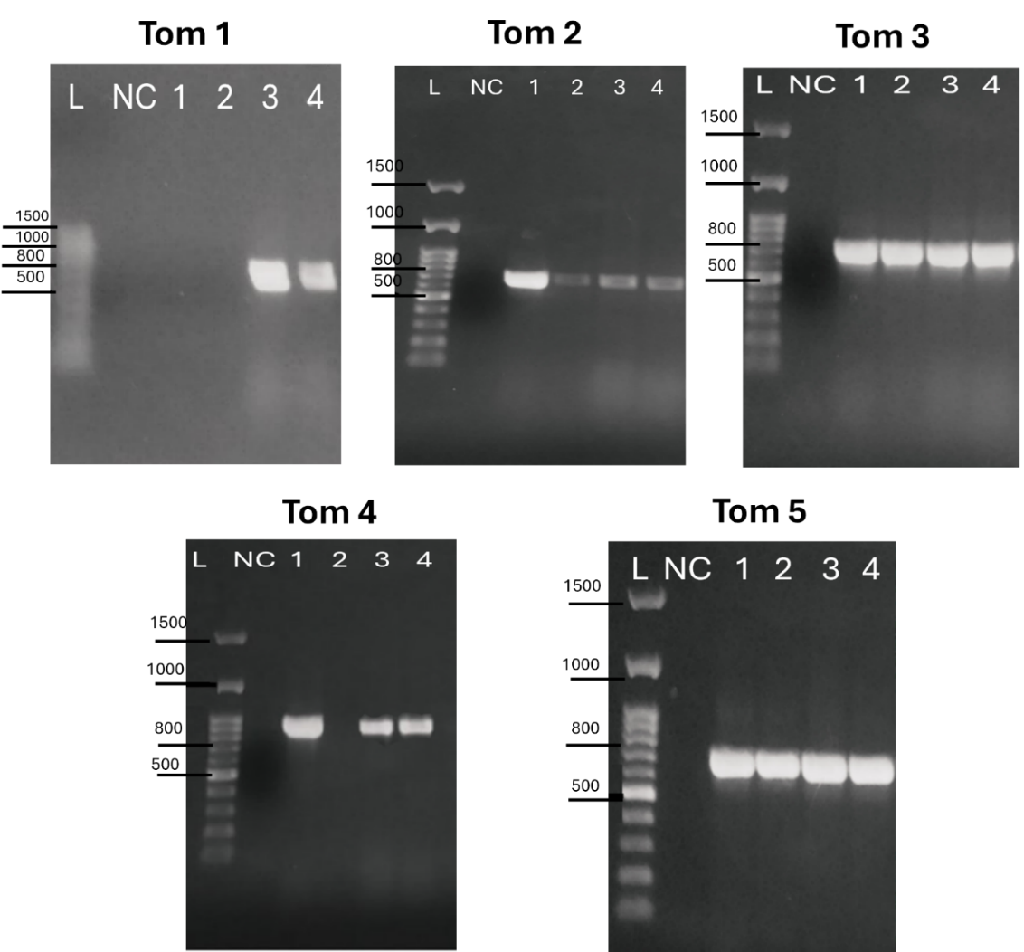

Supplementary Fig.S1 Agarose (1.5%) gel electrophoresis showing a single PCR amplification product of ~600 bp long except Tom4 of ~700 bp long. Reaction was run using DNA extract derived from four Fusarium oxysporum f.sp. lycopersici (FOL) isolates and a pair of specific primers mention in table 1. NC referees to no template control.

Supplementary Table S1. Primer sequences of Tomatinase genes
Gene name | Primer name | Sequence (5’-3’)
Tom1 | Tom1-f | GTCAGTCCATTGGCTCTCTC
Tom1 | Tom1-r | TCCTTGACACCATCACAGAG
Tom 2 | Tom2-f | CCTCTTGTCTTTGTCTCACGA
Tom 2 | Tom2-r | GCAACAGGTCGTGGGGAAAA
Tom 3 | Tom3-f | CCAGAGTGCCGATACCGATT
Tom 3 | Tom3-r | AAGTGTTGGTAGGATAGTTG
Tom 4 | Tom4-f | CTCAAGCAGTCAAAATCCCCT
Tom 4 | Tom4-r | CGACGAGTTGTGCTACCATCT
Tom5 | Tom5-f | CCACTTCTGCGACACTGCTA
Tom5 | Tom5-r | CTGTGTTTCCTGTTCGTTTCC

