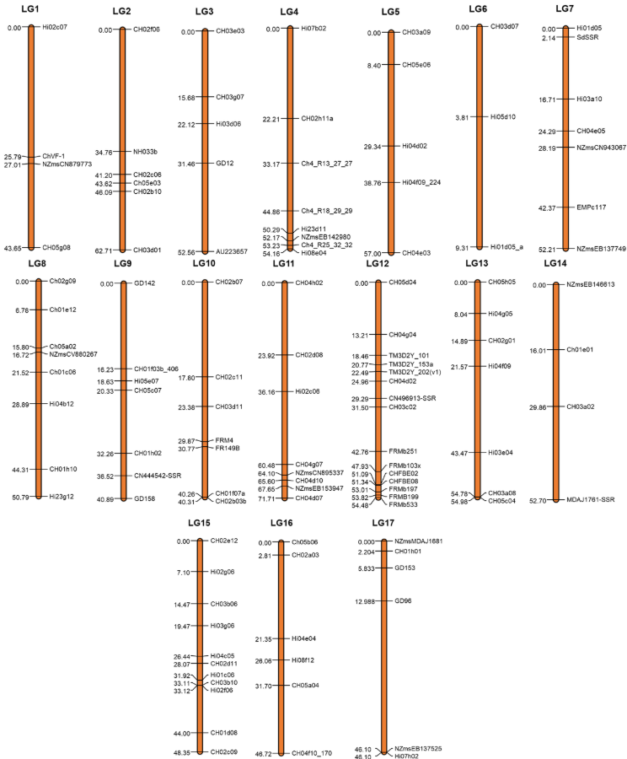
Supplementary Figure 1. SSR genetic map of resistance donor Malus floribunda 821, consisting of 17 linkage groups.

