Supplementary Information

Slippery Surface with Petal-like Structure for Protecting Al Alloy: Anti-corrosion, Anti-fouling and Anti-icing

Junfei Huang^{1,3}, Jiajie Kang^{1,4*}, Jiaxu Zhang^{1,3}, Jinxia Huang^{3*}, Zhiguang Guo^{2,3*}

1. School of Engineering and Technology, China University of Geosciences, Beijing 100083, China
2. Ministry of Education Key Laboratory for the Green Preparation and Application of Functional Materials, Hubei University, Wuhan 430062, China
3. State Key Laboratory of Solid Lubrication, Lanzhou Institute of Chemical Physics, Chinese Academy of Sciences, Lanzhou 730000, China
4. Zhengzhou Institute, China University of Geosciences (Beijing), Zhengzhou 451283, China

*Email address: kangjiajie@cugb.edu.cn (Kang); huangjx@licp.cas.cn (Huang); zguo@licp.cas.cn (Guo)

Fig. S1 High magnification SEM of (a) LDH and (b) SHS.

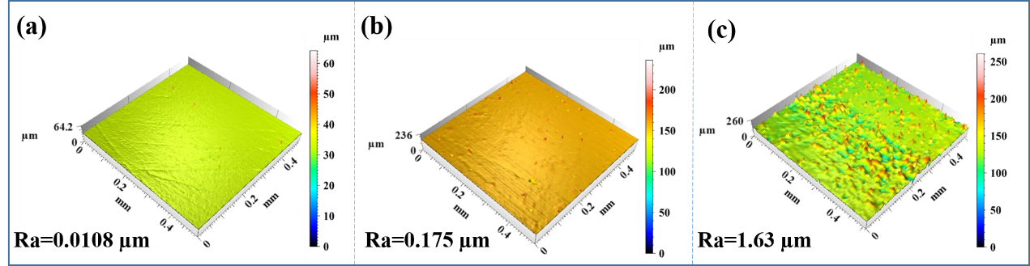
Fig. S2 3D surface roughness profiles of (a) Bare, (b) LDH and (c)SHS.
Fig. S3 CAs and SAs of different liquids on SLIPS.

Fig. S4 EDS spectrum of the (a) LDH and (b) SHS.
Fig. S5 (a) Change of CA of SHS immersed in 0.1 M HCl and NaOH solution for different time, (b) the SHS soaked in 0.1 M HCl and NaOH solution for 10 minutes.
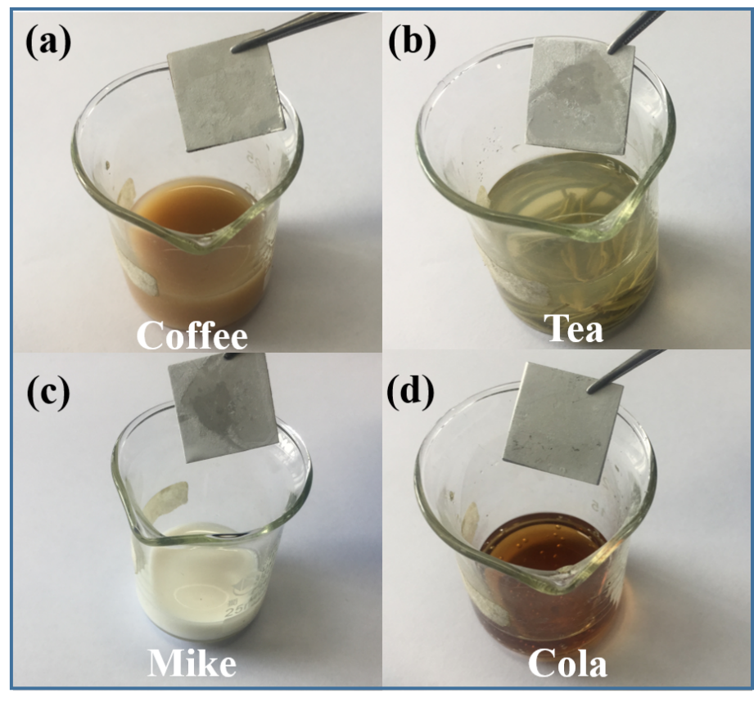
Fig. S6 Anti-fouling test of SHS in different liquids.

