Supporting Information

Title: Foundational Mechanisms of Visual-Perception Control in Cyborg Insects Using UV Stimulation

Fig. S1. 3D and Technical Views of the Helmet for UV Stimulation of Cockroach Compound Eyes.
Fig. S2 Behavioural responses to UV stimulation under eyes-uncovered and eyes-covered conditions.
Fig. S3 Effect of UV blinking frequency on turning behavior.
Fig. S4 Trajectories of Manually Controlled Cyborg Cockroaches Navigating an S-shaped Track Under Targeted Electrical Stimulation.
Movie S1. Video showing neural signal measurements obtained during ultraviolet (UV) stimulation.
Movie S2. Video demonstration of cockroach responses to ultraviolet (UV) stimulation during maze navigation with eyes uncovered.
Movie S3. Video demonstration of cockroach responses to ultraviolet (UV) stimulation during maze navigation with eyes covered.
Movie S4. Demonstration of Manipulating Insect Visual Perception to Guide Locomotion via Ultraviolet (UV) Stimulation. This video shows that UV light directed at the right compound eye induced leftward turns, while UV light directed at the left compound eye induced rightward turns.
Movie S5. Demonstration of Random One UV Stimulation Cyborg Cockroach Navigation Response in S-path Experimental Ara.
Movie S6. Demonstration of successful manual guidance of Cockroach 1 along a predefined S-shaped path (N=1, n=5). Trial 1 represents T1, with subsequent trials labeled T2, T3, T4, and T5. All trial videos' playback speed is 4x the original speed.
Movie S7. Demonstration of successful manual guidance of Cockroach 2 along a predefined S-shaped path (N=1, n=5). Trial 1 represents T1, with subsequent trials labeled T2, T3, T4, and T5. All trial videos' playback speed is 4x the original speed.
Movie S8. Demonstration of successful manual guidance of Cockroach 3 along a predefined S-shaped path (N=1, n=5). Trial 1 represents T1, with subsequent trials labeled T2, T3, T4, and T5. All trial videos' playback speed is 4x the original speed.

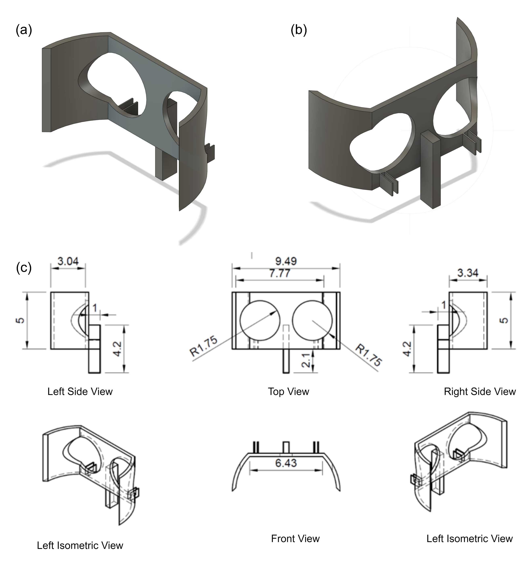

Fig. S1. 3D and Technical Views of the Helmet for UV Stimulation of Cockroach Compound Eyes. (a) Left isometric 3D view. (b) Right isometric 3D view. (c) Detailed orthographic projections of the helmet. From top left to bottom right: Left Side View, Top View, Right Side View, Left Isometric View, Front View, and Left Isometric View (mirrored angle). The schematic includes structural dimensions (in mm), radii, and spacing between key components to ensure accurate alignment with the cockroach’s compound eyes and consistent UV exposure.

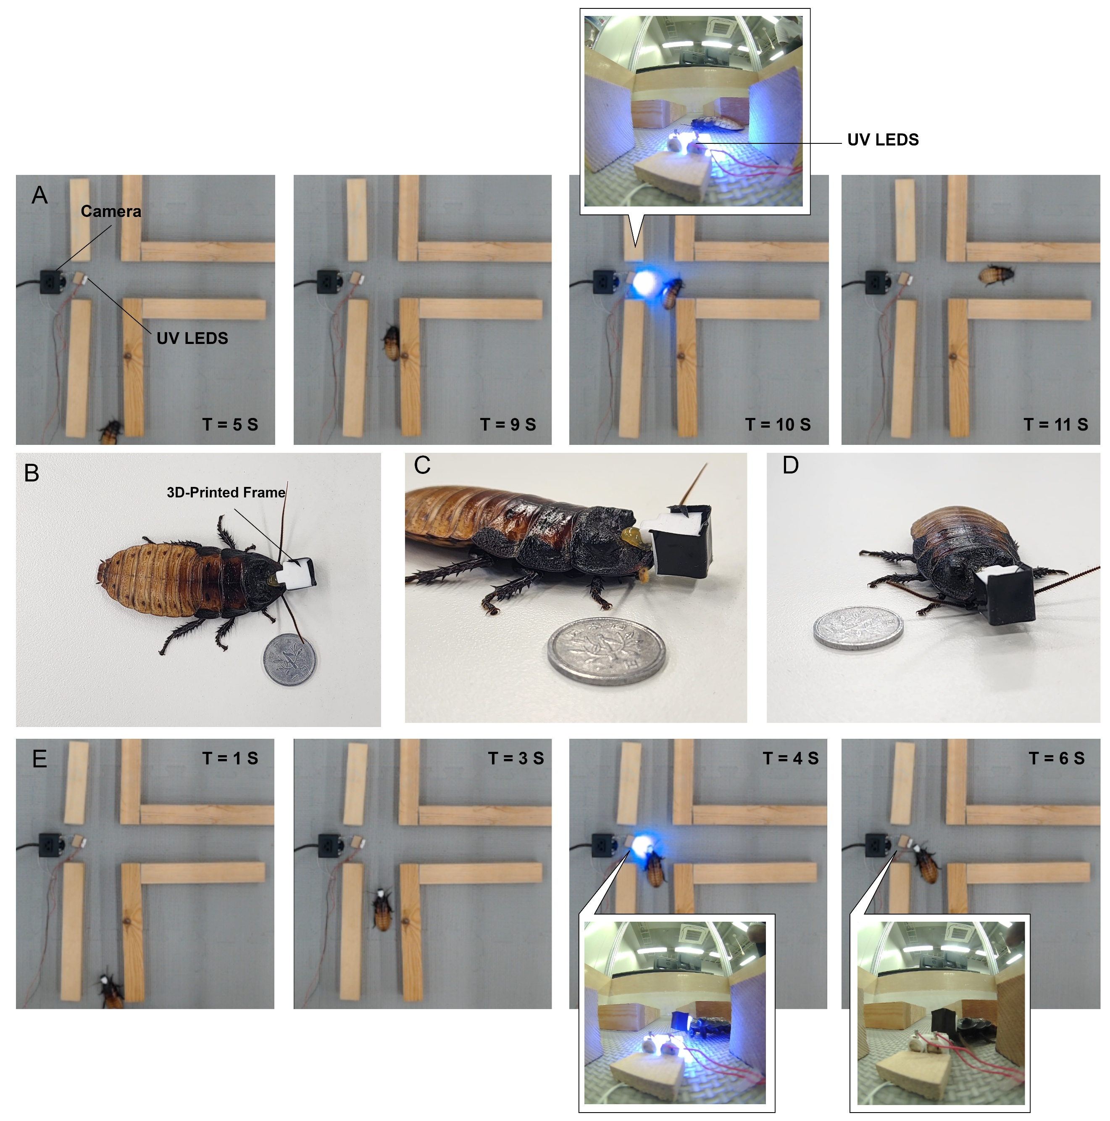

Fig. S2 Behavioural responses to UV stimulation under eyes-uncovered and eyes-covered conditions. (A) Representative time-lapse images of a uncovered eyes cockroach navigating a cross-shaped maze during localized UV LED stimulation (blue light).
(B–D) 3D-printed frame used to cover the compound eyes, shown from multiple viewing angles; a coin is included for scale. The frame blocks visual input without invasive manipulation. (E) After cover the cockroach’s eyes with 3D printed frame the cockroach’s response during the UV stimulation.

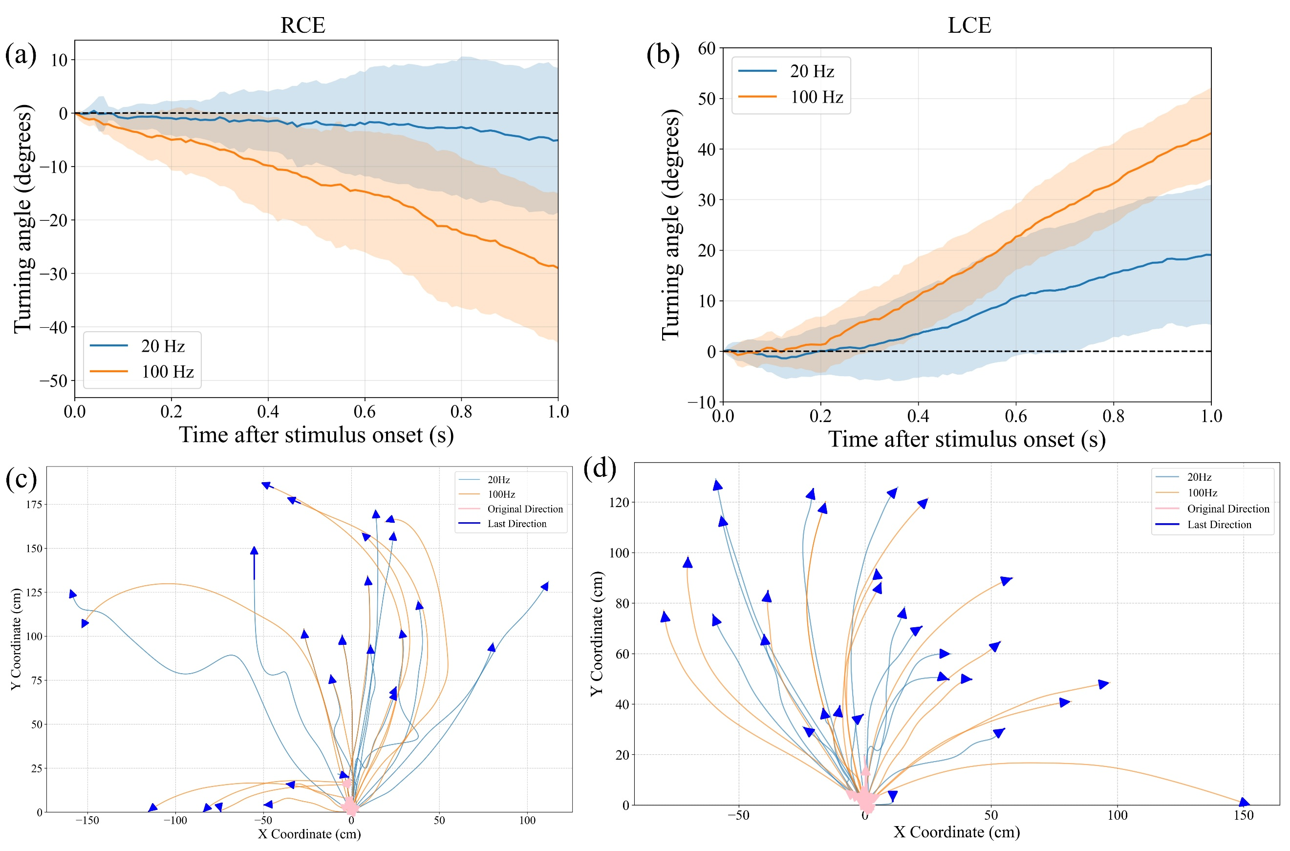

Fig. S3 Effect of UV blinking frequency on turning behavior. (a) Mean turning angle over time after UV stimulation of the right compound eye (RCE) using two blinking frequencies, 20 Hz and 100 Hz. The shaded area shows variation across trials. The higher frequency (100 Hz) produces a larger turning response than the lower frequency (20 Hz). (b) Mean turning angle over time when the left compound eye (LCE) is stimulated. A similar trend is observed, where 100 Hz produces stronger turning compared with 20 Hz. (c) Example movement paths of the insects during RCE stimulation. Each curve represents a trajectory from one trial. The paths show larger directional changes under the higher stimulation frequency. (d) Movement paths during LCE stimulation. The trajectories again show stronger turning responses when the stimulation frequency is increased from 20 Hz to 100 Hz (N = 3, n = 15 per condition).

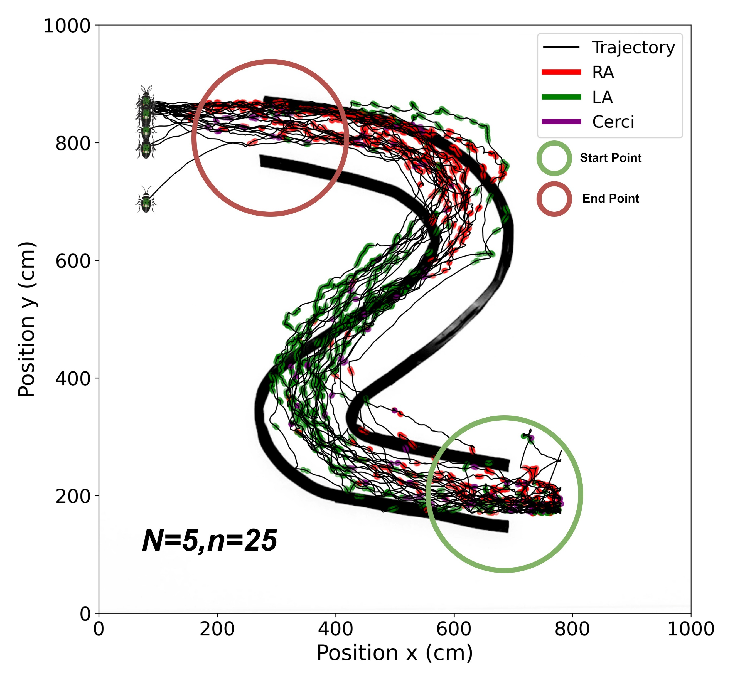
Fig. S4 Trajectories of Manually Controlled Cyborg Cockroaches Navigating an S-shaped Track Under Targeted Electrical Stimulation. This figure shows the overlaid trajectories of cyborg cockroaches (N = 5, n = 25) manually guided along an S-shaped track using real-time electrical stimulation. Stimulation of the right antenna (RA, red traces) induced leftward turns, stimulation of the left antenna (LA, green traces) induced rightward turns, and cerci stimulation (purple traces) triggered forward movement. Black lines indicate the full-body trajectories for each trial.

