Interfacial robustness of commercial amine-based inhibitors mitigates under-deposit corrosion of carbon steel in simulated sour conditions: A merged electrochemical and machine learning study

Eman M. Fayyad¹, Adewale K. Ipadeola^{1*}, Mostafa H. Sliem¹, Dana Abdeen², Noora Al-Qahtani¹, Ashwin RajKumar³, Joel Jeffrey³, Phaneendra K. Yalavarthy³, Aboubakr M. Abdullah^{1*}
¹ Center for Advanced Materials, Qatar University, Doha 2713, Qatar
² Qatar Shell Research and Technology Centre, P.O. Box 3747, Doha, Qatar
³ Department of Computational and Data Sciences (CDS), Indian Institute of Science (IISc),
Bangalore, India.
*Corresponding author: ak.ipadeola@qu.edu.qa; bakr@qu.edu.qa

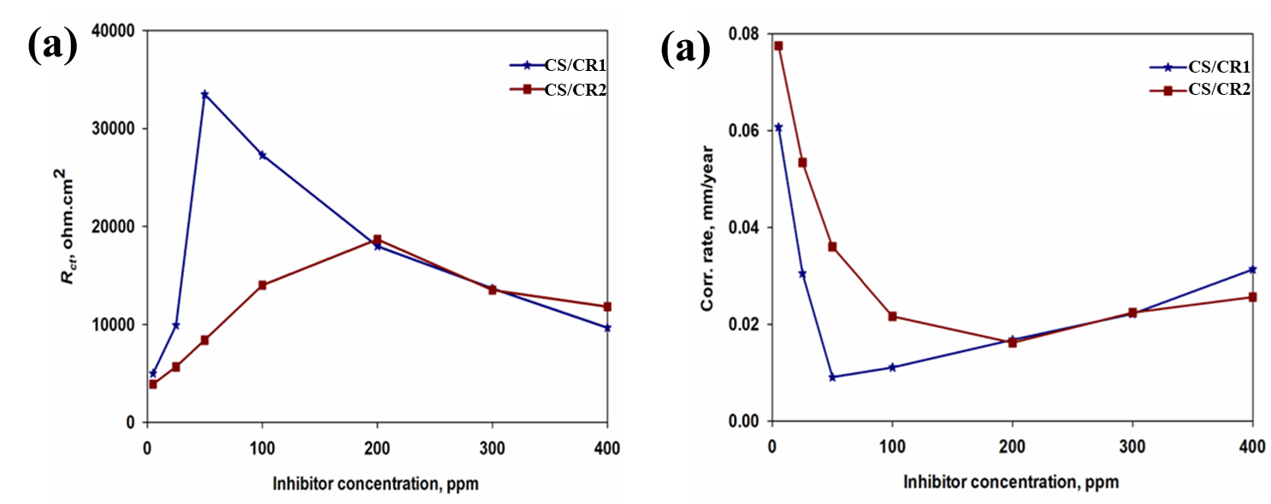
Fig. S1 (a) Plots of R_{ct} vs. concentration of corrosion inhibitors and (b) Corrosion rates vs. concentration of corrosion inhibitors in sour conditions, 60ºC and 1000 rpm

Table S1 EIS parameters obtained for pristine CS, CS/CR1 and CS/CR2 in sour electrolyte (3.5 wt. % NaCl + 1000 ppm Na₂S + CO₂ purging) at 1000 rpm, 60ºC and different inhibitors’ concentrations (C_{inh})
Samples’ name | C_{inh}  (ppm) | R_{f}  (Ω.cm²) |  | CPE_{f} |  | R_{ct}  (Ω.cm²) | CPE_{dl} |  | C_{dl}  (µF.cm⁻²) | Corrosion rate  (mmpy) | θ | I.E.  (%)
Samples’ name | C_{inh}  (ppm) |  |  | Y_{f}  (µS.s^{n} cm⁻²) | n_{f} | R_{ct}  (Ω.cm²) | Y_{dl} x 10⁻⁶  (µS.s^{n}  cm⁻²) | n_{dl}
CS (blank) | --- | --- |  | --- | --- | 915 | 194 | 0.57 | 52.6 | 0.3306 | --- | ---
CS/CR1 | 5 | 1477 |  | 15.7 | 0.50 | 4980 | 337.0 | 0.66 | 440 | 0.0608 | 0.816 | 81.6
CS/CR1 | 25 | 4633 |  | 15.5 | 0.90 | 9915 | 163.0 | 0.80 | 183 | 0.0305 | 0.908 | 90.8
CS/CR1 | 50 |  | 6500 | 15.0 | 0.93 | 33500 | 82.2 | 0.90 | 91.9 | 0.0090 | 0.973 | 97.3
CS/CR1 | 100 | 1980 |  | 31.9 | 0.97 | 27280 | 118.6 | 0.70 | 196 | 0.0111 | 0.966 | 96.6
CS/CR1 | 200 | 1499 |  | 43.0 | 0.92 | 18000 | 164.5 | 0.69 | 267 | 0.0168 | 0.949 | 94.9
CS/CR1 | 300 | 1055 |  | 64.3 | 0.81 | 13660 | 155.5 | 0.63 | 242 | 0.0221 | 0.933 | 93.3
CS/CR1 | 400 | 980 |  | 100.0 | 0.70 | 9650 | 245.0 | 0.55 | 495 | 0.0314 | 0.905 | 90.5
CS/CR2 | 5 | 940 |  | 22.6 | 1.00 | 3900 | 128.0 | 0.90 | 118 | 0.0776 | 0.765 | 76.5
CS/CR2 | 25 | 1179 |  | 17.8 | 0.80 | 5660 | 33.0 | 0.92 | 28.5 | 0.0535 | 0.838 | 83.8
CS/CR2 | 50 | 2460 |  | 10.4 | 1.00 | 8400 | 9.0 | 0.88 | 6.32 | 0.0360 | 0.891 | 89.1
CS/CR2 | 100 | 3170 |  | 25.5 | 0.73 | 14000 | 23.0 | 0.88 | 19.7 | 0.0216 | 0.935 | 93.5
CS/CR2 | 200 | 4460 |  | 3.8 | 0.58 | 18700 | 4.1 | 0.99 | 3.99 | 0.0162 | 0.951 | 95.1
CS/CR2 | 300 | 1050 |  | 52.7 | 1.00 | 13500 | 27.9 | 0.95 | 26.5 | 0.0224 | 0.932 | 93.2
CS/CR2 | 400 | 750 |  | 66.0 | 0.72 | 11800 | 29.7 | 0.89 | 26.1 | 0.0256 | 0.922 | 92.2

Table S2 PDP parameters of pristine CS, CS/CR1 and CS/CR2 in sour electrolyte (3.5 wt. % NaCl + 1000 ppm Na₂S + CO₂ purging) at 1000 rpm, 60ºC and different inhibitors’ concentrations (0 – 400 ppm)
Samples | Conc. (ppm) | E_{corr}  (mV) | i_{corr}  (µAcm⁻²) |  | b_{a}  (V/decade) | b_{c}  (V/decade) | I.E.  (%)
CS (blank) | 0 | -677 | 147 | 0.065 |  | 0.414 | ---
CS/CR1 | 5 | -654 | 24.5 | 0.056 |  | 0.168 | 83.3
CS/CR1 | 25 | -635 | 12.0 | 0.056 |  | 0.120 | 91.8
CS/CR1 | 50 | -604 | 2.60 | 0.032 |  | 0.116 | 98.2
CS/CR1 | 100 | -612 | 5.00 | 0.042 |  | 0.113 | 96.6
CS/CR1 | 200 | -610 | 8.80 | 0.059 |  | 0.148 | 94.0
CS/CR1 | 300 | -621 | 11.0 | 0.051 |  | 0.144 | 92.5
CS/CR1 | 400 | -633 | 15.0 | 0.058 |  | 0.146 | 89.8
CS/CR2 | 5 | -671 | 35.0 | 0.090 |  | 0.180 | 76.2
CS/CR2 | 25 | -659 | 25.0 | 0.040 |  | 0.170 | 82.9
CS/CR2 | 50 | -647 | 12.0 | 0.058 |  | 0.142 | 91.8
CS/CR2 | 100 | -619 | 9.60 | 0.026 |  | 0.154 | 93.5
CS/CR2 | 200 | -610 | 6.20 | 0.013 |  | 0.131 | 95.8
CS/CR2 | 300 | -634 | 10.7 | 0.059 |  | 0.150 | 92.7
CS/CR2 | 400 | -637 | 12.2 | 0.069 |  | 0.110 | 91.7

Table S3 PDP parameters of CS/SiO₂(partial)/CR1, CS/SiO2(partial)/CR2, CS/SiO₂(full)/CR1 and CS/SiO₂(full)/CR2 in the electrolyte (3.5 wt. % NaCl + 1000 ppm Na₂S + CO₂ purging) at 1000 rpm, 60ºC and optimized inhibitors’ concentrations (i.e., CR1 (50 ppm) and CR2 (200 ppm))
Samples | Time  (h) | E_{corr}  (V) | i_{corr}  (µA.cm⁻²) | b_{a}  (V/decade) | b_{c}  (V/decade) | IE  (%)
CS/SiO₂(partial)/CR1 | 0 | -0.715 | 37.0 | 0.055 | 0.276 | 74.8
CS/SiO₂(partial)/CR1 | 6 | -0.669 | 22.5 | 0.037 | 0.095 | 84.7
CS/SiO₂(partial)/CR1 | 12 | -0.617 | 9.80 | 0.033 | 0.079 | 93.3
CS/SiO₂(partial)/CR1 | 24 | -0.627 | 13.5 | 0.031 | 0.056 | 90.8
CS/SiO₂(partial)/CR2 | 0 | -0.737 | 42.5 | 0.130 | 0.524 | 71.1
CS/SiO₂(partial)/CR2 | 6 | -0.713 | 32.5 | 0.027 | 0.045 | 77.9
CS/SiO₂(partial)/CR2 | 12 | -0.682 | 16.0 | 0.043 | 0.048 | 89.1
CS/SiO₂(partial)/CR2 | 24 | -0.638 | 7.90 | 0.010 | 0.025 | 94.6
CS/SiO₂(full)/CR1 | 0 | -0.735 | 65.0 | 0.052 | 0. 307 | 55.8
CS/SiO₂(full)/CR1 | 6 | -0.723 | 46.3 | 0.033 | 0.021 | 68.5
CS/SiO₂(full)/CR1 | 12 | -0.695 | 24.3 | 0.016 | 0.048 | 83.5
CS/SiO₂(full)/CR1 | 24 | -0.666 | 33.0 | 0.089 | 0.114 | 77.6
CS/SiO₂(full)/CR2 | 0 | -0.718 | 52.5 | 0.089 | 0.211 | 64.4
CS/SiO₂(full)/CR2 | 6 | -0.681 | 35.8 | 0.078 | 0.131 | 75.6
CS/SiO₂(full)/CR2 | 12 | -0.668 | 18.7 | 0.038 | 0.147 | 87.3
CS/SiO₂(full)/CR2 | 24 | -0.643 | 12.0 | 0.106 | 0.062 | 91.8
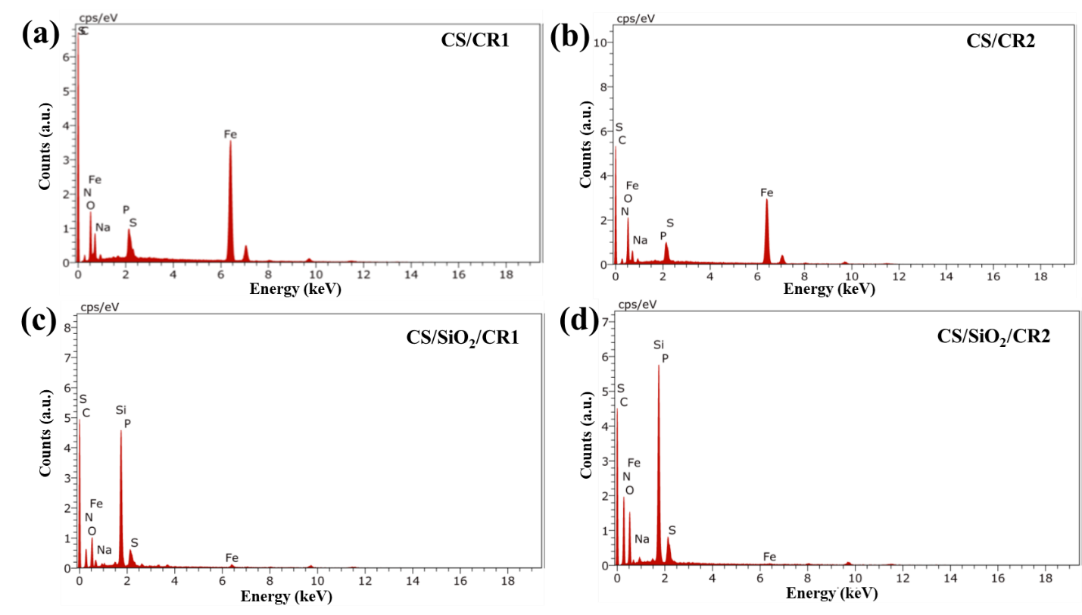
Fig. S2 EDX spectra of (a) CS/CR1, (b) CS/CR2, (c) CS/SiO₂/CR1 and (d) CS/SiO₂/CR2 after electrochemical corrosion tests for 24 h in sour electrolyte

Table S4 EDX compositions of inhibited CS with and without SiO₂ deposit after 24 h electrochemical corrosion tests
Elements | CS/CR1 | CS/CR2 | CS/SiO₂/CR1 | CS/SiO₂/CR2
C (wt.%) | 15.20 ± 0.98 | 15.90 ± 1.12 | 18.90 ± 2.10 | 17.20 ± 2.62
O (wt.%) | 22.50 ± 0.07 | 23.20 ± 0.14 | 23.10 ± 0.42 | 24.50 ± 0.80
Na (wt.%) | 3.90 ± 1.70 | 4.90 ± 2.35 | 14.50 ± 2.96 | 11.40 ± 1.15
S (wt.%) | 5.80 ± 0.08 | 5.70 ± 0.08 | 2.07 ± 0.03 | 2.00 ± 0.03
N (wt.%) | 25.40 ± 0.05 | 23.20 ± 0.05 | 8.37 ± 0.04 | 12.30 ± 0.04
P (wt.%) | 14.50 ± 0.07 | 12.60 ± 0.04 | 3.36 ± 0.05 | 5.30 ± 0.04
Fe (wt.%) | 12.70 ± 1.57 | 14.50 ± 1.32 | 18.80 ± 0.17 | 16.70 ± 0.05
Si (wt.%) | - | - | 2.07 ± 0.03 | 10.60 ± 0.51

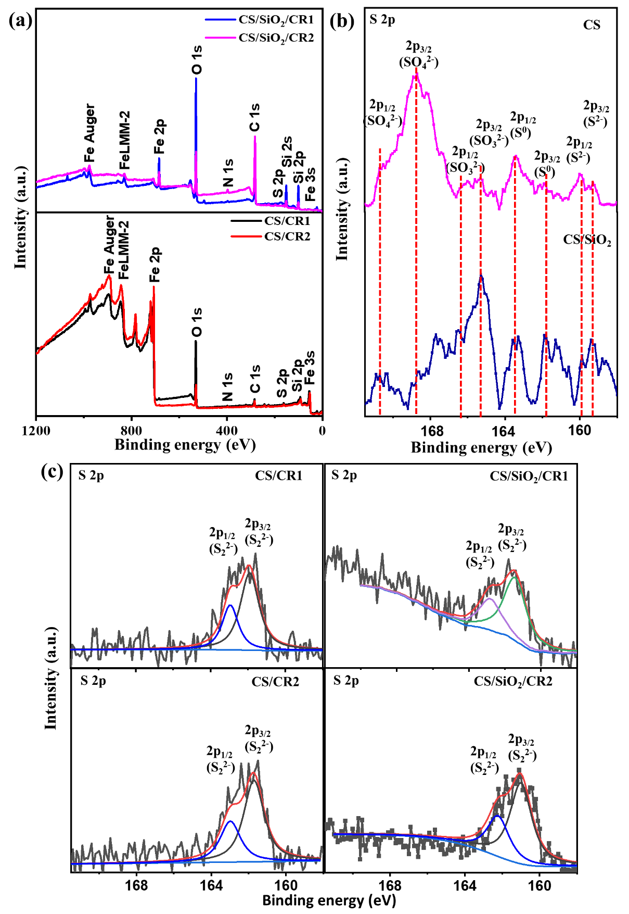
Fig. S3 (a) XPS wide scan and deconvoluted S 2p spectra of (b) CS, and CS/SiO₂, and (c) CS/CR1, CS/CR2, CS/SiO₂/CR1, and CS/SiO₂/CR2 after electrochemical corrosion tests for 24 h in sour electrolyte
Table S5: The Feature importance based on Linear Regression analysis
Features | Coefficient | p-value |  | Significant (p < 0.05)
const | 42.956842 | 0.00 |  | True
EIS | 18.568218 | 0.00 | True
PDP | 24.388625 | 0.00 |  | True
Time | 1.190687 | 0.00 |  | True
SiO₂ deposit | -32.765892 | 0.00 |  | True
CR1 | 23.096244 | 0.00 |  | True
CR2 | 19.860598 | 0.00 |  | True
Concentration | 0.026079 | 0.09 |  | False

Table S6: Re-fitted performance metrics for the models using P_{inh} as the target output variable
Models | Train  R² | Test  R² | Train RMSE | Test RMSE | Train MAE | Test MAE
XGBoost | 1.00 | 0.94 | 0.0 | 0.6 | 0.0 | 0.6
Gradient Boosting | 0.97 | 0.92 | 0.7 | 0.7 | 0.5 | 0.7
Random Forest | 0.97 | 0.90 | 0.6 | 0.8 | 0.5 | 0.6
Decision Tree | 1.00 | 0.77 | 0.0 | 1.3 | 0.0 | 1.1
Linear Regression | 0.58 | 0.44 | 2.3 | 2.0 | 1.9 | 1.6
KNN | 0.48 | 0.23 | 2.6 | 2.3 | 2.0 | 1.7

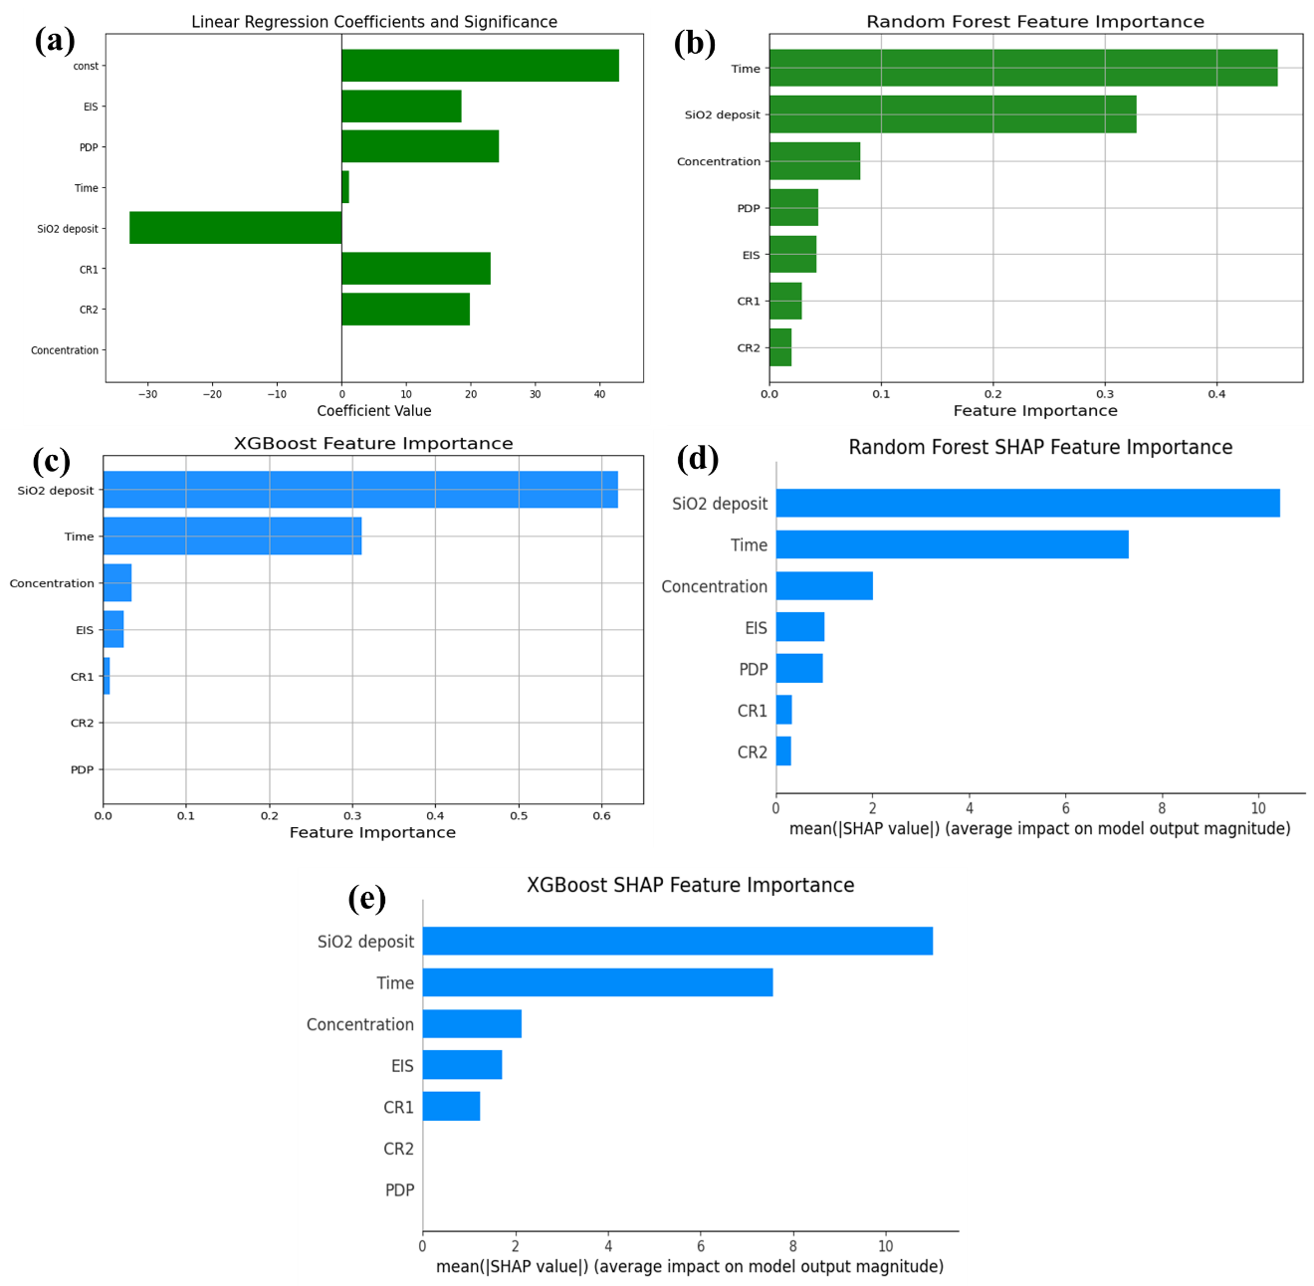
Fig. S4 (a) Linear Regression Coefficients and their statistical significance, (b) Random Forest Feature Importance, (c) XGBoost Feature Importance, (d) SHAP Feature Importance for Random Forest; and (e) SHAP Feature Importance for XGBoost

