Supplementary
Article title
Biodistribution and Hepatotoxicity of Co-Administered PEGylated Gold and Silver Nanoparticles in Rats Following Intravenous Injection
Jornal name
Emergent Materials
Authors
Roua Ismail¹, Hevna Dhulkifle¹, Zaid H. Maayah¹, Andrew Ebenazer¹, Alaaldin M. Alkilany¹, Ousama Rachid^{1#}
¹ College of Pharmacy, QU Health, Qatar University, Doha, Qatar
Corresponding Author
Dr. Ousama Rachid
Associate Professor, College of Pharmacy,
QU Health, Qatar University, Doha, Qatar
P.O. Box 2713
+974 4403 5631
Orachid@qu.edu.qa

Table S1. List of the primer sequences used in the study
slno | Name | Forward | Reverse
1 | b-Actin | CCAGATCATGTTTGAGACCTTCAA | GTGGTACGACCAGAGGCATACA
2 | Sod | GTGCAGGGCGTCATTCACTT | CACAACTGGTTCACCGCTTG
3 | Tgf-b | ATGCTCTTCTTTTTTGCGGAAA | CAGCTTTGAGGTTCGTGTTTGT
4 | Nqo1 | GTGAGAAGAGCCCTGATTGT | CCTGTGATGTCGTTTCTGGA
5 | Cat | CCCGAGTCCAGGCTCTTCT | CGGCCTGTACGTAGGTGTGA
6 | Tnf-a | GTGATCGGTCCCAACAAG | AGGGTCTGGGCCATGGAA
7 | Cyp2c11 | CACCAGCTATCAGTGGATTTGG | GTCTGCCCTTTGCACAGGAA
8 | Cyp2e1 | AAAGCGTGTGTGTGTTGGAGAA | AGAGACTTCAGGTTAAAATGCTGCA
9 | Cyp4a1 | TTGAGCTACTGCCAGATCCCAC | CCCATTTTTGGACTTCAGCACA
10 | Gst | GCTTTACTGTGCAAGGGAGACA | GGAAGGAGGATTCAAGTCAGGA
11 | Ugt | TCCCACTTCTCGGAGACAGTAAC | CTTAGCATCACTGAGGACCTTGAA
12 | Bax | GGTACATCCTCGACGGCATCT | GTGCCTCTTTGCTGCTTTCAC
13 | Cyp2j3 | CATTGAGCTCACAAGTGGCTTT | CAATTCCTAGGCTGTGATGTCG
14 | Cyp4f4 | CAGGTCTGAAGCAGGTAACTAAGC | CCGTCAGGGTGGCACAGAGT
15 | Pgp | CCCGAGATTGACAGCTACAGCA | CCTCGAAGCTCAGTCCCTGAAG

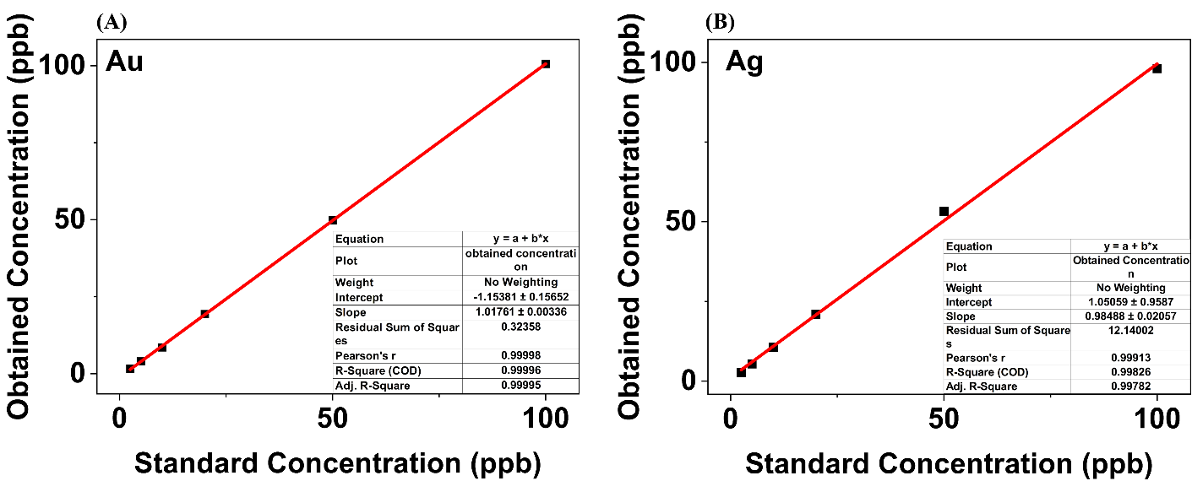
Figure S1. Calibration curves obtained from inductively coupled plasma-mass spectrometry for gold (A) and silver (B)

