Sustainable 3D Mortar Printing: Material Optimization and Ultrasonic Characterization for Enhanced Construction Performance

S1. Material characterization
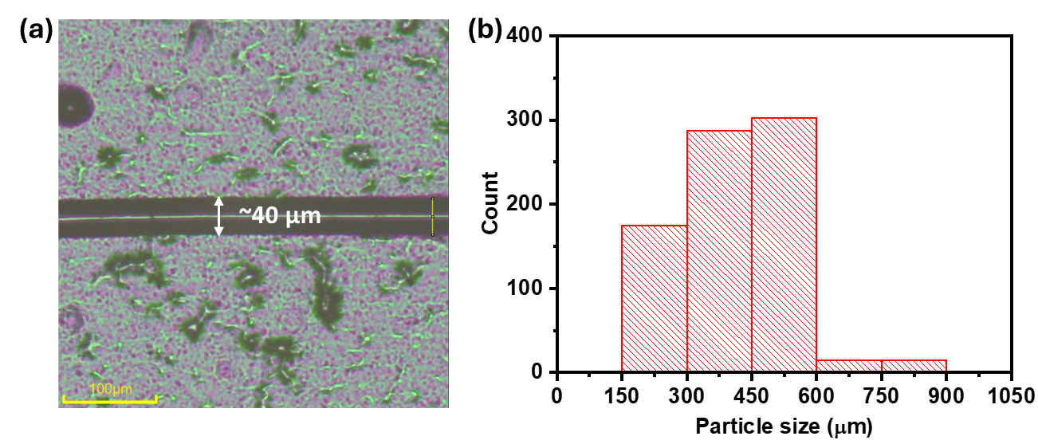
Fig. S1. (a) Optical image of polypropylene fiber. (b) Particle size distribution of silica sand.

S2. Calculation of nozzle and printing parameters
$Cross Sectional Area (A) = πr^{2}$ (S1)
$1.5 cm diameter: (A1) = πr^{2}$ = $π({0.75)}^{2}= 1.77 {cm}^{2}$
$2 cm diameter: (A2) = πr^{2}$ = $π({1)}^{2}= 3.142 {cm}^{2}$
$3 cm diameter: (A3) = πr^{2}$ = $π({1.5)}^{2}= 7.07 {cm}^{2}$

$θ=\tan^{-1}\left(\frac{opposite}{adjacent}\right)=\tan^{-1}\left(\frac{\frac{D_{i}-D_{f}}{2}}{adjacent}\right)$ (S2)
For 1.5 cm nozzle diameter $θ=\tan^{-1}\left(\frac{opposite}{adjacent}\right)=\tan^{-1}\left(\frac{\frac{D_{i}-D_{f}}{2}}{adjacent}\right)=\tan^{-1}\left(\frac{\frac{3.1-1.5}{2}}{1.4}\right)=29.74°$
For 2 cm nozzle diameter $θ=\tan^{-1}\left(\frac{opposite}{adjacent}\right)=\tan^{-1}\left(\frac{\frac{D_{i}-D_{f}}{2}}{adjacent}\right)=\tan^{-1}\left(\frac{\frac{3.1-2}{2}}{1.2}\right)=24.62°$
For 3 cm nozzle diameter $θ=\tan^{-1}\left(\frac{opposite}{adjacent}\right)=\tan^{-1}\left(\frac{\frac{D_{i}-D_{f}}{2}}{adjacent}\right)=\tan^{-1}\left(\frac{\frac{3.1-3}{2}}{0.3}\right)=9.46°$
$v=\frac{d}{t}$ (S3)
$$v1=\frac{d}{t}=\frac{29.7}{13.6}=2.2 cm/s$$
$$v2=\frac{d}{t}=\frac{29.7}{7.66}=3.88 cm/s$$
$$v3=\frac{d}{t}=\frac{29.7}{6.64}=4.47 cm/s$$

$Q = A × v$ (S4)
$\left(1.5 cm diameter\right) Q1 = A1 × v1$ = $\left(1.77 {cm}^{2}\right)* (2.2 cm/s) =3.894$cm³/s
$\left(2 cm diameter\right) Q2 = A2 × v2$ = $\left(3.142 {cm}^{2}\right)* (3.88 cm/s) =12.19$cm³/s
$(3 cm diameter) Q3 = A3 × v3$ = $\left(7.07 {cm}^{2}\right)* (4.47 cm/s) =31.53$cm³/s

Pumping Force (F) $= P × A$ (S5)
(13 bars) Pumping Force $(F) = P × A = 1300,000 * 7.06858{ cm}^{2}$ $≃$918.92 N
(14 bars) Pumping Force$(F) = P × A = 1400,000 * 7.06858{ cm}^{2}≃ 989.60 N$

S3. Hybrid Ultrasonic Parameter
S3.1. Hybrid Ultrasonic Parameter: Sideband Peak Count – Index (SPC-I) Measurement
The SPC-I technique is an effective hybrid (i.e., combining linear and non-linear) ultrasonic evaluation method. As waves travel through heterogeneous materials such as concrete or mortar composites, they can generate frequencies different from the original input wave frequency. If these generated frequencies are integer multiples of the input frequency, they are referred to higher harmonics. Conversely, if the generated frequency is half of the input wave frequency, it is called a subharmonic. Additionally, frequencies other than higher harmonics and subharmonics can arise from frequency modulation between different frequencies of the propagating waves. These newly generated frequency peaks, which are detected by the receiver, have a much lower magnitude than the original exciting frequency peaks and are known as sideband peaks or simply sidebands. When a broadband wave propagates through a material such as mortar composites, multiple sidebands are produced. The interaction between different propagating wave modes can generate additional frequency components, resulting in an increased number of sideband peaks. The SPC-I technique assesses both the linear and nonlinear ultrasonic properties of a material by quantifying the peaks of higher harmonics, subharmonics, and other sideband frequencies within defined boundaries.

S3.2. Hybrid Ultrasonic Parameter: Spectral Dissipation Index (SDI) Measurement SDI is an innovative hybrid ultrasonic parameter that bridges linear and nonlinear wave phenomena to enhance material characterization capabilities. This technique excels at detecting both microscopic and macroscopic defects by leveraging complex ultrasonic behaviors including higher-harmonic generation, frictional contact interactions, and modulation-induced sidebands from breathing cracks. What makes SDI particularly valuable is its exceptional sensitivity to early-stage microcrack formation that conventional linear ultrasonic methods typically overlook, while simultaneously tracking defect progression as they evolve into larger macrocracks. The method quantifies material defects by integrating signal energy across the complete frequency spectrum, capturing contributions from fundamental frequencies alongside all nonlinear harmonic and modulation components, making it especially suitable for monitoring microstructural evolution in sustainable construction materials. The fundamental mathematical relationship governing SDI is presented in the following Equation S6, expressed through the normalized spectral ratio:
$\text{SDI}=\frac{∫_{0}^{f_{c}} \left|\frac{X_{\text{test}}(f)}{max(|X_{\text{test}}(f)|)}\right| df}{∫_{0}^{f_{c}} \left|\frac{X_{\text{control}}(f)}{max(|X_{\text{control}}(f)|)}\right| df}$ (S6)
This equation compares the normalized frequency spectra of test and control ultrasonic signals up to the cutoff frequency f_{c}. where the Fourier transform $X(f)=∫_{-∞}^{∞} x(t)e^{-j2πft} dt$ converts time-domain ultrasonic signals into frequency-domain representations. The mathematical framework incorporates normalization with respect to peak spectral values, ensuring consistent cross-specimen comparisons independent of coupling variations and attenuation effects. SDI < 1, Indicates reduced spectral dissipation compared to the control specimen, signifying improved material integrity with fewer microstructural defects, enhanced densification, and better overall material. Whereas SDI > 1, Indicates increased spectral content relative to the control specimen, suggesting material degradation with higher defect density, increased microcracking, porosity, or other nonlinear sources that generate additional frequency components in the ultrasonic spectrum.

Table S1. Ultrasonic measurement values at critical setting times for Mix 1 (FSC, W/P 0.34). The initial and final setting times were determined by standard Vicat tests (40 min and 120 min, respectively), and the ultrasonic parameters at those times are shown alongside the values at 0 min (fresh mix).
Parameter | 0 min (Fresh mix) | 40 min (Initial set) | 120 min (Final set)
Transmitted Amplitude (V) | 0.004 V | 0.11 V | 5.97 V
Ultrasonic TOF (µs) | 625 µs | 294 µs | 319 µs
Sideband Peak Count Index | 47.4 | 28.8 | 24.9

