Development of magnetic solid phase micro-extraction (MSPE) method for the extraction and preconcentration of the selected β-blockers

Online Resource 1 List of runs obtained using fractional factorial design (FFD) and the corresponding percentage extraction recoveries (%ER)
Runs | MA (mg) | pH | ET (min) | DT (min) | EV (µL) | ACE (%ER) | MET (%ER)
1 | 10 | 3 | 5 | 15 | 1000 | 5.5 | 5.2
2 | 60 | 3 | 5 | 5 | 100 | 20.6 | 14.8
3 | 10 | 9 | 5 | 5 | 1000 | 37.5 | 36.1
4 | 60 | 9 | 5 | 15 | 100 | 82.1 | 76.2
5 | 10 | 3 | 20 | 15 | 100 | 2.6 | 2.3
6 | 60 | 3 | 20 | 5 | 1000 | 26.1 | 20.9
7 | 10 | 9 | 20 | 5 | 100 | 67.9 | 64.1
8 | 60 | 9 | 20 | 15 | 1000 | 82.8 | 81.8
9 (C) | 35 | 6 | 12.5 | 10 | 550 | 90.8 | 62.6
10 (C) | 35 | 6 | 12.5 | 10 | 550 | 90.4 | 68.2
11 (C) | 35 | 6 | 12.5 | 10 | 550 | 87.8 | 69.3

Online Resource 2 Factors and their corresponding levels used in CCD for optimization
Variables | -α | Low level (-1) | Central point (0) | High level (+1) | +α
Mass of adsorbent (mg) | 0.31 | 10 | 35 | 60 | 70.26
pH | 1.76 | 3 | 6 | 9 | 10.24

Online Resource 3 List of runs obtained using central composite design (CCD) and the corresponding percentage extraction recoveries (%ER)
Standard Run | pH | MA | ACE (%R) | MET (%R)
1 | 3.0 | 10.0 | 22.8 | 33.4
2 | 3.0 | 60.0 | 32.9 | 36.7
3 | 9.0 | 10.0 | 71.5 | 73.1
4 | 9.0 | 60.0 | 99.4 | 98.7
5 | 2.6 | 35.0 | 13.3 | 17.1
6 | 9.4 | 35.0 | 98.9 | 97.7
7 | 6.0 | 6.3 | 41.6 | 45.1
8 | 6.0 | 63.7 | 77.3 | 75.8
9 (C) | 6.0 | 35.0 | 69.3 | 71.2
10 (C) | 6.0 | 35.0 | 69.0 | 70.9
11 (C) | 6.0 | 35.0 | 69.4 | 71.3

Online Resource 4 Equations of adsorption isotherm models
Models | Equations
Langmuir isotherm | $$\frac{C_{e}}{Q_{e}}= \frac{1}{Q_{m K_{L}}}+\frac{1}{Q_{m}}C_{e}$$  $$R_{L}= \frac{1}{1+ K_{L}C_{o}}$$
Freundlich isotherm | $$\ln{Q_{e}}= \ln{K_{F} + \frac{1}{n}}\ln{C_{e}}$$
Dubunin-Radushkevich isotherm | $\ln{Q_{e}}= \ln{Q_{D-R }}$-β$Ɛ^{2}$  Ɛ = RT$\ln{(1+ \frac{1}{C_{e}})}$  E=$\frac{1}{√2β}$
Sips isotherm | $$\ln{(\frac{Q_{e}}{Q_{max}-Q_{e}})}= \frac{1}{n}\ln{C_{e}}+\ln{K_{s}}$$
Where Q_{e} (mg g^{­1}) denotes maximum adsorption capacity of β blockers per unit mass of the adsorbent; K_{L} (L mg^{­1}) represents Langmuir constant related to the rate of adsorption; R_{L} represents dimensionless Langmuir constant; n and K_{F} ((mg g^{­1}) (L mg^{­1})^{1/n} are Freundlich constants which provide information about the adsorption intensity and adsorption capacity, respectively; β (mol² J⁻²), $Ɛ$ and Q_{D-R}(mg g^{­1}) represent adsorption energy constant, Polanyi potential and theoretical monolayer adsorption capacity, respectively; T (K) and R (8.314 J mol⁻¹ K⁻¹) and T (K) are temperature and gas constant, respectively; E (kJ mol^{­1}) represents adsorption mean free energy; K_{s} (1/mg) is Sips equilibrium constant, β_{R-P} denotes exponent that lies between 0 and 1 and A is R-P isotherm constant.
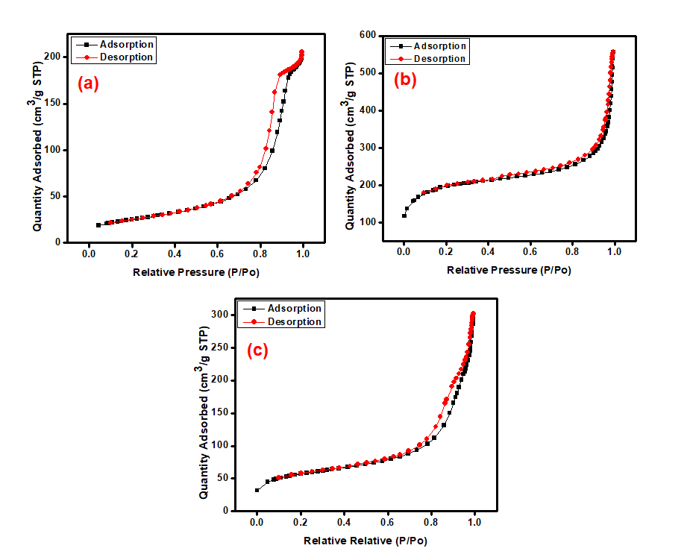
Online Resource 5 Nitrogen adsorption-desorption isotherms of (a) Fe₃O₄, (b) NH₂-MIL-101(Cr) and (c) Fe₃O₄@NH₂-MIL-101(Cr)

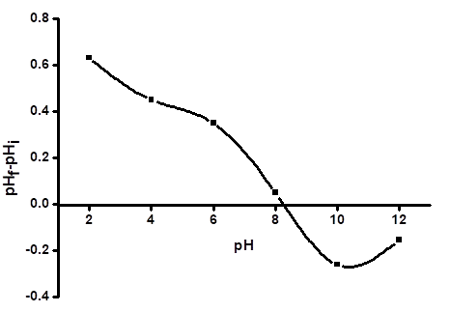
Online Resource 6 Point of zero charge of the Fe₃O₄@NH₂-MIL-101(Cr)

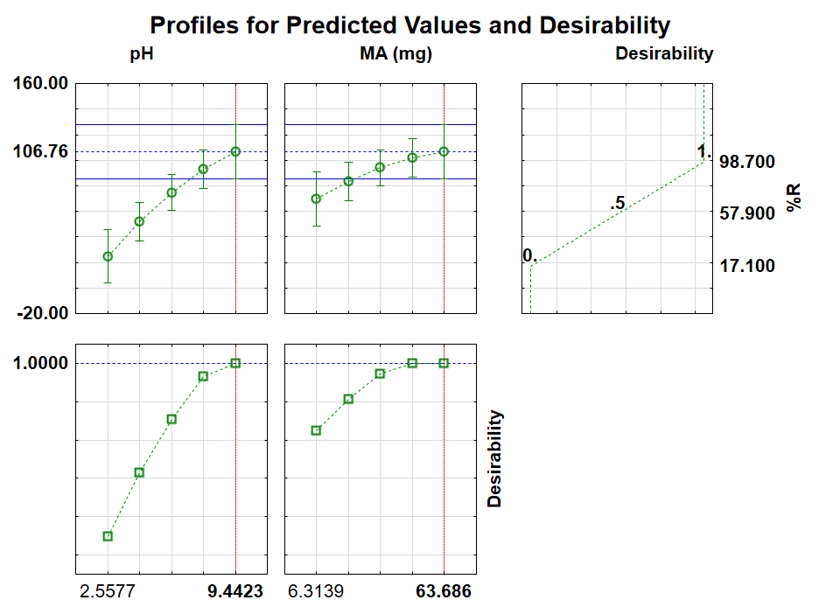 Online Resource 7 Desirability profile of MET confirming the optimum conditions

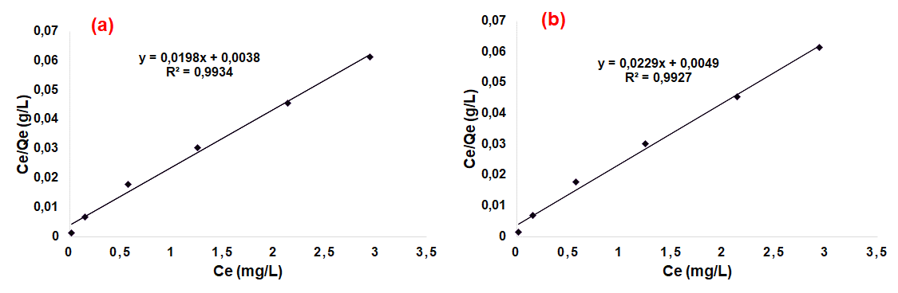
Online Resource 8 Adsorption isotherm data fitted to Langmuir model, (a) ACE and (b) MET
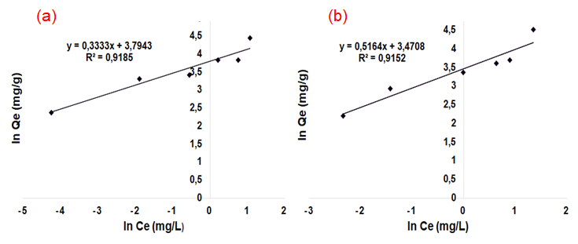
Online Resource 9 Adsorption isotherm data fitted to Freundlich model, (a) ACE and (b) MET

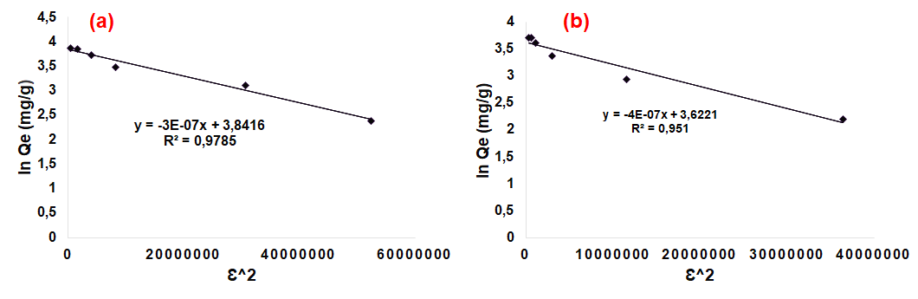
Online Resource 10 Adsorption isotherm data fitted to Dubinin-Radushkevich model, (a) ACE and (b) MET

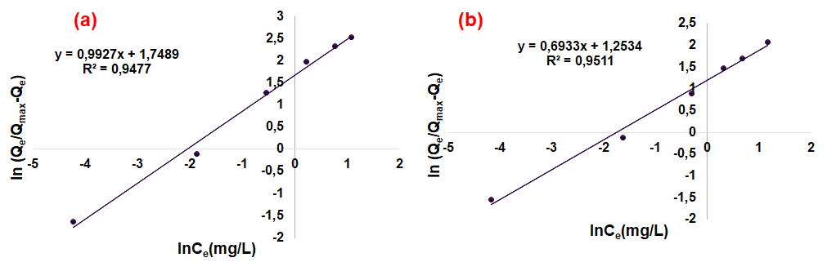
Online Resource 11 Adsorption isotherm data fitted to Sips model (a) ACE and (b) MET

