Supplementary Material
This figure illustrates the methodology used in this study. The PRISMA image was used to obtain the data. Surface and subsurface soil data were collected and measured for soil pH, EC, and CaCO₃. Vis-NIR spectral data for the sampling point were extracted from the PRISMA image and then processed and analysed using various prediction models such as PLSR, RF, MARS, and SVR. Competitive Adaptive Weighted Sampling (CARS) was used to identify the most sensitive ranges for each soil property. Multiple Linear Regression (MLR) was also used to create prediction equations, which were then used to map soil properties from the PRISMA image.

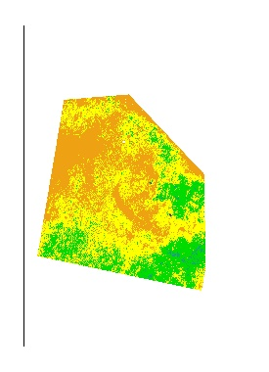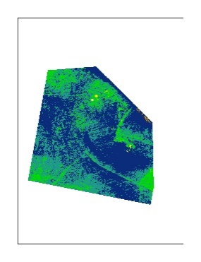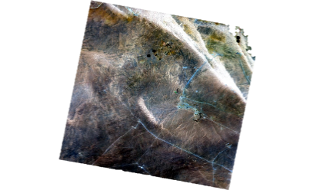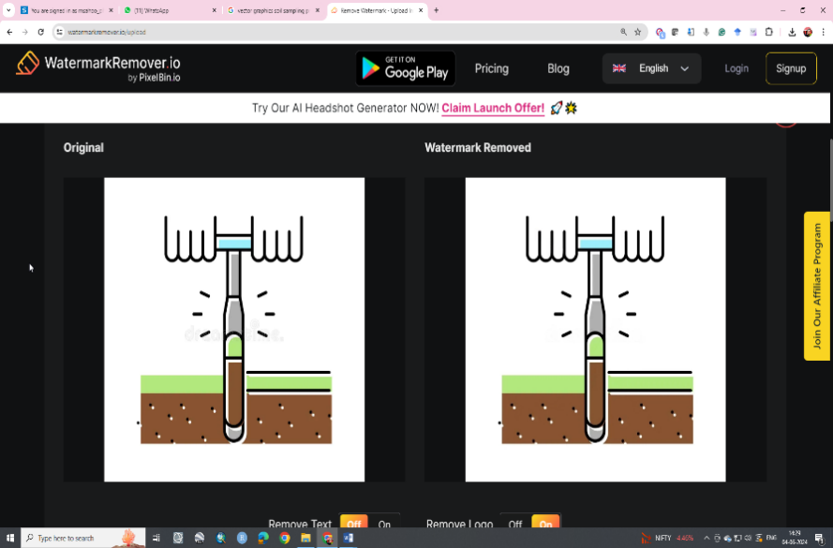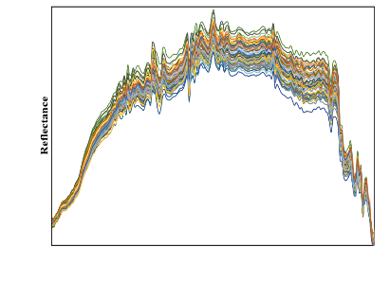
PRISMA image acquisition
Soil profiles’ collection
Soil surface and subsurface analysis
Vis-NIR spectra extraction
Spectral data processing
Prediction modelling
Performance assessment
Sensitive spectral bands selection
Soil properties mapping
The materials and methods of research study.

