Supplement 3: Risk of bias summaries

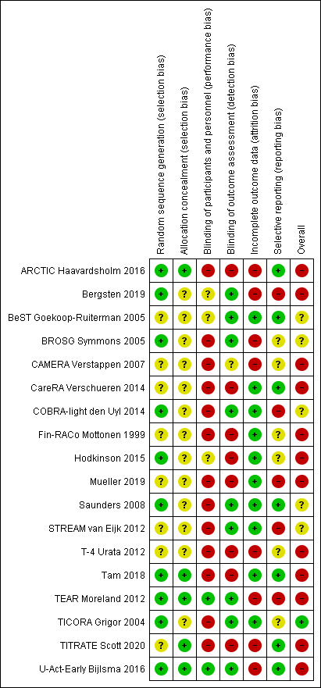
+, low risk of bias; -, high risk of bias; ?, unclear risk of bias
Figure 3: Risk of bias judgements for included non-cluster RCTs

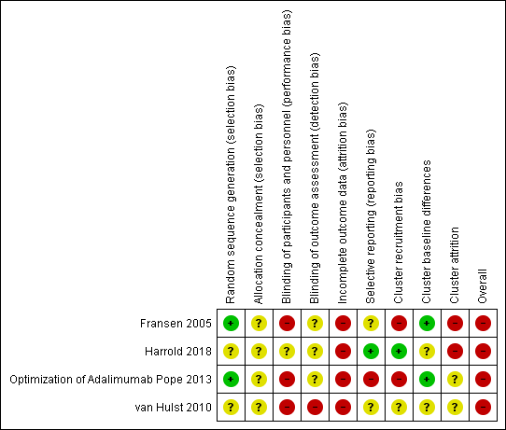

+, low risk of bias; -, high risk of bias; ?, unclear risk of bias
Figure 4: Risk of bias judgements for included cluster RCTs

