Supplementary Material
Topological Data Analysis of Departure Delay Co-occurrence in Japanese Domestic Aviation System
Soumik Nafis Sadeek, Shinya Hanaoka, Kashin Sugishita
This online supplement provides additional results to support the paper Topological Data Analysis of Departure Delay Co-occurrence in Japanese Aviation System submitted to Data Science for Transportation.

Appendix A: Airports considered for ANA and JAL flights in the domestic Japanese market
Table A1: Considered Airports in Japan with IATA Code
Airport Name | IATA Code | ANA | JAL
Kansai International Airport | KIX
Narita International Airport | NRT
Chubu Centrair International Airport | NGO
Tokyo International Airport (Haneda Airport) | HND
Osaka International Airport (Itami Airport) | ITM
Akita Airport | AXT
Asahikawa Airport | AKJ
New Chitose Airport | CTS
Fukuoka Airport | FUK
Hakodate Airport | HKD
Hiroshima Airport | HIJ
Kagoshima Airport | KOJ
Kitakyushu Airport | KKJ
Kochi Airport | KCZ
Kushiro Airport | KUH
Kumamoto Airport | KMJ
Matsuyama Airport | MYJ
Miyazaki Airport | KMI
Nagasaki Airport | NGS
Naha Airport | OKA
Niigata Airport | KIJ
Oita Airport | OIT
Sendai Airport | SDJ
Takamatsu Airport | TAK
Obihiro Airport | OBO
Yamaguchi-Ube Airport | UBJ
Yamagata Airport | GAJ
Amami Airport | ASJ
Aomori Airport | AOJ
Fukushima Airport | FKS
Hanamaki Airport | HNA
New Ishigaski Airport | ISG
Izumo Airport | IZO
Kobe Airport | UKB
Matsumoto Airport | MMJ
Memanbetsu Airport | MMB
Miyako Airport | MMY
Nanki-Shirahama Airport | SHM
Okayama Airport | OKJ
Oki Airport | OKI
Okushiri Airport | OIR
Rishiri Airport | RIS
Tanegashima Airport | TNE
Tokunoshima Airport | TKN
Komatsu Airport | KMQ
Misawa Airport | MSJ
Okadama Airport | OKD
Tokushima Airport | TKS

Appendix B: Conceptual flow-chart and an example calculation of Proportion of Birth Time Overlap
A conceptual flow chart of the PBTO concept is shown in Fig. B1 and a worked example is provided below. Fig. B1 illustrates how loop structures ($H_{1}$) can emerge at different stages of the daily filtration as the delay threshold increases. In the example, a loop among HND-OIT-ITM appears at the 5-minute threshold. As the threshold increases further, the network becomes more connected through additional delay links. After the network becomes mostly connected, additional loop structures may still appear as the filtration continues, because filtration proceeds upto the day’s maximum observed delay weight. Therefore, loop births can occur both before and after the mostly connected stage, but always within the day’s filtration range.
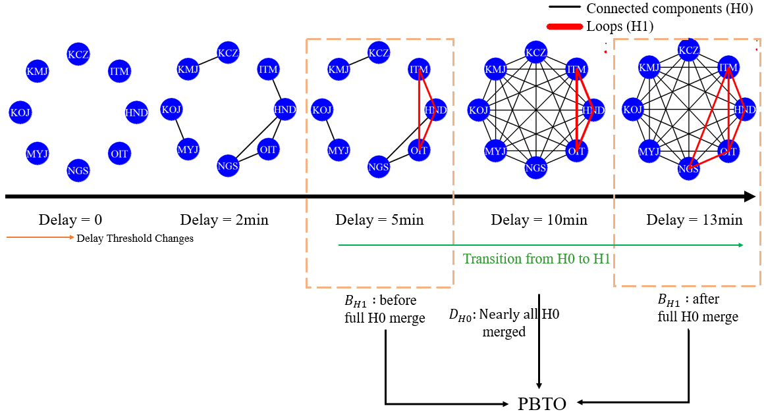
Fig. B1 Conceptual diagram of PBTO calculation (Illustrative example)
To quantitatively assess the transition from connected components to loop structure formation, we computed the Proportion Birth Time Overlap (PBTO) for each day in the dataset. PBTO is designed to capture the fraction of daily loop births that occur after the network becomes mostly connected. In this study, the mostly connected stage is defined using 90th percentile of the $H_{0}$ death thresholds on that day (i.e., the point by which most connected components have already merged). . A higher PBTO value indicates that a larger proportion of $H₁$ loops emerge only after the entire network is structurally unified suggesting a transition from localized to system-wide (higher-order) delay co-occurrence. Conversely, lower PBTO values imply that delay loops tend to form while the network is still fragmented.
Example: Death time of $H_{0}$ Components
Nodes | C1 | C2 | C3 | C4 | C5 | C6 | C7 | C8 | C9 | C10
Death | 2.5 | 4.0 | 5.5 | 6.0 | 6.5 | 8.0 | 9.5 | 10.0 | 11.5 | 13.0
If we take 90th percentile death time then the value is 11.5.
Birth time of $H_{1}$ loop
Loop | L1 | L2 | L3 | L4 | L5 | L6
Birth time | 9.2 | 10.8 | 11.5 | 12.6 | 13.8 | 14.1
PBTO calculation:
Loop | L1 | L2 | L3 | L4 | L5 | L6
Birth | 9.2 | 10.8 | 11.5 | 12.6 | 13.8 | 14.1
>11.5 | X | X | X | Y | Y | Y
Loops born after the threshold value merge is L4, L5, L6 – total 3. So, PBTO value is 3/6 = 0.5.
It means that 50% of loops were born after the network had become mostly connected. This suggests that half of the loop delay emerged only after delays had spread enough to unify the network structurally. PBTO actually gives a sense of transition from $H_{0}$ to $H_{1}$. It informs how much of each day’s loop activity waits until the network is already connected (after most $H_{0}$ components have merged). A high PBTO therefore signals that the appearance of loops is largely a second‑phase phenomenon, while a low PBTO means loops are appearing during the fragmentation phase.

Appendix C: Significance test of persistent diagram between ANA and JAL
Table E1 represents the significance test between winter and summer season for ANA and JAL. These results tell us that ANA’s higher‐order delay‐feedback structures are much more sensitive to seasonal and disruption effects than JAL’s. ANA shows no meaningful summer-winter shift in the pre-COVID years (2018-19), but strong, highly significant seasonality during the pandemic and recovery.
Table C1 Comparing summer and winter seasonal persistent diagram between ANA and JAL
Year | Airline | t-stat | p-value | Interpretation
2018 | ANA | -0.41 | 0.679 | No seasonal difference (p < 0.05)
2018 | JAL | -2.83 | 0.005 | Significant
2019 | ANA | 0.66 | 0.509 | No seasonal difference
2019 | JAL | 1.61 | 0.108 | No seasonal difference
2020 | ANA | -4.67 | 0.000 | Significant
2020 | JAL | -0.89 | 0.377 | No seasonal difference
2021 | ANA | 6.66 | 0.000 | Significant
2021 | JAL | 0.87 | 0.383 | No seasonal difference

JAL only exhibits a significant summer vs winter difference back in 2018, and no statistically detectable seasonality in the other three years. Before COVID, neither airline’s topological delay‐patterns changed markedly by season. JAL had a slight seasonality in 2018 but otherwise stayed uniform. ANA’s network became strongly seasonal once the pandemic hit. Its’ delay‐loop dropped in Summer 2020 (likely due to collapsed schedules) and then flipped to be unusually higher in Summer 2021 (when recovery surges may have stressed its network).

Appendix D: Adopted formula and a sample calculation of Loop Formation Rate (LFR)

For a given airport-set, the loop count is the number of daily networks in which that given airport-set appears as an $H_{1}$ feature in the persistence output. Each airport-set is counted per day. The LFR per 10,000 flights was then computed as: $(\frac{Loop Count}{Total Flights in the Loop Route })×10,000$. For example: ('HND', 'OKA', 'TAK') loop was detected 152 times from 2018-2021 in the summer season. Total count flights in this route (HND-OKA, HND-TAK, OKA-TAK: both way) was counted 27,534. So, the loop formation rate per 10,000 flights in this loop was $\left(\frac{152}{27,534 }\right)×10,000=55$.

Appendix E: Map of Japan with Region Names
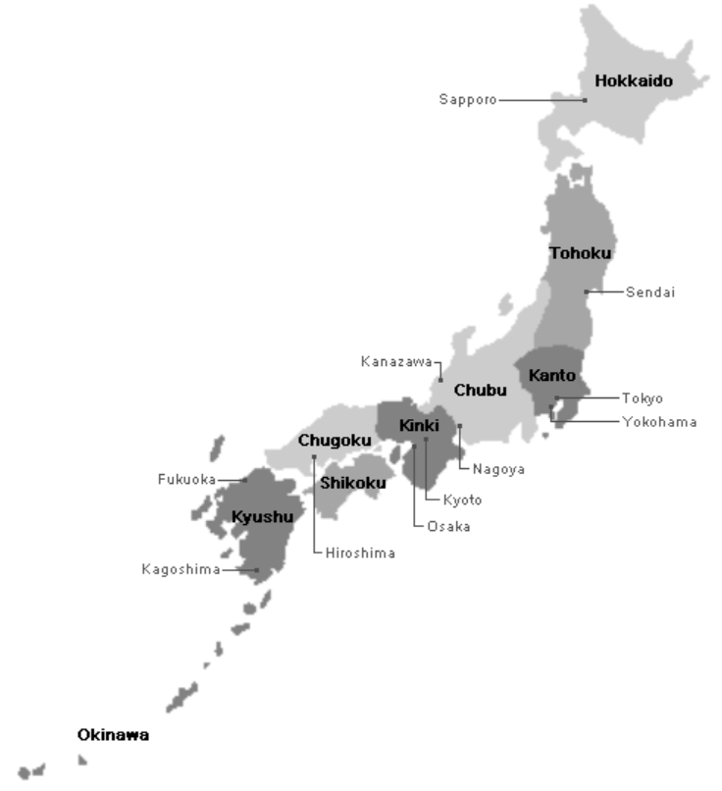
Fig. E1: Map of Japan with official division of eight regions (Web source: https://www.japan-guide.com/list/e1001.html)

Appendix F: Traffic-controlled pre-and post-comparison (2021): Jan-Oct vs Nov-Dec
Table F1: Comparison of LFR, persistence and flight proportion per carrier
Carrier | Metric | Daily observation (pre-period) | Daily observation (post-period) | Median (pre-period) | Median (post-period) | p-value
ANA | LFR (Total) | 183 | 58 | 42.28 | 171.95 | 0.000
ANA | Persistence (Median) | 183 | 58 | 3.00 | 14.58 | 0.000
ANA | Flight proportion departed late (Daily) | 183 | 58 | 0.25 | 1.00 | 0.000
JAL | LFR (Total) | 183 | 59 | 38.46 | 45.46 | 0.175
JAL | Persistence (Median) | 183 | 59 | 2.56 | 28.75 | 0.000
JAL | Flight proportion departed late (Daily) | 183 | 59 | 0.30 | 1.00 | 0.000

Appendix G: Comparison of the percentage of airport sets at each persistent category
To further dissect loop characteristics, we classify loop persistence into Low (0-10 minutes), Medium (11-20 minutes), and High (>20 minutes) categories as summarized in Table E1. Across both carriers, summer operations are characterized by overwhelmingly low-persistence loops, with more than 89% of airport sets in the Low category across all loop sizes. This suggests that summer delays are largely short-lived, likely due to favorable weather conditions, more predictable operations, and possibly increased operational capacity during peak travel periods. However, a shift occurs in winter, particularly for larger airport sets. ANA sees a moderate increase in high-persistent loops during winter, especially in 3-airport and 4-airport configurations, where high-persistence percentages climb to 12.29% and 6.91%, respectively both notably higher than their summer counterparts. For JAL, the contrast is even sharper. It’s winter operations exhibit a sharp rise in high-persistence delay loops for large configurations. In particular, 5-airport sets reach an exceptionally high 24.43% in the High category during winter, the highest value in the entire table, while 6+ airport sets also show elevated persistence at 17.86%. These figures far exceed ANA’s values for the same configurations and season, suggesting that JAL’s network in winter is more susceptible to entrenched
Table G1 Percentage (%) of airport sets at each persistent category
Carrier | Season | Airport-sets | High | Medium | Low
ANA | Summer | 3-airport | 2.32 | 6.62 | 91.07
ANA | Summer | 4-airport | 2.58 | 7.59 | 89.83
ANA | Summer | 5-airport | 2.91 | 7.56 | 89.53
ANA | Summer | 6+ airport | 1.35 | 17.57 | 81.08
ANA | Winter | 3-airport | 6.91 | 11.38 | 81.71
ANA | Winter | 4-airport | 12.29 | 9.97 | 77.74
ANA | Winter | 5-airport | 9.79 | 7.69 | 82.52
ANA | Winter | 6+ airport | 4.41 | 7.35 | 88.24
JAL | Summer | 3-airport | 3.42 | 7.50 | 89.08
JAL | Summer | 4-airport | 3.35 | 7.14 | 89.51
JAL | Summer | 5-airport | 2.29 | 17.56 | 80.15
JAL | Summer | 6+ airport | 4.72 | 19.81 | 75.47
JAL | Winter | 3-airport | 7.98 | 4.24 | 87.78
JAL | Winter | 4-airport | 3.62 | 6.58 | 89.80
JAL | Winter | 5-airport | 24.43 | 7.63 | 67.94
JAL | Winter | 6+ airport | 17.86 | 20.24 | 61.90

feedback loops and systemic delay accumulation. The results indicate that persistent delay loops are more likely to emerge under winter conditions and especially within larger airport sets. For JAL, the problem appears more acute, pointing to potential weaknesses in its winter time operational resilience, such as fewer buffers, longer turnaround times, or greater exposure to weather-affected regional routes. By contrast, ANA maintains a more stable persistence distribution across seasons and loop sizes, potentially reflecting more robust delay mitigation strategies or centralized scheduling coordination.

Appendix H: Boxplot distribution of the birth time and persistence of each of the airport-set
The middle panel presents boxplots of birth time of $H_{1}$ indicating the delay threshold at which each loop forms, and the bottom panel displays how long these loops persist.

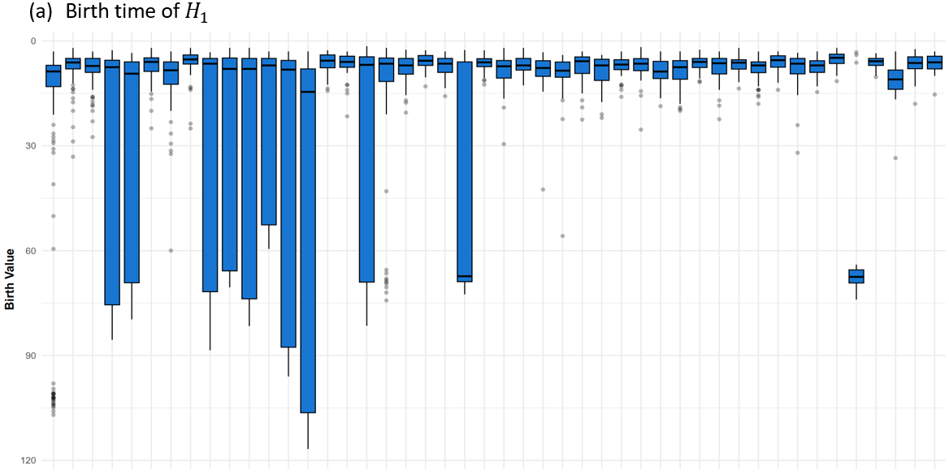

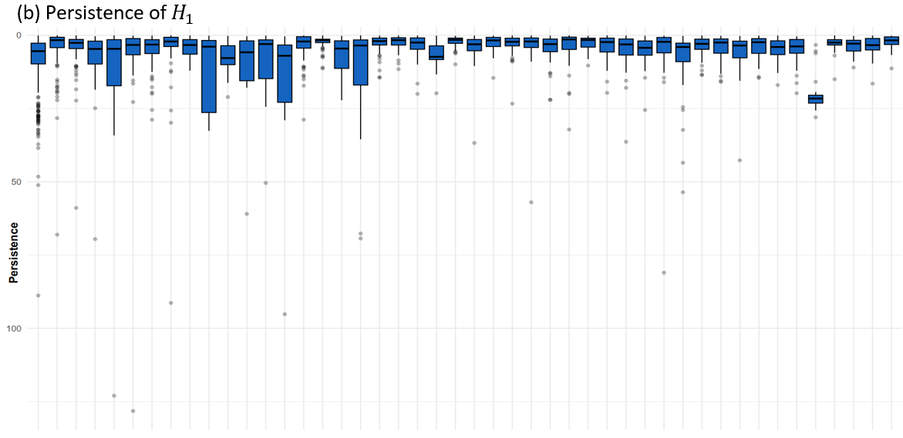
Fig. H1: Boxplot distribution of the (a) birth time (in minutes) and (b) persistence (in minutes) of each of the airport set appearances for ANA

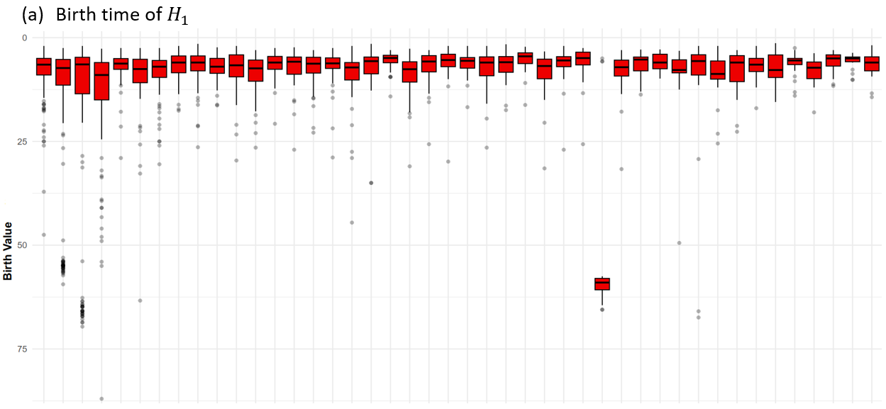

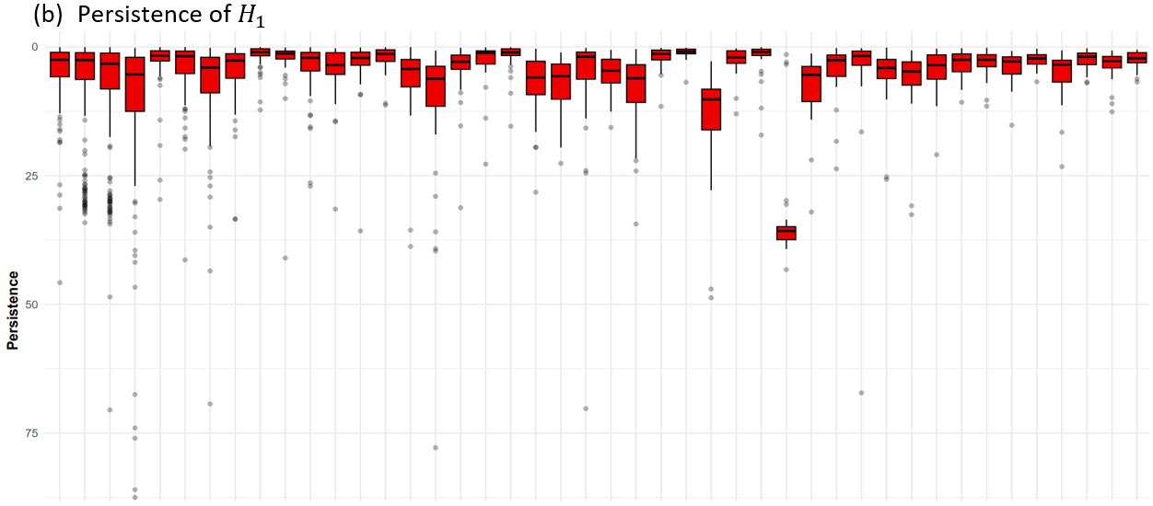

Fig. H2: Boxplot distribution of the (a) birth time (in minutes) and (b) persistence (in minutes) of each of the airport set appearances for JAL

Appendix I: Comparison of the percentage of airport sets at each persistent category

Table I1: HND seasonal buffer recommendation (positive departure delays only)
Carrier | Season | Flight number | Departure delay number | Departure delay (%) | p50 | p75 | p90
ANA | Summer | 108,268 | 66,218 | 0.61 | 5 | 10 | 19
ANA | Winter | 86,180 | 56,363 | 0.65 | 5 | 11 | 39
JAL | Summer | 125,717 | 77,713 | 0.62 | 5 | 10 | 19
JAL | Winter | 100,974 | 68,054 | 0.67 | 6 | 13 | 45

Here, seasonal buffers are suggested using positive departure delay percentiles at HND. P75 provides moderate robustness; P90 provides higher reliability and shows a clear winter increase.

Table I2: Recurrent Winter 2021 large loop-set and most affected legs (JAL example)
Departure airport | Arrival Airport | Flight numbers | Departure delay (%) | Mean departure delay (min) | Delay (P90)
CTS | ITM | 127 | 0.98 | 97.77 | 112.6
HNA | ITM | 89 | 0.93 | 81.98 | 101.8
ITM | CTS | 126 | 0.98 | 80.66 | 90.0
SDJ | ITM | 187 | 0.96 | 69.66 | 85.0
CTS | KIJ | 33 | 0.94 | 59.32 | 71.0
ITM | HNA | 90 | 0.93 | 62.58 | 71.0
KIJ | ITM | 70 | 0.91 | 58.03 | 69.7
KIJ | CTS | 33 | 0.88 | 55.21 | 63.4
CTS | SDJ | 121 | 0.93 | 51.73 | 61.0
SDJ | CTS | 122 | 0.95 | 51.56 | 61.0

Table I2 provides an operable example of a recurrent, high-persistence Winter 2021 large loop-set for JAL. The loop-set (CTS, HNA, ITM, KIJ, SDJ) appears on 25 winter days and shows high persistence (median 36.25; p90 38.61), indicating a stable and potentially disruptive multi-airport delay feedback structure. The table ranks the legs within this loop-set by high-percentile delay severity (p90 of positive departure delay). The highest-risk legs (e.g., CTS to ITM and HNA to ITM) provide direct intervention targets for winter scheduling slack, reinforcing turnaround time, and resource allocation

