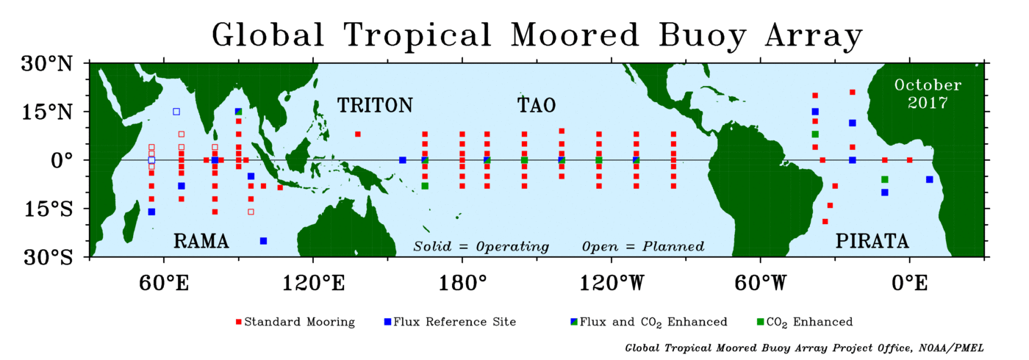

S1: Present status of the Global Tropical Moored Buoy Array (GTMBA).
Source: Global Tropical Moored Buoy Array Project Office, NOAA/PMEL

(a) | TRITON (vs) CM
Dataset | Q_{S} |  |  |  |  | Q_{L}
Parameter/Season | Bias | SD | RMSE | CC | Bias |  | SD | RMSE | CC
DJF (15899/2554) | 7.83 | 38.26 | 39.06 | 0.81 | -3.67 |  | 7.47 | 8.32 | 0.90
MAM (16212/2274) | 7.48 | 41.30 | 41.97 | 0.78 | -3.64 |  | 7.73 | 8.55 | 0.84
JJA (15522/2116) | 6.60 | 39.35 | 39.90 | 0.79 | -3.43 |  | 8.66 | 9.32 | 0.88
SON (15676/2162) | 7.00 | 40.01 | 40.62 | 0.79 | -3.98 |  | 8.07 | 9.00 | 0.90
Aggregate | 7.23 | 39.73 | 40.39 | 0.79 | -3.68 |  | 7.98 | 8.80 | 0.88
(b) | TRITON (vs) CORE-II
Dataset | Q_{S} |  |  |  |  | Q_{L}
Parameter/Season | Bias | SD | RMSE | CC | Bias |  | SD | RMSE | CC
DJF (15899/2554) | -0.99 | 41.25 | 41.26 | 0.78 | -0.71 |  | 12.1 | 12.12 | 0.76
MAM (16212/2274) | 0.65 | 46.91 | 46.92 | 0.7 | -0.71 |  | 10.57 | 10.59 | 0.71
JJA (15522/2116) | -0.03 | 42.7 | 42.7 | 0.74 | -0.3 |  | 11.25 | 11.26 | 0.79
SON (15676/2162) | -0.53 | 43.22 | 43.22 | 0.74 | 1.07 |  | 13.56 | 13.61 | 0.74
Annual | -0.22 | 43.52 | 43.53 | 0.74 | -0.17 |  | 11.87 | 11.89 | 0.75
(c) | TRITON (vs) TropFlux
Dataset | Q_{S} |  |  |  |  | Q_{L}
Parameter/Season | Bias | SD | RMSE | CC | Bias |  | SD | RMSE | CC
DJF (15899/2554) | -6.24 | 35.75 | 36.29 | 0.84 | 3.19 |  | 10.09 | 10.58 | 0.82
MAM (16212/2274) | -2.57 | 37.65 | 37.74 | 0.82 | 3.78 |  | 8.92 | 9.69 | 0.79
JJA (15522/2116) | -6.08 | 34.39 | 34.92 | 0.84 | 3.01 |  | 10.04 | 10.48 | 0.84
SON (15676/2162) | -3.67 | 37.07 | 37.25 | 0.82 | 3.32 |  | 10.95 | 11.44 | 0.83
Aggregate | -4.64 | 36.21 | 36.55 | 0.83 | 3.32 |  | 10.00 | 10.55 | 0.82

S2: Seasonal Pearson correlation of downwelling shortwave radiation (Q_{S}) and downwelling longwave radiation (Q_{L}) from all reanalysis/satellite products compared with TRITON data in Pacific Ocean during 2001-2009. No. of data points are given in the brackets (Q_{S}/Q_{L}) for corresponding seasons.

(a) | PIRATA (vs) CM
Dataset | Q_{S} |  |  |  | Q_{L}
Parameter/Season | Bias | SD | RMSE | CC | Bias | SD | RMSE | CC
DJF (8968/994) | 7.62 | 33.82 | 34.67 | 0.84 | -5.91 | 8.56 | 10.40 | 0.85
MAM (8578/1003) | 4.88 | 35.45 | 35.78 | 0.74 | -6.01 | 8.77 | 10.63 | 0.84
JJA  (8853/1149) | 5.32 | 33.30 | 33.72 | 0.75 | -1.81 | 8.27 | 8.47 | 0.87
SON  (9205/959) | 2.27 | 35.26 | 35.34 | 0.80 | -1.51 | 7.07 | 7.23 | 0.76
Aggregate | 5.02 | 34.46 | 34.88 | 0.78 | -3.81 | 8.17 | 9.18 | 0.83
(b) | PIRATA (vs) CORE-II
Dataset | Q_{S} |  |  |  | Q_{L}
Parameter/Season | Bias | SD | RMSE | CC | Bias | SD | RMSE | CC
DJF (8968/994) | 3.83 | 38.22 | 38.41 | 0.79 | -4.09 | 13.27 | 13.89 | 0.81
MAM (8578/1003) | 2.73 | 42.15 | 42.24 | 0.61 | -5.74 | 13.68 | 14.83 | 0.77
JJA  (8853/1149) | 3.01 | 37.98 | 38.10 | 0.65 | 2.61 | 11.43 | 11.72 | 0.74
SON  (9205/959) | -0.57 | 39.73 | 39.73 | 0.74 | 2.35 | 13.79 | 13.99 | 0.41
Aggregate | 2.25 | 39.52 | 39.62 | 0.70 | -1.22 | 13.04 | 13.61 | 0.68
(c) | PIRATA (vs) TropFlux
Dataset | Q_{S} |  |  |  | Q_{L}
Parameter/Season | Bias | SD | RMSE | CC | Bias | SD | RMSE | CC
DJF (8968/994) | -0.38 | 33.16 | 33.16 | 0.85 | -0.55 | 16.38 | 16.38 | 0.67
MAM (8578/1003) | 1.35 | 33.11 | 33.14 | 0.78 | -0.05 | 17.98 | 17.98 | 0.60
JJA  (8853/1149) | -0.12 | 30.63 | 30.63 | 0.80 | 2.20 | 12.08 | 12.28 | 0.71
SON  (9205/959) | -2.53 | 31.79 | 31.89 | 0.84 | 1.78 | 9.74 | 9.90 | 0.60
Aggregate | -0.42 | 32.17 | 32.20 | 0.82 | 0.84 | 14.04 | 14.14 | 0.64
S3: Seasonal Pearson correlation of downwelling shortwave radiation (Q_{S}) and downwelling longwave radiation (Q_{L}) from all reanalysis products compared with PIRATA data in Atlantic Ocean during 2001-2009. No. of data points are given in the bracket (Q_{S}/Q_{L}) for corresponding seasons.

(a) | RAMA (vs) CM
Dataset | Q_{S} |  |  |  | Q_{L}
Parameter/Season | Bias | SD | RMSE | CC | Bias | SD | RMSE | CC
DJF (2945/569) | 5.26 | 43.36 | 43.68 | 0.78 | -6.25 | 7.04 | 9.42 | 0.95
MAM (2104/328) | 3.71 | 41.65 | 41.82 | 0.79 | -8.30 | 6.57 | 10.59 | 0.93
JJA (1802/216) | 2.57 | 39.95 | 40.04 | 0.78 | -6.31 | 4.76 | 7.90 | 0.90
SON (2938/526) | 2.18 | 45.32 | 45.38 | 0.79 | -6.14 | 5.76 | 8.42 | 0.86
Aggregate | 3.43 | 42.57 | 42.73 | 0.78 | -6.75 | 6.03 | 9.08 | 0.91
(b) | RAMA (vs) CORE-II
Dataset | Q_{S} |  |  |  | Q_{L}
Parameter/Season | Bias | SD | RMSE | CC | Bias | SD | RMSE | CC
DJF (2945/569) | -3.36 | 48.87 | 48.99 | 0.71 | -8.88 | 11.57 | 14.59 | 0.92
MAM (2104/328) | -0.83 | 50.71 | 50.72 | 0.66 | -14.13 | 13.07 | 19.25 | 0.86
JJA (1802/216) | -0.95 | 46.95 | 46.96 | 0.67 | -5.60 | 7.25 | 9.16 | 0.78
SON (2938/526) | -4.62 | 53.89 | 54.09 | 0.68 | -4.17 | 8.45 | 9.42 | 0.75
Aggregate | -2.44 | 50.10 | 50.19 | 0.68 | -8.20 | 10.09 | 13.11 | 0.83
(c) | RAMA (vs) TropFlux
Dataset | Q_{S} |  |  |  | Q_{L}
Parameter/Season | Bias | SD | RMSE | CC | Bias | SD | RMSE | CC
DJF (2945/569) | -9.44 | 42.34 | 43.38 | 0.80 | 1.60 | 10.18 | 10.30 | 0.93
MAM (2104/328) | -3.72 | 37.31 | 37.49 | 0.83 | 3.17 | 10.41 | 10.88 | 0.87
JJA (1802/216) | -10.85 | 33.10 | 34.84 | 0.85 | 5.76 | 6.05 | 8.35 | 0.85
SON (2938/526) | -11.54 | 41.03 | 42.62 | 0.83 | 5.07 | 6.41 | 8.17 | 0.82
Aggregate | -8.89 | 38.44 | 39.58 | 0.83 | 3.90 | 8.26 | 9.43 | 0.87

S4: Seasonal Pearson correlation of downwelling shortwave radiation (Q_{S}) and downwelling longwave radiation (Q_{L}) from all reanalysis products compared with RAMA data in Indian Ocean during 2001-2009. No. of data points are given in the bracket (Q_{S}/Q_{L}) for corresponding seasons.

