Supplementary Information
The viscoplastic constitutive parameters for the individual planes of interest are obtained via nanoscale dynamic impact on multiple prepared β-HMX crystals. The strain and stress for each impact experiment are calculated as $ε≈\frac{h_{res}^{2}}{h_{max}^{2}}$, and $σ≈\frac{P}{πh_{max}^{2}}.$ These values are fit to a power law model which is assumed to represent the effective stress-effective viscoplastic strain relationship. The main document of this submission displays the power law fit of stress-strain data for the (100) plane, here we present additional stress-strain data for the remaining planes.
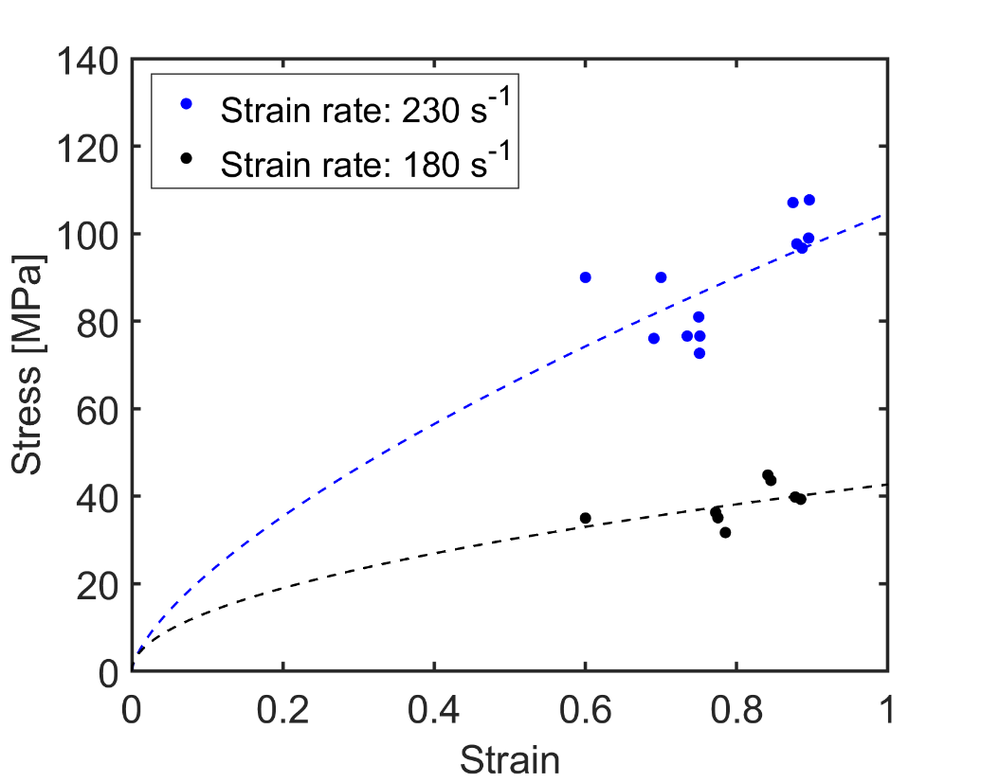
Figure 1. Data from impact experiments on {110} plane fit to viscoplastic power law
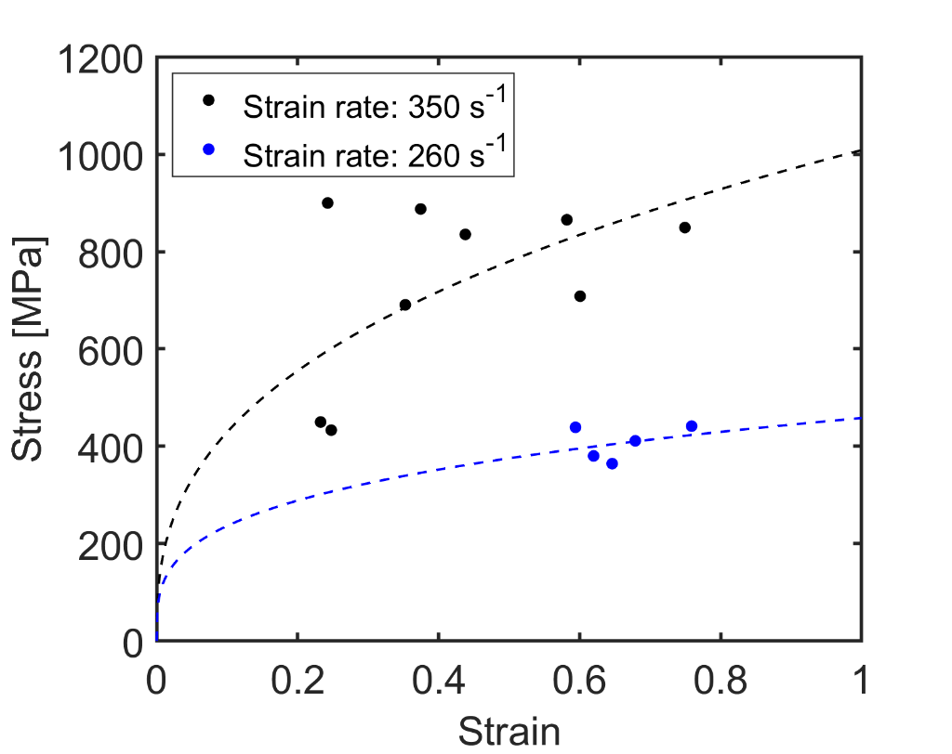
Figure 2. Data from impact experiments on (010) plane fit to viscoplastic power law
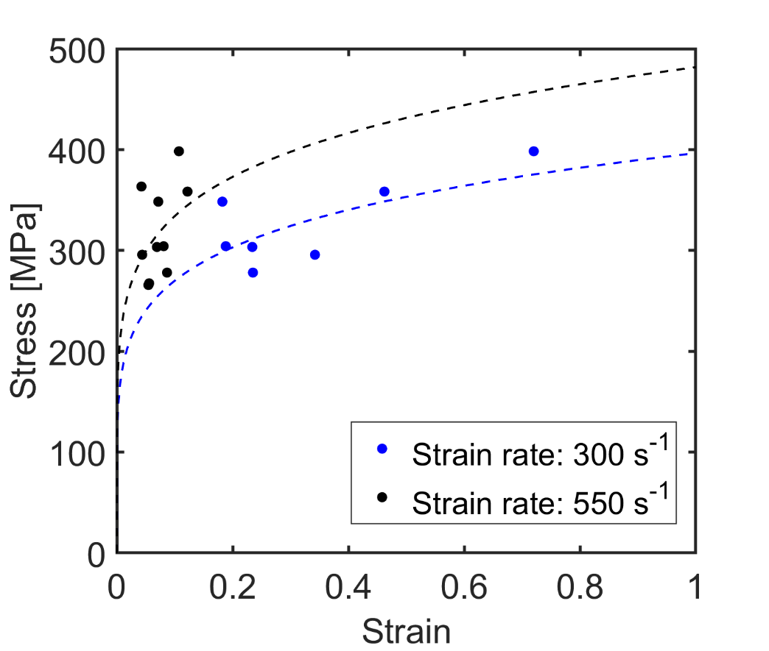
Figure 3. Data from impact experiments on (001) plane fit to viscoplastic power law
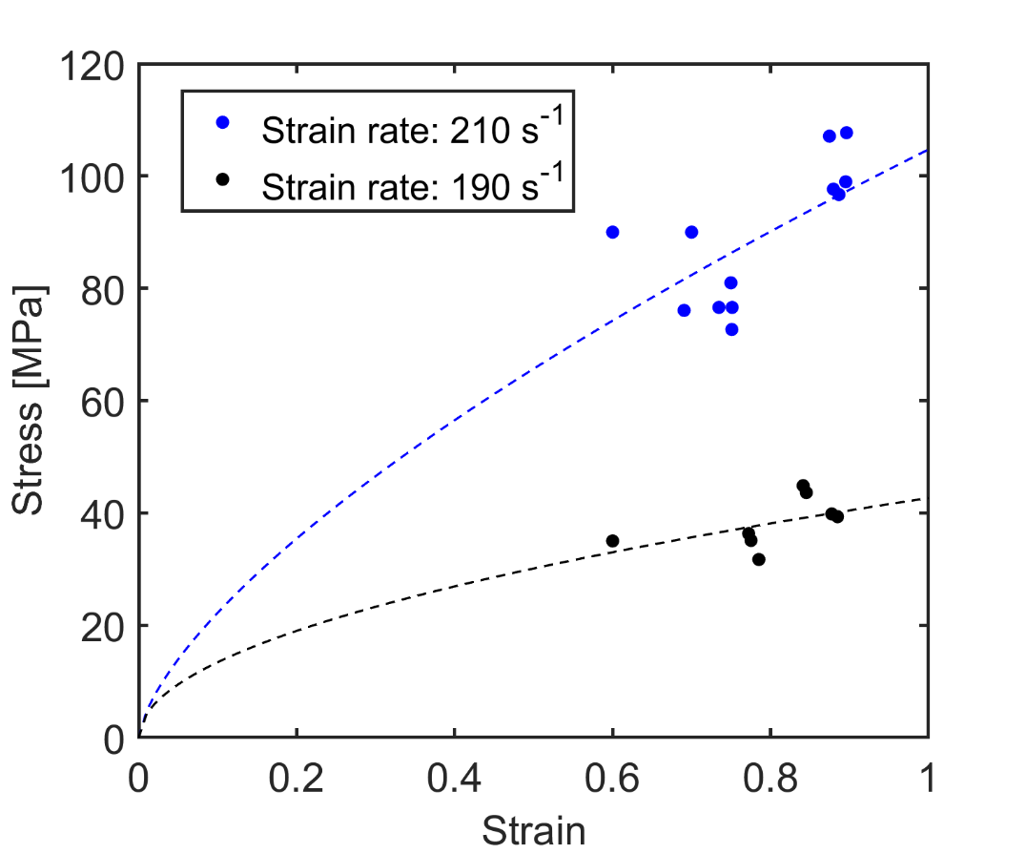
Figure 4. Data from impact experiments on {011} plane fit to viscoplastic power law

