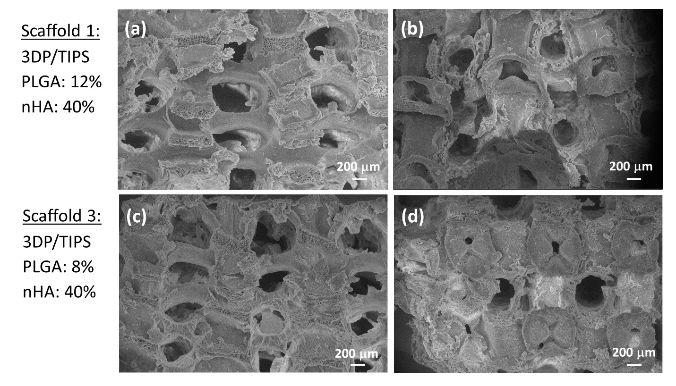
Fig. S1 SEM images showing (a & b) the side and top views of scaffold 1, and (c & d) the side and top views of scaffold 3 prepared using the 3DP/TIPS method

