Supplementary Information

SI1 (August-September)
CO Calibration
 | Coefficients | Standard Error | t Stat | P-value | Lower 95% | Upper 95% | Lower 95.0% | Upper 95.0%
Intercept | -0.148804 | 0.049549 | -3.00319 | 2.80E-03 | -0.24615 | -0.05146 | -0.24615 | -0.05146
Humidity | 0.000178 | 9.52E-05 | 1.873431 | 6.16E-02 | -8.7E-06 | 0.000365 | -8.7E-06 | 0.000365
Temperature | 0.000702 | 0.000304 | 2.306652 | 2.15E-02 | 0.000104 | 0.0013 | 0.000104 | 0.0013
CO_We | 2.464927 | 0.024677 | 99.88947 | 0.00E+00 | 2.416447 | 2.513407 | 2.416447 | 2.513407
CO_Aux | -1.753123 | 0.142297 | -12.3202 | 1.03E-30 | -2.03268 | -1.47356 | -2.03268 | -1.47356

NO Calibration
 | Coefficients | Standard Error | t Stat | P-value | Lower 95% | Upper 95% | Lower 95.0% | Upper 95.0%
Intercept | 60.02519 | 7.402433 | 8.108846 | 3.90E-15 | 45.48183 | 74.56854 | 45.48183 | 74.56854
Humidity | -0.05884 | 0.013585 | -4.33096 | 1.79E-05 | -0.08552 | -0.03215 | -0.08552 | -0.03215
Temperature | -0.47914 | 0.062874 | -7.62059 | 1.26E-13 | -0.60267 | -0.35561 | -0.60267 | -0.35561
NO_We | 1448.207 | 37.48393 | 38.63542 | 6.46E-153 | 1374.564 | 1521.851 | 1374.564 | 1521.851
NO_Aux | -1688.78 | 48.25185 | -34.9993 | 4.00E-137 | -1783.58 | -1593.98 | -1783.58 | -1593.98

SI2 (June)
CO Calibration
 | Coefficients | Standard Error | t Stat | P-value | Lower 95% | Upper 95% | Lower 95.0% | Upper 95.0%
Intercept | 0.019658 | 0.198394 | 0.099084 | 0.92128 | -0.3742 | 0.41352 | -0.3742 | 0.41352
Humidity | -0.00067 | 0.00037 | -1.81861 | 0.072122 | -0.00141 | 6.17E-05 | -0.00141 | 6.17E-05
Temperature | -0.00283 | 0.001559 | -1.81746 | 0.072299 | -0.00593 | 0.000262 | -0.00593 | 0.000262
CO_We | 2.279597 | 0.104903 | 21.73057 | 1.23E-38 | 2.071338 | 2.487855 | 2.071338 | 2.487855
CO_Aux | -1.5305 | 0.525146 | -2.91443 | 0.004444 | -2.57305 | -0.48795 | -2.57305 | -0.48795

NO Calibration
 | Coefficients | Standard Error | t Stat | P-value | Lower 95% | Upper 95% | Lower 95.0% | Upper 95.0%
Intercept | -30.9396 | 30.55722 | -1.01251 | 0.313978 | -91.6377 | 29.7586 | -91.6377 | 29.7586
Humidity | 0.003335 | 0.039771 | 0.083843 | 0.933366 | -0.07567 | 0.082335 | -0.07567 | 0.082335
Temperature | -1.08332 | 0.335358 | -3.23034 | 0.001721 | -1.74947 | -0.41717 | -1.74947 | -0.41717
NO_We | 1068.537 | 115.2178 | 9.274061 | 8.43E-15 | 839.6708 | 1297.403 | 839.6708 | 1297.403
NO_Aux | -938.12 | 186.0365 | -5.04266 | 2.33E-06 | -1307.66 | -568.581 | -1307.66 | -568.581

SI3
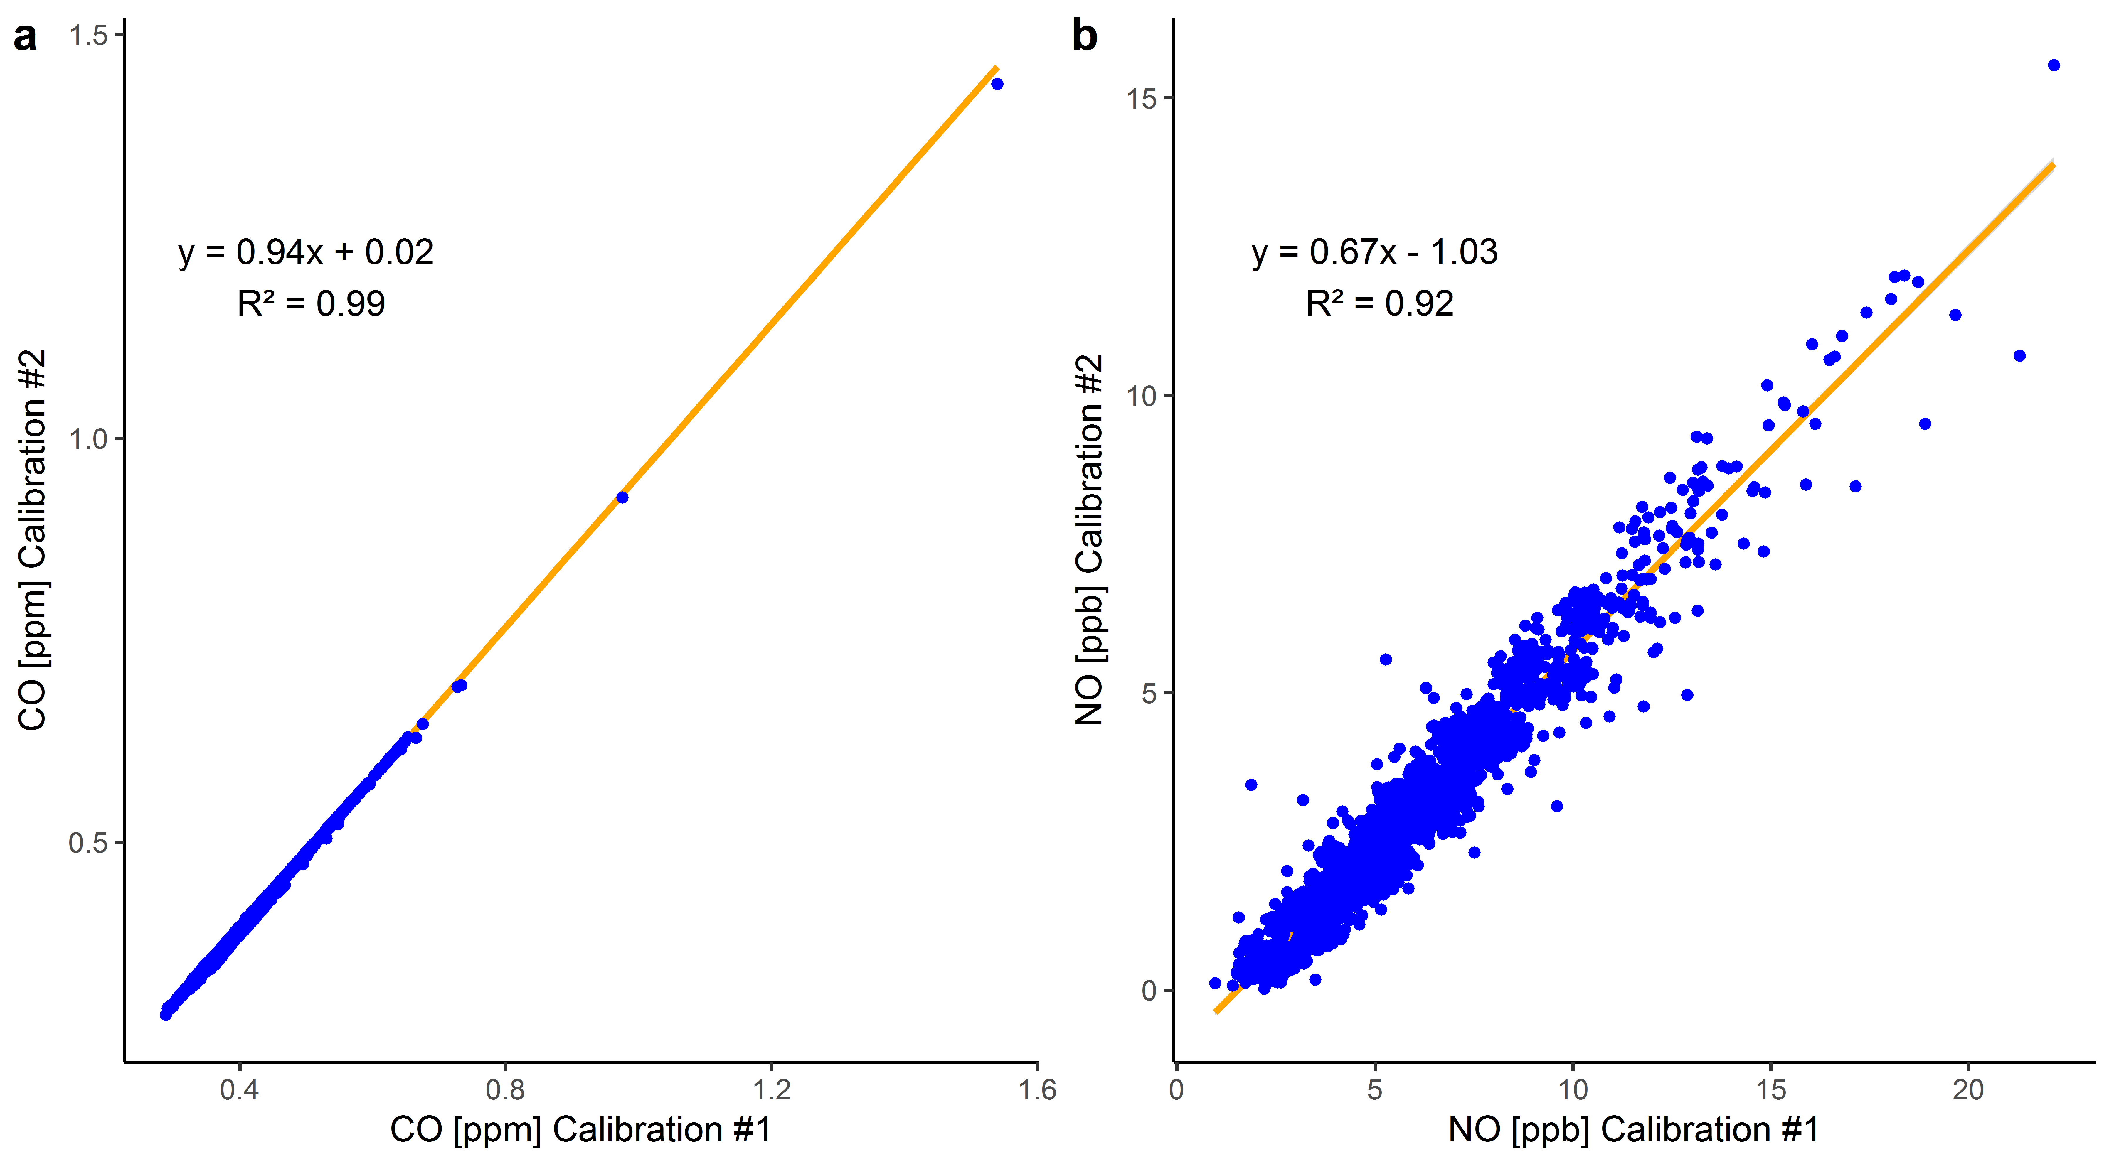
Figure SI3: Field measurements comparison of two calibrations. Calibration#1 was conducted for 500 hours and calibration#2 for 100 hours.

SI4

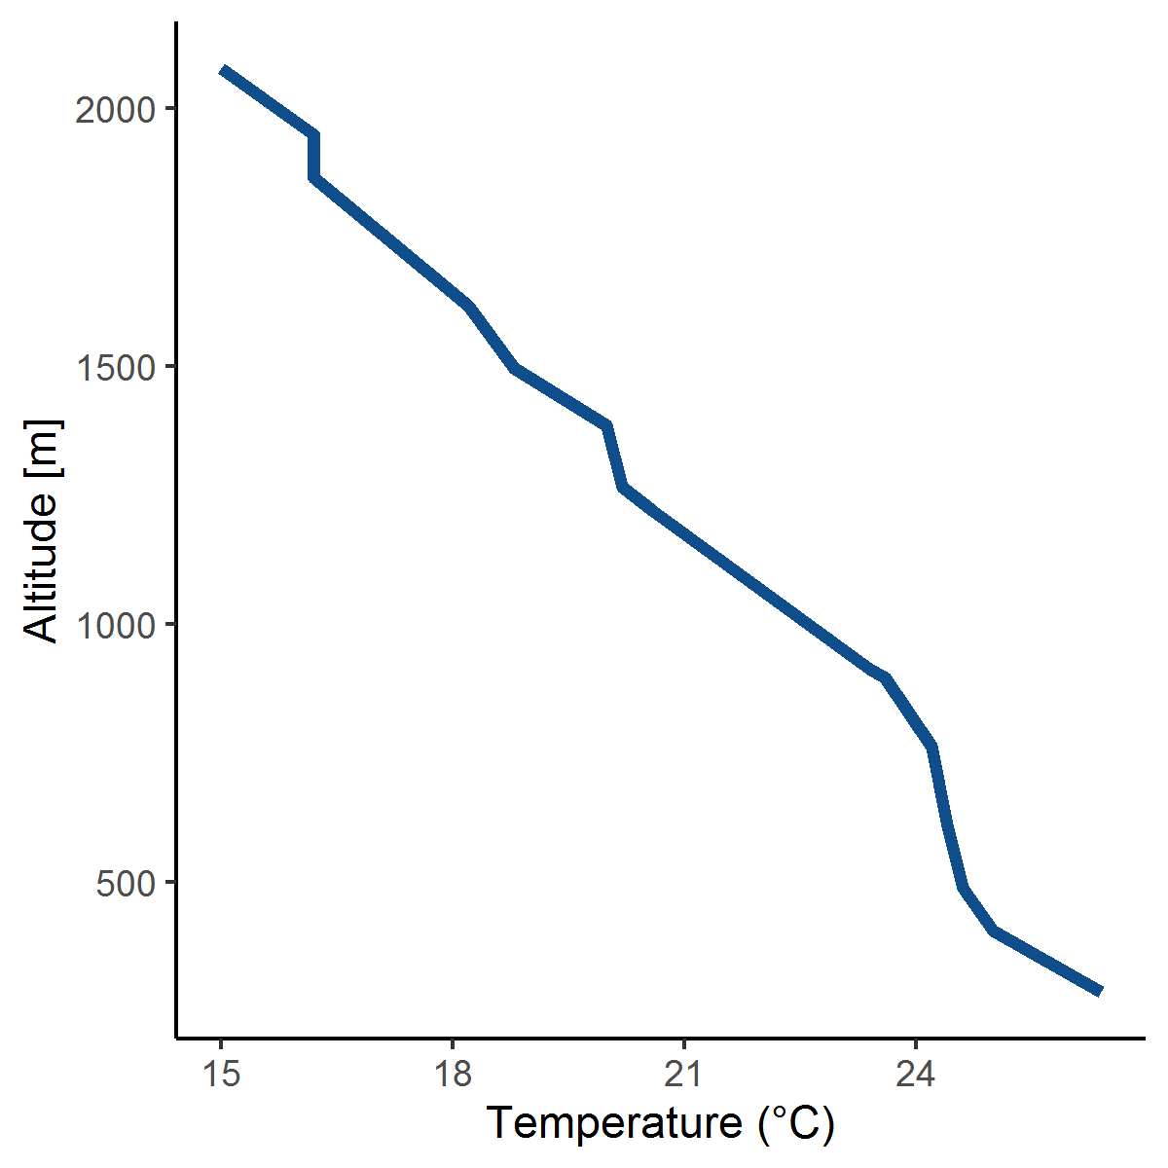
Figure SI4: Temperature profile on July 4th at 12 am. X-axis is the temperature in Celsius. The right Y-axis is the altitude in meter. Source: data from the University of Wyoming Dept of Atmospheric Science website (http://weather.uwyo.edu/upperair/sounding.html).

SI5
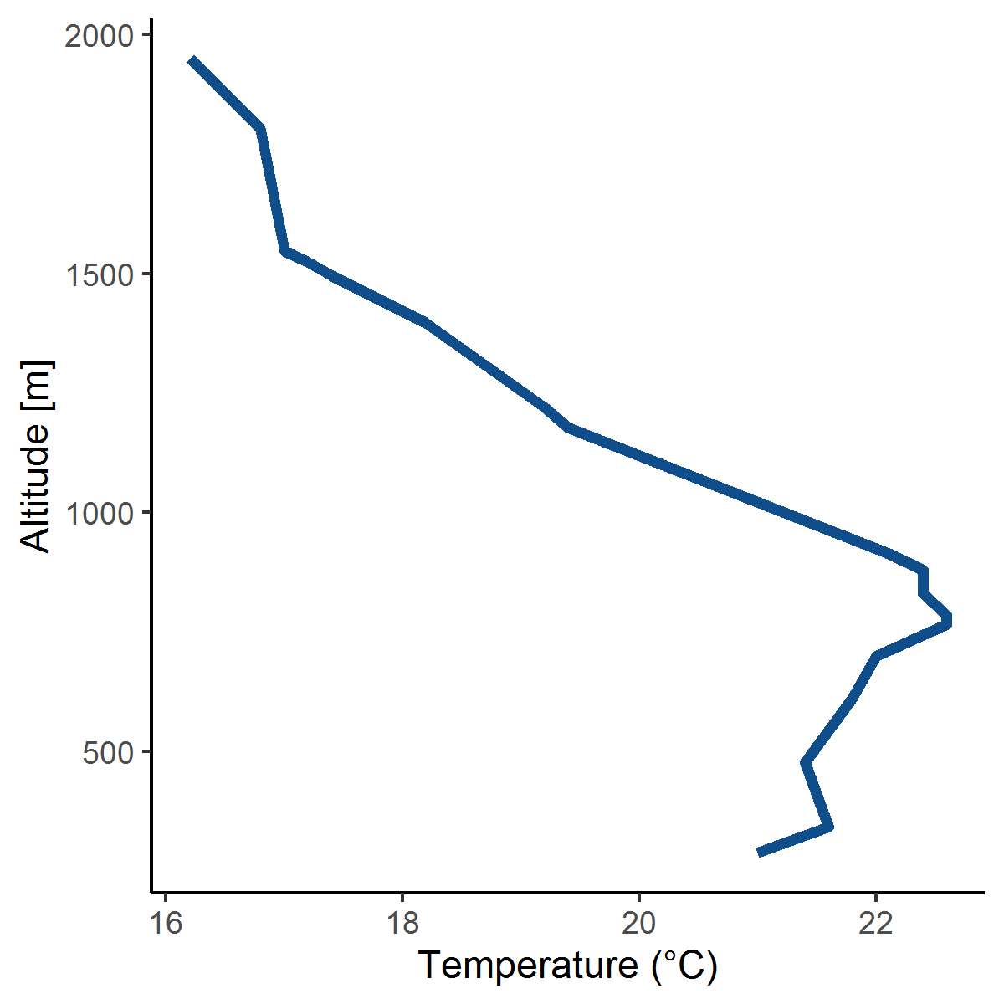
Figure SI5: Temperature profile on July 4th at 12 pm. X-axis is the temperature in Celsius. The right Y-axis is the altitude in meter. Source: data from the University of Wyoming Dept of Atmospheric Science website (http://weather.uwyo.edu/upperair/sounding.html).

SI6
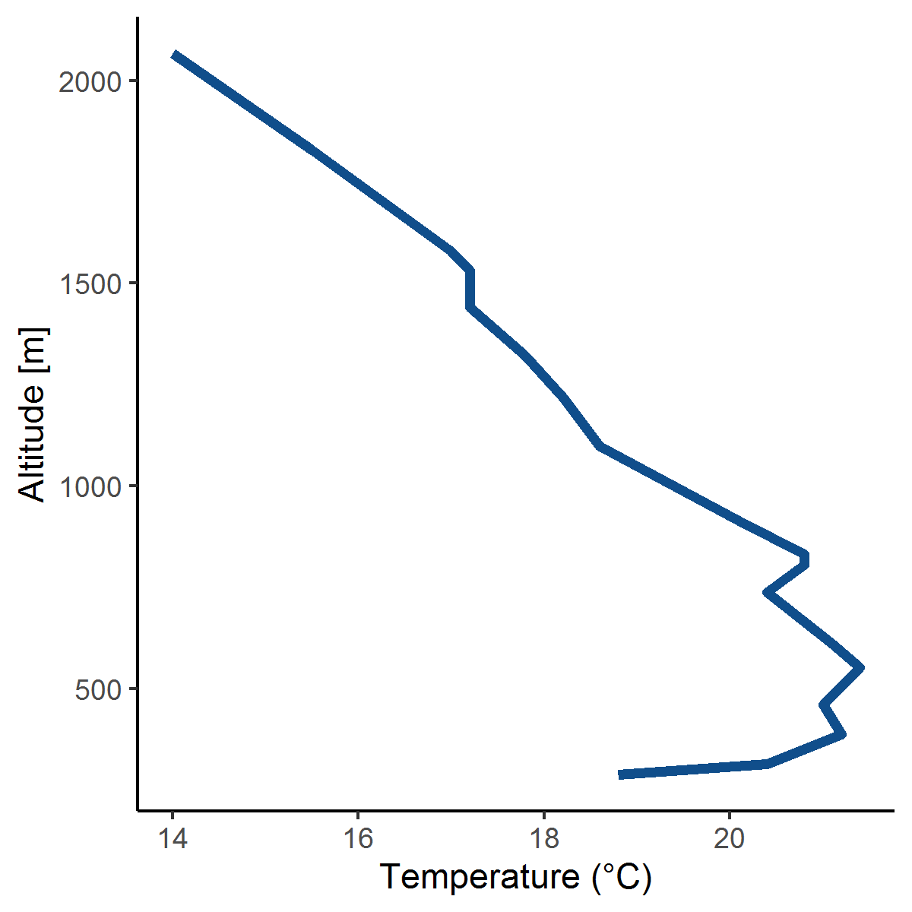
Figure SI6: Temperature profile on July 5th at 12 pm. X-axis is the temperature in Celsius. The right Y-axis is the altitude in meter. Source: data from the University of Wyoming Dept of Atmospheric Science website (http://weather.uwyo.edu/upperair/sounding.html).

