Preferentially oriented growth of diamond films on silicon with nickel interlayer

Anupam K.C.ª, Anwar Siddique ^{a,†}, Jonathan Andersonª , Rony Sahaª, Chhabindra Gautam^{b}, Anival Ayalaª, Chris Engdahl^{c}, Mark Holtz^{a,b} and Edwin L. Piner ^{a,b,*}

ª Materials Science, Engineering and Commercialization Program (MSEC), Texas State University, San Marcos, Texas 78666, United State.

^{b} Department of Physics, Texas State University, San Marcos, Texas 78666, United State.

^{c} Crystallume Inc., 3397 De La Cruz Boulevard, Santa Clara, California 95054, United State.

† Currently at Intel Corp., Phoenix, Arizona, USA.

* Corresponding author : epiner@txstate.edu

Supplementary Materials

Diamond growth on unseeded 10 nm Ni layer on Si (1.5 % methane for 9h)

Fig. 1. SEM image after 3h CVD environment exposure on unseeded Ni layer (10 nm) on Si. Diamond nucleation is poor and diamond grains lacking stable crystalline structure are observed (marked by yellow square). Such structure is known as ballas or cauliflower type growth morphology.
Fig. 2. EDS analysis. Spot-2 (top) indicates the formation of a Ni-C-Si intermediate phase in-between the diamond seed during the CVD growth process. EDS spot-1 (bottom) indicates the corresponding signals at the developing diamond grains. (The Ni and Si signal are largely due to spectroscopic signal from underneath the diamond grain.)
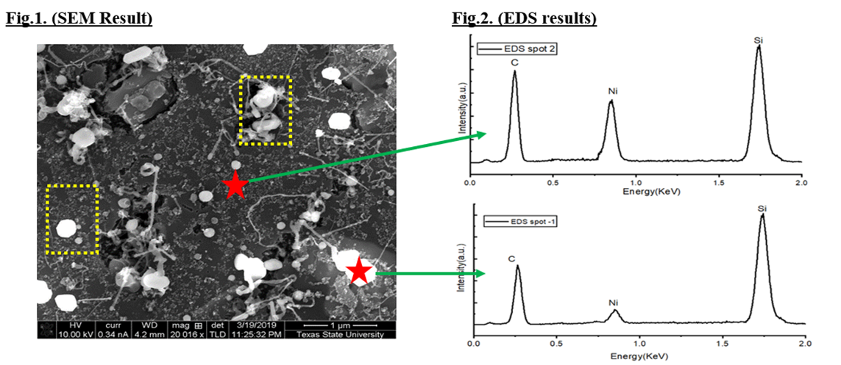

Fig. 3. Raman spectroscopy indicates no diamond peak at 1332 cm⁻¹ and the scattering intensity due to NDC (D & G peaks) is negligible thereby confirming the Ni consumes carbon while also reacting with Si to form a Ni-C-Si phase which limits the nucleation of diamond.
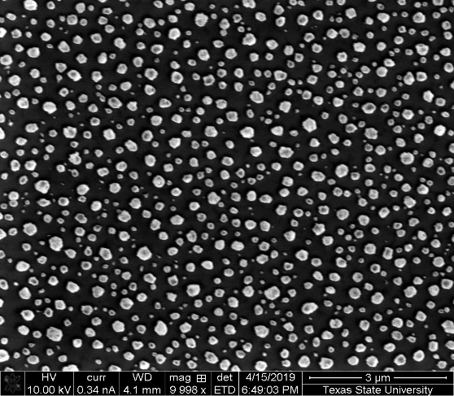
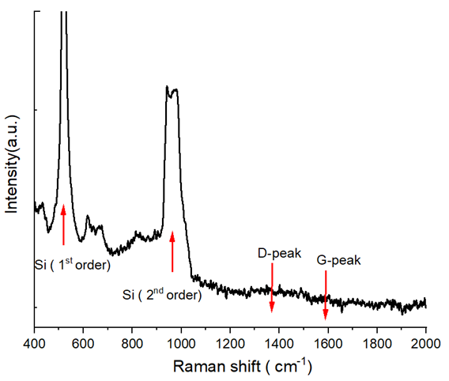

Fig. 4. SEM image for Ni-precipitation on Si substrate as nickel nanodots when 10 nm Ni is annealed for 3 h at 750 °C in N₂ atmosphere.

Fig. 5. XRD analysis of diamond film grown on Si with and without Ni interlayer with 10¹⁰ cm⁻² diamond seeding density. These data show that the diamond film texturing is substantially improved with Ni interlayer compared to bare Si substrate grown with the same seeding density.

