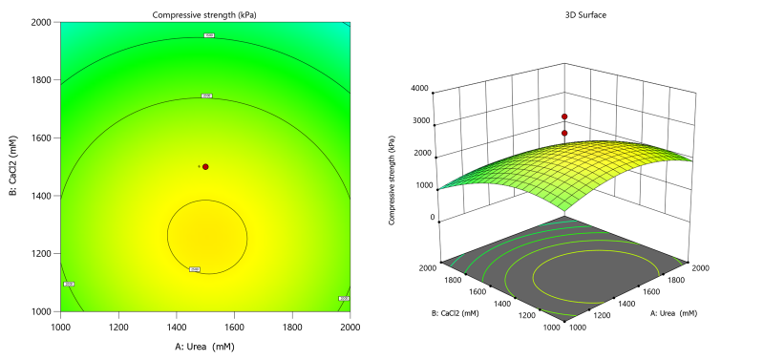
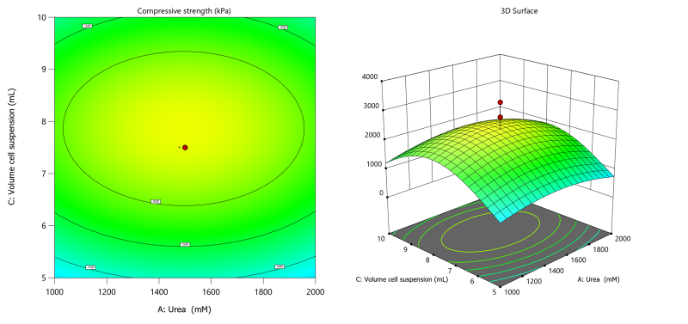
Supplementary 1. Response surface plots of the interactive effects of urea concentration (A) and calcium chloride concentration (B) on the compressive strength at constant cell suspension volume of 7,5 mL
Supplementary 2. Response surface plots of the interactive effects of urea concentration (A) and cell suspension (C) on the compressive strength at constant calcium chloride concentration of 1500 mM

