Supporting Information
Comparative study of different lithium salts as electrolyte additives of Li/SiO_{x}-Si-C half-cells for lithium sulfur batteries
Deepa Elizabeth Mathew^{1,2}, R. Baby Dhanalakshmi¹, S. Sathya^{1,2}, M. Kathiresan^{1,2}, Sabu Thomas^{2,3}, A. Manuel Stephan^{1,2*}
¹CSIR- Central Electrochemical Research Institute, Karaikudi 630 003, India
²Academy of Scientific and Innovative Research (AcSIR), Ghaziabad 201002, India
³Mahatma Gandhi University, Kottayam 686560 India
⁴ Center for Materials Science, Zewail City of Science and Technology, Giza 12578, Egypt

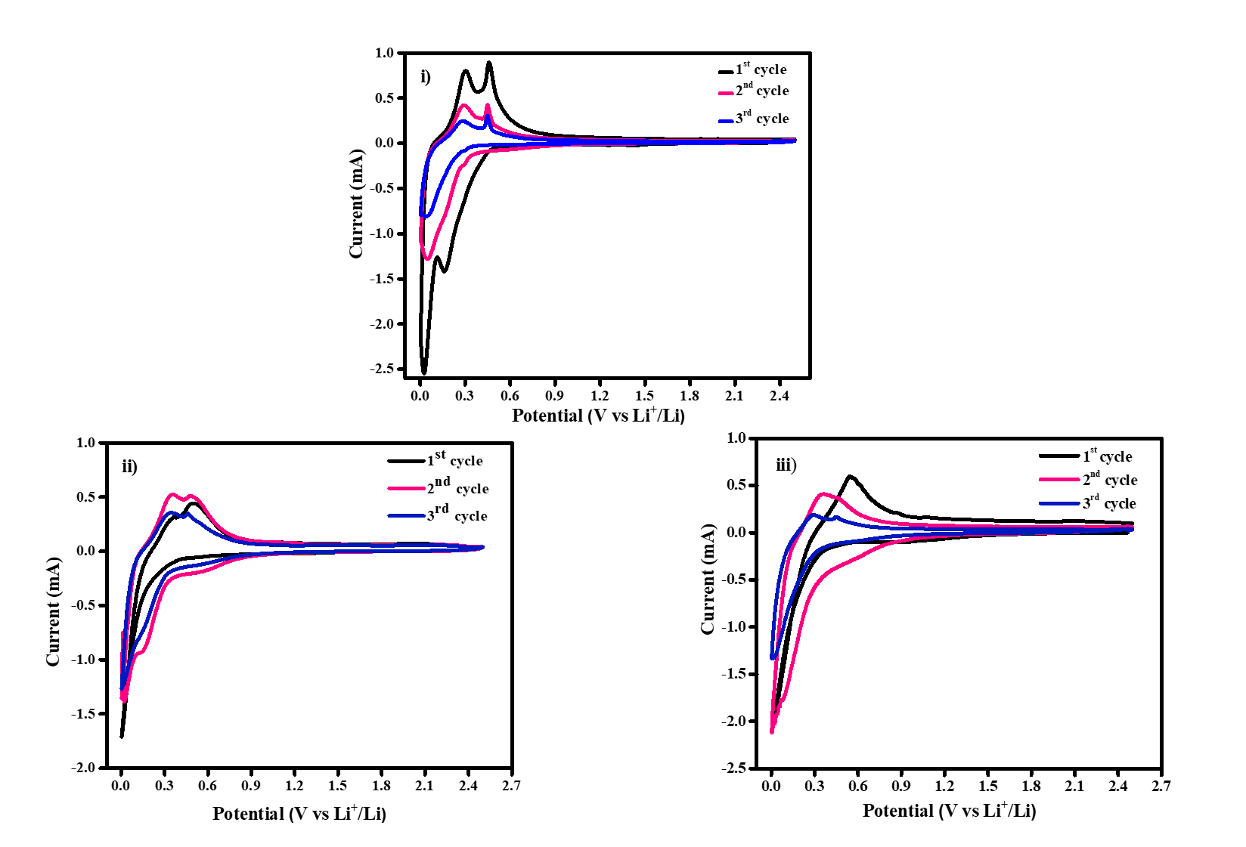
Figure SI 1. Cyclic voltammetry of Li/ SiO_{x}-Si-C half-cell i) without additive ii) with LiFSI iii) with LiBOB

*Corresponding author
amstephan@cecri.res.in

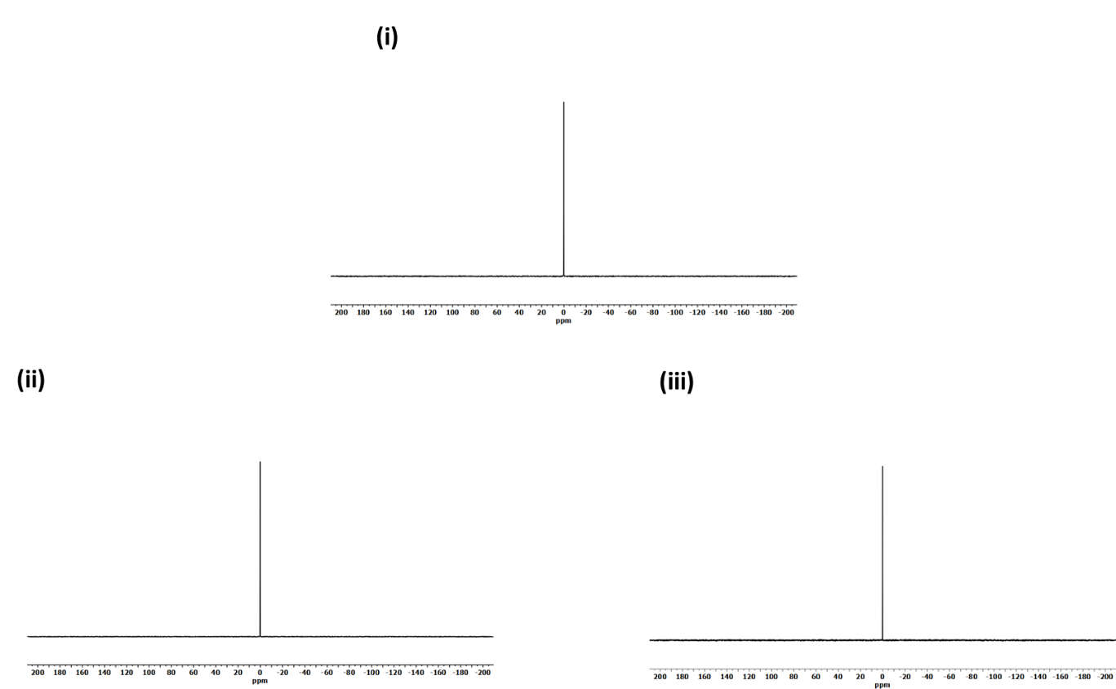
Figure SI 2. ⁷Li NMR spectroscopy of (i) without additive (ii) with LiFSI (iii) with LiBOB

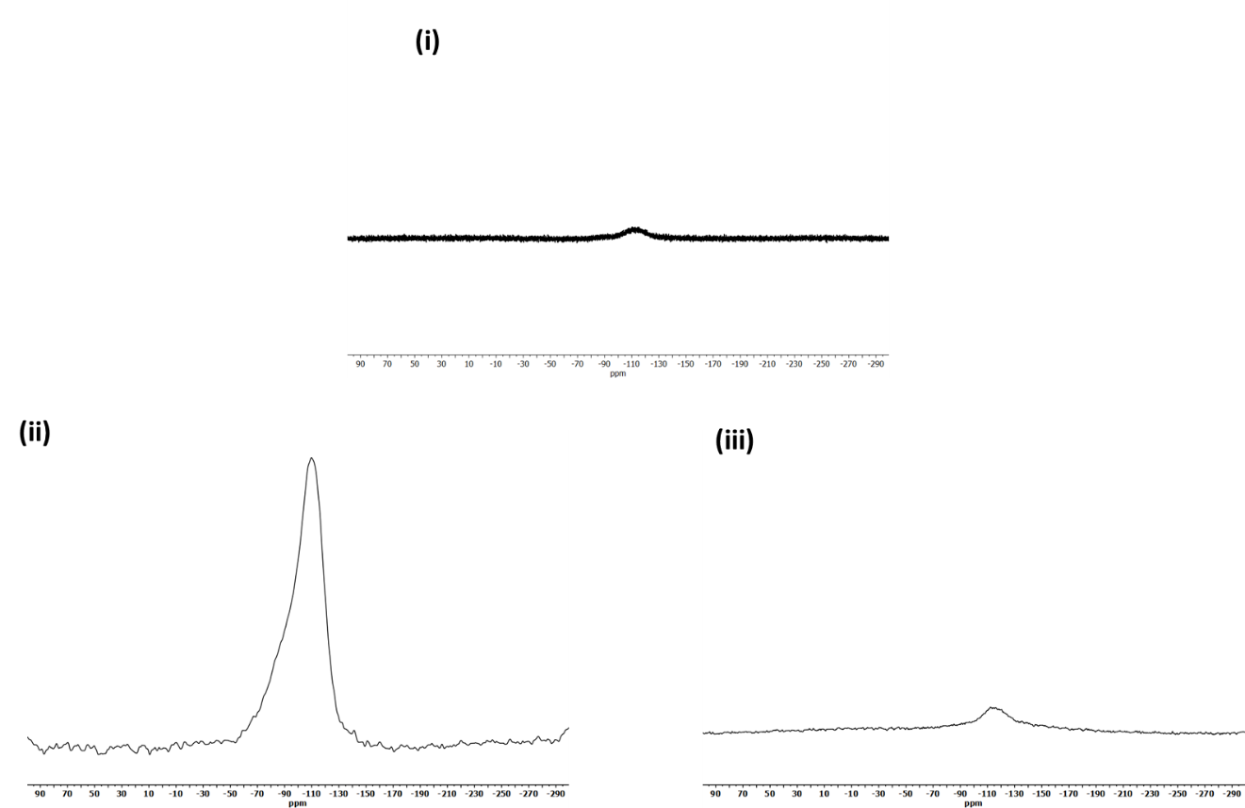
Figure SI 3. ²⁹Si NMR spectroscopy of SiO_{x}-Si-C electrodes upon cycling (i) without additive (ii) with LiFSI (iii) with LiBOB

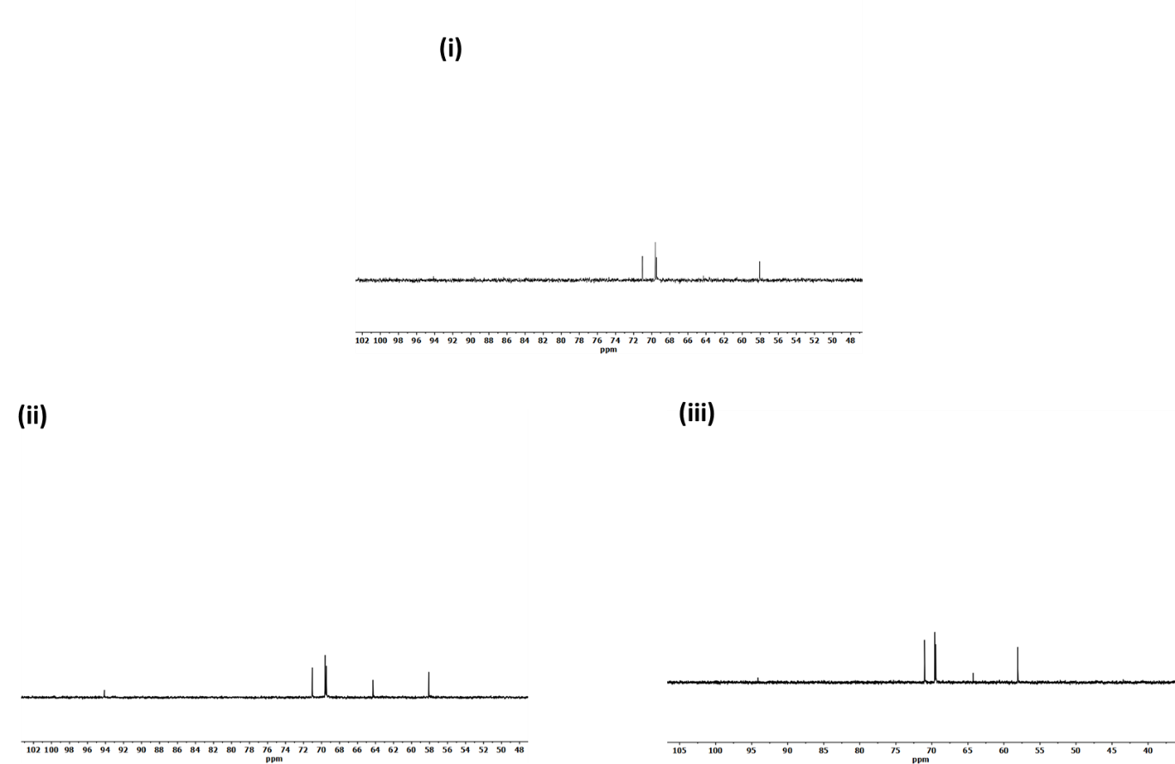
Figure SI.4 ¹³C NMR spectroscopy of SiO_{x}-Si-C electrodes upon cycling (i) without additive (ii) with LiFSI (iii) with LiBOB

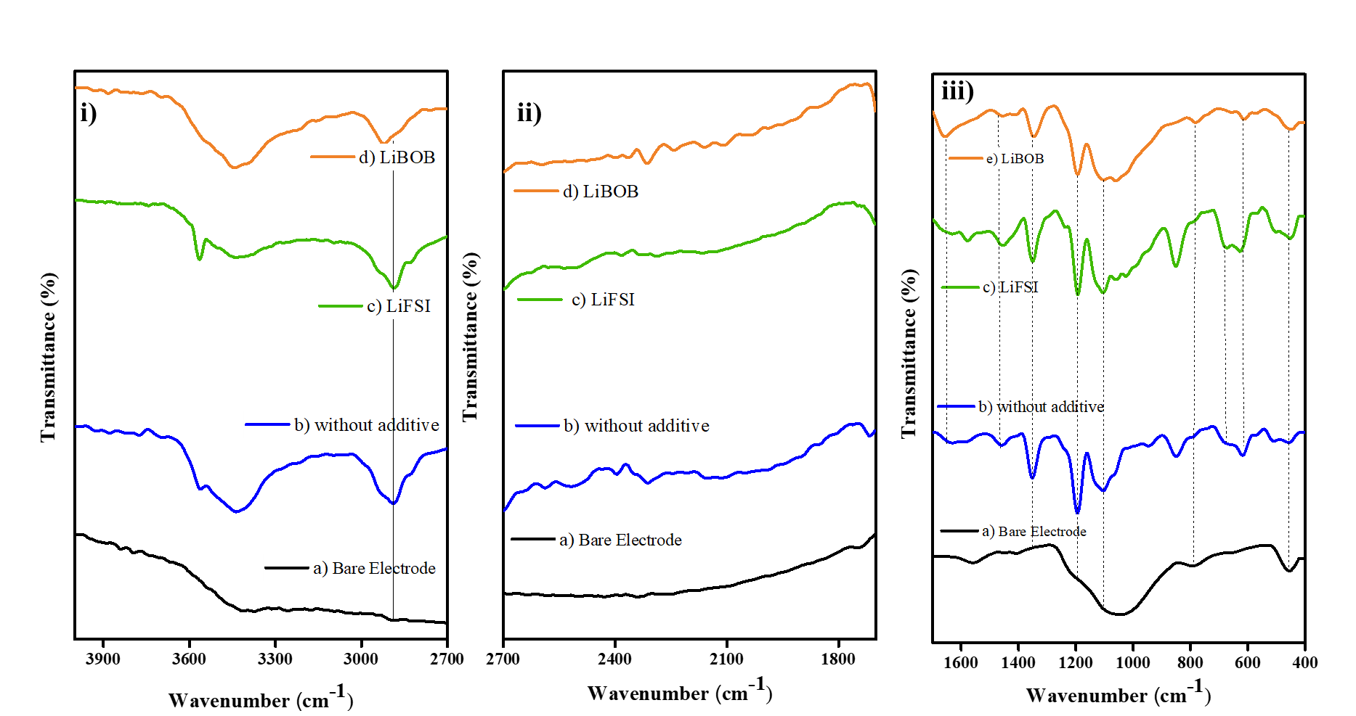
Figure SI 5. FTIR Spectra of SiO_{x}-Si-C electrodes upon 20 cycles at different regions
- 2700 -4000 cm⁻¹ (ii) 1700-2700 cm⁻¹ (c) 400- 1700 cm⁻¹

