Supplementary Information
Impact of changes in sea surface temperature on hurricane wind and storm surge hazards across US Atlantic and Gulf coast regions
Babak Salarieh¹, Izuchukwu A. Ugwu², Abdullahi M. Salman Ph.D.^{3*}
¹PhD Candidate, Department of Civil & Environmental Engineering, The University of Alabama in Huntsville
²Graduate Student, Department of Civil & Environmental Engineering, The University of Alabama in Huntsville
^{3*}Corresponding author, Assistant Professor, Department of Civil & Environmental Engineering, The University of Alabama in Huntsville, ams0098@uah.edu

Hurricane Simulation Model Description

Genesis model
The number of storms to be simulated in any year is obtained by sampling from a negative binomial distribution [1, 2] with a mean value of 11.20 storms/year and a standard deviation of 5.6 storms per year based on statistical analysis of historic hurricanes records from 1944 to 2020. The genesis point of each storm is sampled from the historic hurricanes recorded in HURDAT [3] to provide starting coordinates, date and time, initial heading, and translational speed for the initial point. Using this sampling method of historic hurricanes ensures that the climatology and seasonal preferences for the genesis point of the storm are retained [1].

Track model
After the selection of the genesis point for a hurricane, the Track module estimates the new position, speed, and heading angle of the storm on 6-hour intervals using Equations (S1) and (S2):
 | $$Δ\ln{V_{t}}=a_{1}+a_{2}ψ+a_{3}λ+a_{4}\ln{V_{t(i)}}+a_{5}θ_{i}+ε_{\begin{aligned}&Vt \\ &\end{aligned}}$$ | (S1)
 | $$Δθ=b_{1}+b_{2}ψ+b_{3}λ+b_{4}V_{t(i)}+b_{5}θ_{i}+b_{6}θ_{i-1}+ε_{θ}$$ | (S2)
where, $a_{j}(j=1,2,...,5)$ and $b_{k}(k=1,2,...,6)$ are coefficients of linear regression, $ψ$ and $λ$ are the latitude and longitude of hurricane centre, $V_{t(i)}$is the translational speed of the hurricane at time step i, $θ_{i}$ is the heading angle of the hurricane measured from north at time step i and $-180<θ_{i}<180$, $ε_{c}$ and $ε_{θ}$ are random error terms for translational speed and heading angle. The coefficients are derived for each cell from a $5^{o}×5^{o}$ grid over the entire Atlantic basin by performing a linear regression analysis. In cases where there are insufficient data to calculate the coefficients for a given grid, the coefficients from the nearest neighboring grid are used.

Intensity model
The central pressure of a storm on the ocean is modeled using the relative intensity (RI) technique pioneered by Darling [4] coupled with the sea surface temperature (SST), which relates the hurricane central pressure deficit, $∆p$, to the greatest possible central pressure deficit allowed for given meteorological conditions [5]. The relative intensity of the hurricane at each step is calculated for each point along the track on the ocean using Equation (S3).
 | $$Δ\ln{(}RI)_{i+1}=c_{1}+c_{2}.V_{s(i)}+c_{3}.Δ\ln{(}RI)_{i}+c_{4}.Δ\ln{(}RI)_{i-1}+c_{5}.Δ\ln{(}RI)_{i-2}+c_{6}.SST_{i}+c_{7}.ΔSST_{i}+ε_{RI}$$ | (S3)
where, $c_{j}(j=1,2,...,7)$ are the coefficients of linear regression, (RI)_{i} is the Relative Intensity value at step i, $V_{s}$ is the environmental shear (m/s) between 850 and 200 mb pressure levels, SST_{i} is the sea surface temperature at current point in ̊C, $ΔSST_{i}$ is the changes in sea surface temperature between previous point and current point (SST_{i}); and $ε_{RI}$is a random error term. The procedure to calculate RI, has been discussed in details by Darling [4].
The environmental parameters like tropopause temperature ($T_{0}$) and wind shear $V_{s}$ in Equation (S3) were obtained from the NCAR re-analysis database [6], providing data on a ${2.5}^{o}$ grid. The sea surface temperature (SST) values for the years 2005 and 2020 were obtained from the Hadley Ice and Sea Surface Temperature (HadISST) database, which provides monthly mean values on a $1^{o}$ grid recorded from 1870 to present [7]. The projected SST under different future climate change scenarios represented by RCPs is obtained from NOAA’s GFDL-CM3 climate model from the Coupled Model Intercomparison Project Phase 5 (CMIP5). The relative humidity is assumed herein as a value of 0.80 [8].

Decay model
Once a storm makes landfall, its central pressure deficit ($∆p$) decreases, which weakens and decays the storm. To model the changes of the central pressure due to landfall, the filling rate (decay) model by Vickery [9] is employed. For each region, the difference in central pressure for time t after landfall, ${∆P}_{c}(t)$, is defined as:
 | $$ΔP_{c}\left(t\right)=Δp_{0}.\exp{(}-αt)$$ | (S4)
where $Δp_{0}$ is the central pressure difference at the time of landfall, and $α$ is an empirical decay constant, for location of the landfall. The empirical decay constant $α$ can be calculated as:
 | $$α=α_{0}+α_{1}Δp_{0}+ε_{α}$$ | (S5)
where, $α_{0}$ and $α_{1}$ are the exponential filling rate constants and $ε_{α}$is the error term which obeys normal distribution error term.

Wind field model
The asymmetric wind field model, first developed by Georgiou et al. [10], is used to calculate the gradient wind speed from hurricane parameters as given below:
 | $$V_{g}=\frac{1}{2}\left(V_{t}.sinθ-f.r\right)+\sqrt{\frac{1}{2}{\left(V_{t}.sinθ-f.r\right)}^{2}+\frac{B.∆P}{ρ}. {\left(\frac{RMW}{r}\right)}^{B}exp\left[-{\left(\frac{RMW}{r}\right)}^{B}\right]}$$ | (S6)
where f is the Coriolis parameter, r is the distance from hurricane eye to the location of interest, $ρ$ is the air density and $Δ$P is the central pressure difference which is a function of SST from Intensity model. RMW is the radius to the maximum wind speed which can be calculated from the hurricane parameters [11] and B is a pressure profile parameter (also known as Holland B parameter, a dimensionless parameter that controls the shape of the wind profile proposed by Holland [12]) can be calculated by using RMW, f, $Δ$P and SST [13]. Since RMW and B are both a function of $Δ$P (central pressure difference), their values are also function of SST. These parameters are calculated at every time interval and used to calculate the gradient wind speed for the study location. Then, the gradient wind speed is converted to wind speed at 300m ($V_{300}$) elevation using wind adjustment factors provided by Franklin et al. [14]. Using equation (S7), the mean wind speed at 300 m elevation is then converted to 10m elevation [14, 15].
 | $$V_{10}=V_{300}.\frac{ln\left(\frac{10}{z_{0}}\right)}{ln\left(\frac{300}{z_{0}}\right)}$$ | (S7)
where $z_{0}$ is the surface roughness length. Finally, the mean surface wind is converted to 3s-gust wind speed using 1.46 as conversion factor which is provided in ESDU model [16].

Model Validation

Hurricane simulation validation
Parameters of the simulated hurricanes that come close to the shore are compared to the parameters obtained from historical data. The parameters include central pressure, translational speed, heading angle, and frequency of occurrence. They are chosen for comparison since all the other parameters are a function of these main parameters in the hurricane simulation process. The parameters from the simulation are compared to recorded parameters at mileposts along the Atlantic shore and the Gulf coast, which are located approximately 75 km (50 miles) apart. Figure S1 shows the locations of the mileposts.
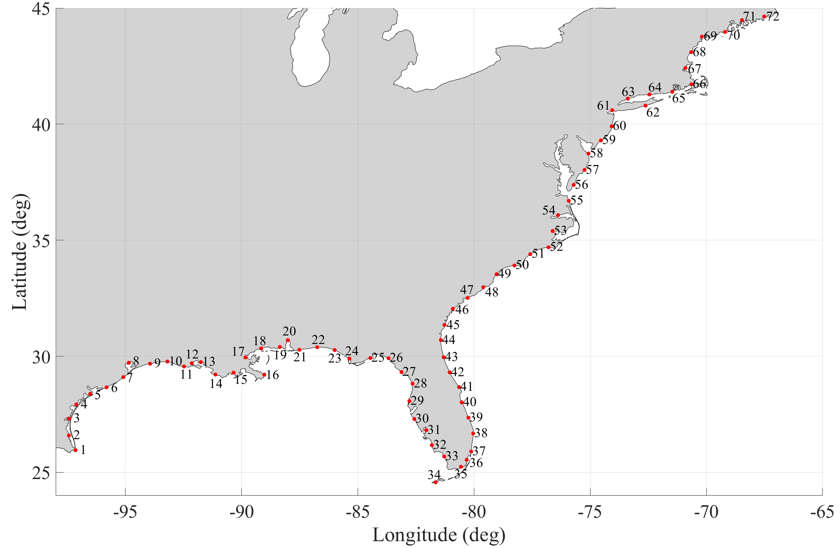
000
000
000
000
000
000
000
000
Milepost
Major Milepost (study site)
000
Gulf of Mexico
Northern Atlantic
Atlantic coast
Figure S1. Location of mileposts and study sites for hurricane parameters comparison for the Atlantic basin
The properties of any hurricane or tropical storm that has entered a 150 km vicinity of these mileposts are stored and averaged. Figure S2 compares the mean value of the selected parameters calculated from historical data and the simulated hurricanes based on the climate scenario of the year 2020. The simulated results agree well with the recorded values. The root mean square error (RMSE) is found to be 0.042, 1.19 m/s, 10.57˚, and 6.41 mb, with Percent Bias (PBIAS) values calculated as -0.5%, 6.53%, -2.9% and -0.28% for the annual frequency, the translational speed, the heading angle, and the central pressure, respectively. The minor discrepancies between simulated results and the historical records could be related to the random error term that has been considered in each of these parameters. This error term will not be able to capture the variation for the calculated parameter entirely, and as a result, a small degree of error is expected. Moreover, accurate records of hurricane parameters, specifically consistent central pressure, are only available after the late 1950s. Meanwhile, insufficient recorded data points (specifically latitude above 42.5º) could lead to a certain level of error in the estimations of the coefficients. The calculated standard deviations for historical records and simulated results are comparable for most sites. As a result, all of the averaged simulated results are within the standard deviation range. In general, the simulated standard deviation shows a greater range due to the number of simulated hurricanes year being significantly greater than the available historic hurricane years. This fact and the random error term considered in the calculation process of these parameters lead to more variation and diversion in the simulated results, as expected.

Simulation Mean
HURDAT Mean
Simulation Mean ± standard deviation
HURDAT Mean ± standard deviation
Simulation Mean
HURDAT Mean
Milepost Number

Figure S2. Comparison of Hurricane simulation parameters (annual frequency, translational speed, heading angle, and central pressure) with the observed mean values from HURDAT

Wind model validation
The specified design wind speed by ASCE 7-16 guideline corresponds to the 3-sec gust wind speed at 10-m elevation over open terrain at any given location [17]. The wind speed corresponding to specific mean return intervals (MRIs) of 300, 700, 1,700, and 3,000 years are used to design structures with Risk Categories of I through IV, respectively. To further validate the hurricane simulation method used in this study, simulated 3-sec gust wind speeds corresponding to various mean recurrence intervals (MRI) for the eight study locations are compared to values specified by ASCE 7-16 [17]. Figure S3 presents the results. Overall, the simulated results match the ASCE 7-16 values wells. The simulation model estimates the winds with higher MRIs across the studied areas with reasonable accuracy, while minor underestimation is observed for wind speeds with small return intervals compared to ASCE 7-16 values. It is worth mentioning that the design wind speeds from the guideline include both hurricane and non-hurricane winds to derive the wind speed distribution. Since the selected study sites are located in regions where hurricane wind is dominant, and the used method corresponds to hurricane winds, a minor underestimation for wind speeds with low MRIs (frequent winds below MRI of 100 years) is expected.
Figure S4 shows the observed HURDAT average central pressure for the chosen locations as well as the simulated average central pressure for 2005, 2020, and the four RCP scenarios. RCP 8.5 resulted in the lowest average central pressure in all locations, indicating an increase in hurricane intensity under the scenario. RCP 2.6 resulted in the highest average central pressure compared to other RCPs. Results for RCP 4.5 and 6.0 are similar because the difference in SST over a large portion of the Atlantic basin for the two scenarios is negligible. Comparing the recorded HURDAT average central pressure with the simulated 2020 results yielded a percentage error ranging from -1% to 1% in the eight locations. A similar comparison with the 2005 results showed a percentage error ranging from -1% to 0.8% in all areas. As mentioned earlier, the slight discrepancies could be related to the random error term that has been considered in each hurricane parameter in the simulation. Moreover, the derived wind MRI curves for 2020 closely follow the trend of the 2005 results because of the minor changes in SST over the past 15 years, which leads to minor variation in the average central pressure of hurricanes (Figure S4). The average global sea temperature in 2020 increased an approximate 0.3$℃$ over 15 years [18]. While this clearly shows an increasing trend in the sea surface temperature, it is considered a minor change compared to the predicted increase for the end of the century (2.6-4.8 $℃$ for RCP 8.5 from IPCC [19]).

Figure S3. Comparison of simulated (years 2005 and 2020) and ASCE 7-16 wind speeds for various Mean Recurrence Intervals (MRI)

Figure S4. Average Central Pressure of recorded hurricanes in the vicinity (150 km) of study sites for different climate scenarios

Surge model comparison
A selected set of hurricanes that cause a storm surge at each study site is used in the ADCRIC model to compare with the storm surge results from SLOSH. Due to the extensive computational load of the ADCIRC model, only 1,200 hurricanes are selected and modeled. These hurricanes are sampled based on the SLOSH results for each study site. Hurricanes that have caused maximum, minimum, and average surge height in SLOSH are modeled using the ADCIRC model, and the results are presented in Figure S5. Overall, good agreement is observed between the results, and the SLOSH simulation observes a slight overestimation compared to the surge height predicted by ADCIRC. This overestimation could be related to the lower wind speed values calculated by ADCIRC compared to the SLOSH wind field model. While both models used in this study are extensively used by federal and local agencies to predict the storm surge heights of hurricanes in real-time, they have been previously evaluated against historical hurricanes and the resulted storm surge, in which satisfactory performance was observed [20-25].

Figure S5. Comparison of the simulated storm surge height between the SLOSH and ADCIRC
References:
1. Vickery, P.J., et al., Hurricane hazard modeling: The past, present, and future. Journal of Wind Engineering and Industrial Aerodynamics, 2009. 97(7-8): p. 392-405.
2. Landsea, C.W., et al., Impact of duration thresholds on Atlantic tropical cyclone counts. Journal of Climate, 2010. 23(10): p. 2508-2519.
3. Landsea, C., et al., The revised Atlantic hurricane database (HURDAT2). 2015.
4. Darling, R., Estimating probabilities of hurricane wind speeds using a large-scale empirical model. Journal of Climate, 1991. 4(10): p. 1035-1046.
5. Vickery, P.J., et al., Prediction of hurricane wind speeds in the United States. Journal of Structural Engineering, 1995. 121(11): p. 1691-1699.
6. Kalnay, E., et al., The NCEP/NCAR 40-year reanalysis project. Bulletin of the American meteorological Society, 1996. 77(3): p. 437-472.
7. Met Office, H.C., HadISST 1.1. Global sea-ice coverage and SST (1870–present). NCAS British Atmospheric Data Centre, 2006.
8. Mudd, L., et al. Advancements in Synthetic Hurricane Track Modeling in the Gulf of Mexico. in Proceedings of 14th Int’l Conf. Wind Eng.(ICWE14), Porto Allegro, Brazil. 2015.
9. Vickery, P.J., Simple empirical models for estimating the increase in the central pressure of tropical cyclones after landfall along the coastline of the United States. Journal of applied meteorology, 2005. 44(12): p. 1807-1826.
10. Georgiou, P., et al., Design wind speeds in regions dominated by tropical cyclones. Journal of Wind Engineering and Industrial Aerodynamics, 1983. 13(1-3): p. 139-152.
11. Vickery, P.J., et al., Statistical models of Holland pressure profile parameter and radius to maximum winds of hurricanes from flight-level pressure and H* Wind data. Journal of Applied Meteorology and climatology, 2008. 47(10): p. 2497-2517.
12. Holland, G.J., An analytic model of the wind and pressure profiles in hurricanes. Monthly weather review, 1980. 108(8): p. 1212-1218.
13. Vickery, P.J., et al., A hurricane boundary layer and wind field model for use in engineering applications. Journal of Applied Meteorology and Climatology, 2009. 48(2): p. 381-405.
14. Franklin, J.L., et al., GPS dropwindsonde wind profiles in hurricanes and their operational implications. Weather and Forecasting, 2003. 18(1): p. 32-44.
15. Pita, G., et al., Assessment of hurricane-induced internal damage to low-rise buildings in the Florida Public Hurricane Loss Model. Journal of wind engineering and industrial aerodynamics, 2012. 104: p. 76-87.
16. ESDU, Strong winds in the atmospheric boundary layer, Part 2: Discrete gust speeds. 1983, ESDU.
17. ASCE, ASCE/SEI 7 Minimum Design Loads For Buildings and Other Structures. 2016, American Society of Civil Engineers.
18. Huang, B., et al., NOAA extended reconstructed sea surface temperature (ERSST), version 5. NOAA National Centers for Environmental Information, 2017. 30: p. 8179-8205.
19. IPCC, Technical Summary [H.-O. Pörtner, D.C. Roberts, V. Masson-Delmotte, P. Zhai, E. Poloczanska, K. Mintenbeck, M. Tignor, A. Alegría, M. Nicolai, A. Okem, J. Petzold, B. Rama, N.M. Weyer (eds.)]. In: IPCC Special Report on the Ocean and Cryosphere in a Changing Climate [H.- O. Pörtner, D.C. Roberts, V. Masson-Delmotte, P. Zhai, M. Tignor, E. Poloczanska, K. Mintenbeck, A. Alegría, M. Nicolai, A. Okem, J. Petzold, B. Rama, N.M. Weyer (eds.)]. . In press, 2019.
20. Bilskie, M.V., et al., Data and numerical analysis of astronomic tides, wind‐waves, and hurricane storm surge along the northern Gulf of Mexico. Journal of Geophysical Research: Oceans, 2016. 121(5): p. 3625-3658.
21. Glahn, B., et al., The role of the SLOSH model in National Weather Service storm surge forecasting. National Weather Digest, 2009. 33(1): p. 3-14.
22. Marsooli, R., et al., Numerical modeling of historical storm tides and waves and their interactions along the US East and Gulf Coasts. Journal of Geophysical Research: Oceans, 2018. 123(5): p. 3844-3874.
23. Taylor, A.A., et al. Probabilistic guidance for hurricane storm surge. in 19th Conference on probability and statistics. 2008.
24. Orton, P., et al., Detailed modeling of recent severe storm tides in estuaries of the New York City region. Journal of Geophysical Research: Oceans, 2012. 117(C9).
25. Pei, B., et al., Mapping joint hurricane wind and surge hazards for Charleston, South Carolina. Natural hazards, 2014. 74(2): p. 375-403.

