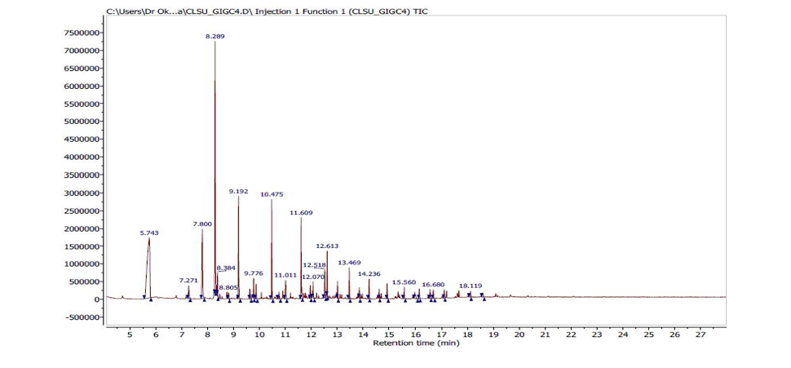
Figure S1: Chromatogram of V. negundo essential oil

