Cellulose and Gellan Gum Compresses for Cleaning Mud and Pomegranate Stains from a Historical Printed Paper

Rushdya R. A. Hassan^{1,*}, Wael S. Mohamed², Mohamed Z. M. Salem^{3,*}, Aya M. O. Abu ElMajd¹, Eman E. M. Ebrahim¹, Eman M. A. Naeem¹, Esraa G. A.-E. Elsayed¹, Rehab A. A. Hassan¹

¹ Restoration and Conservation Department, Faculty of Archaeology, Cairo University, 12613 Giza, Egypt.
² Polymer Department National Research Centre, Dokki, Giza, Egypt
3 Forestry and Wood Technology Department, Faculty of Agriculture (El-Shatby), Alexandria University, Alexandria 21545, Egypt; mohamed-salem@alexu.edu.eg

*Corresponding authors: rushdyarabii@cu.edu.eg; mohamed-salem@alexu.edu.eg

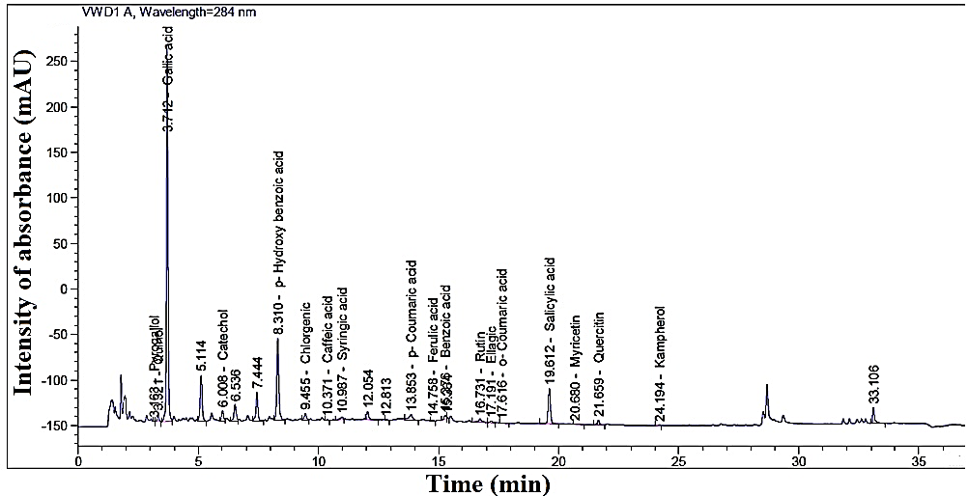

Figure S1. HPLC chromatograms of phenolic compounds identified in pomegranate juice

