Conversion of Iota Carrageenan Hydrocolloids to hydrophobic hydrocolloids, by the replacement of potassium to Barium ion, for the entrapment of water insoluble drugs.
Aman Shukla, Sachin Kumar, Akanksha Bhatt and Priyank Purohit*
Department of Pharmacy, Graphic Era Hill University Dehradun, Dehradun, 28008, India
Corresponding author: Dr Priyank Purohit:
Email: priyank.niper@gmail.com
prpurohit@gehu.ac.in

Mass spectra:
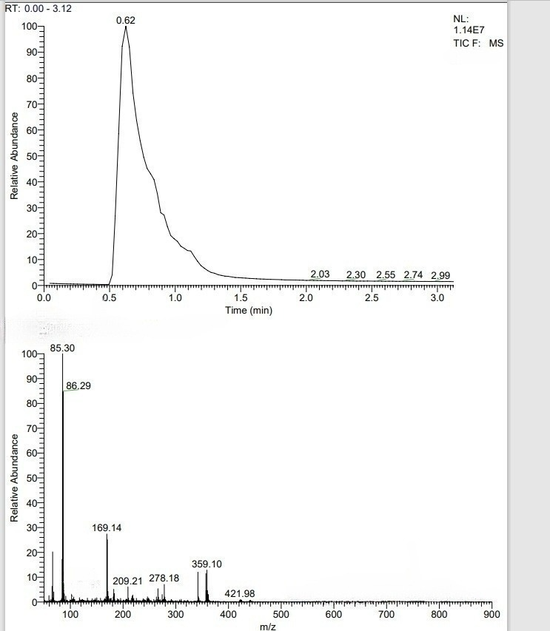

NMR
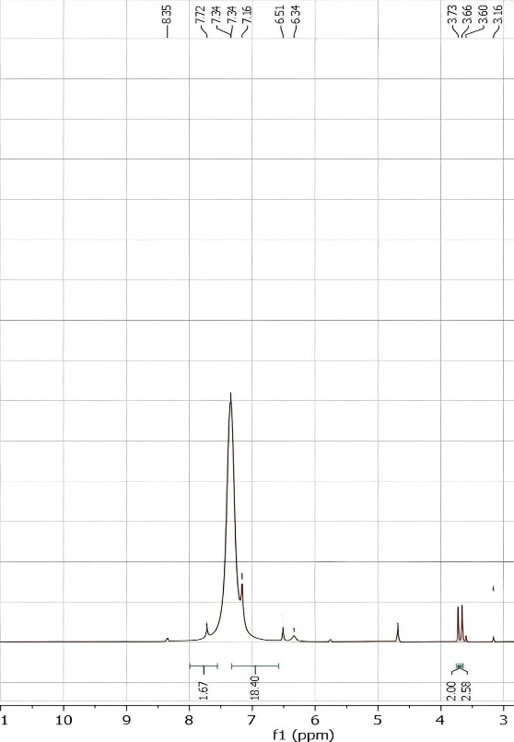
Figure 1: NMR of compound 2
Corrosion rate detection by weight loss method.
Two iron plates of equal weight and surface area have been immersed in two different beakers containing 1 M HNO_{3.} In one beaker plate immersed without any coating whereas in another beaker iron plate was coated with prepared gel. This process was continued till 24 hours but weight loss of both the plates was recorded 4 times of 6 hours interval. After each and every trial, we have seen a drastic change in the weight and surface area of both plates. Before measuring weight loss, each plate was properly washed and dried. Observations are as follows-

The initial weight of iron plate = 0.798 g
 | Ball 1
 | Time interval | Initial weight (g) | Final weight (g) | Weight loss (g)
 | 0-6 hours | 0.798 | 0.619 | 0.179
 | 6-12 hours | 0.619 | 0.452 | 0.167
 | 12-18 hours | 0.452 | 0.294 | 0.158
 | 18-24 hours | 0.294 | 0.082 | 0.212

Ball 2 (with coating)
Time interval | Initial weight (g) | Final weight (g) | Weight loss (g)
0-6 hours | 0.798 | 0.649 | 0.149
6-12 hours | 0.649 | 0.492 | 0.157
12-18 hours | 0.592 | 0.423 | 0.169
18-24 hours | 0.446 | 0.387 | 0.059

Calibration curve of celecoxib in 255 nm. (Y= 0.0266X)

Drug Release Kinetics by Franz diffusion cell apparatus.
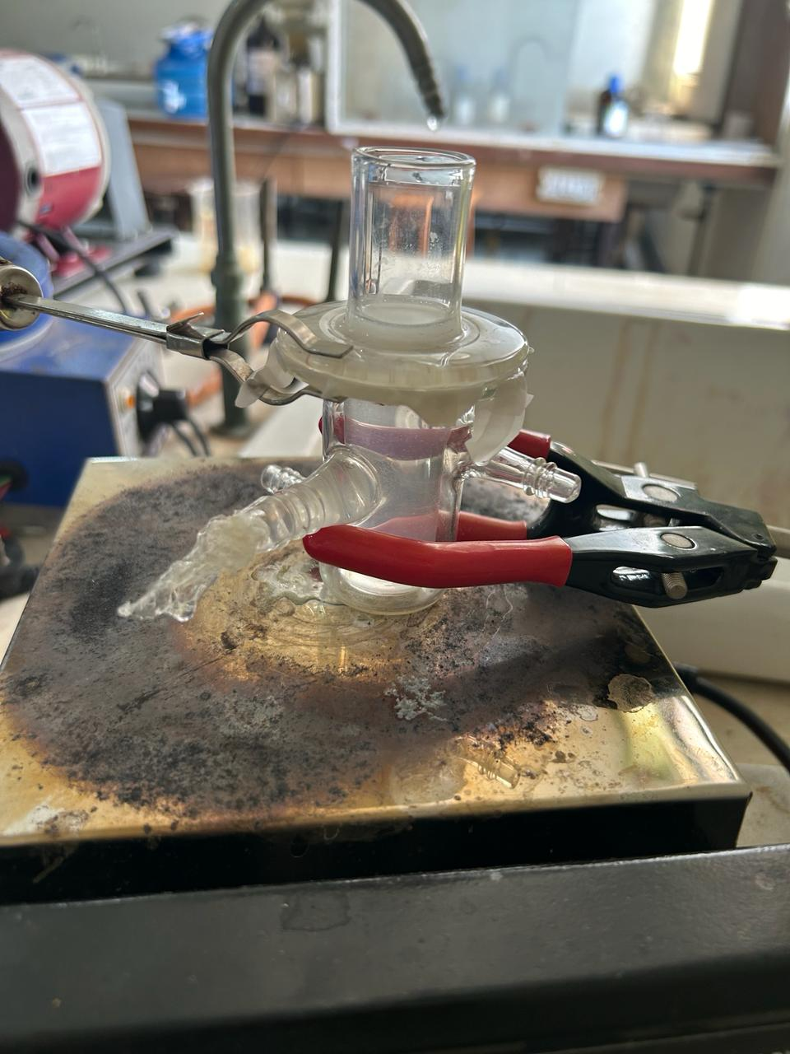
Time (min) | Absorbance | Concentration (mg/ml)  Y= 0.0266X | % drug release
0 | 0 | 0 | 0
30 | .018 | 0.47 | 5
60 | .038 | 1.01 | 11.2
90 | .078 | 2.1 | 23.3
120 | .102 | 2.7 | 30

