Electronic Supplementary Information

Hybrid Photo Paper-based Microfluidic Device for Colorimetric Detection of Iodine in Salt

Arechkang Chong ¹, Tharith Sriv ^{1, 2}, Chan Oeurn Chey ¹, Sovann Khan ³, Kwanwoo Shin ⁴, and Veasna Soum ^{1, *}
¹ Graduate School of Science, Royal University of Phnom Penh, Phnom Penh 12150, Cambodia
² Department of Physics, Royal University of Phnom Penh, Phnom Penh 12150, Cambodia
³International Institute for Carbon-Neutral Energy Research, (WPI-I²CNER), Kyushu University, 744 Motooka, Nishi-ku, Fukuoka 819-0395, Japan
⁴ Department of Chemistry and Institute of Biological Interfaces, Sogang University, Seoul 04107, Korea
*Corresponding author: soum.veasna@rupp.edu.kh

Fig. S1. Various widths of photo paper-based channel made by cutting and laminating.

Fig. S2. Absorption of DI water into the surface of photo paper is indicated by changing the surface contact angle of a droplet. The contact angle of the droplet is decreased when the remaining droplet volume is less.

Fig. S3. Average velocity was plotted against various widths of the photo paper-based channel.

Fig. S4. The fluid transport length in the photo paper-based channel and the filter paper-based channel.

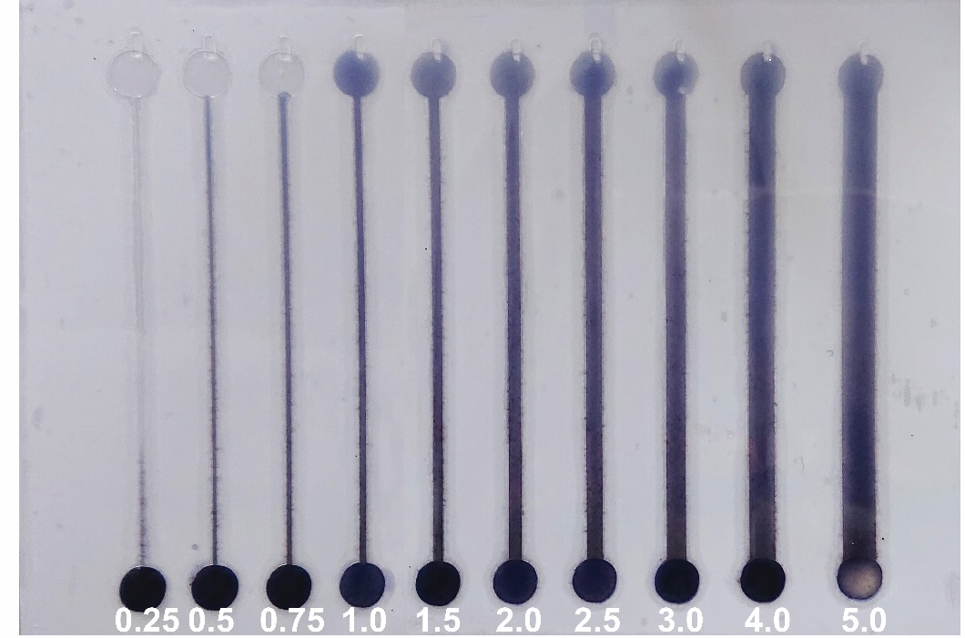
Fig. S1. Various widths of photo paper-based channel made by cutting and laminating.

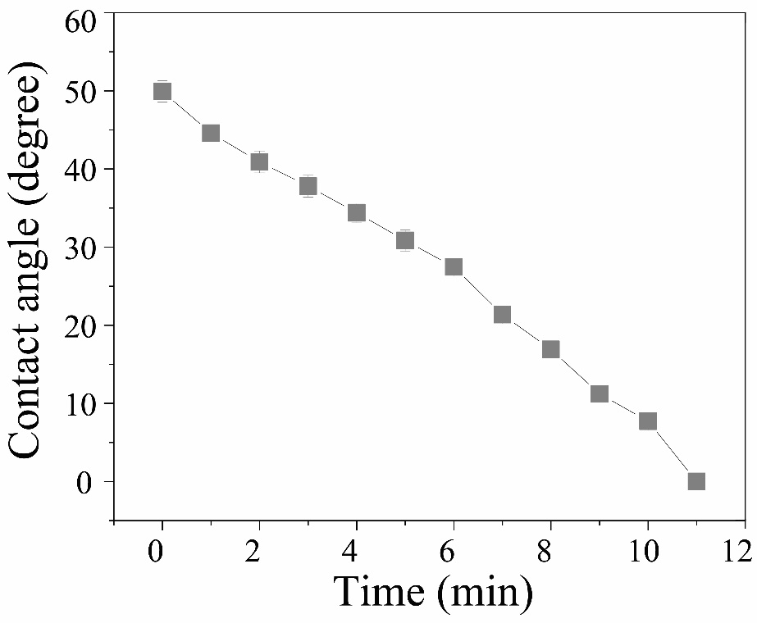
Fig. S2. Absorption of DI water into the surface of photo paper is indicated by changing the surface contact angle of a droplet. The contact angle of the droplet is decreased when the remaining droplet volume is less.

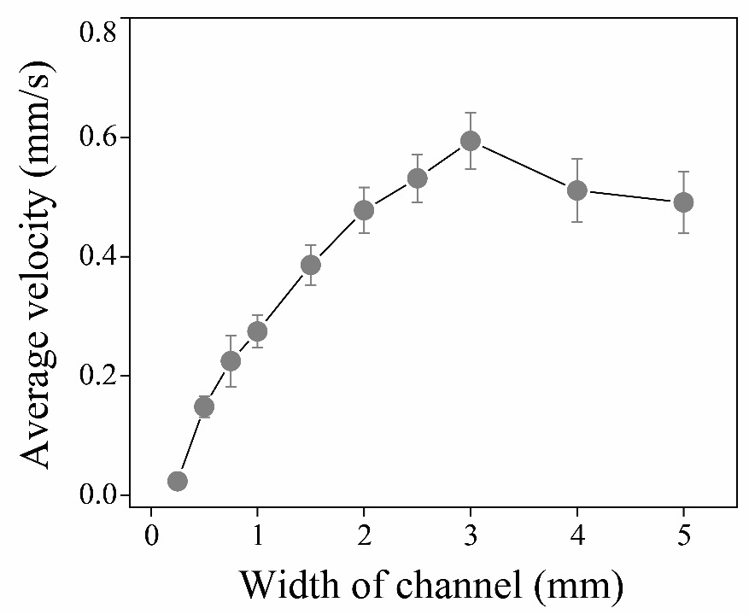
Fig. S3. Average velocity was plotted against various widths of the photo paper-based channel.

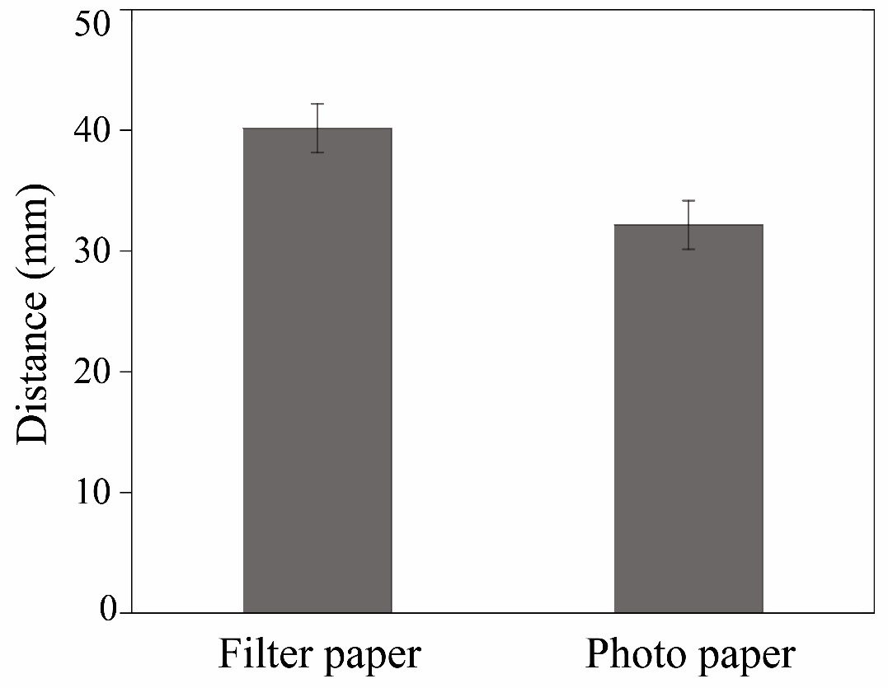
Fig. S4. The fluid transport length in the photo paper-based channel and the filter paper-based channel.

