Supplementary Information Materials
Discover Applied Sciences
Straightforward Microwave-assisted Synthesis of Ultrasmall Gold Nanoparticles Acnhored on Reduced Graphene Oxide for Enhanced Antibacterial Application
Pandji Zamzami Fathurrohman¹, Eko Sri Kunarti¹, Nastiti Wijayanti² , Sri Juari Santosa^{1*}
1 Department of Chemistry, Faculty of Mathematics and Natural Sciences, Universitas Gadjah Mada, Sekip Utara, Yogyakarta 55281, Indonesia
2 Department of Tropical Biology, Faculty of Biology, Universitas Gadjah Mada, Sekip Utara, Yogyakarta 55281, Indonesia
*Corresponding author, email: sjuari@ugm.ac.id
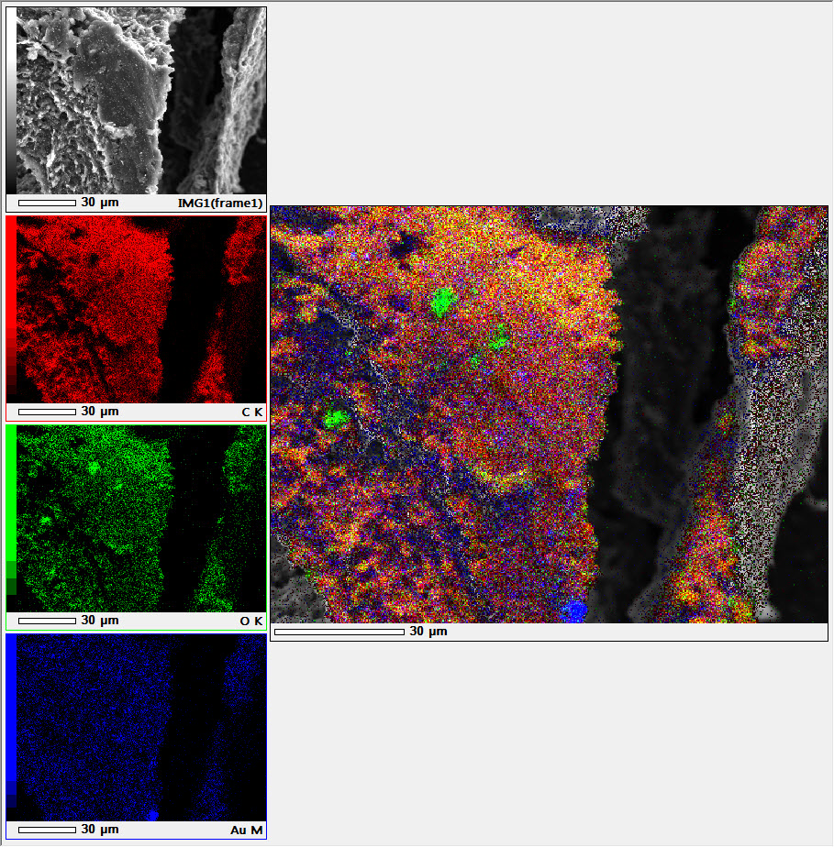
Figure S1. SEM-EDX mapping elements of rGO-Au 4 min nanocomposite

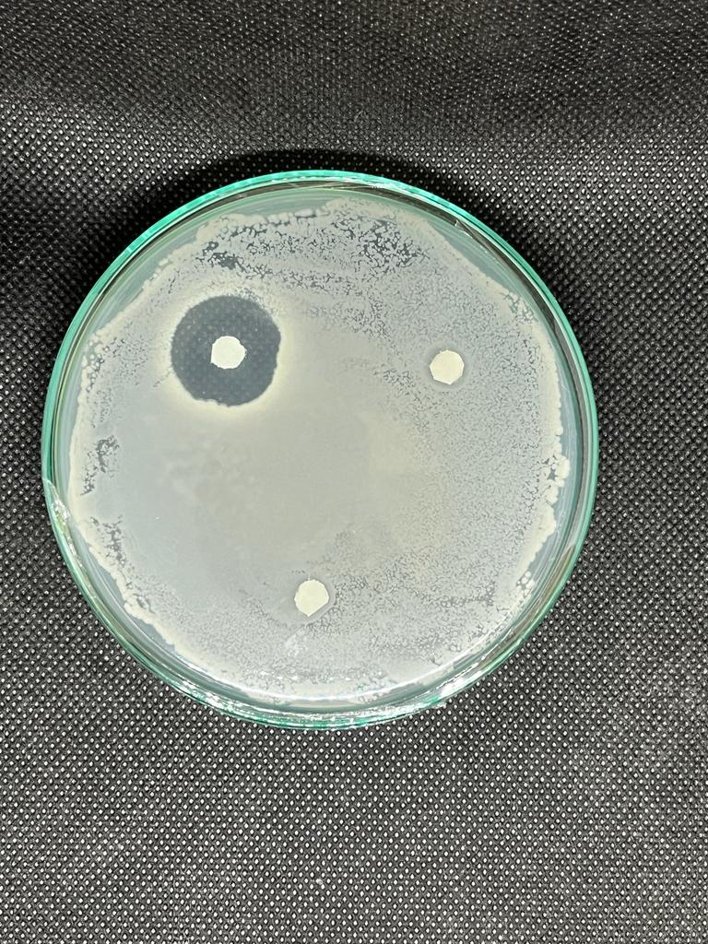
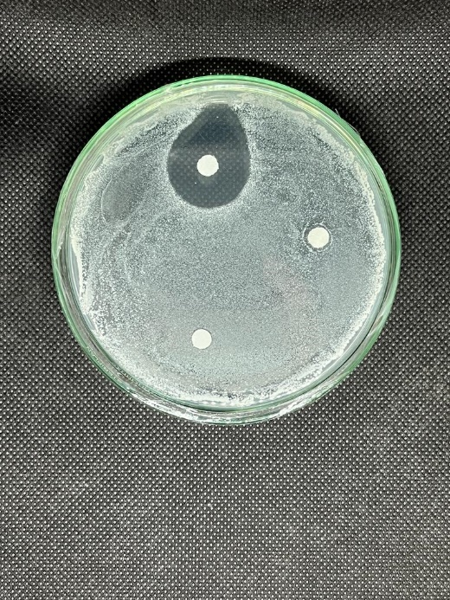
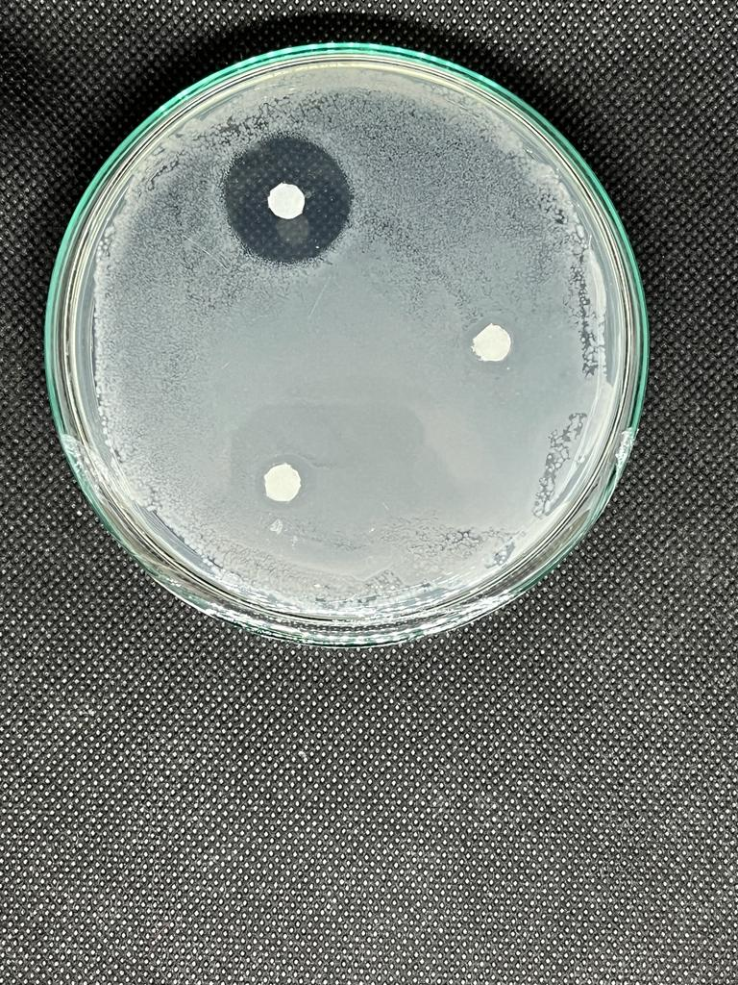
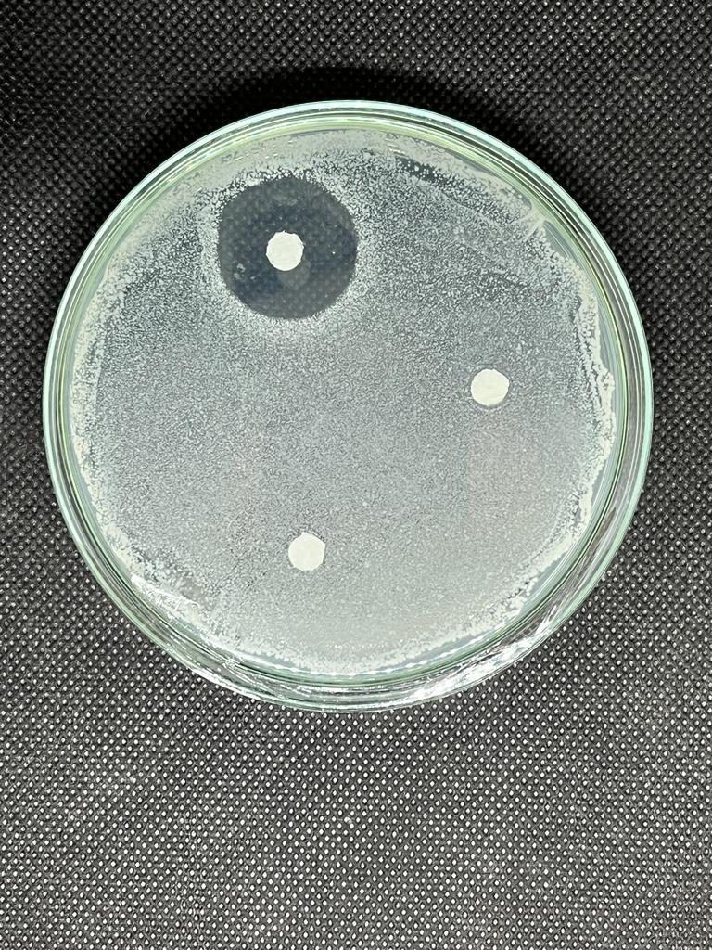
Figure S2. Antibacterial evaluation of GO and rGO-Au nanocomposite by disk diffusion method. No inhibition zone observed for both GO and rGO-Au
S.aureus
E.coli
S.aureus
E.coli
Positive control
Positive control
Positive control
Negative control
Negative control
Negative control
GO
GO
rGO-Au
Negative control
rGO-Au
Positive control

