Supplementary material
Biodegradation of low-density polyethylene by the bacterial strains isolated from the dumping site community
Pornya Khampratueng, Daniel Rice and Anil Kumar Anal *
Food Engineering and Bioprocess Technology, School of Environment, Resources, and Development, Asian Institute of Technology, PO Box 4, Klong Luang, Pathum Thani 12120, Thailand.
*Corresponding author: Anil Kumar Anal (anilkumar@ait.ac.th)
Table S1. Isolated bacterial morphology characteristics
Strain | Colony morphology | Cell morphology | Gram strain
AS3 | fuzzy white, opaque, jagged edges | rod-shaped | Positive
AS8 | yellow, convex, smooth, opaque | rod-shaped | Negative

Table S2. Esterase activity of Bacillus sp. AS3 treatment after a four-week incubation period
Bacteria | Rep | Enzyme activity (Unit/ml)
AS3 | 1 | 0.603
 | 2 | 0.607
 | 3 | 0.614
Average |  | 0.608
SD |  | 0.004

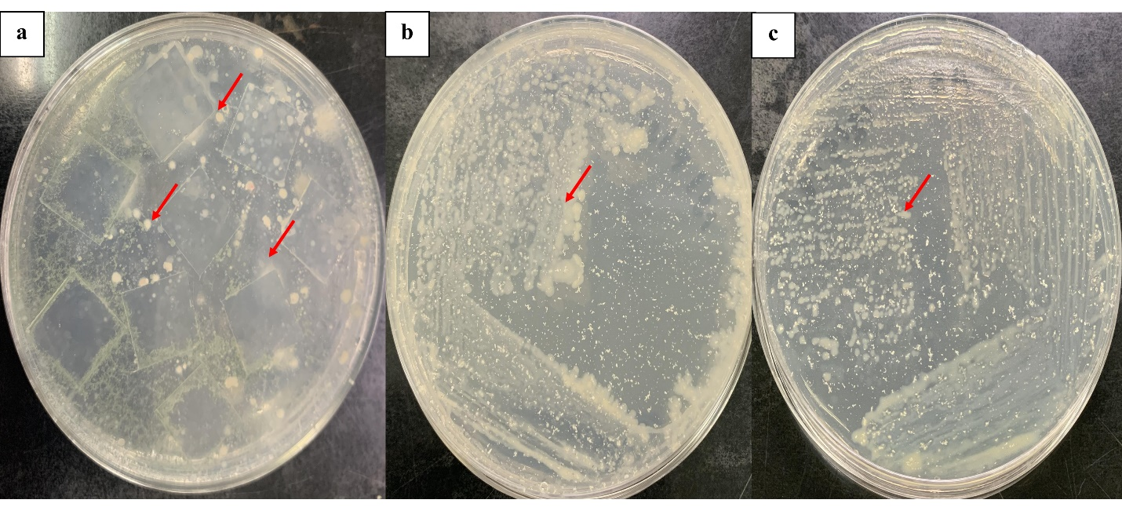
Fig. S1. The first screening: bacterial growth on MSM agar containing nine pieces of LDPE films (a), the second screening: AS3 growth on MSM containing concentrated 0.1% LDPE powder (b), AS8 growth on MSM containing concentrated 0.1% LDPE powder.

Fig. S2. The percentage weight loss of LDPE films of the bacterial isolates AS3 and AS8 after a four-week period of biodegradation assay compared to the control treatment (LDPE films in MSM solution without bacterial inoculation). According to Tukey's test, mean values with letters (a - c) are substantially different at p ≤ 0.05. Bars indicate the means ± the standard deviation.

Fig. S3. Intermediate compounds of LDPE biodegradation by Bacillus sp. AS3 treatment after a four-week period, which consisted of different types of alcohol compounds as (a) 1-dodecanol, (b) 1-Eicosanol, (c)1-hexadecanol, 2-methyl, and carboxylic acids (d) Acetic acid, 3,7,11,15-tetramethyl-hexadecyl ester, (e) hexadecanoic acid, (f) octadecanoic acid, and (g) 7-Z-tetradecen-1-ol acetate.

