Supplementary file
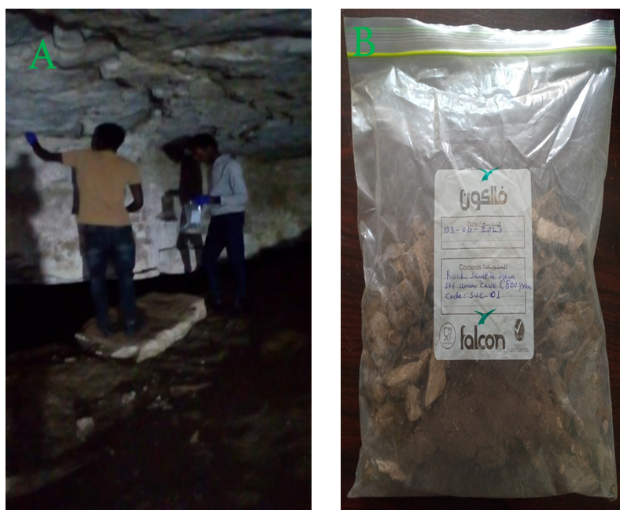
Figure 1 A. Samples taken from the wall of the Sof Umer Cave. B. Collected and homogenized samples.

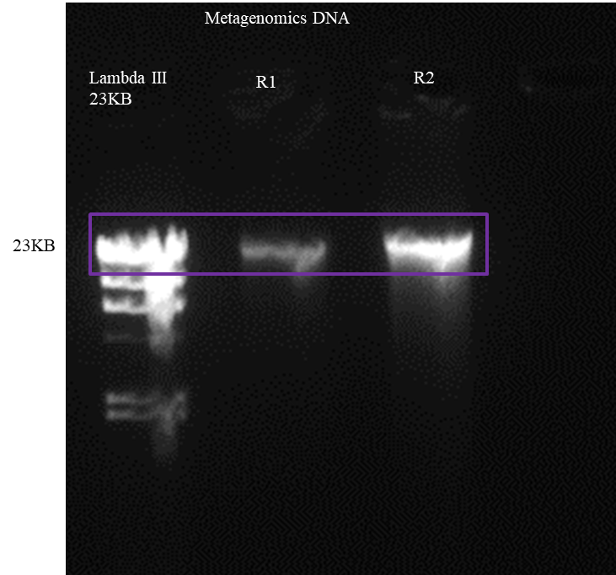

Figure 2 Agarose gel electrophoresis of metagenomic DNA extracted from rocks from Sof Umer Cave: Lane 1: Lambda III (Hind III double digest ladder), Lanes 2 and 3: metagenomic DNA extracted from rocks from Sof Umer Cave.
Table 1 NanoDrop data of metagenomic DNA extracted from the rocks of Sof Umer Cave
No | Sample ID | Nucleic Acid | Unit | A260 (Abs) | A280 (Abs) | 260/280 | Sample Type
1 | R1 | 43.7 | ng/µl | 0.294 | 0.172 | 1.91 | DNA
2 | R2 | 37.4 | ng/µl | 0.227 | 0.101 | 2.03 | DNA
3 | R12 | 17.8 | ng/µl | 0.356 | 0.195 | 1.82 | DNA
4 | R6 | 78.5 | ng/µl | 0.21 | 0.125 | 1.80 | DNA
5 | R9 | 377.9 | ng/µl | 7.559 | 3.698 | 2.02 | DNA
6 | R10 | 89.3 | ng/µl | 0.185 | 0.089 | 2.01 | DNA

Table 2 Shotgun sequence quality statistics of the Sof Umer Cave rock sample
Category | Count | Percentage
Total reads | 94,834,808 | 1000
Clean read | 94, 554, 4542 | 99.70
GC (%) | ….. | 66.31
Number assembled reads | 38548491
Number of contig | 6677
Total contig length | 32064999
Total number of base | 13736379391

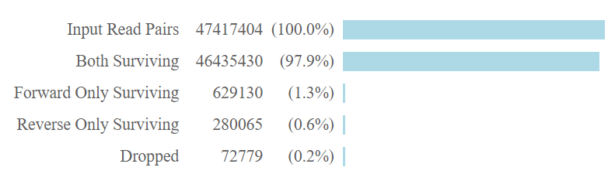 Figure 3 presents the output from Trimmomatic, a widely used tool for preprocessing high-throughput sequencing data. The figure illustrates the effectiveness of Trimmomatic in filtering and trimming raw sequencing reads to improve data quality before downstream analysis
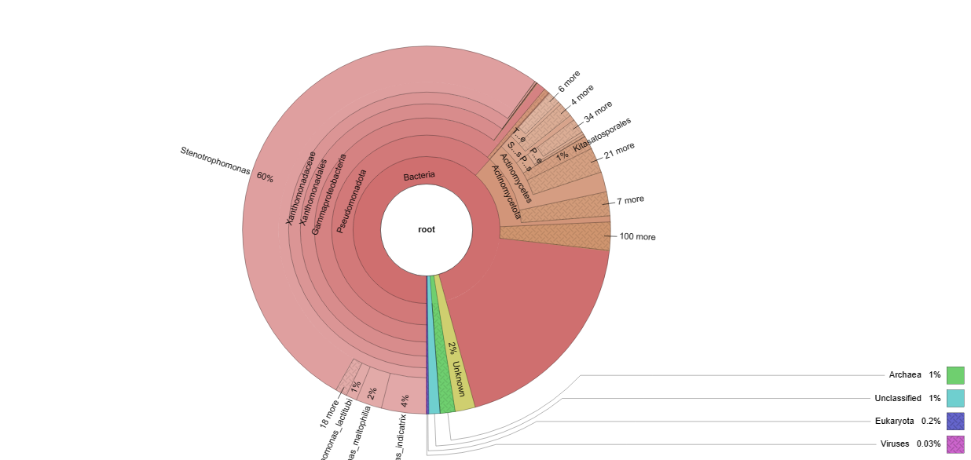
Figure 4. Taxonomies and distribution of microbial genomes at root lvel using Krona and against the Micro-NR database. Notes: Circles from inside to outside represent different taxa, and the area of the sector represents the respective proportion of different taxa.
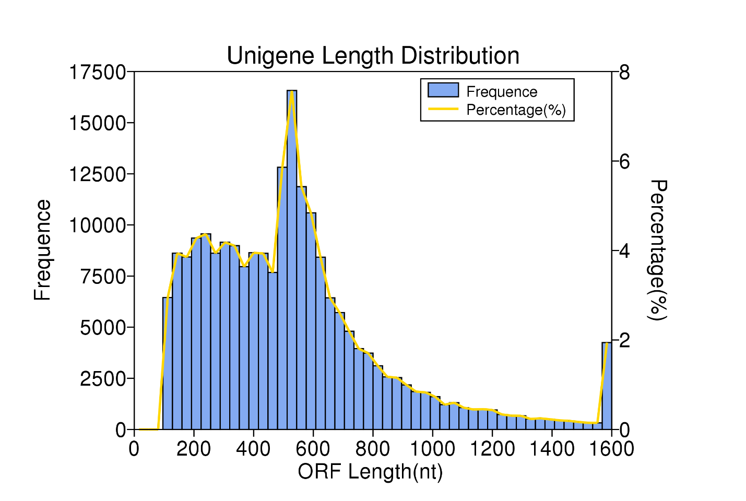
Figure 5. The scaftig (scaffold) length distribution9 scaftigs >500 bp) were used for open reading frame (ORF) prediction.

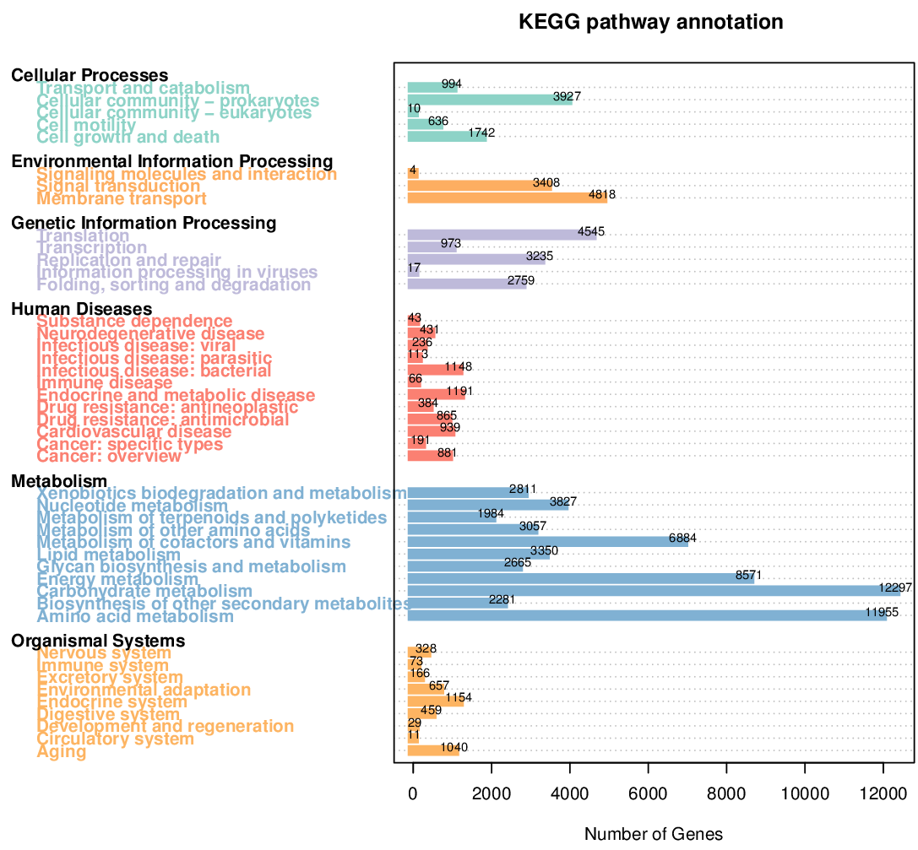
Figure 6 Summary chart of the number of genes annotated by the KEGG database (level 1)
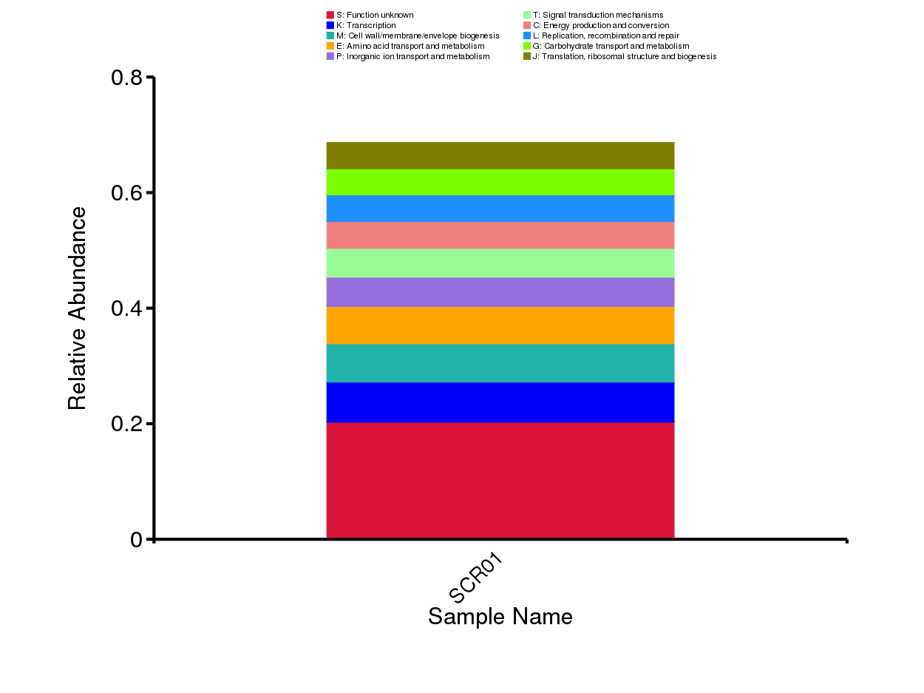
Figure 7 Relative abundance of gene numbers annotated against eggNOG database
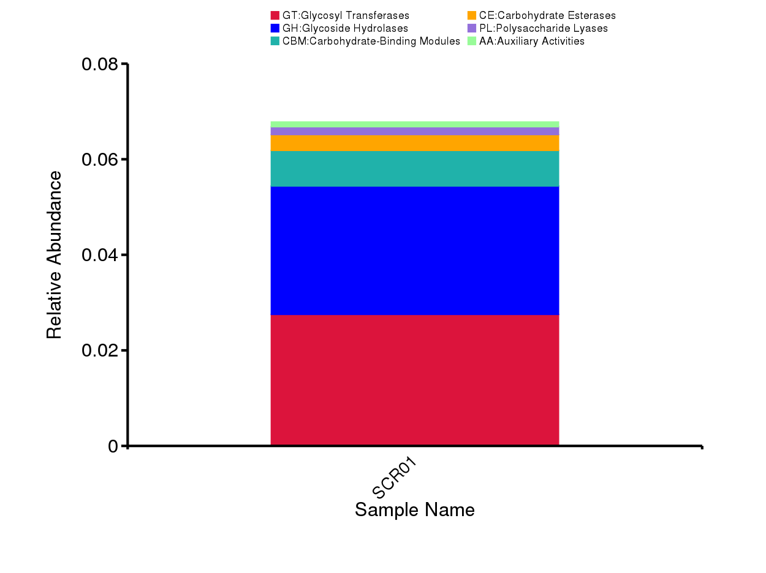
Figure 8 Distribution analysis of gene numbers annotated by the CAZy database (level 2)

Table 3 Statistics of functional genes modeled by the FBA metabolic model platform
Reaction count | 1655
Compound count | 1542
Gene count | 7531
Base gapfilling | 23
Auxotrophy count | 1
Base ATP production | 2.25
Defined biomass | 0.185362
Rich biomass | 0.7616
Defined essential reactions | 248
Defined optional reactions | 700
Defined blocked reactions | 707
Rich essential reactions | 135
Rich optional reactions | 911
Rich blocked reactions | 609

