Eco-Friendly Pyridine–Derivatives for Corrosion Inhibition of Carbon Steel During Acidic Treatments: Mechanistic Insights from Electrochemical, Surface, and Computational Studies

Supplementary Information
- OCP

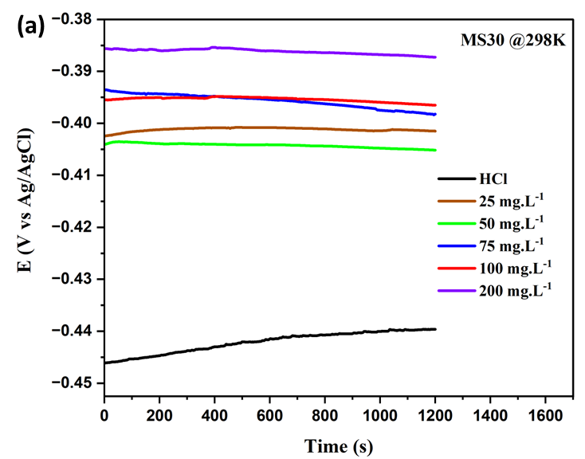 | 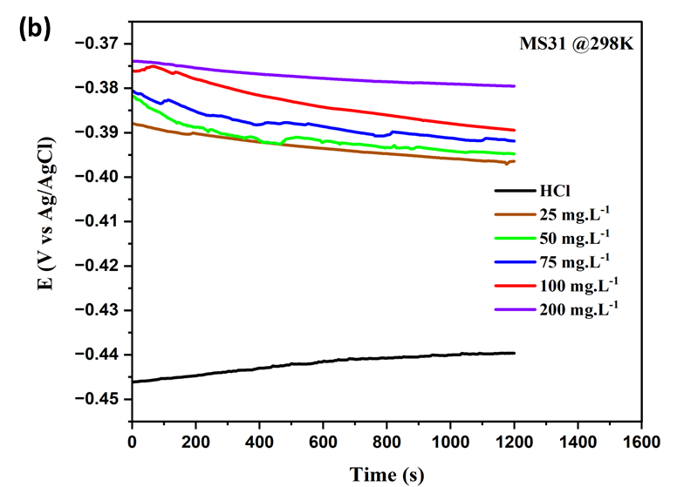
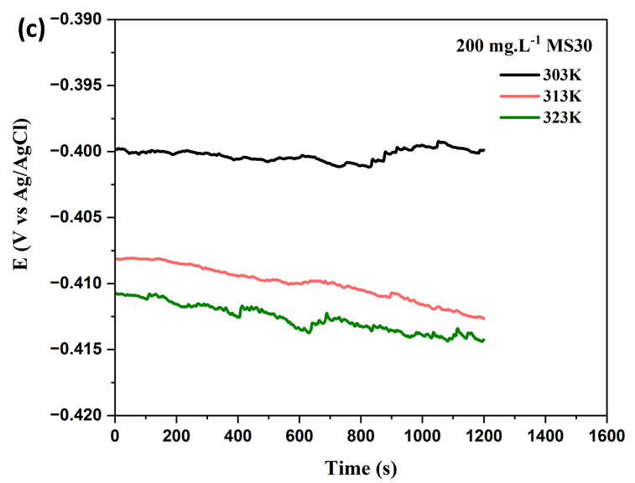 | 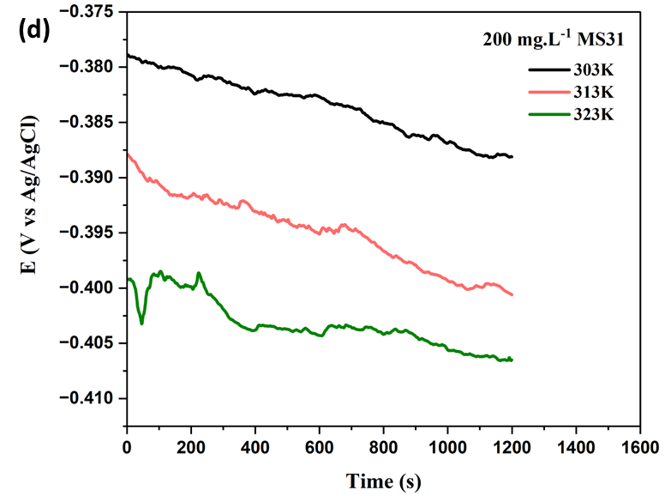

Figure S1. Open circuit potential curves of C-steel in the blank and inhibited 1 M HCl in the presence of different (a) MS30 and (b) MS31 inhibitor concentrations at 298K and OCP evaluated at an optimum concentration of 200 mg.L⁻¹ of (c) MS30 and (d) MS31 at 303, 313, 323K.

- Bode Plots

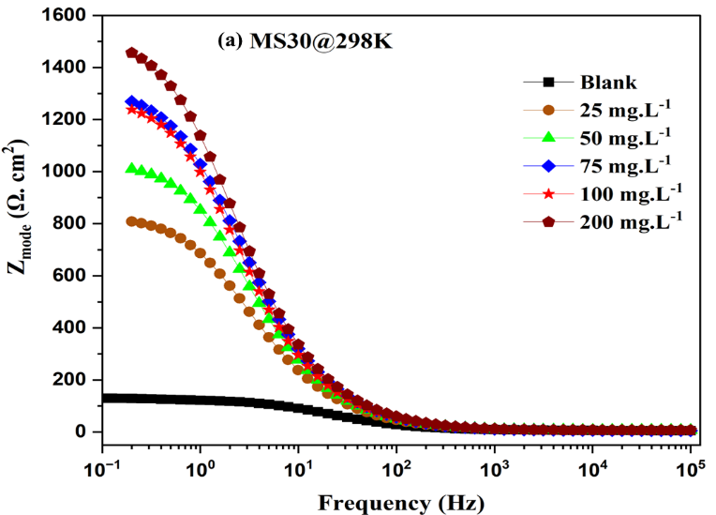 | 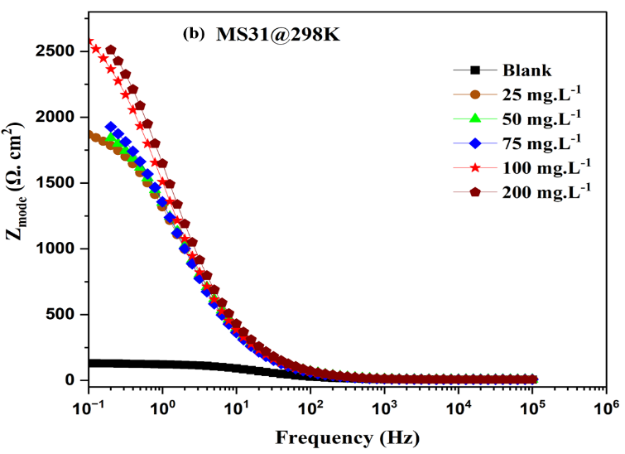
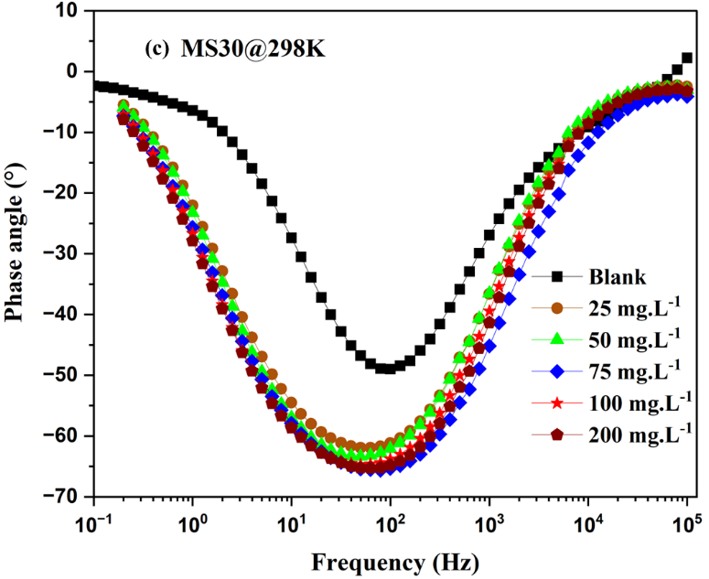 | 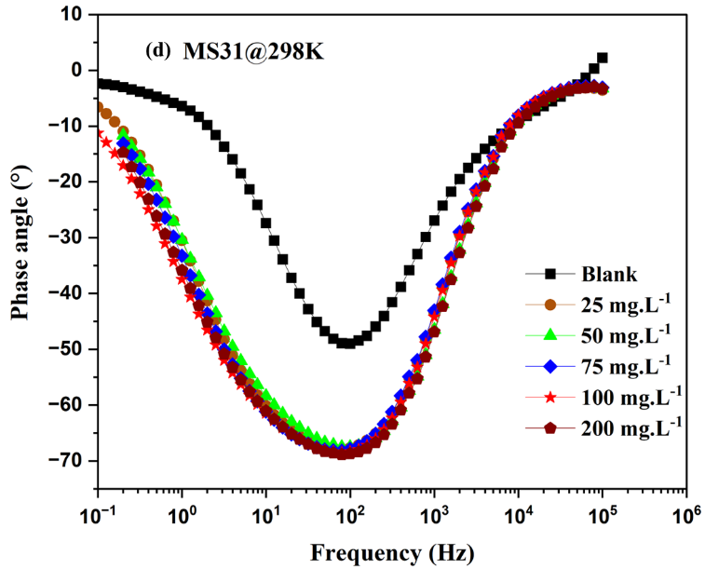

Figure S2. Bode magnitude (a,b) and phase angle plots (c,d) of C-steel in the blank and inhibited 1 M HCl in the presence of different MS30 and MS31 inhibitor concentrations at 298K.

- XPS
Figure S3. High-resolution spectra of Fe 2p for Polished C-Steel (a), Blank 1 M HCl (b), and steel immersed in MS30 inhibitor.
Figure S4. High-resolution spectra of C 1s for Polished C-Steel (a), Blank 1 M HCl (b), and steel immersed in MS30 inhibitor.
Figure S5. High-resolution spectra of N 1s for Polished C-Steel (a), Blank 1 M HCl (b), and steel immersed in MS30 inhibitor.
Figure S6. High-resolution spectra of N 1s for Polished C-Steel (a), Blank 1 M HCl (b), and steel immersed in MS30 inhibitor.
- Computational Study:
In light of the systems employing an HCl solution as its solvent, the adsorption of protonated MS30 and MS31 were also studied. Several stable adsorption configurations along with their corresponding adsorption energies are listed in Figure S5. Notably, the adsorption configurations closely resemble to those of the non-protonated MS30 and MS31, featuring of the N⁺-H bond of the pyridine group tilt away from the Fe surface. The average Fe-N bond length increases in the protonated MS30 and MS31, suggesting weaker Fe-N interactions in the protonated systems. For both protonated MS30 and MS31, their adsorption energies are significantly larger than those of the neutral counterparts, indicating that the acidic solution facilitates the adsorption of the corrosion inhibitors.

Figure S7. Several stable adsorption geometries and the corresponding adsorption energies of protonated MS30 and MS31. (a) Trans adsorption configuration of MS30²⁺. (b) Trans adsorption configuration of MS30²⁺ with one O tilted up. (c) Cis adsorption configuration of MS30²⁺. (d)Trans adsorption configuration of MS31²⁺. (e) Cis adsorption configuration of MS31²⁺.

The EDD plots for the protonated molecules (in the trans configuration) were also calculated (refer to Figure S6). The electron transfers between the molecules and the surface exhibit similarities compared with the corresponding neutral systems. However, it is observed that the N atoms in the pyridine groups gain fewer electrons than the adjacent C atoms in the protonated MS30 and MS31 structures.

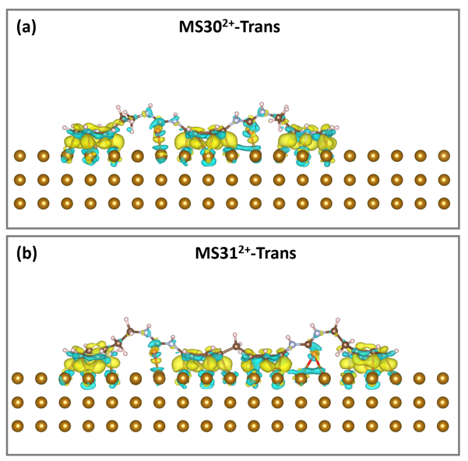
Figure S8. 3D electron density difference plots of absorbed protonated systems on Fe(110): (a) trans-MS30²⁺ and (b) trans-MS31²⁺. The isosurface level is ±0.005 e/Å³. The yellow and blue regions represent electron accumulation and depletion, respectively.

