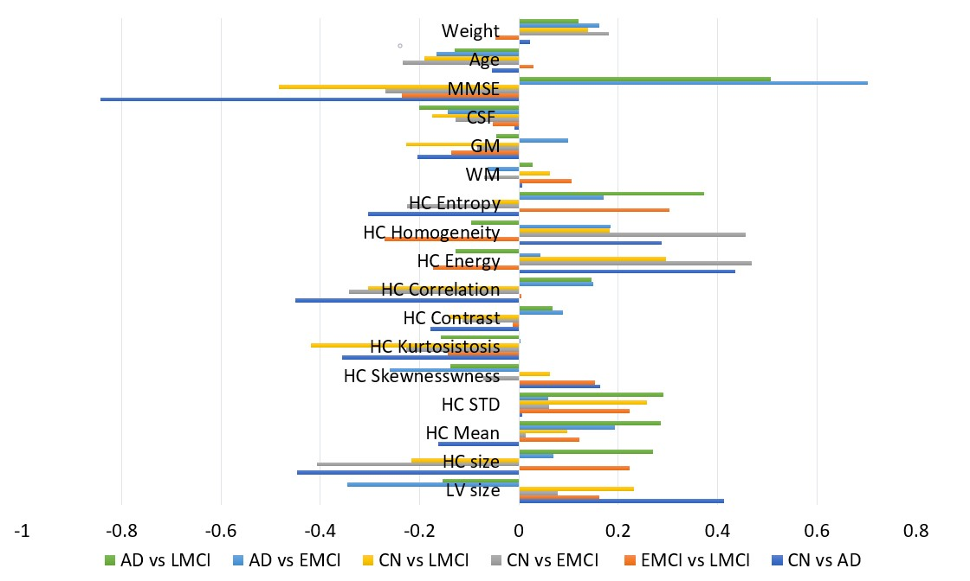
Fig. S1 The Spearman correlation coeﬃcients between the extracted features and each group target.
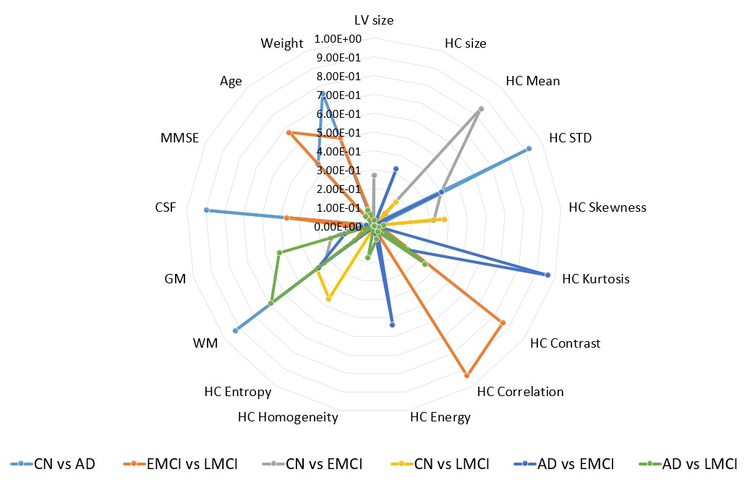
Fig. S2 The P-value based on the Spearman correlation between the extracted features and each group target.

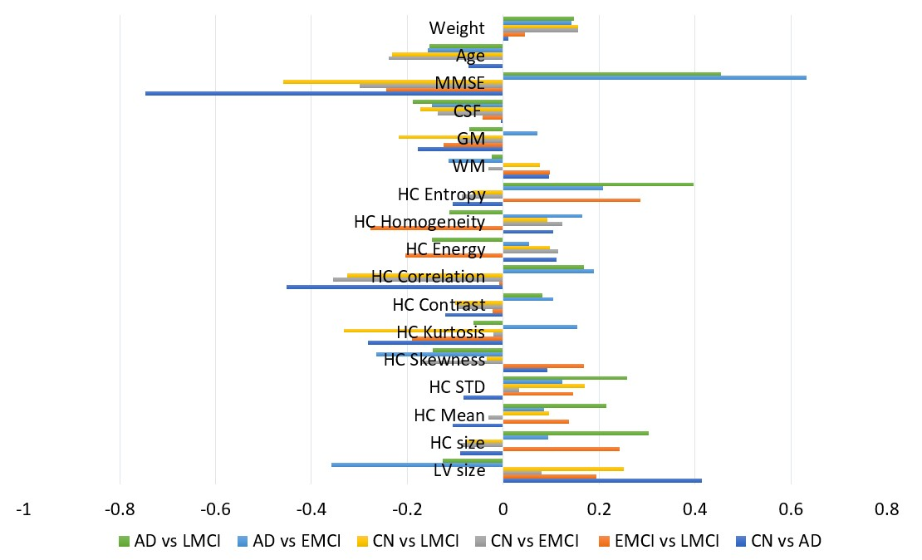
Fig. S3 The Pearson correlation coeﬃcients between the extracted features and each group target.
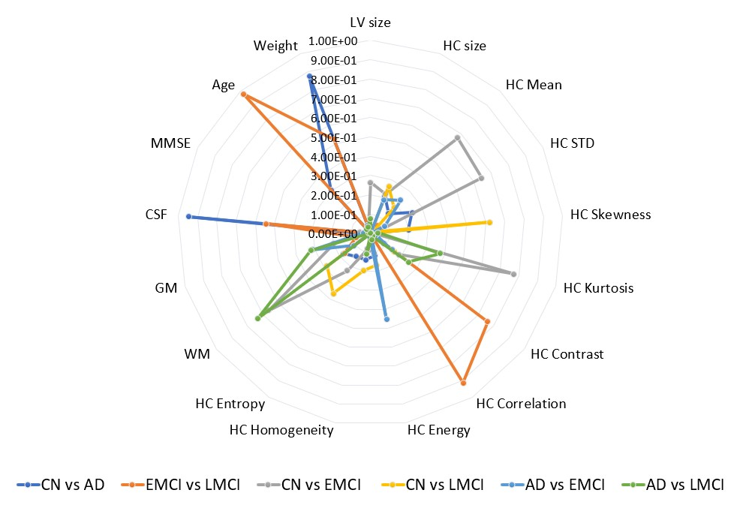
Fig. S4 The P-value based on the Pearson correlation between the extracted features and each group target.
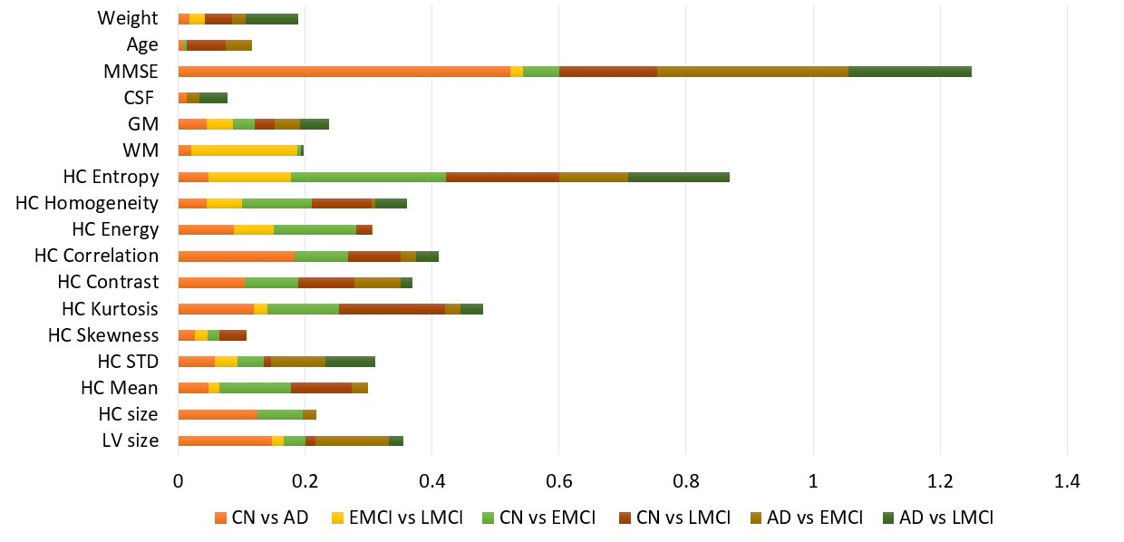
Fig. S5 The Mutual Information between the extracted features and each group target.

