Supporting materials:

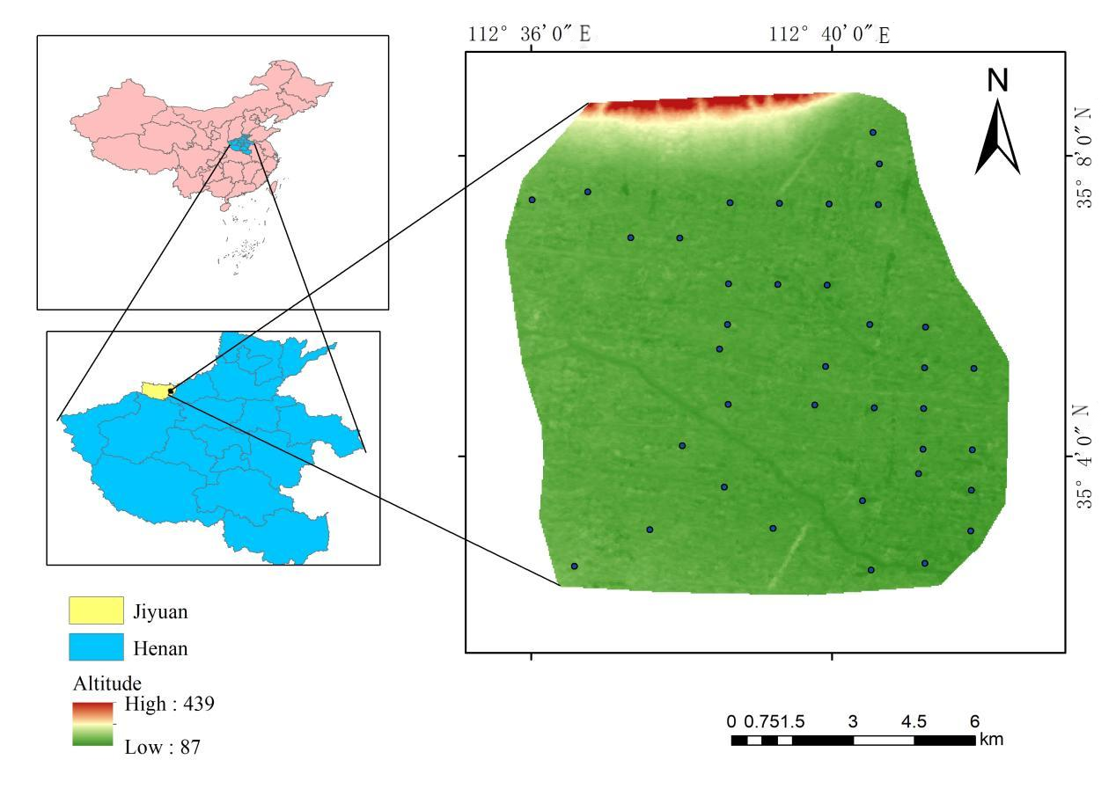

Figure 1s. Location of the study area

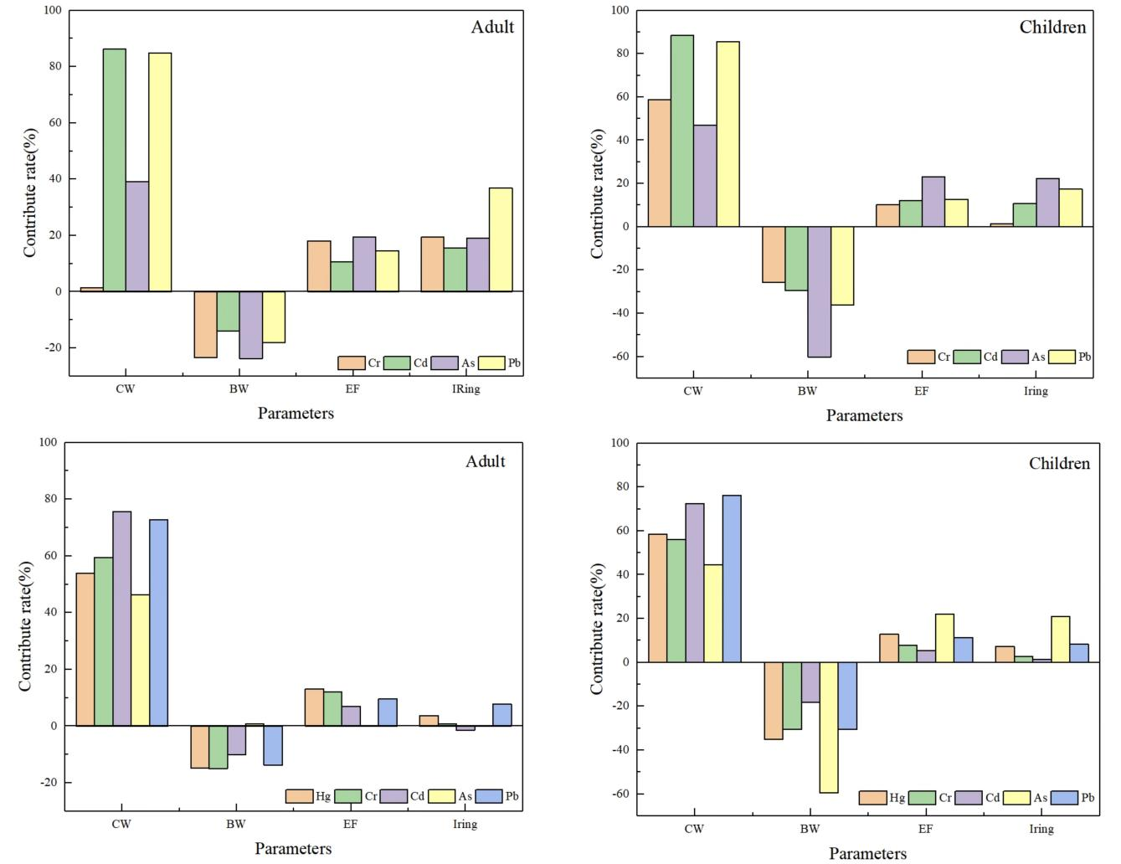

Figure 2s Contribution of different exposure parameters to HI and TCR in wheat

Table 1s Exposure parameters for health risk assessment based on Monte Carlo simulation
parameters | implication | Probability distribution and values
parameters | implication | Adult | Children
IR/（kg/d） | Wheat intake | Triangular distribution  （0.15,0.27,0.31） | Triangular distribution  （0.10,0.26,0.29）
EF/（d/a） | Exposure frequency | Triangular distribution  （180,345,365）
ED/（a） | annual limit on exposure | 24 | 6
BW/（kg） | Body weight | Normal distribution （61.9,11.31） | Normal distribution（5.25,29.3,56.8）
AT-carcinogenic  /（d） | Mean exposure time | 72×365 | 72×365
AT-non-carcinogenic/（d） | Mean exposure time | ED×365 | ED×365
Note: Triangular distribution (minimum, most likely, maximum); Normal distribution (mean, standard deviation)

Table 2s Reference dose and slope factor values
 | Cr | As | Cd | Pb | Hg
RfD | 0.003 | 0.0003 | 0.003 | 0.0035 | 0.0003
SF | 0.5 | 1.5 | 6.1 | 0.0085 | ——
“—”indicates no data

