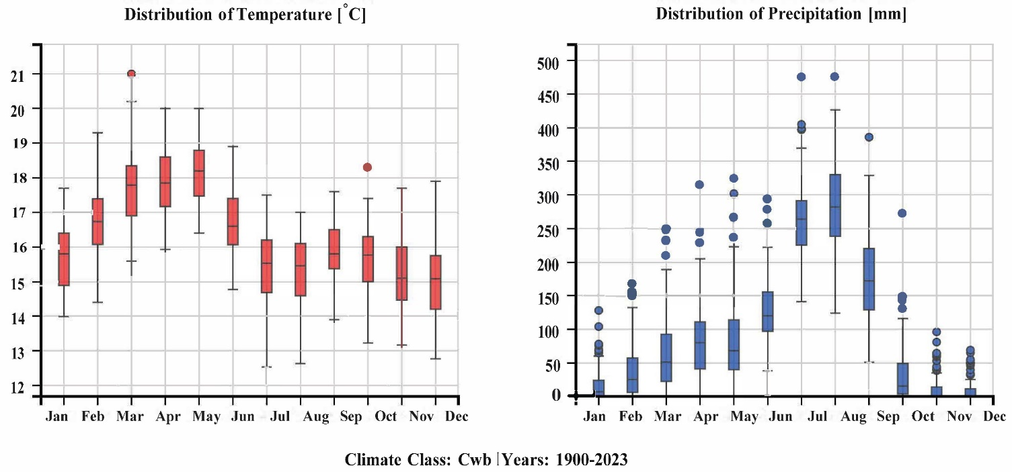
Fig S1. Mean monthly temperature and precipitation distribution in Addis Ababa, Ethiopia (1990–2023).

Table 1. Key Statistical Measures for Model Evaluation
Accuracy | $$\frac{TP+TN}{TP+TN+FP+FN}$$
Sensitivity | $$\frac{TP}{TP+FN}$$
Specificity | $$\frac{TN}{TN+FP}$$
Kappa Index (κi) | $$\frac{P_{o}-P_{e}}{1-P_{e}}$$
Detection Rate (DR) | $$\frac{TP}{TP+FN}$$
Positive Predictive Value (PPV) | $$\frac{TP}{TP+FP}$$
Negative Predictive Value (NPV) | $$\frac{TN}{TN+FN}$$
Detection Prevalence (DP) | $$\frac{TP+FP}{(TP+FP)+(TN+FN)}$$
F1 Score | $$2\left(\frac{PPV*Sensitivity }{PPV+Sensitivity}\right)$$
Area Under the ROC Curve (AUC) | $$\frac{\sum{TP+\sum{TN}}}{TP+TN+FP+FN}$$
Balanced Accuracy | $$\frac{Sensitivity+Specificity }{2}$$
Where TN is the true negative, FP is the false positive, TP is the true positive, FN is the false negative, $κi$ is the kappa index, P_{o} is the observed agreement, and P_{e} is the expected agreement.

